**VIETNAM NATIONAL UNIVERSITY, HO CHI MINH CITY**

**UNIVERSITY OF INFORMATION TECHNOLOGY**

**FACULTY OF COMPUTER ENGINEERING**

**MIDTERM PROJECT**

**Control the number of human in a store**  
**Mentor: Ph.D Đỗ Trí Nhựt**

**Cao Thanh Bình**

**Đào Tuấn Anh**

**Nguyễn Mạnh Bảo**

**CE224.M13.MTCL(EN)**

**HO CHI MINH CITY, 11/2021**

|  |  |
| --- | --- |
| VIETNAM NATIONAL UNIVERSITY  HO CHI MINH CITY  **UNIVERSITY OF INFORMATION**  **TECHNOLOGY** | **SOCIALIST REPUBLIC OF VIETNAM**  **Independence – Freedom - Happiness** |



# **DETAILED TOPICS**

|  |  |
| --- | --- |
| **VIETNAMESE PROJECT NAME: THIẾT KẾ KIỂM SOÁT SỐ NGƯỜI TRONG MỘT CỦA HÀNG** | |
| **ENGLISH PROJECT NAME:** DESIGN CHECKING NUMBER OF HUMAN IN A STORE DEVICE | |
| **Instructor** PhD. TRI NHUT DO, Department of Computer Engineering | |
| **Implementation time:** From: 8/10/2021 To: 19/10/2021 | |
| **Student Perform:**  Cao Thanh Bình – 19520408  Đào Tuấn Anh – 19520377  Nguyễn Mạnh Bảo -19521249 | |
| **Overview of the topic:** The topic proposes building a device that can detect humans going in or out the store to better assist in controlling the number of human in one small area. Therefore, we can follow the rule of limited people in an area during Covid-19.  **The goal of the subject:** Device can be used easily in detecting human going or out a store with the function that can be fixed every time the user wants and also alarm for the error it meeting.  **Methods of implementation:**  - Research about Arduino syntax  - Research about Infrared Obstacle Avoidance Sensor Module  - Research about servo  - Research about bell  - Test the result and complete the product.  **Main contents of the topic:**  Programming language (s): C / C ++.  To demo the system: Record a comprehensive video test of the device on Proteus. | |
|  | |
| **Certification of Instructor**  (Sign and clearly state full name) | **HCM city, 2021 October 31**  **Student**  (Sign and clearly state full name) |

**Index**

DETAILED TOPICS 2

Chapter 1. INTRODUCTION 6

**1.1.** **Reason** 6

**1.2.** **Target** 6

Chapter 2. Components 7

**2.1. List of Components** 7

**2.2. Components Detail** 7

Chapter 3. Function 11

**3.1. Block diagram** 11

**3.2** **Flowchart** 13

**3.3. Function Detail** 16

Chapter 4. Simulation 17

**4.1 Simulation board** 17

**4.2 Operating Principle** 18

**4.3 App** 19

**LIST OF FIGURES**

Figure 1 Arduino 8

Figure 2 Servo 9

Figure 3 9

Figure 4 IR Obstacle Sensor 10

Figure 5 Button 11

Figure 6 Main Flowchart 13

Figure 7 Fixing Block 14

Figure 8 Interrupt Block 15

Figure 9 Board simulation 17

Figure 10 App Screen 19

Figure 11 Chinh Gioi Han mode 20

# **Chapter 1. INTRODUCTION**

## **Reason**

Covid 19 has many rules about limitation of population which may be a problem for the shop owner to count all the guests going in and out the store. Beside that, Counting students in one room to avoid fake attendants is quite a waste of time for the teacher. Because of all of many problems including two above, we want to provide a device that can count people for you.

## **Target**

IR Obstacle Avoidance Sensor is used to detect whether there is a human or not. Therefore, We can know if anyone goes in or out by the detection and direction of two sensors. Next, we can count the number of guests so that we can close when the store reaches its limitation population. After that, a flexible fixing tool needs to be installed for many errors the machine may meet.

# **Chapter 2. Components**

## **2.1. List of Components**

* *Arduino*
* *Servo*
* *Buzzer*
* *IR Obstacle Sensor*
* *Button*

## **2.2. Components Detail**

* Arduino

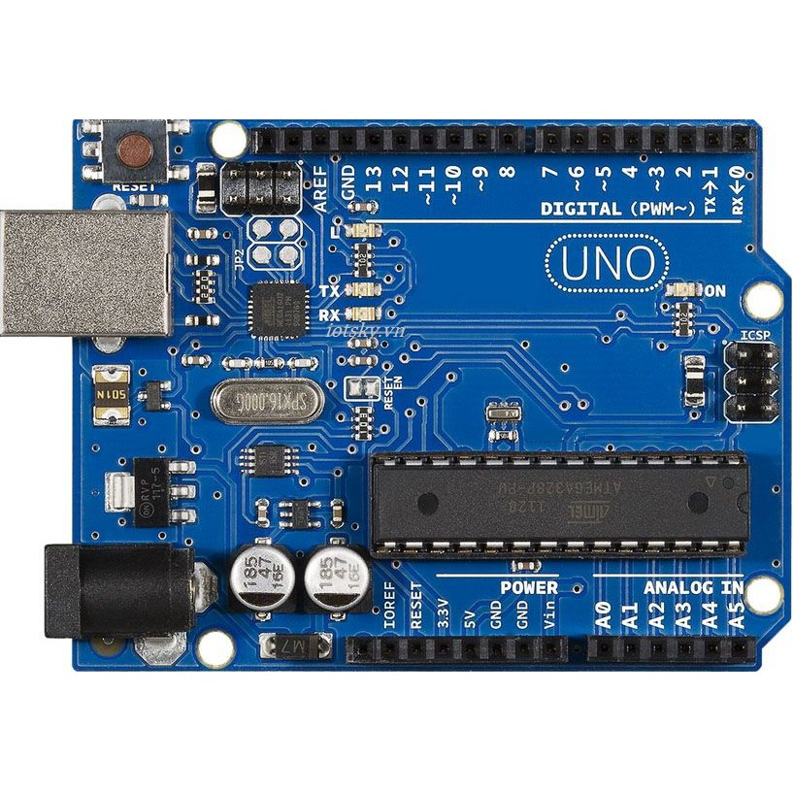

Figure 1 Arduino

Arduino Uno is a microcontroller board based on the ATmega328P. It has 14 digital input/output pins (of which 6 can be used as PWM outputs), 6 analog inputs, a 16 MHz quartz crystal, a USB connection, a power jack, an ICSP header and a reset button. It contains everything needed to support the microcontroller; simply connect it to a computer with a USB cable or power it with a AC-to-DC adapter or battery to get started.

* Servo

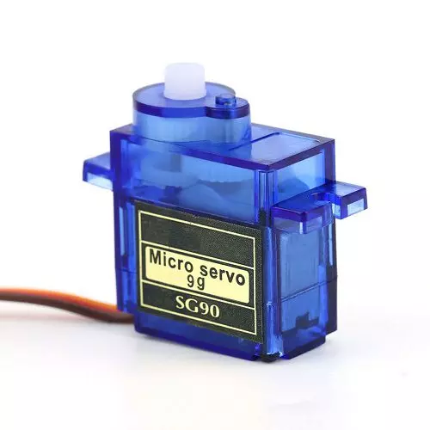

Figure 2 Servo

**A Servo motor** is a rotary actuator that allows for precise control of angular position, velocity and acceleration.

* Buzzer

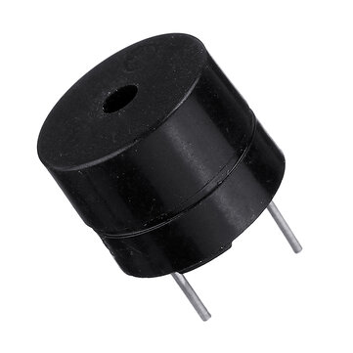

Figure 3 Buzzer

A buzzer or beeper is an [audio](https://en.wikipedia.org/wiki/Sound) signaling device, which may be [mechanical](https://en.wikipedia.org/wiki/Machine), [electromechanical](https://en.wikipedia.org/wiki/Electromechanics), or [piezoelectric](https://en.wikipedia.org/wiki/Piezoelectricity) (*piezo* for short). Typical uses of buzzers and beepers include [alarm devices](https://en.wikipedia.org/wiki/Alarm_devices), [timers](https://en.wikipedia.org/wiki/Timer), and confirmation of user input such as a mouse click or keystroke.

* IR Obstacle Sensor

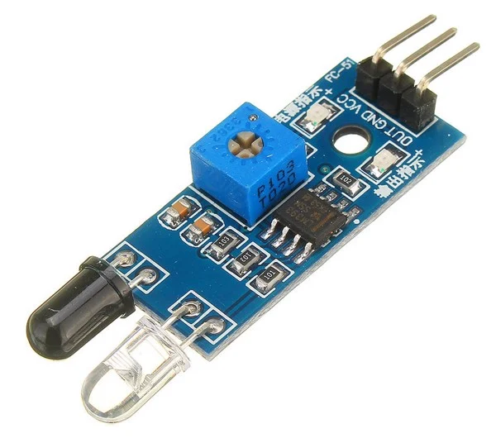

Figure 4 IR Obstacle Sensor

The Infrared Obstacle Avoidance Sensor has a pair of infrared transmitting and receiving sensors. The infrared LED emits Infrared signals at certain frequency and when an obstacle appears on the line of infrared light, it is reflected back by the obstacle which is sensed by the receiver.

* Button

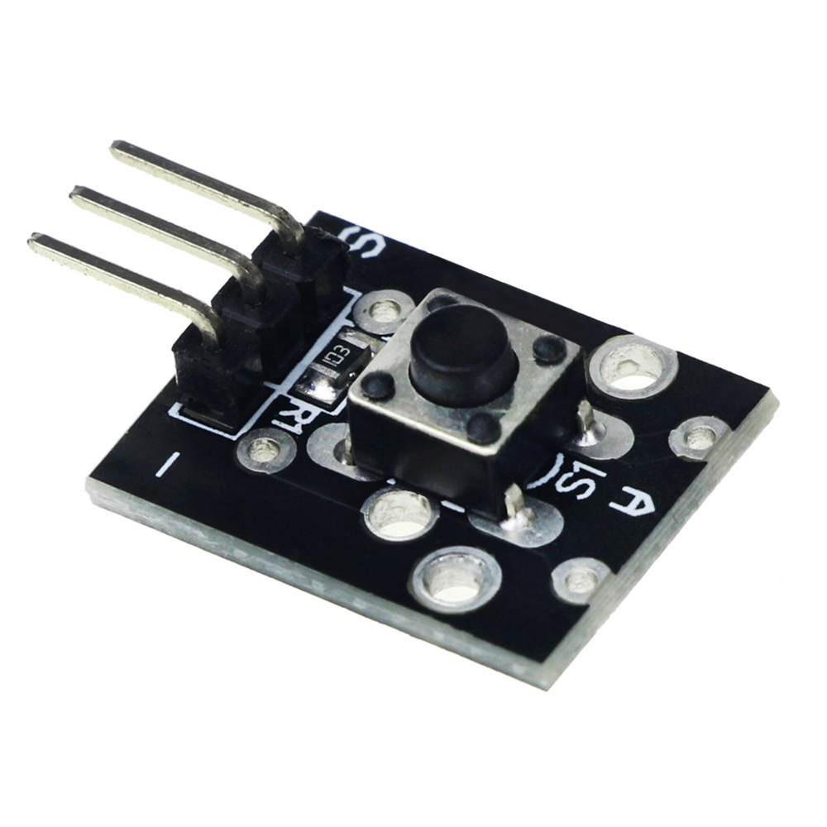

Figure 5 Button

The pushbutton is a component that connects two points in a circuit when you press it.

# **Chapter 3. Function**

## **3.1. Block diagram**

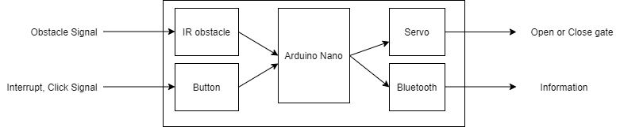

IR obstacle: Receive obstacle signal

Button: receive interrupt, click signal

Servo: Open or close gate

Bluetooth: send information to the app

## **3.2 Flowchart**

Figure 6 Main Flowchart

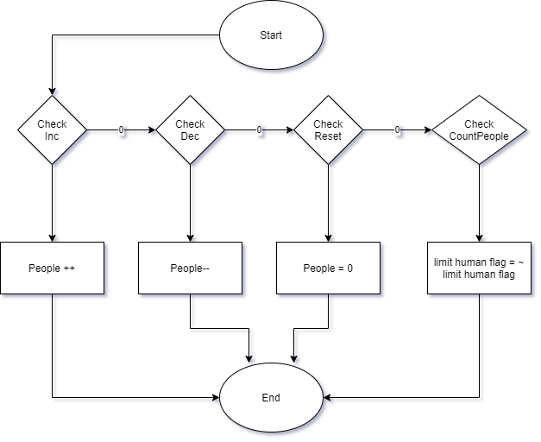

Figure 7 Fixing Block

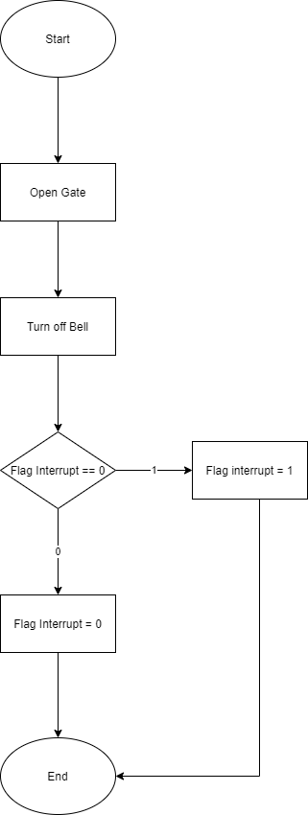

Figure 8 Interrupt Block

## **3.3. Function Detail**

The two sensor will be used to detected whether the human that going in or out based on the direction of detection of two sensor. Because of that, we can calculate the number of humans in one area. Moreover, we can choose to close the gate whenever it reaches limitation.

In case of having trouble with the number of counted people, we can easily adjust by hand with increase, decrease, reset.

More than that, in oder to break the limitation of human, we can bypass the system by the limitation flag

# **Chapter 4. Simulation**

## **4.1 Simulation board**

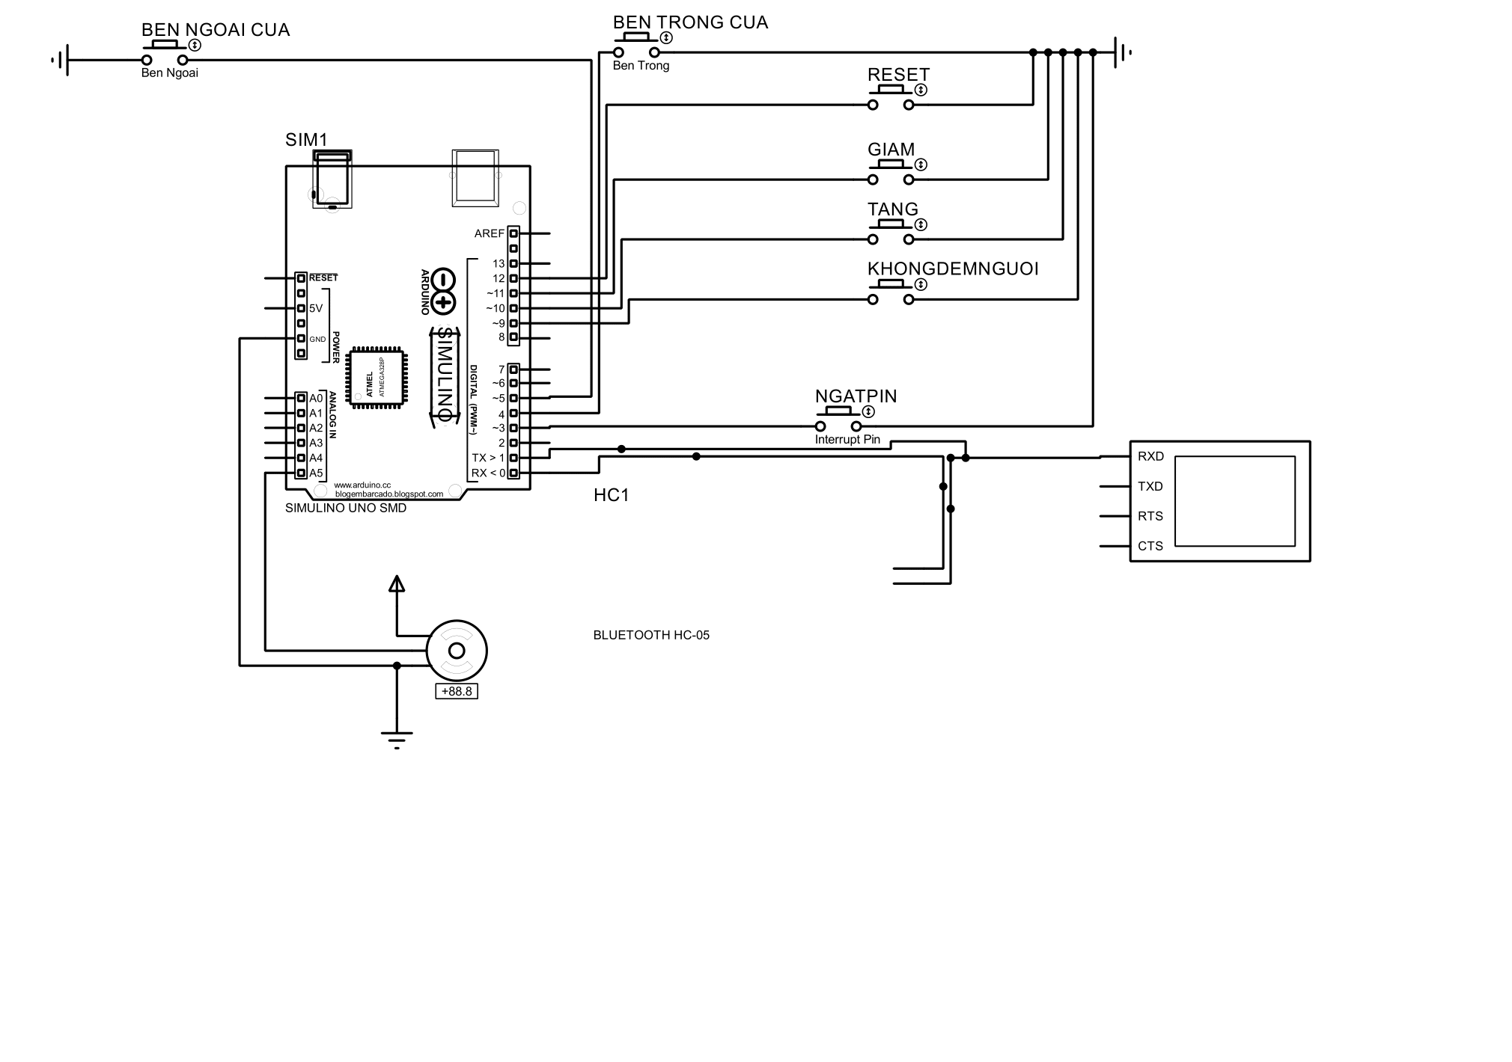

Figure Board simulation

Ben Ngoai Cua, Ben Trong Cua are 2 IR obstacle sensors which are installed outside and inside the door for detect human going out or in.

Ngat Pin is interrupt button.

Reset, Tang, Giam are set number of human 0, plus 1, sub 1 to current number of human.

Khong Dem Nguoi is used to set flag count on or off.

## **4.2 Operating Principle**

When there is a human going in, IR obstacle outside door will be ground signal like the Ben Ngoai Cua button pushed down. After finishing going in, IR obstacle inside door will be ground signal like the Ben Trong Cua button pushed down.

When there is a human going out , it will be oposite of going in operation.

When the interrupt is pushed, we can adjust the number of human or decide to count people or not according to pushing the declared function buttons.

## **4.3 App**

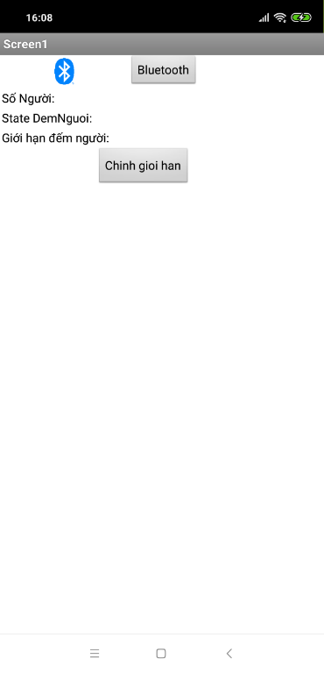

Figure 10 App Screen

Bluetooth to connect the device

So nguoi is the number of people in the store

State Dem Nguoi is the flag of counting on or off

Giới Hạn Đếm Người is number of limit people

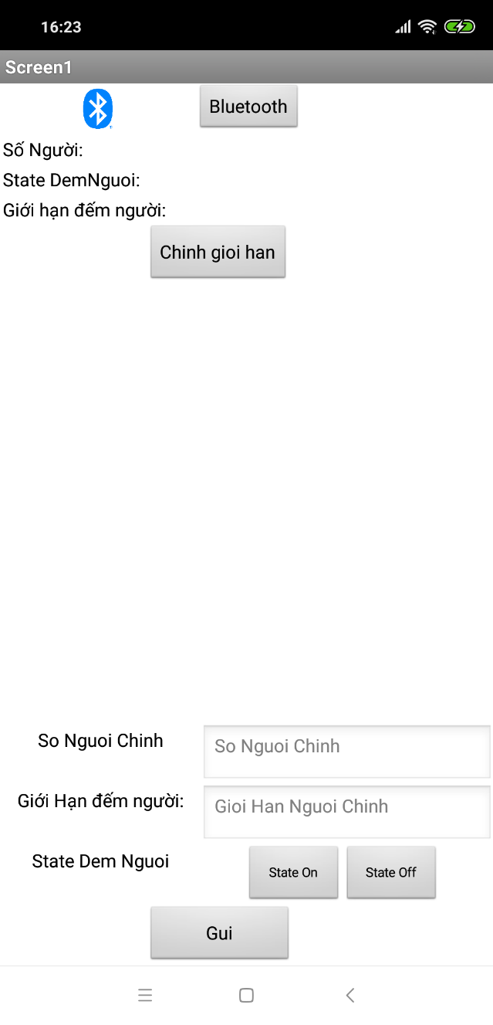

Figure 11 Chinh Gioi Han mode

When Chỉnh goi han is clicked, a hidden div will appear.

So Nguoi Chinh is the adjusted number of people

Gioi Han đếm người is the adjusted limitation of people

Gui is send button

**REFERENCES.**