EECS 4020 - SENIOR DESIGN PROJECT II
Fall Semester 2024

University of Toledo - College of Engineering
Department of Electrical Engineering and Computer Science

Automated Sorting System
Final Deliverable

Group Members:
Rafael Mercado
Tylor Reed
Tran Bao Ngoc Nguyen
Rodion Pelykh
Joel Dumevi

Submitted as partial fulfillment of the requirements for
Bachelor of Science: Computer Science and Engineering
with Honors from the Jesup Scott Honors College
In
Computer Science and Engineering
College of Engineering

Instructor: Dr. Liang Cheng
Faculty Advisor: Dr. Samia Tasnim
Honors Director: Dr. Franchetti,

Submission Date: 12/11/2024
Table of Contents
Abstract
1. Problem Statement
1.1 Need Statement
1.2 Objective
1.3 Background and Related Work
1.3.1 Overview
1.3.2 Device Objective Tree
2. Requirement Specifications
2.1 Market Requirements
2.2 Engineering Requirements
2.3 House of Quality
2.4 Constraints
2.4.1 Budget Constraints
2.4.2 Time Constraints
2.4.3 Environmental
2.4.4 Safety
2.4.5 Maintenance Requirement
3. Design Specifications
3.1 Design Ideation
3.1.1 Comparison of Sorting Methodology
3.1.2 Justification of final design
3.1.3 Alternative Products
3.2 Design Implementation
3.2.1 Physical Design
3.2.2 Electrical System
3.2.3 Code Structure
3.3 Technical Specifications
4. Design Verification
4.1 Testing & Results
5. Risk Assessment and Mitigation Strategies
6. Cost and Schedule Analysis
7. Regulatory and Standards Compliance
8. Considerations
8.1 Ethical Issues
8.2 Accessibility
8.3 Intellectual Property
9. Summary
10. Conclusion
11. References

Appendix A: Project Management Plan
A.1: Project Schedule.
A.2: Member Contributions
Rafael
Tylor
Tran
Rodion
Joel

Appendix B: Source Code

Abstract
The AutoSort EcoBin is an innovative automated waste sorting system designed to tackle the global waste crisis by improving recycling efficiency and reducing contamination. This smart trash bin employs cutting-edge artificial intelligence and machine learning, utilizing the HUSKYLENS AI camera for real-time classification of waste into categories such as plastic, metal, glass, and organic materials. With a focus on environmental sustainability, the system integrates hardware and software, including an Arduino Mega 2560, ultrasonic and obstacle sensors, and servo motors to enable efficient, autonomous operation. The project achieved an 81.82% classification accuracy, surpassing its goal of 80%, and demonstrated its potential for deployment in public spaces, schools, offices, and homes. Future improvements aim to enhance accuracy, robustness, and scalability. By combining precision engineering with advanced technology, AutoSort EcoBin sets a benchmark for sustainable waste management solutions.
- Problem Statement
1.1 Need Statement
The increasing global waste crisis demands innovative waste management solutions to mitigate environmental degradation and enhance recycling efficiency. Current projections indicate that approximately 2.2 billion tons of waste will be generated annually by 2025, with inadequate sorting systems significantly contributing to landfill overflows and pollution (Sharanya et al, 2017). In countries like India and Malaysia, waste segregation rates remain alarmingly low due to limited awareness and inefficient manual sorting processes, leading to substantial amounts of untreated and mismanaged waste (Kamarudin et al, 2019). Automated waste segregation systems have emerged as a practical solution to this problem, improving recycling rates and reducing contamination by efficiently separating waste into categories such as organic material, metal, plastic, and glass (Sunehra, 2021). This project, the AutoSort EcoBin, addresses this urgent need by delivering an affordable, energy-efficient, and highly accurate automated waste sorting solution, suitable for applications in public spaces, schools, offices, and homes.
1.2 Objective
The objective of this project is to design and develop the AutoSort EcoBin, an innovative automated waste sorting system that leverages AI technology to accurately classify and segregate waste into categories such as plastic, metal, glass, and organic material. The system aims to achieve at least 80% sorting accuracy while being cost-effective, energy-efficient, and user-friendly, with potential for deployment in public spaces, schools, offices, and homes. This project seeks to contribute to sustainable waste management practices by reducing landfill contamination, improving recycling efficiency, and promoting environmental awareness.

1.3 Background and Related Work
1.3.1 Overview
Automated waste segregation systems have been the focus of various research and development efforts, aiming to enhance recycling efficiency and reduce environmental impact. For instance, Kamarudin et al. (2023) developed an Automatic Waste Segregator with a monitoring system that sorts waste into categories such as wet waste, paper, plastic, and aluminum, utilizing sensors and microcontrollers to automate the process. Similarly, Asani (2023) introduced an Automatic Waste Sorting Machine capable of classifying plastic, metal, and glass wastes, directing them into respective bins through a sensor-based mechanism. Building upon these advancements, CleanRobotics has developed TrashBot, a smart recycling bin that employs artificial intelligence, robotics, computer vision, and machine learning to sort waste at the point of disposal with a reported accuracy of up to 95% (CleanRobotics, n.d.).TrashBot not only automates waste separation but also collects data on disposed items, providing valuable insights for waste management strategies. These initiatives collectively contribute to the evolution of waste management practices, integrating technology to address the challenges of waste segregation and recycling.
1.3.2 Device Objective Tree
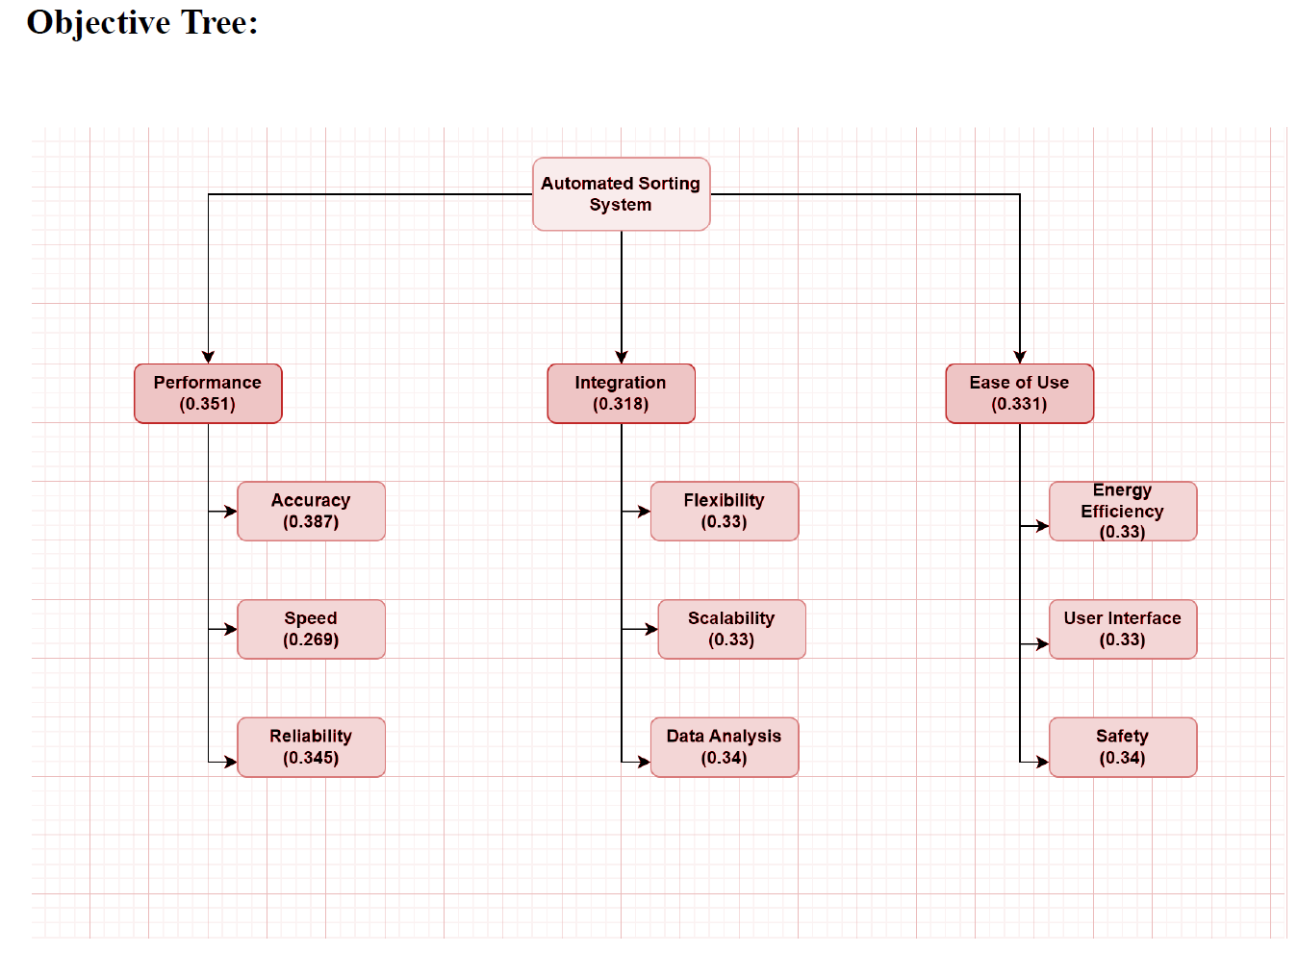
Figure 1: AutoSort EcoBin’s Objective Tree

Figure 1 illustrates the Objective Tree for this project, which breaks down and categorizes each marketing requirement described in Section 2.1. This decomposition highlights the connections between supporting components and their associated requirements, forming the foundation for the project’s Engineering Requirements.
- Requirement Specifications
2.1 Market Requirements
The system’s key market requirements should focus on:
- Reliability
- Energy efficiency
- Accuracy
- Ease of use
2.2 Engineering Requirements
The key engineering requirements for the system would be:
- Consistent recognition of items passing under the photo eye with >80% success
- Intuitive user interface
- Uses minimal power to run the system, potential to be run from a battery
- Vision System identifies Glass, Metal, Plastic, and Organics
- Setup of the system must be a quick process, can power up and start sorting
- Users should be able to quickly calibrate the vision system and bin levels
2.3 House of Quality
House of Quality highlights the trade-offs and dependencies in meeting customer and engineering goals, guiding the design process to optimize performance while aligning with user expectations.
Key Insights:
- Cost has a strong impact on multiple engineering requirements like accuracy and integration.
- Scalability and flexibility are challenging to achieve simultaneously, as indicated by the negative correlation.
- Maintenance plays a critical role in ensuring durability and long-term usability.

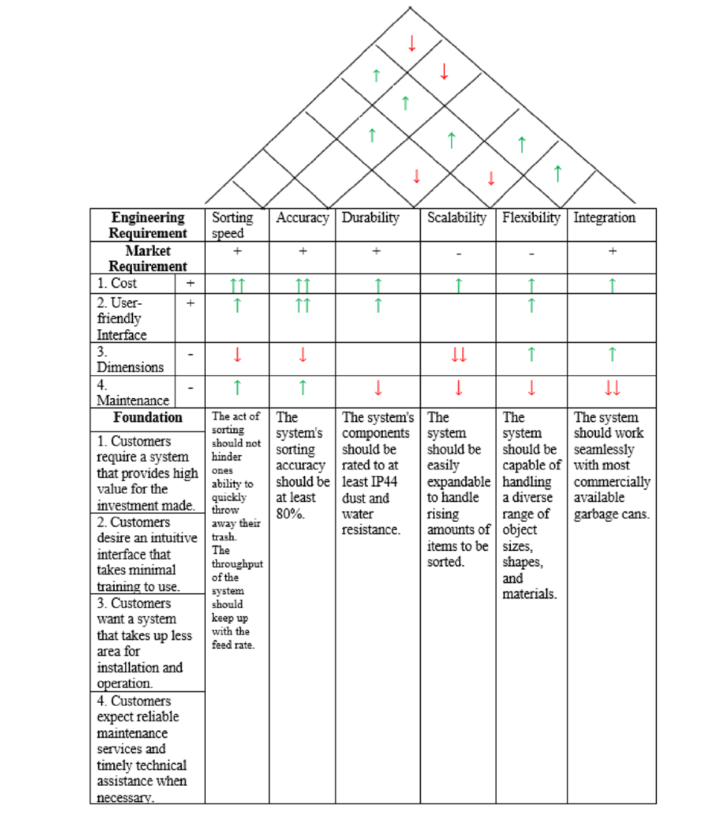
Figure 2: AutoSort EcoBin’s House of Quality diagram

2.4 Constraints
2.4.1 Budget Constraints
Project budget should not exceed $300

2.4.2 Time Constraints
Project should be completed within two semesters (Spring 2024 & Fall 2024)

2.4.3 Environmental
Energy consumption should be minimized to align with sustainability goals.

2.4.4 Safety
Device should meet all regulatory standards such as ANSI/RIA R15.06-2012 and IEC 60204-1:2016

2.4.5 Maintenance Requirements
Device should be durable and easy to maintain

- Design Specifications
3.1 Design Ideation
Technically advanced and feasible with current machine learning tools and hardware.
3.1.1 Comparison of Sorting Methodology
- Technical Feasibility:
AI Camera-Based System: Technically advanced and feasible with current machine learning tools and hardware. However, it requires reliable image recognition algorithms and substantial processing power, making implementation complex.

Sensor-Based System: Simpler to implement, relying on readily available physical sensors (e.g., IR, weight, or conductivity). Requires less computational expertise and infrastructure.

- Cost Effectiveness:
AI Camera-Based System: High initial investment for hardware (cameras, processors) and software development. Maintenance costs include AI model updates and potential hardware replacements.
Sensor-Based System: Lower upfront and operational costs, as sensors are more affordable and easier to replace.

- Innovation and Creativity
AI Camera-Based System: Highly innovative, offering capabilities like object recognition and adaptability to new materials via retraining. It can integrate with data analytics for optimization.
Sensor-Based System: Less innovative, as it relies on traditional sensing techniques. Creativity is limited to the combination of different types of sensors for enhanced accuracy.
- Sustainability and Environmental
AI Camera-Based System: Promotes sustainability by achieving high sorting accuracy, minimizing recyclable contamination. However, it has higher energy consumption due to computational demands.
Sensor-Based System: Lower energy requirements make it more environmentally friendly in energy-constrained environments. However, reduced accuracy may lead to more waste in landfills.
3.1.2 Justification of final design
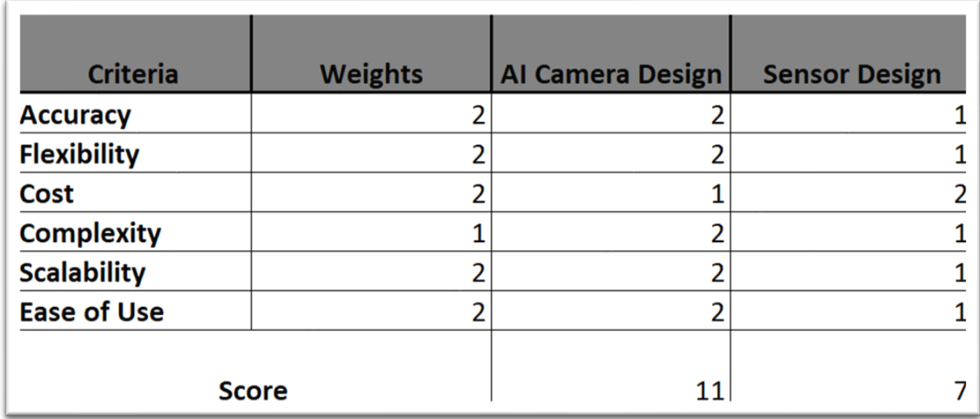 Figure 3: Concept Table comparing AI camera design and the sensor design
When analyzing the data shown in the Concept Table from Figure 3, the AI camera stood out as the more worthwhile implementation for our use case. Some of the supporting points were as follows:
- Higher accuracy: AI cameras can analyze visual data and identify a wide range of objects with high precision.
- Flexibility: AI systems can adapt to new types of waste or changes in sorting criteria, while sensors may require hardware modifications.
- Reduced mechanical complexity: AI based systems require fewer mechanical components, simplifying the design and reducing wear and tear.
3.1.3 Alternative Products
Currently, TrashBot, developed by CleanRobotics, is the only commercially available product on the market that directly aligns with this project’s goals of automated waste sorting. The TrashBot, is an innovative waste sorting system that combines artificial intelligence (AI) and robotic technology to address global waste management challenges. It is a state-of-the-art product designed to eliminate the complexities of manual trash sorting by autonomously identifying and separating waste into the appropriate recycling, compost, and landfill streams with high precision.
While this project aims to develop a low-cost trash-sorting system, the TrashBot serves as an industry-leading benchmark with its advanced AI technology, commercial readiness, and data integration. However, the high cost of TrashBot and its reliance on sophisticated technologies set it apart from the more budget-friendly approach and simplified functionality of this project. Both aim to reduce waste mismanagement but cater to different market segments based on affordability and scalability.
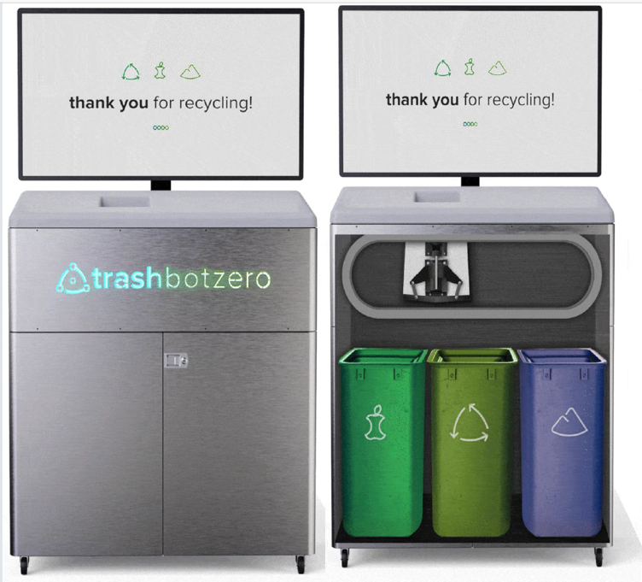
Figure 4: TrashBot by CleanRobotics

3.2 Design Implementation
When viewing our design from the most abstract perspective, it essentially takes an item and identifies it. With this data, it then determines which bin position to locate it to. The level 0, level 1, and level 2 diagrams are shown in Figures 5, 6, and 7.

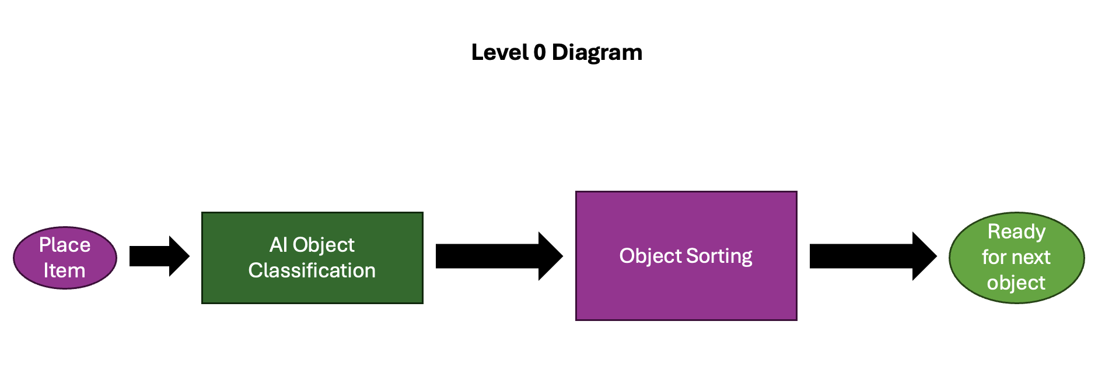
Figure 5: Level 0 Diagram

For the level 0 implementation, the core functionality of the sorting system was established, with no real focus on the specifics of how this system will be created. In this diagram, we see that the system flow involves placing the object in the sorting area, allowing the AI system to classify the object, sorting the object, and resetting to allow for the next object to be sorted. The level 1 diagram, shown in Figure 6, provides a high-level implementation of the system design. This doesn’t quite show us the individual componentry but instead provides us with a high-level view of the product. In this diagram the input and output components are represented as they interface with the microcontroller which handles all the code.

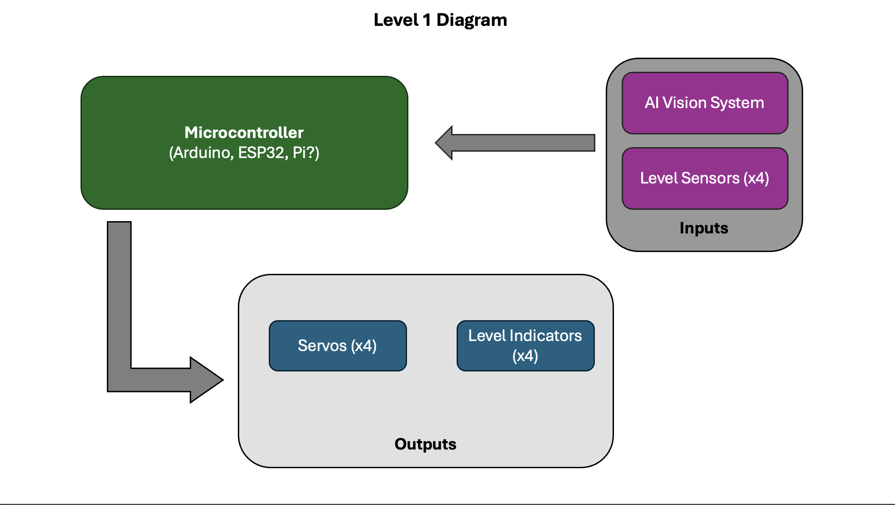
Figure 6: Level 1 Diagram

For the Level 2 design, shown in Figure 7, we see the final component implementation as used in our working design. The main flow of the control mirrors the original designs in the Level 0 and 1 design while expanding upon it.
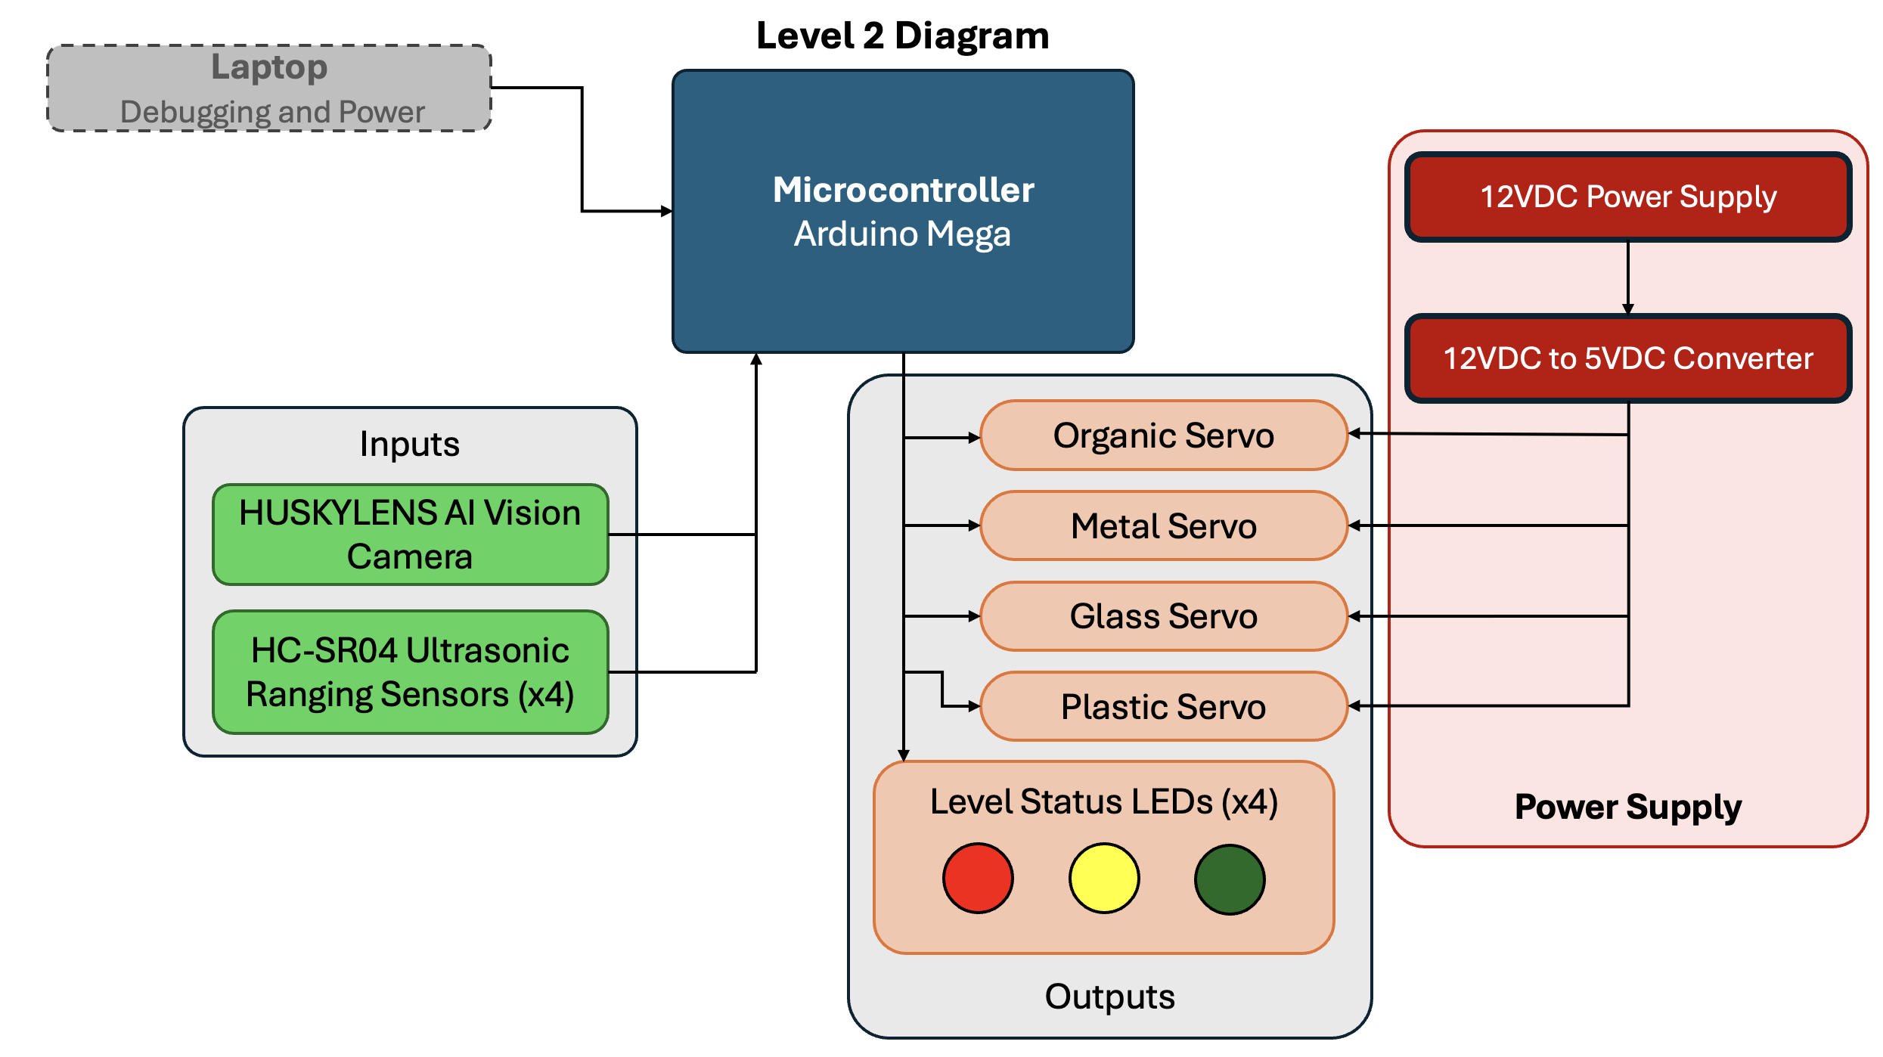
Figure 7: Level 2 Diagram

3.2.1 Physical Design
The final design of the control system revolved around an Arduino Mega R3. This microcontroller was chosen to interface with our choice in servos. The initial microcontroller utilized was an Arduino Uno R4, however a bug exists within the servo control library which affects most of the newer Revision 4 Arduinos and the decision to switch to the well-supported and documented Mega R3 was taken. The 12V DC power supply chosen was a commodity object found on Amazon. The 12V to 5V buck-boost converter was used in conjunction with the 12V supply to provide the four motion control servos the appropriate current needed to move multiple doors for each sorting operation and allowing adequate power through the Arduino to support the AI camera. The camera chosen for our use case was the DFROBOT HUSKYLENS AI Vision Sensor. This small PCB mounted camera provided all AI functionality for our project and utilized UART/I2C to return the identified object to our code on the Arduino. The camera contained a built in LCD screen which allowed for real-time observation of the objects in the view of the camera. Ultrasonic sensors were used to measure the volume of trash within each of the 4-bin compartment, and the returned value was then passed to the respective set of 3 LEDs – red, yellow, and green, for each of the different sensors. These colors represent full, near full, and empty. While operating the system, a laptop running the Arduino IDE was used to monitor the state of the device – both learning mode and sorting.
With the electrical system created, a prototype design was designed out of cardboard and hot glue to give a better indication of the validity of our design. The following images show this initial iteration:
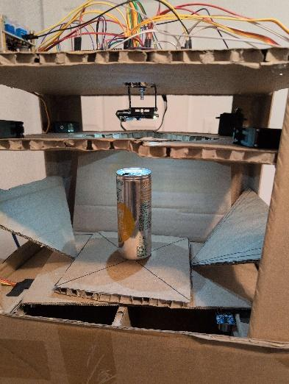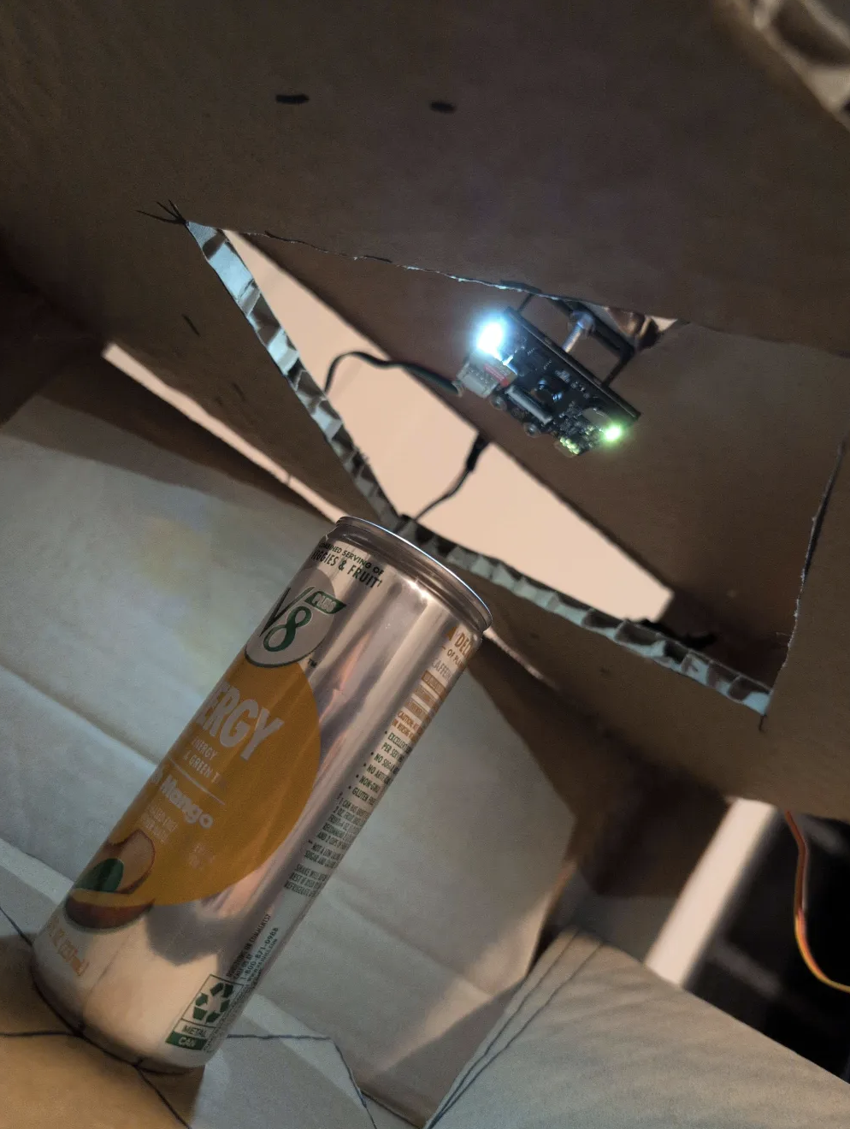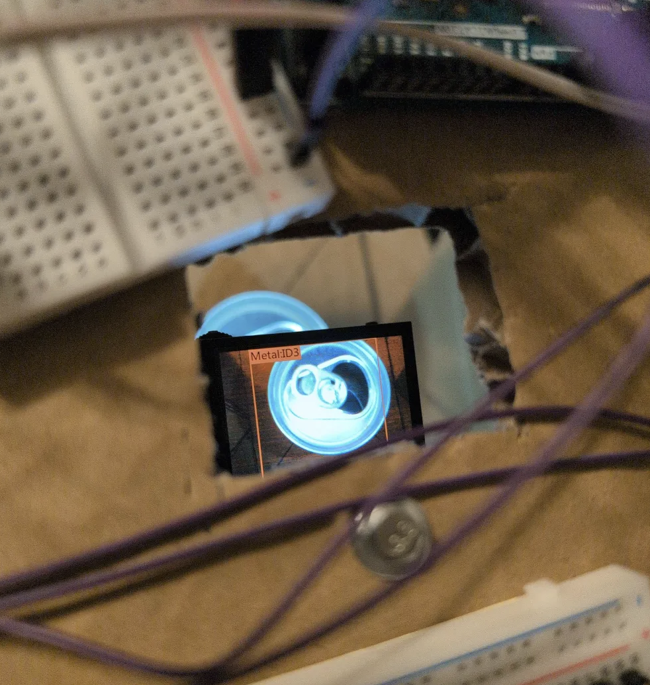
Figures 8-10: Electronics Prototype

With a rough idea in place for the sorting portion, one group member dedicated their focus on refining the design in Autodesk Fusion, a 3D modelling software. The design considered the end use, ensuring a place to securely and safely store the electronics, sensors, and motion control componentry. The cost constraint also played a large part in choosing the end material used. For our purpose, a mix of medium density fiberboard, hardy panel, and miscellaneous hardware. The construction methods employed in the 3D design considered the use of the UT Makerspace’s wood shop, to avoid the backlog and extensive queue time for larger format 3D printing. For our use case, the scale of a 3D printed design would prove to be ineffective. Screenshots from the 3D model are shown below:
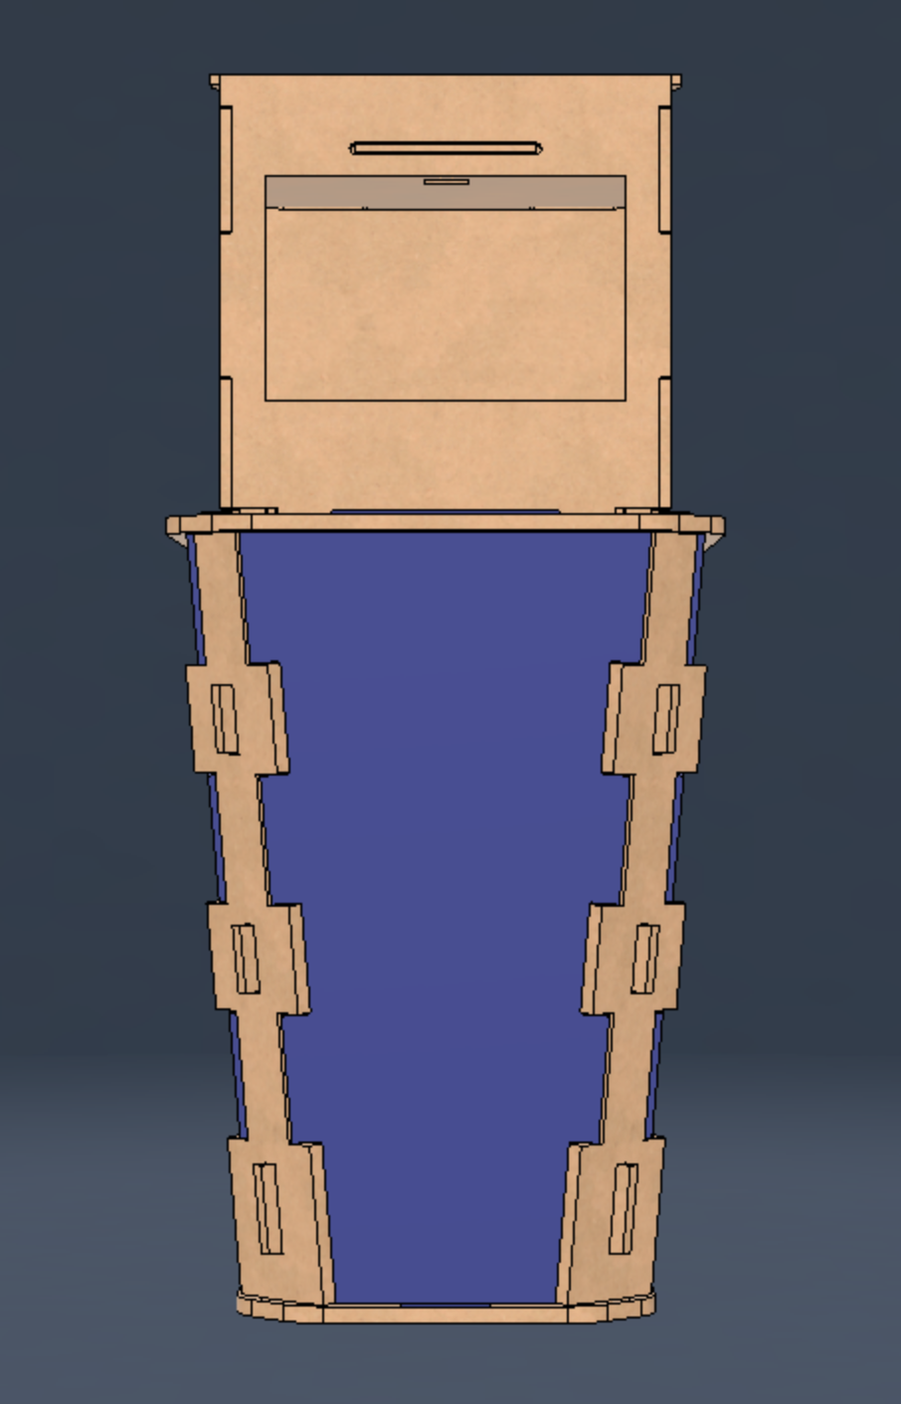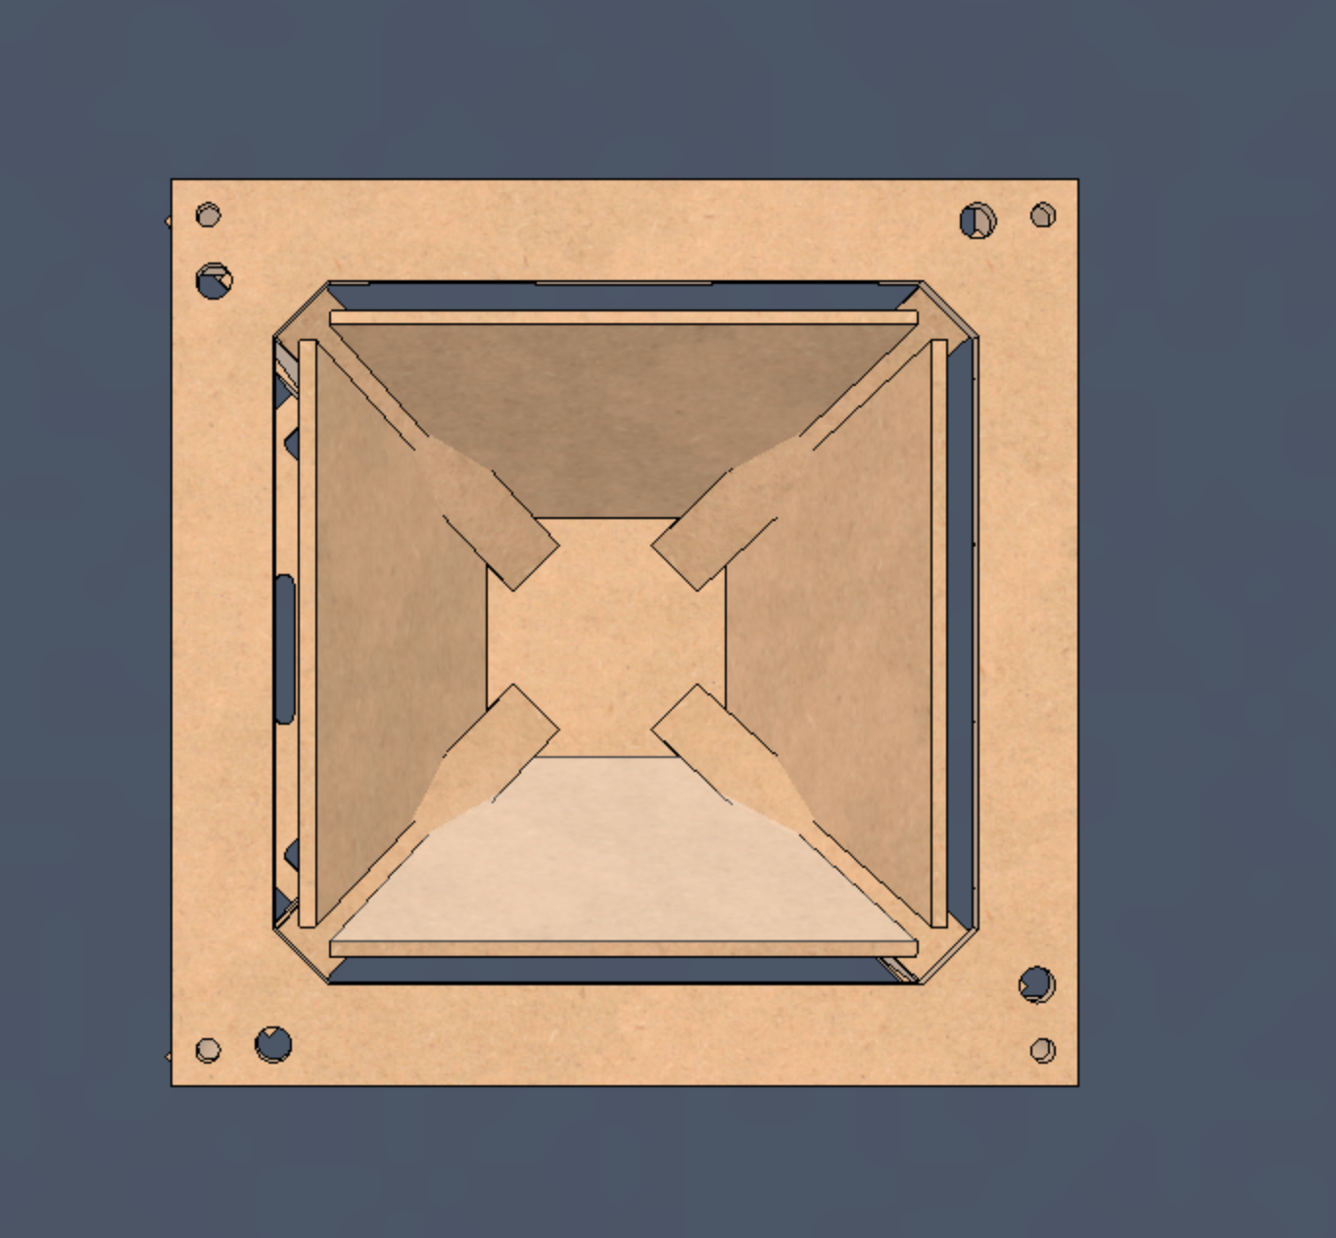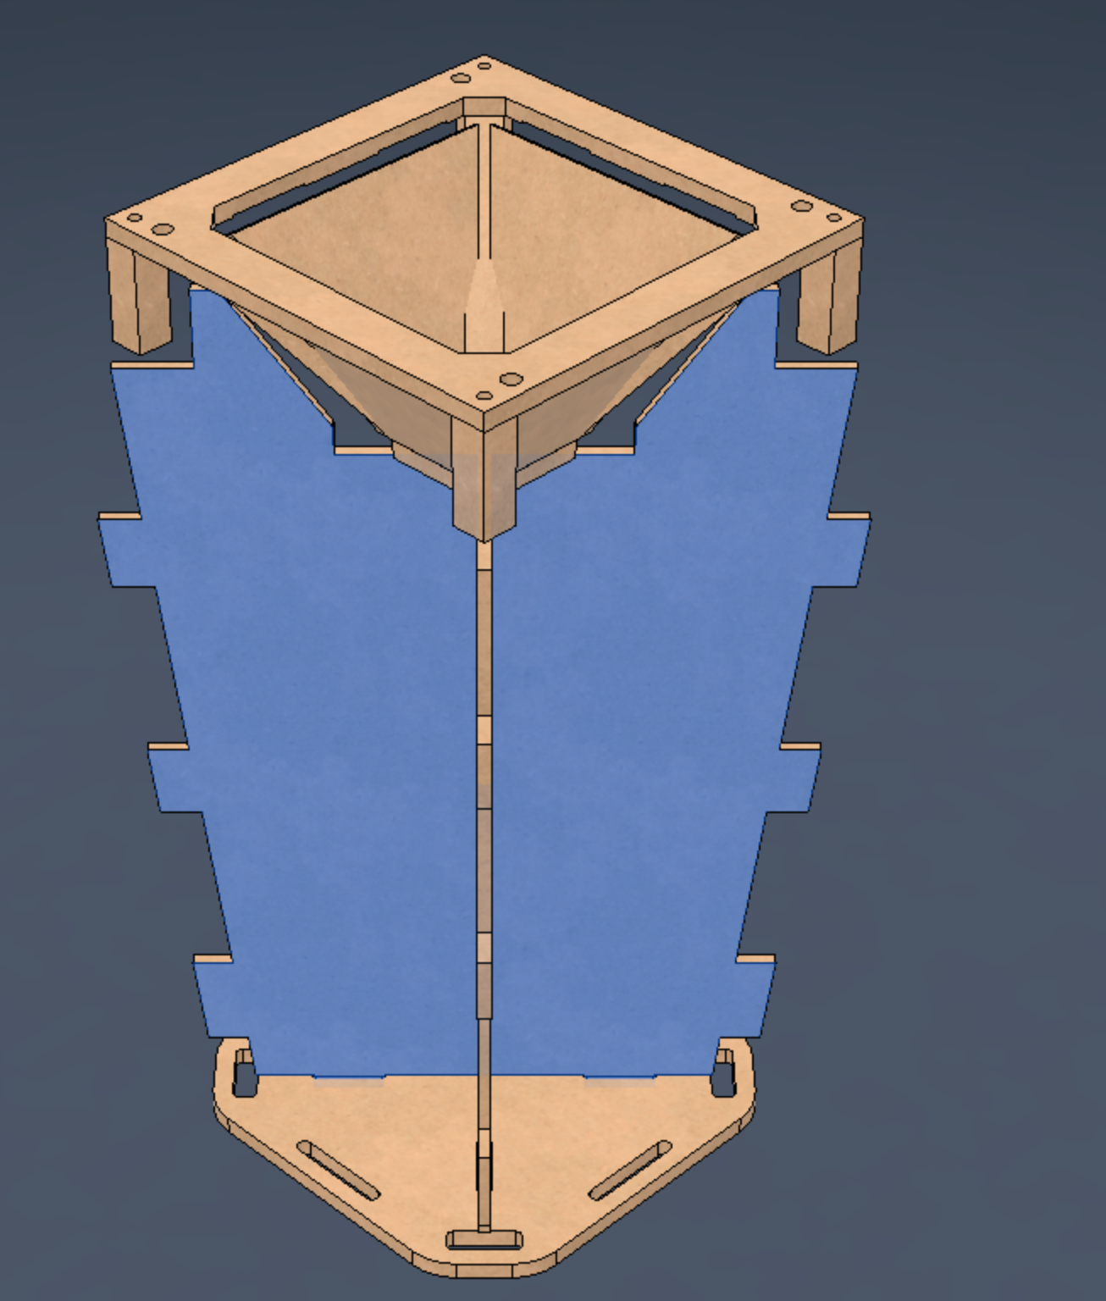
Figures 11-13: 3D Model Screenshot
Construction of the final build was met with the need to adapt. Rather than using the 3D model as a blueprint, it served more as inspiration and something to aim our design towards. The issue faced in the buildout had to do with inconsistent hours of the makerspace, along with a change in the material dimensions found in store to those used in the design. The images shown below show detail images of various portions of the final sorting bin, along with the buildup process.

Product Images:
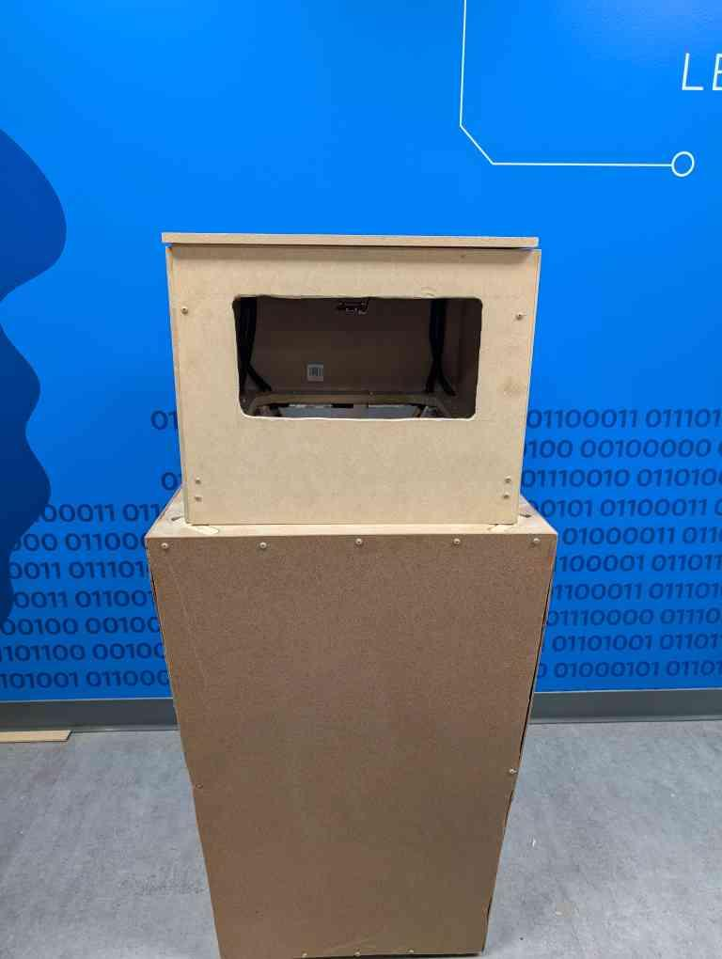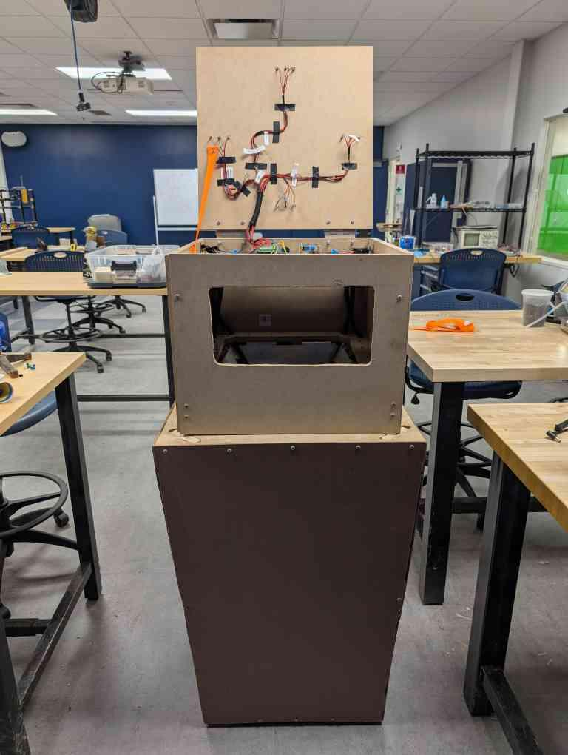
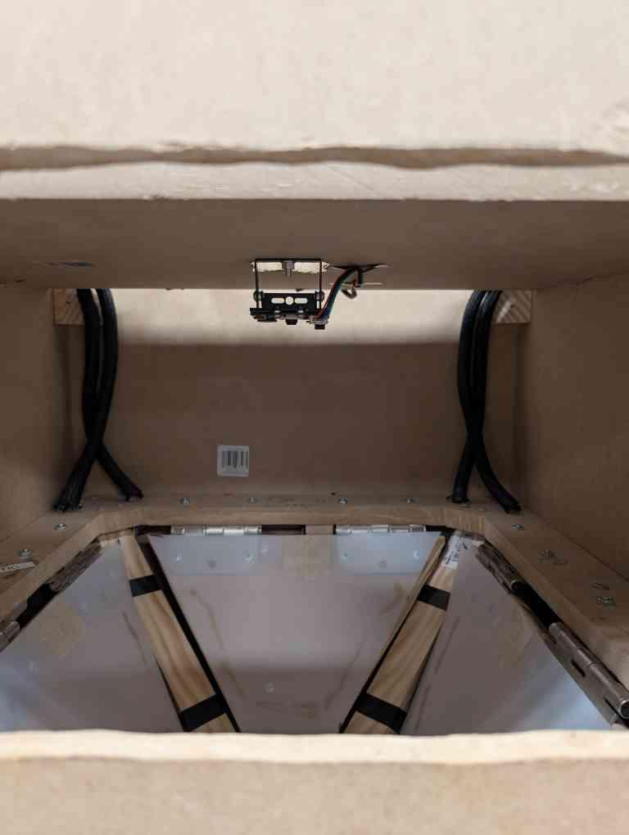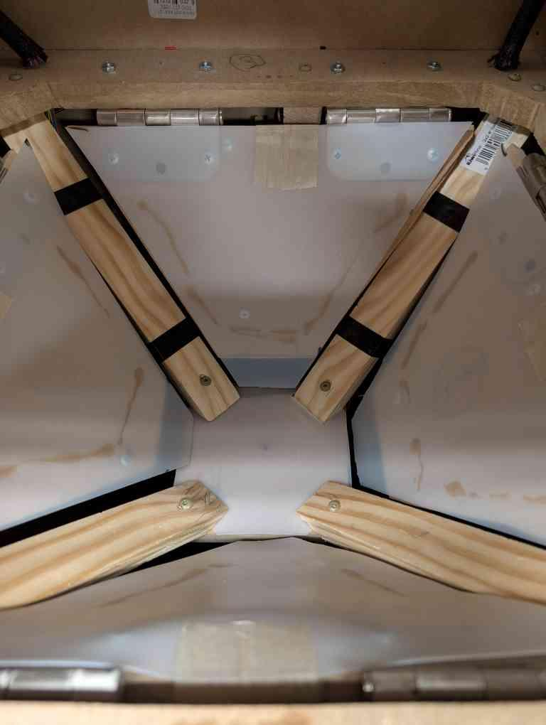
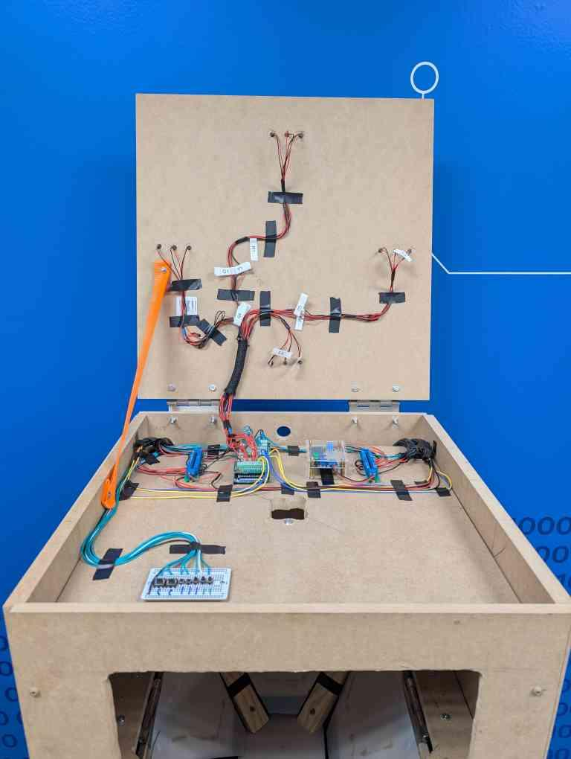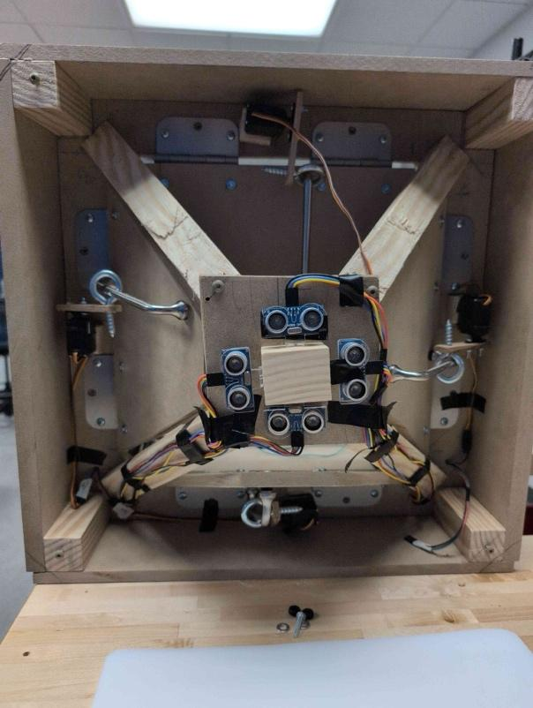
Figures 14-19: Final Buildout

The above images show the full view of the sorting bin, the upper enclosure opened, the interior detail of the sorting chamber, including the AI camera, detail within the electronics cabinet, and the last showing the mounting and motion control of the servos, and at the center the ultrasonic range sensors. The motion control of the servos was created by using common hardware, involving drawer handles, eyelets, and miscellaneous wooden trim cuttings. The hinges used in moving the doors, as well as the upper hinge on the enclosure were common door hinges. The build process wholly relied on hand tools and some power tools, such as a table saw for some of the larger components.

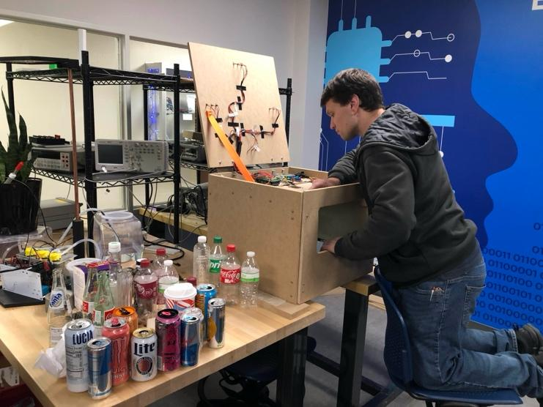
Figure 20: AI Model Training
With the physical design completed, our AI model was trained utilizing portions in the code which allowed for the manual training of classes for objects within the sorting chamber. A small solderable breadboard was used, which is shown in the bottom left of Figure 18. With this breadboard, the mode of operation can be selected, between the training mode and the sorting mode. When in training mode, buttons exist to assign the respective object to a class relating to its material type. Once assigned, the AI vision system will return the correct class for that specific item.

3.2.2 Electrical System
The main component in our electrical system was the Arduino MEGA R3. Mounted above the Arduino is a terminal block shield to facilitate a cleaner installation and easier access to all the pins available to us on the MEGA. This combination is mounted in the center left of Figure 21. To the right of the Arduino was an adjustable buck-boost converter which took in the 12V from a power supply not shown in the image. This power supply fed the terminal strip to the right of it. This terminal strip provided the 5V supply for the servos used for door movement. The opposite terminal strip adjacent to the Arduino provided the 5V DC voltage needed to power the ultrasonic range sensors. This supply voltage was provided by the Arduino. All terminal strips and controllers had a common ground to avoid any potential grounding issues affecting control or communication. Figure 19 above shows the detail on the mounting of the ultrasonic sensors along with the servo locations.

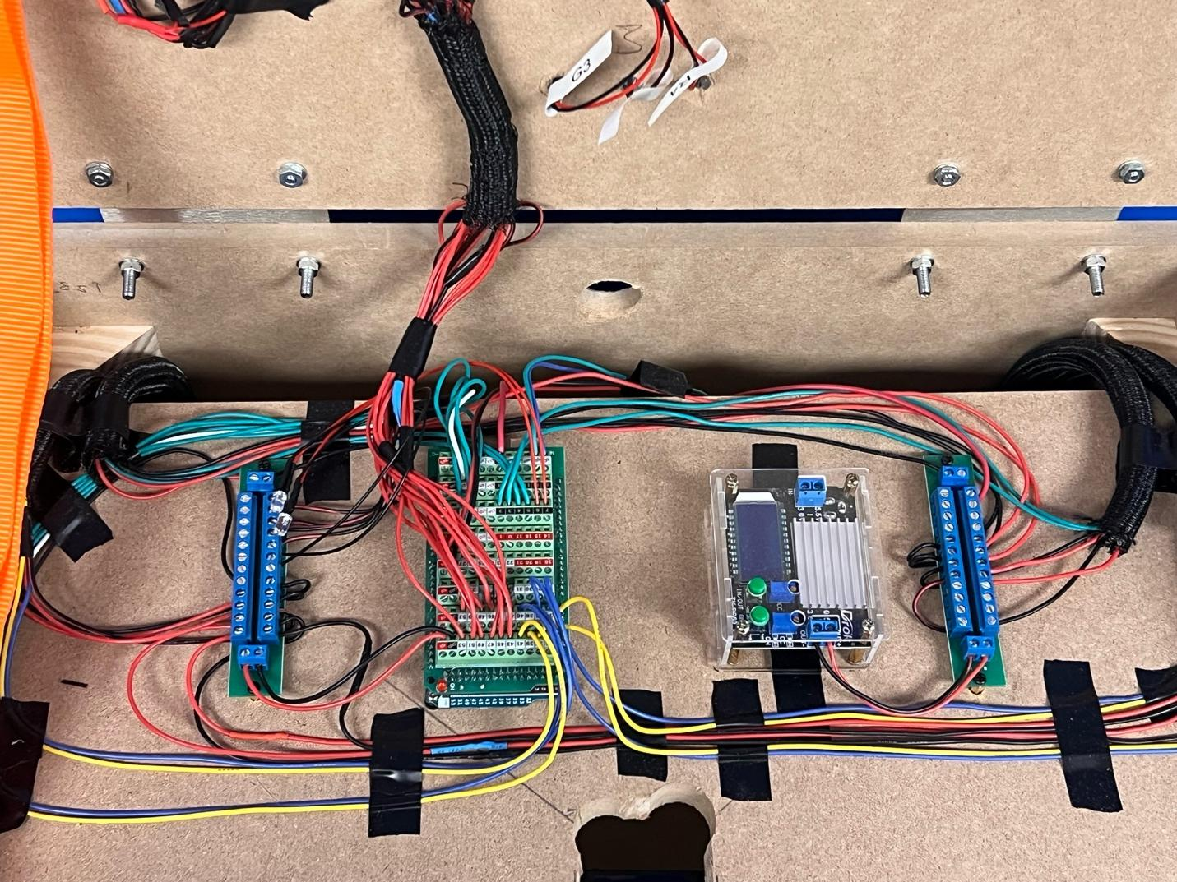
Figure 21: Control Detail
Figure 22 shows the control interface created to facilitate an easy way to switch between sorting and training modes. While in training mode, additional buttons exist to train the AI model on which respective class is present in the bin. This training holds consistent when moving the object in and out of the bin. Multiple images can be taken for each object across multiple orientations to allow for redundancy. The final button is the nothing class. This exist to recalibrate the vision system to not react to an empty chamber, which was found to occur through training when external ambient lighting would change the shadows cast into the chamber. The solderable prototyping PCB was chosen for the ease of implementation in addition to time constraints in having a formal PCB created.

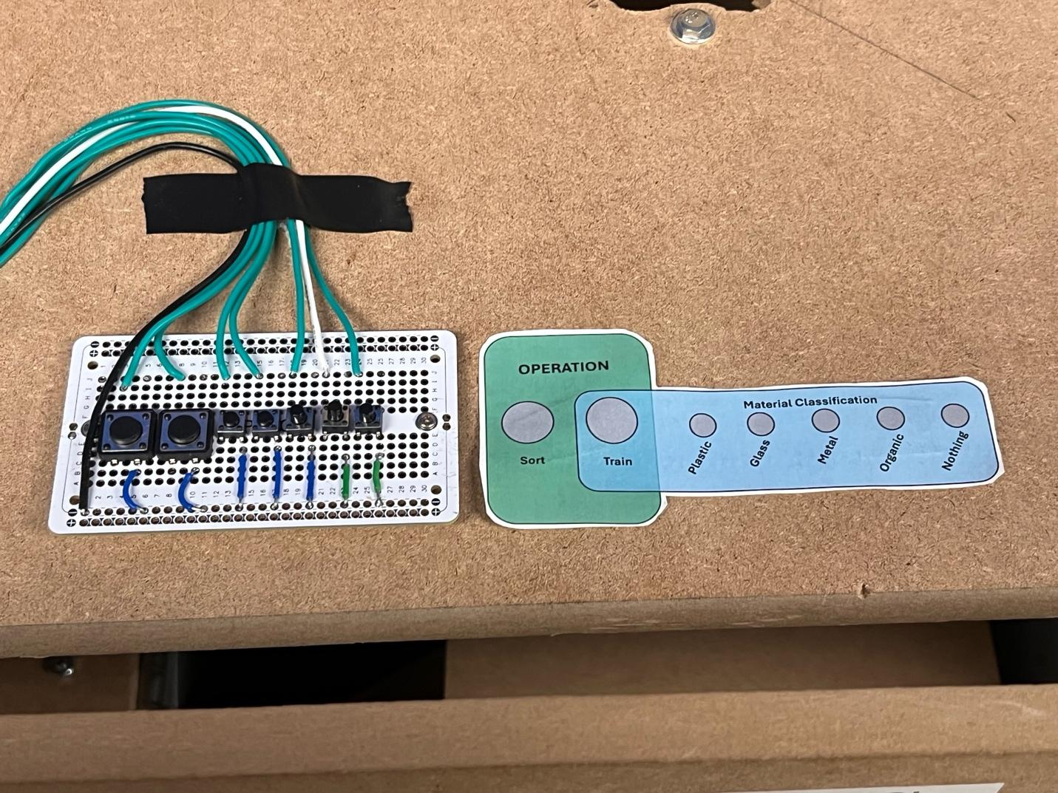
Figure 22: Control PCB
The final electrical components in the system are the 12 status LEDs on the upper portion of the lid covering the electrical cabinet component of the model. Groups of 3 LEDs are mounted around the 4 edges. The Red, Yellow, Green color serve as the indicators of the fill of each bin compartment. Two additional LEDs are present connected to the Arduino and the left terminal strip. These were added at the senior expo to easier identify the operation mode of the system.
3.2.3 Code Structure
The code used in the identification and control portions of our project is presented attached to this report in Appendix B. The code begins with calling the necessary libraries and defining input and output pins for the servo pins, camera interface, ultrasonic level sensors, and the output LEDs. The HUSKYLENS AI Sensor interfaces with the Arduino using I2C. The main flow of the program takes the class of the object in the view of the AI camera and passes it to the main code. With the proper state, the code then commands the respective servo to open, and its complimentary servo to push the other to hyper extend, and then reset and await the next object to be sorted. The main code also scans the state of each ultrasonic sensor and records the value. These sensors operate through a 4-wire connection, DC+, DC-, Trigger, and Echo. Trigger will enable the ultrasonic ping, and the Echo returns the analog value. The use of existing libraries for the HUSKYLENS control, along with the Arduino servo control made the implementation of this code straightforward, with most testing spent on integrating all components together.
3.3 Technical Specifications
- Core Components: Arduino Uno, HUSKYLENS vision sensor.
- Recognition Accuracy: ≥80%.
- Power: Energy-efficient design (battery or solar-powered).
- Sorting Mechanism: Electro-mechanical system for directing waste into separate compartments.
- Environment: Indoor and outdoor compatibility.
- Durability: Long-lasting materials, resistant to weather and user wear-and-tear.

4. Design Verification
Hardware and Software Design
- Hardware:
  - Arduino Uno: Acts as the processing core, integrating sensors and actuators.
  - HUSKYLENS: Implements machine vision algorithms for object recognition based on features such as color, shape, and texture.
  - Sorting Mechanism: Consists of servo motors controlling partitions to route waste into the correct compartment.
- Software:
  - C++ code is developed for Arduino to integrate the HUSKYLENS library and control servo mechanisms.
  - Machine learning model fine-tuned to achieve optimal recognition accuracy for distinct waste types.
Documentation
Development tools include CAD for mechanical design, flowcharts for algorithm logic, and simulation tools to validate electrical circuits and sorting mechanism behavior.
Alternative Designs
- Use of Raspberry Pi for more advanced computation.
- Integration of RFID tags for waste categorization instead of vision-based methods.
- Pneumatic sorting mechanisms for faster waste routing.
4.1 Testing & Results
Testing Phases
- Initial Tests: Validate HUSKYLENS object recognition accuracy on individual items under controlled conditions.
- Integrated Tests: Combine vision and sorting subsystems, testing the system with mixed waste samples.
- Environmental Tests: Assess power consumption, durability, and accuracy in various lighting and weather conditions.
Validation Results
- Achieved a recognition accuracy of 83% after iterative tuning of machine vision parameters.
- The sorting mechanism showed reliable performance with a misclassification rate of less than 5%.
The prototype met the defined specifications, achieving over 80% accuracy and operating efficiently with minimal power consumption. Testing demonstrated robustness, ease of use, and scalability. Future improvements include enhancing recognition algorithms, expanding waste categories, and refining energy management systems for diverse environments.
5. Risk Assessment and Mitigation Strategies
Risk: Misclassification of Trash Materials:
The AI camera may misclassify certain materials, especially those with ambiguous appearances, such as contaminated recyclables or multi-material objects.
Mitigation:
Improve the training dataset for the AI model by including a diverse range of images representing various waste categories and their edge cases. Conduct extensive testing and validation to refine the accuracy of classifications.

Risk: Multiple Trash Materials Placed Simultaneously
If multiple trash items are placed in the bin at the same time, the AI system may struggle to accurately identify and classify each item, leading to sorting errors.
Mitigation:
Incorporate a mechanism that ensures one item is processed at a time, such as a conveyor system or timed entry gate. Additionally, optimize the AI algorithm to detect and separate overlapping materials in real-time.

Risk: Hardware Failure or Degradation
The mechanical components, servos, or AI camera could fail or degrade over time due to wear and tear, resulting in reduced system performance or downtime.
Mitigation:
Choose durable components rated for industrial or heavy-duty use and implement a regular maintenance schedule. Include diagnostic features that alert users to potential hardware issues before failures occur.

Risk: Budget Constraints
With a limited budget of $300, the project may face difficulties sourcing reliable hardware components or software licenses for AI algorithms.

Mitigation:
Prioritize cost-effective alternatives such as open-source AI models and second-hand or discounted components. Optimize the design to use minimal hardware without compromising essential functionalities.

Risk: Limited Scalability
The system may face challenges in scaling up to handle larger volumes of waste or integrating with existing infrastructure.
Mitigation:
Design the system to be modular, allowing for easy upgrades or additional components. Ensure the software is adaptable to accommodate future scalability needs.

By addressing these potential risks and implementing the suggested mitigation strategies, the project can enhance its reliability, efficiency, and overall user satisfaction while ensuring its success within the given constraints.

6. Cost and Schedule Analysis
Cost Analysis
For our overall costs, some portions of the budget were subsidized by group members who had the intention of retaining the electrical componentry or other small components that were integrated into the final product. Including all expenses into the consideration for this initial prototype, we were at about $350-400. This cost and minor oversight of the budget must be understood as in need of refinement. With subsequent iterations of the sorting mechanism, along with the potential to develop a custom board to handle camera input, servo control, and all other electronic functions, the final cost can be considerably cut down. The use of MDF and other wooden materials in the development of the product inflated the price spent on raw materials, and to greatly reduce this expense, leveraging the existence of commercial-grade garbage bins would allow for easier expansion of our product. Consolidating the working device to a compact lid that mounts to most existing garbage bins in a commercial or public setting could lead to a large adoption of our end design.

Schedule
A Gantt chart was developed to monitor progress across research, design, testing, and reporting phases. Adjustments were made based on testing delays and resource availability. Figure 23 shows the initial roadmap laid out during Senior Design I in Spring of 2024.
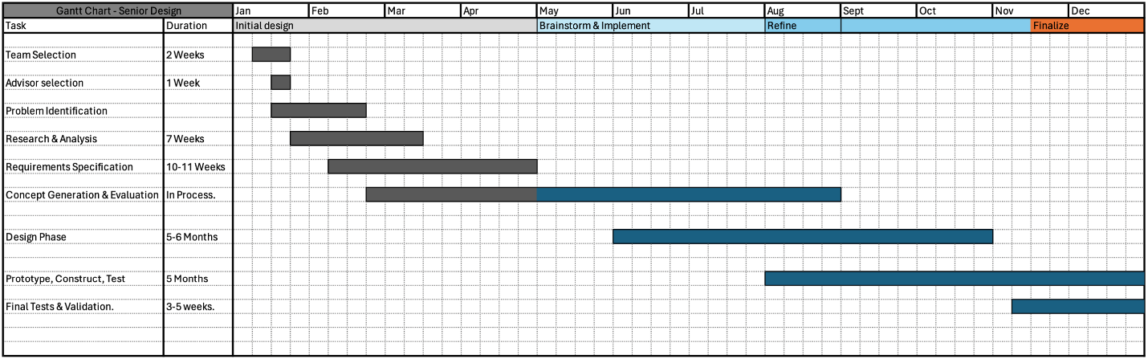
Figure 23: Initial Predicted GANTT Chart
When we view this chart, our actual plan deviated slightly. Figure 24 shows the Gantt chart that documents the actual progress made during this semester, and the two prior to it. In our project, the design and conceptualization phase took significantly longer than expected. This led to issues with compressing the construction, testing, and validation portion. In the end, our project timeline worked out and we met all milestones required as the project progressed.
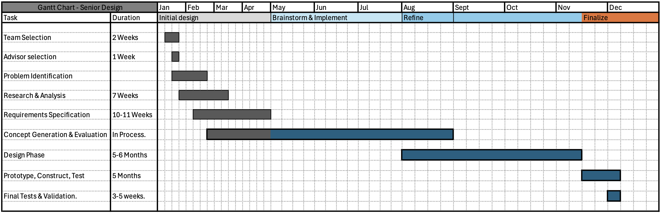
Figure 24: GANTT Chart of Actual Progress.
7. Regulatory and Standards Compliance
Government Regulations
- Waste Electrical and Electronic Equipment Directive (WEEE): Ensures proper disposal and recycling of electronic components.
- RoHS Compliance: Restricts hazardous substances in electrical devices.
Health, Safety, and Environmental Impacts
- Safety protocols in electrical design ensure no risk of user harm.
- Eco-friendly materials minimize environmental impact during production and disposal.
8. Considerations
8.1 Ethical Issues
- Privacy: No data storage or transmission related to waste disposal habits.
- System Reliability: Minimized misclassification risks through thorough testing.
8.2 Accessibility
- Simple setup and operation ensure usability across demographics.
- Visual and audible indicators for user feedback.
8.3 Intellectual Property
- Patent 1: Automated waste-sorting mechanisms using sensors.
- Patent 2: Machine vision for object classification in recycling systems.

9. Summary
This project focuses on designing and implementing a low-cost automated trash-sorting system aimed at improving waste management efficiency. The system utilizes an AI-powered camera to classify waste into appropriate categories, such as organics, plastics, glass and metal, reducing human intervention and contamination in recycling streams. By incorporating engineering and marketing requirements like sorting speed, accuracy, durability, scalability, flexibility, and integration, the project strives to address the needs of users and environmental sustainability. With a budget of $300, the system balances functionality and affordability, targeting a segment that cannot access high-end commercial solutions like the TrashBot. The project emphasizes user-friendly design, environmental impact, and compatibility with existing waste infrastructure while overcoming constraints such as cost, material availability, and component selection.

10. Conclusion
The successful development of this low-cost automated trash-sorting system demonstrates the potential to make waste management more efficient and accessible for communities and organizations with limited resources. By leveraging AI technology within a constrained budget, the project offers a sustainable and scalable solution to global waste management challenges. It addresses key issues like recycling contamination, operational efficiency, and user interaction, contributing to environmental sustainability and resource conservation. Future enhancements could focus on improving the system’s scalability, integrating real-time data analytics, and incorporating additional features to align with evolving waste management needs. Overall, this project serves as a stepping-stone toward more sustainable and innovative solutions in the waste management industry.

11. References
- Automatic Waste Sorting Machine. (n.d.). Instructables. https://www.instructables.com/Automatic-Waste-Sorting-Machine/

- Dar, F., Olapade, M., Ottun, A.-R., Yin, Z., Liyanage, M., Zuniga, A., Passanantti, M., Tarkoma, S., Nurmi, P., & Flores, H. (2024). LIZARD: Pervasive Sensing for Autonomous Plastic Litter Monitoring. 2024 IEEE/ACM Ninth International Conference on Internet-of-Things Design and Implementation (IoTDI), 37–48. https://doi.org/10.1109/iotdi61053.2024.00008

- Gravity: HUSKYLENS - An Easy-to-use AI Machine Vision Sensor. (n.d.). Wiki.dfrobot.com. https://wiki.dfrobot.com/HUSKYLENS_V1.0_SKU_SEN0305_SEN0336

- HuskyLens. (2023, April 9). HUSKYLENS Arduino API. GitHub. https://github.com/HuskyLens/HUSKYLENSArduino

- Kamarudin, N. H., Rahim, A. A. A., Abdullah, N. E., Halim, I. S. A., & Hassan, S. L. M. (2019). Development of Automatic Waste Segregator with Monitoring System. 2019 4th International Conference on Information Technology, Information Systems and Electrical Engineering (ICITISEE). https://doi.org/10.1109/icitisee48480.2019.9003813

- Klements, M. (2021, April 21). Adding AI Vision To A Robot Car Using A Huskylens. The DIY Life. https://www.the-diy-life.com/adding-ai-vision-to-a-robot-car-using-a-huskylens/

- Sharanya, A., Harika, U., Sriya, N., & Kochuvila, S. (2017, September 1). Automatic waste segregator. IEEE Xplore. https://doi.org/10.1109/ICACCI.2017.8126023

- ‌ Sunehra, D., Pravalika, K., Sruthi, A., & Rajasri, G. (2021). Implementation of an Automatic Waste Segregator System using Arduino Uno. 2021 6th International Conference for Convergence in Technology (I2CT). https://doi.org/10.1109/i2ct51068.2021.9418212

- Tomari, R., Kadir, A. A., Zakaria, W. N. W., Zakaria, M. F., Wahab, M. H. A., & Jabbar, M. H. (2017). Development of Reverse Vending Machine (RVM) Framework for Implementation to a Standard Recycle Bin. Procedia Computer Science, 105, 75–80. https://doi.org/10.1016/j.procs.2017.01.202

- Zaman, T. S., Islam, T., Vadla, S. R., & Rangu, U. K. (2023, April 1). WasteMiner: An Efficient Waste Collection System for Smart Cities Leveraging IoT and Data Mining Technique. IEEE Xplore. https://doi.org/10.1109/SoutheastCon51012.2023.10115200

Appendix A: Project Management Plan
A.1: Project Schedule
For accurate data related to the schedule and stages of development, refer to section 6, Cost and Schedule Analysis where Figures 21 and 22 show the projected and final project timelines.
A.2: Members’ contributions
Rafael Mercado:
- Design of Bin & Sorting Mechanism within Autodesk Fusion
- Construction and Refinement of physical implementation
- Coordinated Weekly Meeting Progress Updates with faculty
- Assisted in teaching group members how to effectively solder
- Final Project Report Formatting and Content Contribution
- Presentation Slides.
Tylor Reed:
- Integrating Code with Physical Structure
- Servo Implementation and Operation
- Assisted with Construction of Sorting Chamber
- AI Training, Testing, Troubleshooting, and Validation
- Integration of Classification and Motion Control Code
Tran Bao Ngoc Nguyen:
- Document and report preparation
- Presentation Formatting and Editing
- Object Identification and Classification Code
- Testing
- Assisted with training AI
Rodion Pelykh:
- Final Video Editing
- Contributed to Control Code
- Presentation Poster Design
Joel Dumevi:
- Soldering and wiring of electrical components
- Researched project’s sensors and servos
- Document and report preparation
Appendix B: Source Code
https://github.com/PastaManInc/Automatic-Sorting-System 