VIETNAM GENERAL CONFEDERATION OF LABOR

TÔN ĐỨC THẮNG UNIVERSITY

FACULTY OF INFORMATION TECHNOLOGY



Instructor: NGUYỄN THÀNH AN

Performer:

LÊ TRẦN TRANG BẢO NGỌC

520K0328

baongoccode

[520K0328@student.tdtu.edu.vn](mailto:520K0328@student.tdtu.edu.vn)

& NGUYỄN TƯỜNG HOÀNG

520k0250

lilianagp

520K0328@student.tdtu.edu.vn

Class : 20K50201

Course: 24

HỒ CHÍ MINH City, December 2022.

CONTENT

1. Designated tasks: We do all we can
2. Completion percentage:90%
3. 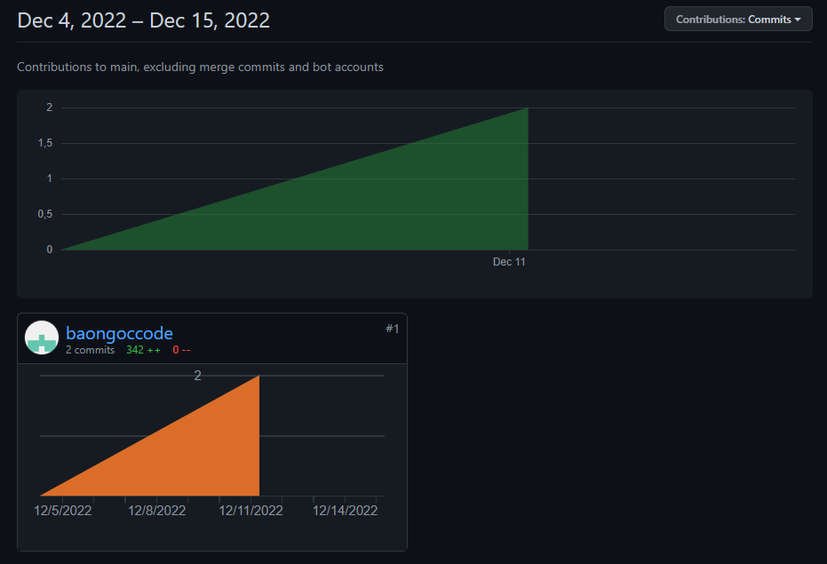
4. A use-case diagram with short explanation to illustrate functionalities of the application.

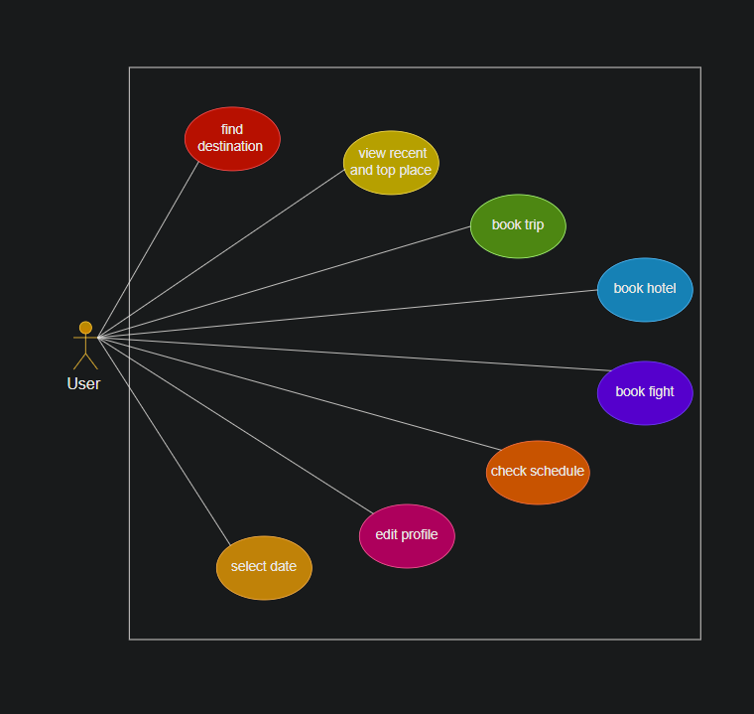

1. Screenshots of major functionalities.

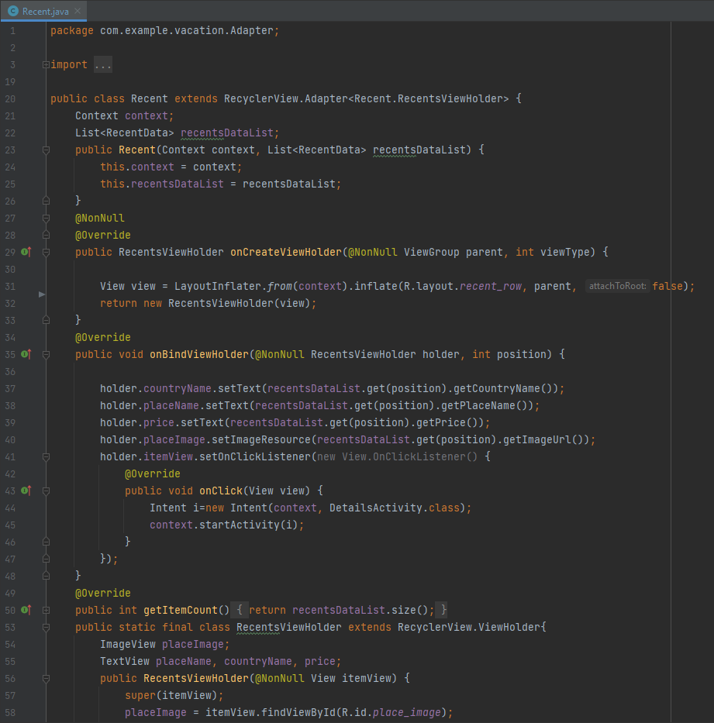

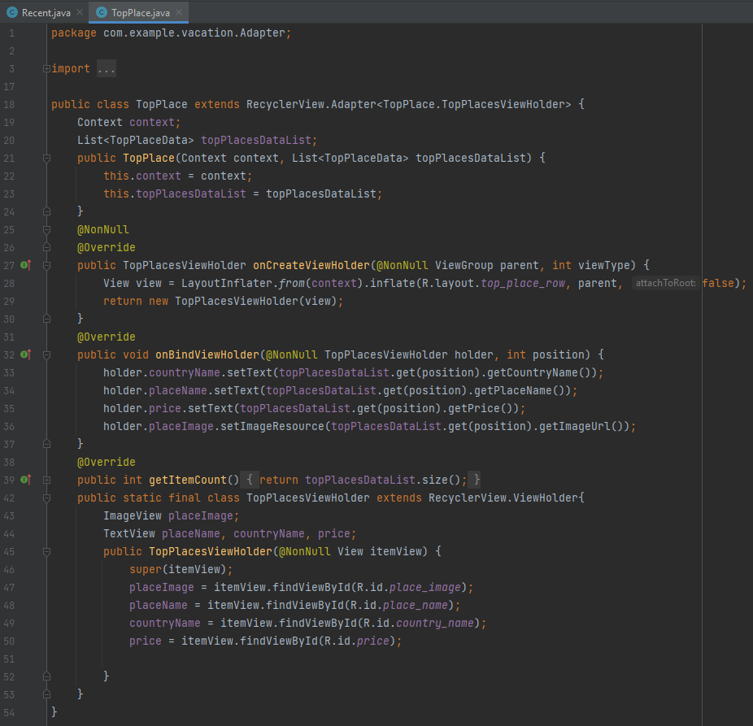

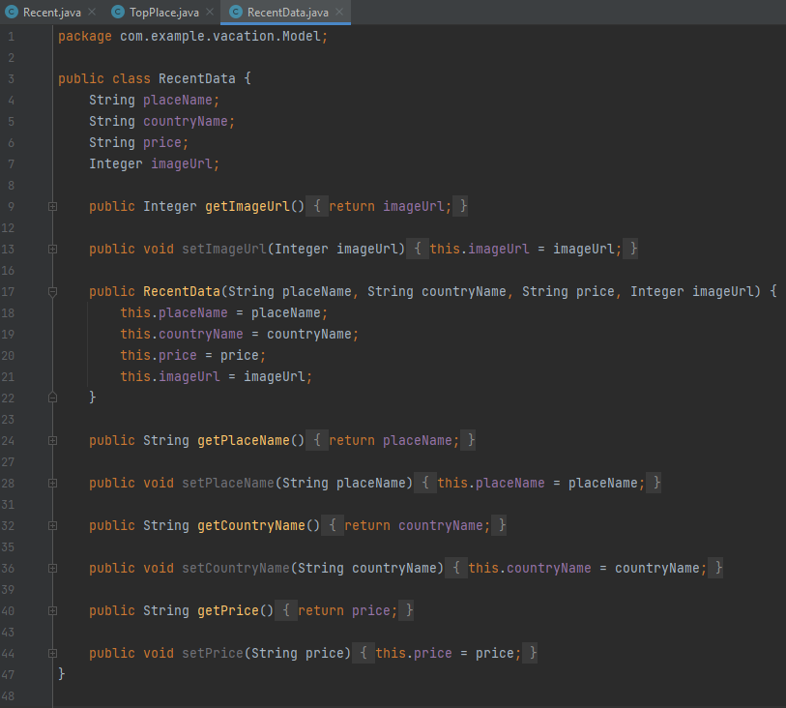

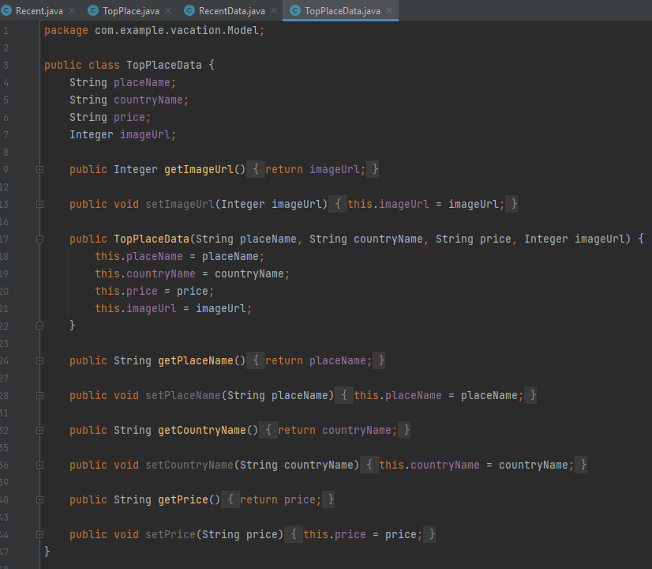

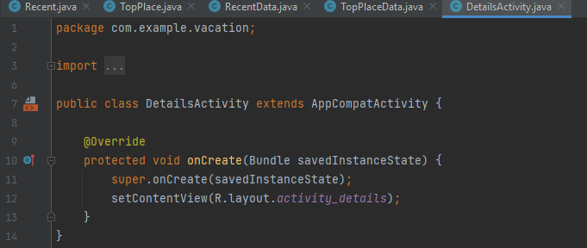

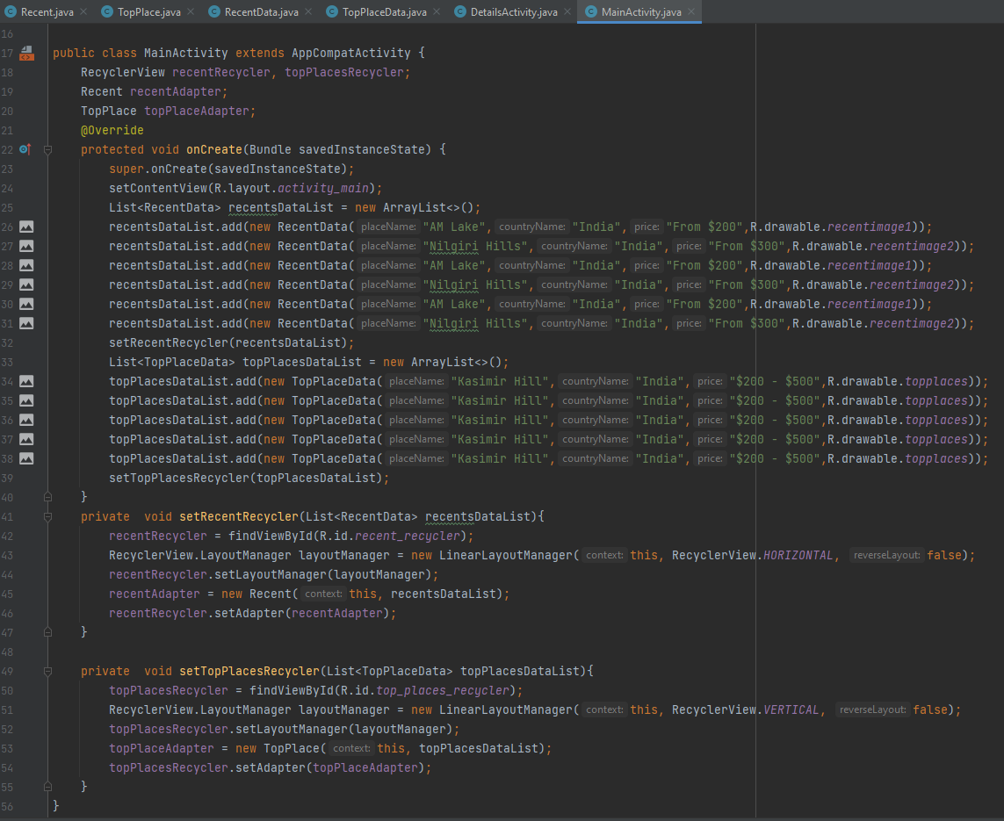

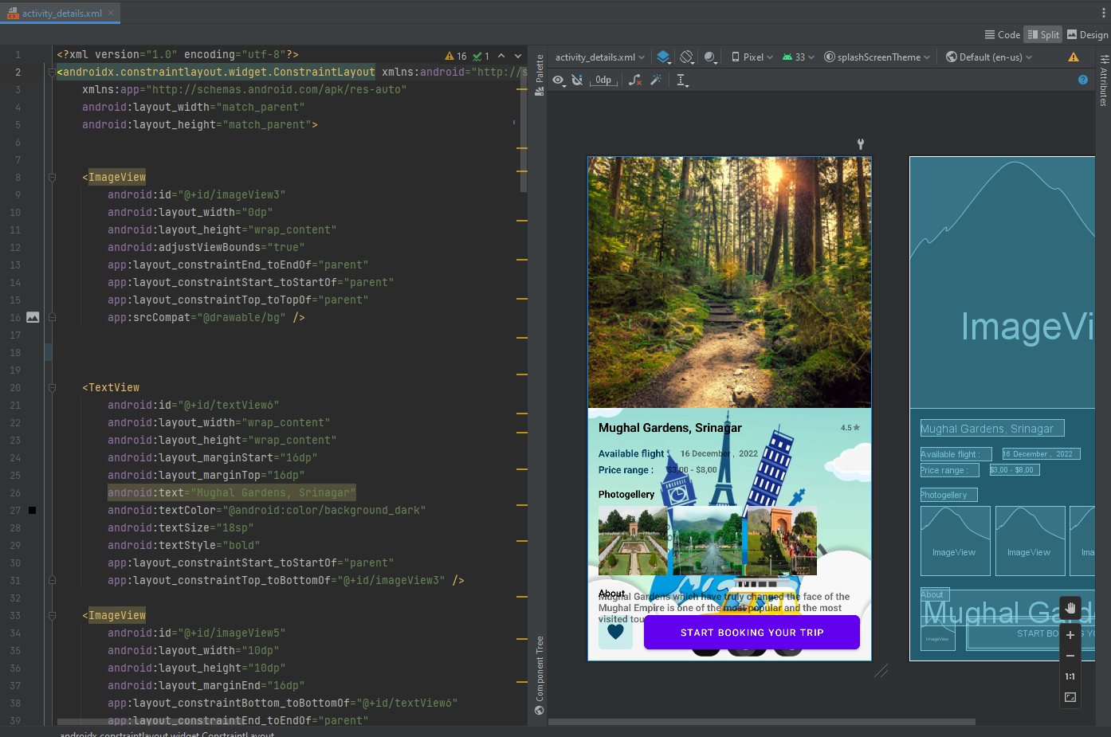

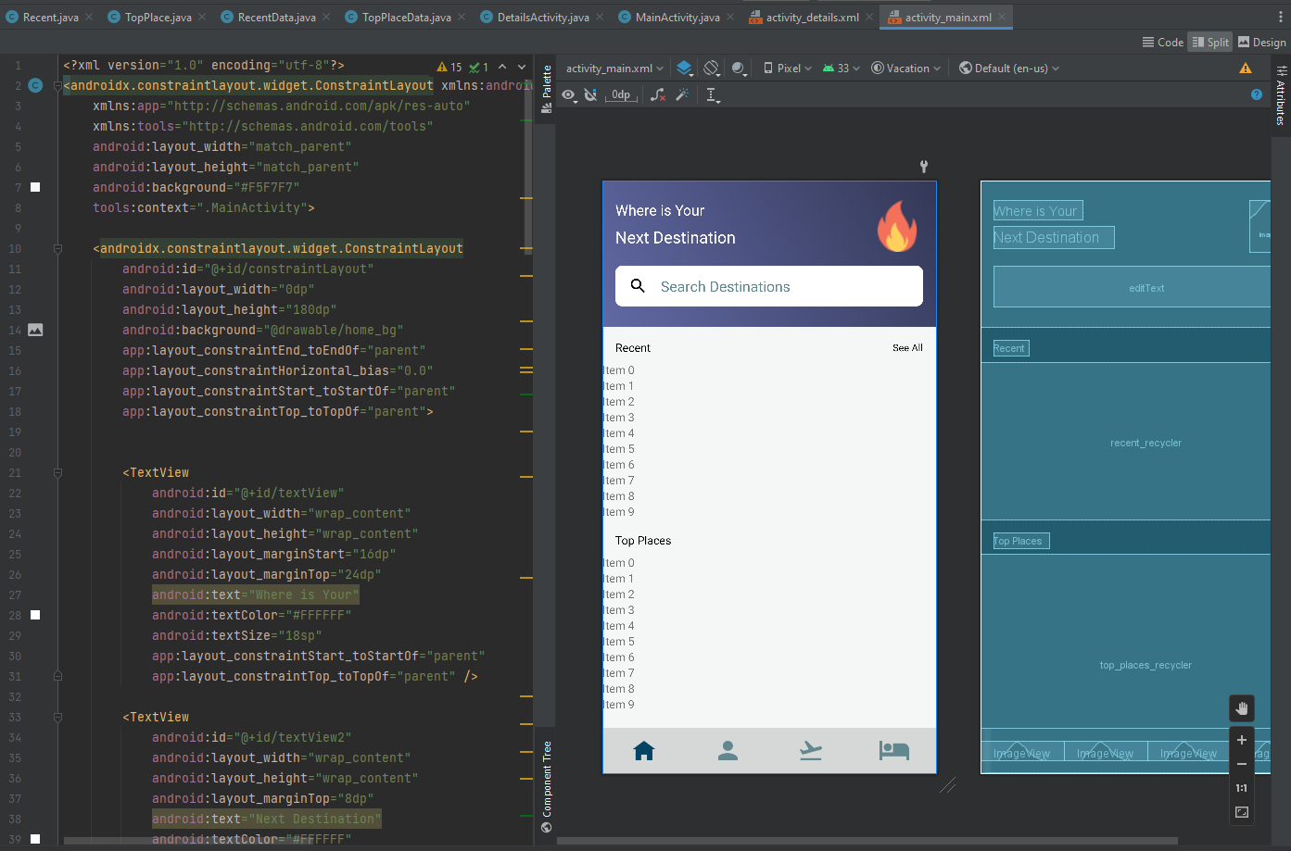

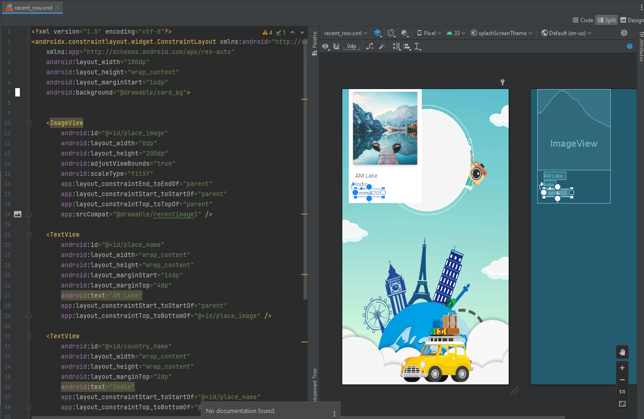

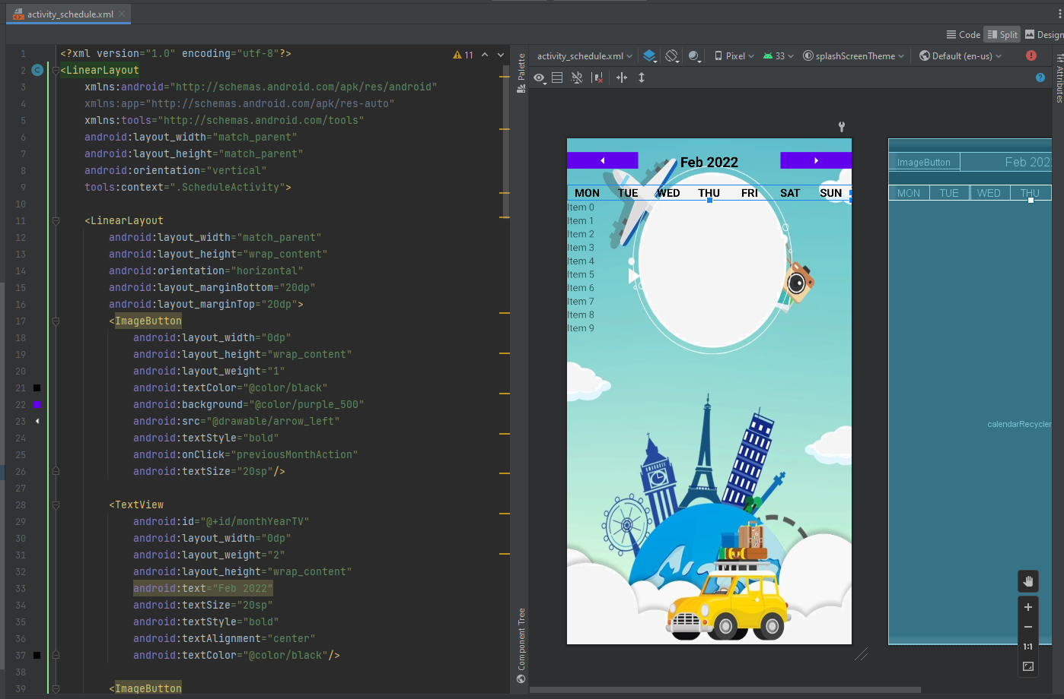

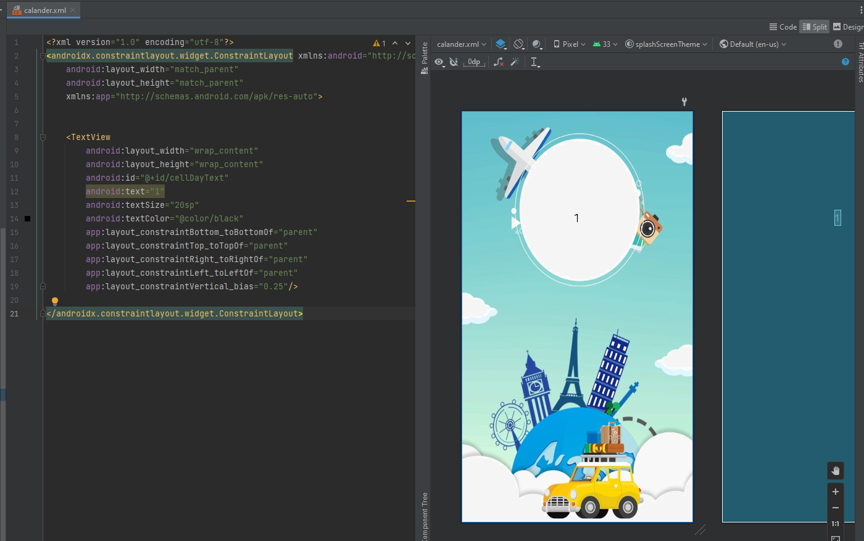

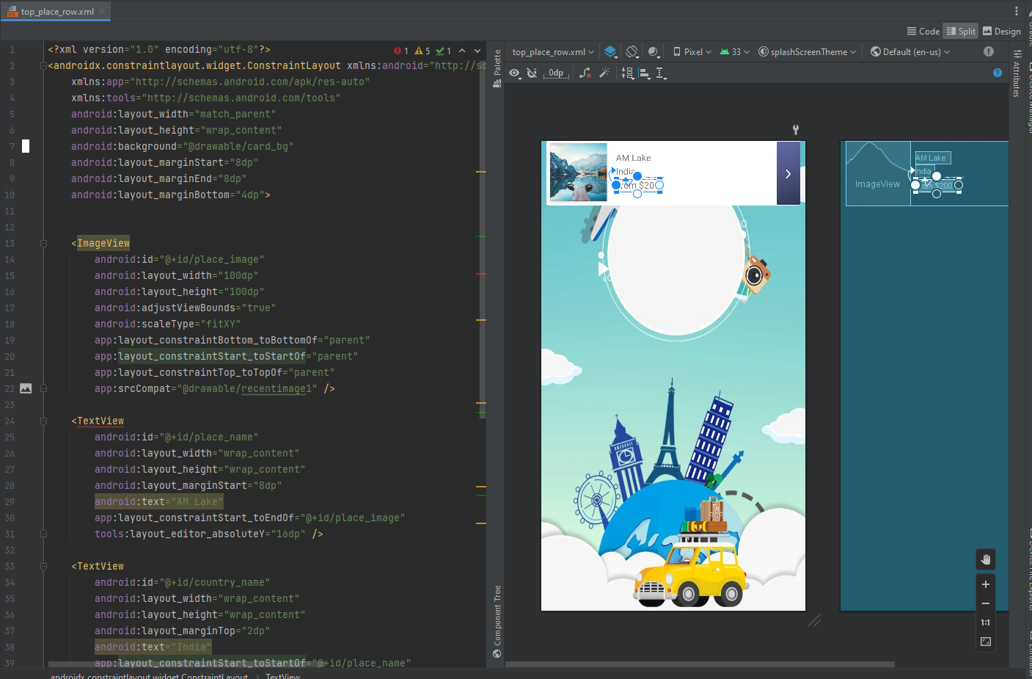

1. Advantages and disadvantages in conducting the midterm project.

+ Advantages: We've been reminded knowledge and happy with what we did.

+ Disadvantages: Some screen displayed unexpected background, computer does not show expected screen

1. Summarize techniques applied in each functionality, i.e., class names

+ Recent

+ TopPlace

+ RecentData

+ TopPlaceData

+ DetailActivity

+ MainActivity

+ AndroidManifest

+ ScheduleActivity

+CalanderAdapter

+ CalanderViewHolder

1. Conclusion and self-assessed score for the project.

+ Conclusion

+ Self-assessed score: 9.0

1. References
2. Additional information as needed.