Because Apple support background mode, the app can continue to get callbacks as the device’s location changes.

So the first, I turn on Background mode configure in Xcode.

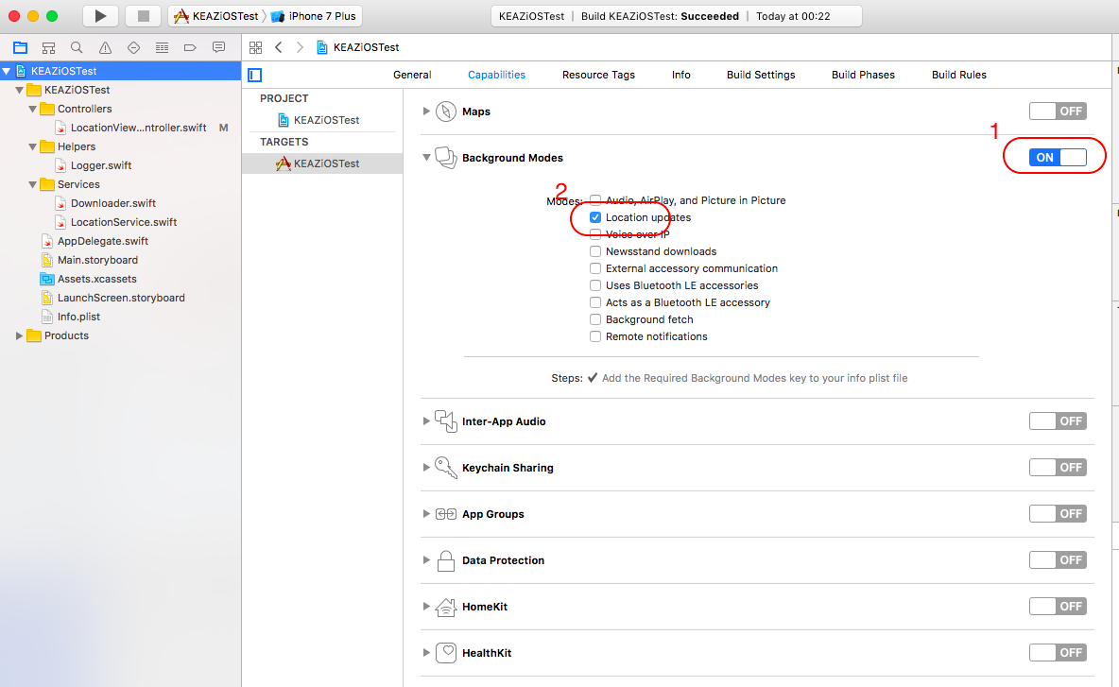

To get location and send to server after every 1 minutes. I use one timer for schedule every 1 minute for start and stop updating location, and to save power, I stop update location after post new location to server, and turn on it after 1 minute.

In LocationViewController: In ViewDidLoad method, I start timer and start updating location.

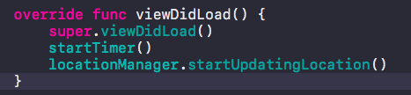

When location updating, It’s call delegate and I stop timer and post new location to Server.

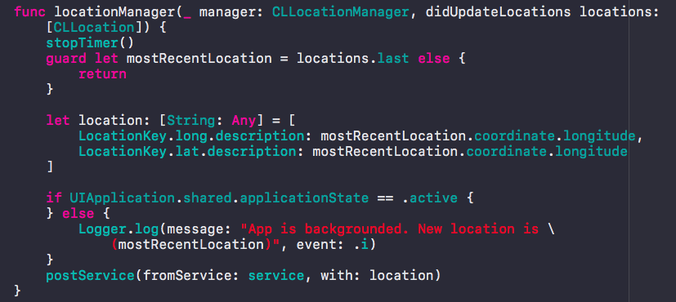

When in location background mode, An app will still receive location delegate messages with the updated location of the user.

Also I created class Logger to help manager log in project. Class LocationManager and Downloader to support call request to server with post method.

SOURCE CODE: https://github.com/baonguyena1/KEAZiOSTest