

**electronics store online**

**Software Requirement Specification**

– Hanoi, May 2022–

**Table of Contents**

I. Overview 3

1. Introduction 3

2. System Functions 4

3. Common Requirements 5

II. Functional Requirements 6

1. <<Feature Name 1>> 6

a. <<Function Name 1>> 6

b. <<Function Name 2>> 7

2. <<Feature Name 2>> 7

# I. Overview

## 1. Introduction

This document describes the requirements for computer.com website, which provides services and supplies electronic devices for purchaser. Types of reader this document is intended for: developers, project managers, testers, etc.

1.1 Overview of the project

This project develops a website called “computer.com” to serve the needs of online shopping for electronic goods. People can visit this website to refer to the products and choose for themselves the best electronic products for themselves and their families. This website mainly serves people about technology products for daily life.

1.2 Environment

The computer.com website shall be compatible with standard web browsers on Windows, Mac, and Web-enabled smart phone platforms.

1.3 The users

1.3.1 Guest

A guest is someone who visit the "computer.com" website to learn more information about product sold on this website. Use cases:

- View all products

- Search for a product

- View product’s detail

- Read blog

1.3.2 Customer

A customer is someone who orders a product from the "computer.com" website. Use cases:

- Login

- View all products

- Search for a product

- View product’s detail

- Add product to cart

- Checkout

- Check order status

- Cancel order

- Rate product

- Give feedback

- Read blog

1.3.3 Seller

A seller is someone who has the responsibilities to manage the website’s products and the business important data

- Create a product

- Modify a product

- Delete a product

- Add promotion detail

- View dashboard

1.3.4 Admin

An admini is the person who has the responsibility to manage users of computer.com website. Use cases:

- Change users’ information

- Delete an user

1.4 Constraints

- The administrator shall be able to maintain and modify the site without requiring any specialized technical knowledge.

- The backend web must be written in Java programming language.

- All HTML code shall conform to the HTML 5.0 standard

1.5 Assumptions and Dependencies

## 2. System Functions

#### a. Screen Flow

User

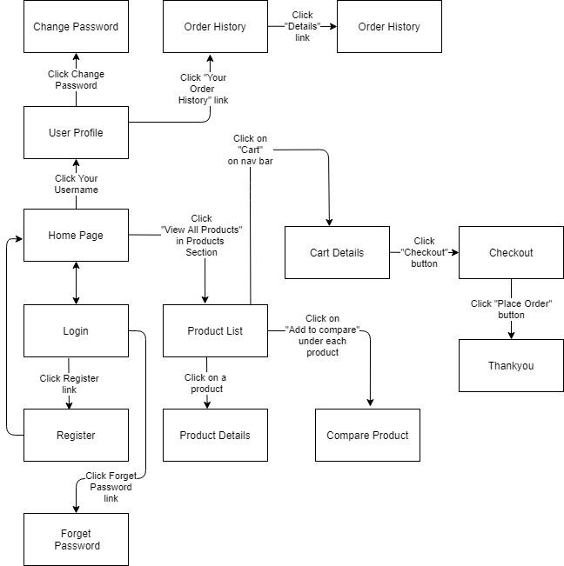

Figure 1-1: Screen Flow for User

#### b. Screen Details

| **#** | **Feature** | **Screen** | **Description** |
| --- | --- | --- | --- |
|  |  |  |  |
|  |  |  |  |
|  |  |  |  |
|  |  |  |  |
|  |  |  |  |
|  |  |  |  |
|  |  |  |  |
|  |  |  |  |
|  |  |  |  |
|  |  |  |  |
|  |  |  |  |
|  |  |  |  |
|  |  |  |  |
|  |  |  |  |
|  |  |  |  |

#### c. User Authorization

| **Screen** | **Guest** | **User** | **Seller** | **Admin** |
| --- | --- | --- | --- | --- |
|  |  |  |  |  |
|  |  |  |  |  |
|  |  |  |  |  |
|  |  |  |  |  |
|  |  |  |  |  |
|  |  |  |  |  |
|  |  |  |  |  |
|  |  |  |  |  |
|  |  |  |  |  |
|  |  |  |  |  |

In which:

#### d. Non-Screen Functions

| **#** | **Feature** | **System Function** | **Description** |
| --- | --- | --- | --- |
|  |  |  |  |
|  |  |  |  |
|  |  |  |  |

## 3. Common Requirements

*<<fill here with all the common requirements...>>*

# II. Functional Requirements

## 1. <<Feature Name 1>>

### a. <<Function Name 1>>

*[A function can be a screen or a non-screen function (listed in the part 5.1 above). In this part, you need to provide the details on the related function, focus on mentioning below information*

* *Function trigger: [how this function is triggered (navigation path, a timing frequency, etc.]*
* *Function description: [actors/roles, purpose, interface, data processing, etc.]*
* *Screen layout: [mockup prototype of the screen, sample below is for Manage Products screen]*

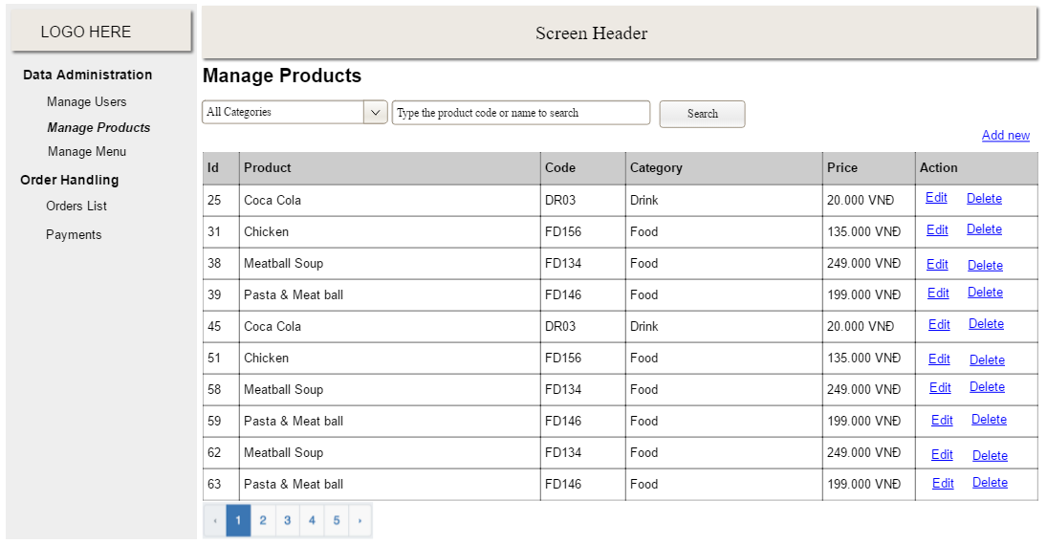

**Table 3-1: Screen Definition**

| **#** | **Field Name** | **Type** | **Mandatory** | **Max Length** | **Description** |
| --- | --- | --- | --- | --- | --- |
| 1 | Category | dropdown | N/A | 20 |  |
| 2 | Product code | Text | No | 20 |  |
|  |  |  |  |  |  |

* *Function Details: provide explanation for the data, validation, business logics, functionalities (for both normal cases and abnormal cases), etc. of the function so that the reader can image how it work.*

*Example:*

Process flow

| **#** | **Actor** | **Action description** |
| --- | --- | --- |
| 1 | User | Click on Manage Product menu on the left menu bar on the Home screen |
| 2 | System | Display the Manage Product screen with the following fields   * Category dropdown * Product code text box * Search result table (Product Id, Product Name…) |
|  |  |  |

Business rules

| **#** | **Description** |
| --- | --- |
| BR-1 | Deliveries must be completed in 1 week after the order approved |
| BR-2 | All goods in a single order must be paid for by using the same payment method. |
| BR-3 | Only sellers can create, modify, or delete products. |
| BR-4 | Only administrators can modify, or delete users. |
| BR-5 | Order price is calculated as the sum of each order item price times the quantity of that order item ordered, plus shipping fee |

*]*

### b. <<Function Name 2>>

…

## 2. <<Feature Name 2>>

…