Jay Pandya

I pledge my honor that I have abided by the Stevens Honor System.

HW5 SSW-567

**Summary:**

I used Pylint and Coverage.py to analyze my code, and although coverage.py showed 84% test code coverage, pylint showed many syntax errors like whitespaces and naming conventions that weren’t met. So most changes I made were syntax-focused.

**Github URL**: <https://github.com/jjjpanda/SSW-567/tree/master/HW2>

**Pylint Output:**

************* Module Triangle

C: 12, 0: Exactly one space required after comma

def classifyTriangle(a,b,c):

^ (bad-whitespace)

C: 12, 0: Exactly one space required after comma

def classifyTriangle(a,b,c):

^ (bad-whitespace)

C: 14, 0: Trailing whitespace (trailing-whitespace)

C: 15, 0: Trailing whitespace (trailing-whitespace)

C: 16, 0: Trailing whitespace (trailing-whitespace)

C: 19, 0: Trailing whitespace (trailing-whitespace)

C: 26, 0: Trailing whitespace (trailing-whitespace)

C: 33, 0: Trailing whitespace (trailing-whitespace)

C: 36, 0: Trailing whitespace (trailing-whitespace)

C: 37, 0: Trailing whitespace (trailing-whitespace)

C: 39, 0: Exactly one space required after comma

if not(isinstance(a,int) and isinstance(b,int) and isinstance(c,int)):

^ (bad-whitespace)

C: 39, 0: Exactly one space required after comma

if not(isinstance(a,int) and isinstance(b,int) and isinstance(c,int)):

^ (bad-whitespace)

C: 39, 0: Exactly one space required after comma

if not(isinstance(a,int) and isinstance(b,int) and isinstance(c,int)):

^ (bad-whitespace)

C: 41, 0: Trailing whitespace (trailing-whitespace)

C: 42, 0: Trailing whitespace (trailing-whitespace)

C: 48, 0: Trailing whitespace (trailing-whitespace)

C: 49, 0: Trailing whitespace (trailing-whitespace)

C: 52, 0: Line too long (123/100) (line-too-long)

C: 1, 0: Module name "Triangle" doesn't conform to snake_case naming style (invalid-name)

C: 12, 0: Function name "classifyTriangle" doesn't conform to snake_case naming style (invalid-name)

C: 12, 0: Argument name "a" doesn't conform to snake_case naming style (invalid-name)

C: 12, 0: Argument name "b" doesn't conform to snake_case naming style (invalid-name)

C: 12, 0: Argument name "c" doesn't conform to snake_case naming style (invalid-name)

R: 50, 4: Unnecessary "else" after "return" (no-else-return)

R: 12, 0: Too many return statements (8/6) (too-many-return-statements)

--------------------------------------------------------------------

Your code has been rated at -5.62/10 (previous run: -5.62/10, +0.00)

**Coverage.py Output**

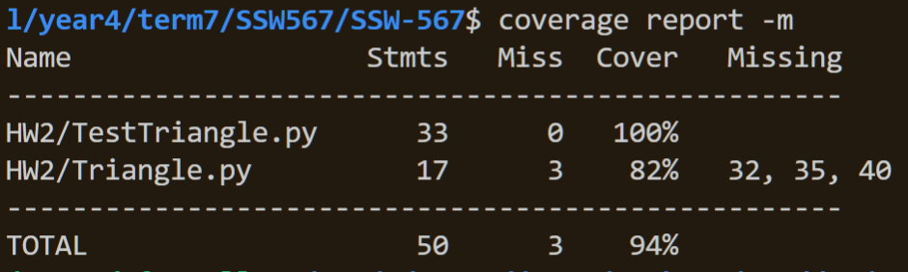

Original test cases met 80% so no changes were made to TestTriangle.py

**Pylint Output after Changes**

No config file found, using default configuration

------------------------------------

Your code has been rated at 10.00/10