**ASSIGNMENT 1 BRIEF**

|  |  |  |  |
| --- | --- | --- | --- |
| **Qualification** | **BTEC Level 5 HND Diploma in Computing** | | |
| **Unit number** | Unit 16: Cloud computing | | |
| **Assignment title** | Cloud Computing Solutions | | |
| **Academic Year** | 2021 – 2022 | | |
| **Unit Tutor** | Ho Hai Van | | |
| **Issue date** |  | **Submission date** |  |
| **IV name and date** |  | | |

|  |
| --- |
| **Submission Format:** |
| *Format:* The submission is in the form of 1 document  You must use font *Calibri size 12, set number of the pages and use multiple line spacing at 1.3. Margins must be: left: 1.25 cm; right: 1 cm; top: 1 cm and bottom: 1 cm.* The reference follows Harvard referencing system.  *Submission* Students are compulsory to submit the assignment in due date and in a way requested by the Tutors. The form of submission will be a soft copy posted on <http://cms.greenwich.edu.vn/>  *Note:* The Assignment *must* be your own work, and not copied by or from another student or from  books etc. If you use ideas, quotes or data (such as diagrams) from books, journals or other sources, you must reference your sources, using the Harvard style. Make sure that you know how to reference properly, and that understand the guidelines on plagiarism. *If you do not, you definitely get failed* |
| **Unit Learning Outcomes:** |
| **LO1** Demonstrate an understanding of the fundamentals of Cloud Computing and its architectures.  **LO2** Evaluate the deployment models, service models and technological drivers of Cloud Computing and validate their use. |
| **Assignment Brief and Guidance:** |
| Scenario  ATN is a Vietnamese company which is selling toys to teenagers in many provinces all over Vietnam. The company has the revenue over 700.000 dollars/year. Currently each shop has its own database to store transactions for that shop only. Each shop has to send the sale data to the board director monthly and the board director need lots of time to summarize the data collected from all the shops. Besides the board can’t see the stock information update in real time.  The table of contents in your technical report should be as follows:   1. As a developer, explain to the board director the fundamentals of cloud computing and how it is popular nowadays (about 2500 words) 2. Proposed solution (higher level solution description – around 700 words) and explain the appropriateness of the solution for the scenario (about 400 words with images and diagrams) which might include:    1. Architectural design (architectural diagram and description).    2. Detailed design:       1. Deployment model (discussion on why that model was chosen).       2. Service model (discussion on why that model was chosen).       3. Programming language/ webserver/database server chosen. 3. Summary.   General guidelines:   * Instead of providing definitions but also provide with examples. * Provide more own arguments instead of definitions * Making use of academic references instead of web tutorials * For a cloud architecture look at the bottom of this document |

|  |  |  |
| --- | --- | --- |
| Learning Outcomes and Assessment Criteria | | |
| Pass | Merit | Distinction |
| **LO1** Demonstrate an understanding of the fundamentals of Cloud Computing and its architectures | | **LO1 & 2**  **D1** Justify the tools chosen to realize a Cloud Computing solution. |
| **P1** Analyse the evolution and fundamental concepts of Cloud Computing.  **P2** Design an appropriate architectural Cloud Computing framework for a given scenario. | **M1** Discuss why an organisation should migrate to a Cloud Computing solution. |
| **LO2** Evaluate the deployment models, service models and technological drivers of Cloud Computing and validate their use | |
| **P3** Define an appropriate deployment model for a given scenario.  **P4** Compare the service models for choosing an adequate model for a given scenario. | **M2** Demonstrate these deployment models with real world examples. |

A cloud architecture example:

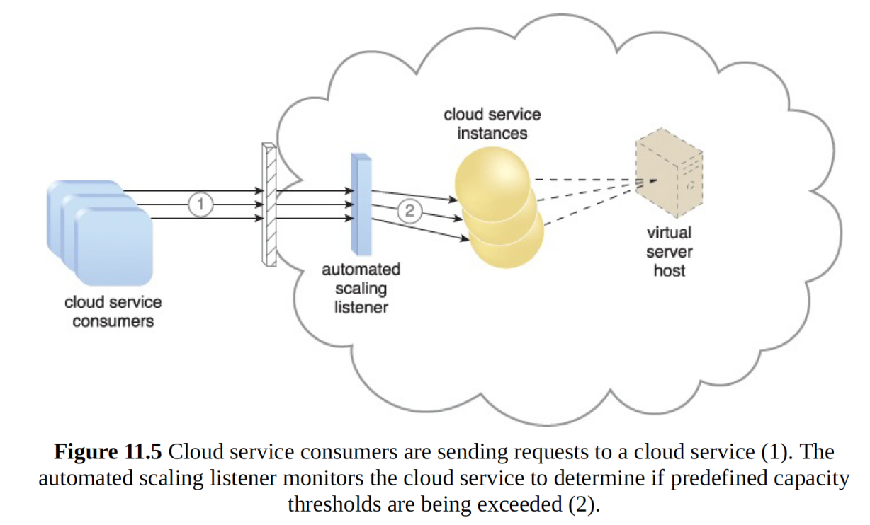

The dynamic scalability architecture can be applied to a range of IT resources, including

virtual servers and cloud storage devices. Besides the core automated scaling listener and

resource replication mechanisms, the following mechanisms can also be used in this form

of cloud architecture:

• Cloud Usage Monitor – Specialized cloud usage monitors can track runtime usage

in response to dynamic fluctuations caused by this architecture.

• Hypervisor – The hypervisor is invoked by a dynamic scalability system to create or

remove virtual server instances, or to be scaled itself.

• Pay-Per-Use Monitor – The pay-per-use monitor is engaged to collect usage cost

information in response to the scaling of IT resources.

Contents

**P1 Analyse the evolution and fundamental concepts of Cloud Computing.** 6

**1. Evolution of Cloud Computing .** 6

**a) What is cloud computing:** 6

**b) Why cloud comptuing important:** 6

**c) How cloud computing work:** 6

**2. Evolution of Cloud Computing.** 7

**3. Fundamental concepts of Cloud Computing .** 9

**a) Role and Boundaries.** 9

**b) Cloud Characteristics.** 10

**c) Cloud Delivery Models.** 10

**D) Cloud Deployment Models.** 11

**P2 Design an appropriate architectural Cloud Computing framework for a given scenario.** 14

**1.Cloud computing architecture .** 14

**2.Architecture design for ATN organization** 15

**P3. Define an appropriate deployment model for a given scenario.** 16

**I.** **Four deployment model:** 16

**II.** **Deployment model for ATN Company:** 17

**P4 Compare the service models for choosing an adequate model for a given scenario. Which service model should be used and why ?** 17

# **P1 Analyse the evolution and fundamental concepts of Cloud Computing.**

# **1. Evolution of Cloud Computing .**

## **a) What is cloud computing:**

A type of computing that stores data on the internet is called cloud computing, or virtual server computing.This platform for computing on the Internet combines computer technologies and relies on the internet and remote central servers to keep programs and data up to date.In addition, it discusses software as a service, Web 2.0, and other significant technological advancements and current issues, focusing particularly on the issue of users relying on the Internet to obtain their devices.

## **b) Why cloud comptuing important:**

Cloud computing continues to be adopted by a significant portion of the business community due to its numerous advantages for consumers in terms of business efficiency, cost savings, and competitive advantages.

**Common benefits of using cloud computing:**

• Cost savings .

• Security.

• Flexibility

• Mobility.

• Disater Recovery.

## **c) How cloud computing work:**

You will need terminal equipment that is network-capable to use cloud computing.To put it another way, cloud computing works through the data centers of service providers.Instead of being stored on hard drives on your smartphone, tablet, or computer, your data is kept on virtual servers.These virtual servers are linked to massive data centers that provide all of the storage and security features that are required.

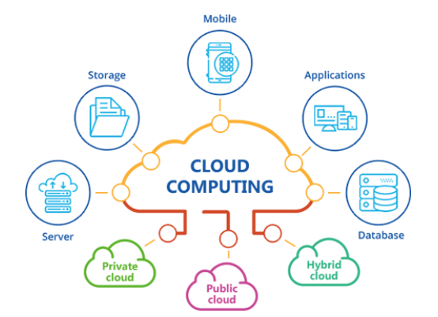

***Figure 1 Cloud Computing.***

Cloud computing services like Gmail, Yahoo Mail, Facebook, Hotmail, and Orkut, among others, are among the most fundamental and widely used.This technology is currently utilized by individuals or businesses via desktop, tablet, and other devices.

# **2. Evolution of Cloud Computing.**

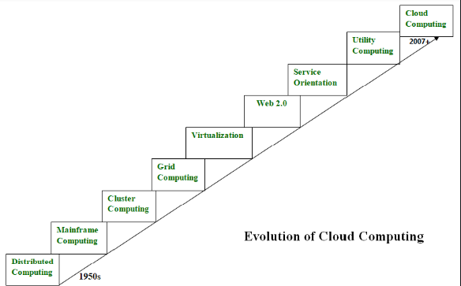

***Figure 2 Evolution of Cloud Computing***

**Distributed systems:**

• The term "distributed system" was first used to describe a computing environment in the 1950s. A network connects multiple computers, distributing various components across them.

• In order to complete the task more quickly than if only one device was in charge, these devices divided the work and shared their resources.

**Mainframe computing:**

• This was made with the help of a platform for distributed systems. For critical applications, bulk data processing, massive throughput, and hot-swapping of hardware, large organizations use mainframe computing.

**Cluster computing:**

• In the 1980s, cluster computing emerged as a superior alternative to mainframe computers.A high-bandwidth network connected each cluster machine to the others.

**Grid computing:**

• In the 1990s, a group of computers collaborates to complete a task that a single computer could not.To function as a virtual supercomputer, each machine on the network must adhere to the same protocol.

**Virtualization:**

• This program makes it possible to run multiple operating systems and applications on the same computer by separating computational environments from physical infrastructures.It serves as the foundation for important cloud computing services like VMwarevCloud and Amazon EC2.

**Web 2.0:**

• In order to define the current state of online technology in comparison to the early days of the internet, the term "Web 2.0" was coined in 2004.It involves more user involvement and collaboration as well as improved communication channels.

**Service orientation:**

• It is a good example of cloud computing.It offers applications that are adaptable, affordable, and able to change.This computer model introduced two significant aspects.Software as a Service (SaaS) and Quality of Service (QoS), which includes Service Level Agreements (SLAs), were the themes.

**Utility computing:**

• Data storage space, computational power, and even hardware like CPUs, displays, and other computer components are available for rent to customers, users, and organizations.Utility computing also allows users to scale up or down according to their requirements.

**Cloud Computing:**

• By 2007, the cloud service had matured into a robust service platform that now serves as the foundation for all different kinds of cloud services.

• In conclusion, cloud computing has come a long way since its early 1950s inception.Businesses and individuals alike are now expected to increase employee productivity.In the decades that followed, numerous concepts for elevating the cloud to new heights emerged as a result.

# **3. Fundamental concepts of Cloud Computing .**

## **a) Role and Boundaries.**

Organizations and individuals can play a variety of roles based on how they relate to and interact with the cloud and its hosted IT resources.The fundamental roles are depicted in the following presentations: Ricardo Puttini, Thomas Erl, and Zaigham Mahmood (2013)

**Cloud Provider & Cloud Consumer:**

Because they own IT resources, cloud consumers access a cloud from a cloud provider through a cloud service consumer.

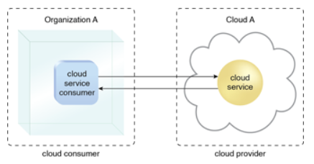

***Figure 3 Cloud consumer and provider.***

**Cloud Service Owner**

The company that purchases cloud services from a cloud service provider, like Platform or Infrastructure as a Service, then adds components and configures them to provide the cloud customer with the necessary mission functionality.

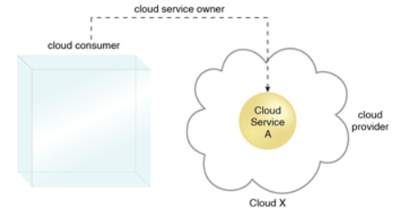

***Figure 4 Cloud service owner model***

**Boundaries &Trust Boundary:**

In the cloud, the term "organizational boundaries" is mostly used to distinguish one company from another that is related to it.The level of trust placed in IT resources is represented by a trust boundary, which is a conceptual boundary that typically extends beyond physical boundaries.

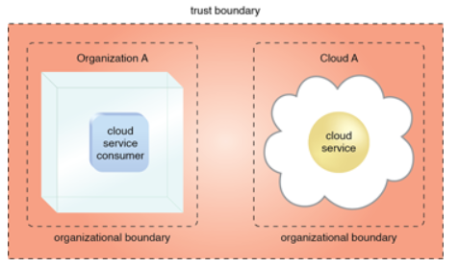

***Figure 5 Trust boundary***

## **b) Cloud Characteristics.**

• An IT environment must have a specific set of features in order to enable successful remote provisioning of scalable and measured IT resources.These characteristics need to be present to a significant degree for an IT environment to be considered an effective cloud.Ricardo Puttini, Thomas Erl, and Zaigham Mahmood (2013).

**The bulk of cloud environments share the following six distinct characteristics:**

• on-demand usage.

• ubiquitous access.

• multitenancy (and resource pooling).

• elasticity.

• measured usage.

• resiliency.

# **c) Cloud Delivery Models.**

A pre-packaged combination of IT resources offered by a cloud provider is referred to as a cloud delivery model.Ricardo Puttini, Thomas Erl, and Zaigham Mahmood (2013)

**There are three main cloud service delivery models that are well-known and well-accepted:**

**• Software as a Service (SaaS) :**

SaaS is the most well-known of the three cloud service delivery models. That is the

most using by user. For example, Netflix, Drive, Dropbox...etc.

**• Infrastructure as a Service (IaaS)**

Typically, a company's IT infrastructure was kept on-site. This meant that businesses

had to invest in expensive gear like servers and storage on a regular basis and

guarantee that everything was up to current.

**• Platform as a Service (PaaS)**

A solution stack is another name for this type of cloud service delivery strategy. It

allows businesses to design, run, and administer cloud-based software without

having to invest in physical infrastructure

## **D) Cloud Deployment Models.**

• A type of cloud environment known as a cloud deployment model is primarily defined by ownership, scale, and access.Ricardo Puttini, Thomas Erl, and Zaigham Mahmood (2013)

**The four most widely used cloud deployment models are as follows:**

**• Public cloud:**

The name says everything: In public clouds, data is created and stored on servers owned by third parties and accessible to the general public.

The public cloud deployment strategy is the best choice for businesses in industries with low privacy concerns.

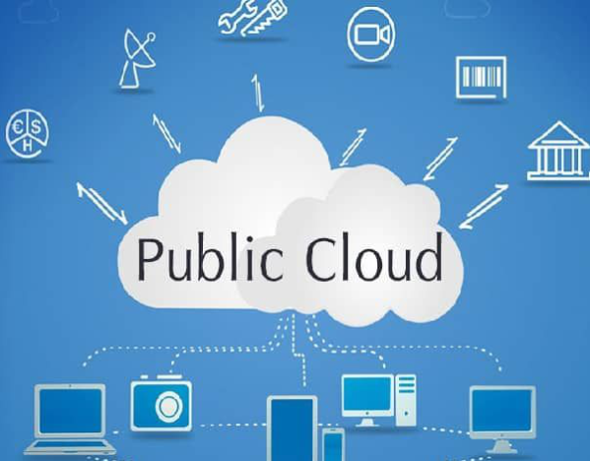

***Figure 6 Public cloud***

**• Private cloud:**

Technology-wise, there is little to no difference between a public model and a private model due to their similar structures.

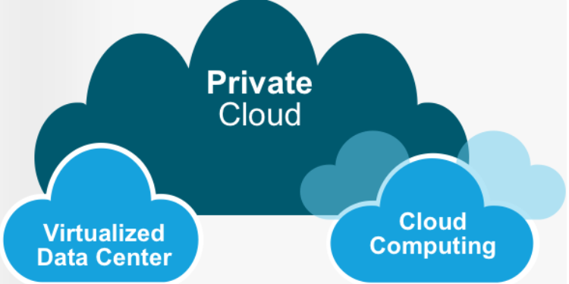

***Figure 7 Private cloud***

**• Community cloud:**

The number of users is the only thing that separates a private deployment strategy from a community deployment model.A private cloud server's infrastructure and associated resources are owned by a single company, whereas those of a community cloud are shared by numerous organizations with comparable backgrounds.

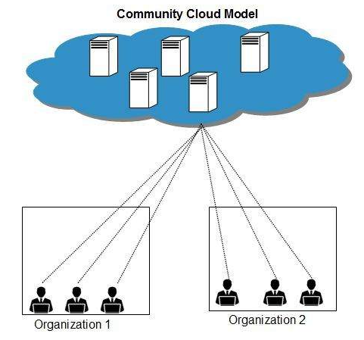

***Figure 8 Community cloud***

**• Hybrid cloud:**

As with any hybrid phenomenon, a hybrid cloud combines the best features of the public, private, and community deployment patterns discussed earlier.Businesses are able to combine the aspects of the three categories that best meet their requirements thanks to this.

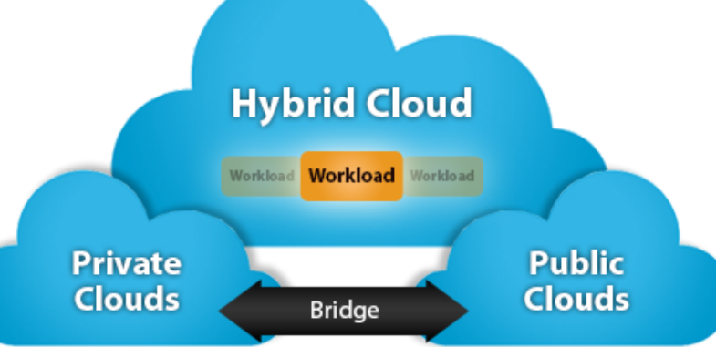

***Figure 9 Hydrid cloud***

# **P2 Design an appropriate architectural Cloud Computing framework for a given scenario.**

# **1.Cloud computing architecture .**

**DEFINITION:** A collection of components designed to utilize the power of cloud resources to address business challenges—such as databases, software capabilities, apps, and so on—is referred to as "cloud architecture."Cloud architecture is what defines components and how they interact with each other.

# 

FRONT-END ARCHITECTURE: Any aspect of the cloud computing architecture that is visible to the user is referred to as "front-end architecture."It is the component that the end user interacts with, and it has sub-components that provide the user experience.When it comes to how users interact with cloud applications, the front-end architecture, which typically takes the form of a user interface, is crucial.The user interface is where most IT workers today will interact with cloud software architecture.The front-end architecture includes standard web applications, local area networks, and web browsers.

BACK-END ARCHITECTURE: The part of cloud computing's architecture that powers the front-end architecture is called the back-end architecture.This typically exists in a server farm in a faraway location and houses the essential components of the system, such as storage and hardware.The back-end architecture is the responsibility of the cloud software provider.AWS and other well-known cloud providers often have robust backend infrastructure to guarantee low latency uptime.Additionally, sophisticated frontend cloud architecture contributes to the development of a dependable and user-friendly solution.

# **2.Architecture design for ATN organization**

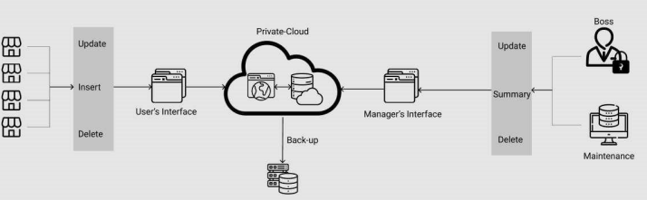

**EXPLAINATION FOR THE ARCHITECTURE DESIGN:**

• In order to resolve the issues that the company is facing right now, we create a cloud architecture using the ATN scenario.

• Initially, the shop manager uses their own interface to edit, add, and delete daily data before sending it to a private cloud for storage.

• The private cloud is set up and maintained by a third party.

• A second server at the company's helm stores all of the data from the private cloud in addition to the private cloud.

• The summary delete monitoring database and systems are updated through their respective interfaces by the boss and maintenance staff.

**3. Dependencies and components of ATN application components of ANT application**

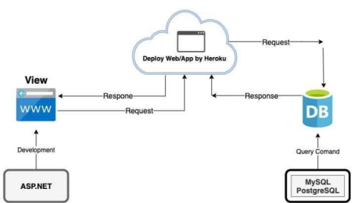

• The database and cloud of the ATN business model are built with MySQL server and ASP.net technology, respectively.

• Next, on the local host, we execute the development process and complete website requests.

• Following that, we deploy our website to PaaS Heroku and then distribute it to users.

# **P3. Define an appropriate deployment model for a given scenario.**

1. **Four deployment model:**

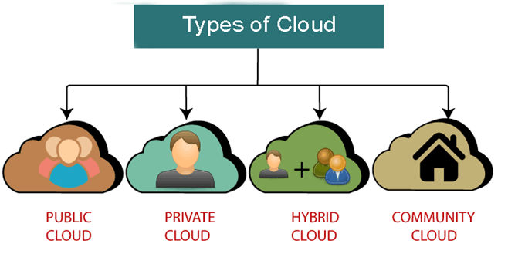

**The model has four deployments:**

• Private Cloud.

• Hybrid Cloud.

• Public Cloud.

• Community Cloud.

**Compare four cloud Deployment Models:**

|  |  |  |  |  |
| --- | --- | --- | --- | --- |
|  | **Public** | **Private** | **Community** | **Hybrid** |
| **Ease of use and setup** | Easy | Requires IT proficiency | Requires IT proficiency | Requires IT proficiency |
| **Privacy and security of data** | Low | High | Comparatively high | High |
| **Control of data** | Little to none | High | Comparatively high | Comparatively high |
| **Reliability** | Vulnerable | High | Comparatively high | High |
| **Flexibility and scalability** | High | High | Fixed capacity | High |
| **Cost-effectiveness** | The cheapest one | Cost-intensive, the most expensive one | Cost is shared among community members | Cheaper than a private model but more costly than a public one |
| **Demand for hardware made in-house** | No | Depends | Depends | Depends |

1. **Deployment model for ATN Company:**

Despite the fact that ATN is a large company with a high-productivity product chain, the company's stability, cost savings, ability to Great scalability, and flexibility make it an ideal solution to the issue raised in the article.Rapid Deployment The Public Cloud can be deployed in a matter of hours.A public cloud can be an option because it is managed by an external provider like Amazon Web Services or the Cloud Server of Viettel IDC in Vietnam, which is used by millions of people every day.appropriate for ATN.However, due to the fact that data is frequently stored in a single location, it is technically less secure than Private Cloud or Colocation.However, the public cloud is significantly safer when the appropriate information security measures are in place.

# **P4 Compare the service models for choosing an adequate model for a given scenario. Which service model should be used and why ?**

• Section 2.4 of P1 states that there are three service models:Software as a Service (SaaS), Platform as a Service (PaaS), and Infrastructure as a Service (IaaS) are all examples.

• We created a comparison table by utilizing the previously mentioned data.

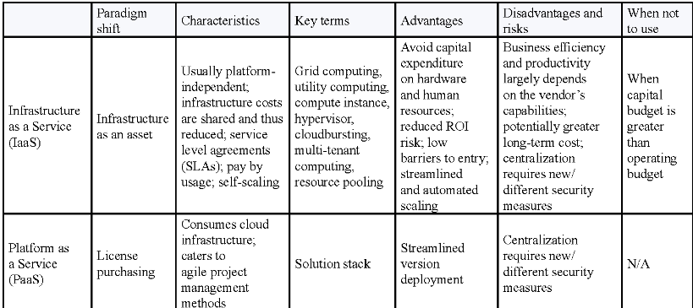

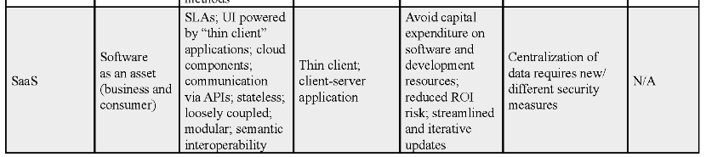

The comparison table the different attributes of three classifications of Cloud Computing

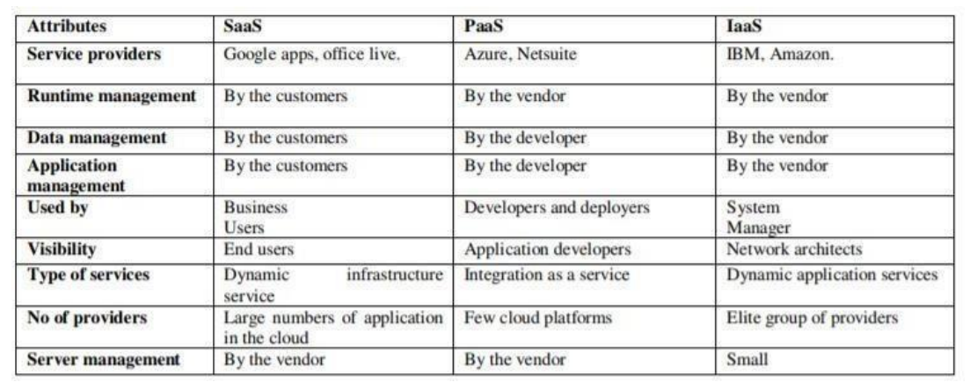

• A company like ATN that has a lot of manual work and basic procedures is best served by the SaaS service model.

• Since ATN Company only cares about the storage and processing of remote economic data, store branches in all of Vietnam's provinces will be able to report earnings through a web cloud.

• Management can view, aggregate, and extract economic data more easily as a result of this.Because of the SaaS service model, ATN won't have to set up a data system because the supplier will take care of that. The supplier will also make sure the company's data are safe.

• After that, the PaaS management application service will be hosted on the website of the ATN company, which is extremely convenient for store expansion and remote access.Shops can use the provided account to access the software and use a web browser to enter their own transaction data.In the meantime, the board of directors can quickly save time by accessing the software through a web browser and viewing, extracting, and synthesizing data from the store.

• As a result, SaaS is the best option for the business if it wants to manage its stack of real-time print data because it provides access to the website via web browser applications.This is an unlimited service that can be used at any time.The company can then use SaaS to keep track of its stack of real-time print data because it makes it possible to access the website through browser-based applications and access.This is a service that is free for the whole day and night.

• Lastly, organizations do not need to worry about upgrades or maintenance because the SaaS model is handled.As a result, instead of worrying about processing and system administration, businesses might concentrate on their core competencies.In addition, businesses will save a lot of time when installing apps on devices, managing equipment, and upgrading it to support the software.

**Reference**

Stouchlighting.com. 2022. Lighting as a Service (LaaS): How it relates to LED retrofits.

[online] Available at: [https://www.stouchlighting.com/blog/lighting-as-a-service laas](https://www.stouchlighting.com/blog/lighting-as-a-service%20laas) [Accessed October 5, 2022].

[online] Available at: <https://www.dreamstime.com/stock-photo-cost-reduction-word-cloud-concept-grey-background-image88534160> [Accessed October 5, 2022].

[online] Available at: <https://www.avsystem.com/blog/saas-software-as-a-service/> [Accessed October 5, 2022].

[online] Available at: <https://www.researchgate.net/figure/A-reference-model-for-the-delivery-of-cloud-computing-services_fig2_330359722> [Accessed October 5, 2022].

[online] Available at: <https://toidicodedao.com/2018/10/23/so-sanh-iaas-paas-saas-la-gi/> [Accessed October 5, 2022].

[online] Available at: <https://www.javatpoint.com/types-of-cloud> [Accessed October 5, 2022]

[online] Available at: <https://www.javatpoint.com/cloud-computing-architecture> [Accessed October 5, 2022].

[online] Available at: <https://docs.rightscale.com/cm/designers_guide/cm-cloud-computing-system-architecture-diagrams.html> [Accessed October 5, 2022].

[online] Available at:<https://ivim.vn/hybrid-cloud-la-gi-tai-sao-can-cho-doanh-nghiep.htm> [Accessed October 5, 2022].

[online] Available at:<https://www.tutorialspoint.com/cloud_computing/cloud_computing_community_cloud_model.htm> [Accessed October 5, 2022].

[online] Available at:<https://bizflycloud.vn/tin-tuc/public-cloud-la-gi-so-sanh-private-cloud-vs-public-cloud-20180620092018139.htm> [Accessed October 5, 2022].

[online] Available at:<https://patterns.arcitura.com/cloud-computing-patterns/basics/roles-and-boundaries/trust_boundaries> [Accessed October 5, 2022].

[online] Available at:<https://patterns.arcitura.com/cloud-computing-patterns/basics/roles-and-boundaries/cloud_service_owner> [Accessed October 5, 2022].