**Team 1 Website Design Project Proposal**

Team Member

* Bao, Qingjun / 2398022
* Li, Zhi /  0645750
* Bo Kyung Kim / 6268890

# Website Description

The project's focus is to create a visually appealing and user-friendly website for a bubble tea shop using HTML and CSS **Bootstrap** 5. The team envisions a simple and intuitive design that prioritizes easy navigation and accessibility. The proposed website structure includes key sections such as a homepage, an About Us page, a Menu page, and a Contact page.

The project's main goals are to showcase the bubble tea shop's offerings and brand identity effectively. The website will feature an inviting homepage with vibrant images of bubble tea and a welcome message. The About Us page will delve into the brand's story, values, and founder's inspiration, adding a personal touch to the shop's identity. The Menu page will present a comprehensive list of flavors, milk teas, fruit teas, and toppings, complete with high-quality images, descriptions, and prices. The highlight will be the Product Detail pages, which will provide in-depth information about each bubble tea flavor, including customizable options, nutritional details, and pricing. The Contact page will offer opening hours, location details, and interactive maps, enhancing the shop's accessibility. Social media integration will foster a sense of community and keep customers informed about updates and events. The website will be designed with responsive elements to ensure optimal viewing across various devices.

In conclusion, this project aims to create an engaging online presence for the bubble tea shop, providing customers with an easy-to-use platform to explore the shop's offerings and brand story. The team's coordinated efforts will result in a visually appealing, informative, and user-centric website that aligns with the youthful and energetic image of the bubble tea shop.

# Details of the Website

* Home Page
* Designs an attractive homepage with the pictures of bubble tea.
* Welcome message introducing the brand and slogan.
* Navigation links to About Us / Menu / Contact pages.
* About Us
* Shows about the team and the brand story, values and slogan.
* Founder's story and the inspiration behind starting the bubble tea shop.
* Menu
* Shows the category and the details of the menu.
* Displaying various bubble tea flavors, milk teas, fruit teas, and toppings.
* Each item accompanied by a high-quality image, brief description and price.
* Product detail
* High-quality image of the selected bubble tea flavor
* Clear and enticing name of this bubble tea flavor.
* Detailed description of the flavor, including key ingredients and unique characteristics.
* Price and size options
* Customization options (sweetness level, ice level, toppings and add-on)
* Nutritional information
* Contact
* Includes opening hour, location, and contact.
* Interactive map highlighting all physical store locations.
* Social Media Integration: Links to the bubble tea shop's social media profiles, encouraging users to follow and engage.
* Footer
* Links to important pages like Privacy Policy, Terms of Service
* Copyright information and social media icons.

# Website Map

- Home

- Navigation / Quick Links

- Image and Slogan

- Promotions Banner

- Special product recommendation

- Navigation

- Milk tea shop Logo

- Quick Links (Home, Menu, News, About Us)

- Members (Log in / Register)

- Menu

- Classic Bubble Teas

- Item 1 / Item 2 / ...

- Fruit Teas

- Item 1 / Item 2 / ...

- Snacks

- Item 1 / Item 2 / ...

- News / Blog

- Events and Promotions

- Blog Post 1 / Blog Post 2 / ...

- About Us

- Brand History

- Founder's Story

- Behind-the-Scenes Photos

- Store Locations (Interactive Map)

- Contact us (Contact Form)

- Footer

- Social Media Integration (Social Media Icons / Links to Social Media Profiles)

- Privacy Policy and Terms of Service

- Copyright Information

- Links to Important Pages

# User Interface Prototyping Design

Main Page

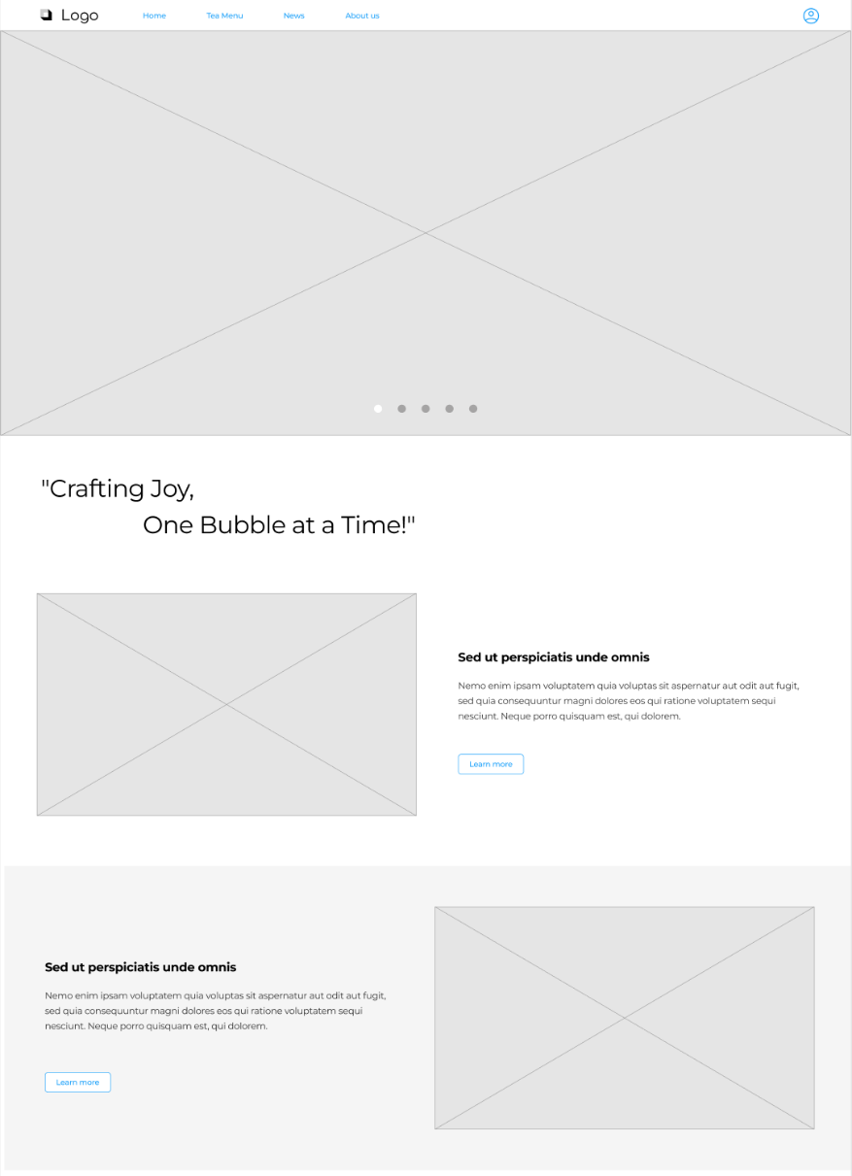

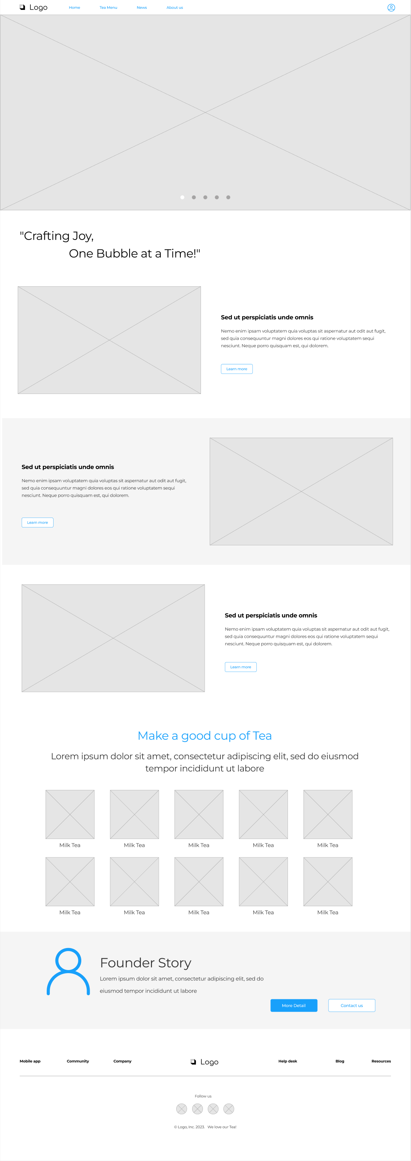

Navigation

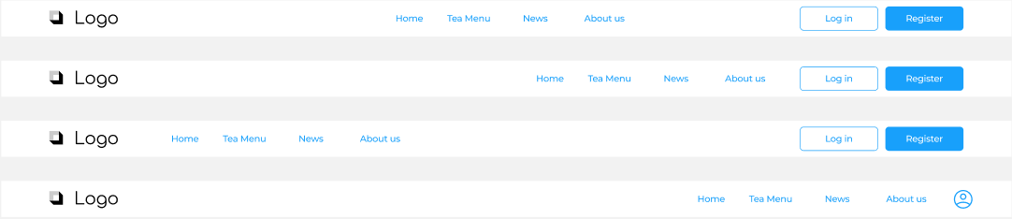

Tea_Menu

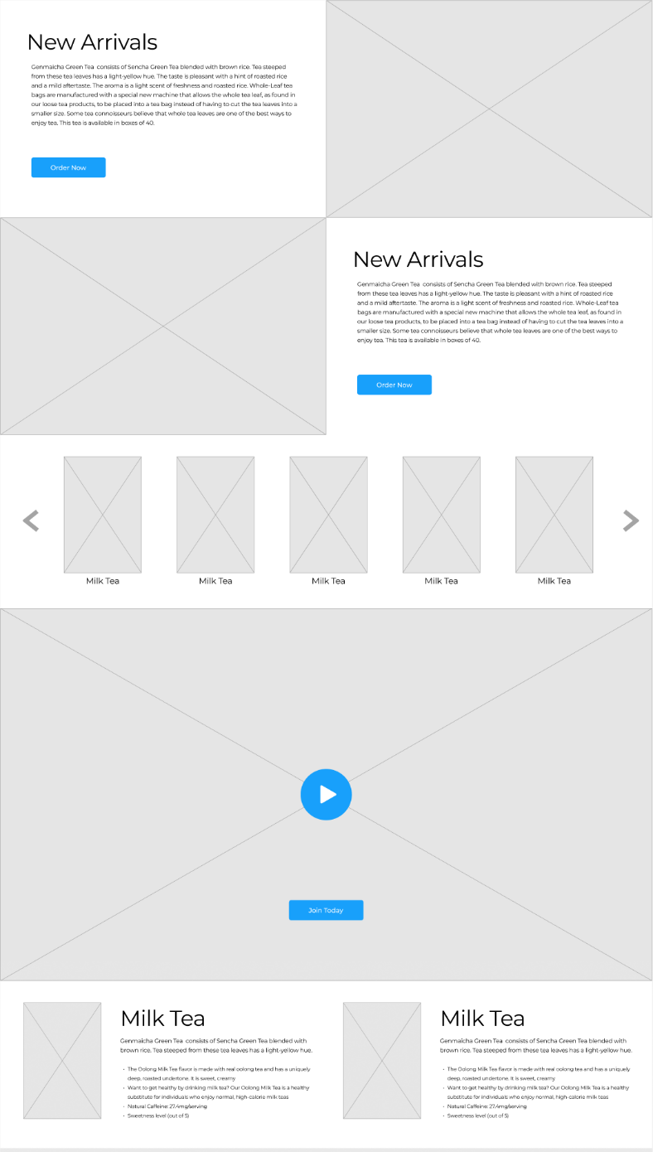

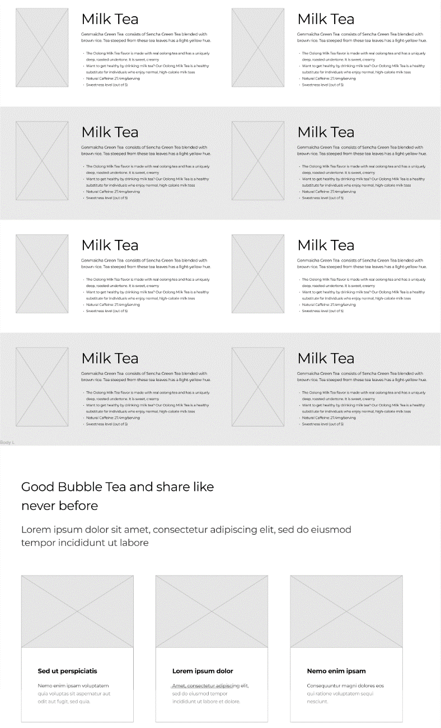

About us

