If you do not partition a /home while installing a linux system,this particle will be help for you.

1.use gparted to re-partition disk,google for details.

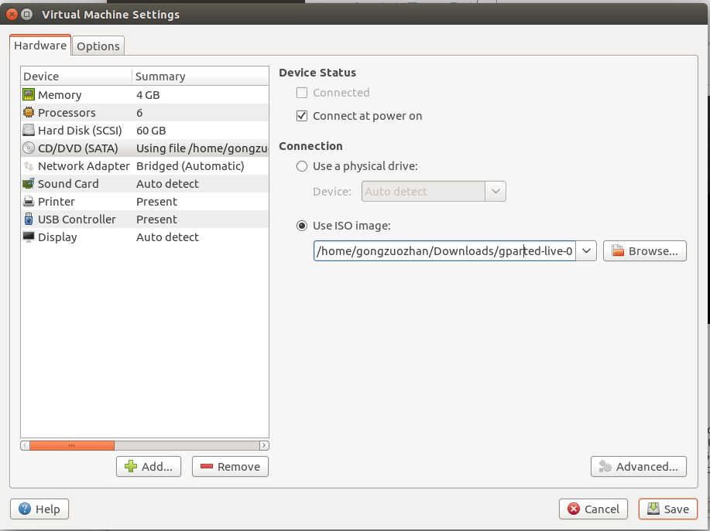

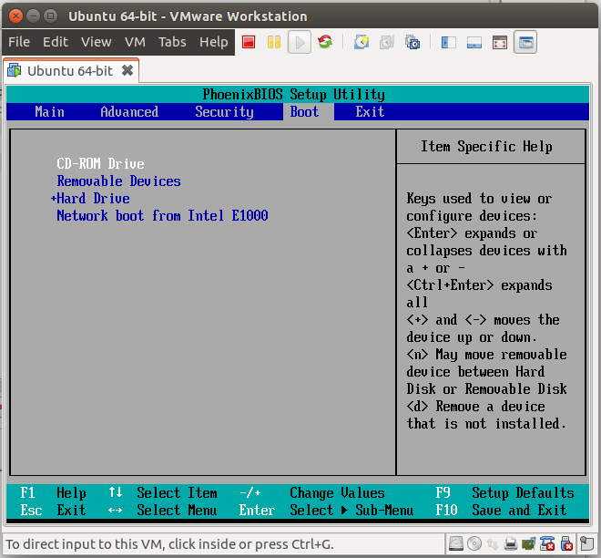

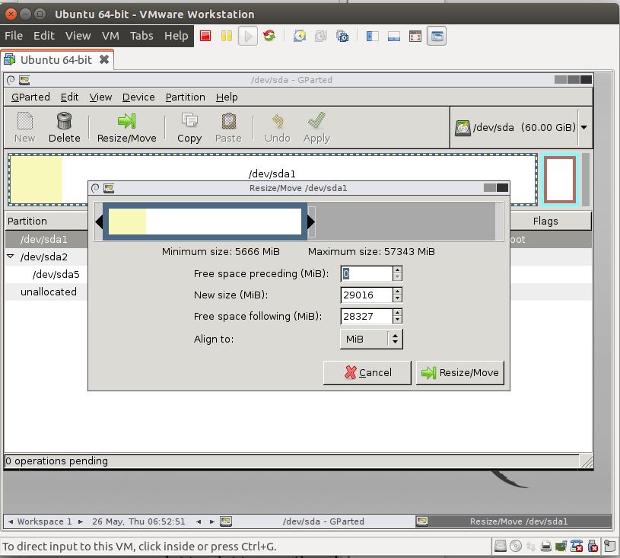
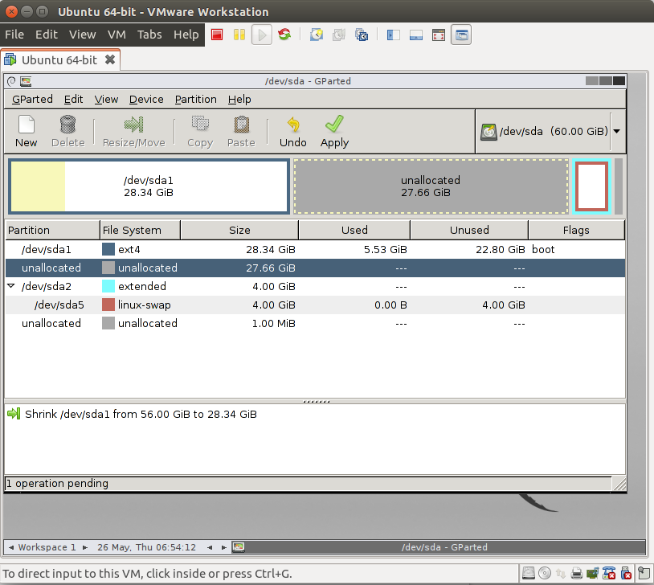
2.backup /home
~$:sudo cp -R /home /media/gongzuozhan/home
3.create a new partition /dev/sda3 for unallocated space
~$:sudo -i
~#:fdisk /dev/sda
~#:n
~#:p
~#:w
~#:partprobe
~#:mkfs.ext4 /dev/sda3
4.mount the new partition to /home,and restore /home
~#:mount /dev/sda3 /home
~#:cp -R /media/gongzuozhan/home /
5.change owner and group to user gongzuozhan
~#:chown -R gongzuozhan:gongzuozhan /home/gongzuozhan

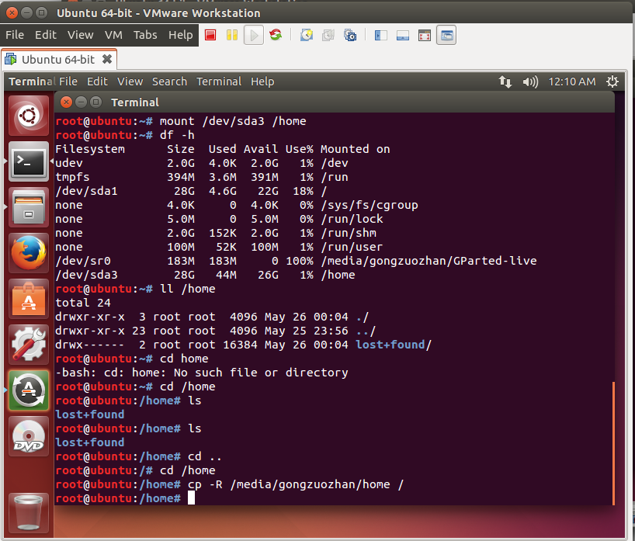

6.auto mount all partition when startup,then restart
~#:vi /etc/fstab
/dev/sda3 /home ext4 defaults 0 2

