1. Copy files in the var-lib-apt-lists folder into /var/lib/apt/lists folder
2. Install synaptic

cd synaptic

sudo dpkg -i \*.deb

1. Copy files in the var-cache-apt-archives folder into /var/cache/apt/archives folder
2. Install flowing packages by using synaptic. This packages is required for building PCL from source

libeigen3-dev 3.3.7

libpcl-dev

libpcl-doc

libusb-1.0-0-dev

cmake-gui

1) Open synaptic

sudo synaptic

2) Click “Search” button

3) In the dialog box, type package name, and then click “Search”

4) Click searched package name, and then click “Mark for installation”

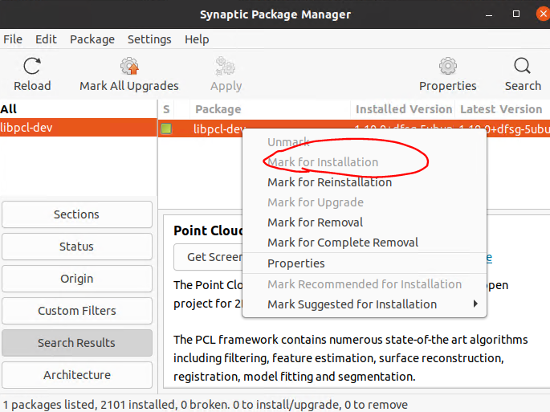

5) Click “Apply button”

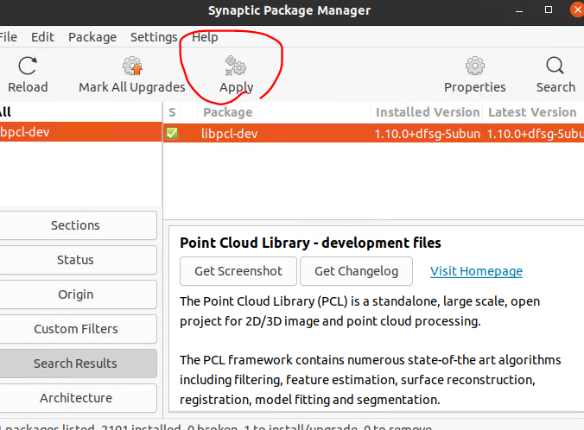

6) Click “Apply button” in the following dialog box.

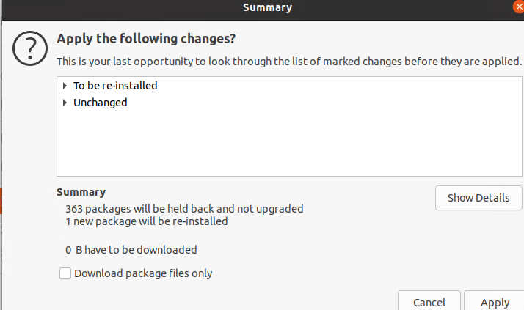

1. Step 2 ~ 4 is also done by using apt command simply.

sudo apt install libeigen3-dev libpcl-dev libpcl-doc libusb-1.0-0-dev cmake-gui

1. Build and install PCL by using cmake

(source link https://github.com/PointCloudLibrary/pcl )