1. Copy files in the var-lib-apt-lists folder into /var/lib/apt/lists folder

2. Install synaptic

cd synaptic

sudo dpkg -i libept1.6.0_1.1+nmu3ubuntu3_amd64.deb

sudo dpkg -i libxapian30_1.4.14-2_amd64.deb

sudo dpkg -i synaptic_0.84.6ubuntu5_amd64.deb

OR

sudo dpkg –I *.deb

3. Extract gnuradio_3.8.1.0~rc1-2build2_amd64.zip file in the var-cache-apt-archives directory to the same folder

4. Install packages by using synaptic

1) Open synaptic

sudo synaptic

2) open Menu -> File -> Add download packages

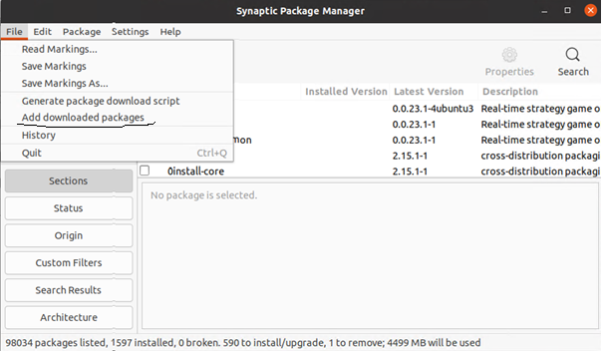

3) In the dialogbox, select var-cache-apt-archives folder

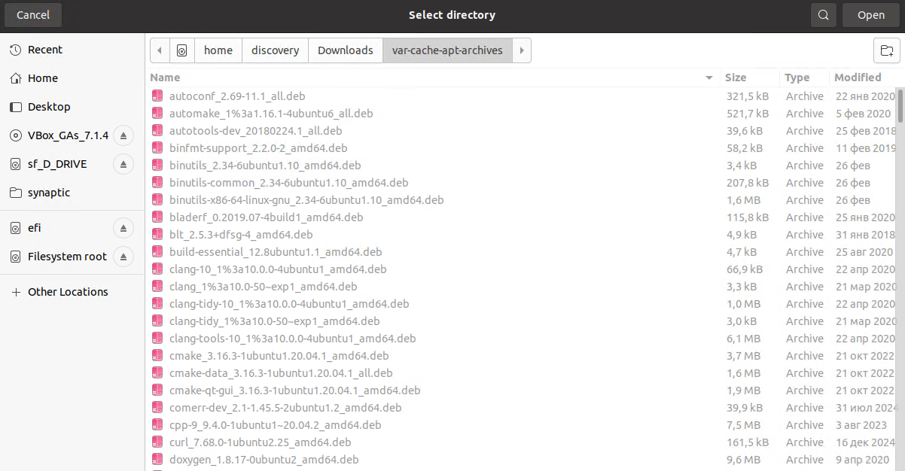

4) Click Apply button

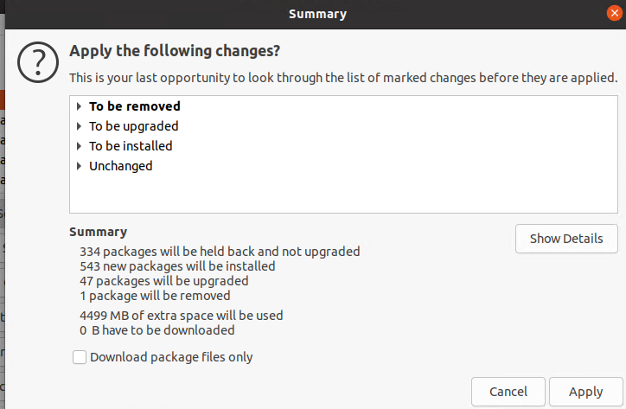

After this operation, the following packages are installed

|  |  |  |
| --- | --- | --- |
| Package name | Version | Required by |
| libfmt-dev | 6.1.2 | volk |
| libboost-all-dev | 1.71.0 | gnuradio |
| libspdlog-dev | 1.5.0-1 | gnuradio |
| libgsl-dev | 2.5 | gnuradio |
| libuhd-dev | 3.15 | gnuradio |
| libjack-dev | 0.125 | gnuradio |
| libsdl-dev | 1.2 | gnuradio |
| libiio-dev | 0.19 | gnuradio |
| python3-pybind11 | 2.4.3 | gnuradio |
| librtlsdr-dev | 0.2.0 | gr-osmosdr |
| libbladerf-dev | 0.2019.07 | gr-osmosdr |
| libhackrf-dev | 2018.01.1 | gr-osmosdr |
| libairspy-dev | 1.0.9 | gr-osmosdr |
| libairspyhf-dev | 1.1.5 | gr-osmosdr |
| libmirisdr-dev | 0.0.4.59 | gr-osmosdr |
| libfreesrp-dev | 0.3.0 | gr-osmosdr |
| doxygen | 1.8.17 | gr-osmosdr |
| **gnuradio-dev** | 3.8.1 | gr-osmosdr |
| **gr-osmosdr** | 0.2.0 |  |

5. Build and install SoapySDR by using cmake

(source link <https://github.com/pothosware/SoapySDR>, version 0.8.1 )

1. Extract SoapySDR.zip file
2. Make SoapySDR-build folder
3. Run cmake gui

sudo cmake-gui

1. Select source folder and build folder
2. Press “config” and “generate” button

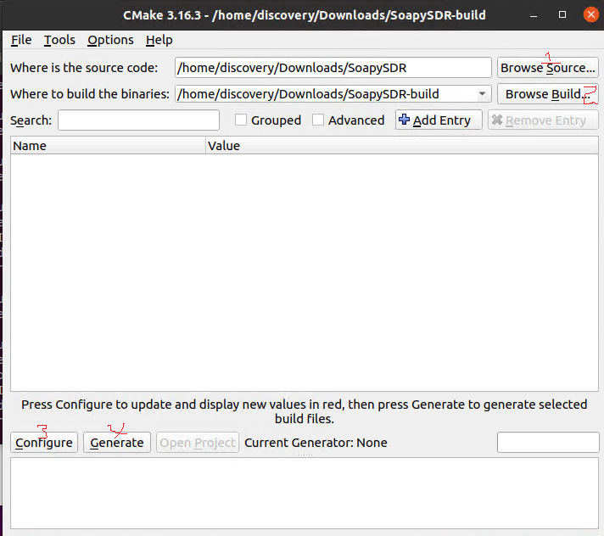

6) build and install

sudo cd SoapySDR-build

sudo make –j4

sudo make install

6. Build and install volk by using cmake like as step 5.

7. Build and install gnuradio by using cmake like as step 5.

8. Build and install gr-osmosdr by using cmake like as step 5.