<https://technet.microsoft.com/en-us/library/hh779113(v=ocs.14).aspx>

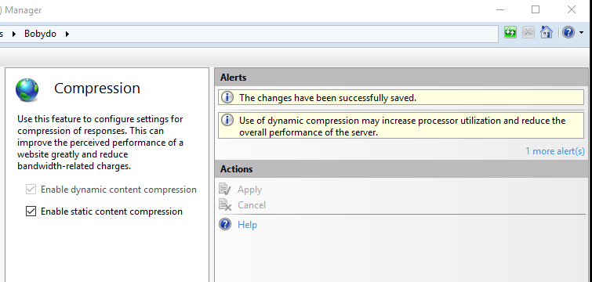

<http://caniuse.com/#search=promise>

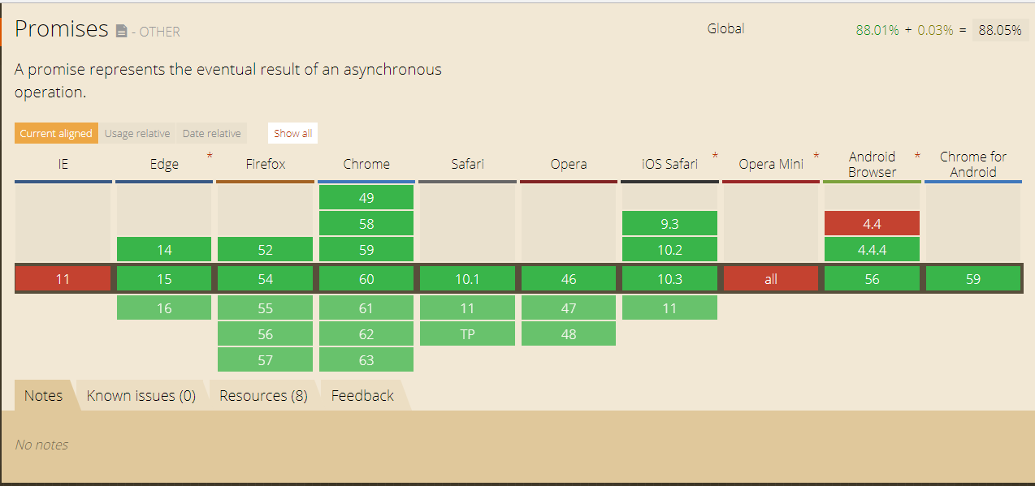

<http://caniuse.com/#search=gzip>

