1. Installation sequency

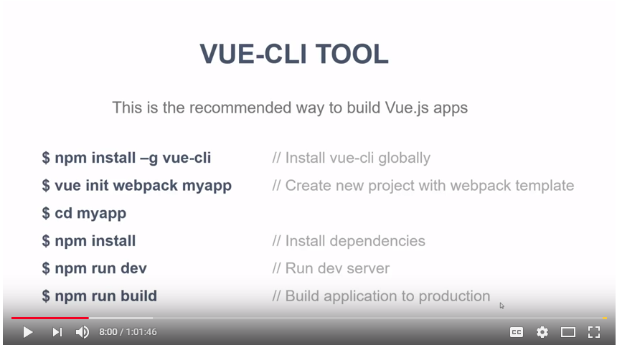

1. Installation details

? Project name myapp

? Project description A Vue.js project

? Author shenyi

? Vue build standalone

? Install vue-router? Yes

? Use ESLint to lint your code? Yes

? Pick an ESLint preset Standard

? Set up unit tests Yes

? Pick a test runner jest

? Setup e2e tests with Nightwatch? (Y/n) Y

1. Reinstall webpack

Npm install webpack --save

<https://stackoverflow.com/questions/22891211/what-is-the-difference-between-save-and-save-dev>

* --save-dev is used to save the package for development purpose. Example: unit tests, minimisation..
* --save is used to save the package required for the application to run.

1. Features of directives

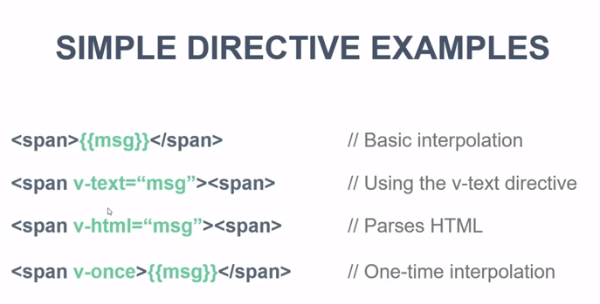

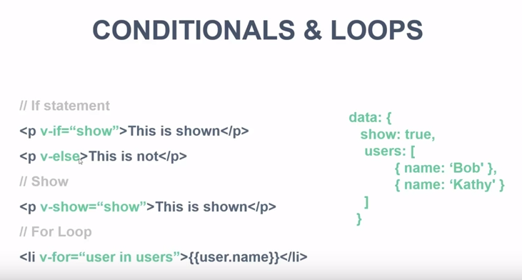

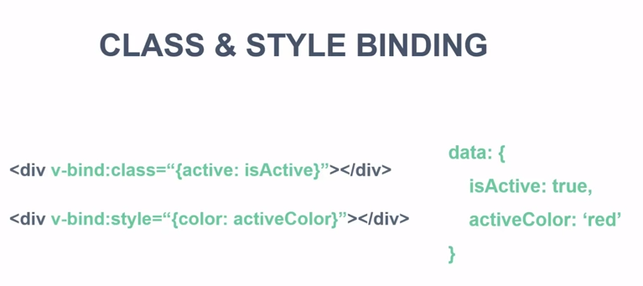

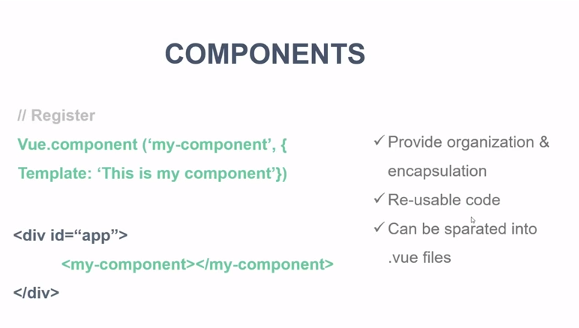

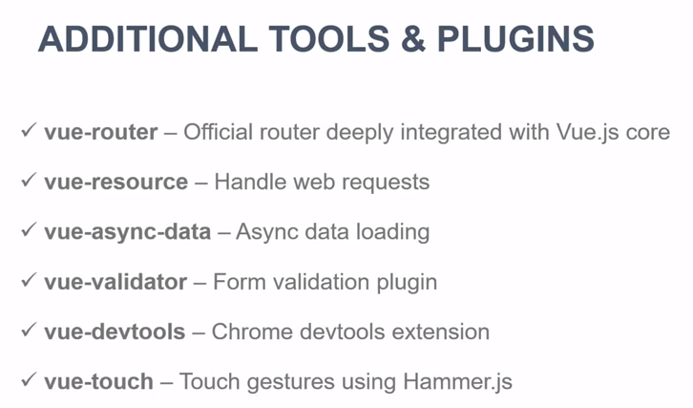

1. File structure

webpack.dev.conf.js

const PORT = 8080

main.js import vue and inport app

1. Set environment

Files -> preferences->setttings

{

**"terminal.integrated.shell.windows": "C:\\Program Files (x86)\\Git\\bin\\bash.exe",**

**"editor.fontSize": 19,**

**"terminal.integrated.fontSize": 20,**

**"workbench.activityBar.visible": true**

}

C:\Source\myapp>npm install vue-resource --save

+ vue-resource@1.3.5

added 16 packages in 7.854s

╭─────────────────────────────────────╮

│ │

│ Update available 5.5.1 → 5.6.0 │

│ Run npm i -g npm to update │

│ │

╰─────────────────────────────────────╯

C:\Source\myapp>npm install vue-router --save

+ vue-router@3.0.1

added 1 package in 6.149s