Hoang test document

Files structure: main.rb, service.rb, order.rb, product.rb, receipt.rb

How it work
1. Copy folder hoangtest to your directory
2. In terminal, CD to inside of the folder hoangtest (EX: ~/Projects/tests/jobready/hoangtest )
3. run the command: $ ruby main.rb

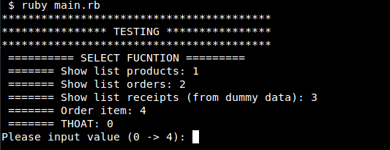
- Input 1: show list of product ( from dummy data )
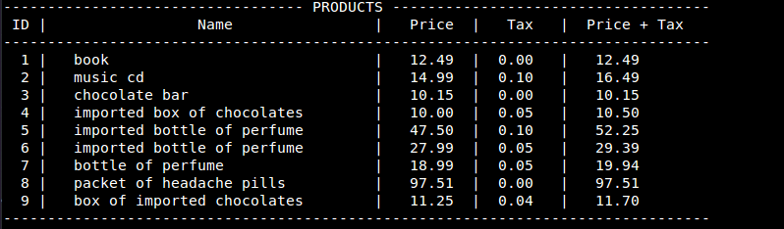
- Input 2: show list orders ( from dummy data )
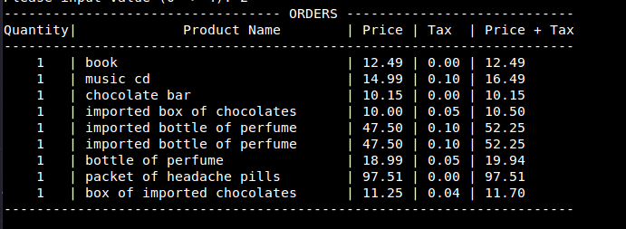
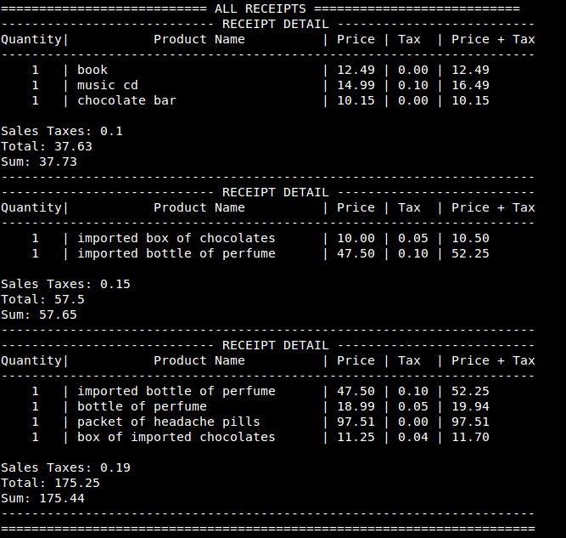
- Input 3: show list receipts ( from dummy data )

- Input 4: Create new order
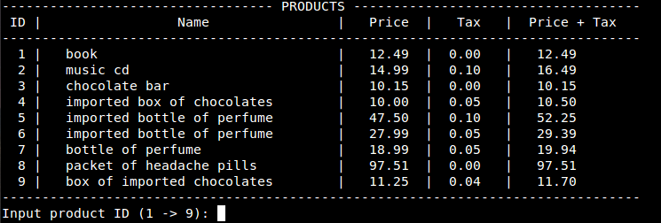
- Choose product from list ( input product ID ) and input number of product.
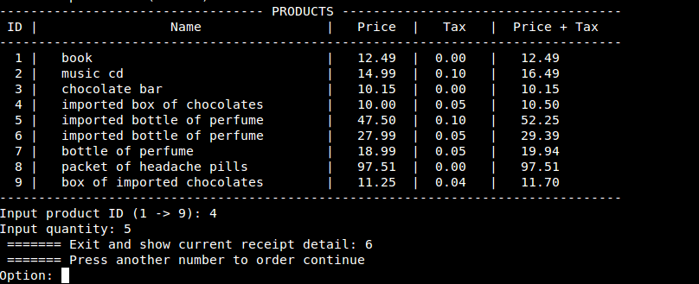
- Option: continue order or exit & show receipt detail. Ex: input 6

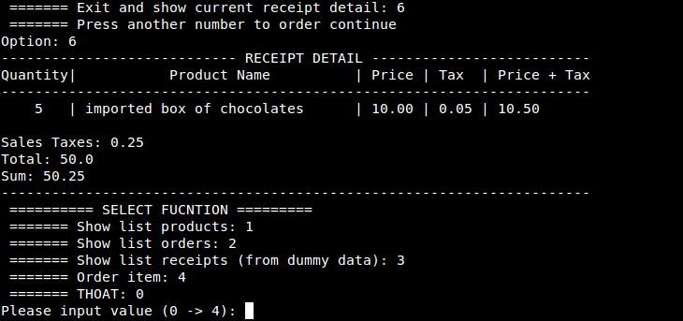
- Choose option:
1: list products, all products from dummy data
2: list orders, all orders from dummy data and new orders
3: list receipts, all receipts from dummy data and new receipts
4: continue to create order

