Object Retrieving from Image Database
Bao Nguyen Thien, Yoshiaki Shirai
Computer Vision Lab, Department of Human and Computer Intelligent, Graduate School of Science and Engineering, Ritsumeikan University, Japan.

Abstract: The objective of this study is to develop a system that can retrieval some objects from large image database. We propose a novel method for generic object detecting in still image. The main advantages of this method are that it is simple, computationally efficient and bases on features that is easily seen by naked-eye and very close with natural detecting by human. We present experimental results for detecting five visual categories including side view car, front view car, bike, train and aero plane. These results clearly demonstrate that the proposed method is robust and produces good detection accuracy rate.

1. Introduction
Content-based image retrieval (CBIR) system often works on semantic of image. But the semantic is not easy to get. So, instead of basing on semantic we can base on which object that image contains. The more object a system can detect, the more precise that system is in retrieving. Automatic object recognition is really needed in CBIR. The goal of this research is to develop a necessary methodology for automated recognition of generic object in still images. Although different solution for object detection have been developed over the past few years, but it is now still a difficult problem for computer vision. These approaches based on features of an image including both local and global ones. But almost these approaches based on features which with human eyes it is difficult to see. Only computer can detect and recognize these features. So, in our method, we base on features that are easily seen by naked-eye and very close with natural detecting by human. When artist draws an object, he outlines some basic lines in some directions. These lines meet each other at some specific points. This arrangement makes human easily recognize what the object is. From this viewpoint, we propose a simple approach for detecting object in a still image base on edge, corner and orientation of edge. We believe that our method works efficiently because it resembles with the way that human being detect objects, and our performance for some-object-detecting shows that it is true.

2. Object Detection Based on Combination Multi Local Feature
1.1 Edge, Corner and HoG Feature
It is easy to see that the most important features for recognition object are the overall shape of that object and all boundaries which separate main parts of object. Shape or boundary is basically composed by edges which are located at some important positions. These edges are arranged in a specific order and meet each other at some points called corners.

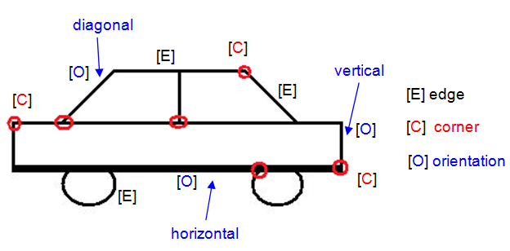
Fig. 1. Three main components make object be figured.
Beside, edge orientation also plays a prominent role for figuring object. With the same number of edges, a talent artist can organize in different order and different orientation to make viewer imagine different objects. Fig. 1 describes how these principal components make object imagination. Based on this, we propose an approach for object detecting which focuses on edge, corner and edge orientation. More detail is presented in the next diagram:
Input image
Corner
detecting
Integrate
Object
localization
Corner position
Ellipse position/ Vocabulary
Edge
detecting
Ellipse/SURF
detecting
Edge position

Fig. 2. A model for object detecting based on edge, corner and other strong features.
In order to know whether edge/corner is at right position or not, we should point out the place where edge/corner must belong to before detecting object. The position of edge/corner is called edge map/corner map. To make edge map and corner map, we use same method as Zhenfeng Zhu et al in [1]. For all images in the training-image set, after detecting edge/corner we accumulate them in one temp image T_{e} or T_{c}. Then edge map and corner map will be made from these temp images respectively. To extract edges for making edge image, we use canny edge detector with 3x3 structure. And to consider the position of corners, Harris detector is used with 5x5 structure.
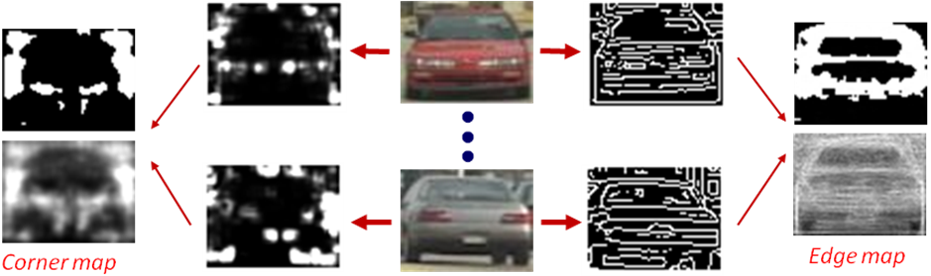
Fig. 3. Making edge map and corner map from training set.
The edge map and corner map are constructed from T_{e} and T_{c} as
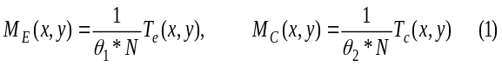
where N is the number of images in the training set, and θ₁, θ₂ are specific thresholds. M_{E}(x,y) and M_{C}(x,y) denotes for edge map and corner map respectively.
1.2 SURF Feature
In order increase the accuracy rate, after a candidate satisfies edge map, corner map and orientation of edge, that candidate continue to be passed to SURF[2] checking stage. We choose SURF because it is invariant with scale, illumination, and similar but faster than SIFT.
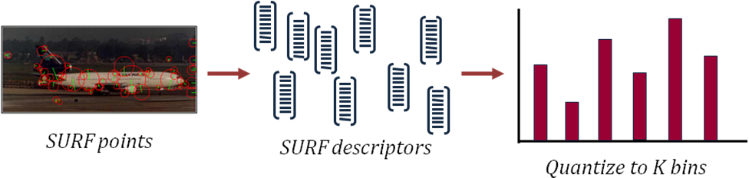
Fig. 4. Making vocabulary for matching SURF feature.
We choose the method for matching between two set of SURF descriptors as Gabriella et al in [11]. Bag of keypoints or vocabulary are made by quantizing all descriptors from training image set to K bins. Once descriptors have been assigned to form feature vectors, we use Naïve Bayes classifier to determine whether an input image belongs to one category or not.
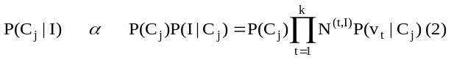To categorize a new image, we apply Bayes’ rule and take the largest posterior score as the prediction:

where I is new image, C_{j} is category class (object/non-object), v_{t} represents for keypoint (i.e. cluster center), and N^{(t,I)} is the number of times keypoint v_{t} occurs in image I. The class is chosen with argmax{P(C _{j} | I)}

3. Experimental Results

Our proposed scheme is evaluated on five object-categories, including front/rear view car, side view car, bicycle, train and airplane. We use CALTECH image databased for testing with front/rear view car, bicyle, and airplane. While side view car database is downloaded from UIUC’s webpage. With train object, we have to select manualy from internet. Beside, in order to evaluate the result more exactly, we also get object image from the officcial website of PASCAL 2009. Morover, an additional about 1500 negative examples are collected randomly from many websites and added to the database. Thus with each object-category, the whole database contains about more than 1500 negative images and 1500 positive images (including 1000 images for training, and 500 images for testing). With a testing image, we preprocess it by resizing it into four times of basic size. After detecting at this scale, we reduce it size and continue until it’s size is equal to training image.
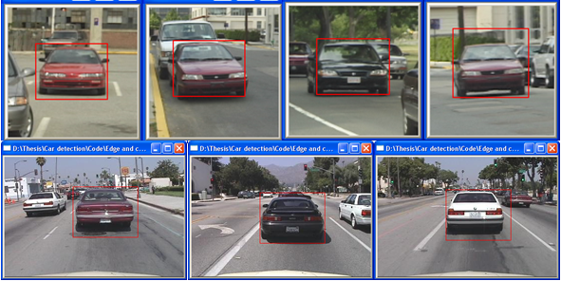
Fig. 5. Example of front/rear view car detection result
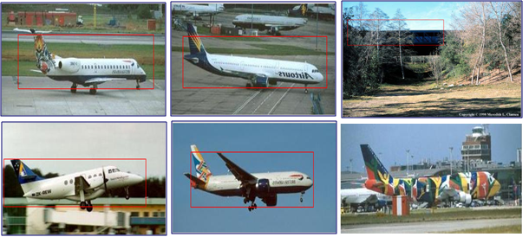
Fig. 6. Example of areoplane detection result
It is show that if the input image is so blur or is cut-edge some part of the object, then it cannot be detected and it leads to negative false. Otherwhile, if there are edges and corners arranged similar to the object then our shema knows that it is object wanted to detect. We also test seperately with only CEH (corner, edge, HoG), only SURF and combination. The final result average precision (AV), average recall (AR) is shown in table 1.
Object | ECH |  | SURF |  | ECH+SURF
Object | AP | AR | AP | AR | AP | AR
F/r car | 97.4% | 89.7%
Side car | 95.8% | 92.4%
Bike | 83.8% | 72.7% | 69.1% | 88.7% | 76.8% | 70.7%
Train | 76.3% | 75.8% | 71.9% | 72.1% | 84.1% | 74.1%
Plane | 79.8% | 80.9% | 80.4% | 88.2% | 85.6% | 87.6%
Table 1. Comparison between ECH, SURF and combination
- Evaluation and Future Work
It shows that if the object has unchanged-size, the result is better. Result of train is lowest with ECH, because train has no specific size. Then it can’t make Edge map and Corner map correctly. But when combining with SURF, it gets a better result. SURF works well with object having “large surface” (plane, train), with bike almost SURF features fall into background not belong to object, so SURF’s result is not good.
In this study, we combine Edge, Corner, HoG and SURF feature for detecting five object categories. We will continue to apply other feature to find which feature is most suitable for which object. And in a near future we want to build a system that can automatically choose features for recognizing new object correctly.
Reference
[1] Zhenfeng Zhu., J. Uchimura, “Car detection based on multi-cues integration,” ICPR04, Cambridge, UK, Aug. 2004.
[2] H. Bay, T. Tuytelaars, and L. V. Gool, “Surf: Speeded up robust features,” ECCV06, Graz, Austria, May 2006.
[3] H. Harzallah, F. Jurie, C. Schmid, “Combining efficient object localization and image classification,” ICCV09, Kyoto, Japan, Sep. 2009.

