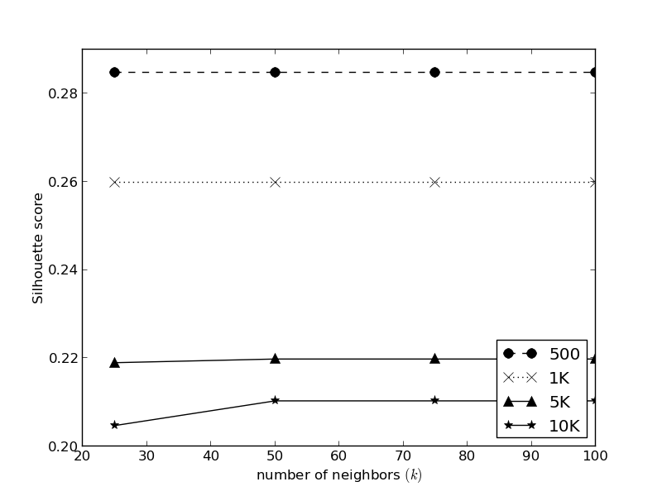
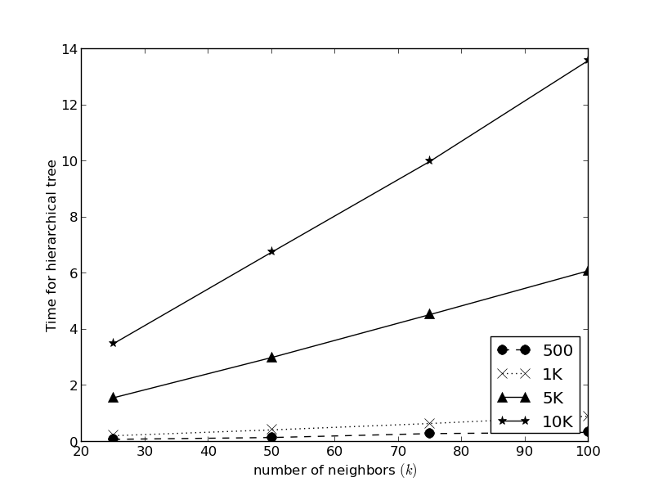

Silhouete Score (top line) and Time (bottom line) of Ward algorithm
with different value of k in connectivity matrix
on real dataset of subject 101 in ALS dataset.
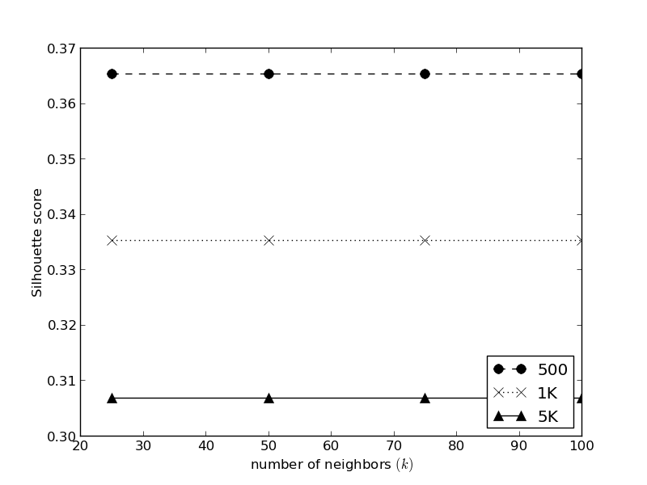
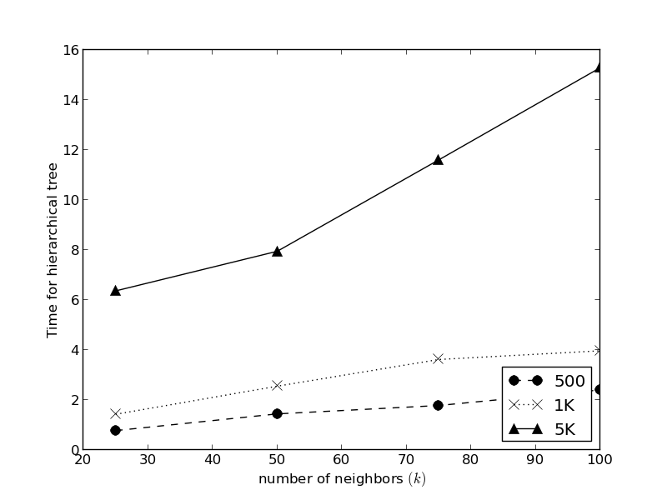

Silhouete Score (left) and Time (right) of Ward algorithm
with different value of k in connectivity matrix on simulated data.

Source Location: /home/bao/tiensy/Integrate/Results/101

