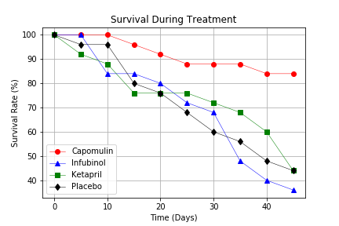

Survival chart indicate the number of survival mice for 40 days.

Number of the mice which were treated by Capomulin dropped and levelled off when other receivers’ amounts keeps dropping.

We can conclude that the Capomulin have better effect to save the patients’ life.

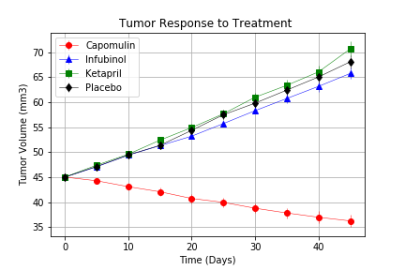

Tumor size trend chart shows the treatments effect for controlling the sizes of tumor.

The Capomulin make the tumors’ size decreasing when other 3 treatments can’t effectively control the tumor’s size.

We can conclude that the Capomulin have better effect then other treatments for controlling tumor size.

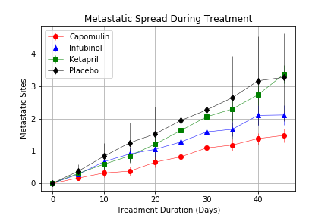

The Metastatic Spread chart show the Metastatic spreading trend in 40 days.

4 treatments all show increase trend.

And the Capomulin treatment has the smallest spreading number.

We can conclude that the Capomulin is effective for controlling the metastatic spreading speed.