**Openweather report**

In this report, we randomly choose 644 cities and use API to pull the weather data from “Openweather” website.

We skipped the cities values include missing data, and finally we have 581 rows of data to analysis.

The below plots show the relations between temperature, Humidity, cloudiness, wind speed to Latitude.

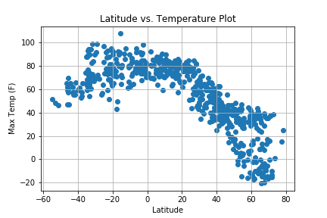

We conclude that the world cities’ temperature increased gradually and stay stable from latitude -16 degree to 0-degree increase, and from latitude 0 to 80 degrees the temperature in cities dropped through the latitude increase.

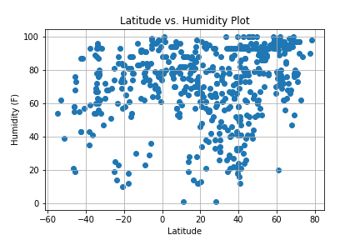

The humidity has no relation with the latitude.

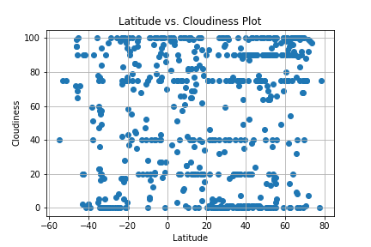

There is no evidence shows that the cloudiness is related to latitude in our work.

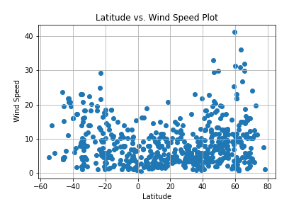

This plot shows that the wind speed is not effected by latitude, the speed keeps between 0 to 20 (mph).