Laser Pulse Control (LPC)
雷射脈衝控制
Brady Perkins, 2026年1月
Biodesign Lab, Asia University, Taichung City, Taiwan
台灣台中市亞洲大學生物設計實驗室

Table of Contents
1. Device description (2)
A. Overview (2)
B. Laser control/user interface (3)
C. Device usage (4)
2. Resources (6)
3. Bill of Materials (7)
1. Device description
A. Overview
The control device for low-level laser therapy application reuses the PCB design from the Asia University Biodesign Lab’s automatic pressure control device, making use of the 12 V DC output originally for the solenoid valve for the laser power supply. The device setup is given in Figure 1.
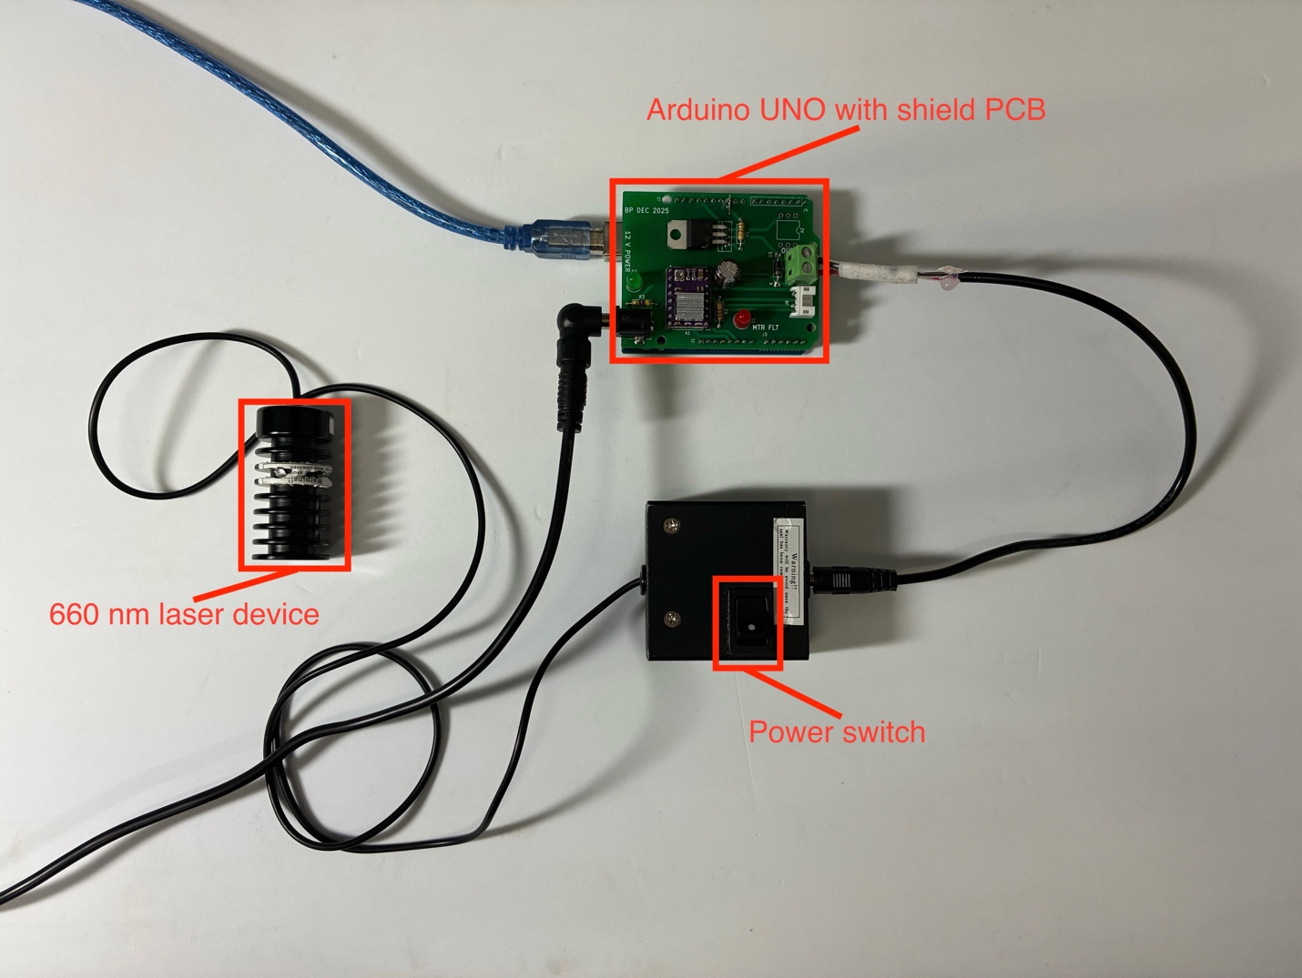
Figure 1: Low-level laser therapy control device.
The laser used is a 660 nm-wavelength device with a power input box that uses a DC voltage regulator to convert a range of higher-voltage input power between 8 and 30 V into the 3.3 V power used by the laser device, as well as containing a power switch used to turn the device on and off.
The microcontroller utilized in this device is an Arduino UNO instead of the Adafruit Metro ESP32-S3 board used for the automatic pressure control device, since removable storage, Internet capability, and additional speed are not necessary.
B. Laser control/user interface
Laser control is also done via a serial terminal, running at 9600 baud on the Arduino UNO instead of the 115200 baud utilized by the ESP32 microcontroller. The user can only enter commands into the serial terminal in one format:
nn,dd
where nn is the desired flashing rate of the laser (in Hz), and dd is the desired duty cycle of the laser refresh (in percent). The default setting is:
1,50
which corresponds to a refresh rate of 1 Hz and a 50 percent duty cycle.
Trials are conducted by deciding the amount of time that the laser should remain on for, and this time is tracked using an external stopwatch which is begun as the power switch on the laser box as shown in Figure 1 is turned on, and where the power switch is turned back off once the stopwatch reaches the set amount of time.

C. Device usage
To run the laser device, connect the Arduino from the laser device to the laptop with a USB cable and plug the power supply from the pressure device in to the barrel jack on the shield PCB on the laser device’s Arduino, as shown in Figure 2.
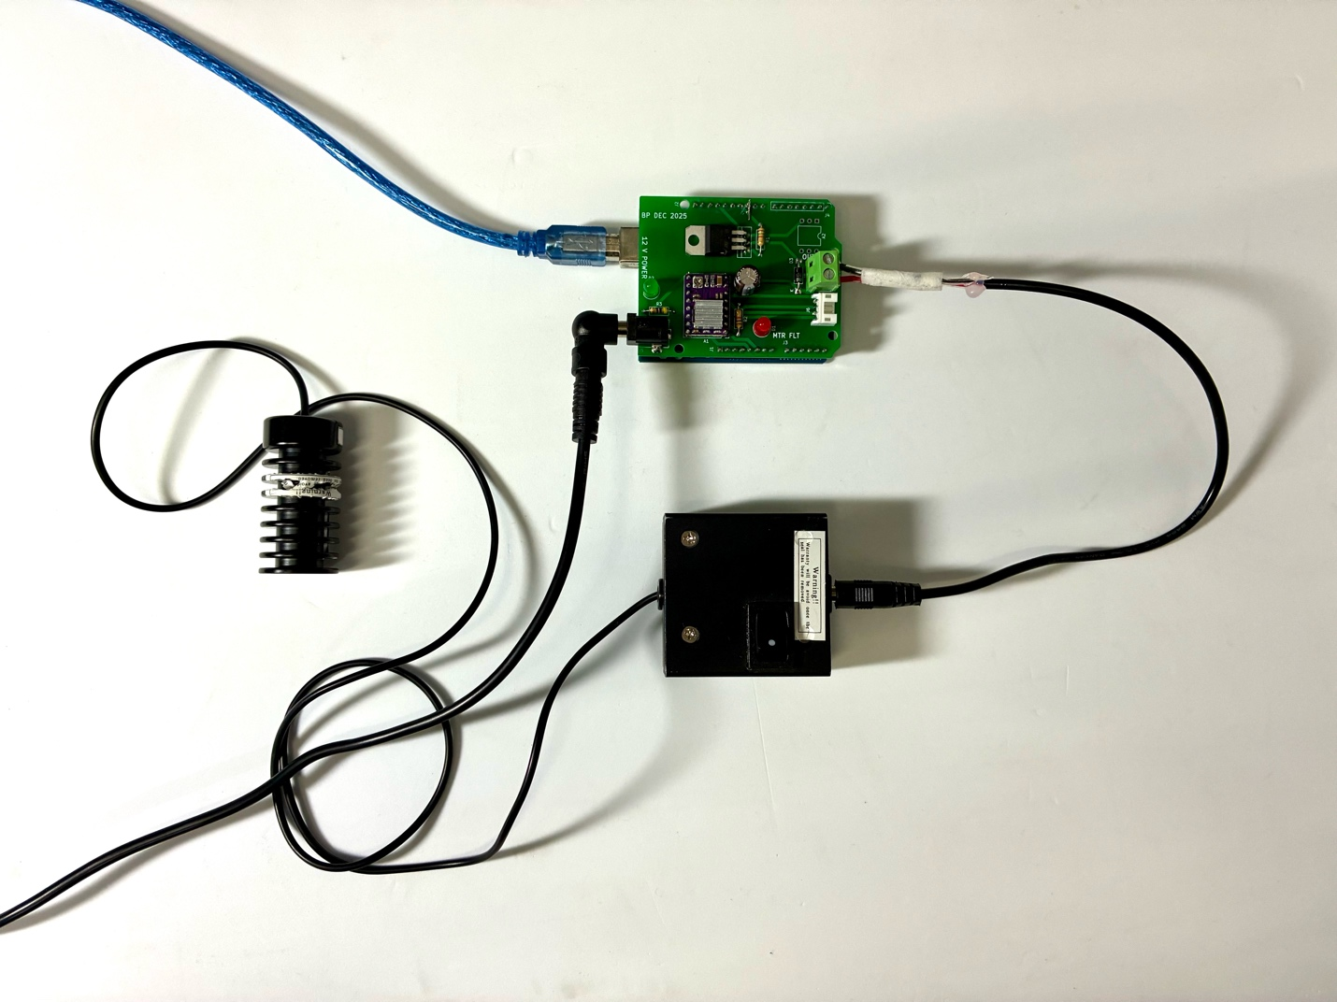
Figure 2: The laser device's Arduino and USB cable plugged into the laptop.
Go to the top-left corner of the Arduino IDE window and select the new device, “Arduino UNO”, shown in Figure 3. The serial speed in the serial monitor should change to 9600 baud. If not, change the speed manually to 9600 baud.
Note: there is no need to change the loaded software in Arduino IDE, using the software can be done entirely over serial with no need to update or re-upload code to either of the microcontrollers.
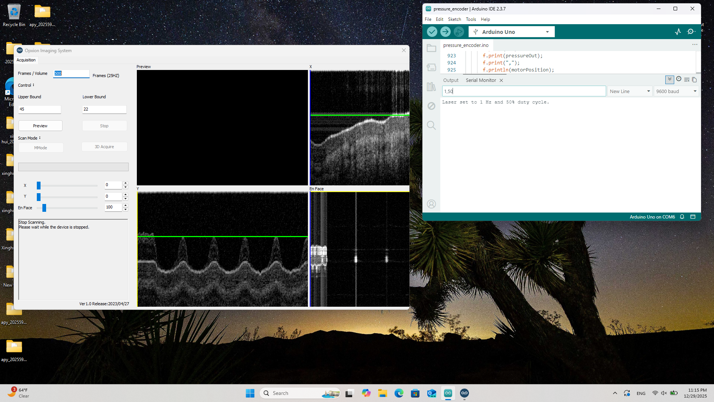
Figure 3: A connection to the laser device in the Arduino IDE window.
Enter a laser refresh rate and duty cycle (portion of a refresh that the laser is on), such as 1,50 for 1 Hz at 50% duty cycle (on and off for equal amounts of time), into the serial terminal to see a response from the laser device.
Enter any refresh rate followed by a 100% duty cycle, such as 1,100, to turn the laser on continuously. Any set of frequency and duty cycle can also be input for use in trials. Use the switch on the power box to turn the laser on and off (visible in Figure 2) and a stopwatch to track time during the trial.

2. Resources
Low-level laser therapy device program (GitHub):
https://github.com/bap10357/oct-pressure-device
Video instruction (YouTube):
https://youtu.be/tmNsAq3Uzz8

3. Bill of Materials
Parts necessary to build the laser pulse control device are given in Table 1.
Table 1: Device Bill of Materials.
Part name/Cost/Units | Manufacturer | Resources | Web
… | … | … | …

