**Website Konversi Suhu**

**Preparations and Submission Details**

- **The deadline** will be on Thursday in 2nd week at 23.59 (WIB)

- Link to submit the assignment [here](https://rebrand.ly/FCSWE-miniproject) **(will be opened on Wednesday week 2)**

**Introduction**

In this ten-day short course, you’ll learn all about becoming a software engineer, including the career path possibilities. We’ll also give you the opportunity to practice the main responsibilities of a software engineer as well!

Before you start...

1. Make sure you have downloaded **Visual Studio Code, Git** and have access to **Google Chrome**

**Mini Project Instructions**

As Software Engineer, you are asked to create a website of Kalkulator Suhu using the mockup design below:

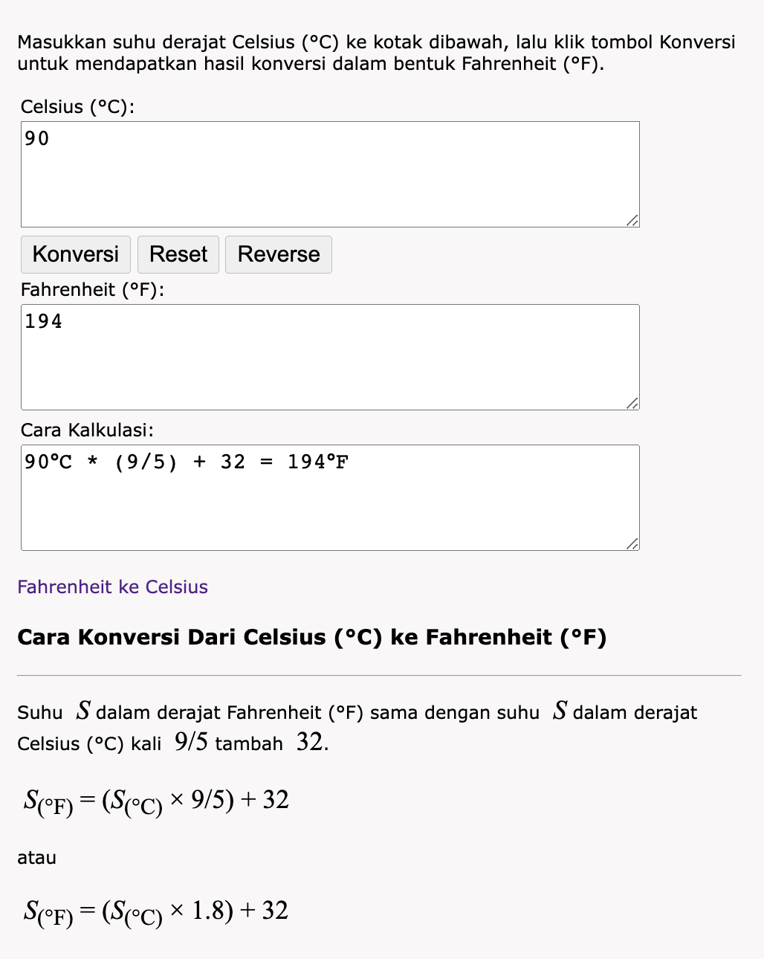

Workflow:

1. Design is only reference, you can improve for your own design but you must have the feature :

* Form Temperature Input
* Display Temperature Conversion (Celsius/Fahrenheit)
* Explanation the Conversion Result

1. Validate Input Form Temperature
2. Create Logic For Conversion Calculation with JavaScript (Celsius & Fahrenheit)
3. Kalkulator Temperature and Hasil on the same page in web
4. Conversion Result is display on website when submitted “Konversi”
5. Put css file inside of the css/ folder
6. Please only put only 1 css for the entirety of the project
7. Put javascript files inside the js/ folder
8. Please put only 1 javascript file for the entirety of the project
9. After finish your website, upload Source Code in [GitHub Classroom](https://rebrand.ly/fcse-github) and publish the website in [Github Pages](https://pages.github.com/)
10. Submit URL repository and published website through dedicated [Typeform submission](https://rebrand.ly/FCSWE-miniproject) that will be opened on Wednesday week 2

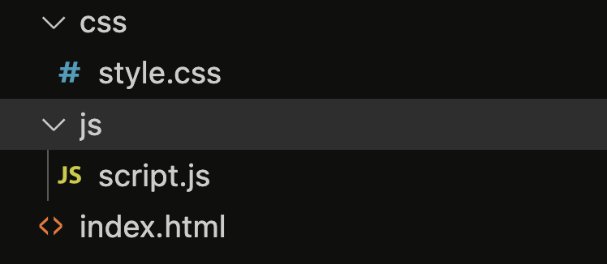**Expected file structure:**