This is a reproducible document

Dr. Brendan Palmer

23rd August 2019

# This is the beginning of the project

Our initial reports might be restricted to lab meetings etc. We can use R Markdown to show the code we are using, so that the meetings are not just a demonstration of the results, but also an examination of the code used to obtain them.

## Data overview

The plot below is call from the ggplot object entitled report_plot created in the script 03_final_analysis.R.

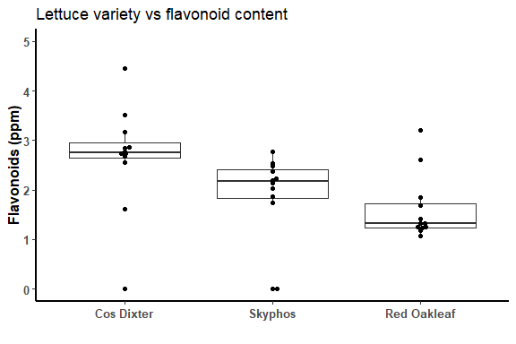

**Fig. 1.** Flavonoid content of three lettuce varieties under three experimental conditions.

Or we can also recreate the code within the R Markdown document as seen below.

source("scripts/01_data_clean.R")  
  
lettuce_variety <- c(cos = "Cos Dixter",  
 red = "Red Oakleaf",  
 sky = "Skyphos")  
  
data %>%  
 filter(week_no == "3") %>%  
 ggplot(aes(x = variety, y = flavonoids)) +  
   
 geom_boxplot(outlier.shape = NA) + # Hides the outlier points   
 geom_beeswarm() +  
   
 scale_x_discrete(breaks = c("cos", "red", "sky"),  
 labels = c("Cos Dixter", "Red Oakleaf", "Skyphos")) +  
   
 ylim(0,5) +  
   
 labs(x = "",  
 y = "Flavonoids (ppm)",  
 title = "Lettuce variety vs flavonoid content") +  
   
 theme(panel.background = element_blank(), #Remove grey background  
 axis.title = element_text(face = "bold", size = 12),  
 axis.text = element_text(face = "bold", size = 10),  
 axis.line = element_line(colour = "black", size = 1),  
 plot.title = element_text(hjust = 0.0))



## Statistical tests

This table summarises the statistical tests we conducted in the script 03_analysis.R.

**Table 1.** Pairwise comparisons from a two way Analysis of Variance of flavonoid content by lettuce type and filter.

|  |  |  |  |  |  |
| --- | --- | --- | --- | --- | --- |
| Variable | Comparison | Estimate | Lower CI | Upper CI | Adjusted p-value |
| variety | cos-red | 1.044 | 0.118 | 1.970 | 0.024 |
| variety | sky-red | 0.245 | -0.681 | 1.171 | 0.794 |
| variety | sky-cos | -0.799 | -1.725 | 0.127 | 0.101 |
| filter_name | my-ca | -0.110 | -1.036 | 0.816 | 0.954 |
| filter_name | ptp-ca | -0.122 | -1.048 | 0.804 | 0.943 |
| filter_name | ptp-my | -0.012 | -0.938 | 0.914 | 0.999 |

The data suggests that we do not have enough evidence to conclude that filter type alters the mean flavonoid content of the lettuce varieties tested.

The data does support the alternative hypothesis that the mean flavonoid content differs between the lettuce varieties used in this experiment.

The flavonoid content of Cos Dixter was observed to be higher overall than Red Oak leaf (1.044 ppm, 95% CI: 0.118 - 1.97).

## Conclusion

The information presented here can be traced all the way back to the raw CSV data file. If an error is detected, it can be corrected. If Reviewer #2 requests changes to any element of the work, it can be done in a straightforward manner.

### Reviewer # 2 comments

I don’t like B/W images. Give me some colour!

### Response

No problem

