This is a reproducible document

Dr. Brendan Palmer

4th December 2018

# This is the beginning of the project

## Data overview

The plot below is created directly from the code I wrote in the scripts

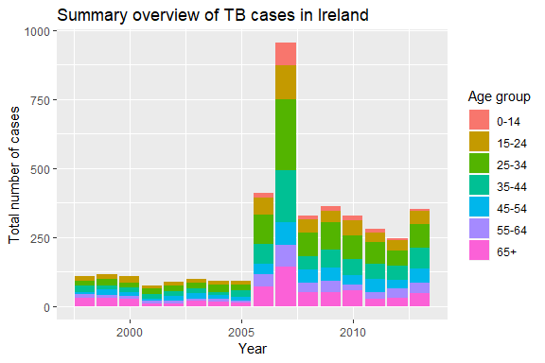

This table summarises the TB data for four countries with similar population sizes.

Table 1. Summary of TB cases in four countries

|  |  |  |
| --- | --- | --- |
| country | Mean | SD |
| Costa Rica | 25.11 | 19.67 |
| Ireland | 11.31 | 20.15 |
| New Zealand | 9.26 | 8.72 |
| Norway | 7.11 | 8.34 |