COMPUTER FUNDAMENTALS & OFFICE AUTOMATION
High-Yield Pictorial Study Notes & Formula Revision Guide (Units 1 to 5)
Dept of Physics • S.V.A. Govt. Degree College, Srikalahasti • Sem-III

UNIT 1: HARDWARE ARCHITECTURE, NUMBER SYSTEMS & EVOLUTION [Foundations]

1.1 Von Neumann CPU Architecture & System Buses
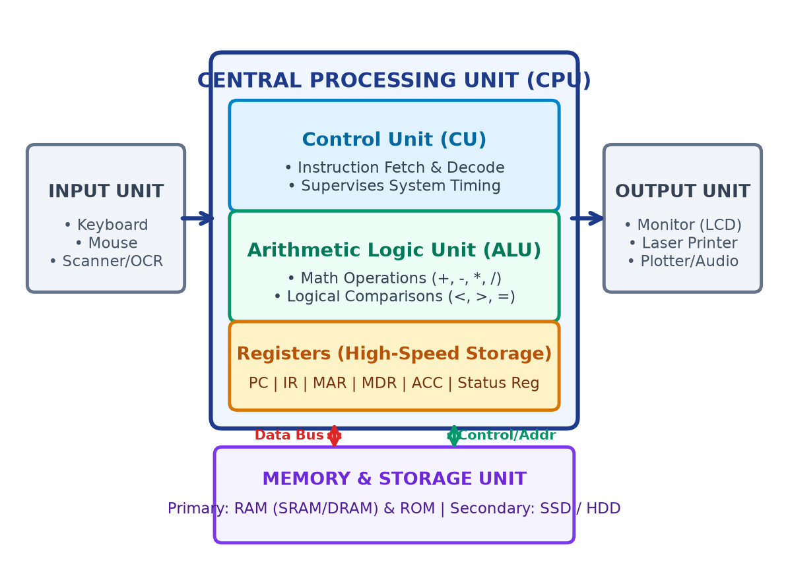
Figure: Von Neumann CPU Block Diagram & System Buses
Key Functional Units of Central Processing Unit (CPU)
• Input Unit: Accepts human-readable data & converts to binary pulses (Keyboard, Mouse, Optical Scanner).
• Control Unit (CU): The 'brain coordinator'; fetches instructions from RAM, decodes opcodes, generates micro-timing signals.
• Arithmetic Logic Unit (ALU): Executes arithmetic (+, -, *, /) and logical decisions (<, >, =).
• Internal Registers: Ultra-fast scratchpad memory: PC (Program Counter), MAR (Memory Address Reg), MDR (Data Reg), IR (Instruction Reg), ACC (Accumulator).
• System Buses: Data Bus (bidirectional, 32/64-bit width); Address Bus (unidirectional, determines addressable memory); Control Bus (read/write/interrupt strobes).

1.2 Positional Number Systems & Conversion Bridges
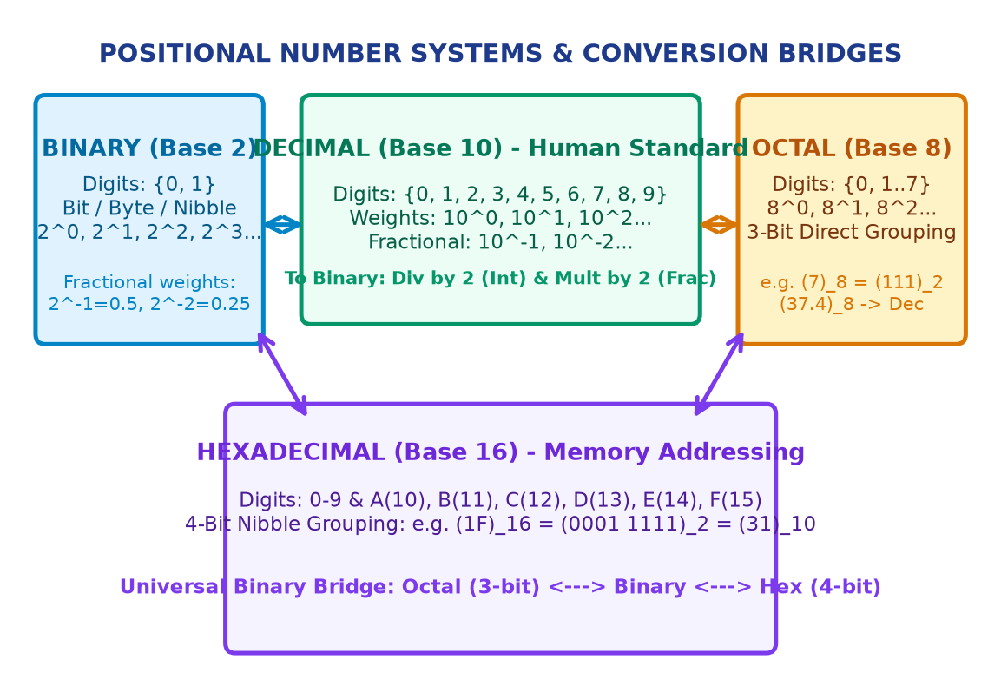
Figure: 4 Positional Radix Systems & Universal Binary Bridge
System | Base | Digits Used | Position Weight | Example
Binary | 2 | {0, 1} | 2^3, 2^2, 2^1, 2^0 . 2^-1 | (11001.101)2
Octal | 8 | {0, 1, 2, 3, 4, 5, 6, 7} | 8^2, 8^1, 8^0 . 8^-1 | (372.4)8
Decimal | 10 | {0 to 9} | 10^2, 10^1, 10^0 . 10^-1 | (24.34)10
Hexadecimal | 16 | {0-9, A=10..F=15} | 16^2, 16^1, 16^0 . 16^-1 | (2A.8)16

Step-by-Step Conversion Algorithms (Integer & Fractional)
Conversion Rules Summary
• Decimal -> Base R (Integer): Repeated division by R; collect remainders bottom-up (MSB to LSB). e.g. (24)10 / 2 => (11000)2.
• Decimal -> Base R (Fraction): Repeated multiplication by R; record integer carries top-down. e.g. 0.34 * 2 = 0.68 (0), 0.68 * 2 = 1.36 (1) => (0.0101011...)2.
• Base R -> Decimal: Polynomial expansion: Sum of (di * R^i). For (11001.1011)2: 16+8+0+0+1 + 0.5+0+0.125+0.0625 = (25.6875)10.
• Octal <-> Binary Bridge: Direct 3-bit grouping: (7)8 = (111)2; (653)8 = (110 101 011)2.
• Hex <-> Binary Bridge: Direct 4-bit nibble grouping: (A)16 = (1010)2; (1F)16 = (0001 1111)2.

1.3 Binary Arithmetic & 1's / 2's Complement Subtraction
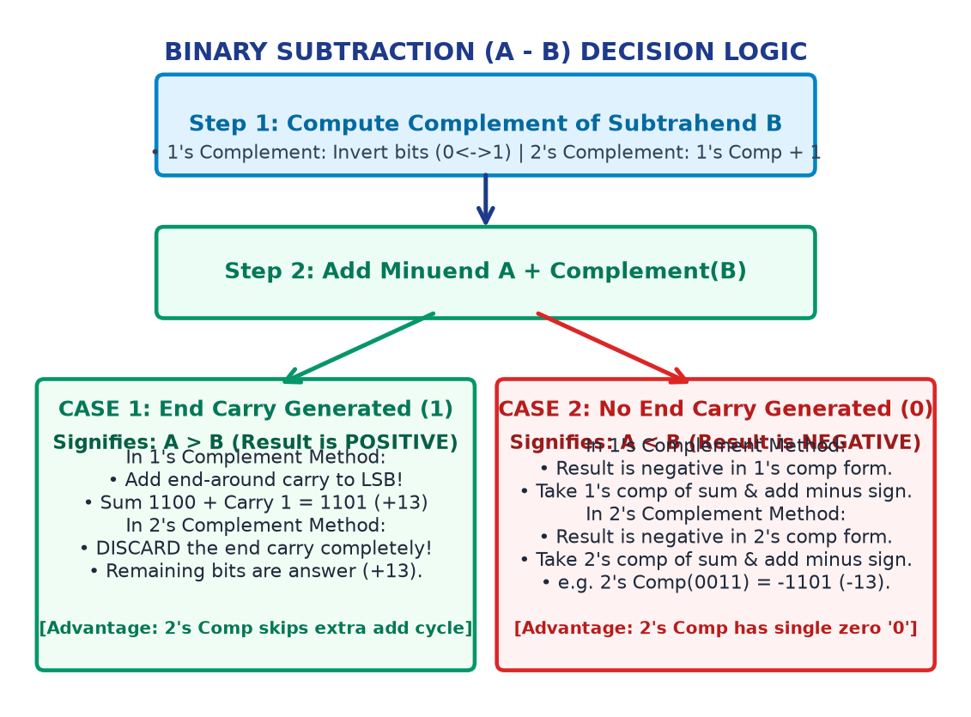
Figure: Binary Subtraction Decision Flowchart (1's vs 2's Complement)
Criterion | 1's Complement Method | 2's Complement Method (Industry Std)
Definition | Invert all bits (0<->1) | 1's Complement + 1 to LSB
If End Carry = 1 | Add carry back to LSB (End-Around) | DISCARD the end carry completely!
If End Carry = 0 | Negative; take 1's comp & prefix - | Negative; take 2's comp & prefix -
Zero Ambiguity | Two zeros: +0 (0000) & -0 (1111) | Single unique zero: 0000 (No ambiguity!)
Hardware Speed | Slower (needs extra addition step) | Faster (single addition step; used in ALUs)

1.4 Computer Evolution & 5 Generations
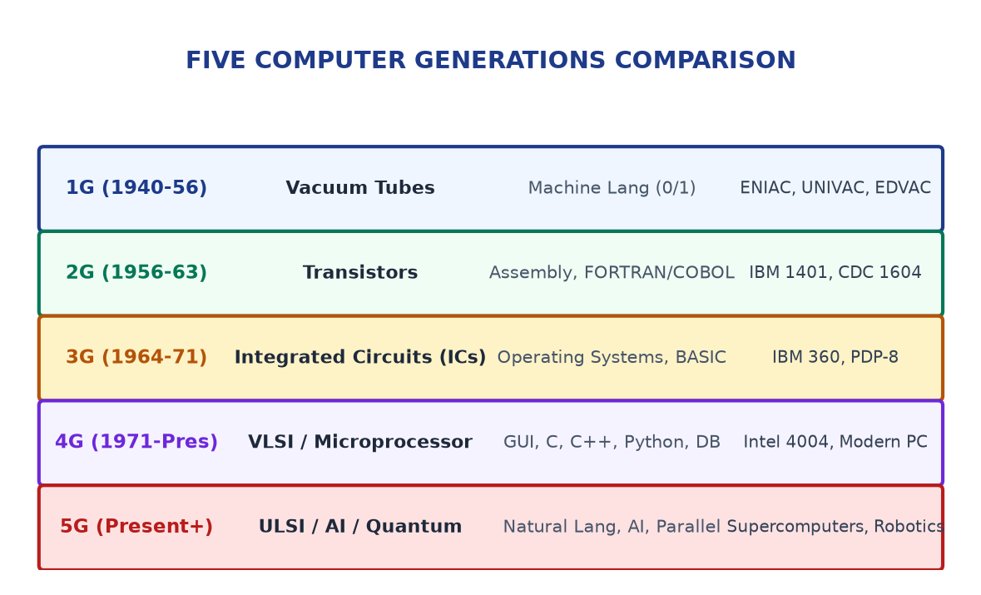
Figure: Timeline of Five Computer Generations
Historical Computing Milestones
• Abacus (3000 BC): First manual calculating frame utilizing beads on wires.
• Napier's Bones (1617): Rods for multiplication using logarithms.
• Pascaline (1642): Blaise Pascal's gear-driven mechanical adding machine.
• Babbage Engines (1833): Difference & Analytical Engine (Stored program architecture, Father of Computing; Ada Lovelace: First Programmer).
• ENIAC & EDVAC (1945-49): First general-purpose electronic digital computer (ENIAC); EDVAC implemented Von Neumann stored program concept.

UNIT 2: COMPUTER ORGANISATION, MEMORY HIERARCHY & NETWORKING [Architecture]

2.1 The 5-Tier Memory Hierarchy Pyramid
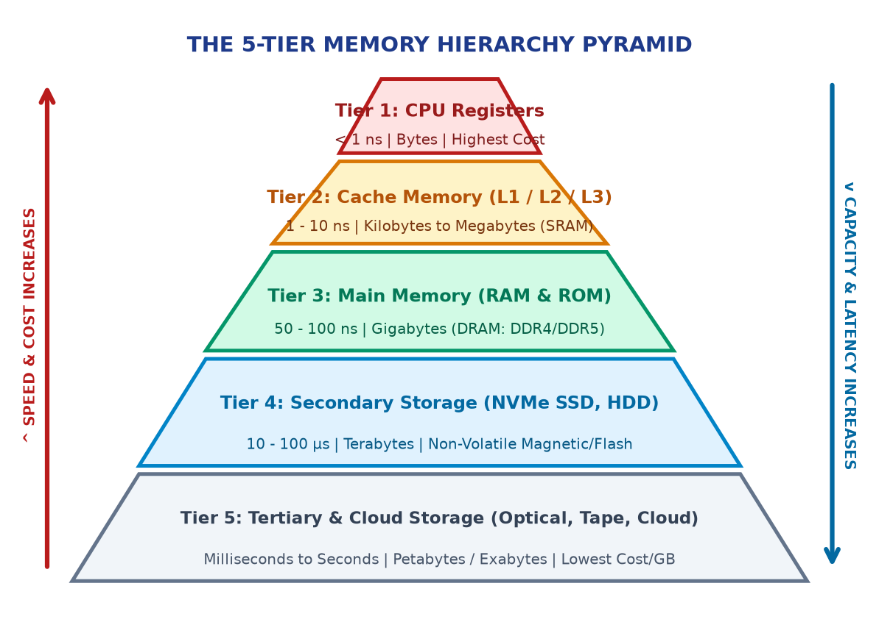
Figure: The 5-Tier Memory Hierarchy Pyramid (Speed vs Capacity)
Memory Type | Technology | Typical Latency | Capacity | Volatility
CPU Registers | Flip-Flops on CPU Die | < 1 ns | Bytes (64-bit) | Volatile
L1/L2/L3 Cache | Static RAM (SRAM) | 1 - 10 ns | KB to MB | Volatile
Main Memory | Dynamic RAM (DDR4/5) | 50 - 100 ns | 8 - 64 GB | Volatile
Secondary SSD | NAND Flash NVMe | 10 - 50 μs | 512 GB - 4 TB | Non-Volatile
Hard Disk (HDD) | Magnetic Platters | 5 - 15 ms | 1 - 16 TB | Non-Volatile
Optical / Cloud | Tape / Cloud Servers | 100 ms - Sec | Petabytes | Non-Volatile

2.2 Input / Output Devices & Computer Types
Essential I/O Hardware Guide
• Optical Mark Reader (OMR): Scans light reflection on standardized bubble exam answer sheets.
• Optical Character Rec (OCR): Converts printed text documents into editable digital characters.
• Magnetic Ink Character (MICR): Reads iron oxide magnetic bank cheque routing codes.
• Display Monitors: CRT (Cathode Ray Tube) -> LCD (Liquid Crystal Display) -> LED -> OLED (Organic LED, infinite contrast, no backlight).
• Impact vs Non-Impact Printers: Impact: Dot-matrix (pins strike inked ribbon; multipart forms). Non-impact: Laser (toner drum, high-speed, 1200 DPI) & Inkjet (liquid ink droplets).
• Computer Classification: Microcomputer (PC/Laptop) -> Minicomputer (Midrange departmental server) -> Mainframe (Enterprise banking/airlines, high I/O) -> Supercomputer (PARAM series, Frontier; tera/petaflops).

2.3 Transmission Media & Network Scales
Media / Scale | Type / Subcategory | Bandwidth / Range | Key Characteristic
Twisted Pair | Guided (UTP/STP Cat6) | Up to 10 Gbps (100m) | Cost-effective, RJ45 connectors
Coaxial Cable | Guided (BNC connector) | 10 - 100 Mbps (500m) | Central copper core, cable TV
Fiber Optic | Guided (Light Total Refl) | 100+ Gbps (100km+) | Immune to EMI, glass core, high speed
Radio / Micro | Unguided (Wireless) | WiFi / Microwave | Omnidirectional (Radio), Line-of-sight (Micro)
PAN / LAN | Network Scale | 10m / 1km | Bluetooth (PAN), College Lab / Building (LAN)
MAN / WAN | Network Scale | 50km / Global | City Cable TV (MAN), The Internet (WAN)

2.4 Network Topologies Architecture
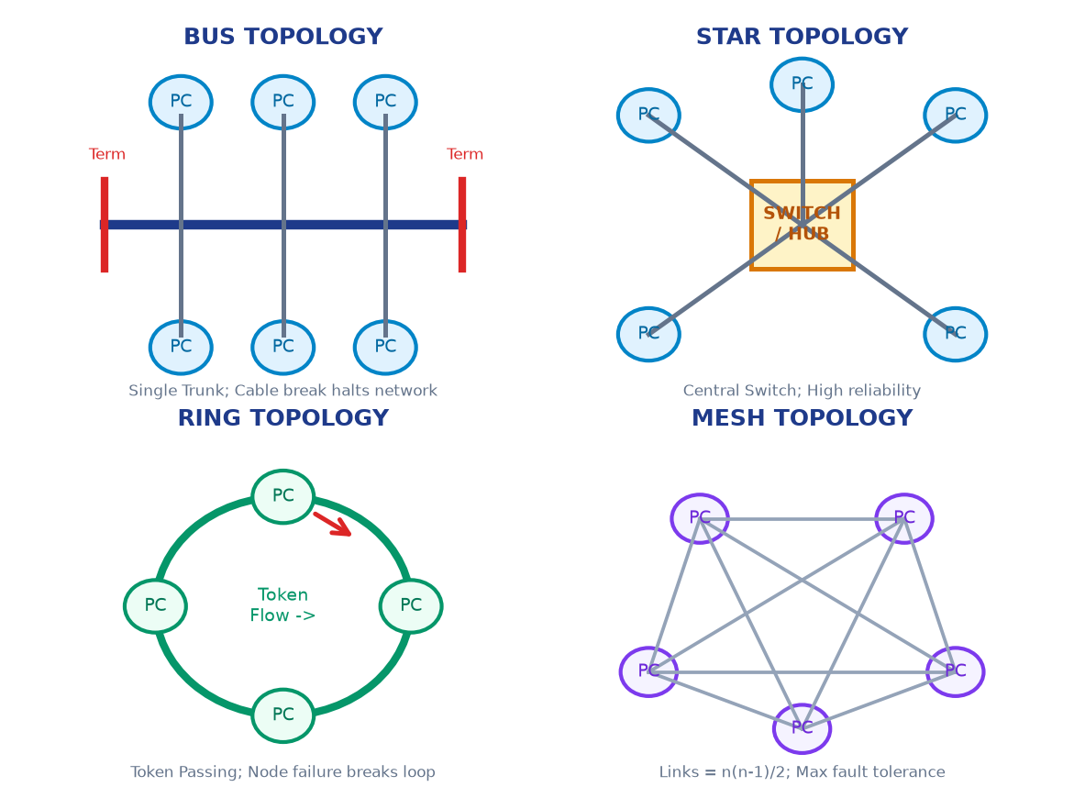
Figure: 4 Classic Network Topologies (Bus, Star, Ring, Mesh)
Topology | Physical Layout | Advantages | Disadvantages / Failure Mode
Bus | Single linear trunk + terminators | Low cable cost, easy install | Trunk cable break halts whole network
Star | Central Switch / Hub with drops | High fault tolerance, easy debug | Central Switch failure downs entire network
Ring | Closed circular loop (Token) | Equal access, no collisions | One node failure breaks the token ring
Mesh | n(n-1)/2 links (Fully connected) | Max redundancy & security | Extreme cabling cost & complexity

2.5 Internet, Web & Communication Protocols
Internet Protocol Suite Essentials
• IPv4 vs IPv6: IPv4 is 32-bit (4 octets: 192.168.1.1, ~4.3 billion addresses); IPv6 is 128-bit (8 hex groups: 2001:db8::1, trillions of addresses).
• DNS (Domain Name System): The 'Internet Phonebook'; translates human URLs (www.svagdc.edu.in) into machine IP addresses.
• HTTP vs HTTPS: HTTP (Port 80, plaintext unencrypted); HTTPS (Port 443, SSL/TLS cryptographic encryption).
• Email Protocol Flow: Sender MUA -> SMTP (Port 25/587, sending) -> Mail Server -> POP3 (Port 110, downloads & deletes) OR IMAP (Port 143, multi-device cloud sync).

UNIT 3: WORD PROCESSING, FORMATTING & DIGITAL PRESENTATIONS [Office Suite]

3.1 Word Workspace, Page Setup & Typographic Layout
MS Word Page Setup & Layout Blueprint
• Workspace Anatomy: Title Bar, Quick Access Toolbar, Ribbon Tabs (Home, Insert, Layout, References, Review, View), Status Bar, Word Counter.
• Page Setup: Margins: Normal (2.54cm) vs Narrow (0.25cm); Orientation: Portrait vs Landscape; Paper Size: A4 (21 x 29.7cm); Columns: 1, 2, or 3 with custom spacing & line separator.
• Paragraph Alignment: Left (Ctrl+L), Center (Ctrl+E), Right (Ctrl+R), Justified (Ctrl+J). Line Spacing: Single (1.0), 1.15, 1.5, Double (2.0).
• Dynamic TOC (Table of Contents): Assign Heading 1, Heading 2, Heading 3 styles -> References Tab -> Table of Contents -> Auto-generates clickable TOC with page numbers!
• Text Wrapping around Images: In Line with Text, Square, Tight, Through, Behind Text, In Front of Text.

3.2 Mail Merge Three-Tier Architecture
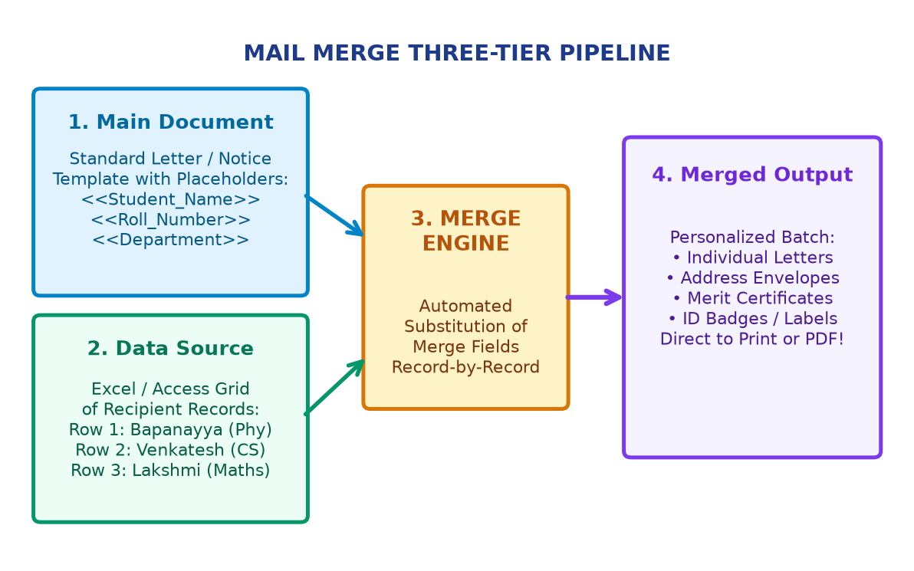
Figure: Mail Merge Pipeline: Main Doc + Data Source -> Merged Letters
Mail Merge Stage | Tool / Action | Operational Function & Exam Highlight
1. Main Document | Letter / Notice Template | Contains universal static text and «Merge_Fields» placeholders.
2. Data Source | Excel Sheet / Access DB | Contains structured tabular records: Name, Roll No, Address, Marks.
3. Field Insertion | Insert Merge Field | Binds data columns: e.g. «Student_Name», «Hall_Ticket_No».
4. Preview & Filter | Preview Results (< >) | Cycle through records to verify personalized field replacement.
5. Finish & Merge | Complete Merge Batch | Outputs to printer, separate individual files, or bulk emails.

3.3 Presentation Principles & Slide Master
PowerPoint High-Impact Design Rules
• The 6x6 Rule: Maximum 6 bullet points per slide, and maximum 6 words per bullet point! Avoid wall-of-text fatigue.
• The 60-30-10 Color Rule: 60% neutral background, 30% structural text/cards, 10% vivid accent color for key focal points.
• Slide Master (View -> Slide Master): The master hierarchy controller! Modifying the root slide automatically propagates college logos, typography, headers, and color themes across all slides.
• Transitions vs Animations: Transitions apply to slide-to-slide movement (Fade, Push, Wipe). Animations apply to individual slide elements (Entrance: Green, Emphasis: Yellow, Exit: Red, Motion Paths).
• Presenter View (Alt + F5): Displays current slide, upcoming slide, speaker notes, and timer on presenter's monitor while projector shows fullscreen slide.

3.4 Essential Office Keyboard Shortcuts Cheat Sheet
Shortcut | Word Processing Function | PowerPoint / General Function
Ctrl + N / O | New document / Open file | New presentation / Open deck
Ctrl + S / P | Save document / Print dialog | Save slide deck / Print handouts
Ctrl + Z / Y | Undo last edit / Redo action | Undo shape move / Redo edit
Ctrl + B / I / U | Bold / Italic / Underline text | Format slide text typography
Ctrl + E / L / R / J | Center / Left / Right / Justify align | Align text boxes and shapes
Ctrl + K | Insert Hyperlink | Insert hyperlink to web/slide
F5 / Shift + F5 | Find & Replace (Go To) | Slide show from start / from current slide
F7 | Spelling & Grammar Check | Spelling check across deck

UNIT 4: SPREADSHEET ENGINEERING & FORMULA ARCHITECTURE [Analytics]

4.1 Grid Anatomy & Cell Referencing Mechanics ($ Locks)
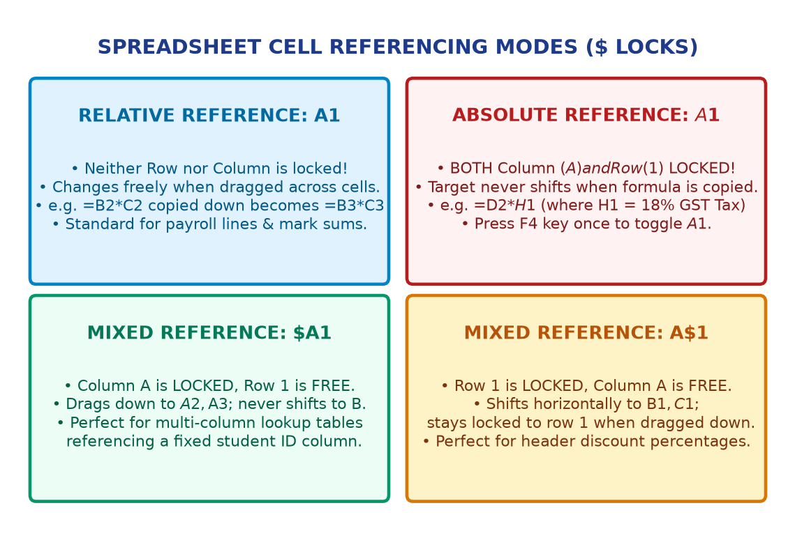
Figure: 4 Cell Referencing Modes: Relative, Absolute & Mixed ($ Locks)
Reference Mode | Syntax | Behavior When Copied / Dragged | Standard Practical Use-Case
Relative | A1 | Both Column and Row change freely | =B2*C2 (Item Total = Qty * Price)
Absolute | $A$1 | BOTH Column ($A) and Row ($1) LOCKED | =D2*$H$1 (Multiplying by fixed 18% GST)
Mixed (Col Lock) | $A1 | Column A locked; Row shifts freely | =$A2*B$1 (Multiplication / lookup tables)
Mixed (Row Lock) | A$1 | Row 1 locked; Column shifts freely | =B2/B$10 (Percentage of column total)

4.2 Core Mathematical, Statistical & Text Functions
Standard Formula Syntax Reference
• =SUM(range): Adds all numeric values: e.g. =SUM(B2:B20).
• =AVERAGE(range): Computes arithmetic mean: =AVERAGE(C2:C50).
• =COUNT(range): Counts cells containing numbers only (ignores text/blank).
• =COUNTA(range): Counts all non-empty cells (numbers, text, symbols).
• =COUNTBLANK(range): Counts completely empty cells.
• =MIN() / =MAX(): Returns minimum / maximum value in range.
• =LEFT(text, n) / =RIGHT(text, n): Extracts n characters from start / end.
• =MID(text, start, n): Extracts n characters starting at position start.
• =LEN(text) / =TRIM(text): Returns character length / strips extra irregular spaces.
• =TEXTJOIN(delim, ignore, range): Merges range with delimiter: =TEXTJOIN(", ", TRUE, A2:A10).

4.3 Logical Functions & Grading Automation
Decision Logic & Error Trapping
• Single IF Statement: =IF(logical_test, value_if_true, value_if_false)
e.g. =IF(E2>=35, "Pass", "Fail")
• Nested IF (University Grading): =IF(E2>=75, "Distinction", IF(E2>=60, "First Class", IF(E2>=50, "Second Class", IF(E2>=35, "Pass", "Fail"))))
• Compound AND / OR Conditions: All pass: =IF(AND(B2>=35, C2>=35, D2>=35), "PROMOTED", "DETAINED")
Grace mark: =IF(OR(B2<35, C2<35), "Needs Re-evaluation", "Clear")
• IFERROR Function: =IFERROR(VLOOKUP(A2, Table, 2, 0), "Record Not Found") - Prevents ugly #N/A crashes!

4.4 Lookup Functions Comparison (VLOOKUP vs XLOOKUP vs INDEX+MATCH)
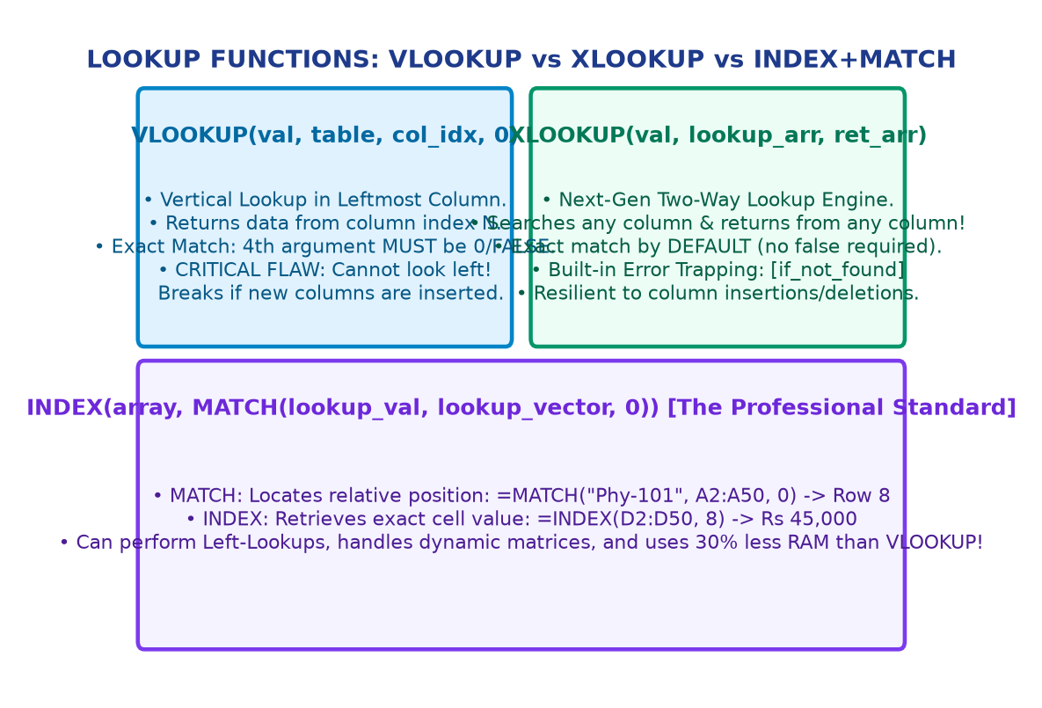
Figure: Lookup Engines Comparison: VLOOKUP vs XLOOKUP vs INDEX+MATCH
Lookup Engine | Standard Formula Syntax | Strengths | Weaknesses / Limitations
VLOOKUP | =VLOOKUP(val, table, col_idx, 0) | Simple, universally supported | Cannot look left; breaks on column insert
HLOOKUP | =HLOOKUP(val, table, row_idx, 0) | Searches top row horizontally | Restricted to horizontal tables
INDEX + MATCH | =INDEX(ret_col, MATCH(val, lk_col, 0)) | Looks left/right, robust, fast | Requires combining two functions
XLOOKUP | =XLOOKUP(val, lk_arr, ret_arr, [err]) | Exact match by default, 2-way | Requires Excel 2021 / Office 365 / Sheets

Spreadsheet Error Diagnostics Cheat Sheet
Common Error Codes Decoded
• #DIV/0!: Division by zero (formula attempts to divide by 0 or an empty cell).
• #N/A: Value Not Available (lookup value cannot be found by VLOOKUP/MATCH).
• #VALUE!: Data type mismatch (e.g. attempting arithmetic on text: ="Hello" + 5).
• #REF!: Invalid cell reference (referenced cell or column was deleted).
• #NAME?: Unrecognized function name or unquoted text string (e.g. =SUMM(A1:A5)).
• #####: Column is too narrow to display the formatted number (double-click header to auto-fit).

UNIT 5: DATA MODELLING, PIVOT TABLES, WHAT-IF & DASHBOARDS [Executive BI]

5.1 Advanced Conditional Formatting & Data Validation
Data Integrity & Visual Auditing Tools
• Conditional Formatting Visuals: • Highlight Cells Rules (Greater than, Less than, Text contains)
• Data Bars (In-cell gradient bars proportional to magnitude)
• Color Scales (2-color & 3-color heatmaps for mark distributions)
• Icon Sets (Traffic lights, flags, arrows for ranking)
• Formula Rules: =$E2="FAIL" formats the entire row automatically!
• Data Validation Controls: Enforces strict input rules (Data Tab -> Data Validation):
• Allow: List (Drop-down source: B.Sc Physics, B.Sc CS, B.Com)
• Allow: Decimal (Marks between 0.0 and 100.0)
• Allow: Date (Birth date between 01-01-2000 and 31-12-2008)
• Input Message: Active tooltip guidance when cell is clicked
• Error Alert Styles: Stop (strict block), Warning (override), Info.

5.2 Pivot Table Four-Quadrant Field Architecture
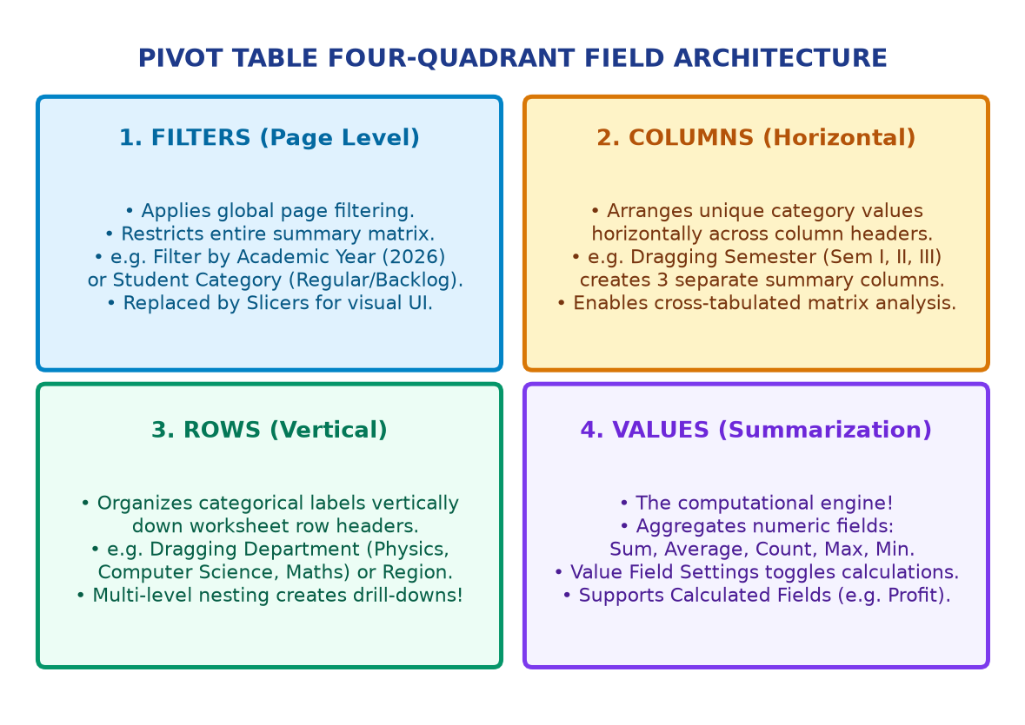
Figure: The 4 Pivot Table Quadrants: Filters, Columns, Rows, Values
Quadrant | Layout Orientation | Operational Role | Practical Student Example
Filters | Top Page Banner | Applies global filter to entire matrix | Filter by Academic Year (2026)
Columns | Horizontal Headers | Displays unique category values as columns | Drag Semester (Sem I, II, III)
Rows | Vertical Row Headers | Displays categorical labels down left side | Drag Department (Physics, Maths)
Values | Data Body Grid | Calculates aggregates (Sum, Avg, Count) | Drag Marks -> Summarize by Average

Advanced Pivot Table Techniques
• Interactive Slicers: Clickable visual filter buttons (Insert -> Slicer) that provide an instant visual UI.
• Report Connections: Right-click Slicer -> Report Connections -> Link to ALL Pivot Tables across workbook to synchronize filters with 1 click!
• Date & Bracket Grouping: Right-click date -> Group by Years/Quarters/Months. Right-click marks -> Group by brackets (0-34, 35-59, 60-74, 75-100).
• Calculated Fields: Create formulas inside Pivot: PivotTable Analyze -> Fields, Items & Sets -> Calculated Field (e.g. Profit = Revenue - Cost).

5.3 What-If Analysis Studio: Goal Seek vs Scenario Manager
What-If Decision Modelling Tools
• Goal Seek (Backwards Equation Solver): Solves backwards for a single target output.
• Set cell: Cell containing formula (e.g. Net Savings = B4 - B8)
• To value: Desired target amount (e.g. 20000)
• By changing cell: Input variable cell (e.g. Income B4)
Goal Seek automatically iterates until Income reaches exact required value!
• Scenario Manager (Multi-Case Projections): Saves and compares multiple financial cases (Best Case, Realistic Case, Worst Case) changing tuition fees, expenses, and enrollment.
Clicking 'Summary...' creates an automatic side-by-side comparative report.
• Data Tables (Sensitivity Analysis): 1-Variable and 2-Variable matrices calculating formula outputs across varied interest rates or rent fees in a single table.

5.4 Executive KPI Dashboard Blueprint & Sparklines
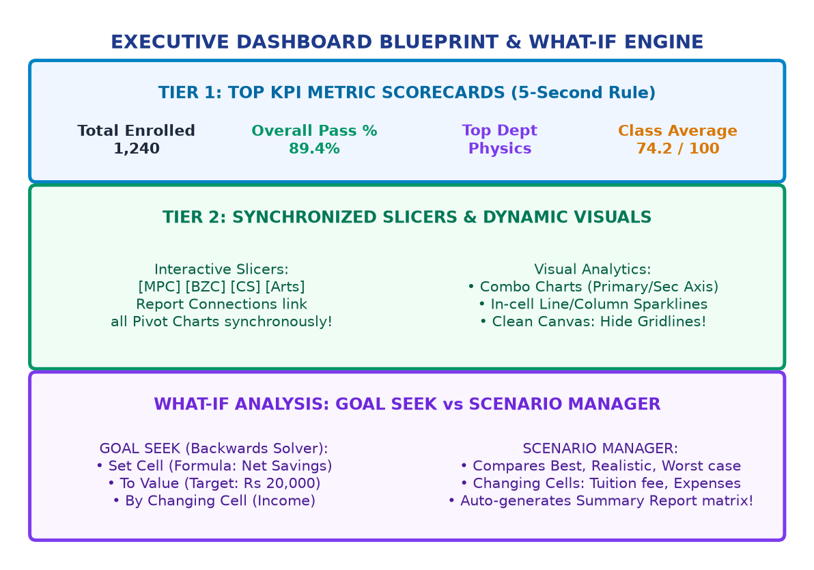
Figure: Executive KPI Dashboard Blueprint & What-If Engine
Rule # | Dashboard Design Principle | Spreadsheet Implementation Strategy
Rule 1 | Single Screen Rule | Fit entire dashboard on 1920x1080 canvas without scrolling.
Rule 2 | Clean Canvas Aesthetics | Uncheck View -> Gridlines & View -> Headings for clean software look.
Rule 3 | Top KPI Scorecard Tiles | Place 4 prominent tiles across top (Total Students, Pass %, Avg Mark).
Rule 4 | The 60-30-10 Color Rule | 60% neutral light gray, 30% structural navy, 10% accent color.
Rule 5 | In-Cell Sparklines | Insert -> Sparklines (Line, Column, Win/Loss) for inline 6-sem trends.
Rule 6 | Synchronized Slicers | Position Slicers at top banner linked via Report Connections.

Spreadsheet Productivity & Sheet Protection
Professional Productivity Workflows
• Named Ranges (Ctrl + F3): Replace cryptic cell references with names: =SUM(Gross_Salary) instead of =SUM(D2:D500). Easier to read and debug!
• Freeze Panes (View -> Freeze Panes): Locks header rows/columns while scrolling through thousands of student records.
• Split View (View -> Split): Divides worksheet into 2 or 4 scrollable quadrants for comparing distant rows.
• Protect Sheet (Review -> Protect Sheet): Lock formula cells with a password, leaving only designated data entry cells unlocked.

