## Attacks on the OSI Model:

Threats and Consequences

#### INTRODUCTION

The OSI (Open Systems Interconnection) model and its far-reaching consequences on network security. In an increasingly interconnected world, where networks serve as the backbone of modern communication, it is crucial to understand the vulnerabi lities and risks that exist within the layers of the OSI model.

The OSI model provides a structured framework for network communication, dividing the complex process into seven distinct layers. Each layer plays a crucial role in ensuring the reliable and secure transmission of data. However, attackers continually find innovative ways to exploit vulnerabilities at different layers, compromising network security and potentially causing severe damage.

In this presentation, we will delve into the common attack vectors, techniques, and vulnerabilities that exist at each layer of the OSI model. By exploring real-world examples, we will gain insights into the consequences of these attacks on network security and the potential implications for organizations.

From physical layer eavesdropping to application layer vulnerabilities, we will examine the techniques used by attackers to breach network defenses and the impact these attacks can have on confidentiality, integrity, and availability of critical data and services. We will also discuss mitigation strategies and best practices to defend against these threats, emphasizing the importance of a multi-layered security approach.

By the end of this presentation, you will have a comprehensive understanding of the different layers of the OSI model, the vulnerabilities that exist within each layer, and the steps you can take to safeguard your network infrastructure against potential attacks.

So, let's embark on this journey through the layers of the OSI model and explore the intricate world of attacks and their consequences on network security.

## OSI Model Overview

The OSI (Open Systems Interconnection) model is a conceptual framework that defines the functions of a network into seven distinct layers. These layers provide a structured approach to network communication, allowing devices and systems to exchange data seamlessly.

•Layer 1: Physical Layer

•Layer 2: Data Link Layer

•Layer 3: Network Layer

•Layer 4: Transport Layer

•Layer 5: Session Layer

•Layer 6: Presentation Layer

•Layer 7: Application Layer

#### OSI MODEL LAYERS AND ATTACK

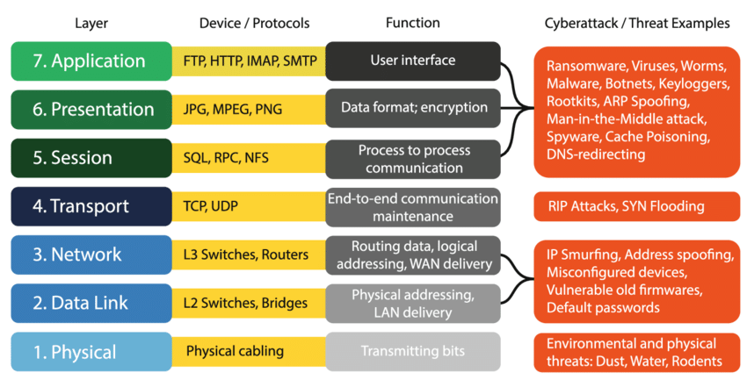

[Source: https://www.researchgate.net/figure/The](http://www.researchgate.net/figure/The-OSI-model-and-cyber-attack-examples-)-OSI-model-and-[cyber](http://www.researchgate.net/figure/The-OSI-model-and-cyber-attack-examples-)-[attack-examples-](http://www.researchgate.net/figure/The-OSI-model-and-cyber-attack-examples-) originally-published-in-Manninen-2018_fig2_346192126

## LAYER_1

Physical Layer: Physical Layer attacks target the actual physical components of the network infrastructure. They exploit vulnerabilities at the lowest layer of the OSI model, which includes the physical connections and media.

Common attack vectors, techniques, and vulnerabilities:

* Eavesdropping on physical connections
* Cable tampering or cutting
* Denial-of-Service (DoS) attacks on physical infrastructure

Examples of attacks and their consequences:

* Tapping into network cables to intercept sensitive information
* Physically damaging network cables, disrupting connectivity
* Overloading power sources to disrupt network operations

## LAYER_2

Data Link Layer: Data Link Layer attacks focus on the communication between network devices and the establishment of reliable connections. These attacks often target the protocols and addressing schemes used at this layer.

Common attack vectors, techniques, and vulnerabilities:

* MAC spoofing and address flooding
* ARP (Address Resolution Protocol) spoofing
* VLAN (Virtual Local Area Network) hopping attacks

Examples of attacks and their consequences:

* Impersonating a trusted device by spoofing its MAC address
* Flooding a switch with fake MAC addresses, causing network congestion
* Exploiting VLAN configurations to gain unauthorized access to restricted networks

## LAYER_3

Network Layer: Network Layer attacks aim to compromise the routing and forwarding of data packets across networks. Attackers exploit vulnerabilities in network protocols and routing mechanisms.

Common attack vectors, techniques, and vulnerabilities:

* IP (Internet Protocol) spoofing
* ICMP (Internet Control Message Protocol) attacks (e.g., Ping flood, Smurf attack)
* Routing attacks (e.g., Routing table poisoning)

Examples of attacks and their consequences:

* Forging the source IP address of packets to bypass network filters
* Flooding a network with ICMP echo requests, causing network congestion
* Manipulating routing tables to redirect network traffic to unauthorized destinations

## LAYER_4

Transport Layer: Transport Layer attacks target the mechanisms responsible for reliable data transfer and end-to-end communication. These attacks exploit vulnerabilities in transport layer protocols and their associated services.

Common attack vectors, techniques, and vulnerabilities:

•SYN flooding (TCP SYN flood)

•UDP flooding

•Transport layer protocol vulnerabilities (e.g., TCP sequence prediction)

Examples of attacks and their consequences:

•Overwhelming a server with a high volume of TCP connection requests

•Flooding a network with a large number of UDP packets, causing network congestion

•Exploiting vulnerabilities in TCP protocols to bypass security measures

## LAYER_5

Session Layer: Session Layer attacks aim to disrupt or manipulate the establishment and maintenance of sessions between network entities. These attacks often target the session establishment, authentication, and encryption mechanisms.

Common attack vectors, techniques, and vulnerabilities:

* Session hijacking
* Man-in-the-Middle (MitM) attacks
* Session brute-forcing

Examples of attacks and their consequences:

* Taking control of an ongoing session to eavesdrop or tamper with the communication
* Intercepting and altering data exchanged between two parties in a session
* Repeatedly attempting different session identifiers to gain unauthorized access

## LAYER_6

* + Presentation Layer: Presentation Layer attacks exploit vulnerabilities in how data is formatted, transformed, and presented for transmission. These attacks often target data encoding, compression, and encryption schemes.

Common attack vectors, techniques, and vulnerabilities:

* + Malicious code injection
  + Exploiting format string vulnerabilities
  + Code or data injection attacks

Examples of attacks and their consequences:

* + Injecting malicious code into transmitted data to compromise recipient systems
  + Exploiting vulnerabilities in format string handling to execute arbitrary code
  + Injecting malicious code or data into application-level protocols to exploit vulnerabilities in recipient systems

## LAYER_7

Application Layer: Application Layer attacks focus on exploiting vulnerabilities in the applications and services that utilize the network infrastructure. These attacks often target the protocols, authentication mechanisms, and input handling of application-level services.

Common attack vectors, techniques, and vulnerabilities:

* Cross-Site Scripting (XSS)
* SQL injection
* Distributed Denial-of-Service (DDoS) attacks targeting application servers

Examples of attacks and their consequences:

* Injecting malicious scripts into web applications to steal user data or gain unauthorized access
* Manipulating SQL queries to gain unauthorized access to databases
* Overwhelming application servers with a massive volume of requests, rendering them unavailable

## Impact on Network Security

Attacks on the OSI model have a significant impact on network security.

* + Attacks disrupt network: compromising integrity and confidentiality.
  + Cascading effect: lower layer breaches invite higher-level attacks.
  + Downtime and disruptions affect productivity and operations.
  + Breaches lead to financial losses and legal consequences.
  + Exploiting vulnerabilities: weaknesses in protocols and configurations.
  + Defense-in-depth approach: layered security mitigates risks.
  + Proactive monitoring, response, and employee awareness vital.

### CONT...

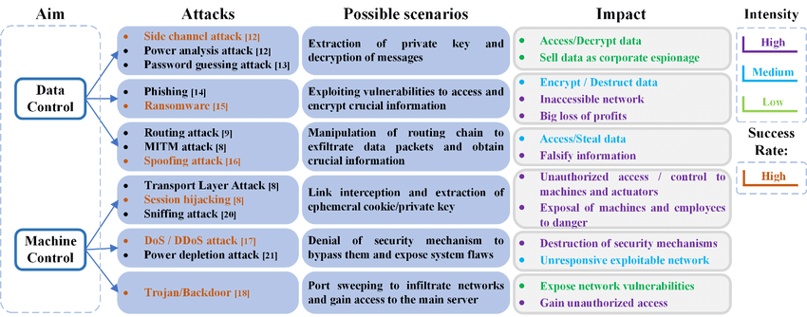

* + - [Source: https://www.researchgate.net/figure/An-assessment-of-Cyber-attacks-in-a-CPS-](http://www.researchgate.net/figure/An-assessment-of-Cyber-attacks-in-a-CPS-) Estimation-Factors-The-estimation-of-impact_fig2_335631500

## Mitigation Strategies

Implementing robust network security measures is crucial to protect against attacks at

various OSI layers. Recommended mitigation strategies include:

* Layer-specific defense mechanisms
* Network monitoring and anomaly detection
* Regular security audits and updates
* Employee training and awareness programs
* Incident response and disaster recovery plans

## CASE STUDY

Layer 2 Attack - VLAN Hopping

* Background: A large financial institution had implemented a VLAN (Virtual Local Area Network) infrastructure to segregate different departments and secure sensitive data. Each department was assigned a dedicated VLAN to ensure network isolation and restrict unauthorized access. However, an attacker found a vulnerability in the network configuration, allowing them to hop between VLANs and gain unauthorized access to sensitive information.
* Attack Scenario:

1. Reconnaissance: The attacker conducted extensive reconnaissance to identify the VLANs and their associated network

devices within the target organization.

2. Double Tagging: The attacker discovered that some network switches were not properly configured to prevent double tagging (also known as "double encapsulation"). They realized they could exploit this misconfiguration to bypass VLAN segregation.

3. VLAN Hopping: By manipulating the tagging of Ethernet frames, the attacker added a second VLAN tag to their

packets. This caused the packets to be mistakenly forwarded to a different VLAN than their original destination.

4. Unauthorized Access: With VLAN hopping, the attacker successfully accessed a VLAN dedicated to a different department, allowing them to intercept and potentially manipulate sensitive financial data.

5. Data Exfiltration: The attacker exfiltrated the stolen data to their own remote server, posing a significant risk to the financial institution's confidentiality and integrity of the data.

**CONT…**

* Consequences:
* Breach of Data Confidentiality: The attacker gained unauthorized access to sensitive financial data, exposing

confidential information such as customer records, account details, and transaction data.

* Regulatory Compliance Violation: The financial institution was at risk of violating industry regulations and data protection laws, resulting in potential legal and financial repercussions.
* Reputational Damage: The breach undermined the institution's reputation and eroded customer trust, potentially

leading to customer churn and negative publicity.

* Lessons Learned:

1. Proper VLAN Segmentation: It is crucial to implement strong VLAN segmentation with appropriate access control mechanisms to prevent unauthorized VLAN hopping.

2. Configuration Audits: Regular audits of network device configurations can help identify and address misconfigurations that could lead to security vulnerabilities.

3. Network Monitoring: Implement robust network monitoring tools and techniques to detect and respond to suspicious activities, such as VLAN hopping attempts.

4. Security Awareness Training: Educate employees about VLAN hopping and other network security risks, promoting a

culture of vigilance and responsible network usage.

* This case study highlights the importance of securing Layer 2 of the OSI model and the need for regular security assessments and vulnerability management to protect against such attacks.

### Cont...

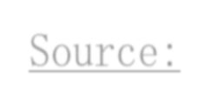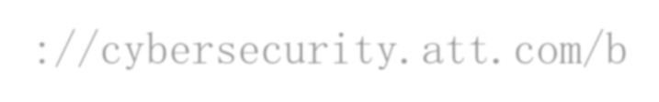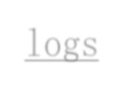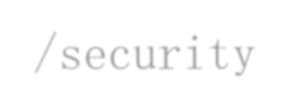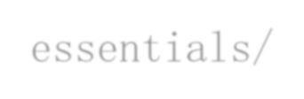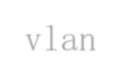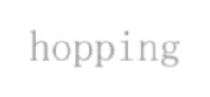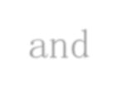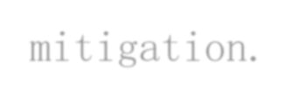

Source:https://cybersecurity.att.com/b logs/security-essentials/vlan-hopping- and-mitigation.

Source:https://cybersecurity.att.com/blogs/se curity-essentials/vlan-hopping-and- mitigation.

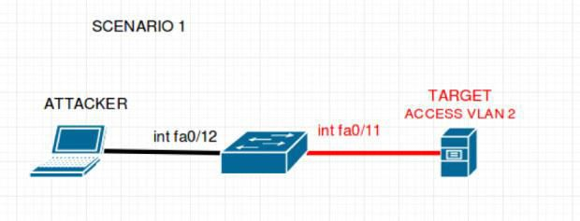 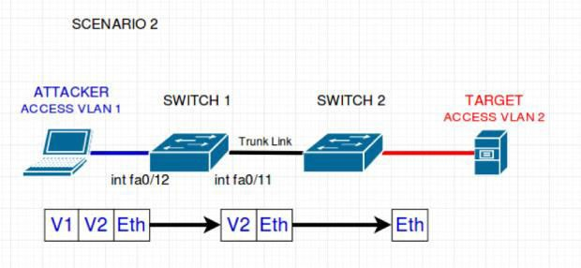

### Conclusion:

In conclusion, our exploration of attacks on the OSI model has highlighted the critical nature of network security. Attacks targeting various layers of the OSI model can have severe consequences, ranging from data breaches and unauthorized access to service disruptions and reputational damage.

* + The interdependencies between layers emphasize the need for a comprehensive defense-in-depth strategy. It is crucial to implement security measures at each layer, including physical security, access controls, encryption, intrusion detection systems, and robust authentication mechanisms. Regular security audits, employee training, and incident response plans also play vital roles in enhancing network security.
  + To protect against attacks, organizations must stay proactive in monitoring and mitigating vulnerabilities. This involves regularly updating systems, patching known vulnerabilities, and staying informed about emerging threats and best practices.
  + In closing, network security requires a multi-layered approach that addresses the unique challenges at each OSI layer. By implementing a combination of technical safeguards, user awareness, and incident response plans, organizations can significantly enhance their resilience against attacks and safeguard their critical assets and data.
  + Remember, network security is an ongoing process. Stay vigilant, adapt to evolving threats, and continue to prioritize the protection of your network infrastructure.

# GROUP TASK :2

Submitted BY

Anushma Manoj

Analyze a real-world case study of an attack on Layer 1 (Physical Layer) of the OSI model. Focus on the impact,

consequences, and countermeasures used in the case study.

* + - Analyze the attack's impact on the Physical Layer.
    - Document the consequences of the attack.
    - Research and analyze the countermeasures employed.

Real-world case study of an attack on the Physical Layer (Layer 1) of the OSI model is the

* 2007 undersea cable cut incident.
* The Cut Fiber Optic Cable incidents.
* 2015 fiber optic cable sabotage in California.

One real-world case study of an attack on the Physical Layer (Layer 1) of the OSI model is the 2007 undersea cable cut incident. This incident involved multiple undersea fiber optic cables being intentionally severed, disrupting telecommunications and internet services in several countries.

**Impact on the Physical Layer**:

The Physical Layer of the OSI model deals with the transmission of raw data bits over physical media, such as cables or wireless signals. In the case of the undersea cable cut incident, the physical infrastructure that carries these data signals was directly targeted. The attackers physically cut the undersea cables, causing a loss of connectivity and disrupting communication channels. The impact on the Physical Layer was significant as the severed cables interrupted the transmission of data and caused a loss of connectivity between affected regions. This disruption affected various sectors heavily reliant on telecommunications infrastructure, including businesses, governments, and individuals. Internet and telephone services were disrupted, resulting in communication blackouts and a loss of connectivity for extended periods.

Consequences of the attack:

The consequences of the undersea cable cut incident were widespread and varied. Some of the

major consequences include:

1. **Disrupted Communications**: The physical cable cuts caused widespread disruptions in communication services, including internet connectivity, voice calls, and data transmission. Businesses faced challenges in conducting day-to- day operations, individuals experienced difficulties in accessing online services, and emergency services were also impacted.
2. **Economic Impact**: The incident resulted in significant economic losses. Industries relying on uninterrupted connectivity, such as e-commerce, banking, and global trading, faced financial setbacks due to disrupted supply chains and interrupted transactions.
3. **National Security Concerns**: The incident raised concerns regarding national security as it highlighted the vulnerability of critical infrastructure. It emphasized the potential impact of physical attacks on vital communication networks, leading to increased scrutiny and investment in securing these infrastructure assets.
4. **Investigation and Repair Costs**: The incident triggered large-scale repair efforts, requiring the identification and repair of multiple cable cuts across vast stretches of the seabed. These repair operations incurred substantial costs and required specialized equipment, ships, and skilled personnel.

Countermeasures employed:

To mitigate the impact of attacks on the Physical Layer, various

countermeasures have been implemented:

1. **Redundancy and Diverse Routing**: Telecommunication companies have built redundant networks with multiple undersea cables and diverse routing options. This allows traffic to be rerouted in the event of a cable cut, minimizing service disruptions.
2. **Cable Protection and Monitoring**: Measures such as using reinforced cable sheaths, burying cables deeper in the seabed, and deploying monitoring systems to detect potential cable cuts help enhance the physical security and resilience of undersea cable infrastructure.
3. **Increased Surveillance and Security Cooperation**: Governments and international organizations have increased surveillance efforts to detect and prevent potential attacks on undersea cables. They also promote cooperation between countries to strengthen security measures and share information about threats.
4. **Early Detection and Rapid Response:** Developing technologies and systems to quickly detect and locate cable cuts is crucial for minimizing downtime. This includes using advanced monitoring equipment, such as acoustic sensors and remotely operated vehicles (ROVs), to identify and repair cable cuts promptly.
5. **Legal and Diplomatic Measures**: Countries have strengthened legal frameworks to address such attacks and established diplomatic channels to collaborate on addressing the consequences and preventing future incidents. This includes prosecuting perpetrators and raising awareness about the importance of protecting critical infrastructure.

Overall, attacks on the Physical Layer can have severe consequences, impacting communication, economy, and national security. Implementing redundancy, enhancing physical security, and improving detection and response capabilities are essential countermeasures to mitigate the risks associated with such attacks.

**THANK YOU**

Layer 2 and Layer 3 In

OSI Model

Presented By-Harshada Desai

**Data Link Layer (Layer 2)**

* The data link layer of a network is a second layer in the OSI reference model that provides forward of data and error correction that happen in physical layer.
* It also provides a service interface to the network layer. Generally, most of systems administrators of networks do not monitor the data link layer unless there is connectivity issue.

**The Data-Link Layer has two sublayers:**

1. **Logical Link Control (LLC)**

This is the upper sub-layer of the data-link layer.

The LLC sub-layer is responsible for handling and maintaining the communication between the

other layers of the OSI Model.

It is also responsible for handling error messages and reliability checks for the data.

1. **Media Access Control (MAC)**

This is the lower sub-layer of the data-link layer.

The MAC sub-layer is responsible for framing the data received from the upper layers.

It also is responsible for data encapsulation and media access control for the data received.

**The following is intended to be a simple overview of the most common data link layer**

**attacks based on the OSI model Mac spoofing**

* A MAC (Media Access Control) Address is a unique identifier assigned to every network

card. This identifier is used to identify and communicate with other devices on the network.

* MAC Spoofing is a type of cyber-attack that allows attackers to change their MAC Address and impersonate another device on the network.
* Once the MAC Address is spoofed, the attacker can access sensitive information, eavesdrop

on network traffic, and conduct a variety of malicious activities.

**ARP spoofing and poisoning**

* This one looks to send fakes ARP packets to a LAN network in a way that an internal MAC

address results as the attacker’s MAC address.

**Email Spoofing Attacks**

* Email spoofing attacks are where an attacker sends an email imitating another sender.
* In these attacks, the sender field is spoofed to show fake contact details. The attacker

impersonates this entity and then sends you an email requesting information.

* These attacks are often used to pose as administrators and ask other members of staff for account details.

**DNS Spoofing**

* DNS Spoofing means getting a wrong entry or IP address of the requested site from the DNS server.
* Attackers find out the flaws in the DNS system and take control and will redirect to a malicious

website.

**Real-Life example of Data Link Layer (DNS SPOOFING) Attack**

**Stolen cryptocurrency from MyEtherWallet via a DNS spoofing attack on Amazon Web Services (AWS)**

* In 2018, a DNS server poisoning attack was set in motion against AWS. A number of DNS servers were hijacked, which made it possible for the cyber criminals to redirect traffic from several of the domains belonging to the AWS system. One of the most damaging outcomes of this attack focused on the cryptocurrency website MyEtherWallet.
* When people entered this domain address into their web browser, they were taken to a fake website that looked very similar to the original one. The cyber criminals were therefore able to steal many of the user’s login credentials. Once these were captured, the pharmers could enter the user’s accounts and drain their funds. It is estimated that a total of $17 million worth of Ethereum was stolen during the attack.

**Following are some techniques which is used to protect from layer 2 attacks**

1. **Introduce DNS Security Extensions (DNSSEC)**

* Introducing DNSSEC is one of the most valuable steps you can take to protect against DNS

poisoning attacks.

* Quite simply, DNSSEC takes the added step of verifying DNS data something that is not standard in the current internet protocols.

1. **Always encrypt data**

* This offers an added layer of protection by preventing hackers who might be able to intercept that data from doing anything with it.
* For example, even if a hacker does manage to intercept that data, if it’s encrypted, they won’t be able to read it in order to get the information they need to duplicate it for use in responses to future DNS requests.

1. **Regularly run system updates**

* Making sure you always run updates so that you use the most recent version of your DNS is extremely important, since these updates often include new security protocols and fixes to any identified vulnerabilities.
* Additionally, staying on the latest version will ensure you can continue to receive updates going

forward.

1. **Lead end user training**

* Another important detection tactic is leading end user training to help users become aware of

potential risks.

* While DNS poisoning attacks can be very difficult for even well-trained users to spot, strong training can certainly help stem the spread of certain attacks.

**Network layer (Layer 3)**

###### The Layer 3 approach to security looks at the entire network as a whole including edge devices (firewalls, routers, web servers, anything with public access), endpoints such as workstations along devices connected to the network including mobile phones to create an effective plan for security management.

**Features of Network Layer**

* The main responsibility of the Network layer is to carry the data packets from the source to the destination without changing or using them.
* If the packets are too large for delivery, they are fragmented i.e., broken down into smaller

packets.

* It decides the route to be taken by the packets to travel from the source to the destination among the multiple routes available in a network (also called routing).
* The source and destination addresses are added to the data packets inside the network layer.

**Here are some examples of cyber attacks on Network layer**

**IP spoofing:** Manipulating the source IP address in IP packets to make it appear as if they are originating from a trusted source.

**Manipulating routing tables:** Modifying routing tables to redirect network traffic to unauthorized

destinations.

**ICMP redirect:** Sending ICMP redirect messages to modify a host's routing table and redirect traffic

through an attacker-controlled system.

**TCP/UDP flood (DDoS):** Overwhelming a target system with a flood of TCP or UDP packets to consume its resources and make it unavailable.

**SYN flood (DDoS):**

Exploiting the TCP three-way handshake by flooding a target system with a high volume of SYN requests, exhausting its resources.

**Man-in-the-Middle (MitM) Attacks**:

In this attack an attacker intercepts and potentially modifies network traffic between two devices,

in order to eavesdrop on sensitive information or inject malicious code into the network.

**Code and SQL injection attacks:**

Many websites accept user inputs and fail to validate and sanitize those inputs. Attackers can then fill out a form or make an API call, passing malicious code instead of the expected data values. The code is executed on the server and allows attackers to compromise it.

**Real life Example Of Network Layer Attack(MITM)**

**The Lenovo Superfish Adware MitM Attack (HTTPS Spoofing):**

One of the famous man-in-the-middle attack examples is the Lenovo adware attack, where computers from this brand were shipped with pre-installed Superfish Visual Search adware, making users the potential targets for MitM attacks (CISA, 2016). The software installed a self-signed root certificate on the user’s device, allowing the software to intercept a user’s encrypted web traffic and inject its own ads.

**Impact Of This Attack**

A machine with Superfish VisualDiscovery installed will be vulnerable to SSL spoofing attacks without a

warning from the browser.

**Solution Of This Attack**

**Uninstall Superfish VisualDiscovery and associated root CA certificate**

* Users should uninstall Superfish VisualDiscovery. Lenovo has provided a tool to uninstall superfish and remove all associated certificates.
* It is also necessary to remove affected root CA certificates. Simply uninstalling the software does not remove the certificate. Microsoft provides guidance and deleting and managing certificates in the Windows certificate store.
* In the case of Superfish VisualDiscovery, the offending trusted root certification authority

certificate is issued to “Superfish, Inc.”

**Following are some techniques which is used to protect from layer 2 attacks**

1. **Install antivirus software.**

* One of the first lines of defense against malware and other viruses is to install antivirus

software on all devices connected to a network (Roach & Watts, 2021).

* Antivirus software can detect and prevent malicious files from being installed on a system, and it should be updated regularly to include the latest definitions.

1. **Create strong passwords.**

* Another essential step in protecting a network is to create strong passwords. Passwords should be at least eight characters long and include a mix of letters, numbers, and symbols.
* They should also not be easy to guess for instance, the user’s name or the name of the company.

1. **Enforce security policies.**

* Security policies can help ensure that all devices on a network are protected against viruses and malware and that users are using strong passwords.
* These policies can also restrict access to some network regions and limit user privileges

1. **Use firewalls.**

* A firewall can help prevent unauthorized access to a network by blocking incoming traffic from untrusted sources.
* Additionally, firewalls can be configured to allow only certain types of traffic, such as web

traffic or email.

1. **Monitor activity.**

* Finally, it’s important to monitor activity on the network. Tracking logs and other data enables suspicious activity to be identified quickly, allowing security personnel to take steps to investigate and mitigate potential threats.

**THANK - YOU**

Case Study: SYN Flood Attack (Layer 4 - Transport Layer)

Introduction:

###### SYN flood attack targets the Transport Layer of the OSI model.

* + Attacker sends a flood of TCP connection requests with spoofed

source IP addresses.

* + Connection requests are SYN packets that initiate the TCP

three-way handshake process.

* + Attacker does not complete the handshake, causing a buildup of half-open connections on the target server.

Impact on Transport Layer:

* Exhaustion of server resources:
  + Server allocates resources to track and maintain the state of incoming

connection requests.

* + Flood of SYN packets exhausts server resources.
* Denial of Service (DoS):
  + Target server becomes overwhelmed and unable to handle legitimate

connection requests.

* Slow network performance:
  + Excessive half-open connections consume network bandwidth and processing power, degrading performance.

Consequences

* Disrupted communication:
  + Target server becomes unresponsive or significantly slows down, disrupting communication.
* Service unavailability:
  + Targeted service or application may become completely unavailable, resulting

in financial losses and reputational damage.

* Loss of data:
  + Attack may lead to data loss or corruption if the server crashes or needs to be

forcefully restarted.

Countermeasures:

* SYN cookies:
  + Server generates cryptographic cookies to track connection state without allocating significant resources.
* Rate limiting:
  + Implement rate-limiting mechanisms to restrict the number of SYN packets from a specific source IP within a timeframe.
* Firewalls and IPS:
  + Deploy firewalls and Intrusion Prevention Systems to detect and mitigate SYN flood attacks.
* Load balancers:
  + Use load balancers to distribute incoming traffic across multiple servers, preventing a single server from being overwhelmed.
* ISP assistance:
  + Seek assistance from the Internet Service Provider to implement traffic filtering and rate limiting closer to the source of the attack.

Effective protection:

###### Implement countermeasures in combination for effective protection.

* Keep systems up to date with the latest security patches.
* Employ network monitoring tools to detect and respond to attacks

promptly.

Conclusion of SYN Flood Attack (Layer 4 -

Transport Layer)

* SYN flood attacks pose significant risks to the Transport Layer.
* Understanding the impact, consequences, and countermeasures is crucial for effective protection.
* Organizations should adopt a multi-layered defense strategy to

mitigate SYN flood attacks.