SubZeroAstro
From subs to masters – zero hassle.
User Manual
A beginner's guide to culling, stacking, processing and finishing your astrophotos
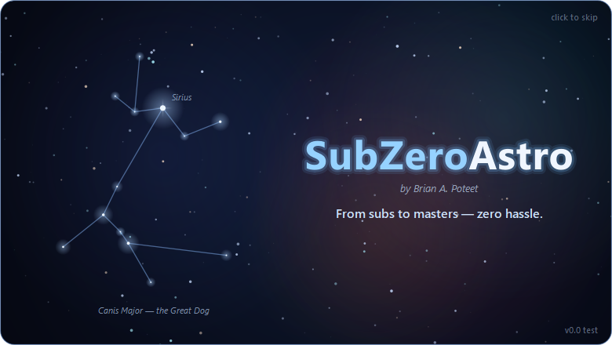
Version 0.9.51 beta · Windows and Mac (Apple silicon)
by Brian A. Poteet · October 2026

Contents
1 Welcome to SubZeroAstro 4
1.1 What SubZeroAstro does
1.2 Who this manual is for
1.3 Words you will meet
2 What you need 6
2.1 Computer requirements
2.2 Companion programs (optional but recommended)
2.3 Your images
3 Installing SubZeroAstro 8
3.1 Windows
3.2 Mac (Apple silicon)
3.3 Updating to a new version
3.4 Removing SubZeroAstro
4 First-time setup 9
4.1 Tell SubZeroAstro where your tools are
4.2 Choose where results are saved
4.3 The calibration library
4.4 Settings worth knowing
5 Finding your way around 14
5.1 The banner and page buttons
5.2 The log and the status bar
5.3 Saved progress and undo
5.4 Stop Here – Continue in PixInsight
6 Page 1 – Astro Image Quality and Cull 15
6.1 Loading your sub-frames
6.2 Reading the measurements
6.3 Choosing which frames to keep
6.4 Filters and the FITS header
6.5 On to stacking
7 Page 2 – Calibrate and Stack 18
7.1 The light frame groups
7.2 Calibration: what the ✓ ⚠ ✗ mean
7.3 Stacking options
7.4 Running the stack
7.5 Results
7.6 Build Calibration Masters (no lights needed)
8 Page 3 – Astro Image Processing 21
8.1 Masters and target sets
8.2 Crop
8.3 Plate solve
8.4 Remove gradients
8.5 The XTerminators
8.6 Saving the results
8.7 Running and the step history
9 Page 4 – Finishing Touches 25
9.1 How it works
9.2 Going back
9.3 The steps
9.4 Mote Buster: dust donuts
9.5 Stars: take out, brighten, colour, put back
9.6 Darker sky, Final Crop, Spot Fix and your signature
9.7 Saving and sharing
9.8 Starting your next target
10 Recipes for common setups 31
10.1 Colour camera (OSC), broadband
10.2 Colour camera with a dual-band filter
10.3 Mono camera: LRGB
10.4 Mono camera: narrowband (SHO)
10.5 Smart telescopes (Seestar, DWARF, Vespera)
10.6 Comets
10.7 Target types
11 Troubleshooting and questions 33
11.1 Common questions
11.2 Getting help and reporting problems
12 Keyboard shortcuts 35
12.1 Page 1 – Quality and Cull
12.2 Page 4 – Finishing Touches
13 Files and folders SubZeroAstro creates 36
13.1 Next to your images
13.2 On your computer
14 Privacy, licence and credits 37
14.1 Privacy
14.2 Licence and credits
15 Index 38

1 Welcome to SubZeroAstro

1.1 What SubZeroAstro does
SubZeroAstro takes you from a folder of raw sub-frames to a finished astrophoto - with as little hassle as possible. It walks you through four pages, one after the other, like turning the pages of a book:
Page | What happens there
1. Astro Image Quality and Cull | Every sub-frame is measured (star size, roundness, signal, cloud). You keep the good ones and set aside the bad ones.
2. Calibrate and Stack | Your kept frames are calibrated with darks, flats and bias and combined into one clean master per filter.
3. Astro Image Processing | The masters are cropped, plate solved, cleared of gradients and (optionally) sharpened, de-noised and separated from their stars with the RC-Astro XTerminators.
4. Finishing Touches | A guided, pick-the-one-you-like workflow turns the masters into a finished colour picture you can save, sign and share.

At every page you can also stop and continue in PixInsight - SubZeroAstro saves exactly what you have so far, plus a note of what to do next there.
The SubZeroAstro start-up screen

1.2 Who this manual is for
This manual is written for newcomers to astrophotography processing. No knowledge of PixInsight or other processing software is needed. Experienced imagers will find the PixInsight equivalent of each step mentioned along the way.

1.3 Words you will meet
Word | What it means
Sub-frame (sub, light) | One single exposure of your target, e.g. 180 seconds.
Calibration frames | Darks (lens cap on, same exposure), flats (evenly lit, shows dust and vignetting), bias (shortest exposure) and dark-flats. They remove the camera's and telescope's own fingerprints.
Master | Many frames combined into one: a master light (your target) or a master dark / flat / bias.
Linear / stretched | Straight from the camera a picture is linear and looks almost black. Stretching (Brighten the Image) makes the faint detail visible.
OSC (colour camera) | One-shot-colour camera: records red, green and blue at once (e.g. ZWO ASI2600MC).
Mono camera | Records one filter at a time (L, R, G, B, Ha, OIII, SII); the colours are combined later.
Narrowband / dual-band | Filters that pass only the glow of hydrogen (Ha), oxygen (OIII) or sulphur (SII). A dual-band filter (e.g. Optolong L-Ultimate, Askar D1) passes two of them on a colour camera.
Plate solving | Working out exactly where in the sky the picture points, by matching its stars to a star catalogue.
FWHM | Star size (full width at half maximum). Smaller = sharper.
Eccentricity | How round stars are: 0 = round, 1 = a line. Above about 0.5 stars look elongated.
SNR | Signal-to-noise ratio: how clearly the stars rise above the sky. Drops with cloud, haze or moonlight.
Starless / stars-only | The picture split in two by StarXTerminator, so the nebula and the stars can be processed separately.

2 What you need

2.1 Computer requirements
SubZeroAstro runs on Windows and on Macs with Apple silicon. Astro images are big (a 26-megapixel camera makes ~50 MB files; a night can easily be 20-50 GB), so more memory and a fast disk make everything quicker.
 | Minimum | Recommended
Operating system | Windows 10 (64-bit) or a Mac with Apple silicon (M1 or newer) and a recent macOS | Windows 11, or macOS 14 (Sonoma) or newer
Processor | 4 cores | 8 cores or more
Memory (RAM) | 16 GB | 32 GB or more (64 GB for 60-megapixel cameras or very large stacks)
Free disk space | 20 GB plus room for your images | An SSD with 100 GB or more free - stacking keeps temporary aligned frames on the local disk
Graphics card | Not required | An NVIDIA RTX card (Windows) or Apple silicon GPU makes the RC-Astro XTerminators many times faster
Screen | 1600 × 900 | 1920 × 1080 or larger

Tip: Images on a network drive (NAS) work fine. SubZeroAstro reads them carefully (3 files at a time) and remembers the measurements, so re-opening a session is quick.

2.2 Companion programs (optional but recommended)
SubZeroAstro works on its own, but it can call these free or commercial programs for the best results. Install them before the first setup (Chapter 4); SubZeroAstro finds them automatically in their usual places. Each time it starts, page 1 checks for them quietly in the background and shows an amber note if one is missing or not licensed (4.1).
Program | Used for | Where to get it | Without it
ASTAP + a star database (D50 suits most setups) | Plate solving (page 3) | hnsky.org/astap.htm (free) | Plate solving is skipped (PixInsight can do it later)
GraXpert | AI gradient removal (page 3) | graxpert.com (free) | A built-in gradient remover is used
RC-Astro CLI with your BlurXTerminator, NoiseXTerminator and StarXTerminator licences | Sharpening, noise reduction and star removal (pages 3 and 4) | Your RC-Astro account (rc-astro.com) | These steps are skipped; Take Stars Out is not available
PixInsight (optional) | Further processing after any page | pixinsight.com | Not needed - SubZeroAstro can finish the picture

2.3 Your images
- SubZeroAstro reads FITS (.fit, .fits, .fts) and PixInsight XISF (.xisf) files on every page - light frames, calibration frames and masters - from capture programs such as N.I.N.A., ASIAIR, SharpCap and smart telescopes (ZWO Seestar, DWARF, Vaonis Vespera, Stellina, eVscope). XISF files can be uncompressed or compressed with any of PixInsight's options (zlib, LZ4, LZ4-HC, Zstandard, with or without byte shuffling).
- Keep each night's lights in their own folder, and your calibration frames in a calibration library folder with one subfolder per telescope (see 4.3).
- Your original files are never changed or deleted. Rejected frames are only moved into a REJECTED subfolder.

3 Installing SubZeroAstro

3.1 Windows
- Open the SubZeroAstro releases page: github.com/bapoteet/SubZeroAstro/releases.
- Under the newest release, click SubZeroAstro-Windows.zip to download it.
- Right-click the downloaded zip › Extract All… and choose a permanent place, e.g. C:\Astro\SubZeroAstro.
- Open the extracted folder and double-click SubZeroAstro.exe. (Right-click › Pin to Start or Send to › Desktop gives you a shortcut.)
- If Windows shows "Windows protected your PC", click More info › Run anyway. This appears because the app is new and not yet code-signed; it is safe to continue.

3.2 Mac (Apple silicon)
- Open github.com/bapoteet/SubZeroAstro/releases and download SubZeroAstro-macOS-AppleSilicon.zip from the newest release.
- Double-click the zip in your Downloads folder; SubZeroAstro.app appears.
- Drag SubZeroAstro.app into your Applications folder.
- The first time only: right-click (or Control-click) the app › Open, then Open again in the message. After that it opens normally.
- If macOS says the app "is damaged" or "can't be opened", open Terminal (Applications › Utilities) and type: xattr -dr com.apple.quarantine /Applications/SubZeroAstro.app then press Return and open the app again.
Why the warnings?: Both messages appear because SubZeroAstro is not yet signed by Microsoft or notarized by Apple. Signing is being set up for future versions.
Mac: window size: SubZeroAstro opens filling the screen, with the menu bar and Dock still showing. Avoid the green button's full-screen mode on a Mac: it hides the menu bar (where Stack › Build Calibration Masters… and Help live). To fill the screen yourself, Option-click the green button, or double-click the window's title bar. If you make the window smaller, it opens at that size next time.

3.3 Updating to a new version
Download the newest zip from the releases page and replace the old app folder (Windows) or the app in Applications (Mac). Your settings, tool locations, rig names, saved measurements and saved progress are kept - they are stored separately from the app.

3.4 Removing SubZeroAstro
Delete the app folder (Windows) or drag SubZeroAstro from Applications to the Bin (Mac). Saved progress can be cleared first under Settings › Saved Progress. Your images are never touched.

4 First-time setup

4.1 Tell SubZeroAstro where your tools are
When SubZeroAstro starts, it checks for ASTAP, GraXpert and the RC-Astro CLI in the background. If one is missing - or RC-Astro is installed but a tool is not licensed - a slim amber banner appears at the top of page 1, saying what you would miss (for example plate solving is skipped). Nothing is wrong: you can still cull and stack. The banner has two buttons:
- Set Up… - opens the Your Tools window (also in Settings › Your Tools (ASTAP, GraXpert, RC-Astro)…).
- Don't Remind Me - hides the banner until something else changes. Use it if you have chosen not to use one of the programs.
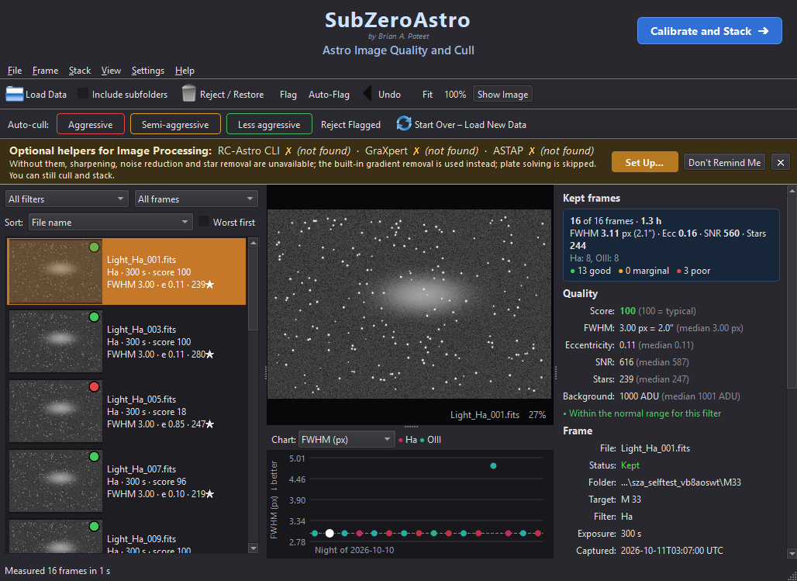
The amber banner on page 1 when helper programs are missing (example)
The Your Tools window lists each program with its status, a Download Page button for anything missing, and Browse… to point at a program installed somewhere unusual. Click Check Again after installing something.
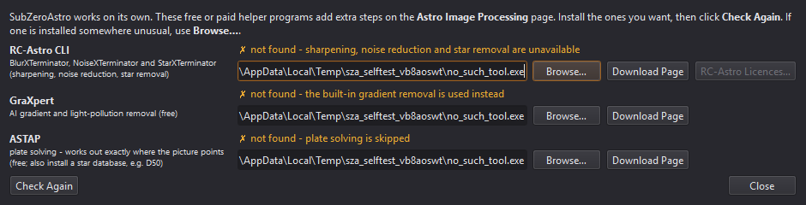
Settings › Your Tools: status, Browse… and Download Page for each helper program
The same programs are also shown in the Your tools box at the top of page 3 (Astro Image Processing), with a green ✓ found when detected. If one is missing, click Browse… next to it and pick the program:
Tool | Typical location on Windows | Typical location on a Mac
ASTAP | C:\Program Files\astap\astap.exe | /Applications/ASTAP.app (or astap_cli)
GraXpert | C:\Users\<you>\AppData\Local\Programs\GraXpert\GraXpert.exe | /Applications/GraXpert.app
RC-Astro CLI | C:\Program Files\RC-Astro\CLI\rc-astro.exe | where the RC-Astro installer put rc-astro

Activating RC-Astro licences. You do not need a terminal: click RC-Astro Licences… (next to the RC-Astro CLI row on page 3, or in the Your Tools window). The window shows which tools are licensed on this computer. To activate:
- Click Open My RC-Astro Account and sign in on rc-astro.com.
- Click Get Activation Code on the account page, then click it again to copy the code.
- Paste the code into the box and click Activate. One code activates every RC-Astro tool you own.
The tools turn green and page 3 is updated straight away. If activation does not work, Do It in a Terminal Window runs RC-Astro's own rc-astro license command, where you paste the code and press Enter. Check for Updates and Download & Install Update keep the RC-Astro CLI itself up to date.
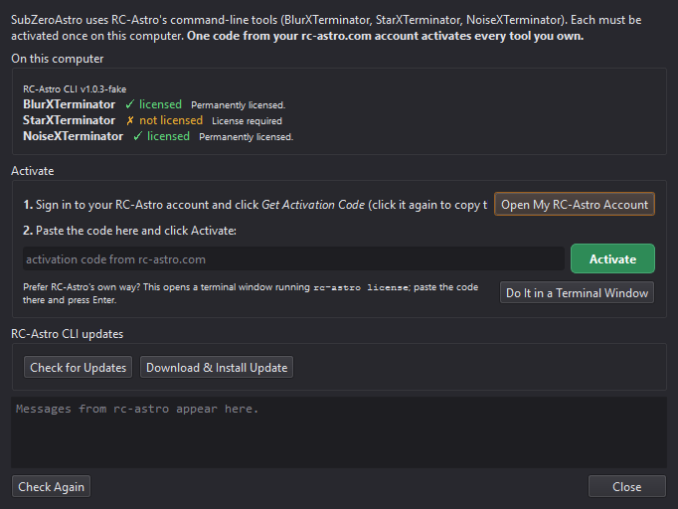
The RC-Astro Licences window (example: StarXTerminator not yet activated)
For the RC-Astro CLI the status line lists BlurXTerminator ✓ · StarXTerminator ✓ · NoiseXTerminator ✓ for every product licensed on this computer. Below the XTerminator settings, RC-Astro device chooses the processor: pick your dedicated graphics card (e.g. NVIDIA RTX…) - it is much faster than integrated graphics.
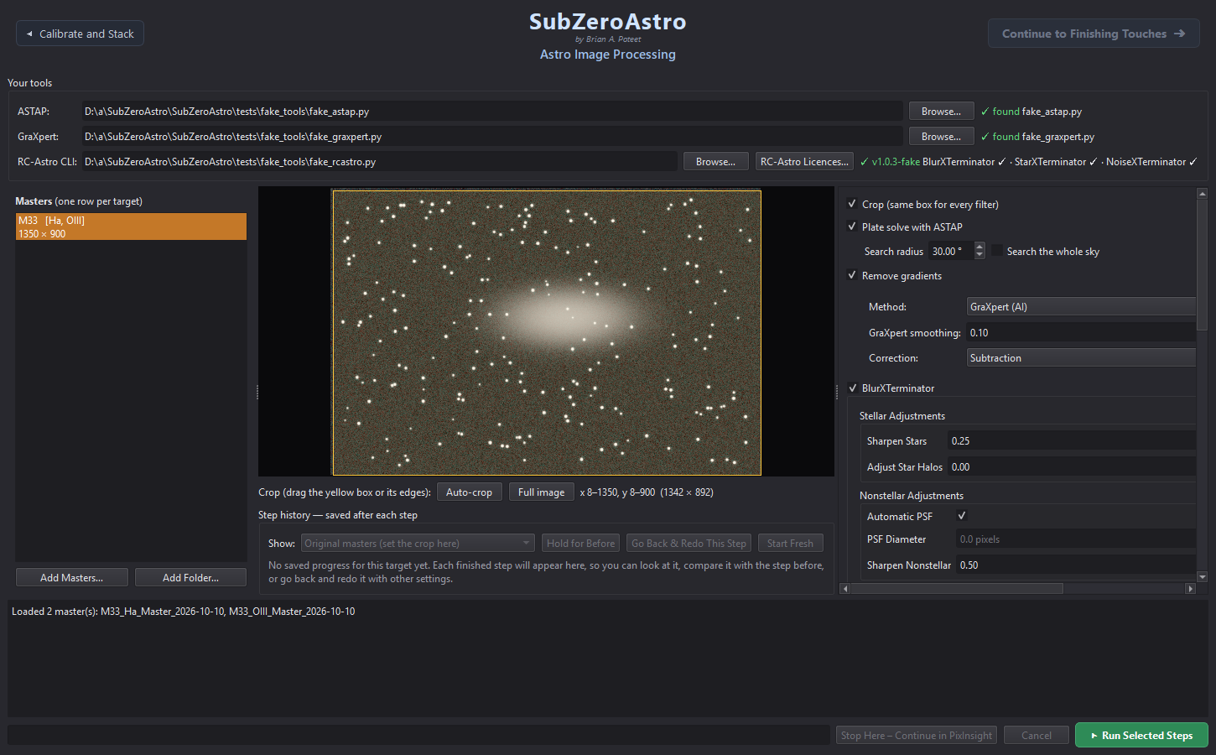
Page 3 with the tools box at the top (example data)

4.2 Choose where results are saved
On page 2 (Calibrate and Stack) set two folders under Save locations once; they are remembered:
- Calibration masters - your calibration library (4.3). New master darks, flats and bias are saved there and found again automatically next time.
- Master lights - where your stacked masters go, one subfolder per target, e.g. …\Master Lights\IC1805\IC1805_L-Ultimate_Master_2026-10-09_to_2026-10-11.fits.

4.3 The calibration library
SubZeroAstro keeps calibration masters in a tidy structure inside the calibration folder:
<calibration folder>\<telescope rig>\Masters\<camera>\Bias | Darks | Flats\<filter>\…
- Rig names: the first time, pick a rig name for each camera + focal length (e.g. 265mm scope or SQA55). This matters for ASIAIR, which records the mount, not the telescope.
- Darks are matched by exposure, gain, offset and temperature (±3 °C). Flats are matched by camera, filter and rig, nearest in date. Bias or dark-flats are needed to calibrate flats properly.
- You can add a folder of raw calibration sub-frames; SubZeroAstro builds the masters and saves them into the library.

4.4 Settings worth knowing
- Settings › Star measurement - Fast (default, about 3-4× quicker on a network drive), Full frame or Off.
- Settings › Your Tools (ASTAP, GraXpert, RC-Astro)… - see, locate and download the helper programs, and activate RC-Astro licences (4.1).
- Settings › Saved Progress… - where crash-recovery copies are kept, how much space they use and how long they are kept (30 days by default).
- Settings › Show Intro Animation at Startup - turn the start-up animation on or off. Help › Play the Intro Animation plays it any time.

5 Finding your way around

5.1 The banner and page buttons
Every page has the same banner at the top: SubZeroAstro, the author and the version in small print (e.g. v0.9.10 beta), and the page title. On the right is a blue Continue to … ➜ button that turns to the next page; on the left a grey ◀ previous page button goes back. Going back keeps your work: press Continue again and the page you left comes back exactly as it was.

5.2 The log and the status bar
The text area at the bottom of each page is the log: it tells you what was done, what was found and any warnings, in plain language. The orange bar shows progress and an estimate of the time left.
When a page has finished its job, its green run button turns amber - ✓ Stacked – Run Again? on page 2, ✓ Done – Run Again? on page 3 - so you can see at a glance that the page is done. Pressing it again asks first, so nothing is redone by accident. Add new images and it turns green again.

5.3 Saved progress and undo
- Page 1: your folders and flags are saved as you go. Ctrl+Z undoes rejects, flags and auto-cull.
- Pick up where you left off: when you start SubZeroAstro again - after quitting normally or after a crash - it offers Pick Up Where I Left Off: your frames and flags come back and it goes straight to the page you were on (Calibrate and Stack, Image Processing with the same masters, or Finishing Touches, where your steps resume). Start Fresh begins a new project; after End this Project and Start New Project nothing is offered.
- Page 2: each master is noted as soon as it is saved; an interrupted run offers Continue With the Rest.
- Page 3: the image is saved after every step; Go Back & Redo This Step and Start Fresh are under the preview.
- Page 4: every step is saved: Undo (Ctrl+Z), Go Back to Here, Back to Start, and reopening the same masters later resumes the project.

5.4 Stop Here – Continue in PixInsight
The purple Stop Here – Continue in PixInsight button (pages 2, 3 and 4) saves the image exactly as it is right now as PixInsight-ready XISF, writes a short note listing the PixInsight processes to use next, and opens the folder with the files selected.

6 Page 1 – Astro Image Quality and Cull
Page 1: frame list (left), the selected frame, the session chart and the measurements (example data)

6.1 Loading your sub-frames
- Click Load Light Frame Data (Ctrl+O), then Add Folders…. You can pick several folders at once: click one, then Shift-click to add a range, or Ctrl-click (Cmd-click on a Mac) to add others one by one. Click Add Folders… again for folders in other places (other nights, other drives), or Add Files… for individual files.
- Include subfolders is ticked by default, so nights kept in subfolders are found too (FLAT, DARK, BIAS, CALIB and OFFSET folders are skipped). Untick it to load only the files directly in each folder; your choice is remembered.
- If your capture software does not record the filter (e.g. ASIAIR with a manual filter drawer), choose it under Filter used.
- Press Start Processing. Frames appear at once and are measured in the background.
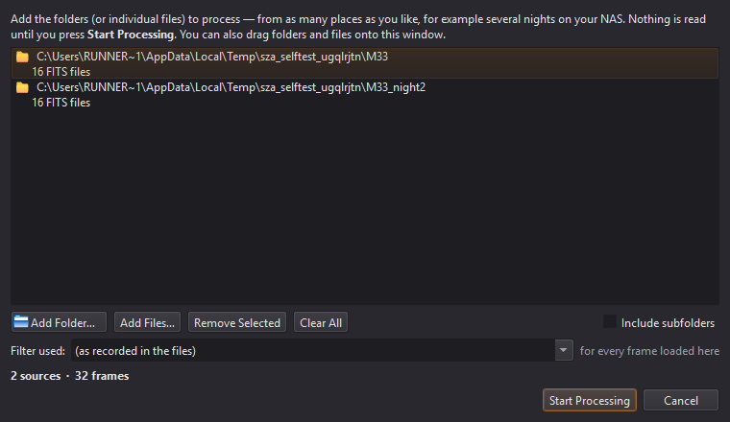
The Load Light Frame Data window
Calibration frames?: Load Light Frame Data is for light frames only. To turn bias, darks and flats into masters, use Stack › Build Calibration Masters… instead (7.6) - no light frames needed.
Tip: If the file names mention the filter (e.g. …_SQA55Lult_0001.fit), SubZeroAstro notices after the first few frames and offers to use it for the whole set. Duplicate files are skipped and reported.

6.2 Reading the measurements
Each frame gets a coloured badge (green = good, amber = check it, red = probably reject) and a score where 100 = a typical frame for that filter. Frames are only ever compared with frames from the same camera and filter.
Measurement | What it tells you | Bad sign
FWHM | Star size in pixels (and arcseconds) | Much larger than the median: poor focus or seeing
Eccentricity | Star roundness (0 = round) | Above ~0.5: tracking, guiding or wind
SNR | How clearly stars stand out | A drop: cloud, haze, dew, moonlight
Stars | Number of stars detected | A sudden drop: cloud or trees
Background | Sky brightness | A rise: moon, twilight, light pollution

The session chart below the image shows one dot per frame in capture order. Choose what to plot, click a dot to jump to that frame, or drag across the chart to select a range. The Kept frames box on the right shows the averages of what you are keeping.

6.3 Choosing which frames to keep
- Click an Auto-cull button - Aggressive, Semi-aggressive or Less aggressive. It only flags frames (yellow ring); hover over a button first to see how many it would flag.
- Review the flagged frames (switch the list to Flagged); the measurements panel says why each was picked. Press F to un-flag one you want to keep.
- Press Reject Flagged (Shift+X). Rejected frames are moved into a REJECTED subfolder - nothing is deleted, and Ctrl+Z brings them back.
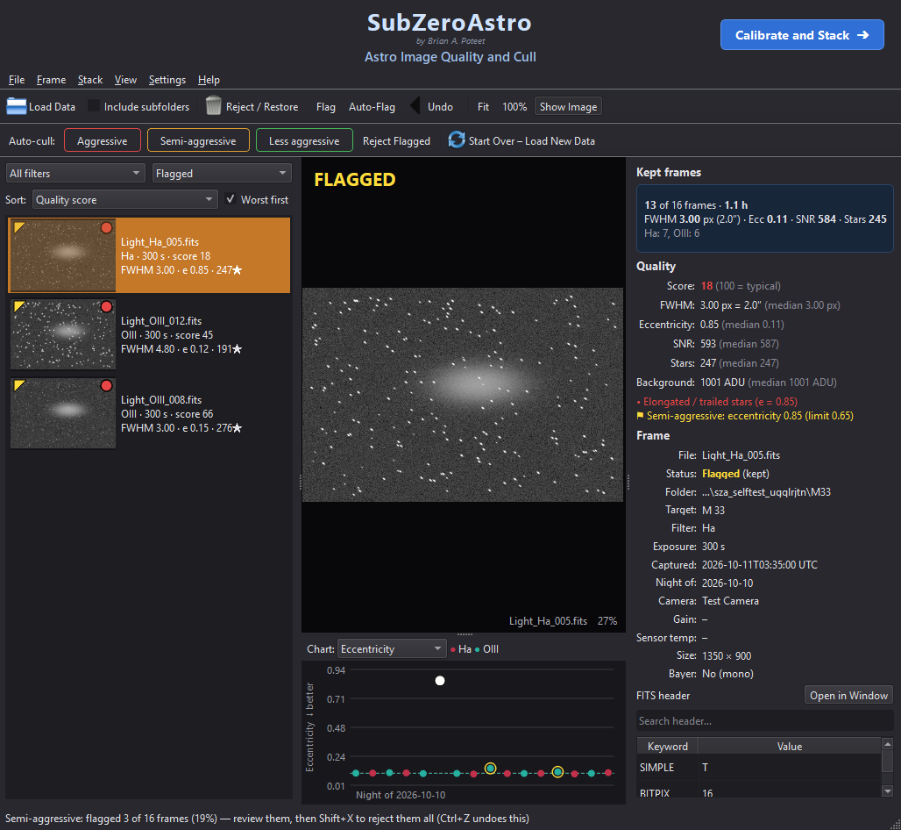
After Semi-aggressive: suspect frames are flagged for review (example data)
Auto-Flag (Ctrl+F) lets you set your own limits. X rejects or restores the selected frame(s), F flags them, D clears all flags.

6.4 Filters and the FITS header
- Frame › Set Filter Name… changes the filter for the selected frames (your files are not changed). Use it when the filter is missing or wrong - flats are matched by filter.
- Ctrl+H opens the full FITS header of the selected file, with search and Copy All.
- Ctrl+I hides or shows the image - useful on a slow network drive.

6.5 On to stacking
When you are happy, click Calibrate and Stack ➜ at the top right. Only your kept frames go to page 2.

7 Page 2 – Calibrate and Stack
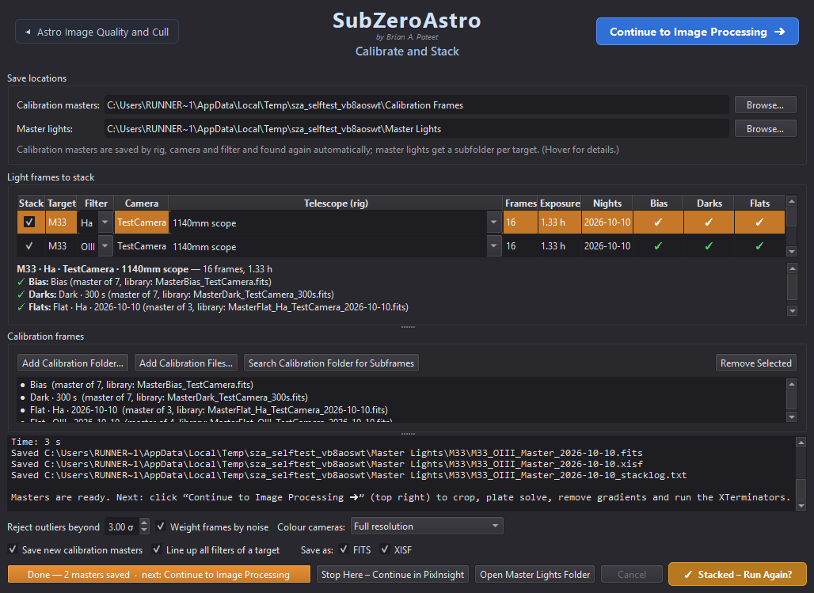
Page 2 after stacking: one row per target and filter, with the calibration found for each (example data)

7.1 The light frame groups
Your kept frames are grouped by target + filter + camera + telescope - one row each, with the number of frames, total exposure and nights. The Filter of a row can be changed from its drop-down (for example to match your flats).

7.2 Calibration: what the ✓ ⚠ ✗ mean
Mark | Meaning
✓ green | A matching calibration master was found (or will be built).
⚠ orange | Usable, with a note - e.g. darks scaled from another exposure, or flats taken long ago ("dust may have moved"). It will be used.
✗ red | Nothing suitable - e.g. No flats for filter OIII. You can still stack, without that correction.

Click a row to read the details below the table. Add calibration with Add Calibration Folder…, Add Calibration Files… or Search Calibration Folder for Subframes.
No flats at all? SkyFlats (Mote Buster). When a filter has no flats, SubZeroAstro can make a flat from your light frames (option SkyFlats (Mote Buster) when flats are missing, on by default; at least 12 frames). It uses every light with that filter, camera and rig - from all your targets and nights, because the stars land somewhere different in each. Each frame is scaled to the same brightness, its stars are hidden, and its own light-pollution tilt is taken out (that tilt changes from frame to frame, while the vignetting stays put). Of every pixel's values only the lower half is used - a nebula can only add light - and what remains is what your optics and dust do to an even sky: a flat. The Flats cell then shows ⚠ SkyFlat (Mote Buster) (made from N light frames). SkyFlats are never saved to your library. (For donuts that remain, Mote Buster – Fix Dust Donuts on Finishing Touches works on one picture.)
Ready-made data is recognised. Lights bought already calibrated - from Telescope Live and similar services, or calibrated earlier in other software - must not be calibrated again (the dark would be subtracted twice and the flat divided in twice). SubZeroAstro recognises them from their headers and names: Telescope Live's PROC = True, MaxIm DL's CALSTAT, PixInsight's and Siril's calibration notes, and names such as _cal.fits or PixInsight's _c.xisf. Such a set shows ✓ not needed - the lights are already calibrated (…) in the Bias, Darks and Flats cells, gets no SkyFlat, raises no missing-calibration warnings - and its frames are never used to build a SkyFlat for your own lights.
Every SkyFlat is checked before it is used. If it may not be good enough - too few usable frames, grainy, a brightness range no vignetting has (nebulosity or a light-pollution gradient got in), large areas filled in - or it cannot be made at all because the master dark or bias is as bright as the sky (a light leak, or the wrong exposure or gain), SubZeroAstro stops and asks: Proceed Without Flats (the default), Use the SkyFlat Anyway, or Cancel Stacking. The reasons are listed in the box and in the log. A poor flat adds blotches or rings instead of removing them; without flats you can still fix dust donuts afterwards with Mote Buster – Fix Dust Donuts on Finishing Touches.
SkyFlats: A SkyFlat is best from several targets. From a single target whose nebula fills most of the picture, part of the nebula could be mistaken for vignetting - the Flats note warns you. Real flats are still the best: take some when you can.
Calibration check. Every stack checks its dark (or bias) against the lights and writes a Calibration check line in the log: light background - dark = sky left. If a master does not fit - brighter than the lights, uneven like a picture (light leaked in while the darks were taken: lens cap, filter wheel, focuser or room light) or practically zero (saved on another scale) - a window says so when stacking finishes. Such a frame makes bright bands, borders or blotches that no later step can fix: remove it from the Calibration frames list, or take new ones (scope fully covered, same gain, offset, temperature and exposure as the lights).
Important: If the Flats cell says the flats have no matching bias or dark-flats, the correction will be too strong: bright corners and dark rings. Add a bias or dark-flats for that camera and gain.

7.3 Stacking options
- Reject outliers beyond 3.0 σ - removes satellite trails, planes and hot pixels. The default suits almost everything.
- Weight frames by noise - better frames count more.
- Colour cameras: Full resolution (default) or half resolution (faster, less noise per pixel).
- Save as FITS and/or XISF; Save new calibration masters into your library.
- Line up all filters of a target (on) - all masters of a target share one pixel grid, ready to combine (LRGB, SHO).
Sharp stars to the corners. Every telescope bends the field a little, mostly at the edges. After a meridian flip (or between nights with another setup) that bending is turned round with the camera, so a plain shift-and-rotate alignment lines up the centre but leaves stars a pixel or two apart near the edges - doubled or smeared corner stars. SubZeroAstro measures each frame's stars against the reference and, when the edges are off, lines that frame up with a smooth distortion model instead. The stack log says how many frames were corrected.

7.4 Running the stack
Press ▶ Check & Stack. Anything missing is listed first, with Stack Anyway or Add Calibration Frames First…. The log shows each step. If a run is interrupted, the next run offers Continue With the Rest. When it finishes, the button turns amber: ✓ Stacked – Run Again?. Stacking again never overwrites a master - new versions are saved as _2, _3…

7.5 Results
Masters are saved in your master lights folder, one subfolder per target, with a _stacklog.txt listing every frame used. Open Master Lights Folder shows them. Click Continue to Image Processing ➜ to carry on.

7.6 Build Calibration Masters (no lights needed)
Took a fresh set of darks, flats or bias? Turn them into masters right away - no light frames needed: on page 1 choose Stack › Build Calibration Masters… (or click Build Calibration Masters… in the Calibration frames box on page 2). Choose the folder with the subframes - bias, darks, flats and dark-flats can all be mixed together in one folder (for example RedCat51Calis), or sit in subfolders. SubZeroAstro reads each file's header (and, if the header doesn't say, the file or folder name: Darks, Flats, Bias…) and sorts them:
- Bias - one master per gain and offset.
- Darks - one master per exposure, gain, offset and temperature (180 s and 300 s darks make two master darks).
- Flats - one master per filter (and night). Each flat is calibrated with dark-flats or short darks of the same exposure, or else a bias - from the same folder or already in your library.
- Dark-flats - saved as masters too, for next time.
The telescope (rig) name is taken from the folder name (RedCat51Calis → RedCat51) or the headers - check it, because flats are only used for lights from the same rig. Untick any set you don't want, then click Build Masters. Each master is saved to your calibration library (<library>/<rig>/Masters/<camera>/…) with its settings in the name, and is used automatically whenever you stack lights with matching settings.
Every master is checked as it is built. You are warned when a dark or bias is uneven like a picture (light leaked in), a dark is far brighter than the bias (light, or the camera not cooled), a bias is practically zero (saved on a 0..1 scale or with a pedestal taken off), or flats are over-exposed (clipped) or very dim. A warned master is still saved, so you can compare - but better to retake that set.
Taking good darks: Darks: cap the telescope (or take the camera off) and cover it, at night or in a dark room, with the filter wheel on a filter - not an empty slot. Match the lights' exposure, gain, offset and temperature.

8 Page 3 – Astro Image Processing
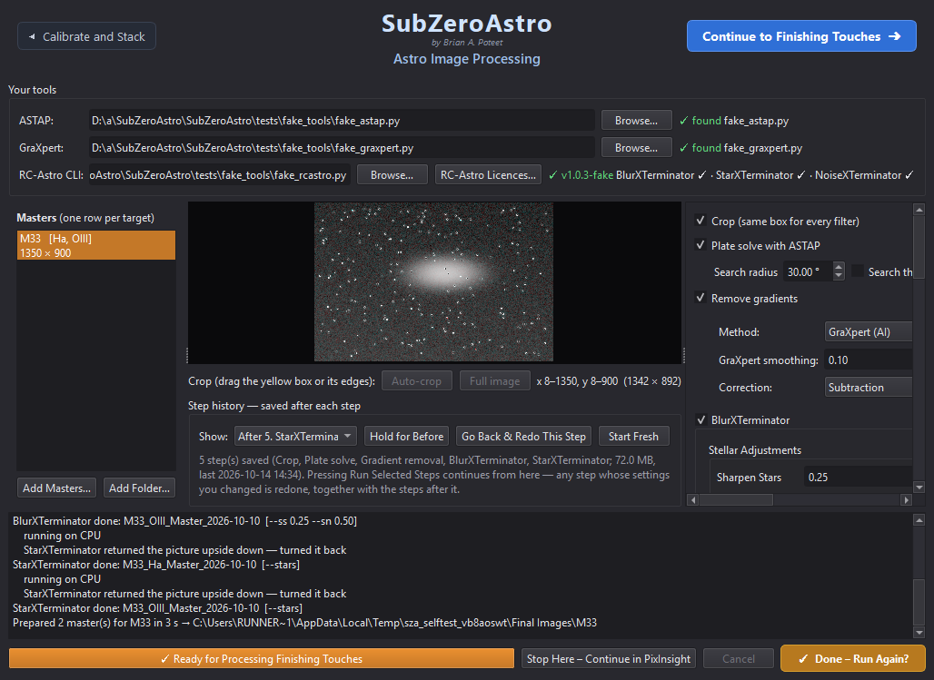
Page 3 after processing: masters (left), preview with crop box, step history, and the step settings (right)

8.1 Masters and target sets
The masters from page 2 are loaded automatically (or use Add Masters… / Add Folder…). Masters of the same target form one row - e.g. NGC281 [Ha, OIII, SII]. If they were stacked in separate runs the row says will be lined up: they are matched star-to-star onto one grid before anything else, and edges not covered by every filter are trimmed.

8.2 Crop
The yellow box on the preview is the crop. Auto-crop trims the ragged stacking edges; drag the box or its sides to adjust, or Full image to keep everything. The same box is used for every filter, so they stay aligned.

8.3 Plate solve
ASTAP finds where the picture points in the sky, using the position and pixel scale recorded in the masters. If it fails, tick Blind solve (slower, searches the whole sky).

8.4 Remove gradients
Removes light-pollution glow and uneven backgrounds. GraXpert (AI) is recommended; Smoothing 0.1 and Correction: Subtraction are good defaults. Without GraXpert a built-in model is used.

8.5 The XTerminators
Tool | What it does | Good starting settings
BlurXTerminator | Sharpens stars and detail | Sharpen Stars 0.25, Sharpen Nonstellar 0.50, Automatic PSF on
NoiseXTerminator | Reduces noise (a light pass on unstretched data) | Denoise 0.6
StarXTerminator | Separates a starless and a stars-only image | Generate Star Image on; Unscreen Stars off

Hover over any setting for a plain-language explanation. Unscreen Stars should stay off here: the stars image is then simply original minus starless and is added back later (what Finishing Touches expects). Turn it on only if you will recombine stretched images with a screen blend in PixInsight.

8.6 Saving the results
- The first time you run, SubZeroAstro asks where the processed images should go: Next to the Masters (a Prepared folder), Folder Used Last Time, or Choose a Folder…. Each target gets its own subfolder.
- Linear masters as XISF and/or FITS (these are what you process further), and a stretched preview as TIFF, JPG and/or PNG in the chosen Preview palette.

8.7 Running and the step history
Tick the steps you want and press ▶ Run Selected Steps. As each step finishes, the preview shows its result. Under Step history:
- Show - look at the result after any step.
- Hold for Before - press and hold to compare with the step before.
- Go Back & Redo This Step - change that step's settings and run again; only that step and the ones after it are redone.
- Start Fresh - forget the saved steps and start from the original masters.
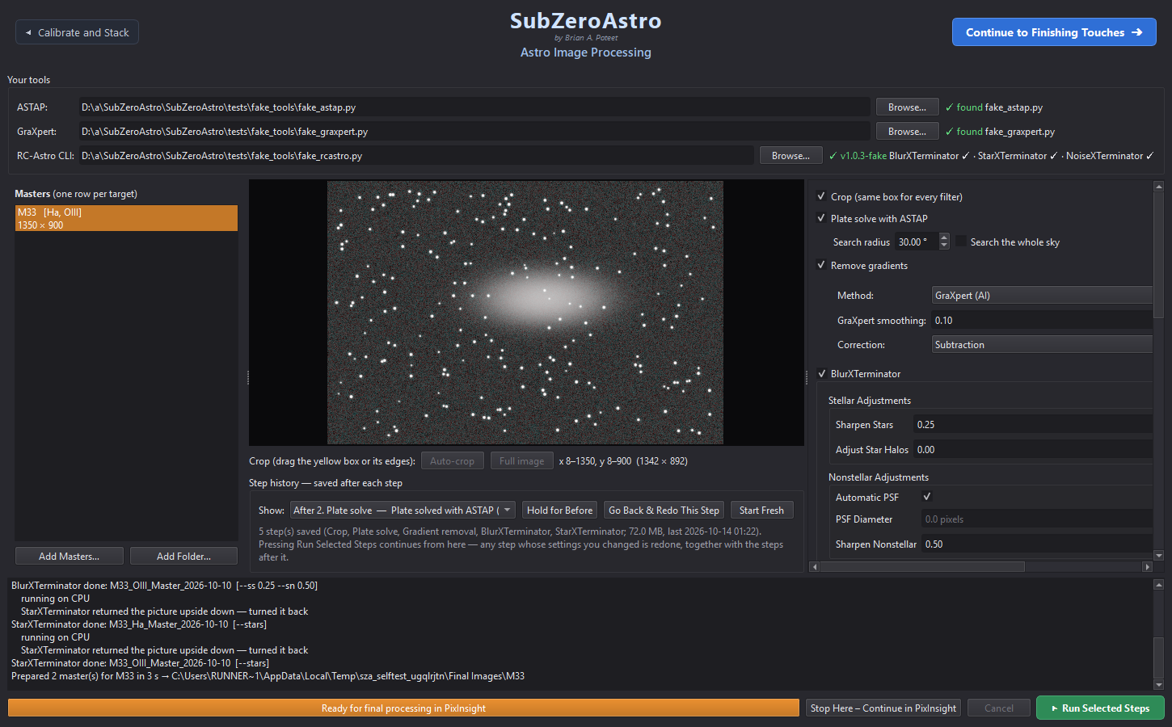
Step history under the preview (example data)
When it finishes, the bar at the bottom reads ✓ Ready for Processing Finishing Touches, the run button turns amber (✓ Done – Run Again?) and the Astro Image Processing – Complete window opens. It says what comes next and, for PixInsight users, lists a recommended order of PixInsight processes (also saved next to your files).
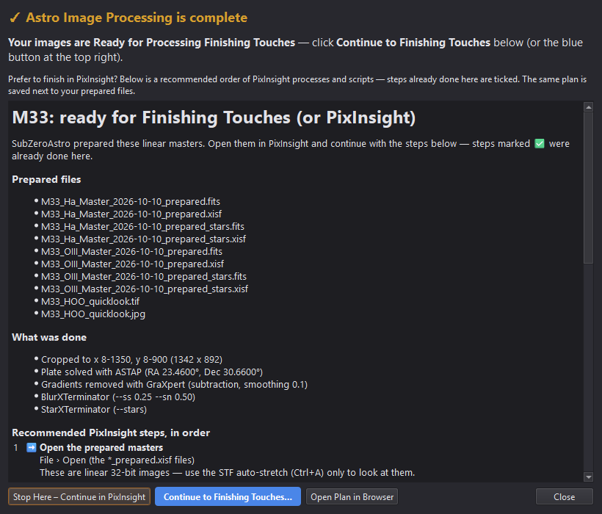
The Astro Image Processing – Complete window
Click Continue to Finishing Touches ➜, or Stop Here – Continue in PixInsight.

9 Page 4 – Finishing Touches
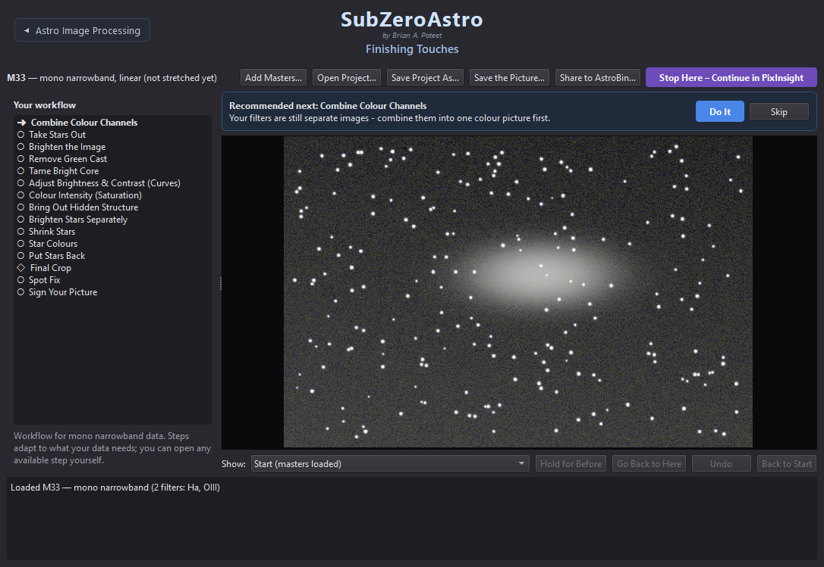
Finishing Touches: the workflow (left), the recommended next step and the picture (example data)

9.1 How it works
- The workflow list on the left shows every step for your kind of data: ✓ done, ➜ next, ○ later, – not needed, ◇ optional.
- The card at the top says what is Recommended next and why. Click Do It (or click any step in the list).
- Pick a version: each step shows 3-5 small pictures of your image - gentle to strong, or different colour mixes. ★ marks the suggestion. Clicking only previews it big - nothing changes yet.
- Optional: tick Fine-tune and move the plain-language sliders; the preview follows. Reset returns to the version you picked. Under the sliders the app says how much of the picture the setting visibly changes - if it says This barely changes your picture, there is little for that step to do on this target (no green cast to remove, no burnt-out core to tame), so the sliders have almost nothing to work on.
- Press Apply to keep it - or Cancel to leave the picture exactly as it was.
- Not quite enough? Many steps can be run again on their own result: after one of them the card shows ↻ Do It Again (and a ✓ step in the list can be clicked to run it again). That works for Balance Colours, Remove Green Cast, Tame Bright Core, Curves, Saturation, Bring Out Hidden Structure, Shrink Stars, Star Colours, Mote Buster, Darken the Sky Background, Final Noise Reduction, Flip, Final Crop and Spot Fix. One-way steps - combining, brightening, taking the stars out or putting them back, signing - are not repeated; use Go Back to Here to redo those.
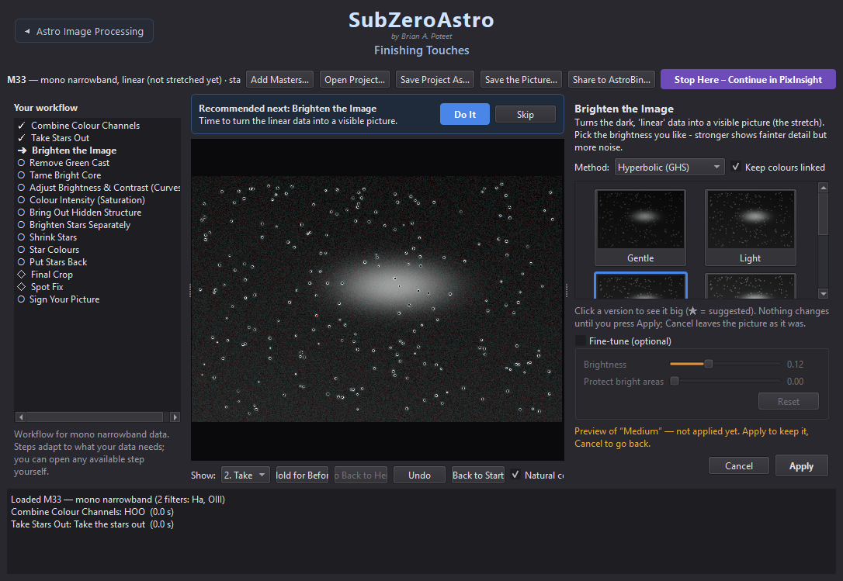
Picking a version: Brighten the Image offers five strengths (example data)
Several masters per filter, or masters from different setups. When you load more than one master of the same filter (other nights, other cameras or telescopes), all of them are used: they are brought to the same brightness and averaged, the less noisy ones counting more. Every master is first matched star by star to one reference master. Masters from another camera or telescope are bent slightly differently by their optics - most at the edges, which would give coloured double stars in the corners - so SubZeroAstro measures that distortion from hundreds of stars and corrects it. A master whose stars cannot be matched to the others is left out (when its filter has other masters), so it can't cause double stars, and the picture is cropped to the area all masters cover. The note under the title says how many masters were combined, corrected or left out.

9.2 Going back
- Undo (Ctrl+Z) removes the last step.
- Show: pick any earlier step to look at it; Hold for Before compares; Go Back to Here continues from that step.
- Back to Start returns to the original masters.
- Every step is saved. Opening the same masters again offers to carry on where you left off.

9.3 The steps
Which steps appear depends on your data. In typical order:
Step | What it does | PixInsight equivalent
Add Hydrogen Glow | Adds Ha to the red of an RGB set, without its stars. For a galaxy (M31, M33, M101, NGC 891…) it adds only the compact HII regions - the red knots along the arms | Continuum subtraction + PixelMath / NBRGBCombination
Combine Colour Channels | Builds colour from separate filters: RGB, LRGB, Hubble (SHO), HSO, HOO, Foraxx… | ChannelCombination / LRGBCombination
Choose a Colour Palette | Dual-band colour cameras: separates Ha and OIII (or SII and OIII) and offers HOO, Gold & blue, Foraxx… | PixelMath palettes
Balance Colours | Neutral sky and natural star colour | BackgroundNeutralization / colour calibration
Remove Green Cast | Removes the green tint (or turns Hubble colours gold and blue) | SCNR
Mote Buster ◇ | Fix Dust Donuts: finds the round shadows of dust and divides them out with a synthetic flat - the detail underneath comes back | A new flat, or DBE with division
Take Stars Out | Hides the stars so the nebula can be brightened strongly (instant if page 3 already separated them) | StarXTerminator
Brighten the Image | The stretch - five strengths, three methods | STF / HistogramTransformation / GHS
Tame Bright Core ◇ | Recovers detail in a burnt-out galaxy core or bright nebula | HDRMultiscaleTransform with a mask
Adjust Brightness & Contrast | Curves presets, sliders and a curve you can drag | CurvesTransformation
Colour Intensity | Richer or calmer colour; dark sky protected | Saturation curve
Bring Out Hidden Structure ◇ | Local contrast for dust lanes and cores | LocalHistogramEqualization
Brighten Stars Separately | Gentle star stretch - small, colourful stars | Star stretch
Shrink Stars | Makes stars smaller | Star reduction / MorphologicalTransformation
Star Colours | Natural star colours (estimated from your data) or clean white stars - recommended for narrowband | Star colour correction
Put Stars Back | Blends the stars back at the strength you pick | PixelMath screen blend
Darken the Sky Background ◇ | Darker (or lighter) sky without dimming the nebula, faint dust or stars; also evens out a brighter corner or side | ABE/DBE model + PixelMath
Final Noise Reduction ◇ | A last, light NoiseXTerminator pass on the finished picture (needs the RC-Astro CLI) | NoiseXTerminator
Flip the Picture ◇ | Flip Horizontally and/or Flip Vertically (each press toggles) - the saved pictures are flipped too | FastRotation
Final Crop ◇ | A last clean-up crop; finds ragged or off-colour edges for you | DynamicCrop
Spot Fix ◇ | Click dust donuts, satellite remnants or hot pixels to patch them | CloneStamp
Sign Your Picture ◇ | Your signature - and the target name above it - in a corner or wherever you drag it | Annotation

◇ = optional: offered in the list but not pushed by Recommended next.

9.4 Mote Buster: dust donuts
Dust on a filter or on the camera window casts round shadows - dust donuts (rings with a reflector, discs with a refractor). A good flat removes them; when the flat is missing or no longer matches, Mote Buster – Fix Dust Donuts helps. A dust shadow does not wipe anything out: it lets through the same fraction of light everywhere inside it, nebula included. So SubZeroAstro measures each donut's shadow ring by ring - in 16 directions against the sky just outside it, levelled for any gradient - builds a synthetic flat just for that donut and divides it out, the way a uniformity (flood-field) correction works. The detail underneath comes back instead of being painted over.
- Open Mote Buster while the picture is still unstretched (it comes before Take Stars Out). The donuts it finds in the sky are already circled in yellow.
- Donuts on bright nebulosity are not searched automatically (a gap between filaments could look like one) - click those yourself. Click to place a circle, then turn the mouse wheel to size that circle while you watch (just cover the donut). Click a circle to pick it again (it turns blue) and drag to move it; right-click removes it. A dashed ring follows the mouse to show the size of the next circle. Clicks need not be exact: each circle is centred on its donut automatically.
- Check the preview, then press the fix button. Mote Buster stays open on the fixed picture, so you can circle any donuts that are left and fix again - as many rounds as you like (each round is its own step; Undo Last Step takes back the last one). Press Done – Next Step ➜ when you are happy. Spot Fix works the same way. For small specks (hot pixels, satellite remnants) use Spot Fix instead.

9.5 Stars: take out, brighten, colour, put back
Stars and nebula look best when processed separately. Take Stars Out hides the stars (the picture shows the nebula alone); the nebula steps follow; then Brighten Stars Separately, Shrink Stars and Star Colours work on the stars (their previews show the stars); Put Stars Back recombines them. If you Skip Take Stars Out, the stars simply stay in the picture.

9.6 Darker sky, Final Crop, Spot Fix and your signature
- Darken the Sky Background is for a sky that looks grey or washed out. Pick Slightly darker, Darker, Much darker or Lighter (each shows the sky's brightness before and after), then fine-tune with Sky darkness. It works like PixInsight's background extraction: SubZeroAstro maps the sky glow across the picture (a nebula cannot push that map up) and takes part of it away. Everything that shines above the sky - nebula, faint dust, stars - keeps exactly the brightness it had above the sky, so faint filaments stay visible and stars are not dimmed. A brighter corner or side loses more, so the sky also evens out. Darker skies show grain more: a lighter setting often looks more natural.
- Final Noise Reduction runs NoiseXTerminator once more on the finished picture - most useful right after a darker sky, which shows grain more. The choices (Light, Medium, Strong) are shown at full size on the busiest part of the picture so you can judge the grain; Strength fine-tunes it. (BlurXTerminator is not offered here on purpose: it is made for unstretched data and already runs on page 3. For more crispness at the end, use Bring Out Hidden Structure.)
- Final Crop shows a yellow box on the whole picture, already placed where it found ragged or off-colour edges. Drag it or its sides (Found Edges / Whole Picture reset it) and press Crop to the Box.
- Spot Fix: click the middle of a blemish - a circle appears - then turn the mouse wheel to make that circle bigger or smaller until it just covers the blemish. Click a circle to pick it again (it turns blue) and drag to move it; right-click removes it. A dashed ring follows the mouse to show the size of the next circle. Then Fix the marked spots.
- Flip the Picture (optional): press Flip Horizontally (left ↔ right) and/or Flip Vertically (upside down) - each press flips the preview, pressing again flips it back (both together turn it 180°). When it looks right, press Keep This Orientation. Useful to match how the object usually looks in charts and other pictures. Flip before signing, so the signature reads the right way.
- Sign Your Picture: type your name once (it is remembered) and, if you like, a Target name for a line above it - filled in for you (for example NGC 281 "Pacman Nebula") and remembered for each target; empty it for none. Pick a font - Elegant script, Handwritten or Classic - a corner and a colour, and fine-tune size, opacity and distance from the edge. To put it anywhere else, drag the dashed box on the picture (or click where it should go); Place then says Where I dragged it. Do this last: the signature becomes part of the picture.
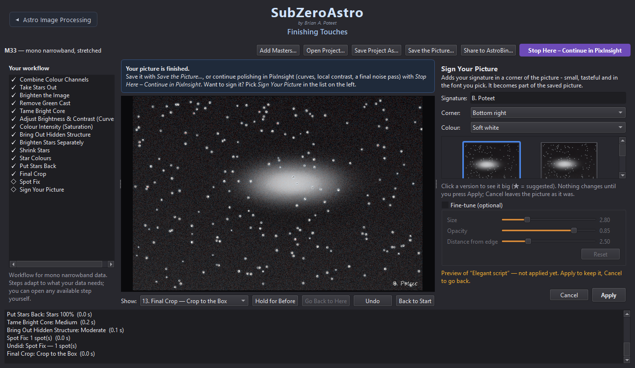
Sign Your Picture: signature text, corner, colour and three fonts (example data)

9.7 Saving and sharing
- Save the Picture… - TIFF (16-bit), JPG, PNG, XISF or FITS. All the files of one picture go into their own folder inside the one you pick, named after the target and telescope - for example Final Astro Pics/M101_RedCat51/ holds M101_finished.tif, .jpg, .fits and the description. The folder you pick is remembered: each target keeps its own, and a new target starts in the folder you used last. Tick Also save a short description of the target to save <target>_about.txt next to the pictures: the opening paragraphs of its Wikipedia article plus facts from SIMBAD (the professional astronomy database at CDS, Strasbourg) - the kind of object, its position (RA / Dec) and brightness. Faint objects without a Wikipedia article still get the SIMBAD facts. It is shown first so you can edit it (or type your own when there is no internet), and both sources are credited.
- Save Project As… / Open Project… - keep every step in a folder of your choice and carry on later.
- Share to AstroBin… - saves an upload-ready JPG (and optional TIFF) plus an acquisition CSV with every night's subs, exposure, gain, temperature and FWHM, then opens AstroBin's upload page. Upload the picture, and on the Acquisition step choose Import CSV.
- Stop Here – Continue in PixInsight - see 5.4.

9.8 Starting your next target
When a picture is finished, click the teal ↺ End this Project and Start New Project button at the top right of Finishing Touches. SubZeroAstro asks first - and if you have not saved the picture yet, offers Save the Picture First…. Then every page and image closes, the helper programs are checked again, and you are back on page 1 (Quality and Cull) with the Load Light Frame Data window open, ready for the next target's light frames: cull, stack, process and finish, from the beginning.
Your work is safe: Nothing on your disk is deleted. Your masters, finished pictures and every Finishing Touches step stay where they are: open the same masters on Finishing Touches later and the project carries on where you stopped.

10 Recipes for common setups

10.1 Colour camera (OSC), broadband
Cull › Stack (flats + darks or bias) › page 3: crop, plate solve, GraXpert, BlurX, StarX › page 4: Balance Colours, Remove Green Cast, Take Stars Out, Brighten, Curves, Colour Intensity, star steps, Put Stars Back, Final Crop, Sign.

10.2 Colour camera with a dual-band filter
Make sure the filter is set (page 1, Filter used or Set Filter Name) so the matching flats are found. On page 4 the first step is Choose a Colour Palette (HOO, Gold & blue, Foraxx…), and Star Colours is recommended so the stars are not all teal. Two dual-band filters of the same target - L-Ultimate + L-Synergy or Askar D1 + D2 - are combined into a full SHO set automatically.

10.3 Mono camera: LRGB
RGB (or LRGB) + Ha of a galaxy: SubZeroAstro recognises galaxies by name (M31, M33, M51, M81, M101, NGC 891, IC 342… or names like Andromeda or Pinwheel). Add Hydrogen Glow then recommends HII regions: the starlight - and the galaxy's own smooth light - is subtracted from the Ha, and only the compact hydrogen knots that clearly stand out are added to red. They stand out crisply against the blue arms without tinting the whole galaxy pink. Tick Show the hydrogen regions to see exactly what is added; All hydrogen glow adds everything, for galaxies set inside nebulosity.
Each filter is stacked separately on page 2 (one row each; keep Line up all filters on). Load all masters together on page 3 - they must appear as one row. Page 4 starts with Combine Colour Channels (RGB or LRGB).

10.4 Mono camera: narrowband (SHO)
As 10.3 with Ha, OIII and SII. Filter names from filter wheels such as Ha 7nm, H-alpha, O, S or Antlia Ha 3nm Pro are recognised. Page 4: Combine Colour Channels › Hubble (SHO), Foraxx or HOO; then Remove Green Cast (turns the green gold), and Star Colours before Put Stars Back.

10.5 Smart telescopes (Seestar, DWARF, Vespera)
Raw subs are recognised as lights automatically, with no calibration needed (the telescope calibrates on board). Alt-az field rotation is handled during alignment and the rotated edges are cropped. Seestar Stacked_… files from several nights can be combined on page 2, or a single stack can go straight to page 3.

10.6 Comets
A comet moves against the stars while you image it, so a normal stack (lined up on the stars) smears it, and a stack lined up on the comet trails the stars. SubZeroAstro does both and joins them. It recognises a comet by its name (C/2023 A3, 12P/Pons-Brooks, 161P Hartley-IRAS, or any name containing comet) - page 2's plan shows ☄ for it. While stacking it finds the comet's head in every frame, works out its motion from the frames' times, makes a second stack that follows the comet (the stars, which move through it, are rejected), and saves three masters: the main one with sharp stars and a sharp comet, plus _Comet (comet only) and _Stars (star-aligned) next to it. The log says how far the comet moved.
When the comet barely moved during the session (under 3 pixels - common with short sessions), or it is too faint or too uncertain to follow, only the ordinary stack is saved and the log says why. Long sessions of several frames per minute work best. On page 4 the main master goes through the usual steps; for a comet Darken the Sky is recommended, while star steps (Take Stars Out, Shrink Stars) are optional.

10.7 Target types
From the target's name SubZeroAstro works out what kind of object it is - galaxy, nebula, planetary nebula, star cluster or comet - and shows it in the title of page 4. The type only fine-tunes the recommendations; no step is ever taken away. Galaxies get Local Contrast recommended and HII regions in Add Hydrogen Glow; star clusters make star removal and shrinking optional (the stars are the subject); comets get a comet stack on page 2. When the name gives nothing away, the usual workflow for your data applies.

11 Troubleshooting and questions

11.1 Common questions
Problem | What to do
Windows: "Windows protected your PC" | Click More info › Run anyway (3.1).
Mac: "can't be opened" or "is damaged" | Right-click › Open, or the Terminal command in 3.2.
Frames show No filter | Set the filter on page 1 (Filter used or Frame › Set Filter Name…). Needed to match flats and to offer the right palettes.
Flats column is ✗ red | No flats for that filter/rig. Change the row's Filter to match your flats, or add the flats folder.
Bright corners and dark rings | Flats calibrated without bias/dark-flats, or flats that don't match. Check the ⚠ note on page 2 and add a bias or dark-flats (7.2).
Filters of one target in separate rows on page 3 | Check that the target names match (OBJECT). Masters stacked in separate runs are lined up automatically.
No Combine Colour Channels on page 4 | The masters were not loaded together, or a filter name was not recognised - the log lists the filters it found.
Plate solve failed | SubZeroAstro already retries with other field sizes (wrong binning or a reducer in the header are the usual cause; when the header has no focal length at all - Telescope Live files say 0 - typical fields from 0.25° to 4.5° are tried, and the one that works is reused for the other masters). If it still fails, read the log line: for small fields (under about 0.5°, e.g. galaxies with long focal lengths) ASTAP needs the D50 or D80 star database; with no pointing in the header tick Search the whole sky. A failed solve only means the picture has no sky coordinates - every other step works as usual.
Tools show not found | Click Browse… and point at the program, or use Settings › Your Tools… (4.1).
Amber banner on page 1 | A helper program is missing or not licensed. Set Up… fixes it; Don't Remind Me if you don't use it (4.1).
An XTerminator says not licensed | Click RC-Astro Licences… on page 3 and activate with the code from your rc-astro.com account (4.1).
Frames skipped: could not match the star field | Usually clouds, trailing or a badly out-of-focus frame. Frames saved mirror-image (some capture programs do this) are recognised and lined up automatically.
XTerminators very slow | Choose your graphics card under RC-Astro device (4.1).
Slow on a network drive | Use Star measurement: Fast; hide the image (Ctrl+I); results are cached for next time.
Something went wrong mid-run | Restart: SubZeroAstro offers to resume from its saved progress.
Doubled stars with frames from a remote observatory (or any camera with many hot pixels) | Fixed in 0.9.51. Calibrated frames that were not dithered can keep hundreds of hot pixels, and those sit in the same place on the sensor in every frame. Before 0.9.51 most of the "stars" found could be hot pixels, so frames from different nights could be lined up on the sensor instead of the sky - giving doubled stars. Now single-pixel spikes are ignored when stars are matched (a real star always spills light into its neighbours). Re-stack such data with 0.9.51 or later.
A frame shows This file is damaged: its picture data was converted to text | The file was downloaded or copied in a way that treated it as text: every byte the text conversion didn't understand was replaced, so the file is about twice its proper size (a 3056×3056 16-bit frame should be about 18.7 MB) and the picture is noise - while the header still reads fine. Such frames can never be aligned or stacked. Download them again (another browser, or as a zip) and check the file size.
Half the frames show unreadable, names starting with ._ | Those are hidden macOS copies (AppleDouble files) that a Mac writes next to every file on a NAS or external drive - not pictures. Version 0.9.31 and later ignore them; with an older version, delete the ._ files or turn off Include subfolders.

11.2 Getting help and reporting problems
Zip My Logs: the button at the top left of every page (also Help › Zip My Logs) puts the log of every open page, the stack logs of your masters, page 3's processing report and a short note about your computer (SubZeroAstro version, system, screen, which helper programs were found) into one zip on your Desktop and shows it - text only, no pictures. Attach that zip to your message: it is the quickest way to get help.
Note the version (in small print under the name at the top of every page, or Help › About) and take a screenshot of the page and its log. Problems and ideas can be reported on the GitHub page (github.com/bapoteet/SubZeroAstro, Issues). Advanced: SubZeroAstro --selftest runs the built-in self-test.

12 Keyboard shortcuts

12.1 Page 1 – Quality and Cull
Keys | Action
↑ ↓ ← → | Previous / next frame
Shift + arrows, Shift / Ctrl + click | Select several frames
X or Delete | Reject / restore the selected frame(s)
F | Flag / unflag
Shift+X | Reject all flagged frames
D | Clear all flags
Ctrl+F | Auto-Flag…
Ctrl+Z | Undo
Ctrl+0 / 1 / double-click | Fit to window / 100% / toggle
Mouse wheel, drag | Zoom, pan
Ctrl+O | Load Light Frame Data
Ctrl+Shift+O | Open one folder
Ctrl+N | Start over – load new data
Ctrl+H | FITS header window
Ctrl+I | Show / hide the image
Ctrl+E | Save a text list of kept frames
F5 | Reload folder

12.2 Page 4 – Finishing Touches
Keys | Action
Ctrl+Z | Undo the last step
Mouse wheel (Spot Fix) | Spot size
Right-click (Spot Fix) | Remove the last spot

13 Files and folders SubZeroAstro creates

13.1 Next to your images
Where | What
<lights folder>\REJECTED\ | Rejected sub-frames (moved, never deleted)
<calibration folder>\<rig>\Masters\… | Calibration masters (bias, darks, flats per filter)
<master lights folder>\<target>\ | Master lights (…_Master_<dates>.fits/.xisf) and their _stacklog.txt
Prepared\ (or your chosen folder)\<target>\ | Page 3 results: …_prepared.xisf, …_prepared_stars.xisf, quick-look JPG/TIFF, PixInsight next steps
Finished\, PixInsight\, AstroBin\ | Page 4 saves, PixInsight hand-overs and AstroBin uploads

13.2 On your computer
What | Windows | Mac
Saved progress | %LOCALAPPDATA%\SubZeroAstro\checkpoints | ~/Library/Application Support/SubZeroAstro
Measurement cache | %LOCALAPPDATA%\FITSBlasterWin\cache | ~/Library/Caches/SubZeroAstro
Settings | Windows registry (SubZeroAstro settings) | ~/Library/Preferences

14 Privacy, licence and credits

14.1 Privacy
SubZeroAstro does not send any information anywhere unless you ask it to. It reads and writes images only where you point it. Share to AstroBin… only opens AstroBin's page in your browser. Companion programs (ASTAP, GraXpert, RC-Astro) are separate programs with their own terms.

14.2 Licence and credits
SubZeroAstro is free software under the MIT License. Created by Brian A. Poteet, built with Claude (Anthropic). The culling view was inspired by FITS Blaster for macOS by Tom van Peer. PixInsight, BlurXTerminator, NoiseXTerminator, StarXTerminator, GraXpert, ASTAP, AstroBin and the telescope and filter names mentioned are trademarks of their respective owners.

15 Index

_
_Comet master 10.6
_Stars master 10.6
A
Add Folders 6.1
Add Hydrogen Glow 9.3
Add Masters 8.1
Aggressive 6.3
Alt-az 10.5
Apply 9.1
Askar D1 10.2
Askar D2 10.2
ASTAP 2.2, 4.1
AstroBin 9.7
Auto-crop 8.2
Auto-cull 6.3
Auto-Flag 6.3
B
Back button 5.1
Back to Start 9.2
Background 6.2
Badges 6.2
Balance Colours 9.3
Banner 5.1
Bias 4.3
Blind solve 8.3
BlurXTerminator 2.2, 8.5
Brighten Stars Separately 9.3
Brighten the Image 9.3
Bring Out Hidden Structure 9.3
Build Calibration Masters 7.6
C
Cache 13.2
Calibration 7.2
Calibration check 7.2
Calibration library 4.3, 7.6
Calibration masters folder 4.2
Cancel 9.1
Check & Stack 7.4
Choose a Colour Palette 9.3
Colour cameras 7.3
Combine Colour Channels 9.3
Comet stack 10.6
Comets 10.6
Continue button 5.1
Continue to Calibrate and Stack 6.5
Continue With the Rest 7.4
Crash recovery 5.3
Credits 14.2
Crop 8.2
Curves 9.3
D
Dark-flats 4.3, 7.6
Darken the Sky Background 9.3, 9.6
Darks 4.3
Device (GPU) 4.1
Disk space 2.1
Do It 9.1
Do It Again 9.1
Double stars 9.1
Dual-band filter 1.3
Dual-band recipe 10.2
Dust donuts 9.4
Dust motes 9.4
DWARF 10.5
E
Eccentricity 1.3, 6.2
End this Project and Start New Project 9.8
F
FAQ 11.1
Field distortion 9.1
File formats 2.3
Filter column 7.1
Filter used 6.1
Final Crop 9.3, 9.6
Final Noise Reduction 9.3
Fine-tune 9.1
Finished folder 13.1
FITS 2.3
FITS header 6.4
Fix Dust Donuts 9.3, 9.4
Flag 6.3
Flat warnings 7.2
Flats 4.3
Flip the Picture 9.3
Folder organisation 2.3
Four pages 1.1
FWHM 1.3, 6.2
G
Galaxy 10.7
Gatekeeper 3.2
Glossary 1.3
Go Back & Redo This Step 8.7
Go Back to Here 9.2
Gradient removal 8.4
Graphics card (GPU) 2.1
GraXpert 2.2, 4.1, 8.4
Grey sky 9.6
H
Hardware requirements 2.1
Hide image 6.4
HII regions 10.3
Hold for Before 8.7
Hold for Before (Finishing Touches) 9.2
Hubble palette 10.4
I
Include subfolders 6.1
Install (Mac) 3.2
Install (Windows) 3.1
Intro animation 4.4
K
Keyboard shortcuts 12.1
L
L-eXtreme 10.2
L-Synergy 10.2
L-Ultimate 10.2
Less aggressive 6.3
Licence 14.2
Light groups 7.1
Light leak 7.2
Light pollution 8.4
Line up all filters 7.3
Linear 1.3
Load Light Frame Data 6.1
Log 5.2
Logs 11.2
LRGB recipe 10.3
M
Master 1.3
Master bias 7.6
Master dark 7.6
Master flat 7.6
Master lights folder 4.2
Memory (RAM) 2.1
Missing calibration 7.2
MIT License 14.2
Mono 1.3
Mote Buster 9.3, 9.4
N
Narrowband 1.3
Narrowband recipe 10.4
Nebula 10.7
Network drive (NAS) 6.1
New project 9.8
Next target 9.8
No flats 7.2
NoiseXTerminator 2.2, 8.5
O
Old flats 7.2
Open Master Lights Folder 7.5
Open Project 9.7
OSC 1.3
OSC broadband recipe 10.1
Output files 13.1
Output folder 8.6
P
Page navigation 5.1
Pick the one you like 9.1
PixInsight 2.2
PixInsight hand-over 5.4
Planetary nebula 10.7
Plate solve 8.3
Plate solving 1.3
Prepared folder 13.1
Preview palette 8.6
Privacy 14.1
Progress bar 5.2
Put Stars Back 9.3
Q
Quarantine 3.2
Quick-look image 8.6
R
RC-Astro CLI 2.2, 4.1
Recommended next 9.1
Reject 6.3
Reject outliers 7.3
REJECTED folder 6.3, 13.1
Remove Green Cast 9.3
Reporting problems 11.2
Resume 5.3
RGB + Ha galaxies 10.3
Rig names 4.3
Run Selected Steps 8.7
S
Saturation 9.3
Save as FITS/XISF 7.3
Save final images 8.6
Save locations 4.2
Save Project As 9.7
Save the Picture 9.7
Saved progress 4.4
Saved progress location 13.2
Score 6.2
Search radius 8.3
Seestar 10.5
Self-test 11.2
Semi-aggressive 6.3
Session chart 6.2
Set Filter Name 6.4
Settings 4.4
Settings location 13.2
Several folders at once 6.1
Several masters per filter 9.1
Share to AstroBin 9.7
SHO recipe 10.4
Shortcuts 12.1
Shrink Stars 9.3
Sign Your Picture 9.3, 9.6
Signature fonts 9.6
Skip 9.1
Sky flat 7.2
SkyFlats (Mote Buster) 7.2
Smart telescopes 10.5
SmartScreen 3.1
SNR 1.3, 6.2
Spot Fix 9.3, 9.6
Stack log 7.5
Star cluster 10.7
Star Colours 9.3
Star count 6.2
Star measurement 4.4
Starless 9.5
Stars workflow 9.5
Start Fresh 8.7
StarXTerminator 2.2, 8.5
Status bar 5.2
Step history 8.7
Stop Here – Continue in PixInsight 5.4
Stretched 1.3
Sub-frame 1.3
Support 11.2
Synthetic flat 9.4
System requirements 2.1
T
Take Stars Out 9.3
Tame Bright Core 9.3
Target sets 8.1
Target types 10.7
Telescope (rig) 7.1
Tool locations 4.1
Troubleshooting 11.1
U
Undo 5.3, 9.2
Uninstall 3.4
Unscreen Stars 8.5
Updating 3.3
V
Vespera 10.5
W
Weight frames by noise 7.3
Will be lined up 8.1
Workflow list 9.1
Workflow overview 1.1
X
XISF 2.3
Z
Zip My Logs 11.2

