SubZeroAstro
From subs to masters – zero hassle.
User Manual
A beginner's guide to culling, stacking, processing and finishing your astrophotos
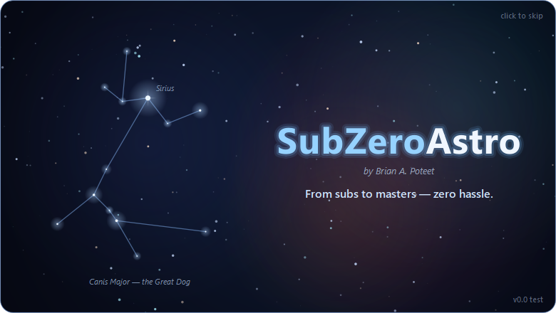
Version 0.9.100 beta · Windows and Mac (Apple silicon)
by Brian A. Poteet · October 2026

Highlights – what makes SubZeroAstro special
The features that set SubZeroAstro apart, grouped by page, with the version each arrived in. Each one is explained in its chapter.

Across the whole app
Feature | What it does | Since
Ready-made data recognised | Telescope Live (PROC = True), MaxIm DL (CALSTAT), PixInsight and Siril calibration notes, and _cal / _c file names mark lights as already calibrated: no double calibration, no SkyFlat, no false warnings | 0.9.49
Damaged-file detection | Spots FITS files whose picture data was turned into text by a bad download or copy, and says so instead of stacking noise | 0.9.50
Clear Everything – Start From Scratch | One menu item, like PixInsight's Reset Engine: forgets measurements and progress, moves old masters aside, optionally resets settings (keeps folders and tools) | 0.9.52
Crash recovery | Every page saves as it goes; after a crash or restart the app offers to bring you back to the same page | 0.6
Stop Here – Continue in PixInsight | From pages 2, 3 or 4, hands the image over as PixInsight-ready XISF with a note of the processes to use next | 0.7
Smart telescopes | Seestar, DWARF, Vespera, Stellina and eVscope raw subs and stacks are recognised and handled without calibration frames | 0.6
XISF everywhere | Reads PixInsight XISF light frames, including every compression (zlib, LZ4, LZ4-HC, Zstandard) | 0.9.28
Windows and Apple-silicon Mac | Both builds run a full self-test on real hardware before every release | 0.9.0

Page 1 – Quality & Cull
Feature | What it does | Since
Star quality on every frame | FWHM, eccentricity, SNR, star count and background, with a badge and a score against frames of the same camera and filter | Stage 2
Session chart | One dot per frame in capture order, nights separated; click to jump, drag a range to flag or reject | Stage 2
Auto-cull presets | Three strengths flag frames from FWHM, stars, SNR (catches thin cloud) and eccentricity; you review before rejecting, and it can be undone | 0.3.0
Fast measuring over a NAS | Reads about a quarter of each file, 3–4× faster on network drives; results are saved, so reopening is nearly instant | Stage 2

Page 2 – Calibrate & Stack
Feature | What it does | Since
Automatic calibration matching | Bias, darks and flats picked by camera, gain, offset, temperature, exposure, filter, rig and nearest date, with ✓ ⚠ ✗ and a plain reason | 0.4.0
SkyFlats (Mote Buster) | No flats? A flat is built from your own light frames; a poor one stops and asks before it is used | 0.9.22
Build Calibration Masters | One folder of mixed bias, dark, flat and dark-flat subs is sorted, checked and turned into masters, no lights needed | 0.9.24
Field-distortion correction | Meridian flips and other setups get a distortion model per frame, so corner stars stay sharp | 0.9.43
Hot pixels removed | Cosmetic correction in every frame: hot pixels and cosmic-ray hits are replaced by their neighbours, so undithered data has no coloured specks | 0.9.54
Hot-pixel-proof star matching | Single-pixel spikes are ignored, so frames with hundreds of hot pixels line up on the sky, not the sensor | 0.9.51
Plate-solution guided alignment | Frames and masters that carry a plate solution are lined up from where they point on the sky, with the stars fine-tuning it - rescues matches that fail and catches ones that are wrong | 0.9.53
Comet stacking | A second stack follows the comet; stars and comet are both sharp in the final master | 0.9.22

Page 3 – Astro Image Processing
Feature | What it does | Since
One run for every filter | Auto-crop, plate solve, gradient removal and the RC-Astro tools on every master of the target, with the same crop | 0.5.0
RC-Astro without a terminal | BlurXTerminator, NoiseXTerminator and StarXTerminator through the RC-Astro CLI, on the fast GPU, licences activated with a pasted code | 0.5.0
Persistent plate solving | ASTAP retries other field sizes and works when the header has no focal length | 0.9.37
PixInsight next steps | Linear XISF/FITS plus a plan of the PixInsight processes still to run, with done steps ticked | 0.5.0

Page 4 – Finishing Touches
Feature | What it does | Since
Recommended next step | Tailored to your data (colour, mono, narrowband, smart scope) and the target (galaxy, nebula, cluster, comet) | 0.7
Pick from your own image, then fine-tune | Small versions of your picture to choose from; clicking previews big without applying; plain-language sliders fine-tune it, and the app says how much of the picture they change | 0.7 / 0.9.48
Do It Again | Repeatable steps (curves, saturation, noise, Mote Buster …) can be run once more on their own result | 0.9.48
Adjust Colours, Full Window, zoom | Bring out one colour at a time; see the picture full-window and zoom in to full resolution at any step | 0.9.58
“Processed with SubZeroAstro” credit | A small, optional credit line in the corner of finished pictures - moves aside for your signature; never on XISF / FITS data | 0.9.59
Planetary nebulae recognised | From the name (M57, M27 …) the whole process is tailored: colour-preserving brightening, the nebula moved back from the stars image, Tame the Ring keeps the centre and halo | 0.9.71-0.9.76
Mote Buster – Fix Dust Donuts | Measures each dust shadow ring by ring and divides it out with a synthetic flat, so the detail underneath comes back; run it in rounds | 0.9.22 / 0.9.47
Every master used | Several masters per filter averaged (less noisy ones count more), other setups bent onto one grid, unmatched ones left out | 0.9.41
Target description | A short write-up from Wikipedia plus SIMBAD facts, credited, saved next to your picture | 0.9.34

Contents
1 Welcome to SubZeroAstro 7
1.1 What SubZeroAstro does
1.2 Who this manual is for
1.3 Words you will meet
1.4 Your data, improved - never painted
2 What you need 10
2.1 Computer requirements
2.2 Companion programs (optional but recommended)
2.3 Your images
3 Installing SubZeroAstro 12
3.1 Windows
3.2 Mac (Apple silicon)
3.3 Updating to a new version
3.4 Removing SubZeroAstro
4 First-time setup 13
4.1 Tell SubZeroAstro where your tools are
4.2 Choose where results are saved
4.3 The calibration library
4.4 Settings worth knowing
5 Finding your way around 18
5.1 The banner and page buttons
5.2 The log and the status bar
5.3 Saved progress and undo
5.4 Stop Here – Continue in PixInsight
6 Page 1 – Astro Image Quality and Cull 19
6.1 Loading your sub-frames
6.2 Reading the measurements
6.3 Choosing which frames to keep
6.4 Filters and the FITS header
6.5 On to stacking
7 Page 2 – Calibrate and Stack 22
7.1 The light frame groups
7.2 Calibration: what the ✓ ⚠ ✗ mean
7.3 Stacking options
7.4 Running the stack
7.5 Results
7.6 Build Calibration Masters (no lights needed)
8 Page 3 – Astro Image Processing 26
8.1 Masters and target sets
8.2 Crop
8.3 Plate solve
8.4 Remove gradients
8.5 The XTerminators
8.6 Saving the results
8.7 Running and the step history
9 Page 4 – Finishing Touches 30
9.1 How it works
9.2 Going back
9.3 The steps
9.4 Mote Buster: dust donuts
9.5 Stars: take out, brighten, colour, put back
9.6 Darker sky, Final Crop, Spot Fix and your signature
9.7 Saving and sharing
9.8 Starting your next target
10 Recipes for common setups 37
10.1 Colour camera (OSC), broadband
10.2 Colour camera with a dual-band filter
10.3 Mono camera: LRGB
10.4 Mono camera: narrowband (SHO)
10.5 Smart telescopes (Seestar, DWARF, Vespera)
10.6 Comets
10.7 Target types
10.8 Step-by-step recipes: how to use them
10.9 Recipe: colour camera, broadband (RGB, no filter or UV/IR cut)
10.10 Recipe: colour camera with one dual-band filter (HOO)
10.11 Recipe: colour camera with two dual-band filters (SHO)
10.12 Recipe: mono camera, RGB or LRGB
10.13 Recipe: mono camera, LRGB + Ha (galaxies)
10.14 Recipe: mono camera, narrowband (SHO or HOO)
10.15 Adjusting any recipe for your target
11 Troubleshooting and questions 43
11.1 Common questions
11.2 Getting help and reporting problems
12 Keyboard shortcuts 45
12.1 Page 1 – Quality and Cull
12.2 Page 4 – Finishing Touches
13 Files and folders SubZeroAstro creates 46
13.1 Next to your images
13.2 On your computer
14 Privacy, licence and credits 47
14.1 Privacy
14.2 Licence and credits
15 Processing Techniques and Tips 48
15.1 Tips for every target
15.2 Galaxies
15.3 Emission nebulae
15.4 Planetary nebulae
15.5 Dark nebulae and faint dust
15.6 Reflection nebulae and star clusters
15.7 Comets (more coming)
15.8 Moon and planets (coming)
15.9 Questions and fixes
16 Index 52

1 Welcome to SubZeroAstro

1.1 What SubZeroAstro does
SubZeroAstro takes you from a folder of raw sub-frames to a finished astrophoto - with as little hassle as possible. It walks you through four pages, one after the other, like turning the pages of a book (each shows Page 1 of 4, Page 2 of 4 … next to its title at the top, the same numbers this manual uses):
Page | What happens there
1. Astro Image Quality and Cull | Every sub-frame is measured (star size, roundness, signal, cloud). You keep the good ones and set aside the bad ones.
2. Calibrate and Stack | Your kept frames are calibrated with darks, flats and bias and combined into one clean master per filter.
3. Astro Image Processing | The masters are cropped, plate solved, cleared of gradients and (optionally) sharpened, de-noised and separated from their stars with the RC-Astro XTerminators.
4. Finishing Touches | A guided, pick-the-one-you-like workflow turns the masters into a finished colour picture you can save, sign and share.

At every page you can also stop and continue in PixInsight - SubZeroAstro saves exactly what you have so far, plus a note of what to do next there.
The SubZeroAstro start-up screen

1.2 Who this manual is for
This manual is written for newcomers to astrophotography processing. No knowledge of PixInsight or other processing software is needed. Experienced imagers will find the PixInsight equivalent of each step mentioned along the way.

1.3 Words you will meet
Word | What it means
Sub-frame (sub, light) | One single exposure of your target, e.g. 180 seconds.
Calibration frames | Darks (lens cap on, same exposure), flats (evenly lit, shows dust and vignetting), bias (shortest exposure) and dark-flats. They remove the camera's and telescope's own fingerprints.
Master | Many frames combined into one: a master light (your target) or a master dark / flat / bias.
Linear / stretched | Straight from the camera a picture is linear and looks almost black. Stretching (Brighten the Image) makes the faint detail visible.
OSC (colour camera) | One-shot-colour camera: records red, green and blue at once (e.g. ZWO ASI2600MC).
Mono camera | Records one filter at a time (L, R, G, B, Ha, OIII, SII); the colours are combined later.
Narrowband / dual-band | Filters that pass only the glow of hydrogen (Ha), oxygen (OIII) or sulphur (SII). A dual-band filter (e.g. Optolong L-Ultimate, Askar D1) passes two of them on a colour camera.
Plate solving | Working out exactly where in the sky the picture points, by matching its stars to a star catalogue.
FWHM | Star size (full width at half maximum). Smaller = sharper.
Eccentricity | How round stars are: 0 = round, 1 = a line. Above about 0.5 stars look elongated.
SNR | Signal-to-noise ratio: how clearly the stars rise above the sky. Drops with cloud, haze or moonlight.
Starless / stars-only | The picture split in two by StarXTerminator, so the nebula and the stars can be processed separately.

1.4 Your data, improved - never painted
SubZeroAstro brings out what your camera recorded - it does not invent detail or paint the target. Every step works from your own data:
- Brightness and colour: brightening, Curves, Saturation and the colour tools re-map the brightness and colour your camera measured. The colour-preserving stretch keeps each pixel's measured colour mix; palettes such as HOO and Foraxx assign your filters' real signal to colours.
- Bright cores and rings: Tame Bright Core and Tame the Ring re-make bright areas from your own unstretched (linear) data - detail they show was in your frames, hidden by the brightening.
- AI, used the accepted way: BlurXTerminator sharpens by deconvolution using the blur measured from your own stars; NoiseXTerminator removes noise; GraXpert models the light-pollution gradient so it can be subtracted. None of them adds structure that is not in the data.
- Smoothing (colour transitions, noise reduction) only averages what is there.
Where pixels are replaced - always to remove a flaw, never to add to the target:
- Spot Fix fills a blemish you circle (a hot pixel, a satellite remnant, a dust speck) from the sky around it - like PixInsight's CloneStamp, and only where you ask.
- Star removal (StarXTerminator) has to fill in the background behind each star it lifts out; Put Stars Back covers those places again with your real stars.
- Mote Buster and flats correct dust shadows and vignetting - artefacts of the optics, not of the sky.

2 What you need

2.1 Computer requirements
SubZeroAstro runs on Windows and on Macs with Apple silicon. Astro images are big (a 26-megapixel camera makes ~50 MB files; a night can easily be 20-50 GB), so more memory and a fast disk make everything quicker.
 | Minimum | Recommended
Operating system | Windows 10 (64-bit) or a Mac with Apple silicon (M1 or newer) and a recent macOS | Windows 11, or macOS 14 (Sonoma) or newer
Processor | 4 cores | 8 cores or more
Memory (RAM) | 16 GB | 32 GB or more (64 GB for 60-megapixel cameras or very large stacks)
Free disk space | 20 GB plus room for your images | An SSD with 100 GB or more free - stacking keeps temporary aligned frames on the local disk
Graphics card | Not required | An NVIDIA RTX card (Windows) or Apple silicon GPU makes the RC-Astro XTerminators many times faster
Screen | 1600 × 900 | 1920 × 1080 or larger

Tip: Images on a network drive (NAS) work fine. SubZeroAstro reads them carefully (3 files at a time) and remembers the measurements, so re-opening a session is quick.

2.2 Companion programs (optional but recommended)
SubZeroAstro works on its own, but it can call these free or commercial programs for the best results. Install them before the first setup (Chapter 4); SubZeroAstro finds them automatically in their usual places. Each time it starts, page 1 checks for them quietly in the background and shows an amber note if one is missing or not licensed (4.1).
Program | Used for | Where to get it | Without it
ASTAP + a star database (D50 suits most setups) | Plate solving (page 3) | hnsky.org/astap.htm (free) | Plate solving is skipped (PixInsight can do it later)
GraXpert | AI gradient removal (page 3) | graxpert.com (free) | A built-in gradient remover is used
RC-Astro CLI with your BlurXTerminator, NoiseXTerminator and StarXTerminator licences | Sharpening, noise reduction and star removal (pages 3 and 4) | Your RC-Astro account (rc-astro.com) | These steps are skipped; Take Stars Out is not available
PixInsight (optional) | Further processing after any page | pixinsight.com | Not needed - SubZeroAstro can finish the picture

2.3 Your images
- SubZeroAstro reads FITS (.fit, .fits, .fts) and PixInsight XISF (.xisf) files on every page - light frames, calibration frames and masters - from capture programs such as N.I.N.A., ASIAIR, SharpCap and smart telescopes (ZWO Seestar, DWARF, Vaonis Vespera, Stellina, eVscope). XISF files can be uncompressed or compressed with any of PixInsight's options (zlib, LZ4, LZ4-HC, Zstandard, with or without byte shuffling).
- Keep each night's lights in their own folder, and your calibration frames in a calibration library folder with one subfolder per telescope (see 4.3).
- Your original files are never changed or deleted. Rejected frames are only moved into a REJECTED subfolder.

3 Installing SubZeroAstro

3.1 Windows
- Open the SubZeroAstro releases page: github.com/bapoteet/SubZeroAstro/releases.
- Under the newest release, click SubZeroAstro-Windows.zip to download it.
- Right-click the downloaded zip › Extract All… and choose a permanent place, e.g. C:\Astro\SubZeroAstro.
- Open the extracted folder and double-click SubZeroAstro.exe. (Right-click › Pin to Start or Send to › Desktop gives you a shortcut.)
- If Windows shows "Windows protected your PC", click More info › Run anyway. This appears because the app is new and not yet code-signed; it is safe to continue.

3.2 Mac (Apple silicon)
- Open github.com/bapoteet/SubZeroAstro/releases and download SubZeroAstro-macOS-AppleSilicon.zip from the newest release.
- Double-click the zip in your Downloads folder; SubZeroAstro.app appears.
- Drag SubZeroAstro.app into your Applications folder.
- The first time only: right-click (or Control-click) the app › Open, then Open again in the message. After that it opens normally.
- If macOS says the app "is damaged" or "can't be opened", open Terminal (Applications › Utilities) and type: xattr -dr com.apple.quarantine /Applications/SubZeroAstro.app then press Return and open the app again.
Why the warnings?: Both messages appear because SubZeroAstro is not yet signed by Microsoft or notarized by Apple. Signing is being set up for future versions.
Mac: window size: SubZeroAstro opens filling the screen, with the menu bar and Dock still showing. Avoid the green button's full-screen mode on a Mac: it hides the menu bar (where Stack › Build Calibration Masters… and Help live). To fill the screen yourself, Option-click the green button, or double-click the window's title bar. If you make the window smaller, it opens at that size next time.

3.3 Updating to a new version
Download the newest zip from the releases page and replace the old app folder (Windows) or the app in Applications (Mac). Your settings, tool locations, rig names, saved measurements and saved progress are kept - they are stored separately from the app.

3.4 Removing SubZeroAstro
Delete the app folder (Windows) or drag SubZeroAstro from Applications to the Bin (Mac). Saved progress can be cleared first under Settings › Saved Progress. Your images are never touched.

4 First-time setup

4.1 Tell SubZeroAstro where your tools are
When SubZeroAstro starts, it checks for ASTAP, GraXpert and the RC-Astro CLI in the background. If one is missing - or RC-Astro is installed but a tool is not licensed - a slim amber banner appears at the top of page 1, saying what you would miss (for example plate solving is skipped). Nothing is wrong: you can still cull and stack. The banner has two buttons:
- Set Up… - opens the Your Tools window (also in Settings › Your Tools (ASTAP, GraXpert, RC-Astro)…).
- Don't Remind Me - hides the banner until something else changes. Use it if you have chosen not to use one of the programs.
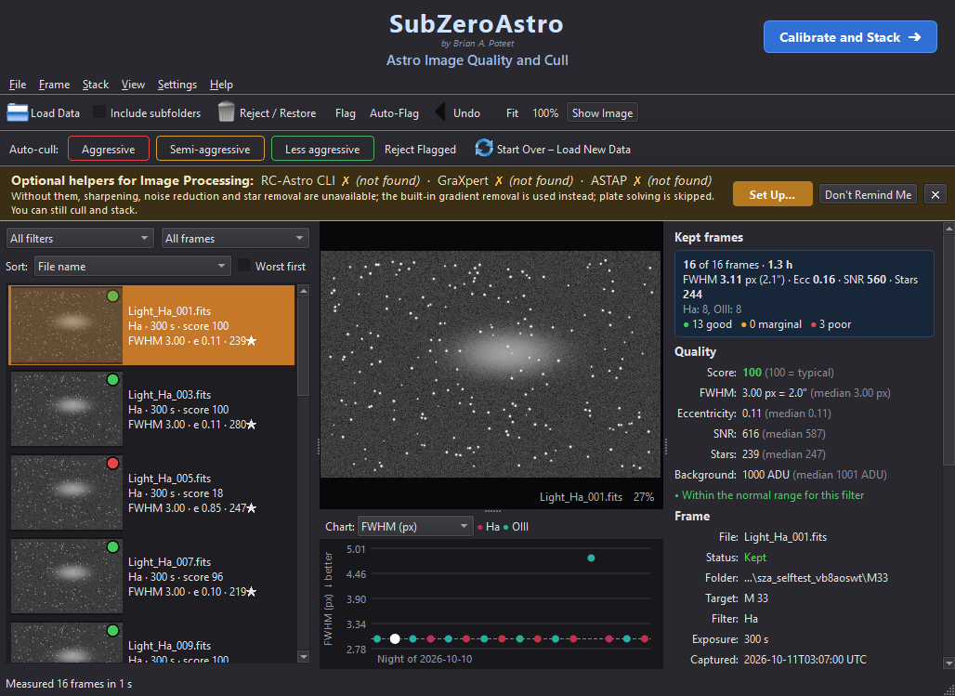
The amber banner on page 1 when helper programs are missing (example)
The Your Tools window lists each program with its status, a Download Page button for anything missing, and Browse… to point at a program installed somewhere unusual. Click Check Again after installing something.
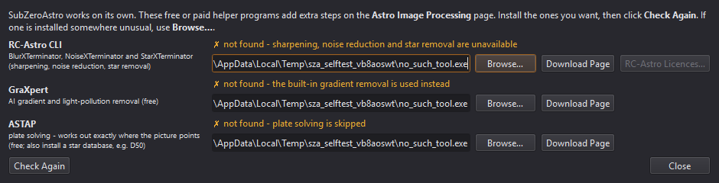
Settings › Your Tools: status, Browse… and Download Page for each helper program
The same programs are also shown in the Your tools box at the top of page 3 (Astro Image Processing), with a green ✓ found when detected. If one is missing, click Browse… next to it and pick the program:
Tool | Typical location on Windows | Typical location on a Mac
ASTAP | C:\Program Files\astap\astap.exe | /Applications/ASTAP.app (or astap_cli)
GraXpert | C:\Users\<you>\AppData\Local\Programs\GraXpert\GraXpert.exe | /Applications/GraXpert.app
RC-Astro CLI | C:\Program Files\RC-Astro\CLI\rc-astro.exe | where the RC-Astro installer put rc-astro

Activating RC-Astro licences. You do not need a terminal: click RC-Astro Licences… (next to the RC-Astro CLI row on page 3, or in the Your Tools window). The window shows which tools are licensed on this computer. To activate:
- Click Open My RC-Astro Account and sign in on rc-astro.com.
- Click Get Activation Code on the account page, then click it again to copy the code.
- Paste the code into the box and click Activate. One code activates every RC-Astro tool you own.
The tools turn green and page 3 is updated straight away. If activation does not work, Do It in a Terminal Window runs RC-Astro's own rc-astro license command, where you paste the code and press Enter. Check for Updates and Download & Install Update keep the RC-Astro CLI itself up to date.
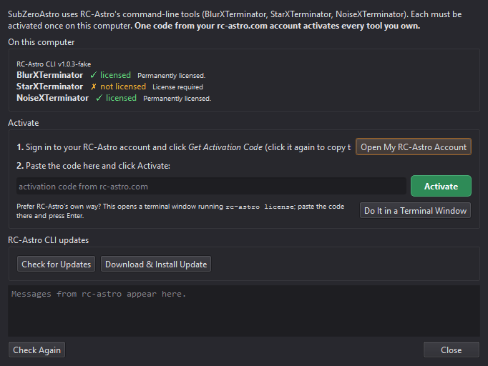
The RC-Astro Licences window (example: StarXTerminator not yet activated)
For the RC-Astro CLI the status line lists BlurXTerminator ✓ · StarXTerminator ✓ · NoiseXTerminator ✓ for every product licensed on this computer. Below the XTerminator settings, RC-Astro device chooses the processor: pick your dedicated graphics card (e.g. NVIDIA RTX…) - it is much faster than integrated graphics.
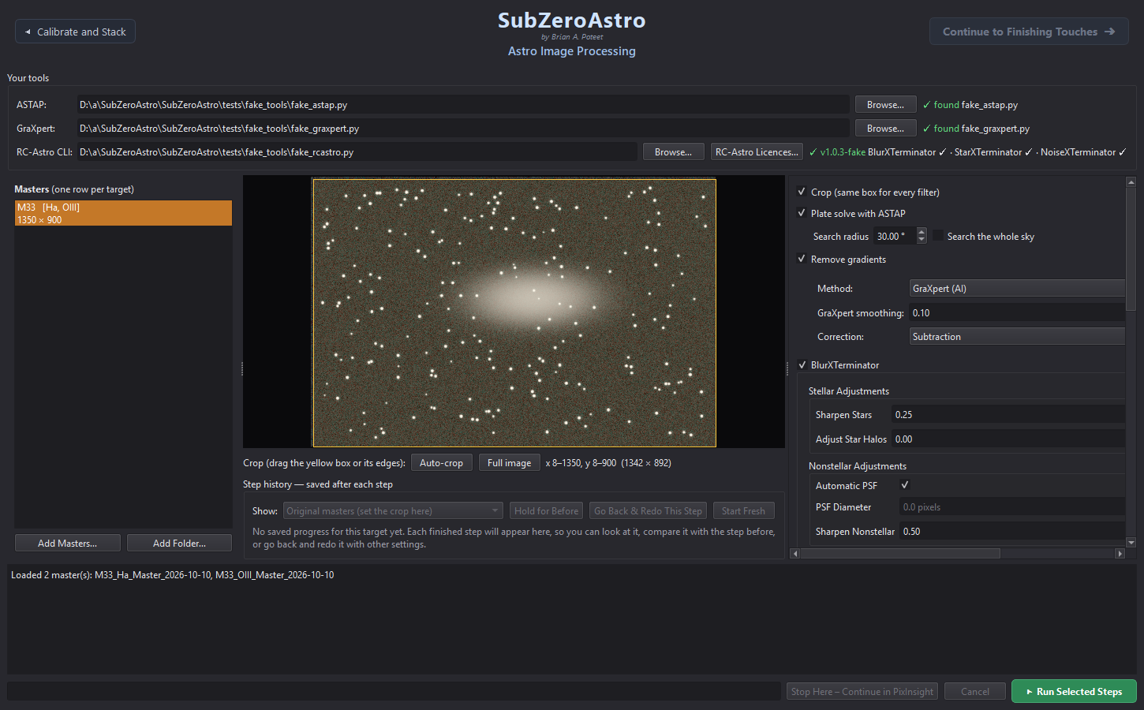
Page 3 with the tools box at the top (example data)

4.2 Choose where results are saved
On page 2 (Calibrate and Stack) set two folders under Save locations once; they are remembered:
- Calibration masters - your calibration library (4.3). New master darks, flats and bias are saved there and found again automatically next time.
- Master lights - where your stacked masters go, one subfolder per target, e.g. …\Master Lights\IC1805\IC1805_L-Ultimate_Master_2026-10-09_to_2026-10-11.fits.

4.3 The calibration library
SubZeroAstro keeps calibration masters in a tidy structure inside the calibration folder:
<calibration folder>\<telescope rig>\Masters\<camera>\Bias | Darks | Flats\<filter>\…
- Rig names: the first time, pick a rig name for each camera + focal length (e.g. 265mm scope or SQA55). This matters for ASIAIR, which records the mount, not the telescope.
- Darks are matched by exposure, gain, offset and temperature (±3 °C). Flats are matched by camera, filter and rig, nearest in date. Bias or dark-flats are needed to calibrate flats properly.
- You can add a folder of raw calibration sub-frames; SubZeroAstro builds the masters and saves them into the library.

4.4 Settings worth knowing
- Settings › Star measurement - Fast (default, about 3-4× quicker on a network drive), Full frame or Off.
- Settings › Your Tools (ASTAP, GraXpert, RC-Astro)… - see, locate and download the helper programs, and activate RC-Astro licences (4.1).
- Settings › Saved Progress… - where crash-recovery copies are kept, how much space they use and how long they are kept (30 days by default).
- Settings › Show Intro Animation at Startup - turn the start-up animation on or off. Help › Play the Intro Animation plays it any time.

5 Finding your way around

5.1 The banner and page buttons
Every page has the same banner at the top: SubZeroAstro, the author and the version in small print (e.g. v0.9.10 beta), and the page title. On the right is a blue Continue to … ➜ button that turns to the next page; on the left a grey ◀ previous page button goes back. Going back keeps your work: press Continue again and the page you left comes back exactly as it was.

5.2 The log and the status bar
The text area at the bottom of each page is the log: it tells you what was done, what was found and any warnings, in plain language. The orange bar shows progress and an estimate of the time left.
When a page has finished its job, its green run button turns amber - ✓ Stacked – Run Again? on page 2, ✓ Done – Run Again? on page 3 - so you can see at a glance that the page is done. Pressing it again asks first, so nothing is redone by accident. Add new images and it turns green again.

5.3 Saved progress and undo
- Page 1: your folders and flags are saved as you go. Ctrl+Z undoes rejects, flags and auto-cull.
- Pick up where you left off: when you start SubZeroAstro again - after quitting normally or after a crash - it offers Pick Up Where I Left Off: your frames and flags come back and it goes straight to the page you were on (Calibrate and Stack, Image Processing with the same masters, or Finishing Touches, where your steps resume). Start Fresh begins a new project; after End this Project and Start New Project nothing is offered.
- Page 2: each master is noted as soon as it is saved; an interrupted run offers Continue With the Rest.
- Page 3: the image is saved after every step; Go Back & Redo This Step and Start Fresh are under the preview.
- Page 4: every step is saved: Undo (Ctrl+Z), Go Back to Here, Back to Start, and reopening the same masters later resumes the project.
- Clear everything and start from scratch: File › Clear Everything – Start From Scratch… forgets the saved quality measurements (page 1 measures every frame again), deletes all saved progress (stacking resume points, page 3 and page 4 step histories, the last session) can move your existing master lights aside into an Old masters <date> folder, so a new stack starts truly from nothing, and can reset all settings to factory defaults (your folders, tool locations, rig names and signature are kept) - like PixInsight's Reset Engine. Your images, calibration library and masters are never deleted. Then load your light frames again.

5.4 Stop Here – Continue in PixInsight
The purple Stop Here – Continue in PixInsight button (pages 2, 3 and 4) saves the image exactly as it is right now as PixInsight-ready XISF, writes a short note listing the PixInsight processes to use next, and opens the folder with the files selected.

6 Page 1 – Astro Image Quality and Cull
Page 1: frame list (left), the selected frame, the session chart and the measurements (example data)

6.1 Loading your sub-frames
- Click Load Light Frame Data (Ctrl+O), then Add Folders…. You can pick several folders at once: click one, then Shift-click to add a range, or Ctrl-click (Cmd-click on a Mac) to add others one by one. Click Add Folders… again for folders in other places (other nights, other drives), or Add Files… for individual files.
- Include subfolders is ticked by default, so nights kept in subfolders are found too (FLAT, DARK, BIAS, CALIB and OFFSET folders are skipped). Untick it to load only the files directly in each folder; your choice is remembered.
- If your capture software does not record the filter (e.g. ASIAIR with a manual filter drawer), choose it under Filter used.
- Press Start Processing. Frames appear at once and are measured in the background.
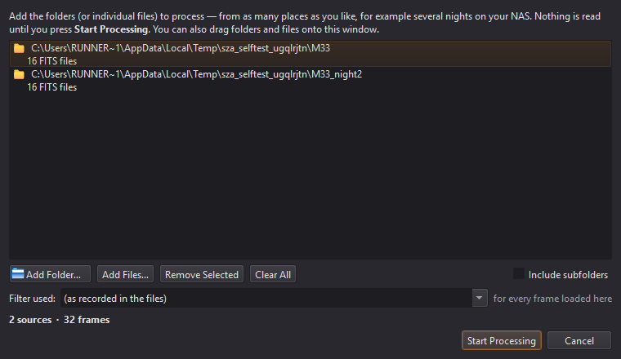
The Load Light Frame Data window
Calibration frames?: Load Light Frame Data is for light frames only. To turn bias, darks and flats into masters, use Stack › Build Calibration Masters… instead (7.6) - no light frames needed.
Tip: If the file names mention the filter (e.g. …_SQA55Lult_0001.fit), SubZeroAstro notices after the first few frames and offers to use it for the whole set. Duplicate files are skipped and reported.

6.2 Reading the measurements
Each frame gets a coloured badge (green = good, amber = check it, red = probably reject) and a score where 100 = a typical frame for that filter. Frames are only ever compared with frames from the same camera and filter.
Measurement | What it tells you | Bad sign
FWHM | Star size in pixels (and arcseconds) | Much larger than the median: poor focus or seeing
Eccentricity | Star roundness (0 = round) | Above ~0.5: tracking, guiding or wind
SNR | How clearly stars stand out | A drop: cloud, haze, dew, moonlight
Stars | Number of stars detected | A sudden drop: cloud or trees
Background | Sky brightness | A rise: moon, twilight, light pollution

The session chart below the image shows one dot per frame in capture order. Choose what to plot, click a dot to jump to that frame, or drag across the chart to select a range. The Kept frames box on the right shows the averages of what you are keeping.

6.3 Choosing which frames to keep
- Click an Auto-cull button - Aggressive, Semi-aggressive or Less aggressive. It only flags frames (yellow ring); hover over a button first to see how many it would flag.
- Review the flagged frames (switch the list to Flagged); the measurements panel says why each was picked. Press F to un-flag one you want to keep.
- Press Reject Flagged (Shift+X). Rejected frames are moved into a REJECTED subfolder - nothing is deleted, and Ctrl+Z brings them back.
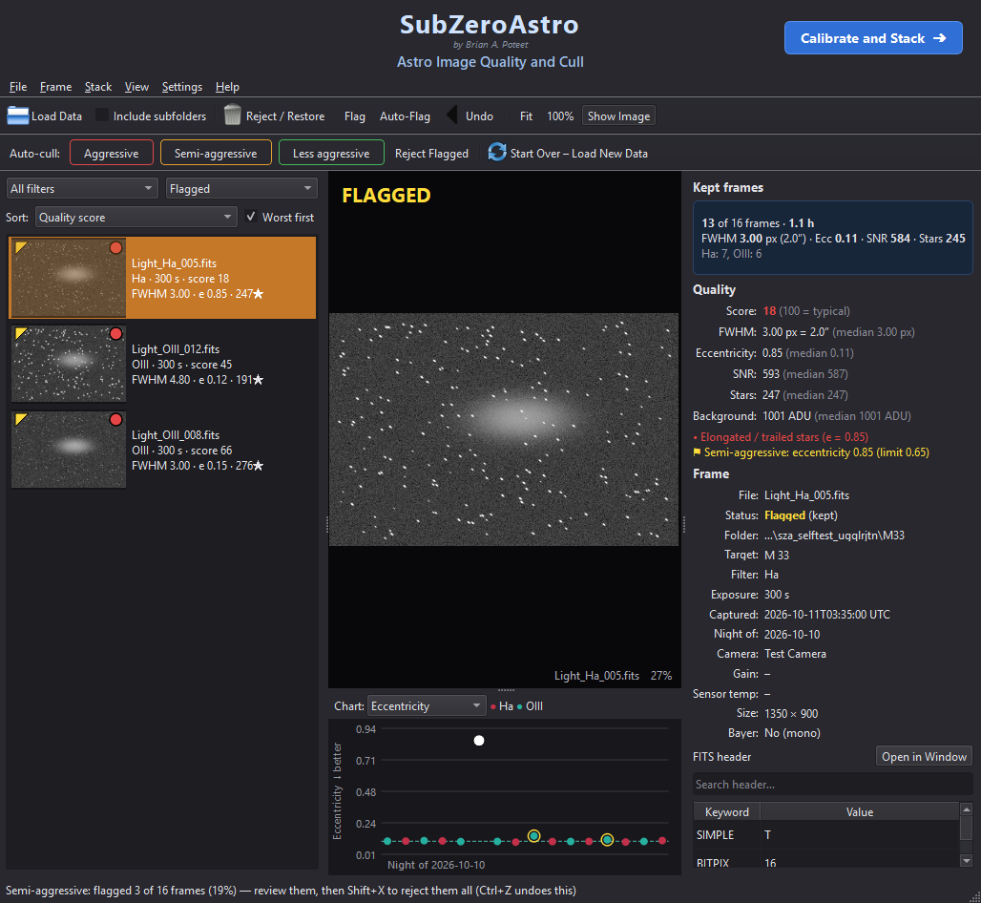
After Semi-aggressive: suspect frames are flagged for review (example data)
Auto-Flag (Ctrl+F) lets you set your own limits. X rejects or restores the selected frame(s), F flags them, D clears all flags.

6.4 Filters and the FITS header
- Frame › Set Filter Name… changes the filter for the selected frames (your files are not changed). Use it when the filter is missing or wrong - flats are matched by filter.
- Ctrl+H opens the full FITS header of the selected file, with search and Copy All.
- Ctrl+I hides or shows the image - useful on a slow network drive.

6.5 On to stacking
When you are happy, click Calibrate and Stack ➜ at the top right. Only your kept frames go to page 2.

7 Page 2 – Calibrate and Stack
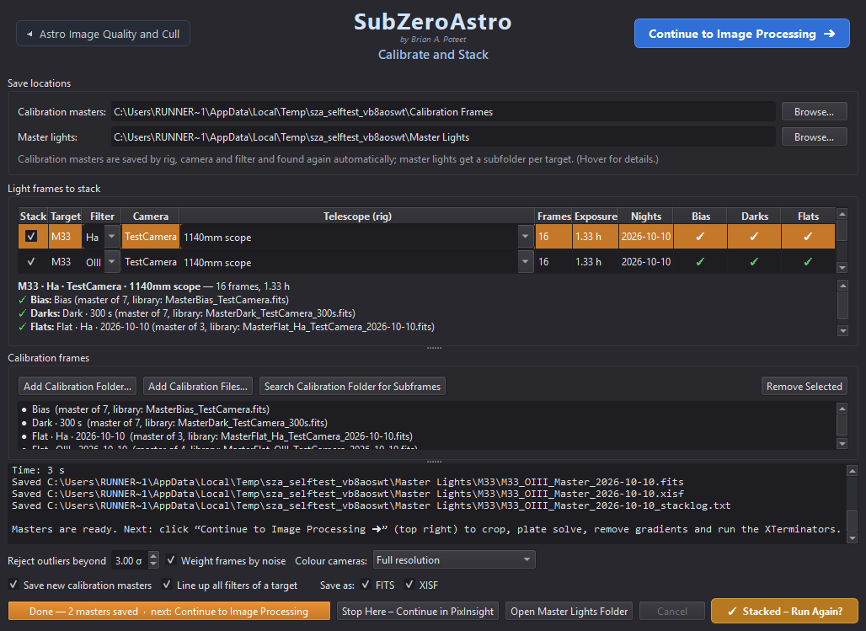
Page 2 after stacking: one row per target and filter, with the calibration found for each (example data)

7.1 The light frame groups
Each target's rows come broadband first (L, R, G, B - tinted blue), then narrowband (Ha, OIII, SII and dual-band filters - tinted red). The Stack: Broadband / Narrowband tick boxes above the table include or leave out a whole kind at once - handy when one target has both, and you want, say, only the LRGB + Ha of a galaxy (untick a single row with its own box).
Your kept frames are grouped by target + filter + camera + telescope - one row each, with the number of frames, total exposure and nights. The Filter of a row can be changed from its drop-down (for example to match your flats).

7.2 Calibration: what the ✓ ⚠ ✗ mean
Mark | Meaning
✓ green | A matching calibration master was found (or will be built).
⚠ orange | Usable, with a note - e.g. darks scaled from another exposure, or flats taken long ago ("dust may have moved"). It will be used.
✗ red | Nothing suitable - e.g. No flats for filter OIII. You can still stack, without that correction.

Click a row to read the details below the table. Add calibration with Add Calibration Folder…, Add Calibration Files… or Search Calibration Folder for Subframes.
No flats at all? SkyFlats (Mote Buster). When a filter has no flats, SubZeroAstro can make a flat from your light frames (option SkyFlats (Mote Buster) when flats are missing, on by default; at least 12 frames). It uses every light with that filter, camera and rig - from all your targets and nights, because the stars land somewhere different in each. Each frame is scaled to the same brightness, its stars are hidden, and its own light-pollution tilt is taken out (that tilt changes from frame to frame, while the vignetting stays put). Of every pixel's values only the lower half is used - a nebula can only add light - and what remains is what your optics and dust do to an even sky: a flat. The Flats cell then shows ⚠ SkyFlat (Mote Buster) (made from N light frames). SkyFlats are never saved to your library. (For donuts that remain, Mote Buster – Fix Dust Donuts on Finishing Touches works on one picture.)
Ready-made data is recognised. Lights bought already calibrated - from Telescope Live and similar services, or calibrated earlier in other software - must not be calibrated again (the dark would be subtracted twice and the flat divided in twice). SubZeroAstro recognises them from their headers and names: Telescope Live's PROC = True, MaxIm DL's CALSTAT, PixInsight's and Siril's calibration notes, and names such as _cal.fits or PixInsight's _c.xisf. Such a set shows ✓ not needed - the lights are already calibrated (…) in the Bias, Darks and Flats cells, gets no SkyFlat, raises no missing-calibration warnings - and its frames are never used to build a SkyFlat for your own lights.
Every SkyFlat is checked before it is used. If it may not be good enough - too few usable frames, grainy, a brightness range no vignetting has (nebulosity or a light-pollution gradient got in), large areas filled in - or it cannot be made at all because the master dark or bias is as bright as the sky (a light leak, or the wrong exposure or gain), SubZeroAstro stops and asks: Proceed Without Flats (the default), Use the SkyFlat Anyway, or Cancel Stacking. The reasons are listed in the box and in the log. A poor flat adds blotches or rings instead of removing them; without flats you can still fix dust donuts afterwards with Mote Buster – Fix Dust Donuts on Finishing Touches.
Meridian flips are handled. When the camera turned 180° with the telescope halfway through the night, the nebula sits on different sensor pixels before and after the flip. SubZeroAstro finds the two sides from the frames themselves and takes each pixel of the SkyFlat from the side that shows plain sky there - otherwise a faint dark copy of the nebula, turned upside down, would be printed into the picture. The stacking log says when this was done.
SkyFlats: A SkyFlat is best from several targets. From a single target whose nebula fills most of the picture, part of the nebula could be mistaken for vignetting - the Flats note warns you. Real flats are still the best: take some when you can.
Calibration check. Every stack checks its dark (or bias) against the lights and writes a Calibration check line in the log: light background - dark = sky left. If a master does not fit - brighter than the lights, uneven like a picture (light leaked in while the darks were taken: lens cap, filter wheel, focuser or room light) or practically zero (saved on another scale) - a window says so when stacking finishes. Such a frame makes bright bands, borders or blotches that no later step can fix: remove it from the Calibration frames list, or take new ones (scope fully covered, same gain, offset, temperature and exposure as the lights).
Important: If the Flats cell says the flats have no matching bias or dark-flats, the correction will be too strong: bright corners and dark rings. Add a bias or dark-flats for that camera and gain.

7.3 Stacking options
- Reject outliers beyond 3.0 σ - removes satellite trails, planes and hot pixels. The default suits almost everything.
- Weight frames by noise - better frames count more.
- Colour cameras: Full resolution (default) or half resolution (faster, less noise per pixel).
- Save as FITS and/or XISF; Save new calibration masters into your library.
- Line up all filters of a target (on) - all masters of a target share one pixel grid, ready to combine (LRGB, SHO).
Sharp stars to the corners. Every telescope bends the field a little, mostly at the edges. After a meridian flip (or between nights with another setup) that bending is turned round with the camera, so a plain shift-and-rotate alignment lines up the centre but leaves stars a pixel or two apart near the edges - doubled or smeared corner stars. SubZeroAstro measures each frame's stars against the reference and, when the edges are off, lines that frame up with a smooth distortion model instead. The stack log says how many frames were corrected.

7.4 Running the stack
Press ▶ Check & Stack. Anything missing is listed first, with Stack Anyway or Add Calibration Frames First…. The log shows each step. If a run is interrupted, the next run offers Continue With the Rest. When it finishes, the button turns amber: ✓ Stacked – Run Again?. Stacking again never overwrites a master - new versions are saved as _2, _3…

7.5 Results
Masters are saved in your master lights folder, one subfolder per target, with a _stacklog.txt listing every frame used. Open Master Lights Folder shows them. Click Continue to Image Processing ➜ to carry on.

7.6 Build Calibration Masters (no lights needed)
Took a fresh set of darks, flats or bias? Turn them into masters right away - no light frames needed: on page 1 choose Stack › Build Calibration Masters… (or click Build Calibration Masters… in the Calibration frames box on page 2). Choose the folder with the subframes - bias, darks, flats and dark-flats can all be mixed together in one folder (for example RedCat51Calis), or sit in subfolders. SubZeroAstro reads each file's header (and, if the header doesn't say, the file or folder name: Darks, Flats, Bias…) and sorts them:
- Bias - one master per gain and offset.
- Darks - one master per exposure, gain, offset and temperature (180 s and 300 s darks make two master darks).
- Flats - one master per filter (and night). Each flat is calibrated with dark-flats or short darks of the same exposure, or else a bias - from the same folder or already in your library.
- Dark-flats - saved as masters too, for next time.
The telescope (rig) name is taken from the folder name (RedCat51Calis → RedCat51) or the headers - check it, because flats are only used for lights from the same rig. Untick any set you don't want, then click Build Masters. Each master is saved to your calibration library (<library>/<rig>/Masters/<camera>/…) with its settings in the name, and is used automatically whenever you stack lights with matching settings.
Every master is checked as it is built. You are warned when a dark or bias is uneven like a picture (light leaked in), a dark is far brighter than the bias (light, or the camera not cooled), a bias is practically zero (saved on a 0..1 scale or with a pedestal taken off), or flats are over-exposed (clipped) or very dim. A warned master is still saved, so you can compare - but better to retake that set.
Taking good darks: Darks: cap the telescope (or take the camera off) and cover it, at night or in a dark room, with the filter wheel on a filter - not an empty slot. Match the lights' exposure, gain, offset and temperature.

8 Page 3 – Astro Image Processing
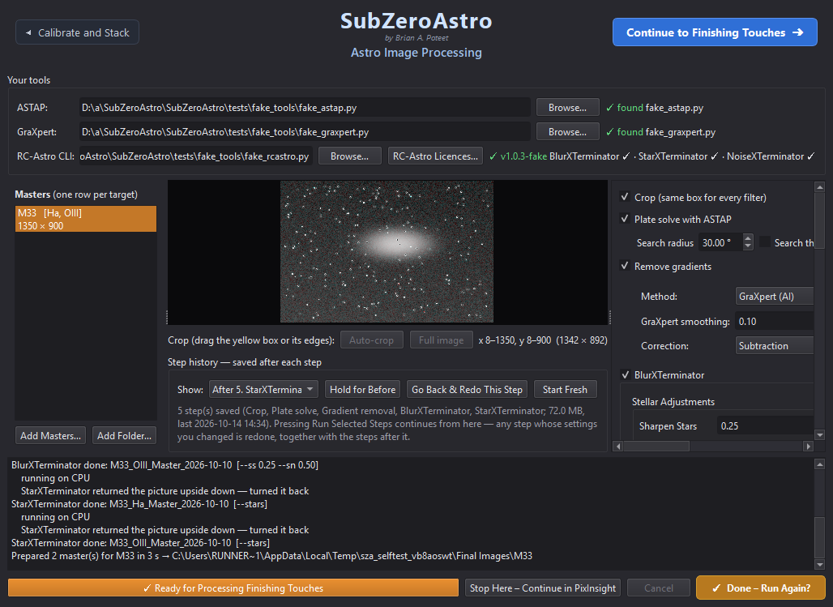
Page 3 after processing: masters (left), preview with crop box, step history, and the step settings (right)

8.1 Masters and target sets
The masters from page 2 are loaded automatically (or use Add Masters… / Add Folder…; with Add Folder… only the newest restack of each master is taken). Masters of the same target form one row - e.g. NGC281 [Ha, OIII, SII]. If they were stacked in separate runs the row says will be lined up: they are matched star-to-star onto one grid before anything else, and edges not covered by every filter are trimmed.

8.2 Crop
The yellow box on the preview is the crop. Auto-crop trims the ragged stacking edges; drag the box or its sides to adjust, or Full image to keep everything. The same box is used for every filter, so they stay aligned.

8.3 Plate solve
ASTAP finds where the picture points in the sky, using the position and pixel scale recorded in the masters. If it fails, tick Blind solve (slower, searches the whole sky).

8.4 Remove gradients
Removes light-pollution glow and uneven backgrounds. GraXpert (AI) is recommended; Smoothing 0.1 and Correction: Subtraction are good defaults. Without GraXpert a built-in model is used.

8.5 The XTerminators
Tool | What it does | Good starting settings
BlurXTerminator | Sharpens stars and detail | Sharpen Stars 0.50, Adjust Star Halos 0.40, Sharpen Nonstellar 0.50, Automatic PSF on
NoiseXTerminator | Reduces noise (a light pass on unstretched data) | Denoise 0.6
StarXTerminator | Separates a starless and a stars-only image | Generate Star Image on; Unscreen Stars off

Hover over any setting for a plain-language explanation. Unscreen Stars should stay off here: the stars image is then simply original minus starless and is added back later (what Finishing Touches expects). Turn it on only if you will recombine stretched images with a screen blend in PixInsight.

8.6 Saving the results
- The first time you run, SubZeroAstro asks where the processed images should go: Next to the Masters (a Prepared folder), Folder Used Last Time, or Choose a Folder…. Each target gets its own subfolder.
- Linear masters as XISF and/or FITS (these are what you process further), and a stretched preview as TIFF, JPG and/or PNG in the chosen Preview palette.

8.7 Running and the step history
Tick the steps you want and press ▶ Run Selected Steps. As each step finishes, the preview shows its result. Under Step history:
- Show - look at the result after any step.
- Hold for Before - press and hold to compare with the step before.
- Go Back & Redo This Step - change that step's settings and run again; only that step and the ones after it are redone.
- Start Fresh - forget the saved steps and start from the original masters.
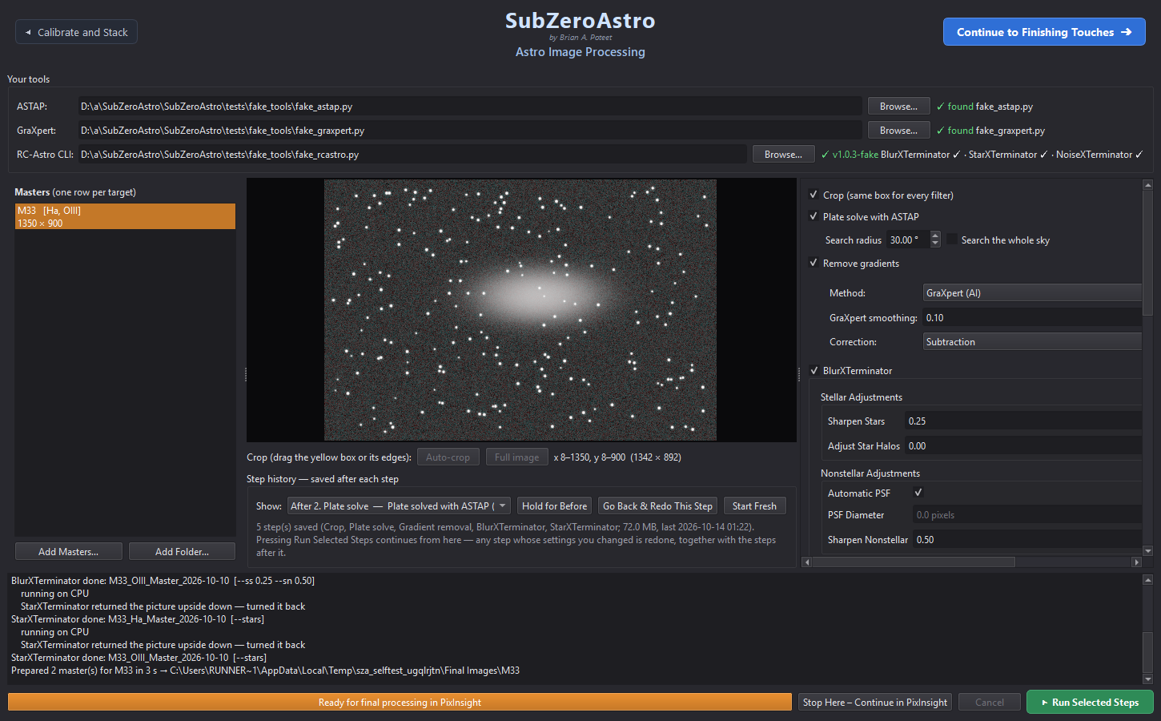
Step history under the preview (example data)
When it finishes, the bar at the bottom reads ✓ Ready for Processing Finishing Touches, the run button turns amber (✓ Done – Run Again?) and the Astro Image Processing – Complete window opens. It says what comes next and, for PixInsight users, lists a recommended order of PixInsight processes (also saved next to your files).
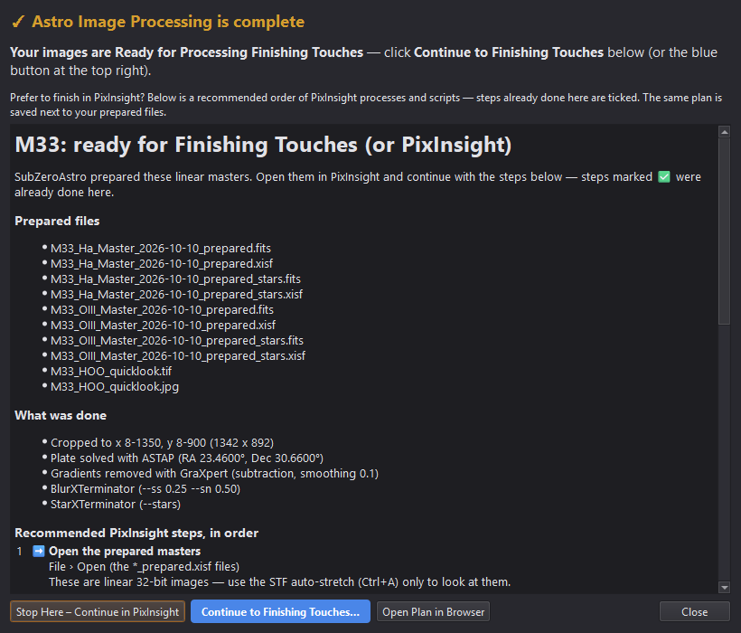
The Astro Image Processing – Complete window
Click Continue to Finishing Touches ➜, or Stop Here – Continue in PixInsight.

9 Page 4 – Finishing Touches
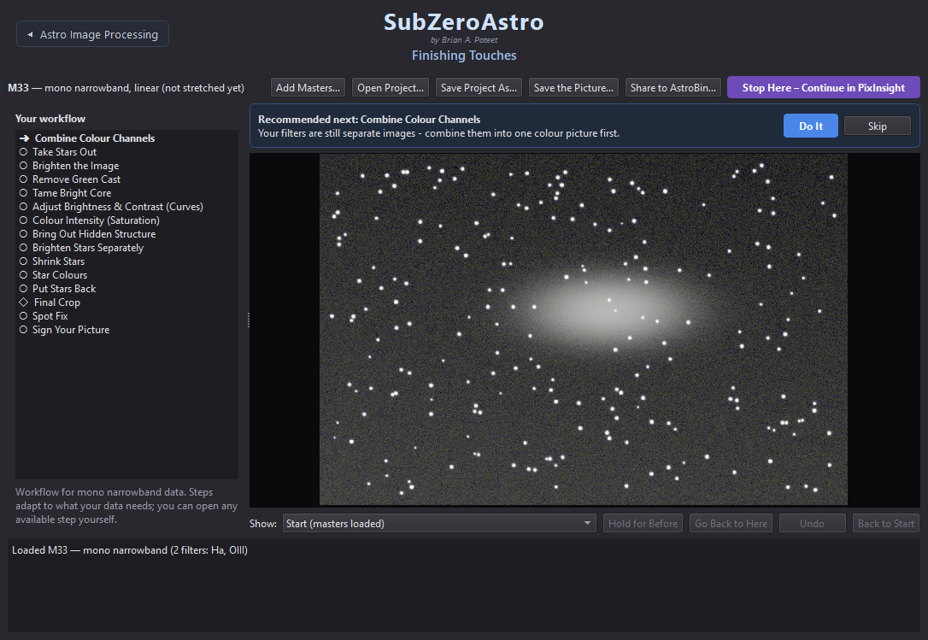
Finishing Touches: the workflow (left), the recommended next step and the picture (example data)

9.1 How it works
- The workflow list on the left shows every step for your kind of data: ✓ done, ➜ next, ○ later, – not needed, ◇ optional.
- The card at the top says what is Recommended next and why. Click Do It (or click any step in the list).
- Pick a version: each step shows 3-5 small pictures of your image - gentle to strong, or different colour mixes. ★ marks the suggestion. Clicking only previews it big - nothing changes yet.
- Optional: tick Fine-tune and move the plain-language sliders; the preview follows. Reset returns to the version you picked. Under the sliders the app says how much of the picture the setting visibly changes - if it says This barely changes your picture, there is little for that step to do on this target (no green cast to remove, no burnt-out core to tame), so the sliders have almost nothing to work on.
- Press the green Apply to keep it - or Cancel to leave the picture exactly as it was. When the step is done the panel says so in green (✓ … applied), Apply disappears and an amber ✓ Applied – Next Step ➜ button takes you straight to the next recommended step - so after a break you can always tell whether a step was applied. Steps that can be repeated also offer Apply Again. The picture goes back to the whole view after every step.
- Not quite enough? Many steps can be run again on their own result: after one of them the card shows ↻ Do It Again (and a ✓ step in the list can be clicked to run it again). That works for Balance Colours, Remove Green Cast, Tame Bright Core, Curves, Saturation, Bring Out Hidden Structure, Shrink Stars, Star Colours, Mote Buster, Darken the Sky Background, Final Noise Reduction, Flip, Final Crop and Spot Fix. One-way steps - combining, brightening, taking the stars out or putting them back, signing - are not repeated; use Go Back to Here to redo those.
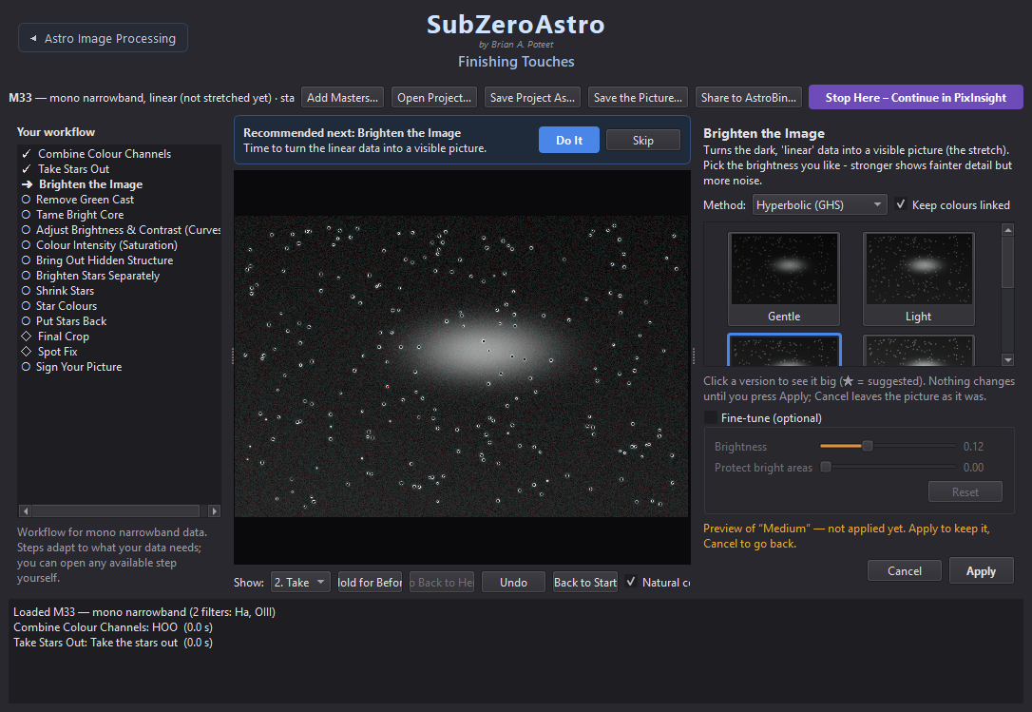
Picking a version: Brighten the Image offers five strengths (example data)
Several masters per filter, or masters from different setups. When you load more than one master of the same filter (other nights, other cameras or telescopes), all of them are used: they are brought to the same brightness and averaged, the less noisy ones counting more. This works the same for colour cameras (each colour separately). With a colour camera and a dual-band filter (L-Ultimate, L-eXtreme …), masters taken without the filter are left out of the picture - broadband starlight would bloat the stars and wash out the Ha / OIII colours - and the log says so. Every master is first matched star by star to one reference master. Masters from another camera or telescope are bent slightly differently by their optics - most at the edges, which would give coloured double stars in the corners - so SubZeroAstro measures that distortion from hundreds of stars and corrects it. When the masters carry a plate solution (data from remote observatories usually does, and page 3 adds one with ASTAP), it guides the match: the masters are lined up from where they point on the sky and the stars fine-tune it, so even masters with few stars in common line up. The deepest master (the most hours) is the reference everything is lined up to. Masters that page 3 already put on one grid are used as they are, and starless masters (StarXTerminator on page 3) are measured together with their stars-only images, so the stars are always there to line up by. After lining up, every master is checked: its four corners are compared with the reference's, and one still more than 1.5 px off is left out (when its filter has other masters) - the note says alignment check: … within X px in every corner. A master whose stars cannot be matched to the others is left out (when its filter has other masters), so it can't cause double stars, and the picture is cropped to the area all masters cover. The note under the title says how many masters were combined, corrected or left out.
Looking closely. Scroll on the picture to zoom in (past the preview's own pixels the full-resolution picture is drawn), drag to move around, double-click to fit it again. ⛶ Full Window (next to Show:) hides the step list, the panels and the log so the picture fills the window - press it again or Esc to go back. Both work at every step, also while looking back through earlier steps.
Bringing out one colour. Adjust Colours strengthens or calms one colour range at a time: pick a version (Boost blues, Boost reds, Blues and reds, Boost magentas, Calm the greens), then fine-tune with one slider per colour (1 = unchanged), Brighten boosted colours and Protect the sky. It is best done after Colour Intensity and before Final Noise Reduction - boosting a colour also boosts its colour noise, which the noise step then cleans - but it can be opened at any time later too (and run again).

9.2 Going back
- Undo (Ctrl+Z) removes the last step.
- Show: pick any earlier step to look at it; Hold for Before compares; Go Back to Here continues from that step.
- Back to Start returns to the original masters.
- Every step is saved. Opening the same masters again offers to carry on where you left off.

9.3 The steps
Which steps appear depends on your data. In typical order:
Step | What it does | PixInsight equivalent
Add Hydrogen Glow | Adds Ha to the red of an RGB set, without its stars. For a galaxy (M31, M33, M101, NGC 891…) it adds only the compact HII regions - the red knots along the arms | Continuum subtraction + PixelMath / NBRGBCombination
Combine Colour Channels | Builds colour from separate filters: RGB, LRGB, Hubble (SHO), HSO, HOO, Foraxx… | ChannelCombination / LRGBCombination
Choose a Colour Palette | Dual-band colour cameras: separates Ha and OIII (or SII and OIII) and offers HOO, Gold & blue, Foraxx… | PixelMath palettes
Balance Colours | Neutral sky and natural star colour | BackgroundNeutralization / colour calibration
Remove Green Cast | Removes the green tint (or turns Hubble colours gold and blue) | SCNR
Mote Buster ◇ | Fix Dust Donuts: finds the round shadows of dust and divides them out with a synthetic flat - the detail underneath comes back | A new flat, or DBE with division
Take Stars Out | Hides the stars so the nebula can be brightened strongly (instant if page 3 already separated them) | StarXTerminator
Brighten the Image | The stretch - five strengths, three methods | STF / HistogramTransformation / GHS
Adjust Colours ◇ | Bring out (or calm) one colour at a time - reds, yellows, greens, cyans, blues, magentas; grey and white stay as they are | ColorSaturation
Tame Bright Core ◇ | Recovers detail in a burnt-out galaxy core or bright nebula: lowers the core's glow towards its surroundings and brings its structure back from the linear data; a nucleus burnt out even in the masters is rounded off so no hard white dot is left, and the stronger versions take in more of the area around the core (works best right after Brighten the Image) | HDRMultiscaleTransform with a mask
Adjust Brightness & Contrast | Curves presets, sliders and a curve you can drag | CurvesTransformation
Colour Intensity | Richer or calmer colour; dark sky protected | Saturation curve
Bring Out Hidden Structure ◇ | Local contrast for dust lanes and cores; the empty sky is protected (fine-tune Protect the sky) | LocalHistogramEqualization
Brighten Stars Separately | Gentle star stretch - small, colourful stars. The star steps show the stars on their own; tick Show the nebula behind the stars to see them over the nebula | Star stretch
Shrink Stars | Makes stars smaller | Star reduction / MorphologicalTransformation
Star Colours | Natural star colours (estimated from your data) or clean white stars - recommended for narrowband | Star colour correction
Put Stars Back | Blends the stars back at the strength you pick | PixelMath screen blend
Darken the Sky Background ◇ | Darker (or lighter) sky without dimming the nebula, faint dust or stars; also evens out a brighter corner or side | ABE/DBE model + PixelMath
Final Noise Reduction ◇ | A last, light NoiseXTerminator pass on the finished picture (needs the RC-Astro CLI) | NoiseXTerminator
Flip or Rotate the Picture ◇ | Flip Horizontally and/or Vertically (each press toggles), Rotate 90° Clockwise or Counter-clockwise (each press turns once more) - the saved pictures are turned too | FastRotation
Final Crop ◇ | A last clean-up crop; finds ragged or off-colour edges for you | DynamicCrop
Spot Fix ◇ | Click dust donuts, satellite remnants or hot pixels to patch them | CloneStamp
Sign Your Picture ◇ | Your signature - and the target name above it - in a corner or wherever you drag it | Annotation

◇ = optional: offered in the list but not pushed by Recommended next.

9.4 Mote Buster: dust donuts
Dust on a filter or on the camera window casts round shadows - dust donuts (rings with a reflector, discs with a refractor). A good flat removes them; when the flat is missing or no longer matches, Mote Buster – Fix Dust Donuts helps. A dust shadow does not wipe anything out: it lets through the same fraction of light everywhere inside it, nebula included. So SubZeroAstro measures each donut's shadow ring by ring - in 16 directions against the sky just outside it, levelled for any gradient - builds a synthetic flat just for that donut and divides it out, the way a uniformity (flood-field) correction works. The detail underneath comes back instead of being painted over.
- Open Mote Buster while the picture is still unstretched (it comes before Take Stars Out). The donuts it finds in the sky are already circled in yellow.
- Donuts on bright nebulosity are not searched automatically (a gap between filaments could look like one) - click those yourself. Click to place a circle, then turn the mouse wheel to size that circle while you watch (just cover the donut). Click a circle to pick it again (it turns blue) and drag to move it; to remove it, right-click it, Control-click it on a Mac (Option- or Command-click also work), or pick it and press Delete. A dashed ring follows the mouse to show the size of the next circle. Clicks need not be exact: each circle is centred on its donut automatically.
- Bright rings count too. When the dust moved between the flats and the lights (or a filter was cleaned), the flat over-corrects: you get a brighter ring, often with a dark centre, and with mono filters it is usually in one filter only - a coloured (e.g. purple) halo. Mote Buster finds and fixes these as well, dimming the bright part and lifting the dark part. Every colour is centred and measured on its own (the same speck sits a little differently in each filter), and lopsided rings are followed too.
- Check the preview, then press the fix button. Mote Buster stays open on the fixed picture, so you can circle any donuts that are left and fix again - as many rounds as you like (each round is its own step; Undo Last Step takes back the last one). Press ✓ Applied – Next Step ➜ when you are happy. Spot Fix works the same way. For small specks (hot pixels, satellite remnants) use Spot Fix instead.

9.5 Stars: take out, brighten, colour, put back
Stars and nebula look best when processed separately. Take Stars Out hides the stars (the picture shows the nebula alone); the nebula steps follow; then Brighten Stars Separately, Shrink Stars and Star Colours work on the stars (their previews show the stars); Put Stars Back recombines them. If you Skip Take Stars Out, the stars simply stay in the picture.

9.6 Darker sky, Final Crop, Spot Fix and your signature
- Darken the Sky Background is for a sky that looks grey or washed out. Pick Slightly darker, Darker, Much darker or Lighter (each shows the sky's brightness before and after), then fine-tune with Sky darkness. It works like PixInsight's background extraction: SubZeroAstro maps the sky glow across the picture (a nebula cannot push that map up) and takes part of it away. Everything that shines above the sky - nebula, faint dust, stars - keeps exactly the brightness it had above the sky, so faint filaments stay visible and stars are not dimmed. A brighter corner or side loses more, so the sky also evens out. Darker skies show grain more: a lighter setting often looks more natural.
- Final Noise Reduction runs NoiseXTerminator once more on the finished picture - most useful right after a darker sky, which shows grain more. The choices (Light, Medium, Strong) are shown at full size on the busiest part of the picture so you can judge the grain; Strength fine-tunes it. (BlurXTerminator is not offered here on purpose: it is made for unstretched data and already runs on page 3. For more crispness at the end, use Bring Out Hidden Structure.)
- Final Crop shows a yellow box on the whole picture, already placed where it found ragged or off-colour edges. Drag it or its sides (Found Edges / Whole Picture reset it) and press Crop to the Box.
- Spot Fix: click the middle of a blemish - a circle appears - then turn the mouse wheel to make that circle bigger or smaller until it just covers the blemish. Click a circle to pick it again (it turns blue) and drag to move it; to remove it, right-click it, Control-click it on a Mac (Option- or Command-click also work), or pick it and press Delete. A dashed ring follows the mouse to show the size of the next circle. Circles go from a hot pixel to a large satellite blob or halo (up to 700 pixels in radius, like Mote Buster's), and the patch blends in smoothly with the sky's own slope and grain even when it is big. Stars inside the circle are kept: they are lifted off, the sky under them is patched, and they are put back on top - as bright as they really are, since a dust donut dims its stars too. Only the thing at the middle of the circle (what you clicked on - a hot pixel, a satellite remnant, an unwanted star) is removed. Then Fix the marked spots.
- Flip or Rotate the Picture (optional): press Flip Horizontally (left ↔ right) and/or Flip Vertically (upside down) - each press flips the preview, pressing again flips it back (both together turn it 180°). Rotate 90° Clockwise and Rotate 90° Counter-clockwise turn it a quarter turn per press (a portrait picture becomes landscape). When it looks right, press Keep This Orientation. Useful to match how the object usually looks in charts and other pictures. If the picture is already signed, the preview turns the signature too, but when you keep it the signature is put back on top the right way round, in the same place (steps done after signing - crop, Spot Fix, colour - are done again underneath it).
- Sign Your Picture: type your name once (it is remembered) and, if you like, a Target name for a line above it - filled in for you (for example NGC 281 "Pacman Nebula") and remembered for each target; empty it for none. Pick a font - Elegant script, Handwritten or Classic - a corner and a colour, and fine-tune size, opacity and distance from the edge. To put it anywhere else, drag the dashed box on the picture (or click where it should go); Place then says Where I dragged it. Do this last: the signature becomes part of the picture.
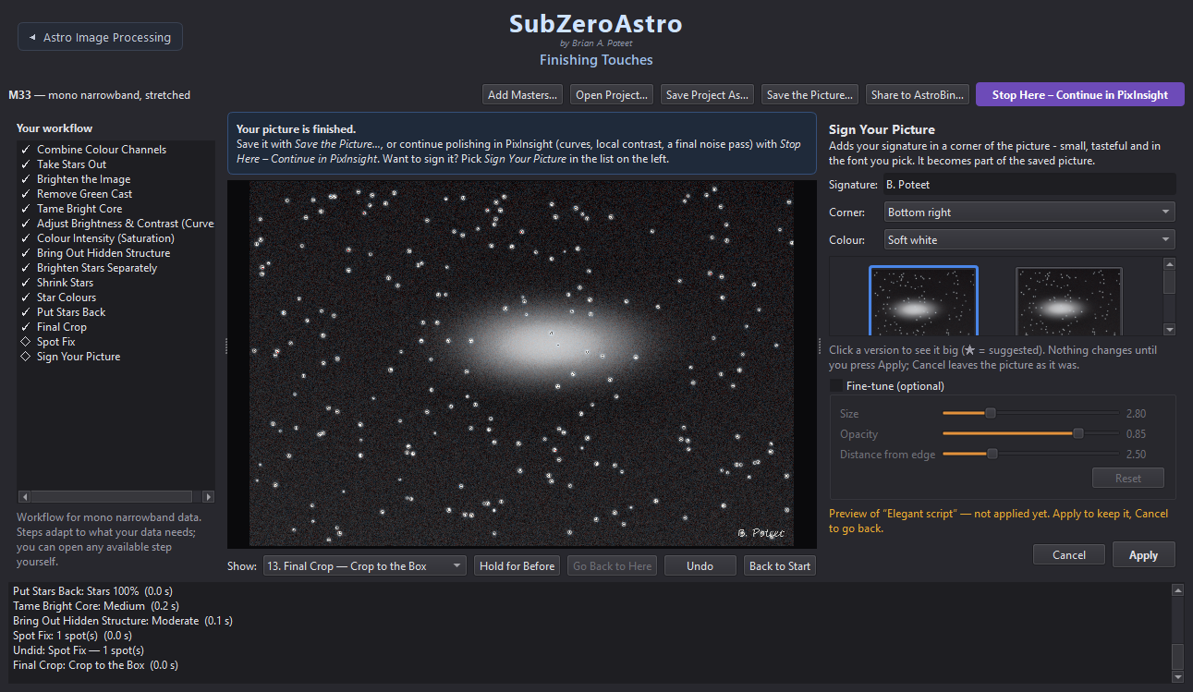
Sign Your Picture: signature text, corner, colour and three fonts (example data)

9.7 Saving and sharing
- Save the Picture… - TIFF (16-bit), JPG, PNG, XISF or FITS. All the files of one picture go into their own folder inside the one you pick, named after the target and telescope - for example Final Astro Pics/M101_RedCat51/ holds M101_finished.tif, .jpg, .fits and the description. The folder you pick is remembered: each target keeps its own, and a new target starts in the folder you used last. Tick Also save a short description of the target to save <target>_about.txt next to the pictures: the opening paragraphs of its Wikipedia article plus facts from SIMBAD (the professional astronomy database at CDS, Strasbourg) - the kind of object, its position (RA / Dec) and brightness. Faint objects without a Wikipedia article still get the SIMBAD facts. It is shown first so you can edit it (or type your own when there is no internet), and both sources are credited. Add a small “Processed with SubZeroAstro” credit (ticked at first) puts that line in small, light-grey, see-through letters in the bottom-left corner of the TIFF, JPG and PNG pictures - or the bottom-right corner if your signature is bottom-left. XISF and FITS files are never marked, and untick the box to leave the pictures clean (the choice is remembered; pictures shared to AstroBin follow it too).
- Save Project As… / Open Project… - keep every step in a folder of your choice and carry on later. A saved project can also be opened right from the start: the Open a Saved Project… button in the Load Light Frame Data window (or File › Open a Saved Project, Ctrl+Shift+O, on page 1) goes straight to Finishing Touches on its last step. Pick the project's folder or the folder you saved it into.
- Already stacked, no saved project? Use Process Existing Masters… in the same window (or File › Process Existing Master Lights…, Ctrl+Shift+M): pick your master lights - e.g. the D1 and D2 masters of one target - and you go straight to Astro Image Processing (page 2) without restacking. Masters are saved next to your lights' folder, named like IC1396_Askar D1_Master_2026-06-29_to_2026-07-03.fits; each restack adds _2, _3, … - from a folder only the newest is used.
- Share to AstroBin… - saves an upload-ready JPG (and optional TIFF) plus an acquisition CSV with every night's subs, exposure, gain, temperature and FWHM, then opens AstroBin's upload page. Upload the picture, and on the Acquisition step choose Import CSV.
- Stop Here – Continue in PixInsight - see 5.4.

9.8 Starting your next target
When a picture is finished, click the teal ↺ End this Project and Start New Project button at the top right of Finishing Touches. SubZeroAstro asks first - and if you have not saved the picture yet, offers Save the Picture First…. Then every page and image closes, the helper programs are checked again, and you are back on page 1 (Quality and Cull) with the Load Light Frame Data window open, ready for the next target's light frames: cull, stack, process and finish, from the beginning.
Your work is safe: Nothing on your disk is deleted. Your masters, finished pictures and every Finishing Touches step stay where they are: open the same masters on Finishing Touches later and the project carries on where you stopped.

10 Recipes for common setups

10.1 Colour camera (OSC), broadband
Cull › Stack (flats + darks or bias) › page 3: crop, plate solve, GraXpert, BlurX, StarX › page 4: Balance Colours, Remove Green Cast, Take Stars Out, Brighten, Curves, Colour Intensity, star steps, Put Stars Back, Final Crop, Sign.

10.2 Colour camera with a dual-band filter
Make sure the filter is set (page 1, Filter used or Set Filter Name) so the matching flats are found. On page 4 the first step is Choose a Colour Palette (HOO, Gold & blue, Foraxx…), and Star Colours is recommended so the stars are not all teal. Two dual-band filters of the same target - L-Ultimate + L-Synergy or Askar D1 + D2 - are combined into a full SHO set automatically: the red pixels of the first give Ha, those of the second SII, and the green and blue pixels of both give OIII. Those pixels also catch a little of the red line, so each OIII estimate carries some Ha or SII; because both filters see the same OIII, SubZeroAstro measures that leakage from your data, for each filter (real OIII is never negative, so where the Ha or SII is brightest the lowest OIII-to-line ratio is the leak - typically 5-9 %, never more than 10 %), takes it out, and combines the two OIII estimates weighted by each filter's exposure time (never less than 20% for either, since both hold real OIII) (the page 4 log shows the numbers). Combine Colour Channels then offers the narrowband palettes - Hubble (SHO), HSO, HOO + SII … - exactly as for a mono SHO set. Filter names such as D1, Askar D2, Ha/OIII or SII-OIII are all recognised.

10.3 Mono camera: LRGB
RGB (or LRGB) + Ha of a galaxy: SubZeroAstro recognises galaxies by name (M31, M33, M51, M81, M101, NGC 891, IC 342… or names like Andromeda or Pinwheel). Add Hydrogen Glow then recommends HII regions: the starlight - and the galaxy's own smooth light - is subtracted from the Ha, and only the compact hydrogen knots that clearly stand out are added to red. They stand out crisply against the blue arms without tinting the whole galaxy pink. Tick Show the hydrogen regions to see exactly what is added; All hydrogen glow adds everything, for galaxies set inside nebulosity.
Each filter is stacked separately on page 2 (one row each; keep Line up all filters on). Load all masters together on page 3 - they must appear as one row. Page 4 starts with Combine Colour Channels (RGB or LRGB).

10.4 Mono camera: narrowband (SHO)
As 10.3 with Ha, OIII and SII. Filter names from filter wheels such as Ha 7nm, H-alpha, O, S or Antlia Ha 3nm Pro are recognised. Page 4: Combine Colour Channels › Hubble (SHO), Foraxx or HOO; then Remove Green Cast - for Hubble (SHO) and Gold & blue it offers Gold 50 / 75 / 100%, which turn the green (your Ha, the strongest signal) gold instead of deleting it, so the bright structure keeps its brightness; Remove only is plain SCNR (darker, bluer, more magenta) - and Star Colours before Put Stars Back.

10.5 Smart telescopes (Seestar, DWARF, Vespera)
Raw subs are recognised as lights automatically, with no calibration needed (the telescope calibrates on board). Alt-az field rotation is handled during alignment and the rotated edges are cropped. Seestar Stacked_… files from several nights can be combined on page 2, or a single stack can go straight to page 3.

10.6 Comets
A comet moves against the stars while you image it, so a normal stack (lined up on the stars) smears it, and a stack lined up on the comet trails the stars. SubZeroAstro does both and joins them. It recognises a comet by its name (C/2023 A3, 12P/Pons-Brooks, 161P Hartley-IRAS, or any name containing comet) - page 2's plan shows ☄ for it. While stacking it finds the comet's head in every frame, works out its motion from the frames' times, makes a second stack that follows the comet (the stars, which move through it, are rejected), and saves three masters: the main one with sharp stars and a sharp comet, plus _Comet (comet only) and _Stars (star-aligned) next to it. The log says how far the comet moved.
When the comet barely moved during the session (under 3 pixels - common with short sessions), or it is too faint or too uncertain to follow, only the ordinary stack is saved and the log says why. Long sessions of several frames per minute work best. On page 4 the main master goes through the usual steps; for a comet Darken the Sky is recommended, while star steps (Take Stars Out, Shrink Stars) are optional.

10.7 Target types
From the target's name SubZeroAstro works out what kind of object it is - galaxy, nebula, planetary nebula, star cluster or comet - and shows it in the title of page 4. The type only fine-tunes the recommendations; no step is ever taken away. Galaxies get Tame Bright Core (right after brightening - skip it if the core already shows its detail) and Local Contrast recommended, and HII regions in Add Hydrogen Glow; other targets get Tame Bright Core recommended only when a burnt-out core is found; star clusters make star removal and shrinking optional (the stars are the subject); comets get a comet stack on page 2. When the name gives nothing away, the usual workflow for your data applies. Tips for each kind of target are in chapter 15.

10.8 Step-by-step recipes: how to use them
The next sections walk through each kind of data from start to finish, with the choice to pick at every step. They are a starting point, not rules: every step shows its versions side by side, so trust your eyes when another one looks better. Pick the section for your data (what you captured with), then check 10.15 for what changes with your kind of target (galaxy, nebula, planetary nebula, cluster).

Pages 1-3: the same for every recipe
- Page 1 - Quality and Cull: load the lights, press Auto-Flag › Semi-aggressive (or Less aggressive for a short session), look through the flagged frames and reject them. Set the filter name if the files don't carry it.
- Page 2 - Calibrate and Stack: check every row has ✓ for darks (or bias) and flats - add them with Add Calibration Folder… or set your calibration masters folder. Keep Line up all filters of a target on, so every filter of one target lands on the same pixels. Press Check & Stack.
- Page 3 - Astro Image Processing: all masters of one target must show as one row. Crop inside the area every frame covers (Auto-crop does it; a note in the log warns when a hand-drawn crop goes past it), keep plate solving and gradient removal on, BlurXTerminator Sharpen Stars 0.50 / Adjust Star Halos 0.40, NoiseXTerminator about 0.6, and StarXTerminator on (it makes Take Stars Out instant). Press Run Selected Steps, then Continue to Finishing Touches.
On page 4 the steps below are listed in order in Your workflow; ◇ marks optional ones. Each recipe names the version to pick - the ★ the app suggests is usually the same.

10.9 Recipe: colour camera, broadband (RGB, no filter or UV/IR cut)
Best for galaxies, star clusters and reflection nebulae - all the starlight colours are kept.
- Balance Colours › Stars white (neutral). Stars white, warmer / cooler only if you prefer that look.
- Remove Green Cast › 25-50 % - a colour camera leaves a little green; real green almost never exists in space.
- Mote Buster ◇ if dust donuts show (check the circles, right-click or Control-click any that are not donuts).
- Take Stars Out, then Brighten the Image › Medium (method Automatic; Colour-preserving keeps star and core colours better).
- Tame Bright Core - galaxies: Medium; other targets only if the centre is burnt out.
- Curves › More contrast or Brighter highlights. Use Lift faint detail only for deep data.
- Colour Intensity › Slight or Rich (the sky is protected).
- Adjust Colours ◇ - a gentle Boost blues for galaxy arms or reflection nebulae; Smooth colour transitions 0.2-0.3 if the colour looks blotchy.
- Bring Out Hidden Structure › Subtle or Moderate (keep Protect the sky about 0.85).
- Brighten Stars Separately › Medium (Keep bright stars small stays on), Shrink Stars › Moderate, Star Colours › Natural, Put Stars Back › 80-100 %.
- Darken the Sky Background › Slightly darker or Darker, then Final Noise Reduction › Medium.
- Final Crop, Spot Fix for any specks, Sign Your Picture, Save the Picture…

10.10 Recipe: colour camera with one dual-band filter (HOO)
For emission nebulae with L-eXtreme, L-Ultimate, L-eNhance, Askar D1/ColourMagic and similar: red pixels record Ha, green and blue record OIII.
- Choose a Colour Palette › HOO (natural red and teal). Alternatives: HOO (vivid), Gold & blue (Hubble-like), Foraxx (dynamic).
- Mote Buster ◇ if needed, then Take Stars Out.
- Brighten the Image › Medium (stronger is fine with the stars out).
- Remove Green Cast - HOO rarely needs much; Gold & blue offers Gold 100 %, which turns the green gold instead of deleting it.
- Tame Bright Core ◇ for a bright centre (Bubble, Orion, Lagoon).
- Curves › More contrast or Lift faint detail.
- Colour Intensity › Rich.
- Adjust Colours › Blues and reds separates the teal OIII from the red Ha; Calm the greens for leftover green; Smooth colour transitions 0.3 if the colour is grainy.
- Bring Out Hidden Structure › Moderate.
- Stars: Brighten Stars Separately › Medium, Shrink Stars › Moderate, Star Colours › Natural (a dual-band filter makes all stars one colour - this gives them back their blue-to-orange range), Put Stars Back › 80-100 %.
- Darken the Sky, Final Noise Reduction, crop, sign, save.
Tip: A galaxy through a dual-band filter: pick As captured (or HOO), keep Colour Intensity at Slight, and expect strong red HII knots but little blue in the arms - the filter blocks most of the starlight that carries a galaxy's colour. Long integration helps; a few hours of broadband data give the full colour.

10.11 Recipe: colour camera with two dual-band filters (SHO)
Askar D1 + D2, or L-Ultimate + L-Synergy, of the same target: SubZeroAstro builds Ha, OIII and SII and the page 4 log shows the line leakage it took out and how the two OIII estimates were combined.
- Stack each filter on page 2 (one row each); load both masters together on page 3 - one row.
- Combine Colour Channels › Hubble (SHO) (or Foraxx, HOO + SII).
- Mote Buster ◇, Take Stars Out, Brighten the Image › Medium.
- Remove Green Cast › Gold 100 % - the green is your Ha; Gold turns it gold instead of deleting it, which gives the classic gold and blue.
- Tame Bright Core ◇, Curves › More contrast.
- Colour Intensity › Slight - the SII and OIII from a colour camera are weak, and stronger saturation turns their noise into speckle.
- Adjust Colours: Blues about 1.2-1.3, Smooth colour transitions 0.4-0.6 (this is what keeps the background calm).
- Bring Out Hidden Structure › Subtle, then the star steps (Star Colours › Natural), Darken the Sky, Final Noise Reduction › Medium or Strong.

10.12 Recipe: mono camera, RGB or LRGB
Galaxies, star clusters and reflection nebulae with separate R, G, B (and L) filters. L carries the detail, RGB the colour - so RGB can be shorter or binned.
- Combine Colour Channels › LRGB (or RGB without L).
- Balance Colours › Stars white, Remove Green Cast › 25-50 %.
- Mote Buster ◇, Take Stars Out, Brighten the Image › Medium (Colour-preserving keeps a galaxy's core colour).
- Tame Bright Core - galaxies Medium; an L filter often needs it.
- Curves › Brighter highlights or More contrast.
- Colour Intensity › Slight or Rich.
- Adjust Colours ◇ - Boost blues 1.2-1.4 for spiral arms, Smooth colour transitions about 0.3 (RGB is usually noisier than L).
- Bring Out Hidden Structure › Subtle or Moderate (sky protected).
- Star steps (Star Colours › Natural or As they are), Darken the Sky › Slightly darker, Final Noise Reduction, crop, sign.

10.13 Recipe: mono camera, LRGB + Ha (galaxies)
The classic galaxy set: broadband colour with the red hydrogen (HII) knots along the arms added from Ha.
- Add Hydrogen Glow › HII regions - natural - the starlight is taken out of the Ha first, so only the compact pink knots are added to red, not a pink wash over the disc. Strong if the knots are the show-piece; tick Show the hydrogen regions to see what is added.
- Combine Colour Channels › LRGB.
- Balance Colours › Stars white (not warmer - neutral keeps the blue arms), Remove Green Cast › 25-50 %.
- Take Stars Out, Brighten the Image › Medium or Gentle, method Colour-preserving.
- Tame Bright Core › Medium.
- Curves › Brighter highlights (avoid Darker background - it brings out faint background blotches).
- Colour Intensity › Slight or Rich; Adjust Colours › Boost blues 1.2-1.4 with Smooth colour transitions 0.3.
- Bring Out Hidden Structure › Subtle or Moderate (sky protected).
- Star steps, Darken the Sky › Slightly darker (keep the faint outer arms), Final Noise Reduction, crop, sign.
Order matters: Add Hydrogen Glow comes before Combine Colour Channels - it works on the separate R and Ha images. Combined without it? The step stays in the list marked ⤼ (passed by): use Back to Start (or pick Start (masters loaded) under Show and press Go Back to Here), then Add Hydrogen Glow, then Combine. Also loaded OIII and SII masters of the galaxy? It is still processed as LRGB + Ha; the SHO and HOO palettes stay available under Combine Colour Channels.
Tip: Look for: a yellow-white core, blue arms and pink-red knots. A pink galaxy means the Ha is too strong - go back to HII regions - natural. Typical time split: L 40-50 %, R, G and B equal, Ha a few hours.

10.14 Recipe: mono camera, narrowband (SHO or HOO)
- Combine Colour Channels › Hubble (SHO) - or HOO with only Ha and OIII, Foraxx (dynamic), HOO + SII, HSO.
- Mote Buster ◇ - with filters, each has its own dust: bright rings or coloured halos are fixed per colour.
- Take Stars Out, Brighten the Image › Medium.
- Remove Green Cast › Gold 100 % for SHO (the classic gold and blue); plain removal for HOO.
- Tame Bright Core ◇ for a bright centre, Curves › More contrast.
- Colour Intensity › Rich; Adjust Colours › Blues and reds to separate the gold and blue; Smooth colour transitions 0.2-0.3.
- Bring Out Hidden Structure › Moderate.
- Star steps - Star Colours › Natural is recommended (narrowband makes stars magenta or one colour), Put Stars Back › 80-100 %.
- Darken the Sky, Final Noise Reduction, crop, sign.

10.15 Adjusting any recipe for your target
Target | What changes
Galaxy | Tame Bright Core (Medium) after brightening; Colour-preserving brightening; Curves › Brighter highlights; Darken the Sky › Slightly darker only (keep the halo and outer arms); a little Boost blues. See 15.2.
Emission nebula | Stars out before brightening, then brighten strongly; Bring Out Hidden Structure › Moderate; Adjust Colours › Blues and reds; Tame Bright Core only for a bright centre. See 15.3.
Planetary nebula | Small and bright: HOO (or SHO), Brighten › Gentle with Colour-preserving; Tame Bright Core comes after Curves and tames the bright ring to show the inner structure; skip Remove Green Cast if the OIII looks green-teal; Smooth colour transitions is on; crop tightly. See 15.4.
Dark nebula / faint dust | Curves › Lift faint detail, a light Bring Out Hidden Structure (Subtle), no strong sky darkening - the dust is the faint part. See 15.5.
Star cluster / reflection nebula | Stars are the subject: Take Stars Out and Shrink Stars are optional, Star Colours › Natural, vivid, Put Stars Back 100 %; reflection nebulae: Boost blues. See 15.6.

11 Troubleshooting and questions

11.1 Common questions
Problem | What to do
Windows: "Windows protected your PC" | Click More info › Run anyway (3.1).
Mac: "can't be opened" or "is damaged" | Right-click › Open, or the Terminal command in 3.2.
Frames show No filter | Set the filter on page 1 (Filter used or Frame › Set Filter Name…). Needed to match flats and to offer the right palettes.
Flats column is ✗ red | No flats for that filter/rig. Change the row's Filter to match your flats, or add the flats folder.
Bright corners and dark rings | Flats calibrated without bias/dark-flats, or flats that don't match. Check the ⚠ note on page 2 and add a bias or dark-flats (7.2).
Filters of one target in separate rows on page 3 | Check that the target names match (OBJECT). Masters stacked in separate runs are lined up automatically.
No Combine Colour Channels on page 4 | The masters were not loaded together, or a filter name was not recognised - the log lists the filters it found.
Plate solve failed | SubZeroAstro already retries with other field sizes (wrong binning or a reducer in the header are the usual cause; when the header has no focal length at all - Telescope Live files say 0 - typical fields from 0.25° to 4.5° are tried, and the one that works is reused for the other masters). If it still fails, read the log line: for small fields (under about 0.5°, e.g. galaxies with long focal lengths) ASTAP needs the D50 or D80 star database; with no pointing in the header tick Search the whole sky. A failed solve only means the picture has no sky coordinates - every other step works as usual.
Tools show not found | Click Browse… and point at the program, or use Settings › Your Tools… (4.1).
Amber banner on page 1 | A helper program is missing or not licensed. Set Up… fixes it; Don't Remind Me if you don't use it (4.1).
An XTerminator says not licensed | Click RC-Astro Licences… on page 3 and activate with the code from your rc-astro.com account (4.1).
Frames skipped: could not match the star field | Usually clouds, trailing or a badly out-of-focus frame. Frames saved mirror-image (some capture programs do this) are recognised and lined up automatically.
XTerminators very slow | Choose your graphics card under RC-Astro device (4.1).
Slow on a network drive | Use Star measurement: Fast; hide the image (Ctrl+I); results are cached for next time.
Something went wrong mid-run | Restart: SubZeroAstro offers to resume from its saved progress.
Coloured specks (single red, green or blue pixels) all over the picture | Hot pixels that survived stacking - they do when the frames were not dithered (common with remote-observatory data), because they sit on the same pixel in every frame. Since 0.9.54 Remove hot pixels (page 2, on by default) replaces them in every frame before stacking; re-stack such data.
Doubled stars with frames from a remote observatory (or any camera with many hot pixels) | Fixed in 0.9.51. Calibrated frames that were not dithered can keep hundreds of hot pixels, and those sit in the same place on the sensor in every frame. Before 0.9.51 most of the "stars" found could be hot pixels, so frames from different nights could be lined up on the sensor instead of the sky - giving doubled stars. Now single-pixel spikes are ignored when stars are matched (a real star always spills light into its neighbours). Re-stack such data with 0.9.51 or later.
A frame shows This file is damaged: its picture data was converted to text | The file was downloaded or copied in a way that treated it as text: every byte the text conversion didn't understand was replaced, so the file is about twice its proper size (a 3056×3056 16-bit frame should be about 18.7 MB) and the picture is noise - while the header still reads fine. Such frames can never be aligned or stacked. Download them again (another browser, or as a zip) and check the file size.
Half the frames show unreadable, names starting with ._ | Those are hidden macOS copies (AppleDouble files) that a Mac writes next to every file on a NAS or external drive - not pictures. Version 0.9.31 and later ignore them; with an older version, delete the ._ files or turn off Include subfolders.

11.2 Getting help and reporting problems
Zip My Logs: the button at the top left of every page (also Help › Zip My Logs) puts the log of every open page, the stack logs of your masters, page 3's processing report and a short note about your computer (SubZeroAstro version, system, screen, which helper programs were found) into one zip on your Desktop and shows it - text only, no pictures. Attach that zip to your message: it is the quickest way to get help.
Note the version (in small print under the name at the top of every page, or Help › About) and take a screenshot of the page and its log. Problems and ideas can be reported on the GitHub page (github.com/bapoteet/SubZeroAstro, Issues). Advanced: SubZeroAstro --selftest runs the built-in self-test.

12 Keyboard shortcuts

12.1 Page 1 – Quality and Cull
Keys | Action
↑ ↓ ← → | Previous / next frame
Shift + arrows, Shift / Ctrl + click | Select several frames
X or Delete | Reject / restore the selected frame(s)
F | Flag / unflag
Shift+X | Reject all flagged frames
D | Clear all flags
Ctrl+F | Auto-Flag…
Ctrl+Z | Undo
Ctrl+0 / 1 / double-click | Fit to window / 100% / toggle
Mouse wheel, drag | Zoom, pan
Ctrl+O | Load Light Frame Data
Ctrl+Shift+O | Open one folder
Ctrl+N | Start over – load new data
Ctrl+H | FITS header window
Ctrl+I | Show / hide the image
Ctrl+E | Save a text list of kept frames
F5 | Reload folder

12.2 Page 4 – Finishing Touches
Keys | Action
Ctrl+Z | Undo the last step
Mouse wheel (Spot Fix) | Spot size
Right-click (Spot Fix) | Remove the last spot

13 Files and folders SubZeroAstro creates

13.1 Next to your images
Where | What
<lights folder>\REJECTED\ | Rejected sub-frames (moved, never deleted)
<calibration folder>\<rig>\Masters\… | Calibration masters (bias, darks, flats per filter)
<master lights folder>\<target>\ | Master lights (…_Master_<dates>.fits/.xisf) and their _stacklog.txt
Prepared\ (or your chosen folder)\<target>\ | Page 3 results: …_prepared.xisf, …_prepared_stars.xisf, quick-look JPG/TIFF, PixInsight next steps
Finished\, PixInsight\, AstroBin\ | Page 4 saves, PixInsight hand-overs and AstroBin uploads

13.2 On your computer
What | Windows | Mac
Saved progress | %LOCALAPPDATA%\SubZeroAstro\checkpoints | ~/Library/Application Support/SubZeroAstro
Measurement cache | %LOCALAPPDATA%\FITSBlasterWin\cache | ~/Library/Caches/SubZeroAstro
Settings | Windows registry (SubZeroAstro settings) | ~/Library/Preferences

14 Privacy, licence and credits

14.1 Privacy
SubZeroAstro does not send any information anywhere unless you ask it to. It reads and writes images only where you point it. Share to AstroBin… only opens AstroBin's page in your browser. Companion programs (ASTAP, GraXpert, RC-Astro) are separate programs with their own terms.

14.2 Licence and credits
SubZeroAstro is free software under the MIT License. Created by Brian A. Poteet, built with Claude (Anthropic). The culling view was inspired by FITS Blaster for macOS by Tom van Peer. PixInsight, BlurXTerminator, NoiseXTerminator, StarXTerminator, GraXpert, ASTAP, AstroBin and the telescope and filter names mentioned are trademarks of their respective owners.

15 Processing Techniques and Tips
Every target type has its own small tricks. These are the ones that work best with SubZeroAstro - short points to try, gathered from real data (yours included). The names in italics are the versions and sliders on page 4. Nothing here is a rule: if a picture looks right to you, it is right.

15.1 Tips for every target
- Follow the recommended order. The card at the top of page 4 knows what your data needs; skipping ahead (Curves before Tame Bright Core, say) makes later steps work harder.
- Colour needs room below white. Anything brightened close to white cannot show colour - Saturation and Adjust Colours only tint its edges. Lower the brightness first (Protect bright areas in Brighten the Image, or Tame Bright Core); the colour then comes back on its own.
- Small steps, then Do It Again. A gentle version run twice usually looks more natural than the strongest version once - and each round can be undone on its own.
- Judge at full size. Full Window, the mouse wheel to zoom, and Hold for Before show what a step really does. The little versions are for choosing a direction, not for judging detail.
- Good data beats any processing. Flats every night (a flat panel at the end of the session is ideal), a dark and bias library at one fixed camera temperature (0 °C works well for modern CMOS), and as many hours as you can: noise halves for every four times the exposure.

15.2 Galaxies
- Tame Bright Core is recommended for every galaxy, right after Brighten the Image. Start with Medium; use Strong or Maximum for a very bright nucleus. Drag Core size to the left when the bright area is larger than the tint of Show what will change.
- Bring Out Hidden Structure (Moderate or Strong) after Curves shows the dust lanes and spiral arms.
- HII regions: with a mono RGB set plus Ha, Add Hydrogen Glow puts the red knots along the arms; with a colour camera, a few hours through a dual-band filter can be added the same way.
- Filters: broadband (or a mild light-pollution filter) gives the brightest arms and most natural colours. A dual-band filter (L-eNhance, L-Ultimate) lets through only a little of a galaxy's starlight, but with long integration it works well and makes the red HII regions stand out - M31 with a 55 mm refractor, an ASI2600MC and an L-Ultimate over about 20 hours shows the disc, the dust lanes and the HII regions clearly.
- Small galaxies: crop tightly at the end (Final Crop), keep the stars in check (Shrink Stars Moderate, Put Stars Back 80-100%) so the galaxy stays the subject.
- Don't darken the sky too much - Slightly darker keeps the faint outer arms and halo that make a galaxy look real.
- Warm core, blue arms: a spiral's bulge is old, yellowish starlight and its arms young, blue stars. If the disc looks grey, a gentle Adjust Colours › Boost reds (with Protect the sky up) warms the core, and Boost blues the arms.
- The faint outer disc: a gentle Curves › Lift faint detail before Darken the Sky Background shows more of the outer arms and halo, when the data is deep enough.

15.3 Emission nebulae
- Palettes for a colour camera with a dual-band filter: HOO (Ha red, OIII teal - natural), HOO (vivid), Gold & blue, or Foraxx (dynamic). With a mono camera, Hubble (SHO) or HOO + SII.
- Take the stars out before brightening - the nebula can then be brightened strongly without bloating the stars, and they go back at the end.
- Separate Ha and OIII: Adjust Colours › Blues and reds makes the blue OIII and red Ha stand apart; Calm the greens for leftover green.
- Bright centres (Bubble, Orion, Lagoon): Tame Bright Core right after Brighten the Image.
- Targets that fill the frame (Veil, North America): a SkyFlat made from that target's own lights can leave faint dark copies of the nebula - use real flats, or untick SkyFlats (Mote Buster) and let gradient removal and Mote Buster deal with vignetting and dust.
- Stars: Star Colours › Natural (narrowband paints stars one colour) and Put Stars Back 80-100% keep the nebula the star of the picture.

15.4 Planetary nebulae
- They are tiny and very bright. Brighten the Image sets the brightness for the faint background, which pushes the bright ring or shell to nearly white - that is why it looks "hot". Use Gentle, and keep the Method on Colour-preserving (the default for planetary nebulae): the Hyperbolic (GHS) method brightens each colour separately and turns a bright planetary grey - no colour step can bring that back.
- Tame the ring, not the centre. A planetary's bright light is in its ring or shell; the middle is faint and see-through. For a planetary nebula Tame Bright Core (recommended, right after Curves - the workflow puts it there, because Curves' contrast would make the ring white again) works as Tame the Ring: inside the mask the nebula is brightened again, gently, from the linear data - the brightest part of the ring goes to the Ring brightness you pick (Gentle 85% … Maximum 55%), everything else follows the nebula's real brightness, so ring and inside separate again and both leave white behind. The outer halo is left as it is. Tick Show what will change to see the area - a light green wash with a yellow line at its edge, which should lie outside the ring; drag Area to the left if it doesn't. The result shows through the wash; untick the box for a clean look. Medium or Strong is a good start. Don't brighten or add contrast after it.
- Star removal and small nebulae: StarXTerminator can take a small, bright planetary for a star and put part of it in the stars image - where no nebula step reaches it, and Put Stars Back makes it white again. For a planetary nebula SubZeroAstro moves anything in the stars image that is much wider than a star, near the middle of the picture, back to the nebula when the stars are taken out.
- Palette HOO: Ha gives the red outer ring, OIII the teal-blue inside - the classic Ring Nebula look. As captured tends to look pale.
- Colour: Saturation Vivid or Rich, then Adjust Colours › Blues and reds (lower Reds a little for a bluer centre). If the colours change in hard bands around the ring, raise Smooth colour transitions - it blends the colours without softening the detail.
- Faint outer halo: after taming, Curves › Lift faint detail can show the dim shell around the bright ring (M57 has one).
- Crop tightly: at 900 mm M57 is only about 100 pixels across - Final Crop makes it fill the picture.
- At the telescope: shorter subs (60-120 s) keep the brightest part from burning out in the masters; collect plenty of them.
Worked example: A recipe that works for M57 (colour camera + L-Ultimate, 3.6 h): HOO palette · Take Stars Out · Brighten the Image: Gentle (Colour-preserving) · skip Remove Green Cast · Curves: Lift faint detail · Tame Bright Core: Medium · Saturation: Vivid · Adjust Colours: Blues and reds with Blues about 1.3, Reds 0.85 and Smooth colour transitions 0.6-1.0 · the star steps · Put Stars Back · a tight Final Crop. The result: a blue centre, a gold-to-red ring and the faint outer halo.

15.5 Dark nebulae and faint dust
- The darkness is the subject. Leave Darken the Sky Background off (or Slightly darker): darkening the sky erases the faint glow the dark clouds stand out against.
- Broadband, dark skies and many hours - dust shows up in broadband light only; dual-band filters hide it.
- Gradients matter most here: check the GraXpert result on page 3; a raised GraXpert smoothing keeps it from mistaking large faint dust for a gradient.
- Lift, don't stretch: Curves › Lift faint detail and a light Bring Out Hidden Structure (Subtle).
- Tame the star field: Shrink Stars Strong and Put Stars Back 60-80% so the dust shapes are not lost among thousands of stars.

15.6 Reflection nebulae and star clusters
- Reflection nebulae (Pleiades, Iris, M78) shine by reflected starlight: broadband only, no dual-band filter. Balance Colours › Neutral sky only keeps their blue.
- Bright stars inside a nebula: BlurXTerminator's Adjust Star Halos on page 3, and Shrink Stars with Halo reduction, calm the glow around them.
- Star clusters: the stars are the subject - taking them out is optional. Star Colours › Natural, vivid shows the mix of blue and orange stars.
- Globular clusters (M13, M92): Brighten Gentle keeps the core resolved; Tame Bright Core if the centre turns into a white disc.

15.7 Comets (more coming)
SubZeroAstro already makes a second stack that follows the comet (10.6). A full comet guide comes with the comet update. For now: many short subs (the comet moves), and process the _Comet master for the comet and the _Stars master for the stars.

15.8 Moon and planets (coming)
A page for video of the Moon and planets (lucky imaging: grade thousands of frames, stack the best, sharpen) is on the way. For now: video (SER/AVI) with very short exposures for planets and Moon close-ups; single frames, stacked, for a full Moon; the best 10-25% of the frames usually give the sharpest result.

15.9 Questions and fixes
Problem | What to try
Bright stars turn into big soft discs | Brighten Stars Separately keeps bright stars their real size (fine-tune Keep bright stars small, about 0.85): one brightening curve for everything would lift a bright star's faint outer glow as much as a faint star's core. Turn it down toward 0 only if you want the big-glow look.
My stars look bloated and have fuzzy edges | Page 3: BlurXTerminator Sharpen Stars about 0.5 and Adjust Star Halos 0.3-0.5. Page 4: Brighten Stars Separately › Subtle, Put Stars Back 80-100% (not 120%), Shrink Stars with Halo reduction - and Do It Again if needed. If the stars are large on page 1 too (FWHM), it is focus or seeing.
The core of my galaxy or nebula is a white blob | Tame Bright Core right after Brighten the Image - Strong or Maximum, Core size to the left. Raise Protect bright areas in Brighten the Image.
My colours look washed out, or the object stays white | Colour needs room below white: lower the brightness first (above), then Saturation Vivid and Adjust Colours. Saturation on a white area does nothing.
The background is green or magenta | Remove Green Cast; Balance Colours › Neutral sky only; Adjust Colours › Calm the greens.
The background is blotchy or noisy | More hours of data helps most. Then Final Noise Reduction (Medium), a gentler Brighten, and Darken the Sky Background.
Dark rings (dust donuts) | Flats taken the same night fix them at the source. Afterwards: Mote Buster (9.4) for donuts, Spot Fix for single blemishes.
A faint dark copy of the nebula, turned or shifted | A SkyFlat made from a target that fills the frame. Use real flats, or stack again with SkyFlats (Mote Buster) unticked (15.3).
Double stars, or coloured edges on stars near the corners | Masters from different nights or setups that did not line up - the page 4 log says which master was left out. Stack those nights together on page 2 if you can.
The faint outer parts disappeared | The sky was darkened too much, or noise reduction was too strong. Use Slightly darker, Curves › Lift faint detail, a lighter Final Noise Reduction.
Purple, blue or green blotches in the dark sky (narrowband) | Colour noise from the weaker filters (OIII, SII) showing in the faint sky. Darken the Sky Background has Calm sky colours (fine-tune; on by default, 0.6 for narrowband): it turns only the darkest areas grey and leaves the nebula's colours. When the faint areas are faint nebula rather than empty sky (IC 1396, the Veil), use Adjust Colours › Calm blues and purples - it calms those hues everywhere, the gold and red untouched. Also: Adjust Colours › Smooth colour transitions 0.4-0.6, Colour Intensity › Slight, and more time on OIII and SII.
The background shows blotches or a moire-like pattern | Faint leftover noise at a large scale (often well under 1 % of the sky brightness), made visible by a strong stretch. Bring Out Hidden Structure protects the sky (keep Protect the sky about 0.85); also try Curves without Darker background, a stronger Final Noise Reduction, and dithering every 2-3 frames when you capture.
The picture looks over-sharpened or crunchy | Use a lower Bring Out Hidden Structure version (or skip it), and Sharpen Nonstellar about 0.3-0.5 on page 3.
Satellite trails | Many frames and sigma clipping on page 2 remove most of them; Spot Fix (with its stars kept) cleans up what is left.
Dew on the camera window | Put the imaging train together indoors, add a dew strip around the filter drawer or spacer, and keep a desiccant pack in the train; a fixed 0 °C camera temperature also helps.

16 Index

_
_Comet master 10.6
_Stars master 10.6
A
Add Folders 6.1
Add Hydrogen Glow 9.3
Add Masters 8.1
Adjust Colours 9.3
Aggressive 6.3
AI 1.4
Alt-az 10.5
Apply 9.1
Askar D1 10.2
Askar D1 D2 recipe 10.11
Askar D2 10.2
ASTAP 2.2, 4.1
AstroBin 9.7
Auto-crop 8.2
Auto-cull 6.3
Auto-Flag 6.3
B
Back button 5.1
Back to Start 9.2
Background 6.2
Badges 6.2
Balance Colours 9.3
Banner 5.1
Barnard 15.5
Bias 4.3
Blind solve 8.3
Bloated stars 15.9
BlurXTerminator 2.2, 8.5
Brighten Stars Separately 9.3
Brighten the Image 9.3
Bring Out Hidden Structure 9.3
Broadband and narrowband rows 7.1
Broadband recipe 10.9
Build Calibration Masters 7.6
Burnt-out core 15.9
C
Cache 13.2
Calibration 7.2
Calibration check 7.2
Calibration library 4.3, 7.6
Calibration masters folder 4.2
Cancel 9.1
Check & Stack 7.4
Choose a Colour Palette 9.3
Cluster recipe 10.15
Colour cameras 7.3
Colour headroom 15.1
Combine Colour Channels 9.3
Comet processing 15.7
Comet stack 10.6
Comets 10.6
Continue button 5.1
Continue to Calibrate and Stack 6.5
Continue With the Rest 7.4
Crash recovery 5.3
Credits 14.2
Crop 8.2
Curves 9.3
D
D1 D2 step by step 10.11
Dark nebula processing 15.5
Dark nebulae 15.5
Dark-flats 4.3, 7.6
Darken the Sky Background 9.3, 9.6
Darks 4.3
Device (GPU) 4.1
Disk space 2.1
Do It 9.1
Do It Again 9.1
Double stars 9.1
Dual-band filter 1.3
Dual-band recipe 10.2
Dual-band step by step 10.10
Dust donuts 9.4
Dust motes 9.4
DWARF 10.5
E
Eccentricity 1.3, 6.2
Emission nebula processing 15.3
End this Project and Start New Project 9.8
F
FAQ 11.1, 15.9
Field distortion 9.1
File formats 2.3
Filter column 7.1
Filter used 6.1
Final Crop 9.3, 9.6
Final Noise Reduction 9.3
Fine-tune 9.1
Finished folder 13.1
FITS 2.3
FITS header 6.4
Fix Dust Donuts 9.3, 9.4
Flag 6.3
Flat warnings 7.2
Flats 4.3
Flip or Rotate the Picture 9.3
Folder organisation 2.3
Foraxx 15.3
Four pages 1.1
Full Window 9.1
Fuzzy stars 15.9
FWHM 1.3, 6.2
G
Galaxies 15.2
Galaxy 10.7
Galaxy processing 15.2
Galaxy recipe 10.15
Galaxy with Ha 10.13
Gatekeeper 3.2
Globular clusters 15.6
Glossary 1.3
Go Back & Redo This Step 8.7
Go Back to Here 9.2
Gradient removal 8.4
Graphics card (GPU) 2.1
GraXpert 2.2, 4.1, 8.4
Grey sky 9.6
H
Hardware requirements 2.1
Headroom 15.1
Hide image 6.4
HII regions 10.3
HII regions recipe 10.13
Hold for Before 8.7
Hold for Before (Finishing Touches) 9.2
Honest processing 1.4
HOO 15.3
HOO recipe 10.10
Hubble palette 10.4
I
IFN 15.5
Include subfolders 6.1
Install (Mac) 3.2
Install (Windows) 3.1
Intro animation 4.4
K
Keyboard shortcuts 12.1
L
L-eXtreme 10.2
L-eXtreme recipe 10.10
L-Synergy 10.2
L-Ultimate 10.2
L-Ultimate L-Synergy recipe 10.11
L-Ultimate recipe 10.10
Less aggressive 6.3
Licence 14.2
Light groups 7.1
Light leak 7.2
Light pollution 8.4
Line up all filters 7.3
Linear 1.3
Load Light Frame Data 6.1
Log 5.2
Logs 11.2
LRGB Ha step by step 10.13
LRGB recipe 10.3
LRGB recipe step by step 10.12
Lucky imaging 15.8
M
M13 15.6
M27 15.4
M45 15.6
M57 15.4
Master 1.3
Master bias 7.6
Master dark 7.6
Master flat 7.6
Master lights folder 4.2
Memory (RAM) 2.1
Missing calibration 7.2
MIT License 14.2
Mono 1.3
Mono HOO step by step 10.14
Mono LRGB step by step 10.12
Mono RGB recipe 10.12
Mono SHO step by step 10.14
Moon processing 15.8
Mote Buster 9.3, 9.4
N
Narrowband 1.3
Narrowband recipe 10.4
Narrowband step by step 10.14
Nebula 10.7
Nebula recipe 10.15
Nebulae 15.3
Network drive (NAS) 6.1
New project 9.8
Next target 9.8
No flats 7.2
NoiseXTerminator 2.2, 8.5
O
Old flats 7.2
Open Master Lights Folder 7.5
Open Project 9.7
OSC 1.3
OSC broadband recipe 10.1
OSC recipe 10.9
Output files 13.1
Output folder 8.6
P
Page navigation 5.1
Painting 1.4
Pick the one you like 9.1
PixInsight 2.2
PixInsight hand-over 5.4
Planetary imaging 15.8
Planetary nebula 10.7
Planetary nebula processing 15.4
Planetary nebulae 15.4
Planetary recipe 10.15
Plate solve 8.3
Plate solving 1.3
Prepared folder 13.1
Preview palette 8.6
Privacy 14.1
Processing tips 15.1
Progress bar 5.2
Put Stars Back 9.3
Q
Quarantine 3.2
Quick-look image 8.6
R
RC-Astro CLI 2.2, 4.1
Real data 1.4
Recipe by target type 10.15
Recipes 10.8
Recommended next 9.1
Reflection nebula processing 15.6
Reject 6.3
Reject outliers 7.3
REJECTED folder 6.3, 13.1
Remove Green Cast 9.3
Reporting problems 11.2
Resume 5.3
RGB + Ha galaxies 10.3
RGB colour camera 10.9
Rig names 4.3
Ring Nebula 15.4
Run Selected Steps 8.7
S
Saturation 9.3
Save as FITS/XISF 7.3
Save final images 8.6
Save locations 4.2
Save Project As 9.7
Save the Picture 9.7
Saved progress 4.4
Saved progress location 13.2
Score 6.2
Search radius 8.3
Seestar 10.5
Self-test 11.2
Semi-aggressive 6.3
Session chart 6.2
Set Filter Name 6.4
Settings 4.4
Settings location 13.2
Several folders at once 6.1
Several masters per filter 9.1
Share to AstroBin 9.7
SHO recipe 10.4
Shortcuts 12.1
Shrink Stars 9.3
Sign Your Picture 9.3, 9.6
Signature fonts 9.6
Skip 9.1
Sky flat 7.2
SkyFlats (Mote Buster) 7.2
Smart telescopes 10.5
SmartScreen 3.1
SNR 1.3, 6.2
Spot Fix 9.3, 9.6
Stack log 7.5
Star cluster 10.7
Star cluster processing 15.6
Star Colours 9.3
Star count 6.2
Star measurement 4.4
Starless 9.5
Stars workflow 9.5
Start Fresh 8.7
StarXTerminator 2.2, 8.5
Status bar 5.2
Step history 8.7
Step-by-step recipes 10.8
Stop Here – Continue in PixInsight 5.4
Stretched 1.3
Sub-frame 1.3
Support 11.2
Synthetic flat 9.4
System requirements 2.1
T
Take Stars Out 9.3
Tame Bright Core 9.3
Target sets 8.1
Target types 10.7
Telescope (rig) 7.1
Tool locations 4.1
Troubleshooting 11.1
U
Undo 5.3, 9.2
Uninstall 3.4
Unscreen Stars 8.5
Updating 3.3
V
Vespera 10.5
W
Washed-out colours 15.9
Weight frames by noise 7.3
Will be lined up 8.1
Workflow by data type 10.8
Workflow list 9.1
Workflow overview 1.1
X
XISF 2.3
Z
Zip My Logs 11.2
Zoom 9.1

