DBMS

to start running the mysql server mysql -u root -p

1. Create the following tables : Tablename: EMPLOYEE Structure : EMP_CODE char(16) EMP_NAME char(20) DEPT_CODE char(16) DESIG_CODE char(16) SEX char(1) ADDRESS char (25) CITY char (20) STATE PIN BASIC JN_DT char (20) char (6) Number Date Primary key is EMP_CODE Tablename : DESIGNATION Structure : DESIG_CODE DESIG_DESC char(16) char(20) Primary key is DESIG_CODE Tablename : DEPARTMENT Structure : DEPT_CODE char(16) DEPT_NAME char(20) Primary key is DEPT_CODE.
mysql> CREATE DATABASE company_1;
Query OK, 1 row affected (0.01 sec)
mysql> use company_1;
Database changed
mysql> show tables;
Empty set (0.00 sec)
mysql> CREATE TABLE DESIGNATION
-> (
-> DESIG_CODE CHAR(16) PRIMARY KEY,
-> DESIG_DESC CHAR(20)
-> );
Query OK, 0 rows affected (0.02 sec)
mysql> CREATE TABLE DEPARTMENT
-> (
-> DEPT_CODE CHAR(16) PRIMARY KEY,
-> DEPT_NAME CHAR(20)
-> );
Query OK, 0 rows affected (0.02 sec)
mysql> CREATE TABLE EMPLOYEE ( EMP_CODE CHAR(16) PRIMARY KEY, EMP_NAME CHAR(20), DEPT_CODE CHAR(16), DESIG_CODE CHAR(16), SEX CHAR(1), ADDRESS CHAR(25), CITY CHAR(20), STATE CHAR(20), PIN CHAR(6), BASIC DECIMAL(10,2), JN_DT DATE ); Query OK, 0 rows affected (0.02 sec)
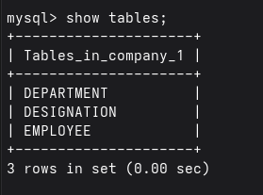
mysql> show tables;
2. Display the structure of each table .
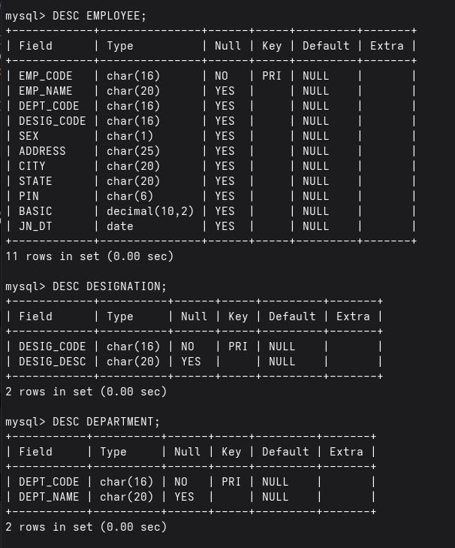
3. Insert few rows in each table . [While entering data in EMP table use DESIG_CODE which exists in DESIGNATION table and DEPT_CODE which is exists in DEPARTMENT table. In DESIGNATION table, assign code for Manager, Executive, officer, clerk and helper. In DEPARTMENT table, assign code for Personnel, Production, Purchase, Finance, Research departments]
mysql> INSERT INTO DESIGNATION VALUES ('D001','Manager');
Query OK, 1 row affected (0.01 sec)

mysql> INSERT INTO DESIGNATION VALUES ('D002','Executive');
Query OK, 1 row affected (0.00 sec)

mysql> INSERT INTO DESIGNATION VALUES ('D003','Officer');
Query OK, 1 row affected (0.01 sec)

mysql> INSERT INTO DESIGNATION VALUES ('D004','Clerk');
Query OK, 1 row affected (0.00 sec)

mysql> INSERT INTO DESIGNATION VALUES ('D005','Helper');
Query OK, 1 row affected (0.01 sec)
mysql> INSERT INTO DEPARTMENT VALUES ('DP01','Personnel');
Query OK, 1 row affected (0.01 sec)

mysql> INSERT INTO DEPARTMENT VALUES ('DP02','Production');
Query OK, 1 row affected (0.00 sec)

mysql> INSERT INTO DEPARTMENT VALUES ('DP03','Purchase');
Query OK, 1 row affected (0.00 sec)

mysql> INSERT INTO DEPARTMENT VALUES ('DP04','Finance');
Query OK, 1 row affected (0.01 sec)

mysql> INSERT INTO DEPARTMENT VALUES ('DP05','Research');
Query OK, 1 row affected (0.00 sec)
mysql> INSERT INTO EMPLOYEE VALUES
-> ('E001','Rahul','DP01','D001','M',
-> 'Kolkata Road','Kolkata','WB','700001',
-> 50000,'2015-03-10');
Query OK, 1 row affected (0.00 sec)

mysql>
mysql> INSERT INTO EMPLOYEE VALUES
-> ('E002','Sneha','DP02','D002','F',
-> 'Park Street','Kolkata','WB','700002',
-> 35000,'2012-06-15');
Query OK, 1 row affected (0.01 sec)

mysql>
mysql> INSERT INTO EMPLOYEE VALUES
-> ('E003','Amit','DP03','D003','M',
-> 'MG Road','Delhi','Delhi','110001',
-> 25000,'2009-11-20');
Query OK, 1 row affected (0.00 sec)

mysql>
mysql> INSERT INTO EMPLOYEE VALUES
-> ('E004','Priya','DP04','D004','F',
-> 'Lake Town','Mumbai','MH','400001',
-> 18000,'2018-01-12');
Query OK, 1 row affected (0.00 sec)
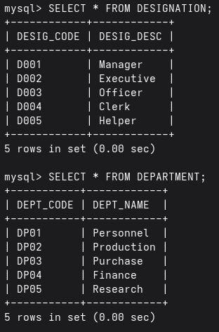
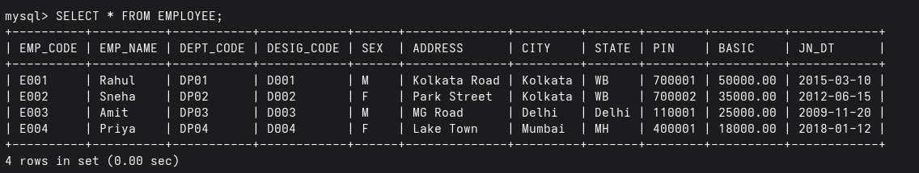
4. In EMP table insert few rows without DEPT_CODE and BASIC.
mysql> INSERT INTO EMPLOYEE -> (EMP_CODE,EMP_NAME,DESIG_CODE,SEX,ADDRESS,CITY,STATE,PIN,JN_DT) -> VALUES -> ('E005','Rina','D005','F', -> 'New Colony','Chennai','TN','600001', -> '2020-05-05'); Query OK, 1 row affected (0.01 sec)
mysql> INSERT INTO EMPLOYEE -> (EMP_CODE,EMP_NAME,DESIG_CODE,SEX,ADDRESS,CITY,STATE,PIN,JN_DT) -> VALUES -> ('E006','Arjun','D004','M', -> 'BT Road','Kolkata','WB','700003', -> '2021-07-18'); Query OK, 1 row affected (0.00 sec)
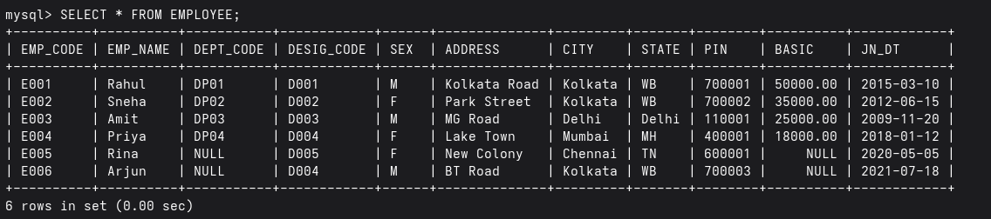
5. Find the rows with unassigned DEPT_CODE
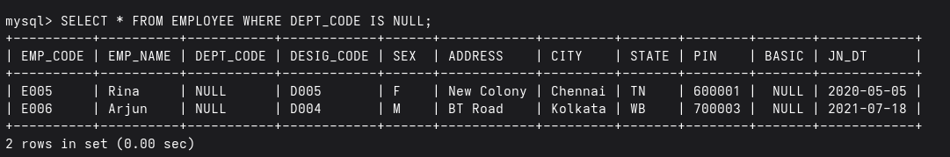
6. Find the rows with BASIC equal to zero
7. Find the rows with unassigned Basic [note down the difference between the results obtained in Q.6 and Q.7]
8. Find the average basic of the employees.
9. Replace the BASIC with 0 for the rows with unassigned Basic.
10. Again, find the average Basic. (Note the difference of result obtained in Q.8 & Q.10.)
11. Delete the rows with unassigned DEPT_CODE.
12. Say, Net pay of an employee= Basic+HRA+DA where HRA is 50% of the Basic & DA is 40% of Basic. Show the employee name & Net pay for all employees.
13. Show the EMP_NAME & BASIC in the ascending order of DEPT_CODE. The employee name must appear in uppercase.
14. Find the employees who have joined after 1st January 2010.
15. Find, how many employees have joined in the month of January?
16. Find the maximum & minimum Basic.
17. Find how many Female employees are there?
18. Replace CITY with existing value converted into uppercase for all rows.
19. Find in how many different cities various employees are residing?
20. Display the employee information in the ascending order of DEPT_CODE and with in a Department, it should be in the descending order of BASIC.

