DB MS LAB
ASSIGNMENT-4

1) a) Create EMP table with ECODE(primary key), ENAME, DCODE, GRADE, BASIC &amp; JN-DT as the columns.[except BASIC &amp; JN-DT,all columns are of char type and site of Grade is 1.]

CREATE TABLE EMP
(
ECODE CHAR(5) PRIMARY KEY,
ENAME CHAR(20),
DCODE CHAR(5),
GRADE CHAR(1),
BASIC NUMBER(8),
JN_DT DATE
);

b)Insert number of rows.

INSERT INTO EMP VALUES
('E001','RAHUL','D01','A',25000,
TO_DATE('10-JAN-2020','DD-MON-YYYY'));

INSERT INTO EMP VALUES
('E002','ANITA','D01','B',20000,
TO_DATE('15-MAR-2021','DD-MON-YYYY'));

INSERT INTO EMP VALUES
('E003','ROHIT','D02','A',30000,
TO_DATE('20-JUN-2019','DD-MON-YYYY'));

INSERT INTO EMP VALUES
('E004','PRIYA','D02','B',22000,
TO_DATE('12-AUG-2022','DD-MON-YYYY'));

INSERT INTO EMP VALUES
('E005','SUMIT','D03','A',28000,
TO_DATE('01-APR-2021','DD-MON-YYYY'));

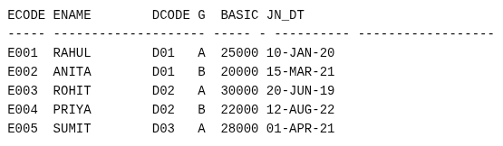
SELECT * FROM EMP;
2. change the column heading as shown below, So that in subsequent SELECT statement newly set heading will be shown:
ECODE EMPLOYEE CODE
ENAME NAME
DCODE DEPT.CODE
JN-DT JONING DATE

COLUMN ECODE HEADING 'EMPLOYEE CODE';
COLUMN ENAME HEADING 'NAME';
COLUMN DCODE HEADING 'DEPT.CODE';
COLUMN JN_DT HEADING 'JOINING DATE';

SELECT * FROM EMP;
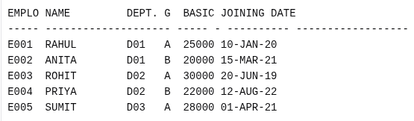
3. Set the format of columns as mentioned below, So that in subsequent SELECT statement ,values appear in the specified format:
*format of BASIC is such that a value of 7000 will be shown as7,000
*Format of GRADE will be such that full column name appears in the display.
*For JN-DT format is such that 01-JAN-00 will be shown as JANURY 01,2000

COLUMN BASIC FORMAT 99,99,999;
COLUMN GRADE FORMAT A5 HEADING 'GRADE';
COLUMN JN_DT FORMAT A20;

SELECT ECODE, ENAME, DCODE, GRADE, BASIC,
TO_CHAR(JN_DT,'MONTH DD,YYYY') JN_DT FROM EMP;

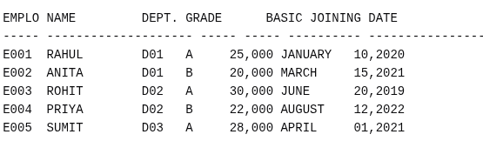

4. a) Show the display attributes of all the columns.

COLUMN
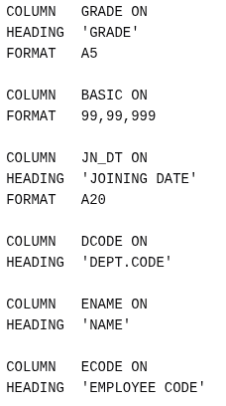
b) Show the display attributes of particular column.

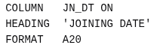
COLUMN JN_DT
c) Suppress the newly set attributes of JN-DT .Try a select statement.

CLEAR COLUMN JN_DT;
COLUMN JN_DT;
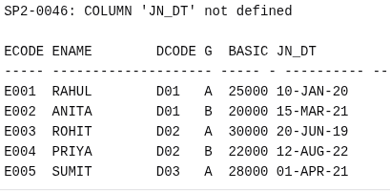
SELECT * FROM EMP;

d) Reset the newly set attributes of JN-DT

COLUMN JN_DT HEADING 'JOINING DATE' FORMAT A20;
SELECT * FROM EMP;
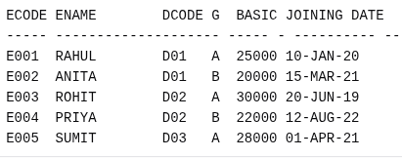
e) Reset the newly set attributes of all columns.

CLEAR COLUMNS
COLUMN
f) Shown the display attributes of all columns.
COLUMN ECODE HEADING 'EMPLOYEE CODE';
COLUMN ENAME HEADING 'NAME';
COLUMN DCODE HEADING 'DEPT.CODE';
COLUMN JN_DT HEADING 'JOINING DATE';
COLUMN BASIC FORMAT 99,99,999;
COLUMN GRADE FORMAT A5 HEADING 'GRADE';
SELECT * FROM EMP;
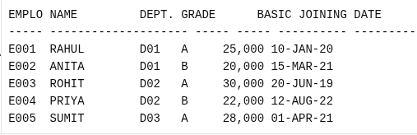

5. a)Show the records from EMP table in the ascending order of DCODE . DCODE value will be shown only for the first record of that department (same of DCODE is not repeated)
BREAK ON DCODE
SELECT DCODE, ECODE, ENAME, GRADE,
BASIC FROM EMP ORDER BY DCODE;
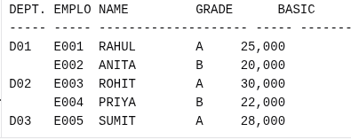
b) Further take measures so that ,after displaying the records of a department it skips one line .
CLEAR BREAKS;
BREAK ON DCODE SKIP 1
SELECT DCODE, ECODE, ENAME, GRADE,
BASIC FROM EMP ORDER BY DCODE;
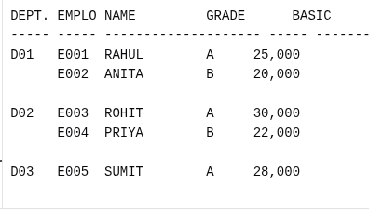

c)Further take measures so that records one also ordered on the basic of GRADE with in a department &amp; same GRADE value is not repeated.
CLEAR BREAKS;
BREAK ON DCODE SKIP 1
BREAK ON GRADE
SELECT DCODE, GRADE, ECODE, ENAME,
BASIC FROM EMP ORDER BY DCODE, GRADE;
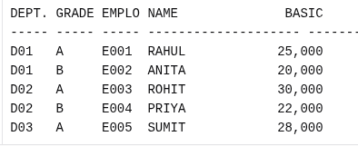

d) Take measure so that at the end of each GRADE in a department it will show average Basic for that grade in that department. At the end of each department, it will show the average &amp; total Basic for the department. At the end of all departments it will show the overall total basic &amp; average basic.
CLEAR BREAKS;
CLEAR COMPUTES;
BREAK ON DCODE SKIP 1
BREAK ON GRADE
COMPUTE AVG LABEL 'GRADE AVG' OF BASIC ON GRADE;
COMPUTE AVG LABEL 'DEPT AVG' OF BASIC ON DCODE;
COMPUTE SUM LABEL 'DEPT TOTAL' OF BASIC ON DCODE;
COMPUTE AVG LABEL 'OVERALL AVG' OF BASIC ON REPORT;
COMPUTE SUM LABEL 'OVERALL TOTAL' OF BASIC ON REPORT;
SELECT DCODE, GRADE, ECODE, ENAME,
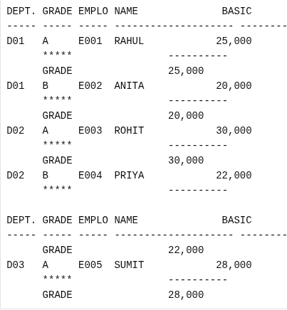
BASIC FROM EMP ORDER BY DCODE, GRADE;

