DBMS LAB
ASSIGNMENT – 2

1. From the EMP table show the minimum, maximum and average basic for each
department (show dept. Code).
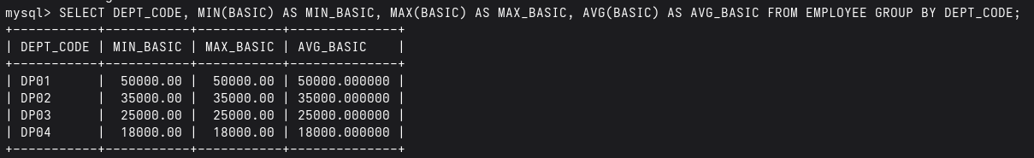

2. Find the number of female employees in each department (show dept. Code).
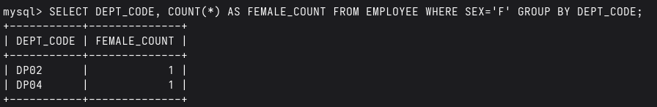

3. Find the city wise no. of employees for each department (show dept. Code).
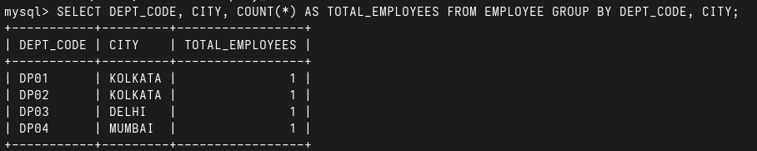

INSERT MORE DATA TO HOUSE ALL QUESTIONS: -

INSERT INTO DESIGNATION VALUES ('D006','Supervisor');
INSERT INTO DESIGNATION VALUES ('D007','Analyst');

INSERT INTO DEPARTMENT VALUES ('DP06','Marketing');
INSERT INTO DEPARTMENT VALUES ('DP07','Sales');

INSERT INTO EMPLOYEE VALUES
('E007','Anita','DP01','D001','F',
'Salt Lake','KOLKATA','WB','700091',
60000,'2000-01-15');

INSERT INTO EMPLOYEE VALUES
('E008','Rohit','DP01','D002','M',
'Behala','KOLKATA','WB','700034',
30000,'2000-01-20');

INSERT INTO EMPLOYEE VALUES
('E009','Suman','DP02','D001','M',
'Howrah','HOWRAH','WB','711101',
70000,'2011-03-11');

INSERT INTO EMPLOYEE VALUES
('E011','Puja','DP02','D003','F',
'Dumdum','KOLKATA','WB','700028',
45000,'2000-01-05');

INSERT INTO EMPLOYEE VALUES
('E012','Vikash','DP03','D004','M',
'Patna Road','PATNA','BR','800001',
15000,'2003-06-10');

INSERT INTO EMPLOYEE VALUES
('E013','Neha','DP03','D001','F',
'Boring Road','PATNA','BR','800002',
80000,'2015-09-18');

INSERT INTO EMPLOYEE VALUES
('E014','Raj','DP04','D002','M',
'Andheri','MUMBAI','MH','400053',
55000,'2000-12-12');

INSERT INTO EMPLOYEE VALUES
('E015','Kavita','DP04','D001','F',
'Borivali','MUMBAI','MH','400066',
90000,'2019-08-22');

INSERT INTO EMPLOYEE VALUES
('E016','Deepak','DP05','D005','M',
'Sector 5','DELHI','DL','110011',
12000,'2007-04-14');

INSERT INTO EMPLOYEE VALUES
('E017','Riya','DP05','D003','F',
'Rohini','DELHI','DL','110085',
40000,'2000-01-09');

INSERT INTO EMPLOYEE VALUES
('E018','Arindam','DP01','D001','M',
'Garia','KOLKATA','WB','700084',
75000,'2016-11-17');

INSERT INTO EMPLOYEE VALUES
('E019','Meena','DP01','D004','F',
'Tollygunge','KOLKATA','WB','700040',
22000,'2014-02-25');

INSERT INTO EMPLOYEE VALUES
('E020','Sourav','DP02','D002','M',
'Barasat','KOLKATA','WB','700124',
50000,'2000-01-30');

INSERT INTO EMPLOYEE VALUES
('E021','Ayesha','DP02','D001','F',
'Park Circus','KOLKATA','WB','700017',
95000,'2021-07-07');

INSERT INTO EMPLOYEE VALUES
('E022','Manoj','DP03','D003','M',
'Bidhan Nagar','DURGAPUR','WB','713201',
28000,'2008-05-21');

INSERT INTO EMPLOYEE VALUES
('E023','Lata','DP03','D002','F',
'City Center','DURGAPUR','WB','713216',
32000,'2000-01-01');

INSERT INTO EMPLOYEE VALUES
('E024','Harsh','DP04','D001','M',
'Shyambazar','KOLKATA','WB','700004',
100000,'2022-09-09');

INSERT INTO EMPLOYEE VALUES
('E025','Tina','DP04','D005','F',
'New Market','KOLKATA','WB','700087',
10000,'2005-03-13');

INSERT INTO EMPLOYEE VALUES
('E026','Kunal','DP05','D002','M',
'Noida','NOIDA','UP','201301',
48000,'2000-01-14');

INSERT INTO EMPLOYEE VALUES
('E027','Sonia','DP05','D001','F',
'Ghaziabad','NOIDA','UP','201302',
85000,'2017-10-19');

INSERT INTO EMPLOYEE VALUES
('E028','Ajay','DP01','D003','M',
'Street 1','KOLKATA','WB','700001',
21000,'2013-01-01');

INSERT INTO EMPLOYEE VALUES
('E029','Mili','DP01','D004','F',
'Street 2','KOLKATA','WB','700002',
18000,'2014-01-01');

INSERT INTO EMPLOYEE VALUES
('E030','Tarun','DP01','D005','M',
'Street 3','KOLKATA','WB','700003',
16000,'2015-01-01');

INSERT INTO EMPLOYEE VALUES
('E031','Nita','DP01','D002','F',
'Street 4','KOLKATA','WB','700004',
34000,'2016-01-01');

INSERT INTO EMPLOYEE VALUES
('E032','Rakesh','DP01','D001','M',
'Street 5','KOLKATA','WB','700005',
72000,'2017-01-01');

INSERT INTO EMPLOYEE VALUES
('E033','Pallavi','DP01','D003','F',
'Street 6','KOLKATA','WB','700006',
38000,'2018-01-01');

4. Show the designation wise no of employees who have joined in the year 2000 in each
department. The listing should appear in the ascending order of no. of employees.
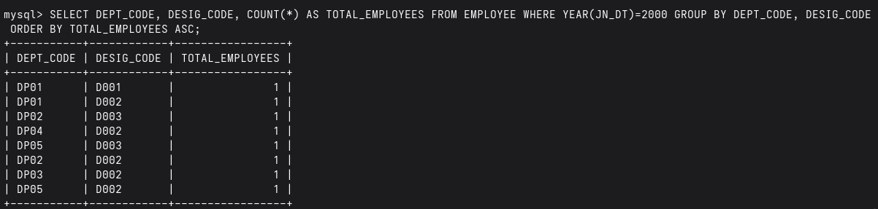

5. Find the department code wise total basic of male employees only for the departments
for which such total is more than 50,000 and the listing should appear in the
descending order of total basic.
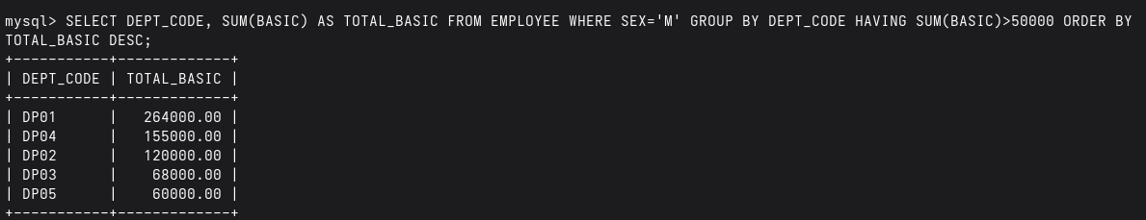

6. Show the employee name, Designation description and basic for all employees.
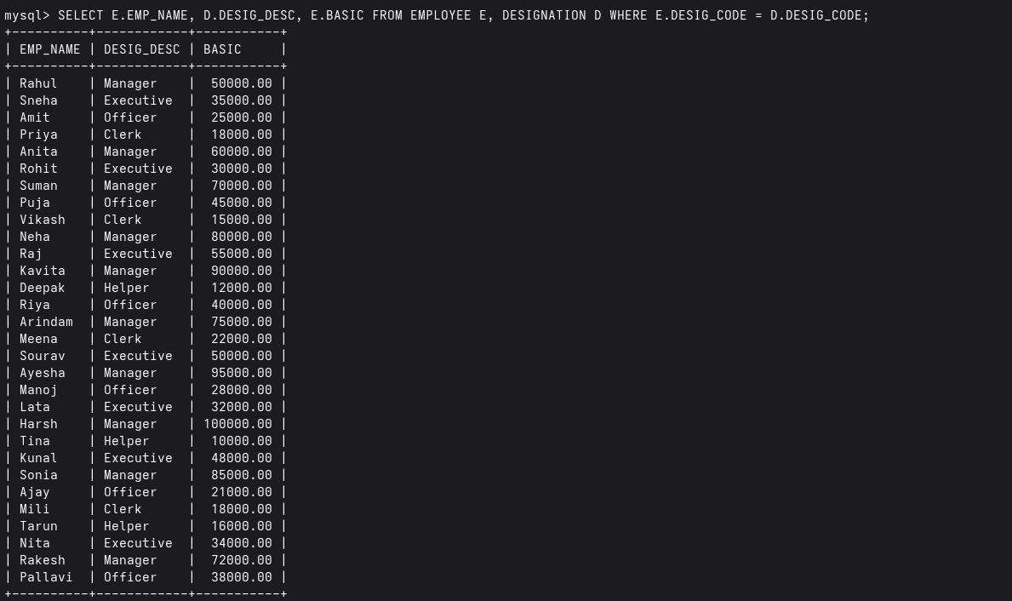

7. Show the employee name, Designation description, Department Name &amp; Basic for all
employees.
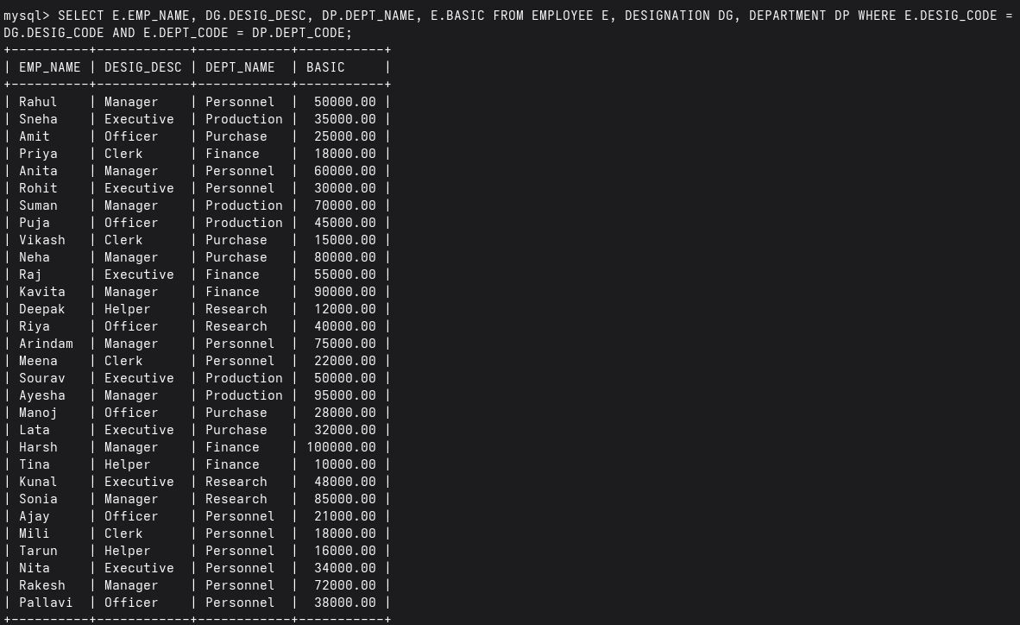

8. Find the department Codes in which no employee works.
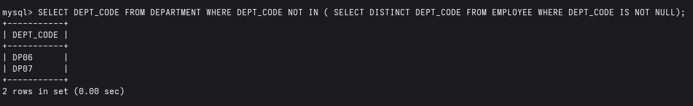

9. Find the department names where at least one employee works.
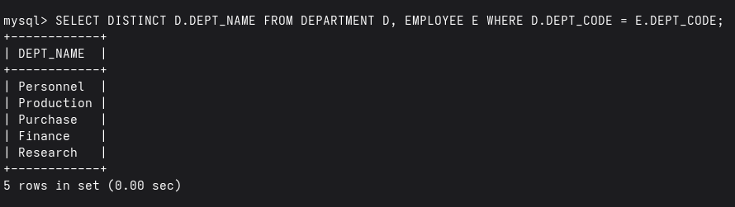

10. Find the department names where at least 10 employees work.
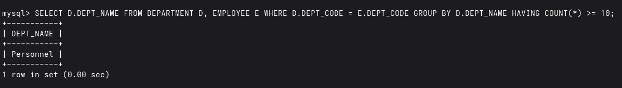

11. Find the department code in which employee with highest Basic works.
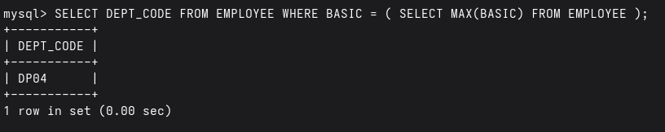

12. Find the Designation description of the employee with highest basic.
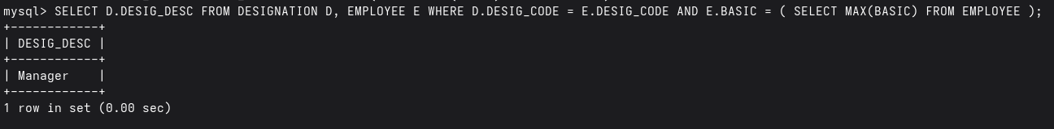

13. Find the no. of managers in each department.
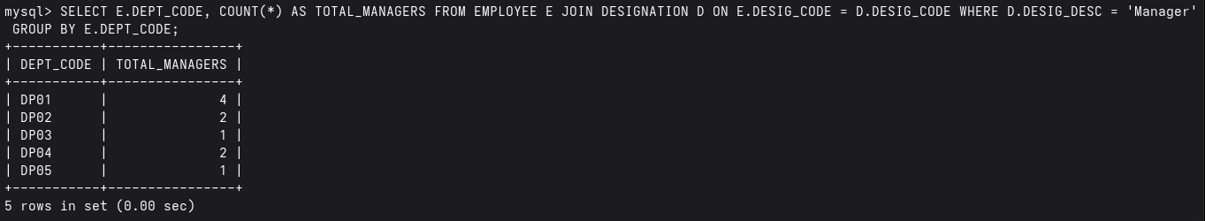

14. Find the maximum basic from EMP table without using MAX().
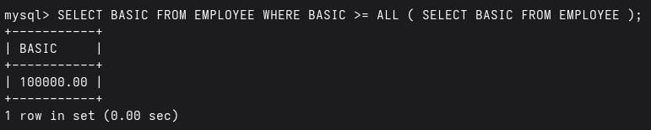

15. Find the minimum basic from EMP table without using MIN().
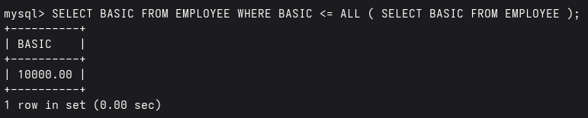

16. Find the name of the department with highest total basic. Do the same for highest
average basic and maximum no. of employee.

Highest Total Basic
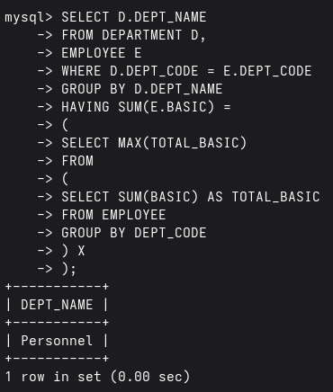
Highest Average Basic
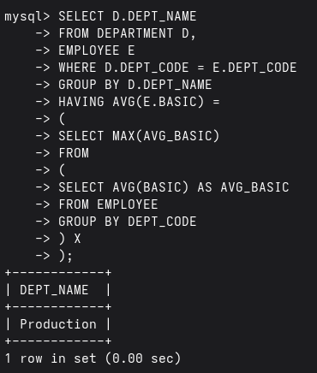
Maximum Numbers of Employees
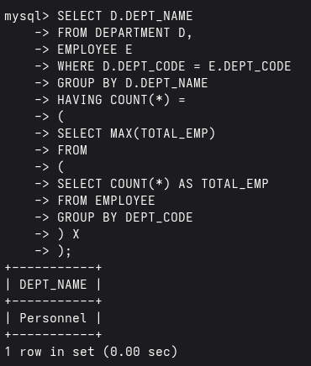

17. Insert same rows into EMP table with designation code not existing in
DESIGNATION table.
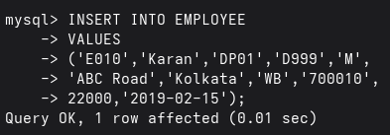
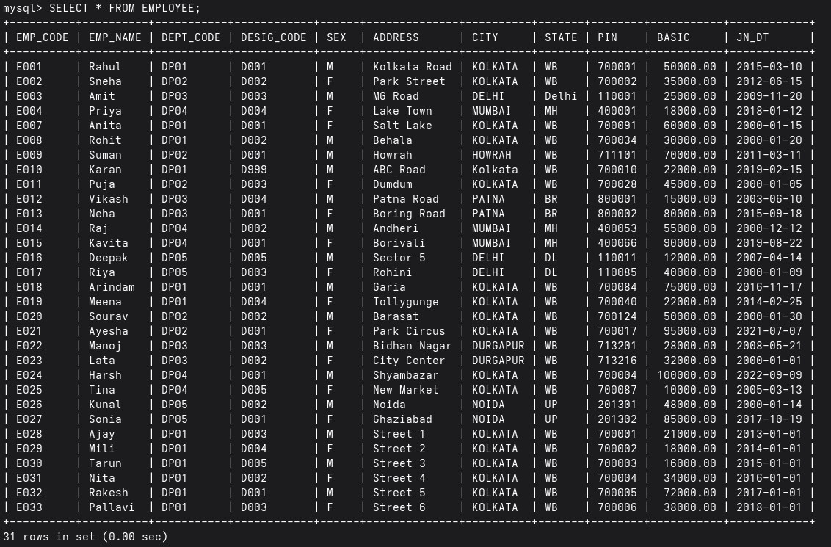
18. Delete the rows from EMP table with invalid DESIG_CODE.
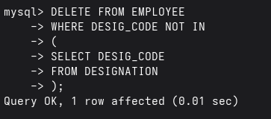

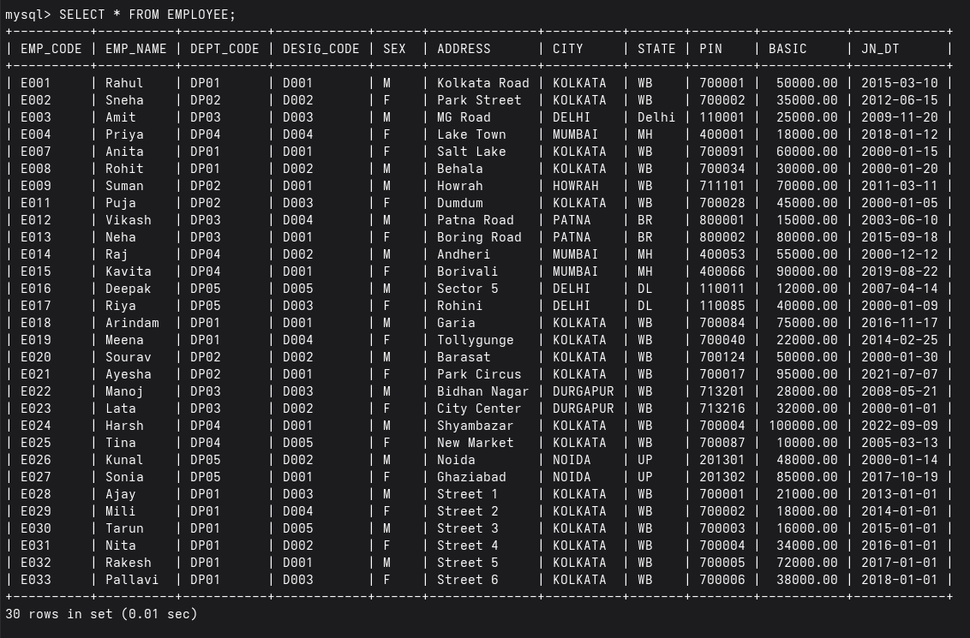
19. Find the name of the female employees with basic greater than the average basic of
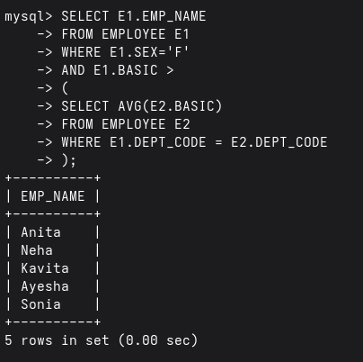
their respective department.

20. Find the number of female managers.

