PROBLEM 1: Check Age Category. Write a java program with a special class
- To store Name and DOB
- To calculate Age
- To specify Age Category as follows:
- "Under Age", if Age < 18
- "Young Adult", if 18 < Age < 30
- "Matured Adult", if 30 < Age < 45
- Middle Aged, if 45<Age<60 & so on…
Source Code:
import java.util.Scanner;
import java.util.Calendar;

class Person_1 {
String name;
int day, month, year;
Calendar today = Calendar.getInstance();
int currentYear = today.get(Calendar.YEAR);
int currentMonth = today.get(Calendar.MONTH) + 1;
int currentDay = today.get(Calendar.DAY_OF_MONTH);
Person_1(String name, int d, int m, int y) {
this.name = name;
this.day = d;
this.month = m;
this.year = y;
}
public boolean isValidDate() {
if (month < 1 || month > 12) return false;
int[] daysInMonth = {0, 31, 28, 31, 30, 31, 30, 31, 31, 30, 31, 30, 31};
if ((year % 400 == 0) || (year % 4 == 0 && year % 100 != 0)) {
daysInMonth[2] = 29;
}
if (day <= 0 || day > daysInMonth[month]) return false;
Calendar dob = Calendar.getInstance();
dob.set(year, month - 1, day);
if (dob.after(today)) return false;
return true;
}
public int calculateAge() {
int age = currentYear - year;
if (currentMonth < month || (currentMonth == month && currentDay < day)) {
age--;
}
return age;
}
public String getAgeCategory() {
int age = calculateAge();
if (age < 18) return "Under Age.";
if (age < 30) return "Young Adult.";
if (age < 45) return "Matured Adult.";
if (age < 60) return "Middle Aged.";
return "Senior.";
}
public void display() {
if (!isValidDate()) {
System.out.println("Error: The date " + day + "/" + month + "/" + year + " is invalid or in the future.");
return;
}
System.out.println("\nName: " + name);
System.out.println("\nAge: " + calculateAge());
System.out.println("\nCategory: " + getAgeCategory());
}
}

public class Q1 {
public static void main(String[] args) {
Scanner sc = new Scanner(System.in);
try {
System.out.println("Enter name: ");
String name = sc.nextLine();
System.out.println("Enter DOB (Day Month Year): ");
int d = sc.nextInt();
int m = sc.nextInt();
int y = sc.nextInt();
Person_1 p = new Person_1(name, d, m, y);
p.display();
} catch (Exception e) {
System.out.println("Error: Enter valid numeric values for the date.");
} finally {
sc.close();
}
}
}

Sample Output:
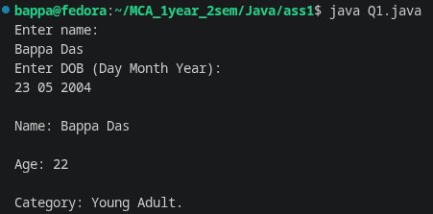
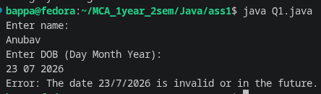
PROBLEM 2: Design your own STACK. Such that the Stack class objects need to be:
- Initialised by a Constructor
- Provided proper push() and pop() methods
- Checked for TOS content using peek()
- Overloaded with display() for several tasks
- Display content of whole stack
- Given depth of a particular element, show the element
Source Code:
Stack.java
package mystack;
public class Stack {
protected int [] arr;
protected int top;
protected int size;
public Stack(int size){
this.size = size;
arr = new int[size];
top = -1;
}
public boolean push(int value){
if(top==size-1){
return false;
}else{
top++;
arr[top] = value;
return true;
}
}
public int size(){
return top+1;
}
public int pop(){
if(top==-1){
return -1;
}else{
int val = arr[top];
top--;
return val;
}
}
public int peek(){
if(top==-1){
return -1;
}else{
return arr[top];
}
}
public void display(){
if(top==-1){
System.out.println("Stack is empty!");
}else{
System.out.println("Stack elements: ");
for (int i=top; i>=0;i--){
System.out.println(arr[i]);
}
}
}
public boolean isEmpty() {
return top == -1;
}
public boolean isFull() {
return top == size - 1;
}
public int display(int depth){
if (depth < 0 || depth > top) {
return -1;
} else {
return arr[top - depth];
}
}
}

Q2.java
import java.util.Scanner;
import mystack.Stack;
public class Q2 {
public static void main(String[] args) {
Scanner sc = new Scanner(System.in);
System.out.print("Enter Stack Size: ");
int n = sc.nextInt();
Stack s = new Stack(n);
int choice;
do {
System.out.println("\n--- STACK MENU ---");
System.out.println("1. Push");
System.out.println("2. Pop");
System.out.println("3. Peek");
System.out.println("4. Display Full Stack");
System.out.println("5. Display Element by Depth");
System.out.println("6. Exit");
System.out.print("Enter Choice: ");
choice = sc.nextInt();
switch (choice) {
case 1:
System.out.print("Enter Value: ");
int value = sc.nextInt();
if (s.push(value)) {
System.out.println(value + " pushed in the stack.");
} else {
System.out.println("Stack overflow!");
}
break;
case 2:
int popped = s.pop();
if (popped == -1) {
System.out.println("Stack underflow!");
} else {
System.out.println(popped + " popped from the stack.");
}
break;
case 3:
int topElement = s.peek();
if (topElement == -1) {
System.out.println("Stack is empty!");
} else {
System.out.println("Top element: " + topElement);
}
break;
case 4:
s.display();
break;
case 5:
System.out.print("Enter Depth: ");
int depth = sc.nextInt();
if (s.isEmpty()) {
System.out.println("Stack is empty!");
} else {
int element = s.display(depth);
if (element == -1) {
System.out.println("Invalid Depth!");
} else {
System.out.println("Element at depth " + depth + " is: " + element);
}
}
break;
case 6:
System.out.println("Exiting Program...");
break;
default:
System.out.println("Invalid Choice!");
}

} while (choice != 6);
sc.close();
}
}
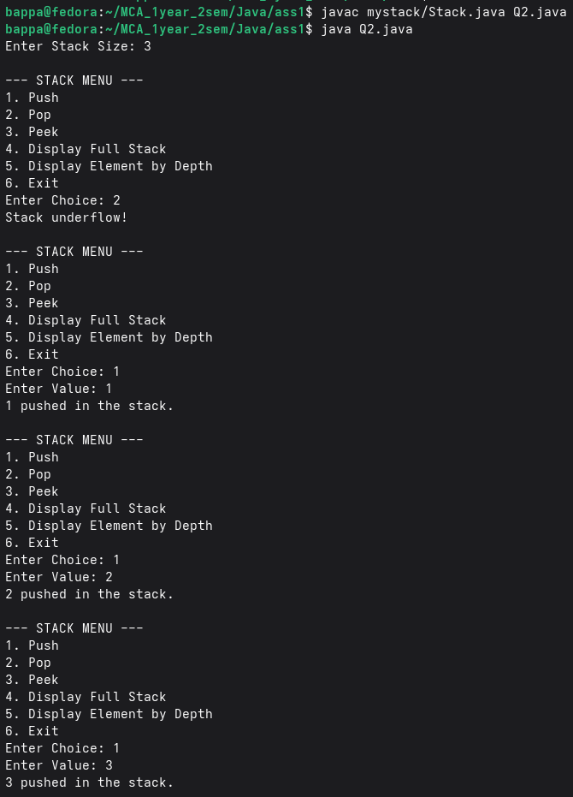
Output:

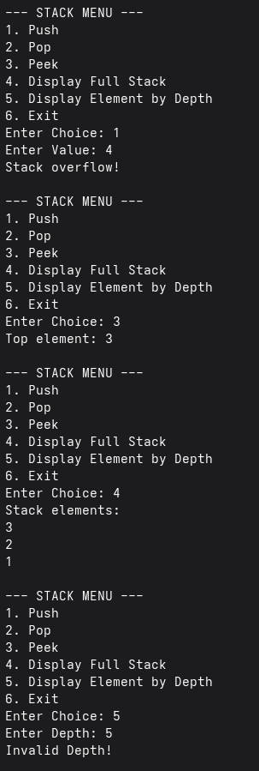
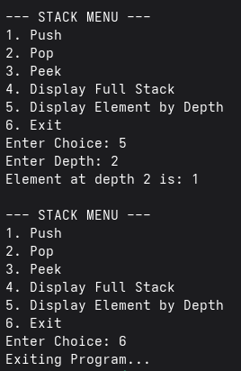

PROBLEM 3: Implement Merge operation on two Stacks presorted in ascending order. Check for stack overflow conditions all along.
PROBLEM 4: Inherit a special stack. The inherited class should allow
- A number to be pushed in if and only if it is less than the one currently at the top
- With the help of such stack objects, solve the Tower of Hanoi problem most economically, by arranging a sequence of haphazard numbers in the original base type Stack in ascending order in a final STACK.
Source Code:
SpecialStack.java
package mystack;
public class SpecialStack extends Stack{

public SpecialStack(int size){
super(size);
}

public boolean push(int val){
if (isFull()){
System.out.println("Stack Overflow!");
return false;
}
if (isEmpty() || val <= peek()){
arr[++top] = val;
return true;
}else{
return false;
}
}
}

StackSorter.java
package mystack;
public class StackSorter {
public static SpecialStack sortStack(Stack A) {
// Stack A = new Stack();
Stack B = new Stack(A.size());
SpecialStack C = new SpecialStack(A.size());

System.out.println("Initial Stack :");
A.display();
System.out.println("-------------------------------------");

while (!A.isEmpty()){
int x = A.peek();
while (!C.isEmpty() && x > C.peek()){
B.push(C.pop());
}
C.push(A.pop());
while (!B.isEmpty()){
C.push(B.pop());
}
}
return C;
}
}

Q3.java
import java.util.Scanner;
import mystack.SpecialStack;
import mystack.Stack;
import mystack.StackSorter;

public class Q3 {
static SpecialStack merge(SpecialStack s1, SpecialStack s2, int totalSize) {
Stack temp = new Stack(totalSize);
while (!s1.isEmpty() && !s2.isEmpty()) {
if (s1.peek() < s2.peek()) {
temp.push(s1.pop());
} else {
temp.push(s2.pop());
}
}
while (!s1.isEmpty()) {
temp.push(s1.pop());
}
while (!s2.isEmpty()) {
temp.push(s2.pop());
}
SpecialStack result = new SpecialStack(totalSize);
while (!temp.isEmpty()) {
result.push(temp.pop());
}
return result;
}

public static void main(String[] args) {
Scanner sc = new Scanner(System.in);
System.out.println("Enter the size of first Array:");
int a = sc.nextInt();
Stack s1 = new Stack(a);
System.out.println("Enter the elements to push in one by one:");
while (s1.size() < a) {
s1.push(sc.nextInt());
}
SpecialStack ss1 = StackSorter.sortStack(s1);
System.out.println("Enter the size of second Array:");
int b = sc.nextInt();
Stack s2 = new Stack(b);
System.out.println("Enter the elements to push in one by one:");
while (s2.size() < b) {
s2.push(sc.nextInt());
}
SpecialStack ss2 = StackSorter.sortStack(s2);
System.out.println("Stack 1:");
ss1.display();
System.out.println("Stack 2:");
ss2.display();
SpecialStack merged = merge(ss1, ss2, 20);
System.out.println("\nMerged Special Stack:");
merged.display();
sc.close();
}
}
Output:
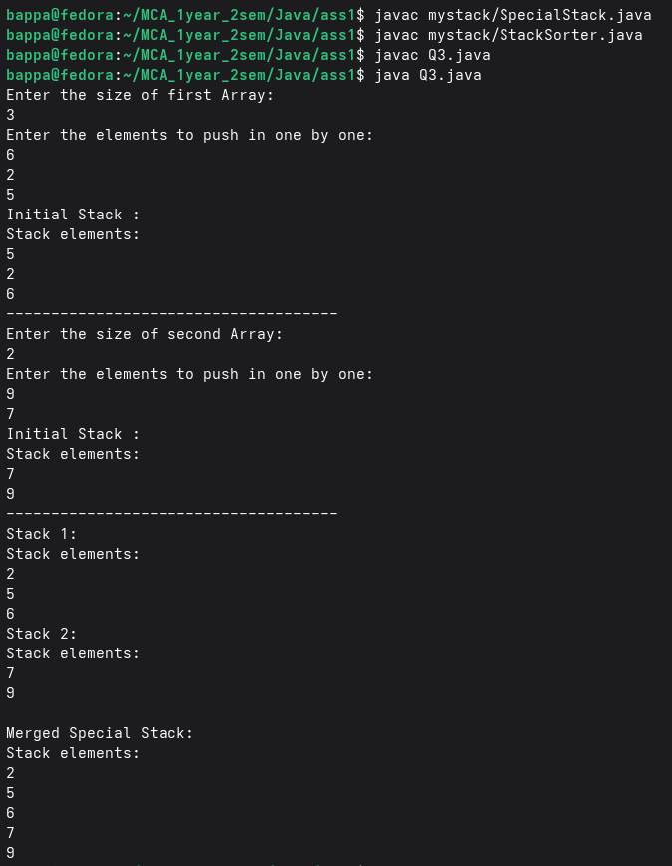
Q4.java
import java.util.Scanner;
import mystack.SpecialStack;
import mystack.Stack;
import mystack.StackSorter;

public class Q4 {
public static void main(String[] args) {
int n = 0;
Scanner sc = new Scanner(System.in);
System.out.println("Enter the number of elements:");
n = sc.nextInt();
Stack A = new Stack(n);
System.out.print("Enter elements in Stack: ");
for (int i = 0; i < n; i++) {
int num = sc.nextInt();
A.push(num);
}
SpecialStack res = StackSorter.sortStack(A);
System.out.println("----------------------------------------");
System.out.println("Final Sorted SpecialStack C: ");
res.display();
sc.close();
}
}
Output:
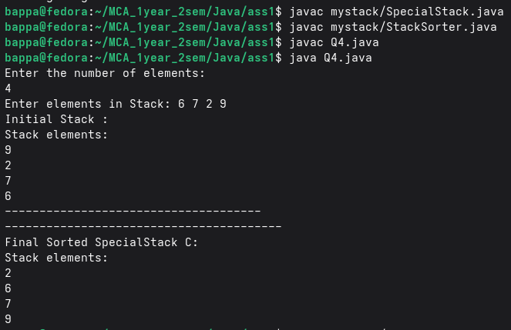

PROBLEM 5: Create a new class Graded_Emp from an existing class Emp, where class Emp has got two fields ID and Dep_Code[0-5], whereas the derived class has and additional field Grade[A-E].
PROBLEM 6: Use the super Keyword judiciously to (a) populate objects of both the base and derived classes above with minimum repetition of code & (b) change Dep_Code 0 to 10 while populating derived objects.
PROBLEM 7: Create your own exception class to trap accepting invalid data above.
PROBLEM 8: How would you restructure your code if the Grade field is dependent on average marks obtained in several skill-tests recorded separately?
Source Code:
import java.util.Arrays;
import java.util.Scanner;
class InvalidEmployeeDataException extends Exception {
public InvalidEmployeeDataException(String message) {
super(message);
}
}

class Emp {
protected int id;
protected int depCode;
public Emp(int id, int depCode) throws InvalidEmployeeDataException {
if (depCode < 0 || depCode > 5) {
throw new InvalidEmployeeDataException("Invalid Base Employee Department Code: " + depCode + ". Allowed range is 0 to 5.");
}
this.id = id;
this.depCode = depCode;
}
protected Emp(int id, int depCode, int maxRange) throws InvalidEmployeeDataException {
if (depCode < 0 || depCode > maxRange) {
throw new InvalidEmployeeDataException("Invalid Department Code: " + depCode + ". Allowed range is 0 to " + maxRange + ".");
}
this.id = id;
this.depCode = depCode;
}
public void display() {
System.out.print("Emp ID: " + id + " | Dep Code: " + depCode);
}
}

class GradedEmp extends Emp {
private double[] skillTestMarks;
public GradedEmp(int id, int depCode, double[] skillTestMarks) throws InvalidEmployeeDataException {
super(id, depCode == 0 ? 10 : depCode, 10);
if (skillTestMarks == null || skillTestMarks.length == 0) {
throw new InvalidEmployeeDataException("Skill test marks cannot be null or empty.");
}
for (double mark : skillTestMarks) {
if (mark < 0 || mark > 100) {
throw new InvalidEmployeeDataException("Invalid test mark discovered: " + mark + ". Must be between 0 and 100.");
}
}
this.skillTestMarks = skillTestMarks;
}
public char calculateGrade() {
double sum = 0;
for (double mark : skillTestMarks) {
sum += mark;
}
double average = sum / skillTestMarks.length;
if (average >= 85) return 'A';
else if (average >= 70) return 'B';
else if (average >= 55) return 'C';
else if (average >= 40) return 'D';
else return 'E';
}
@Override
public void display() {
super.display();
System.out.println(" | Marks: " + Arrays.toString(skillTestMarks) + " | Grade: " + calculateGrade());
}
}

public class Q5 {
public static void main(String[] args) {
Scanner scanner = new Scanner(System.in);
boolean running = true;
System.out.println("=================================================");
System.out.println(" Employee & Graded Employee Verification System ");
System.out.println("=================================================");
while (running) {
System.out.println("\nSelect a Test Scenario:");
System.out.println("1) Test Standard Employee Class (Emp)");
System.out.println("2) Test Graded Employee Class (GradedEmp - with dynamic grading)");
System.out.println("3) Exit");
System.out.print("Enter choice (1-3): ");
int choice = scanner.nextInt();
switch (choice) {
case 1:
System.out.println("\n--- [Scenario 1: Standard Employee] ---");
System.out.print("Enter Employee ID: ");
int empId = scanner.nextInt();
System.out.print("Enter Department Code [0-5]: ");
int depCode = scanner.nextInt();
try {
Emp emp = new Emp(empId, depCode);
System.out.print(">> Success! Created Object: ");
emp.display();
System.out.println();
} catch (InvalidEmployeeDataException e) {
System.out.println(">> Trap Success! Custom Exception Caught: " + e.getMessage());
}
break;
case 2:
System.out.println("\n--- [Scenario 2: Graded Employee] ---");
System.out.print("Enter Employee ID: ");
int gEmpId = scanner.nextInt();
System.out.print("Enter Department Code [0-5]: ");
int gDepCode = scanner.nextInt();
System.out.print("How many skill tests did this employee take? ");
int totalTests = scanner.nextInt();
if (totalTests <= 0) {
System.out.println(">> Test count must be greater than 0.");
break;
}
double[] marks = new double[totalTests];
for (int i = 0; i < totalTests; i++) {
System.out.print(" Enter score for test #" + (i + 1) + " (0-100): ");
marks[i] = scanner.nextDouble();
}
try {
GradedEmp gEmp = new GradedEmp(gEmpId, gDepCode, marks);
System.out.print(">> Success! Created Object: ");
gEmp.display();
} catch (InvalidEmployeeDataException e) {
System.out.println(">> Trap Success! Custom Exception Caught: " + e.getMessage());
}
break;
case 3:
running = false;
System.out.println("\nExiting System");
break;
default:
System.out.println("Invalid selection. Please choose an option between 1 and 3.");
}
System.out.println("\n-------------------------------------------------");
}
scanner.close();
}
}
Output:
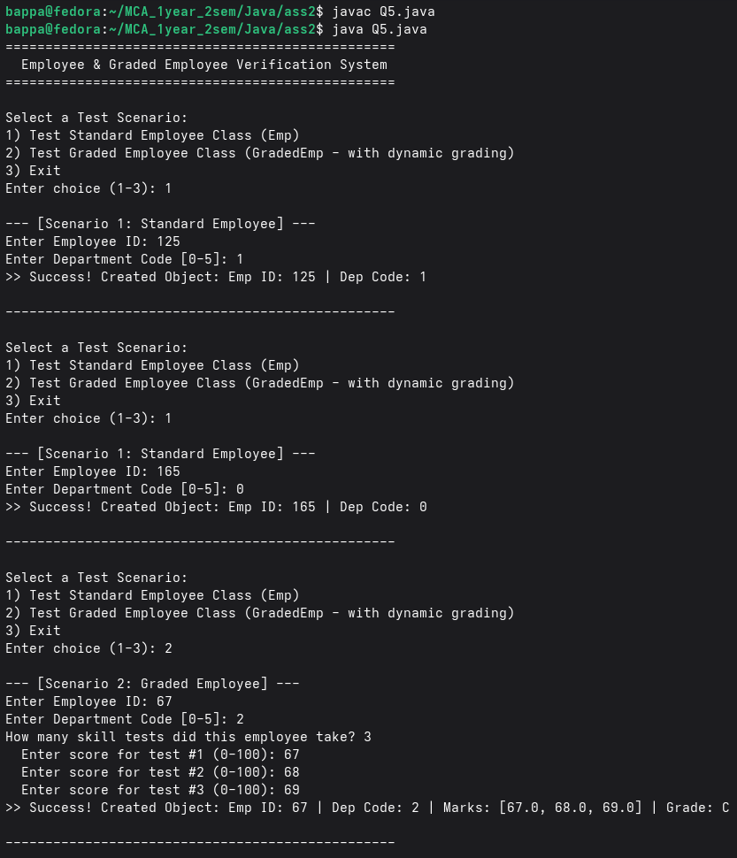

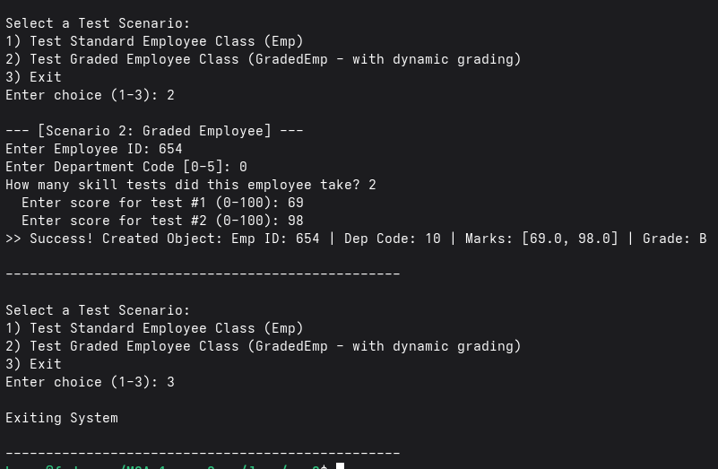

PROBLEM 9: Create an interface Shape with the getArea() method. Create three classes Rectangle, Circle and Triangle that implement the Shape interface the Shape interface. Implement the getArea() method for each of the classes.
Source Code:
Shape.java
package shapes;
public interface Shape {
double getArea();
}

Rectangle.java
package shapes;

public class Rectangle implements Shape {
private double length;
private double width;
public Rectangle(double length, double width) {
this.length = length;
this.width = width;
}
public double getArea() {
return length * width;
}
}

Circle.java
package shapes;

public class Circle implements Shape {
private double radius;
public Circle(double radius) {
this.radius = radius;
}
public double getArea() {
return Math.PI * radius * radius;
}
}

Triangle.java
package shapes;

public class Triangle implements Shape {
private double base;
private double height;
public Triangle(double base, double height) {
this.base = base;
this.height = height;
}
public double getArea() {
return 0.5 * base * height;
}
}

PROBLEM 10: Create a Animal interface with a method called sound() that takes no arguments and returns void. Create a few specific animal classes that implement Animal and overrides sound() differently for each species.
Source Code:
Animal.java
package animals;

public interface Animal {
void sound();
}

Dog.java
package animals;

public class Dog implements Animal {
public void sound() {
System.out.println("Dog barks: Woof Woof");
}
}

Cat.java
package animals;

public class Cat implements Animal {
public void sound() {
System.out.println("Cat meows: Meow Meow");
}
}

Cow.java
package animals;

public class Cow implements Animal {
public void sound() {
System.out.println("Cow moos: Moo Moo");
}
}
PROBLEM 11: Create an interface Sortable with a method sort() that sorts an array of integers in ascending order. Create a class BubbleSort that implements the interface and provides its own version of the sort() method.
Source Code:
Sortable.java
package sorting;

public interface Sortable {
void sort(int arr[]);
}

BubbleSort.java
package sorting;

public class BubbleSort implements Sortable {
public void sort(int arr[]) {
int n = arr.length;
for(int i = 0; i < n - 1; i++) {
for(int j = 0; j < n - i - 1; j++) {
if(arr[j] > arr[j + 1]) {
int temp = arr[j];
arr[j] = arr[j + 1];
arr[j + 1] = temp;
}
}
}
System.out.println("Sorted Array:");
for(int x : arr) {
System.out.print(x + " ");
}
System.out.println();
}
}

PROBLEM 12: Create an interface ResizableTray with methods W(int width) and L(int length) that help trays to be resized. Create a class Tray that implements the interface to carry a number of fixed sized plates.
Source Code:
ResizableTray.java
package resize;

public interface ResizableTray {
void W(int width);
void L(int length);
}

Tray.java
package resize;

public class Tray implements ResizableTray {
int width;
int length;
int plateWidth;
int plateLength;
public void W(int width) {
this.width = width;
}
public void L(int length) {
this.length = length;
}
public void setPlateSize(int plateWidth, int plateLength) {
this.plateWidth = plateWidth;
this.plateLength = plateLength;
}
public int calculatePlateCount() {
if (width <= 0 || length <= 0 || plateWidth <= 0 || plateLength <= 0) {
return 0;
}
int countNormal = (width / plateWidth) * (length / plateLength);
int countRotated = (width / plateLength) * (length / plateWidth);
return Math.max(countNormal, countRotated);
}
public void display() {
System.out.println("Tray Details");
System.out.println("Tray Width: " + width);
System.out.println("Tray Length: " + length);
System.out.println("Plate Width: " + plateWidth);
System.out.println("Plate Length: " + plateLength);
System.out.println("Number of Plates that can fit: " + calculatePlateCount());
}
}

PROBLEM 13: nherit an interface ResizableBox from ResizableTray with a new method D(int depth). Create a class NewBox that implements ResizableBox to house a given number of balls of fixed using the overridden resizing methods.
Source Code:
ResizableBox.java
package resize;

public interface ResizableBox extends ResizableTray {
void D(int depth);
}

NewBox.java
package resize;

public class NewBox implements ResizableBox {
int width;
int length;
int depth;
int ballWidth;
int ballLength;
int ballDepth;
public NewBox(int width, int length, int depth) {
this.width = width;
this.length = length;
this.depth = depth;
}
public void W(int width) {
this.width = width;
}
public void L(int length) {
this.length = length;
}
public void D(int depth) {
this.depth = depth;
}
public void setBallSize(int ballWidth, int ballLength, int ballDepth) {
this.ballWidth = ballWidth;
this.ballLength = ballLength;
this.ballDepth = ballDepth;
}
public int calculateBallCount() {
if (width <= 0 || length <= 0 || depth <= 0 || ballWidth <= 0 || ballLength <= 0 || ballDepth <= 0) {
return 0;
}
int[][] perms = {
{ ballWidth, ballLength, ballDepth },
{ ballWidth, ballDepth, ballLength },
{ ballLength, ballWidth, ballDepth },
{ ballLength, ballDepth, ballWidth },
{ ballDepth, ballWidth, ballLength },
{ ballDepth, ballLength, ballWidth }
};
int maxCount = 0;
for (int[] perm : perms) {
int fitWidth = width / perm[0];
int fitLength = length / perm[1];
int fitDepth = depth / perm[2];
maxCount = Math.max(maxCount, fitWidth * fitLength * fitDepth);
}
return maxCount;
}
public void display() {
System.out.println("Box Details");
System.out.println("Box Width: " + width);
System.out.println("Box Length: " + length);
System.out.println("Box Depth: " + depth);
System.out.println("Ball Width: " + ballWidth);
System.out.println("Ball Length: " + ballLength);
System.out.println("Ball Depth: " + ballDepth);
System.out.println("Number of Balls that can fit: " + calculateBallCount());
}
}

Main Java File
Q9.java
import java.util.Scanner;
import shapes.*;
import animals.*;
import sorting.*;
import resize.*;

public class Q9 {
public static void main(String[] args) {
Scanner sc = new Scanner(System.in);
int choice;
do {
System.out.println("\n===== MENU =====");
System.out.println("1. Shape Area");
System.out.println("2. Animal Sounds");
System.out.println("3. Bubble Sort");
System.out.println("4. Tray Resize");
System.out.println("5. Box Resize");
System.out.println("0. Exit");
System.out.print("Enter Choice: ");
choice = sc.nextInt();
switch(choice) {
case 1:
int shapeChoice;
System.out.println("\n1. Rectangle");
System.out.println("2. Circle");
System.out.println("3. Triangle");
System.out.print("Choose Shape: ");
shapeChoice = sc.nextInt();
switch(shapeChoice) {
case 1:
System.out.print("Enter Length: ");
double l = sc.nextDouble();
System.out.print("Enter Width: ");
double w = sc.nextDouble();
Rectangle r = new Rectangle(l, w);
System.out.println("Area = " + r.getArea());
break;
case 2:
System.out.print("Enter Radius: ");
double radius = sc.nextDouble();
Circle c = new Circle(radius);
System.out.println("Area = " + c.getArea());
break;
case 3:
System.out.print("Enter Base: ");
double b = sc.nextDouble();
System.out.print("Enter Height: ");
double h = sc.nextDouble();
Triangle t = new Triangle(b, h);
System.out.println("Area = " + t.getArea());
break;
default:
System.out.println("Invalid Shape Choice");
}
break;
case 2:
Animal dog = new Dog();
Animal cat = new Cat();
Animal cow = new Cow();
dog.sound();
cat.sound();
cow.sound();
break;
case 3:
System.out.print("Enter Size of Array: ");
int n = sc.nextInt();
int arr[] = new int[n];
System.out.println("Enter Elements:");
for(int i = 0; i < n; i++) {
arr[i] = sc.nextInt();
}
BubbleSort bs = new BubbleSort();
bs.sort(arr);
break;
case 4:
System.out.print("Enter Tray Width: ");
int trayWidth = sc.nextInt();
System.out.print("Enter Tray Length: ");
int trayLength = sc.nextInt();
System.out.print("Enter Plate Width: ");
int plateWidth = sc.nextInt();
System.out.print("Enter Plate Length: ");
int plateLength = sc.nextInt();
Tray tray = new Tray();
tray.L(trayLength);
tray.W(trayWidth);
tray.setPlateSize(plateWidth, plateLength);
tray.display();
break;
case 5:
System.out.print("Enter Box Width: ");
int boxWidth = sc.nextInt();
System.out.print("Enter Box Length: ");
int boxLength = sc.nextInt();
System.out.print("Enter Box Depth: ");
int boxDepth = sc.nextInt();
System.out.print("Enter Ball Width: ");
int ballWidth = sc.nextInt();
System.out.print("Enter Ball Length: ");
int ballLength = sc.nextInt();
System.out.print("Enter Ball Depth: ");
int ballDepth = sc.nextInt();
NewBox box = new NewBox(boxWidth, boxLength, boxDepth);
box.setBallSize(ballWidth, ballLength, ballDepth);
box.display();
break;
case 0:
System.out.println("Program Exited");
break;
default:
System.out.println("Invalid Choice");
}

} while(choice != 0);
sc.close();
}
}

Output:
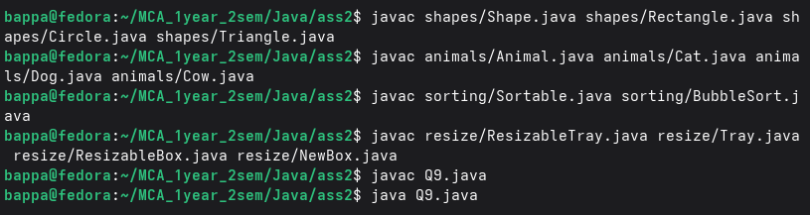

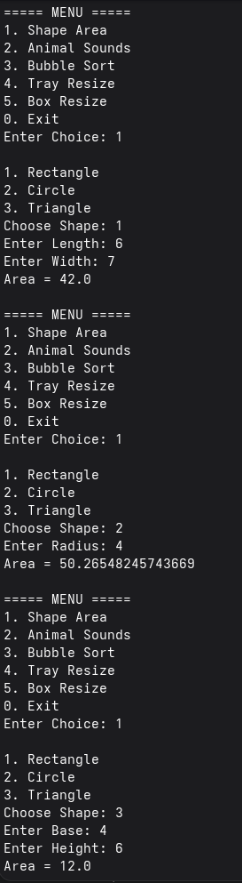
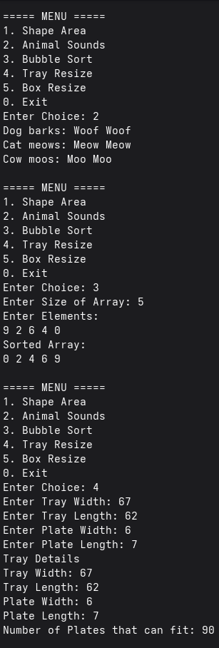

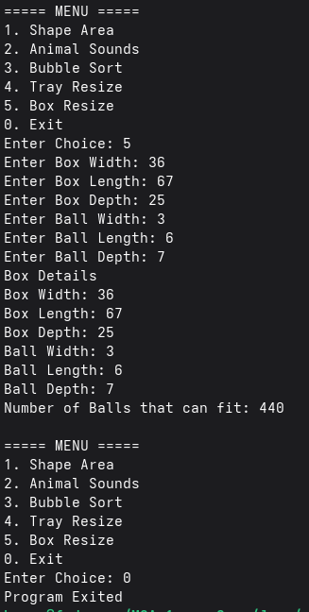
PROBLEM 14: Write the first 10 FIbonacci numbers to a text file “Fibo.txt”.
PROBLEM 15: Read “Fibo.txt” and append next numbers (<250).
PROBLEM 16: Generate a binary file “Fibo.bin” from “Fibo.txt”.
Source Code:
import java.io.*;
import java.util.*;

public class Q14 {
public static void main(String[] args) {
try {
FileWriter fw = new FileWriter("Fibo.txt");
int a = 0, b = 1;
for (int i = 0; i < 10; i++) {
fw.write(a + " ");
int c = a + b;
a = b;
b = c;
}
fw.close();
System.out.println("First 10 Fibonacci numbers written to Fibo.txt");
Scanner sc = new Scanner(new File("Fibo.txt"));
ArrayList<Integer> list = new ArrayList<>();
while (sc.hasNextInt()) {
list.add(sc.nextInt());
}
sc.close();
int n = list.size();
a = list.get(n - 2);
b = list.get(n - 1);
FileWriter appendFile = new FileWriter("Fibo.txt", true);
while (true) {
int next = a + b;
if (next >= 250)
break;
appendFile.write(next + " ");
a = b;
b = next;
}
appendFile.close();
System.out.println("Numbers less than 250 appended.");
Scanner readTxt = new Scanner(new File("Fibo.txt"));
DataOutputStream dos = new DataOutputStream(new FileOutputStream("Fibo.bin"));
while (readTxt.hasNextInt()) {
dos.writeInt(readTxt.nextInt());
}
readTxt.close();
dos.close();
System.out.println("Binary file Fibo.bin created.");
} catch (Exception e) {
System.out.println(e);
}
}
}

Output:
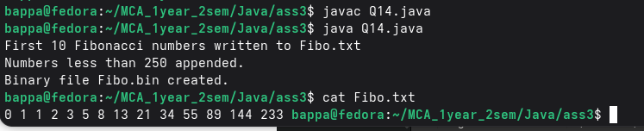

PROBLEM 17: Create a class Profile to store Name, Age, Average Mark. Allow creation of objects and store information for #n persons, with provision for storing content in “Profile.bin”.
PROBLEM 18: Read “Profile.bin” and display the record for the highest scorer.
Source Code:
import java.io.*;
import java.util.*;

class Profile implements Serializable {
private static final long serialVersionUID = 1L;
private String name;
private int age;
private double avgMarks;
Profile(String name, int age, double avgMarks) {
this.name = name;
this.age = age;
this.avgMarks = avgMarks;
}
public String getName(){
return name;
}
public int getAge(){
return age;
}
public double getAvgMarks(){
return avgMarks;
}
}

public class Q17 {
public static void main(String[] args) {
Scanner sc = new Scanner(System.in);
try {
System.out.print("Enter number of persons: ");
int n = sc.nextInt();
sc.nextLine();
ObjectOutputStream oos = new ObjectOutputStream(new FileOutputStream("Profile.bin"));
for (int i = 1; i <= n; i++) {
System.out.println("\nPerson " + i);
System.out.print("Name: ");
String name = sc.nextLine();
System.out.print("Age: ");
int age = sc.nextInt();
System.out.print("Average Marks: ");
double marks = sc.nextDouble();
sc.nextLine();
Profile p = new Profile(name, age, marks);
oos.writeObject(p);
}
oos.close();
System.out.println("\nRecords stored in Profile.bin");
ObjectInputStream ois = new ObjectInputStream(new FileInputStream("Profile.bin"));
Profile top = null;
while (true) {
try {
Profile p = (Profile) ois.readObject();
if (top == null || p.getAvgMarks() > top.getAvgMarks()) {
top = p;
}
} catch (EOFException e) {
break;
}
}
ois.close();
System.out.println("\nHighest Scorer Details");
System.out.println("Name : " + top.getName());
System.out.println("Age : " + top.getAge());
System.out.println("Average Marks : " + top.getAvgMarks());
} catch (Exception e) {
System.out.println(e);
}
sc.close();
}
}

Output:
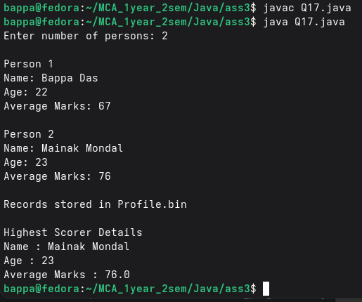

1. Write a prime generator program using only primes and using Python loops.
def is_prime(num):
if num < 2:
return False
for i in range(2, int(num ** 0.5) + 1):
if num % i == 0:
return False
return True

m = int(input("Enter the lower limit to generate primes up to: "))
n = int(input("Enter the upper limit to generate primes up to: "))

primes = []
for num in range(m, n + 1):
if is_prime(num):
primes.append(num)
print(f"Primes up to {n}: {primes}")
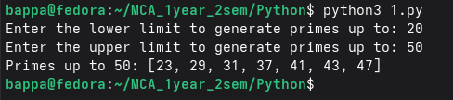

2. Write a discount coupon code using dictionary in Python with different rate coupons for each day of the week.
coupons = {
"Monday": ("MON10", 10),
"Tuesday": ("TUE15", 15),
"Wednesday": ("WED20", 20),
"Thursday": ("THU5", 5),
"Friday": ("FRI25", 25),
"Saturday": ("SAT30", 30),
"Sunday": ("SUN50", 50),
}

day = input("Enter the day of the week (e.g. Monday): ").strip().capitalize()

if day in coupons:
code, discount = coupons[day]
print(f"Day : {day}")
print(f"Coupon : {code}")
print(f"Discount : {discount}%")
else:
print("Invalid day. Please enter a valid day name (e.g. Monday, Tuesday, ...).")
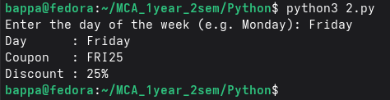

3. Print first 10 odd and even numbers using iterators and comprehension. You can use duck typing.
from itertools import compress, count, islice

# Generate first 20 numbers to ensure we get 10 of each
numbers = list(islice(count(0), 20))

# Selectors (masks)
evens_mask = [1, 0] * 10
odds_mask = [0, 1] * 10

evens = list(compress(numbers, evens_mask))
odds = list(compress(numbers, odds_mask))

print("Evens:", evens)
print("Odds:", odds)

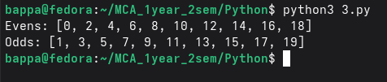

4. Write a regular expression to validate a phone number.
import re

def validate_phone(number):
pattern = r"^\d{10}$" # Matches exactly 10 digits
return bool(re.match(pattern, number))

# Test
phone=input("Enter your phone number: ")
print(validate_phone(phone)) # True
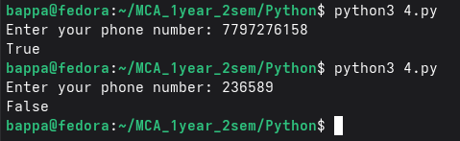

5. Write first seven Fibonacci numbers using generator next function/yield in Python. Trace and memorize the function.
def fibonacci_gen():
a, b = 0, 1
while True:
yield a
a, b = b, a + b

fib = fibonacci_gen()
for _ in range(7):
print(next(fib), end=" ")
print()

6. Write a simple program which loops over a list of user data and adds each user to a directory if valid. Raise exceptions for invalid username, age, email, etc.
import re

class UserDataError(Exception):
"""Base exception for all user data errors."""
pass

class UsernameNotUniqueError(UserDataError):
def __str__(self):
return "Username is not unique (already exists in directory)."

class InvalidAgeError(UserDataError):
def __str__(self):
return "Age is not a positive integer."

class UnderageError(UserDataError):
def __str__(self):
return "User is under 16 years old."

class InvalidEmailError(UserDataError):
def __str__(self):
return "Email is not valid (must contain @ and a domain name)."

directory = {}

def validate_and_add(username, email, age):
if username in directory:
raise UsernameNotUniqueError()

if not isinstance(age, int) or age <= 0:
raise InvalidAgeError()

if age < 16:
raise UnderageError()

email_pattern = r"^[^@]+@[^@]+\.[^@]+$"
if not re.match(email_pattern, email):
raise InvalidEmailError()

# All checks passed
directory[username] = {"email": email}
print(f" '{username}' added to directory.")

print("Enter user data. Type 'done' as username to finish.\n")

users = []
while True:
uname = input(" Username (or 'done'): ").strip()
if uname.lower() == "done":
break
email = input(" Email : ").strip()
age_input = input(" Age : ").strip()

try:
age = int(age_input)
except ValueError:
age = age_input # keep as non-int so InvalidAgeError triggers

users.append((uname, email, age))

print("\n--- Processing Users ---")
for username, email, age in users:
try:
validate_and_add(username, email, age)
except UsernameNotUniqueError as e:
print(f" [{username}] {e}")
except InvalidAgeError as e:
print(f" [{username}] {e}")
except UnderageError as e:
print(f" [{username}] {e}")
except InvalidEmailError as e:
print(f" [{username}] {e}")

print(f"\nFinal Directory: {directory}")
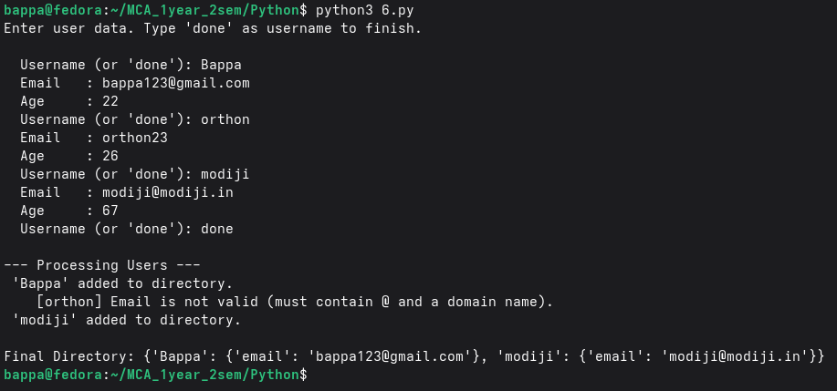

7. Write a function findfiles that recursively descends the directory tree and generates paths of all files.
import os

def findfiles(directory):
"""
Recursively finds and generates paths of all files
under the given directory tree.
"""
for root, dirs, files in os.walk(directory):
for filename in files:
yield os.path.join(root, filename) # generator — yields one path at a time

path = input("Enter a directory path to scan (e.g. /home or .): ").strip()

if not os.path.isdir(path):
print(f"'{path}' is not a valid directory.")
else:
print(f"\nFiles found under '{path}':\n")
count = 0
for filepath in findfiles(path):
print(f" {filepath}")
count += 1

print(f"\nTotal: {count} file(s) found.")
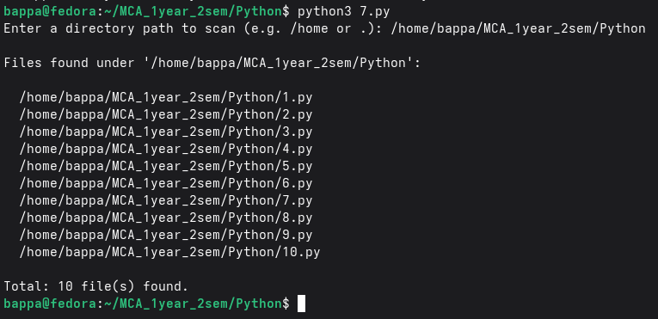

8. Create a list of all numbers up to N=50 which are multiples of five using anonymous function.
N = 50

numbers = range(1, N + 1)

multiples_of_five = list(filter(lambda x: x % 5 == 0, numbers))

print(f"Multiples of 5 up to N={N}:")
print(multiples_of_five)
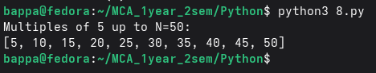

9. Use map and zip to find the element-wise maximum among sequences of student list, subject list, and marks.
def get_list(name):
raw = input(f"Enter {name} (space-separated numbers): ")
return list(map(int, raw.split()))
student_list = get_list("Student List")
subject_list = get_list("Subject List")
marks_list = get_list("Marks List ")

result = list(map(lambda trio: max(trio), zip(student_list, subject_list, marks_list)))

print(f"\nStudent List : {student_list}")
print(f"Subject List : {subject_list}")
print(f"Marks List : {marks_list}")
print(f"Element-wise Max: {result}")

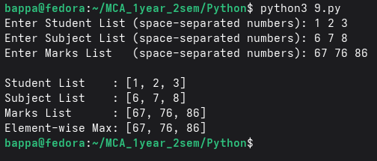
10. Filter out the odd squares using map, filter, and list.
raw = input("Enter numbers (space-separated): ")
numbers = list(map(int, raw.split()))

squares = list(map(lambda x: x ** 2, numbers))

odd_squares = list(filter(lambda x: x % 2 != 0, squares))

print(f"\nOriginal numbers : {numbers}")
print(f"Squared : {squares}")
print(f"Odd squares only : {odd_squares}")
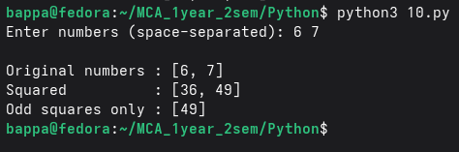

11. List all Pythagorean triples whose short sides are numbers smaller than 10.
limit = int(input("Enter max value for short sides (e.g. 10): "))
triples_comp = [
(a, b, c)
for a in range(1, limit)
for b in range(a, limit)
for c in range(1, 200)
if a ** 2 + b ** 2 == c ** 2
]
candidates = [
(a, b, c)
for a in range(1, limit)
for b in range(a, limit)
for c in range(1, 200)
]
triples_filter = list(
filter(lambda t: t[0] ** 2 + t[1] ** 2 == t[2] ** 2, candidates)
)
print(f"\nPythagorean Triples with short sides < {limit}:")
print(f" Using Comprehension : {triples_comp}")
print(f" Using filter() : {triples_filter}")

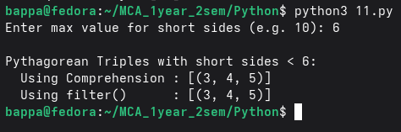

12. Enumerate the sequence of all lowercase ASCII letters starting from 1 using enumerate.
letters = [chr(c) for c in range(ord('a'), ord('z') + 1)]

print("Index Letter")
print("─" * 16)
for index, letter in enumerate(letters, start=1):
print(f" {index:2d} {letter}")
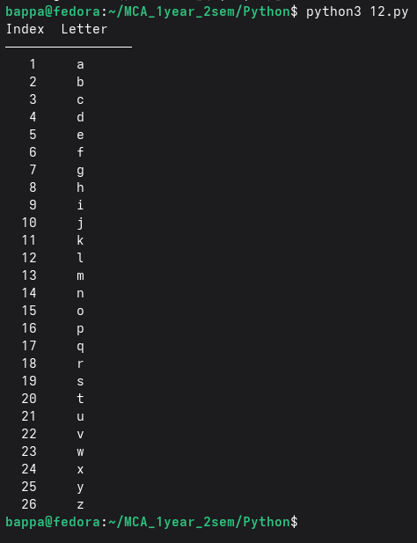

13. Write a code which yields all terms of the geometric progression a, aq, aq², aq³... until the term exceeds 100000.
import time

def geo_gen(a, q):
term = a
loop_time_total = 0.0

while True:
if term > 100000:
return loop_time_total
loop_start = time.perf_counter()
yield term
loop_end = time.perf_counter()

loop_time_total += (loop_end - loop_start)
term = term * q

a = float(input("Enter the first term (a): "))
q = float(input("Enter the common ratio (q): "))

print(f"\nGeometric Progression: a={a}, q={q}")
print("Terms (stops when term > 100,000):\n")

total_start = time.perf_counter()

terms = []
gen = geo_gen(a, q)
loop_time = 0.0

try:
while True:
val = next(gen)
terms.append(val)
print(f" {val}")
except StopIteration as e:
loop_time = e.value

total_end = time.perf_counter()
total_time = total_end - total_start

print(f"\nTotal terms generated : {len(terms)}")
print(f"Last term yielded : {terms[-1] if terms else 'None'}")
print(f"\nTotal time (seconds) : {total_time:.6f}s")
print(f"Time inside loop (sec) : {loop_time:.6f}s")
print(f"Time outside loop (sec) : {total_time – loop_time:.6f}s")

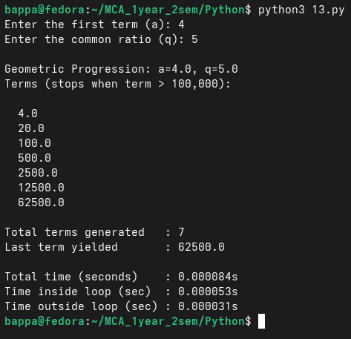

14. Search for palindrome and unique words in a text using class method and string method.
class TextAnalyzer:
def __init__(self, text):
self.text = text

def palindrome_words(self):
words = self.text.lower().split()
palindromes = []

for word in words:
clean_word = ''.join(ch for ch in word if ch.isalnum())

if clean_word == clean_word[::-1] and len(clean_word) > 1:
if clean_word not in palindromes:
palindromes.append(clean_word)

return palindromes

def unique_words(self):
words = self.text.lower().split()
freq = {}

for word in words:
clean_word = ''.join(ch for ch in word if ch.isalnum())

freq[clean_word] = freq.get(clean_word, 0) + 1

unique = []

for word, count in freq.items():
if count == 1:
unique.append(word)

return unique

text = input("Enter a text: ")

obj = TextAnalyzer(text)

print("\nPalindrome Words:")
print(obj.palindrome_words())

print("\nUnique Words:")
print(obj.unique_words())
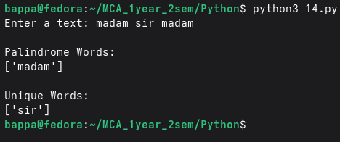

15. Create a BankAccount class and a derived FeeSavingsAccount class with deposit, withdraw, balance inquiry, and fee deduction features.
class BankAccount:
def __init__(self, name, balance):
self.name = name
self.balance = balance

def deposit(self, amount):
self.balance += amount
print("Deposited:", amount)

def withdraw(self, amount):
if amount <= self.balance:
self.balance -= amount
print("Withdrawn:", amount)
else:
print("Insufficient Balance")

def get_balance(self):
print("Current Balance:", self.balance)

def change_pin(self):
old_pin = input("Enter old PIN: ")
new_pin = input("Enter new PIN: ")
print("PIN changed successfully")

class SavingsAccount(BankAccount):
def __init__(self, name, balance, interest_rate, fee):
super().__init__(name, balance)
self.interest_rate = interest_rate
self.fee = fee

def add_interest(self):
interest = self.balance * self.interest_rate / 100
self.balance += interest
print("Interest Added:", interest)

def withdraw(self, amount):
total = amount + self.fee

if total <= self.balance:
self.balance -= total
print("Withdrawn:", amount)
print("Fee Charged:", self.fee)
else:
print("Insufficient Balance")

name = input("Enter account holder name: ")
balance = float(input("Enter initial balance: "))
interest = float(input("Enter interest rate (%): "))
fee = float(input("Enter withdrawal fee: "))

acc = SavingsAccount(name, balance, interest, fee)

while True:
print("\n1.Deposit")
print("2.Withdraw")
print("3.Add Interest")
print("4.Check Balance")
print("5.Change PIN")
print("6.Exit")

choice = int(input("Enter choice: "))

if choice == 1:
amt = float(input("Enter amount: "))
acc.deposit(amt)

elif choice == 2:
amt = float(input("Enter amount: "))
acc.withdraw(amt)

elif choice == 3:
acc.add_interest()

elif choice == 4:
acc.get_balance()

elif choice == 5:
acc.change_pin()

elif choice == 6:
break

else:
print("Invalid Choice")

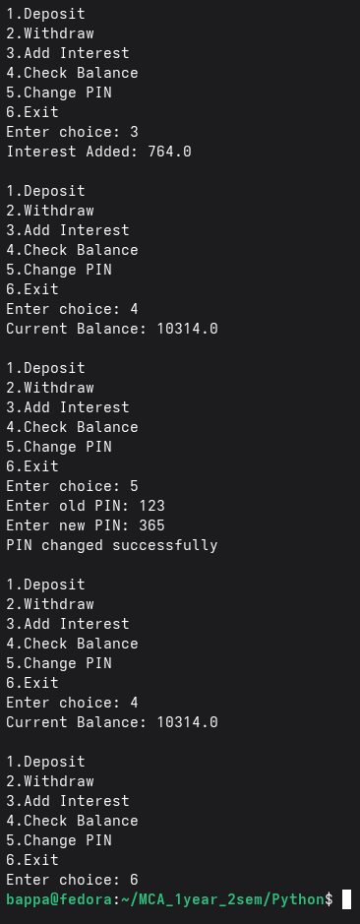

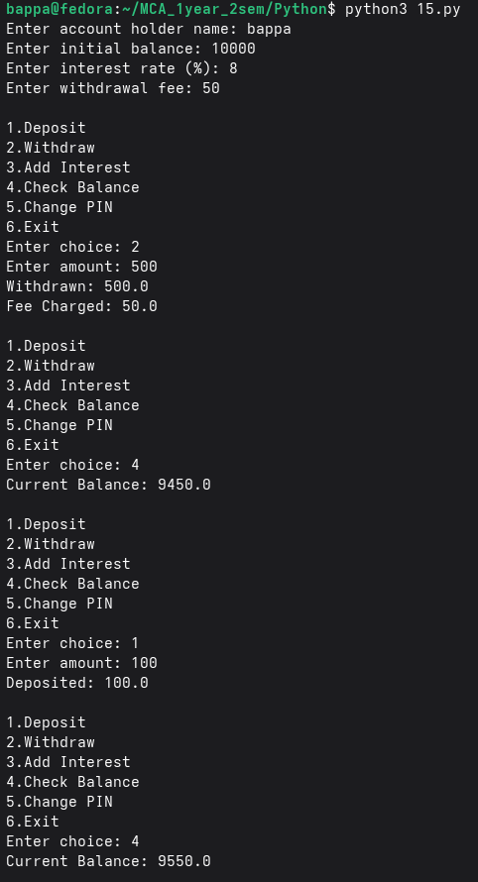

16. Write an operator overloading function that returns the length of repetitive words in text and determines the most frequently occurring words.
from collections import Counter
class TextCheck:
def __init__(self, text):
self.text = text

def __len__(self):
words = self.text.lower().split()
freq = Counter(words)
repetitive = 0

for count in freq.values():
if count > 1:
repetitive += 1

return repetitive

def most_common_word(self):
words = self.text.lower().split()
freq = Counter(words)

return freq.most_common(1)

text = input("Enter text: ")
obj = TextCheck(text)

print("Number of repetitive words:", len(obj))
print("Most Frequent Word:")
print(obj.most_common_word())
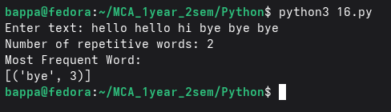

17. Implement a priority queue that sorts items by priority and always returns the highest priority item first.
import heapq

pq = []
n = int(input("How many elements do you want to insert? "))

for i in range(n):
item = input("Enter item: ")
priority = int(input("Enter priority (smaller number = higher priority): "))

heapq.heappush(pq, (priority, item))

print("\nItems removed based on priority:")

while pq:
priority, item = heapq.heappop(pq)
print(item, "with priority", priority)
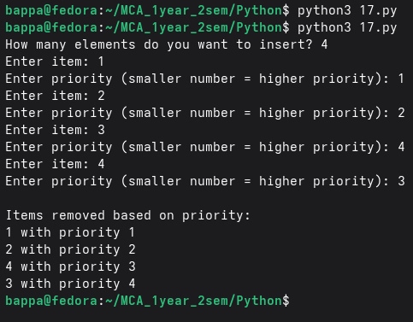

18. Make a list of the largest or smallest N items in a collection.
import heapq

numbers = []

n = int(input("Enter number of elements: "))

for i in range(n):
num = int(input("Enter number: "))
numbers.append(num)

k = int(input("Enter value of N: "))

largest = heapq.nlargest(k, numbers)
smallest = heapq.nsmallest(k, numbers)

print("Largest", k, "items:", largest)
print("Smallest", k, "items:", smallest)
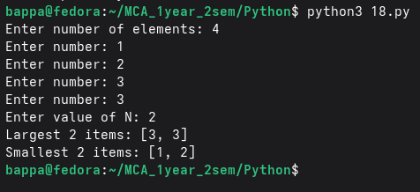

19. Create dictionaries for stock prices, find minimum/maximum prices, compare dictionaries, and group prices by multiples of 500.
stock1 = {}
stock2 = {}

n1 = int(input("Enter number of stocks in first dictionary: "))

for i in range(n1):
name = input("Enter stock name: ")
price = int(input("Enter stock price: "))
stock1[name] = price

print("\nFirst Dictionary:", stock1)

print("\nMinimum Price:", min(stock1.values()))
print("Maximum Price:", max(stock1.values()))

sorted_stock = dict(sorted(stock1.items(), key=lambda x: x[1]))

print("\nSorted by Price:")
print(sorted_stock)

n2 = int(input("\nEnter number of stocks in second dictionary: "))

for i in range(n2):
name = input("Enter stock name: ")
price = int(input("Enter stock price: "))
stock2[name] = price

print("\nSecond Dictionary:", stock2)

print("\nStocks only in first dictionary:")

for key in stock1:
if key not in stock2:
print(key)

print("\nStocks with different prices:")

for key in stock1:
if key in stock2 and stock1[key] != stock2[key]:
print(key, ":", stock1[key], stock2[key])

print("\nIncrementing prices by 500:")

for key in stock1:
stock1[key] += 500

print(stock1)

print("\nGrouping stocks by price multiple of 500:")

group = {}

for key, value in stock1.items():
grp = (value // 500) * 500

if grp not in group:
group[grp] = []

group[grp].append(key)

print(group)
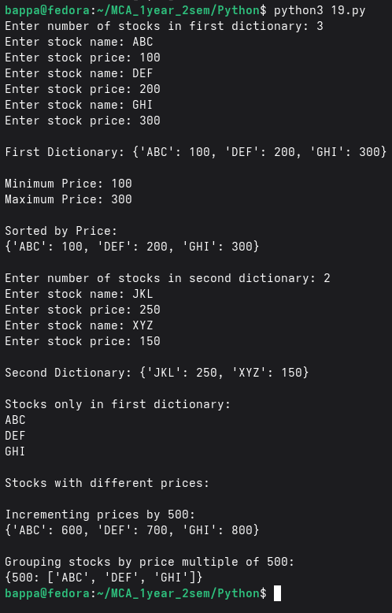

20. Write a function that flattens a nested dictionary structure like one obtained from Twitter and Facebook APIs.
def flatten_dict(d, parent_key="", sep="."):
items = {}

for k, v in d.items():
new_key = parent_key + sep + k if parent_key else k

if isinstance(v, dict):
items.update(flatten_dict(v, new_key, sep=sep))

elif isinstance(v, list):
for i, item in enumerate(v):
if isinstance(item, dict):
items.update(flatten_dict(item, f"{new_key}[{i}]", sep=sep))
else:
items[f"{new_key}[{i}]"] = item
else:
items[new_key] = v

return items

fullname = input("Enter full name: ")
age = int(input("Enter age: "))
phone_count = int(input("How many phone numbers? "))

phones = []
for i in range(phone_count):
phones.append(input(f"Enter phone number #{i+1}: "))

first_line = input("Enter first-line address: ")
second_line = input("Enter second-line address: ")
zip_code = input("Enter ZIP code: ")

nested = {
"fullname": fullname,
"age": age,
"phone-numbers": phones,
"residence": {
"address": {"first-line": first_line, "second-line": second_line},
"zip": zip_code,
},
}

print("\nNested Dictionary:")
print(nested)

flat = flatten_dict(nested)

print("\nFlattened Dictionary:")
for k, v in flat.items():
print(f"{k} : {v}")

