D B M S LAB
ASSSIGNMENT-3

1. In an organization, number of departments exists. Each department has a name &amp; unique code. Number of employees work in each department. Each employee has unique employee code. Detailed information like name, address, city, basic, date of join are also stored. In a leave register for each employee leave records are kept showing leave type (CL/EL/ML etc.), from-date and to-date. When an employee retires or resigns then all the leave information pertaining to him are also deleted. Basic salary must be within Rs.5000 to Rs.9000. A department can not be deleted if any employee record refers to it. Valid grades are A/B/C. Employee name must be in uppercase only. Default value for joining date is system date. Design &amp; implement the tables with necessary constraints to support the scenario depicted above.
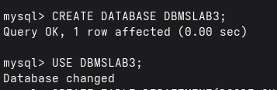
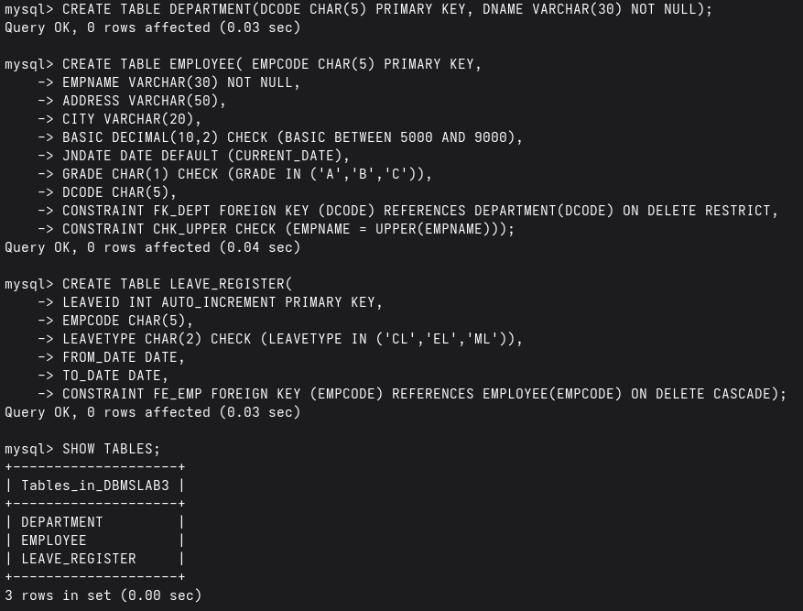
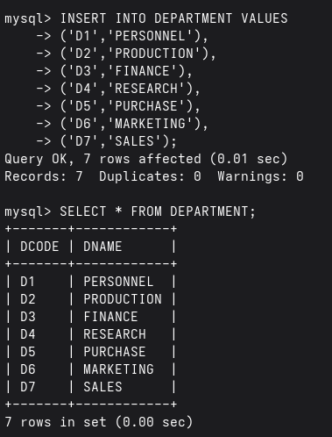
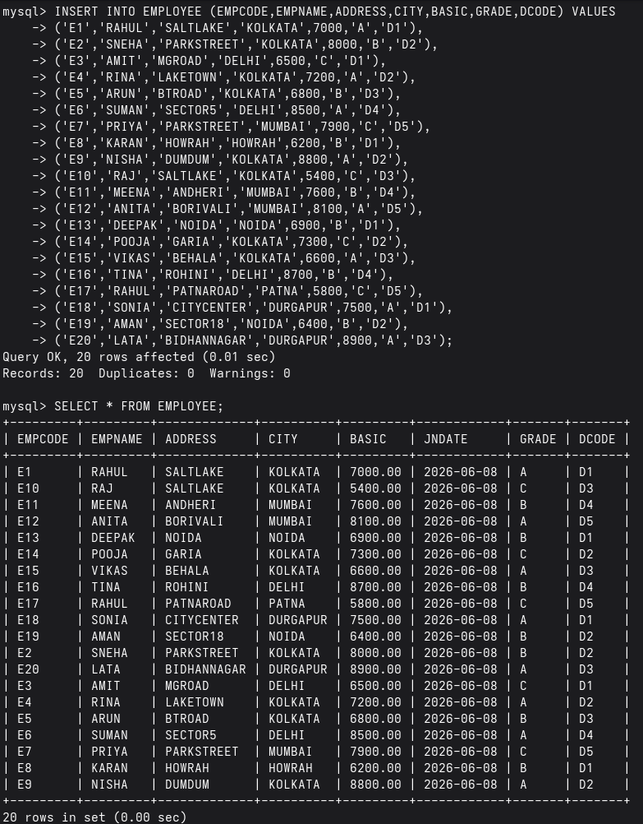

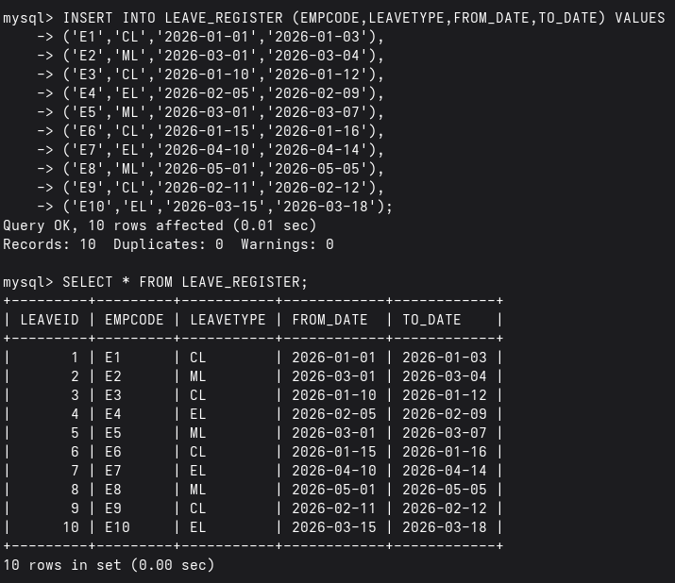
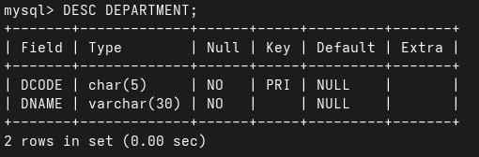
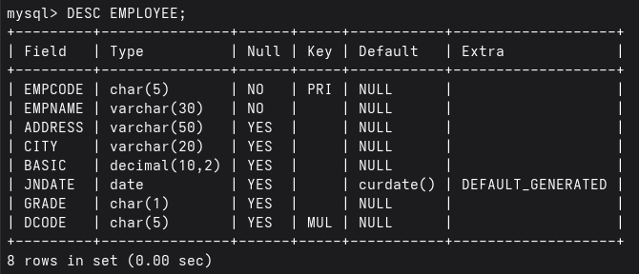
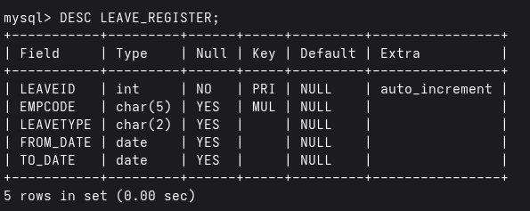
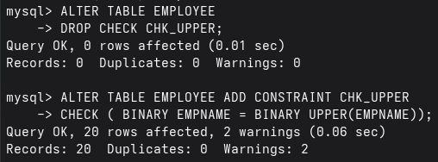

2. Try to violate the constraints that you have implemented in the table &amp; note, what happens. [Try with suitable INSERT/UPDATE/DELETE instruction]
Salary Constraint Violation
Invalid Grade
Lowercase Employee Name
Invalid Department
Invalid Leave Type
Delete Department Referenced by Employee
Delete Employee to Check Cascade Delete
Verify Leave Deletion
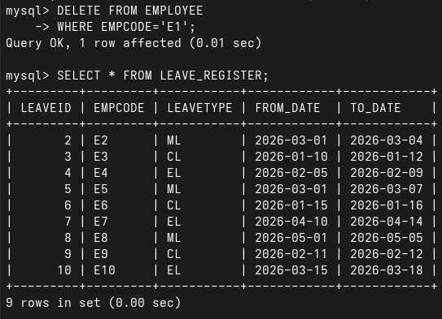
3. a) create a view showing employee code, name, dcode &amp; Basic For a particular department.
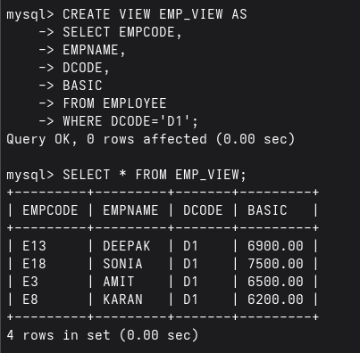
b)Try to ensure a row into the view with valid department &amp; also with invalid ones.
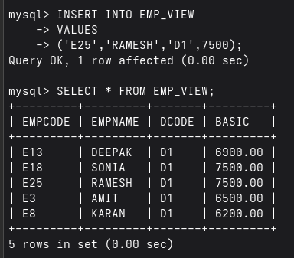
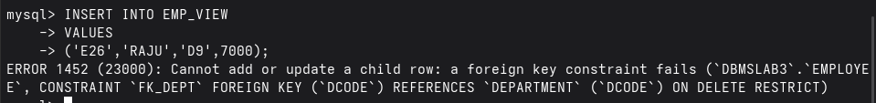
c)Find the newly inserted row in the table From which view was created .
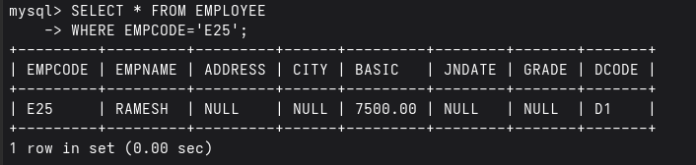
d) Try to increment basic by Rs.100/-
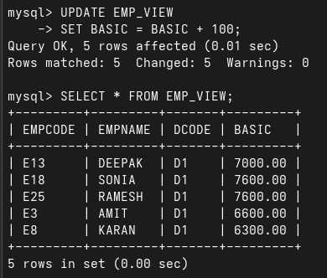
e) Check it in the original table.
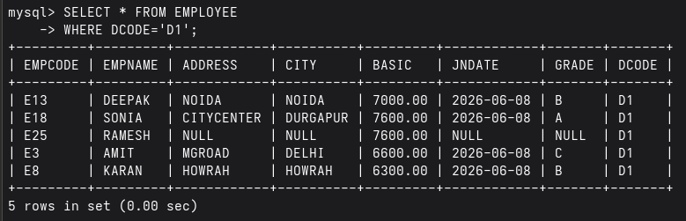
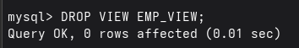
f) Delete the view.
4. a) create a view Showing empcode, name, deptname, basic, leave type, From date &amp; to date.
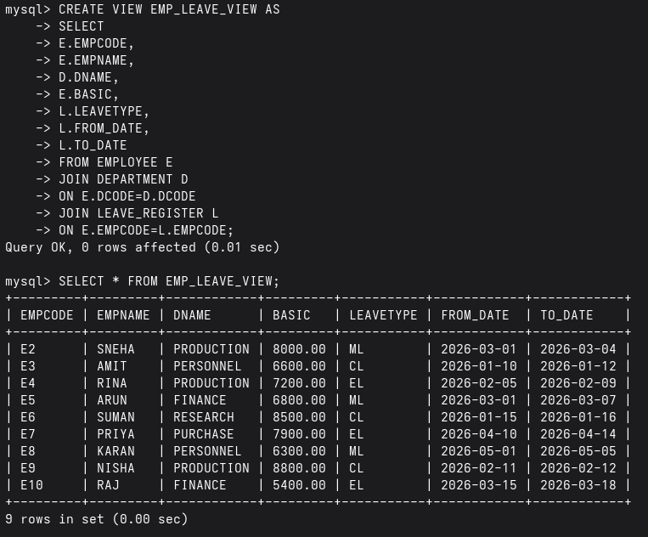
b)Try to insert a row in the view. Check what happens?
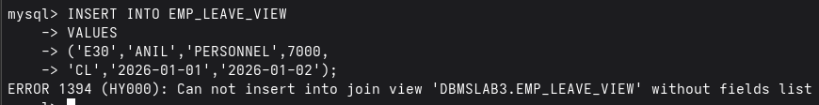
c) Try to increment basic by Rs.100.
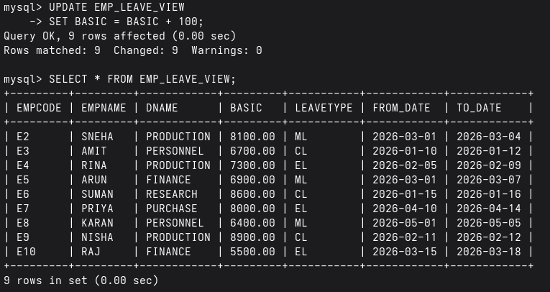
d) Delete the view.


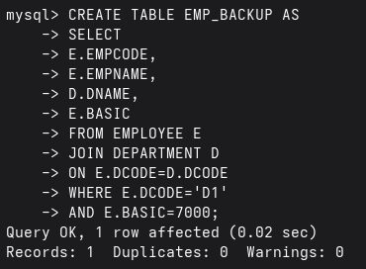
5. a) Create a table having empcode , Name, deptname, &amp; basic From the existing tables along with therecords of the employee who are in a particular department (say, d1) and with a basic Rs. 7000/-
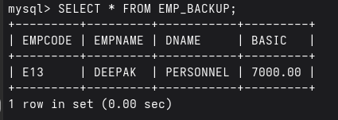
b) From the existing table, add the employees with the basic salary greater than or equal to 7000/-
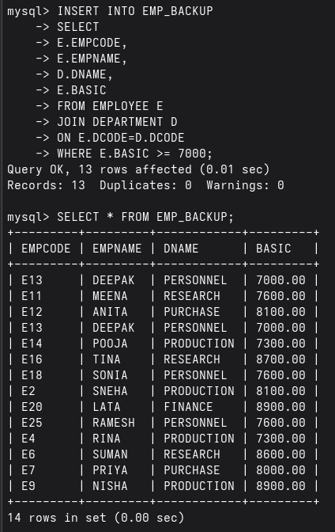
c) Alter the table to add a net pay column.
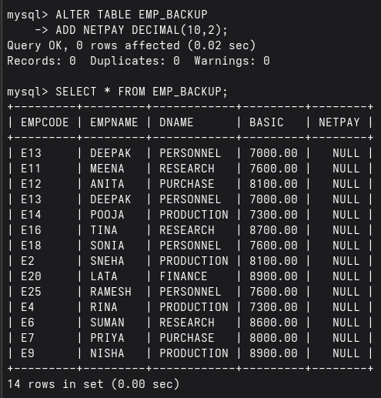
d) Replace net pay with 1.5* Basic.
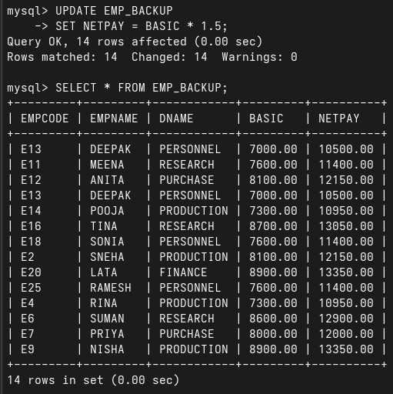
e) Try to remove the net net pay column.
[ It may require no. of steps]
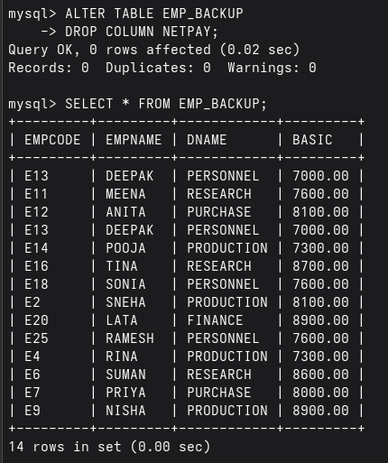

6. Drop all the tables that you have created .

DROP TABLE LEAVE_REGISTER;
DROP TABLE EMPLOYEE;
DROP TABLE DEPARTMENT;
DROP DATABASE DBMSLAB3;

