**Selected Model: SSD MobileNet V2 COCO**

[**http://download.tensorflow.org/models/object_detection/ssd_mobilenet_v2_coco_2018_03_29.tar.gz**](http://download.tensorflow.org/models/object_detection/ssd_mobilenet_v2_coco_2018_03_29.tar.gz)

1. **Step 1: Download model and unpack (ssd_mobilenet_v2_coco_2018_03_29)**

Use the following command to download the model.

wget <http://download.tensorflow.org/models/object_detection/ssd_mobilenet_v2_coco_2018_03_29.tar.gz>

Unpack or extract the model files using tar command as below.

tar -xvf ssd_mobilenet_v2_coco_2018_03_29.tar.gz

1. **Step 2: Generate an IR Model using model optimizer**

Use the command below to generate an IR model

python /opt/intel/openvino/deployment_tools/model_optimizer/mo.py --input_model ssd_mobilenet_v2_coco_2018_03_29/frozen_inference_graph.pb --tensorflow_object_detection_api_pipeline_config ssd_mobilenet_v2_coco_2018_03_29/pipeline.config --reverse_input_channels --tensorflow_use_custom_operations_config /opt/intel/openvino/deployment_tools/model_optimizer/extensions/front/tf/ssd_v2_support.json

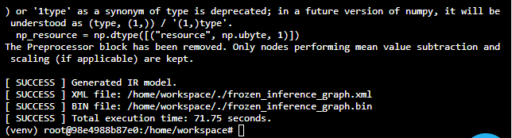

A .bin and .xml files are generated which will be used to perform inference. Copy these files from the ssd_mobilenet_v2_coco_2018_03_29 to the workspace directory.

1. **Step 3:**

Finally, use the below command to see the people counter app in action.

python main.py -i resources/Pedestrian_Detect_2_1_1.mp4 -m frozen_inference_graph.xml -l /opt/intel/openvino/deployment_tools/inference_engine/lib/intel64/libcpu_extension_sse4.so -d CPU -pt 0.6 | ffmpeg -v warning -f rawvideo -pixel_format bgr24 -video_size 768x432 -framerate 24 -i - <http://0.0.0.0:3004/fac.ffm>