**Runtime Permission**

If the device is running Android 6.0 (API level 23) or higher then need Runtime Permission.

Two categories permissions system:

1. Normal permission system. (Automatically granted)
2. Dangerous permission system. (Not automatically granted)

Dangerous permissions table in bellow:

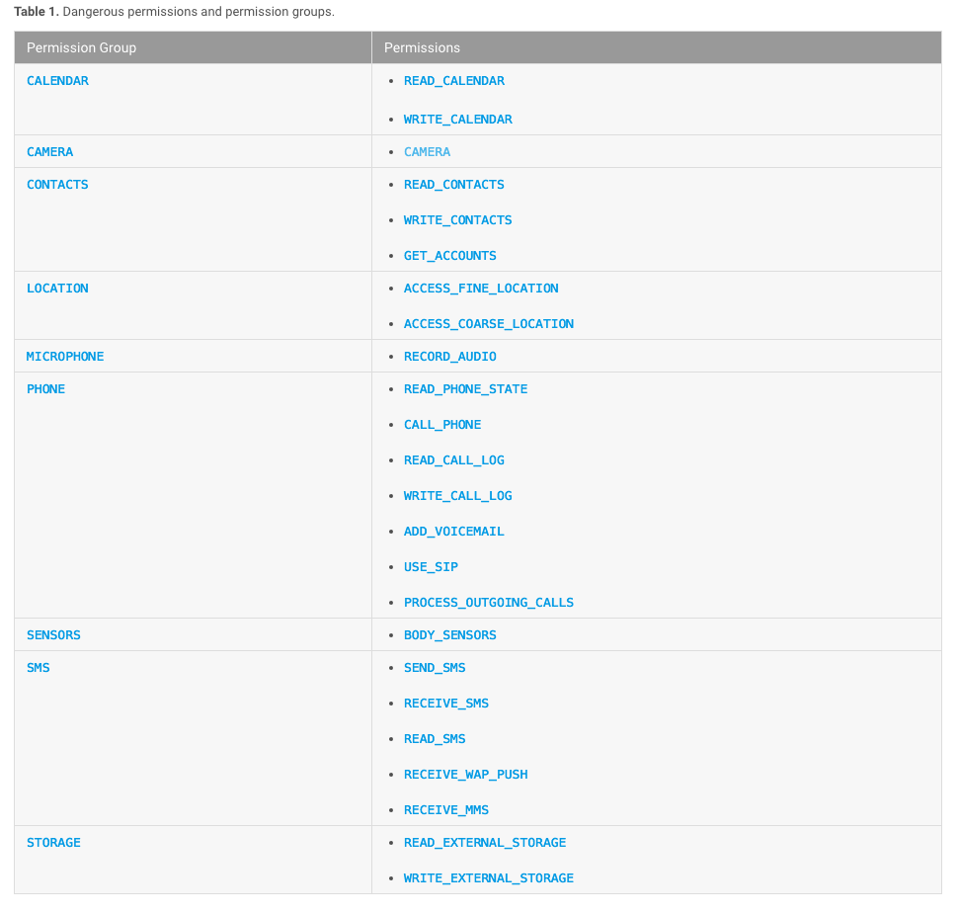

**Target code:**

1. Check permissions.
2. Request Permissions.
3. Permission Request responding.

**Code Here:**

**import** android.Manifest;  
**import** android.content.Intent;  
**import** android.content.pm.PackageManager;  
**import** android.net.Uri;  
**import** android.os.Build;  
**import** android.support.annotation.NonNull;  
**import** android.support.v4.app.ActivityCompat;  
**import** android.support.v7.app.AppCompatActivity;  
**import** android.os.Bundle;  
**import** android.util.Log;  
**import** android.view.View;  
**import** android.widget.Button;  
  
**public class** MainActivity **extends** AppCompatActivity {  
  
 Button **btnCamera**, **btnCall**;  
 @Override  
 **protected void** onCreate(Bundle savedInstanceState) {  
 **super**.onCreate(savedInstanceState);  
 setContentView(R.layout.***activity_main***);  
  
 **btnCall** = (Button) findViewById(R.id.***btnCall***);  
 **btnCamera** = (Button) findViewById(R.id.***btnCamera***);  
  
 **btnCamera**.setOnClickListener(**new** View.OnClickListener() {  
 @Override  
 **public void** onClick(View view) {  
  
 *// calling method* askForPermission(Manifest.permission.***CAMERA***, 2);  
  
 }  
 });  
  
 **btnCall**.setOnClickListener(**new** View.OnClickListener() {  
 @Override  
 **public void** onClick(View view) {  
  
 *// calling method* askForPermission(Manifest.permission.***CALL_PHONE***, 1);  
  
  
 }  
 });  
  
  
 }  
  
  
  
 *// 1. Check permissions.* **private void** askForPermission(String permission, Integer requestCode){  
  
 **if**(ActivityCompat.*checkSelfPermission*(**this**, permission) != PackageManager.***PERMISSION_GRANTED***){  
 *// 2. Request Permissions.  
 //permission Granted* **if**(Build.VERSION.***SDK_INT*** >= Build.VERSION_CODES.***M***){  
  
 ActivityCompat.*requestPermissions*(MainActivity.**this**, **new** String[]{permission}, requestCode);  
  
 }**else**{  
  
 }  
 }**else**{  
 *// Already have permissions.  
 // 2. Request Permissions.* **if**(Build.VERSION.***SDK_INT*** >= Build.VERSION_CODES.***M***){  
  
 ActivityCompat.*requestPermissions*(MainActivity.**this**, **new** String[]{permission}, requestCode);  
  
 }**else**{  
  
 }  
 }  
 }  
  
  
 *// 3. Permission Request responding.* @Override  
 **public void** onRequestPermissionsResult(**int** requestCode, @NonNull String[] permissions, @NonNull **int**[] grantResults) {  
 **super**.onRequestPermissionsResult(requestCode, permissions, grantResults);  
 **if**(ActivityCompat.*checkSelfPermission*(**this**, permissions[0]) == PackageManager.***PERMISSION_GRANTED***){  
 **switch** (requestCode){  
 **case** 1:  
 *//call* **if**(grantResults[0] == PackageManager.***PERMISSION_GRANTED***){  
 Intent callIntent = **new** Intent(Intent.***ACTION_CALL***, Uri.*parse*(**"tel:"** + **"01855333129"**));  
 startActivity(callIntent);  
 }**else**{  
 *//permission denied* }  
 **break**;  
  
 **case** 2:  
 *// camera* **if**(grantResults[0] == PackageManager.***PERMISSION_GRANTED***){  
*// Intent intent = new Intent("android.media.action.IMAGE_CAPTURE");  
// startActivity(intent);* Intent cameraIntent = **new** Intent(android.provider.MediaStore.***ACTION_IMAGE_CAPTURE***);  
 startActivityForResult(cameraIntent, 1);  
 }**else**{  
 *//permission denied* }  
  
 **break**;  
 }  
  
 }**else**{  
  
 }  
  
  
  
 }  
}