 

Module Title: Fuzzy Logic

Module Code: CSFS6021

Module Level: 3

Programme Title: Bsc(Hons) Computing

Module Leader: Professor Hasan Al Saedy

|  |
| --- |
|  |

Student Name: Mohammad Bappy Chowdhary

Student ID: 45765

Contents

INTRODUCTION 3

CLASSICAL SET THEORY AND FUZZY LOGIC 3

CLASSIC AND FUZZY CONTROL SYSTEM, ADVANTAGES AND LIMITATIONS 4

IMPLEMENTING OF FUZZY CONTROL SYSTEM IN DEVICE 6

VISUALISING THE FUZZIFICATION 8

REAL WORLD ADVANTAGES 10

CONCLUSION 10

BIBLIOGRAPHY 10

# INTRODUCTION

Human expectancy is always and always will be higher than before. Accuracy will be the most significant aspect to everyone in any events of our lives. Nowadays daily life has changed so significantly due to the urge of our needs. Most of the technical device we are using in our daily life just to ease the either work effort or to save our time.

All the mechanical devices and their control systems works on logic gates. These logics are based on as we know 0 and 1 which called classical logic system.

Now what if there is something in between 0 and 1 in terms of logic? It can be anything between 1 an 0 which is fuzzy. In 1965 professor Lotfi Zadeh proposed his Fuzzy theory which explains this matter where logic sets between 0 and 1 and how it controls the signals in devices using the Fuzzy logic.

In this work we are going to analyse and explain with a systematic approach using Fuzzy logic in blood pressure monitoring system in devices.

# CLASSICAL SET THEORY AND FUZZY LOGIC

In mathematics a classical set theory is binary relation between a set *A* and an object *o* where *o* is an element of *A*. Relation between two sets and which are derived from binary is also called **set inclusion**.

If we take two sets set A and set B and **Union** of set A and B will be their all elements in them, for example, *A $∪$* *B* is the set of their all elements. Similarly *A $∩$* *B* which typically called will be **Intersection.**

Professor Zadeh introduced the notion of fuzzy sets in 1965 in a seminal paper. He I a professor at the university of southern California and is still active in the field. The idea of fuzzy sets described in his seminal work lays the basis for Fuzzy Logic.

. For any Fuzzy set ***A***, the function represents the membership function for which ***µ(x)*** indicates the degree of membership that *x,* of the universal set ***X***, belongs to set ***A*** and is usually expressed as a number between 0 and 1.

***µ(x): X [0,1]***

. Fuzzy seta can be either discrete or continuous

* **The Fuzzy set notation** for the member, ***x***, of a discrete set with membership ***µ****,* we use the notation ***µ*/*x****.* In other words, **x** is a member of the set to degree ***µ***.
* **Discrete sets** are defined as:

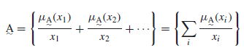

* or (in a more compact form)

***x*1 ,*x*2 , ….. *xn***: members of the set *A*

***µ1*, *µ*2,…..*µn* : *x*1 , *x*2  ….. *xn***’s degree of membership.

* A continuous fuzzy set *A can be* defined as:

***A* = $\int{μ(x)/x}$**

These are the basic fuzzy sets that can be implanted in control system. Fuzzy control system works on the basics of fuzzy logic considering the fact of more accuracy.

# CLASSIC AND FUZZY CONTROL SYSTEM, ADVANTAGES AND LIMITATIONS

Fuzzy logic has had greatest success on control system in terms of problem solving with highest accuracy. Nowadays different applications specifically for medical and electronic devices which have use for some sort of measurement system and it needs to be quiet accurate are based on fuzzy control system.

In this work we are going to explain a control system for the blood pressure measurement, such as how the reading can determine in the device to decide the approximate decision about the measurement.

According to (Hoang ChuDuc, 2013) traditional heart rate calculation could be in two ways, frequency domain measures and time domain measures.

We need to measure the variable, perhaps fixed them to control the physical variables. If we look into a closed loop control system (Charles L. Phillips, 2000) the control problem is

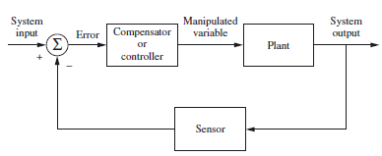

Figure 1 A Classic Closed loop Control System

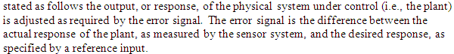

On the other hand a fuzzy control system are more systematic approach, the steps are given below.

1. Variables identifying such as input, output and states.

2. Assigning each variable into fuzzy subset.

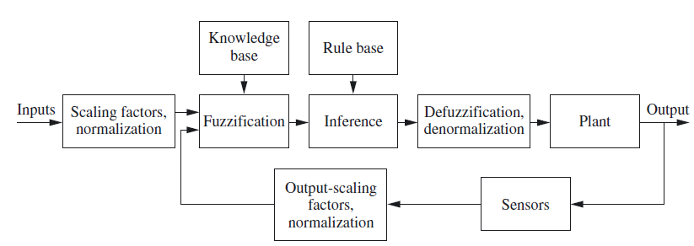

Figure 2 Fuzzy Control Diagram (Ross, 2010)

3. Determining the membership for each fuzzy subset.

4. For input and output variables need to choose appropriate scaling factors.



7. Aggregate the fuzzy outputs recommended by each rule.

8. Apply defuzzification to form a crisp output

# IMPLEMENTING OF FUZZY CONTROL SYSTEM IN DEVICE

Monitoring blood pressure is a significant aspect for those patient who has high or low blood pressure, but how are going to know that the blood pressure will be high or very high or even very low? The fluctuation can vary a lot, although there are some certain range which is in medical science is fixed for blood pressure measurement.

Fuzzy logic has solved the problem how it could be defined all the conditional variables considering the fact of unique measurement ranges.

We will follow our Fuzzy control system diagram as we mentioned earlier in the Figure 2.

At first we need to assign the variables. In blood pressure device typically two factor works, Systolic and Diastolic. Both of the process has three basic readings which are high blood pressure, ideal blood pressure and low blood pressure.

**Defining Variables:**

If we Take Systolic as S, Diastolic as D then for both variables the next step would be to set knowledge base rule for High blood pressure ***h***, Ideal blood pressure ***i***, and low blood pressure as ***l***, Pressure ***p,*** Result ***R***.

**Knowledge based Rule:**

To set the rule at first we need to follow the fuzzification rule. To fuzzify using knowledge based rule we will split the logic into 3 sections each for Systolic and Diastolic process.

for Systolic **S**

if Pressure ***p*** = = 60 $\sim$ 90

THEN Result ***R*** = “very low”

if Pressure ***p*** = = 80 $\sim$ 55

THEN Result ***R*** = “extremely low”

if Pressure ***p*** = = 70 $\sim$ 45

THEN Result ***R*** = “danger Stage 1”

if Pressure ***p*** = = 60- $\sim$ 40

THEN Result ***R*** = “danger Stage 2”

if Pressure ***p*** = = 50 $\sim$ 30

THEN Result ***R*** = “Very Danger”

for Diastolic **D**

if Pressure p > 80 && p < 120

THEN Result R = “Normal”

if Pressure ***p*** = = 120 $\sim$ 139

THEN Result R = “Pre-hypertension”

if Pressure ***p*** = = 140 $\sim$ 159

THEN Result ***R*** = “High_BP_Stage 1”

if Pressure ***p*** > n160

THEN Result ***R*** = “High_BP_Stage 2”

if Pressure ***p*** > 180

THEN Result ***R*** = “Emergency”

end

return ***R***

# VISUALISING THE FUZZIFICATION

About 12 million deaths occur due to heart diseases. (Mayilvaganan M, 2014) Mentioned in his article that medical diagnosis is a type of task where its need to be completed accurately and efficiently.

To understand the fuzziness in blood pressure device it is necessary to visualise information in a graph where we can easily notice the fuzziness and verity of fluctuation. There are many analytical tools available for analysing or visualising fuzziness in logic such as Mat lab r simulink.

Typically blood pressure can be measured in two simple pressure logics, systolic and diastolic. According to the Fuzzification logic given above we have the graph where fuzziness can be shown how this will work on device in terms giving decision or so called output.

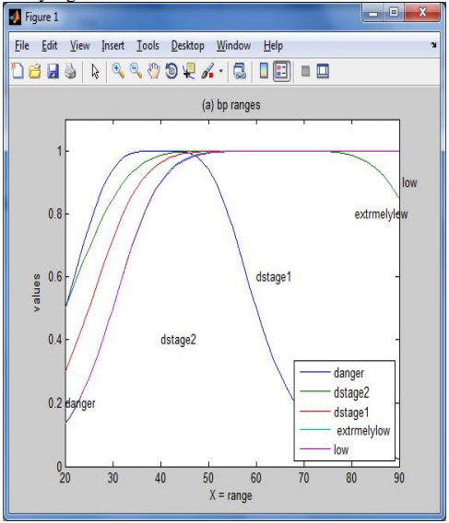

Figure 3 Systolic Fuzzy logic based BP classification (Mayilvaganan M, 2014)

Systolic BP has shown above in fuzzification mood dividing them the most accurate rate as possible. Illustrating the logic into the fuzzification graph where we can notice that the maximum and minimum value has been defined between 1 and 0 as this is how fuzzification should be.

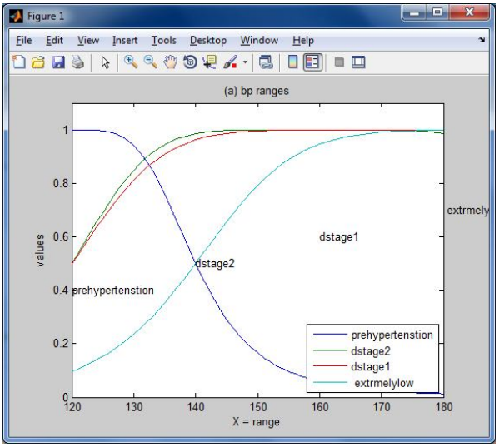

Figure 4 Diastolic Blood pressure category fuzzy logic (Mayilvaganan M, 2014)

Above figure we can notice that Diastolic BP category had been Fuzzify according the logic we have discussed. If we look closely on above diagram which explain intensively about the Diastolic values for blood pressure where the range logic has been shown for different cases.

# REAL WORLD ADVANTAGES

Control system works on logic, this is very simple and clear, but if the logic has its gap or exceptions then accuracy will always turn up as an issue of concern. Fuzzy logic based control system has the ability to overcome the problem which dealt with accuracy a very approximately and preferably more acceptably by the engineers.

In terms huge data analysing in a system, fuzzy control system plays a significant role to verify the accuracy. Economically it helps to reduce the work effort and expenses on production or data mining and many other sectors.

# CONCLUSION

(RICHARD JENSEN, 2008) Has stated that about 20 months or so information get doubles in the world, which means that information handling and implementing them in an accurate format is a challenge.

Fuzzy logic has made the system easier to understand and made much easier for devices to handle logical equations. In medical science, businesses, security such as cyber security fuzzy logic came in an extraordinary helpful to solve the fuzziness in data and logic.

# BIBLIOGRAPHY

Charles L. Phillips, R. D. H., 2000. *Feedback Control Systems.* 4th Edition ed. New york: Prentice Hall.

Hoang ChuDuc, T. N. a. T. L., 2013. International Journal of Bioscience, Biochemistry and

Bioinformatics. *Neuro-Fuzzy Approach to Heart Rate Variability Analysis ,* Vol. 3, No. 5(1), pp. 456-459.

Mayilvaganan M, K., 2014. HUMAN BLOOD PRESSURE CLASSIFICATION ANALYSIS USING FUZZY LOGIC CONTROL SYSTEM IN DATAMINING. *International Journal of Emerging Trends & Technology in Computer Science (IJETTCS) ,* 3(1), pp. 305-306.

RICHARD JENSEN, Q. S., 2008. *COMPUTATIONAL INTELLIGENCE AND FEATURE SELECTION.* 1st ed. New Jersey : Wiley.

Ross, T. J., 2010. *Fuzzy Logic With Engineering Applications.* 3rd edition ed. West Sussex: Wiley & Sons, Ltd.