

Module Title: Data Mining
Module Code: CSDM6022
Programme for this module: Bsc(Hons) Computing
Module Leader: Ihianle Kennedy
Student Name: Mohammad Bappy Chowdhary
Student ID: 45765

CONTENTS
Part A 4
INTRODUCTION: 4
KNOWLEDGE OF DATA MINING 4
APPLICATION REVIEW 4
C4.5 (J48) ALGORITHM AND ITS USES: 5
PART B 6
CREATING ARFF FILE: 6
Step 1 6
Step 2 6
Step 3 7
RAW DATA STUDY 8
CONCERNED ISSUES 9
Issue 1 10
Issue 2 10
Issue 3 10
POSSIBLE FEATURES 10
RUNNING THE FEATURES: 11
Accuracy Test 12
Visualizing Tree 15
Duration 15
Confusion Matrix 16
DETAILED REPORT 16
a. Data analysis and Data mining 16
b. Algorithm C4.5 (j48) in Iris-Plants 17
c. Iris-plants mined data 17
d. Benefit of mined data 18
CONCLUSION 18
References 18

Part A

INTRODUCTION:
The term “data” nowadays has became the significant concern in terms of keeping or organising information to use them for various purposes. What really makes data into sense when we recognise their patterns and evaluate them in our needs. Recognising patterns of data which has been happening since human life began.
For instance crop growth recognition patterns seeking by farmers, animal migration behaviour patterns for hunters, voter opinion patterns for politicians and many more. These are all the patterns where data are collected and organising to make them into sense, in modern science this process we call it Data mining.

KNOWLEDGE OF DATA MINING

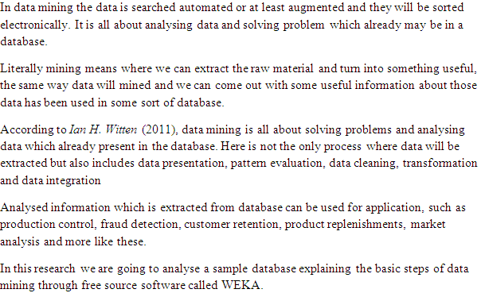

APPLICATION REVIEW

Agricultural prediction is really very important for farmers to get the best out of their cultivation. Predicting by analysing the various plants growth pattern might help a lot to the farmers and agricultural sector.

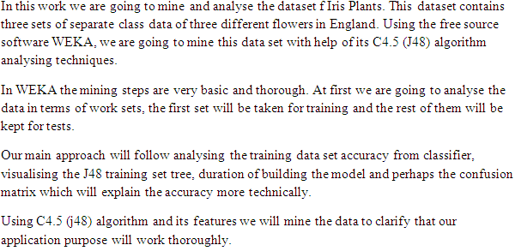

C4.5 (J48) ALGORITHM AND ITS USES:

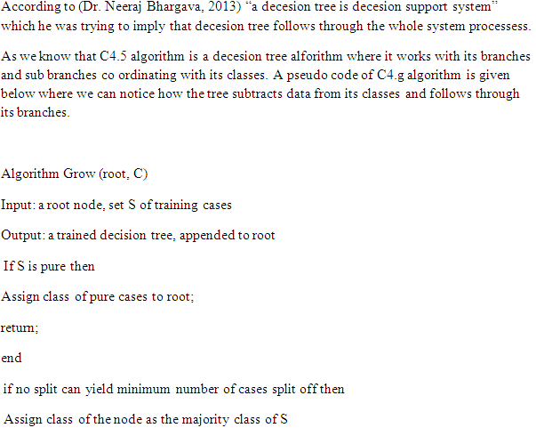

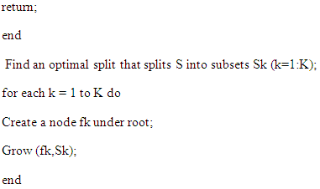

PART B

CREATING ARFF FILE:

WEKA is data mining software where the only format it can process which is ARFF format. Considering the file type it can be sorted to get the specific format, there are few rules we need to maintain so that WEKA can read the file and make it ready for us to process for mining the data.

Step 1
As we are going to collect the data either from a data warehouse or from a database, for that at first we need to select only the data and copy them, then paste them into a plain text file and name it as we desired.

Step 2
Now we have the raw data where we are going to mine them as we found it on the database. According to ARFF file requirements we have to name the file inside exactly the same way as mentioned below.
@relation FILE NAME

Step 3

After naming as data has been arranged in some sort of database where we at least figure out the attributes where data lies underneath it. In ARFF format for WEKA to recognise the attributes of the data type e need to define them according to their types.
For instance, nominal attributes will be written in the file like this:

@attribute Name {Valus_one, Values_second, Values_third}
For string type attributes it must be written like bellow:

@attribute Name string
For numeric attributes the following rules need to be followed:
@attribute Name numeric

When we are done with all the attributes within the file, then we are going to separate the data followed by @data then we are going to place all the data after it.
For better understanding in future for any other person or management, comment can be enter anywhere in the file followed by the % sign.
An example of an ARFF file is given below which we have created for our project.
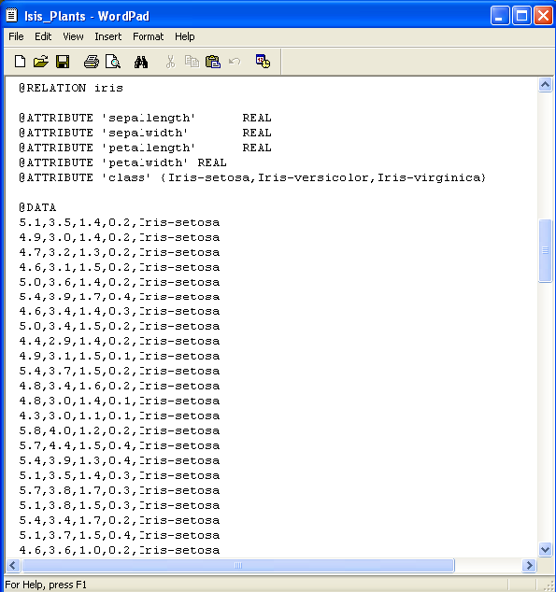
Figure 1 ARFF File Iris Plants

RAW DATA STUDY

IRIS plants pattern, a very well known pattern recognition source can be a significant example for data set for mining.
Bellow the raw data has been shown through WEKA after making the ARFF file and run it. Here what we have noticed a few things which can be very helpful or mining this data sets.
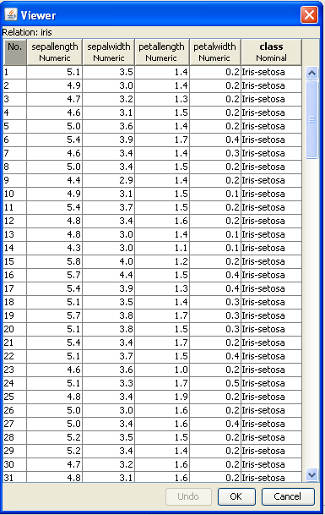
Figure 2 Iris Plants RAW DATA

First of all the whole data set has been taken from three classes.
Secondly every class have fifty instances each of their sepals and petals.
Each sepals and petals are measured by length and width. There are few issues based on where we can mine the data set and will come to a meaningful pattern which could be useful.

CONCERNED ISSUES

In this research we are going to use a specimen database about iris plants where the variation of iris flowers will be investigate considering the changes in their sepals and petals.
We will look into three issues to classify them or even make out any sense where we come to a conclusion.

Issue 1

As we have three classes of the database, at first we would like to investigate that is there any pattern which follows through the three classes comparing them by species.
We have here Iris-Versicolor, Iris-Verginica and Iris-Setosa. These are the classes which data sets are spread among them. We will try to figure them out that if there is any pattern sequel or pattern to differ them from each other.

Issue 2

The second most issue which comes to our mind that the length of each class’s petals and sepal’s width and length pattern, which can be referred to their classes or species.
In the data set the length and width are given of three class’s sepals and petals where it can be define by their pattern which can lead us to a decision.

Issue 3

Distinguishing species from each other according to their sepals and petals measurement patterns which will be the end issue we are going to consider and comes to a pattern wise decision where we can verify the flowers species.

POSSIBLE FEATURES

In WEKA there are several algorithms and features are available but according to our data set we are going try a few features which can be useful for mining the data sets.
- Using J48 –C 0.25 –M 2 an algorithm feature which can be found in classify tab in WEKA, where we can find out the Class tree in real time format.
- In the same algorithm we can set a possible data set for cross validation and leave the rest for training set to check whether the data pattern is correctly applied to their classes or not.
- Building “pruned” and “unpruned” decision tree using the same J48 option which will give us an idea about accuracy of the instances where how many were correct an incorrect will be showed.

RUNNING THE FEATURES:

In Iris plants pattern recognition data sets we have three classes. The ARFF file we have made for this project, we are going to run it through WEKA. A view of the WEKA has given bellow after running the data sets in the ARFF file.
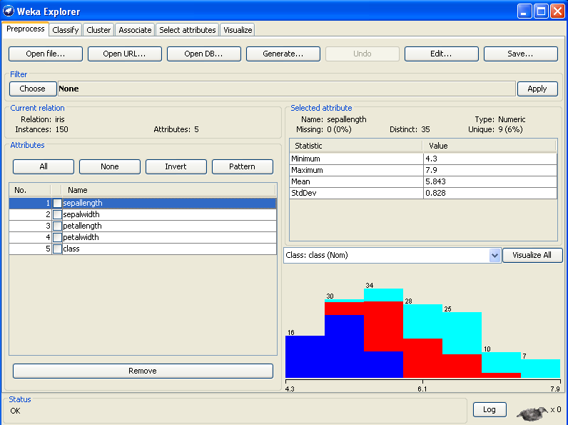
Figure 3 First Look Iris Plants
Here we have noticed the three bright colours on the bottom right of the window which are our Classes. On the left side we have our attributes.
We are going to use an algorithm as we have discussed earlier which is J48 and run some tests, models and nevertheless a detailed report on the mined data.

Accuracy Test

After running the file as we have seen on Figure 3, on the Left top corner next to “processes” we have “classify” option. If we click on it we will have the classifier window as shown on Figure 4 and Figure 5 respectively.
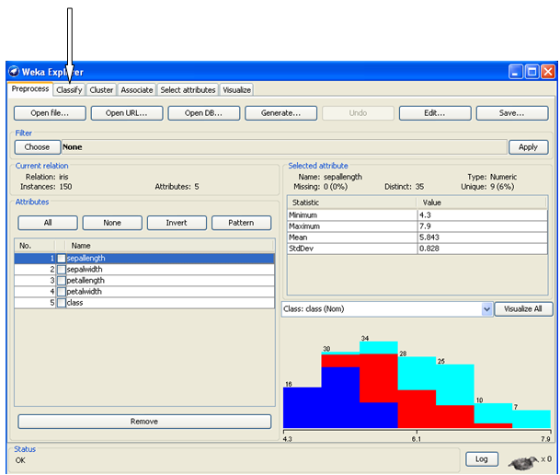
Figure 4 Opening Classifier

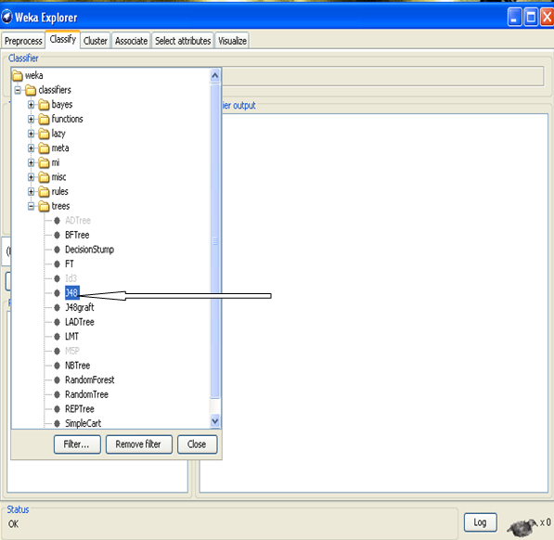
Figure 5 Choosing J48 decision Program
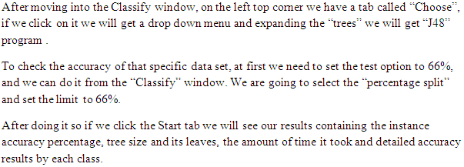In this data set we have 150 instances, among them we have taken 66% to test the accuracy, 51 instances were taken and 49 were accurately classified and 2 were not. So the accuracy result percentage is 96.0784% as shown on the Figure 6.
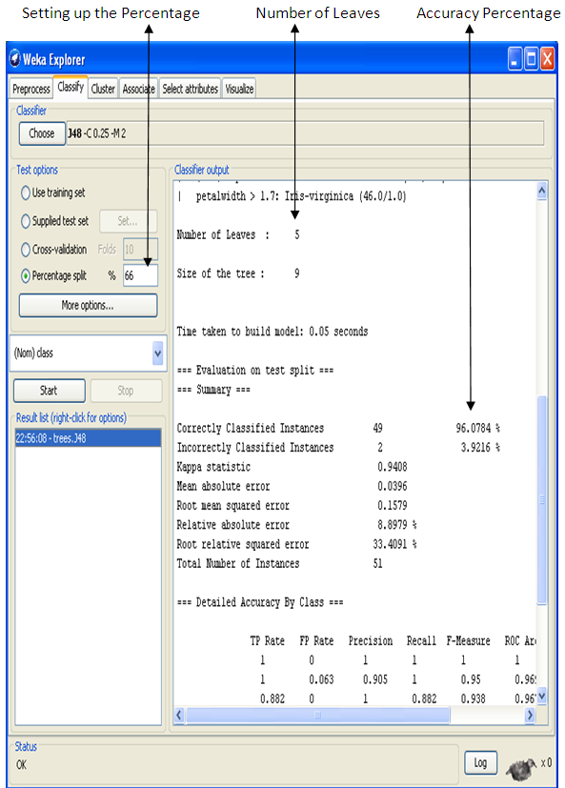
Figure 6 Accuracy Test Results

Visualizing Tree

In the figure 6 we can visually see the tree size and leaves as mentioned the tree size is 9 and there are 5 leaves. If we want to visualise the Pruned decision tree we need to Right click on the J48 Tree option, in our case that will be the highlighted option “22:56:08-trees J48” and then click on “Visualize tree”. We will get a pop up window where the tree is been shown with all its leaves as shown on the figure 7.
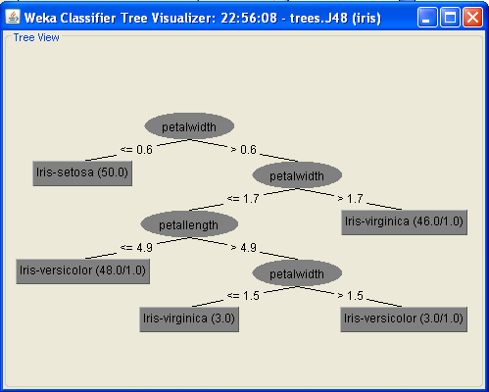
Figure 7 Pruned Decision Tree

Duration

In WEKA features such J48 will take such short time it’s hard to notice, but as we do not have the huge data, here model time is not the concern. But considering the fact of a huge data we need to look into the duration it took to process.
In our project if we look back to Figure 6 we will see it shows us the “time to build the model” , and we know the matter of fact it only took 0.05 seconds.

Confusion Matrix

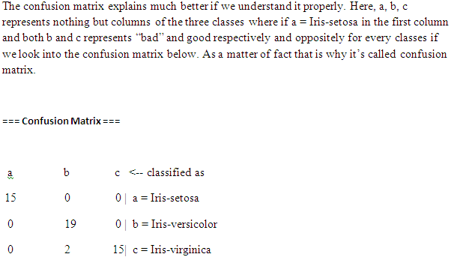

DETAILED REPORT

a. Data analysis and Data mining

Data analysis is a term where data can be examined or inspected in such a way where it can be transformed into a meaningful pattern or resourceful information.
On the other hand data mining is a process of data analysis where data pattern can be recognised for prediction.
In Iris plants we have analysed sepal and petal length and width to make out which plant is more efficient in terms of productivity. C4.5 (J48) algorithm has the technique to divide the data set into a decision tree formation where it explain and analyse its classes.

b. Algorithm C4.5 (j48) in Iris-Plants

In WEKA data mining tool j48 is a java open source implementation tool for C4.5 algorithm. The algorithm builds a decision tree for the data set to recognise the pattern from the training set. We have separated the training set data during the implementation of j48.
The algorithm uses already classified samples and creates the tree where each node chooses the attribute of the data most effectively.
If we look back to the decision tree we can notice that each class has their attributes leaves coordinating with the class node and their data sets are splits according to the training sets taken

c. Iris-plants mined data

Observation of mined data will be an important approach for prediction and transformation of desired application which will be implemented based on the result.
(Han, 2006) stated that, “in terms of information technology data mining can be viewed as a result of natural evolution.”
In this given data set of Iris-Plants we have observed a few important patterns. Those observed patterns are given below.
1. We have 3 different flower plans where 50 specimens were taken from each plant that is why we have 150 instances. We have taken 66% data which is 51 instances. In these test data the accuracy of classified data was 96.0784%.
2. According to the collected samples of sepals and petals length and width we have found in the test data that 2 instances were classified incorrectly.
3. If we closely observe the confusion matrix, we will notice that specific data accuracy comparing to each 3 classes we have here.
4. Iris-setosa has 15 good data where Iris-Versicolor has 19 and as we know that 51 test data were taken as instances, 15 correct data of Iris-Virginica and last but not the least, 2 data from Iris-Virginica were not classify accurately.

d. Benefit of mined data

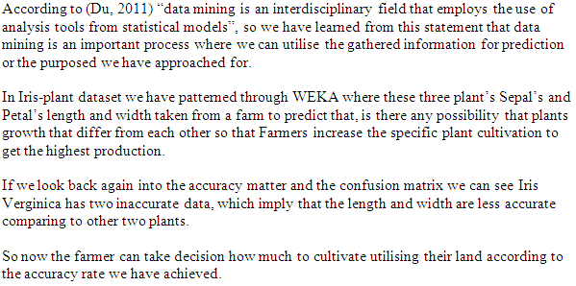

CONCLUSION

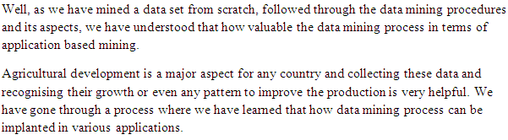

References

Du, S. D. a. X., 2011. Data Mining and mechine learning Cybersecurity. First ed. New York: CRC.
Han, J., 2006. Data Mining Concepts and techniques. 2nd ed. San Francisco: Diane Cerra.
Ian H. Witten, E. F. M. A. H., 2011. Data Mining. 3rd edition ed. Burlington: Morgan Kaufmann.
Rud, O. P., 2001. Data Mining Cookbook. First Edition ed. New York: Wiley.
Software Resource: WEKA ( free source software)
Tan, S. K., 2013. Introduction to Data Mining. First Edition ed. Harlow: Pearson Education .

