1. Steps Meaningful Name = leave it for now



1. Remove this One

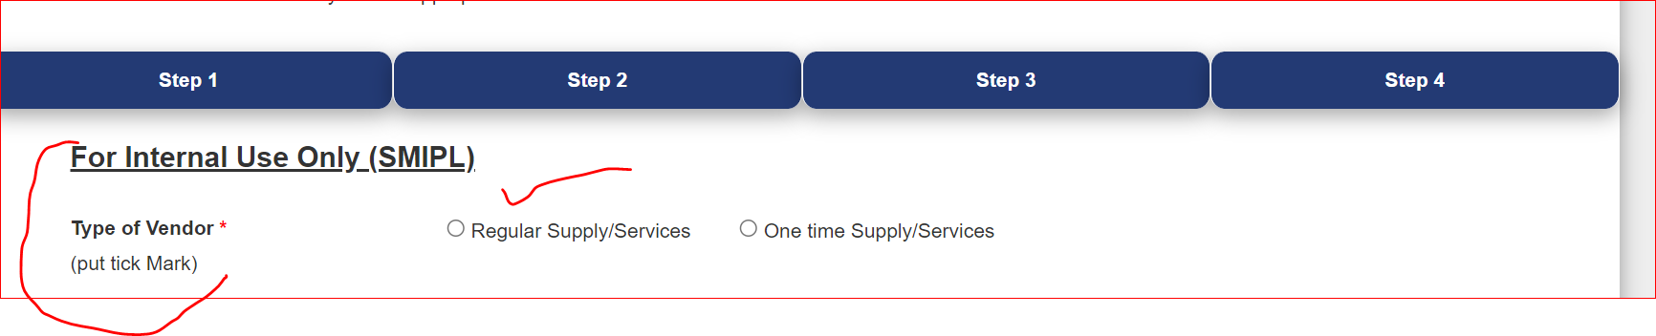

1. Steps of Process

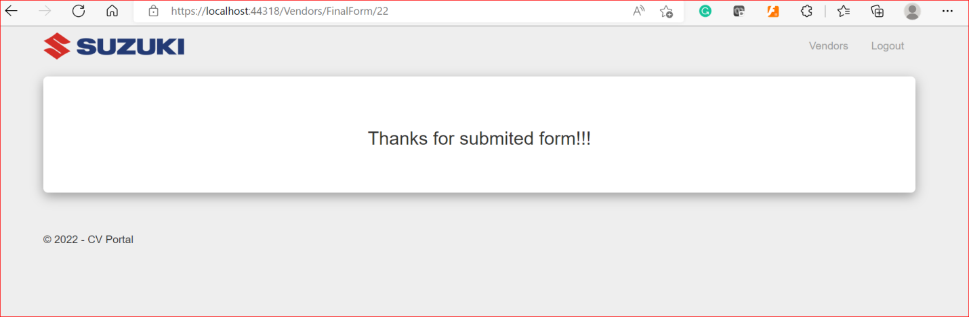

1. Owner/Nextapprover Maintain need in VendRegtbl
2. Send Mail Handle in table with mail ID & URL
3. If Registered vendor & composite that case GSTIN number mandatory

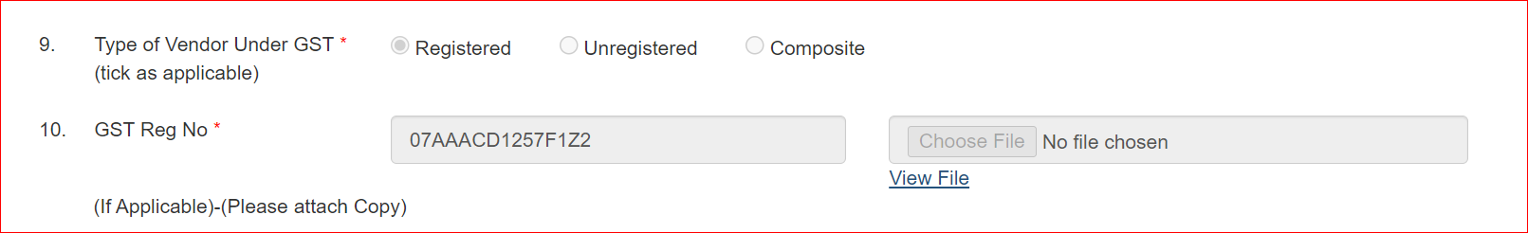

1. Bank Address Length
2. Remarks in Case of Rejected.
3. Drop Down Values not save properly in Tbl.

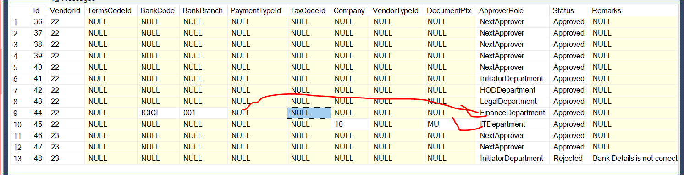

1. Initiator & Admin Case set Link for View Vendor Details, Print Form, Documents,Reports download in Excel.
2. Vendor Code/CustomerCode Creation Basis on type of vendor
3. Auto fill in searching

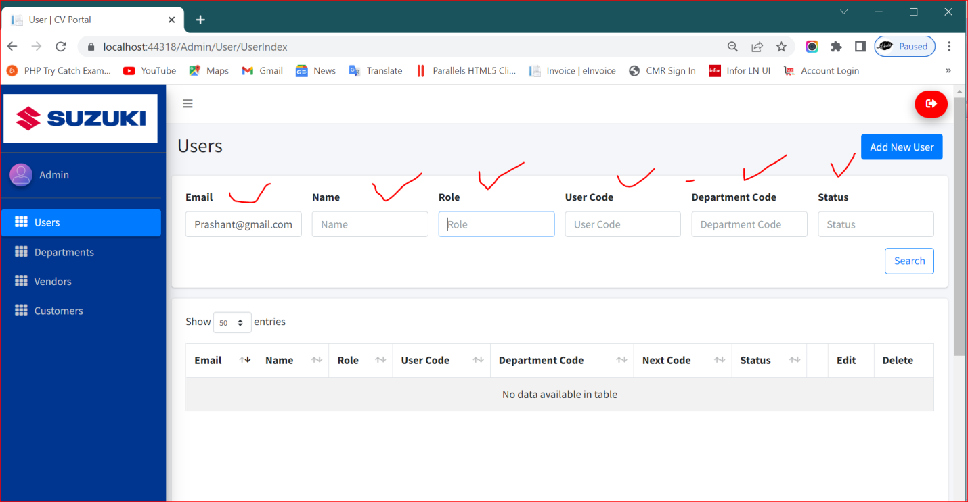

1. Active & Inactive option in Dept(Delete option Remove)

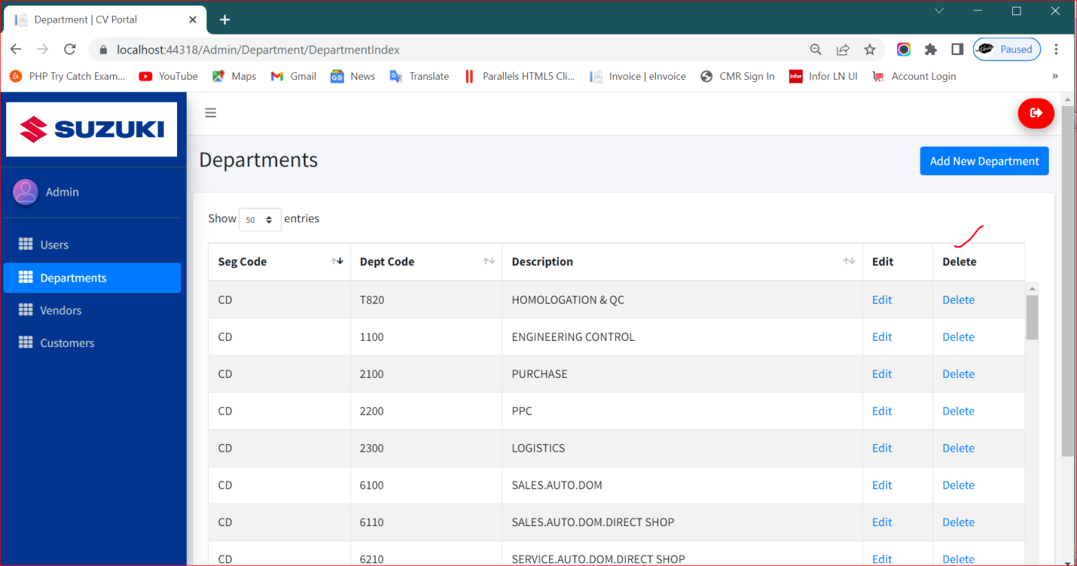

1. After New User Creation Login issue.

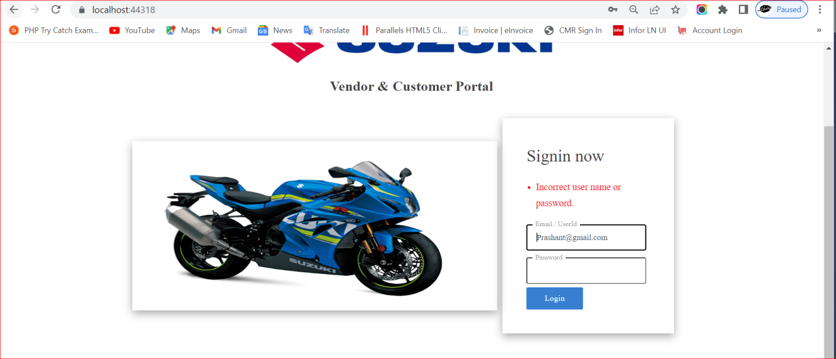

1. Footer year change

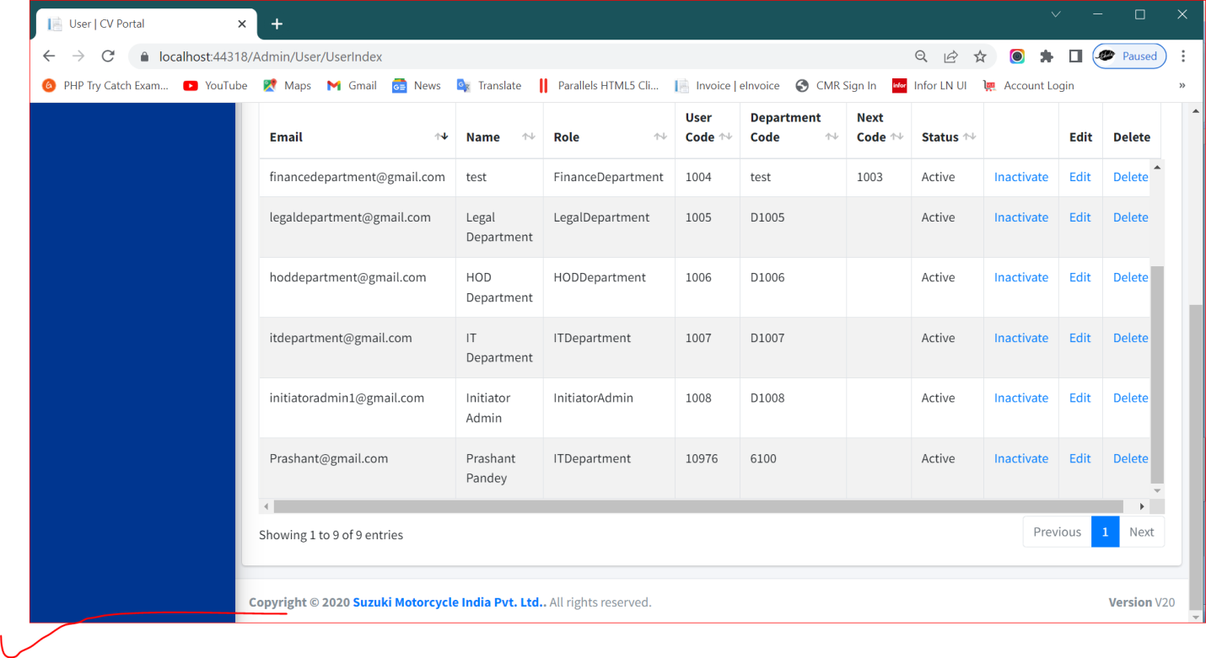

1. Only Pending Records’ show on dashboard & other approved show in report page.

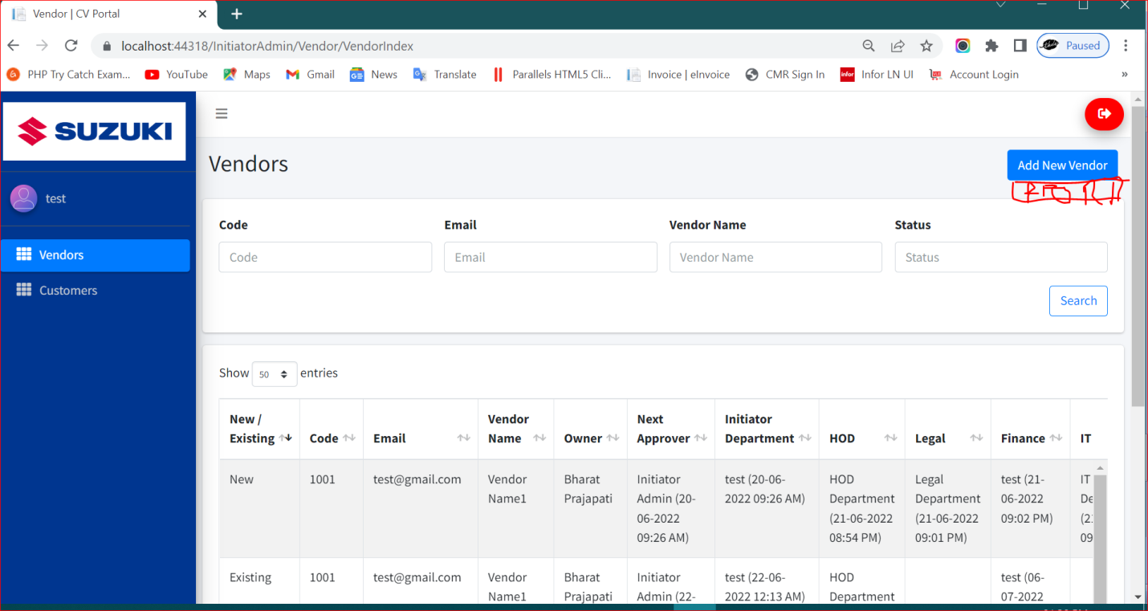

1. Need to be checked below marked

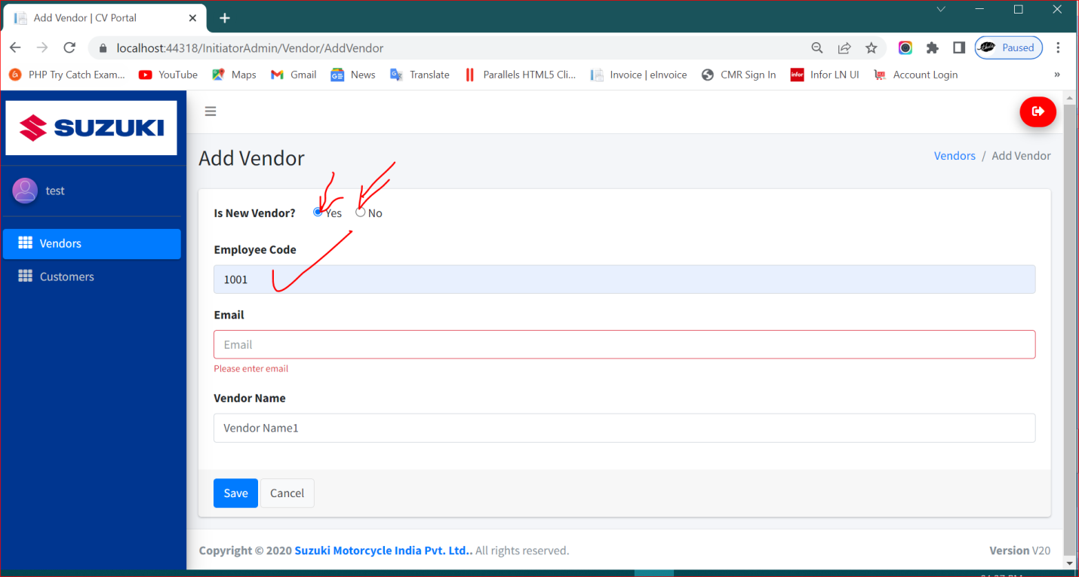

1. Other Options Remove from Vendor Reg Form

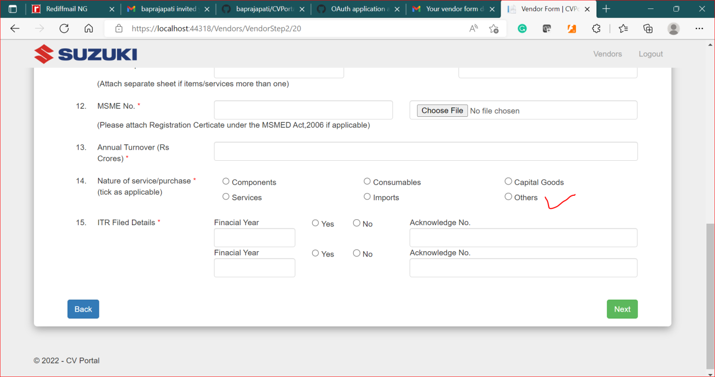

1. Date Picker & Current Date issue

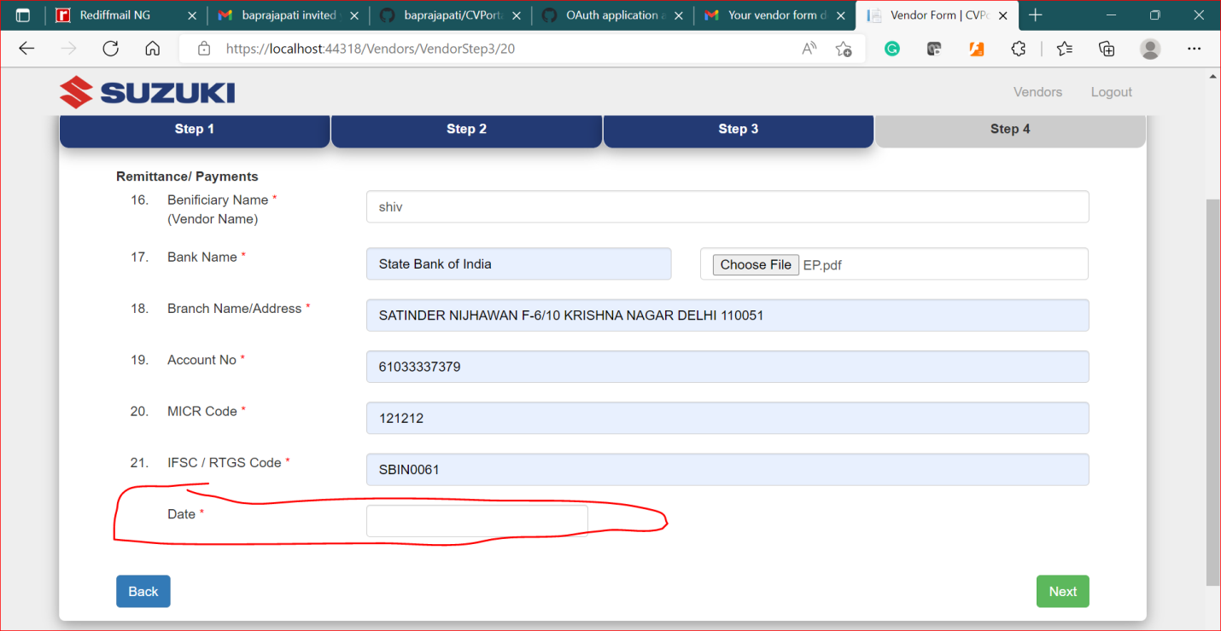

1. Successfully Approved by IT & Code Generated not show Here

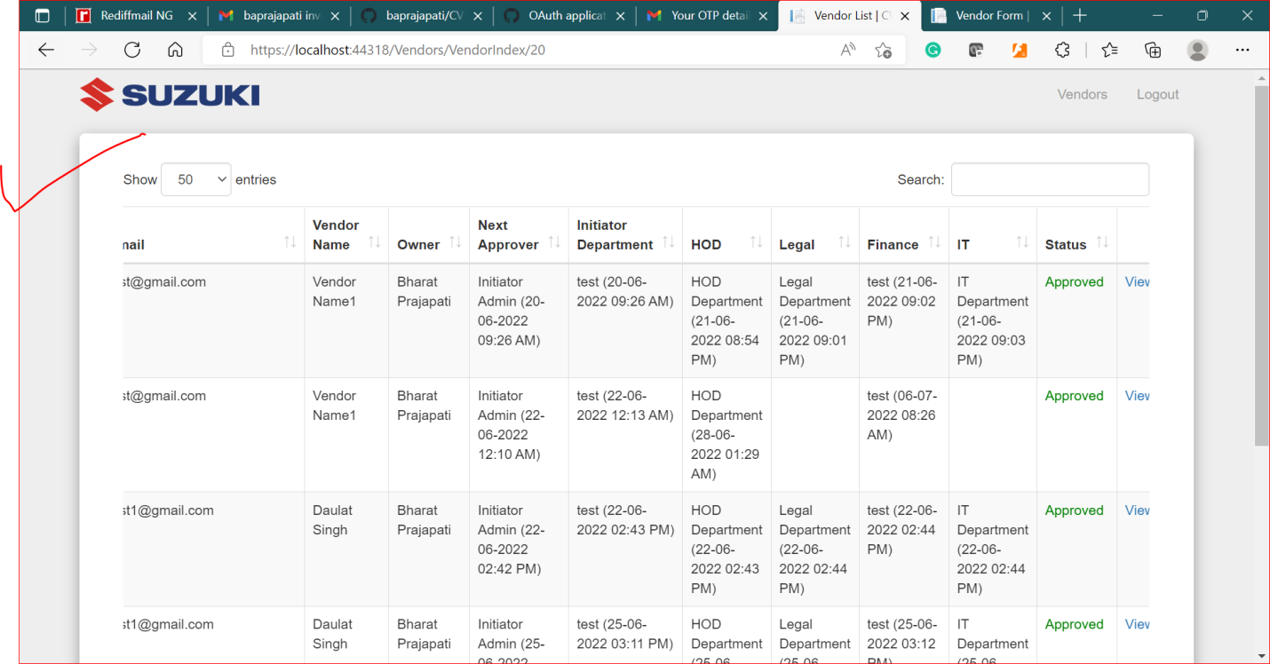

1. Footer Also need to be maintain at Approver page

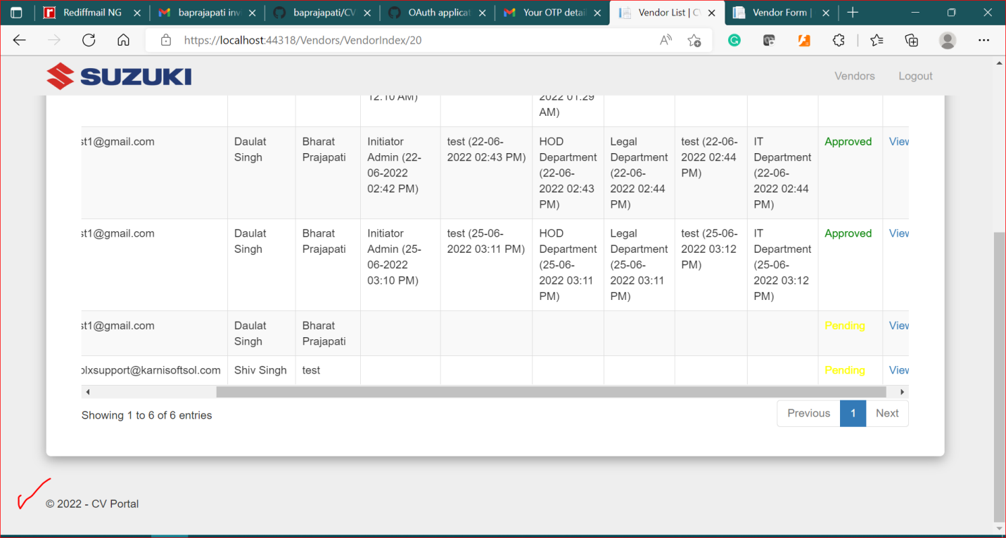

1. Attachments not view here

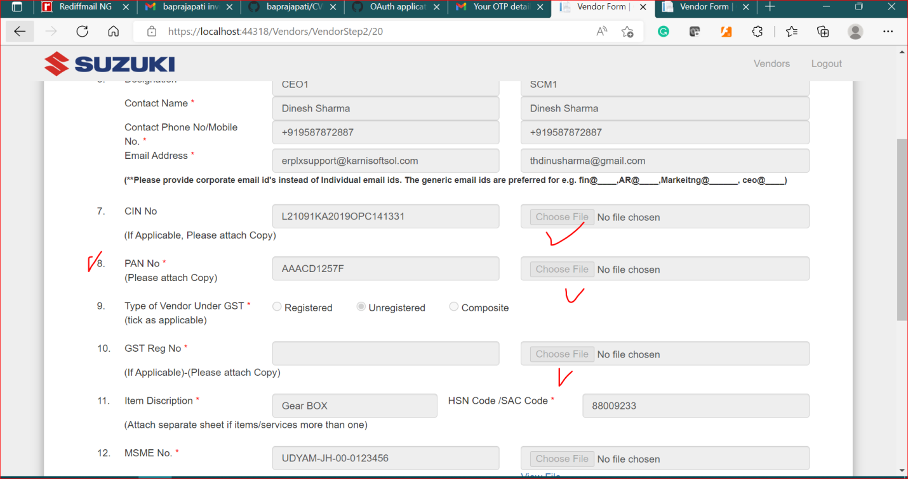

1. `Next Approver Initiator Admin Mail issue
2. Need to save PTermsCode

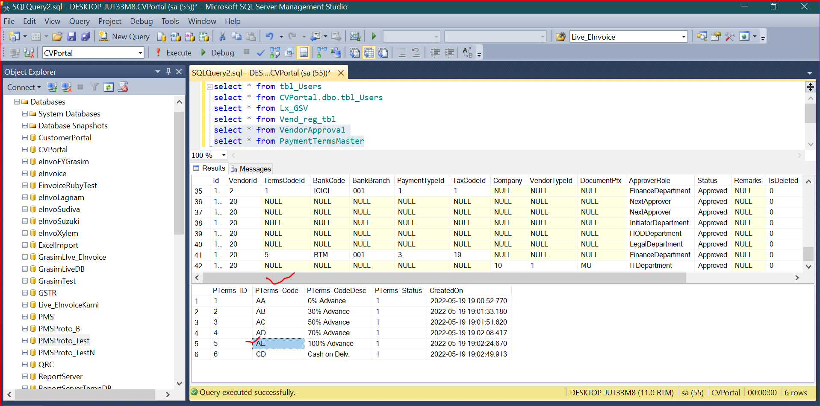

1. Need to save PayType_Code

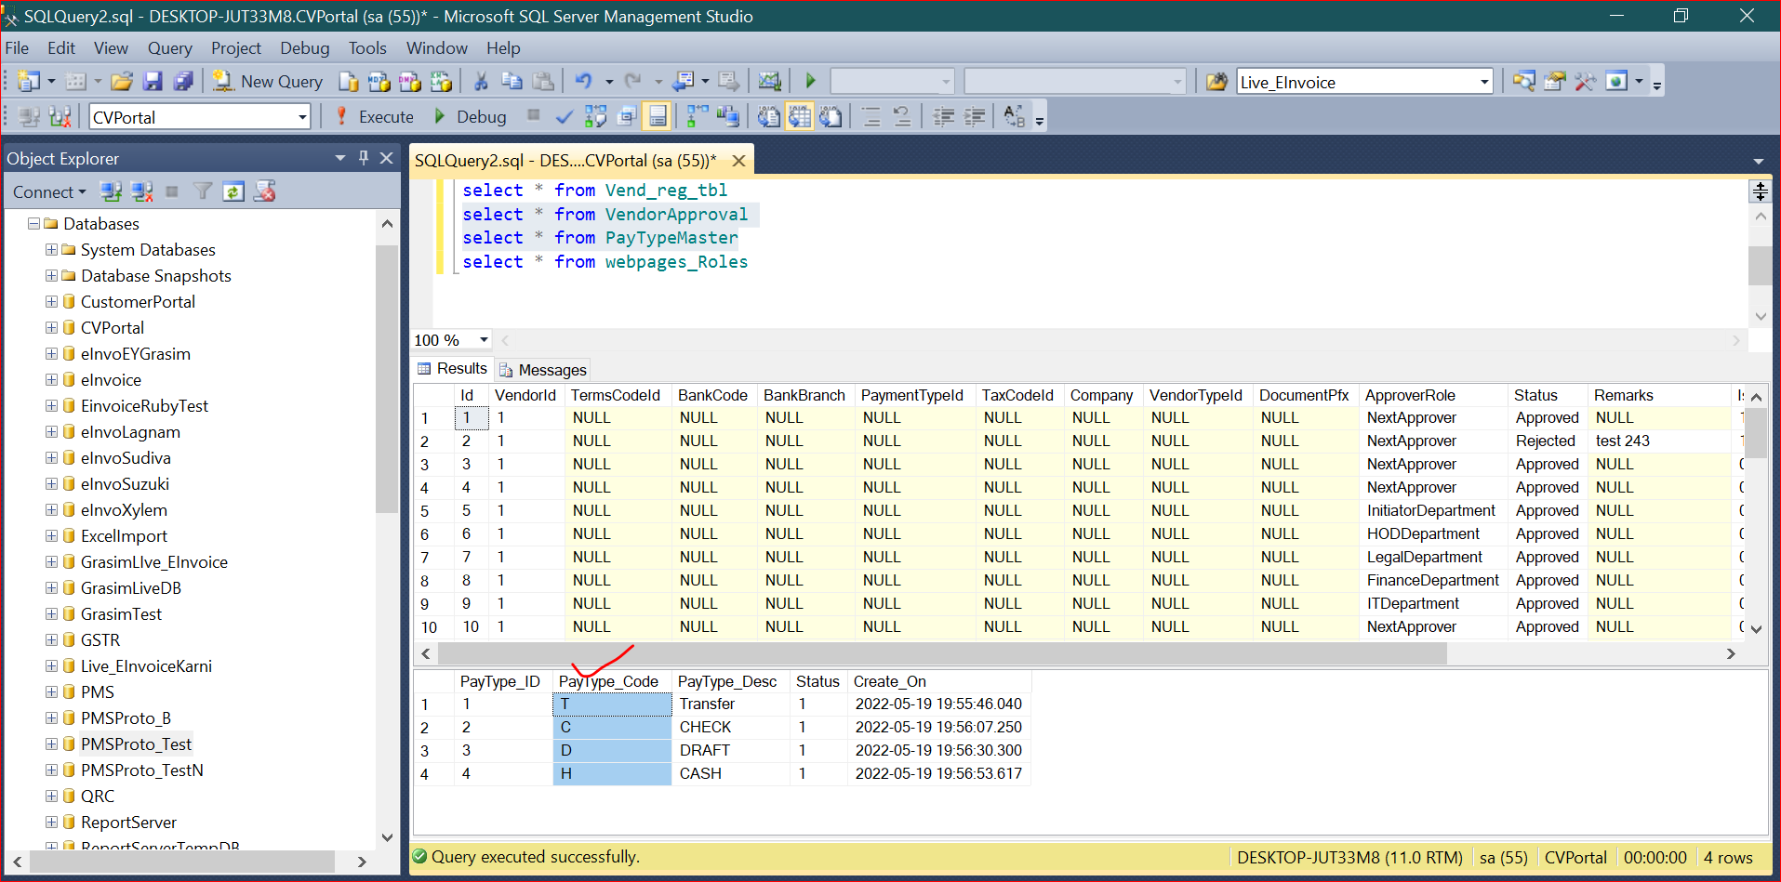

1. Need to save TaxCode

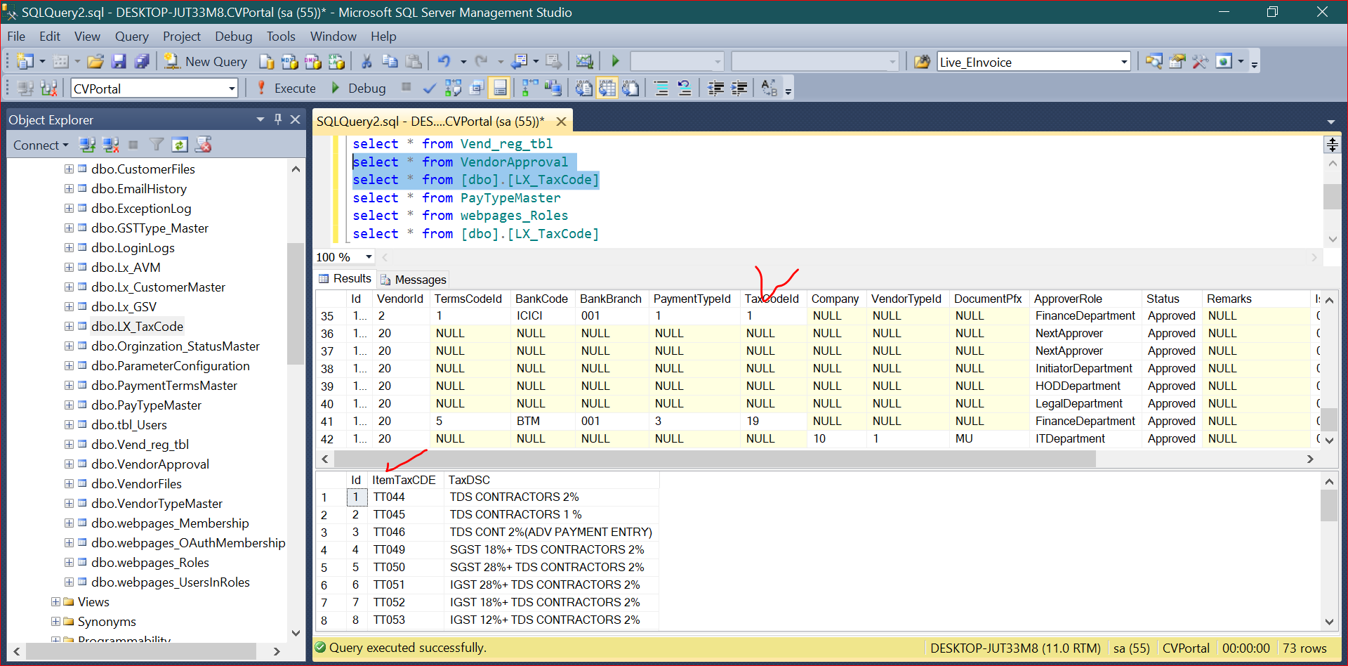

1. Need to save Vendor Type & Currency

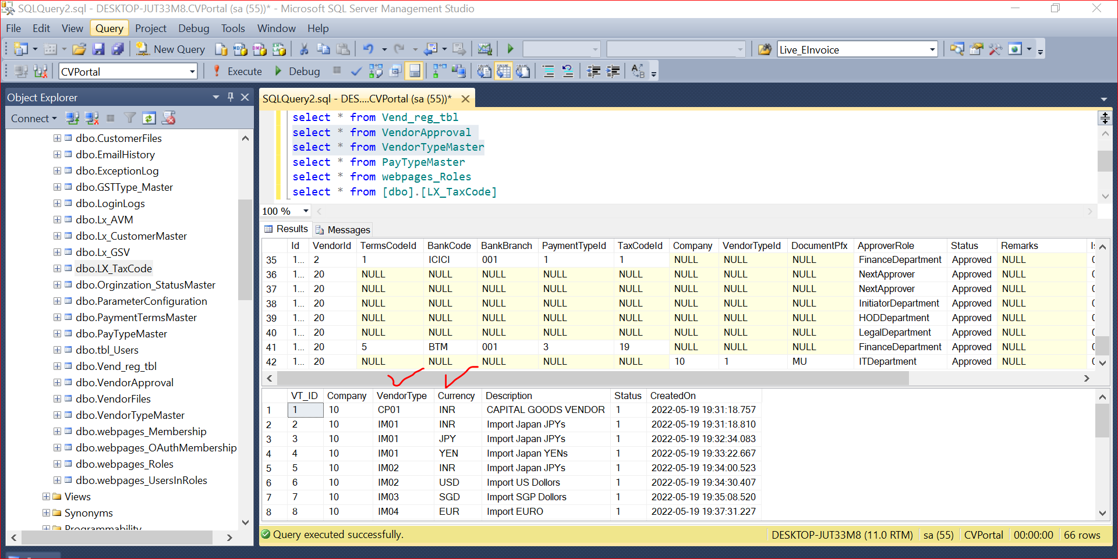

1. Legal Department ,IT Department, finance dept also need DashBoard for Report Download, Print
2. HOD Department and initiator department also need dashboard for Approved report filter Download & View
3. View Link & approve add on Every Approver DashBoard.