Part II

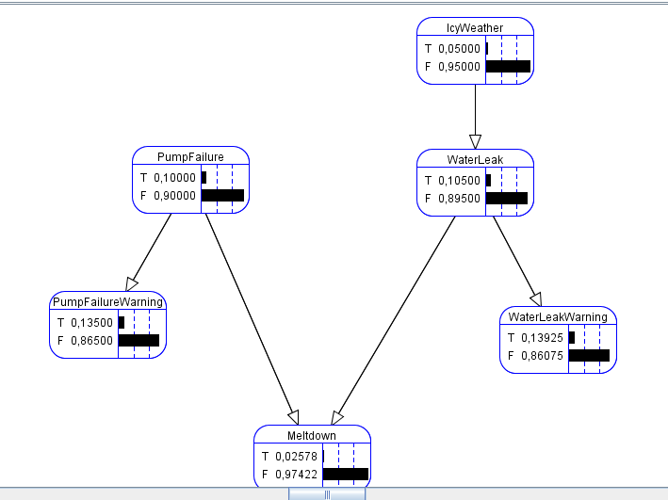Q5 -----

1. There is 2.58 % chance to melt down if no observation was made

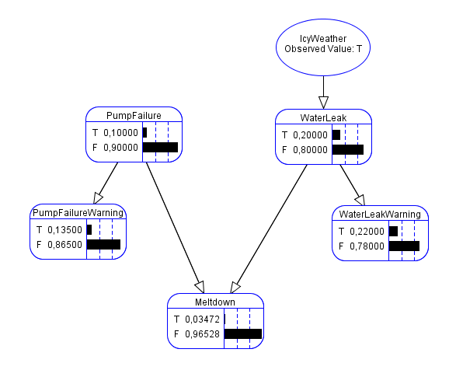If no observation are made, IcyWeather do not change anything but we just assume that there is IcyWeather, the plant have 3.47% chance to melt down

1. If both sensor are failure, there is 14.5% chance to melt down, 20% if there is really a failure. The warning do not necessarily involve that there is a failure, that’s why chance are not the same to melt down
2. Some variables are quite heavy to calculate because of too many variables or a doubt about the related variables. For example Icy Weather depends could depond on the season, the temperature, etc.
3. It will change the range of value. Not a boolean anymore but a continuous value (+20, +21, +22, etc.)

Q6 -----

1. A bayesian netowrk represent a graph with nodes having a table describing probability depending on their parent nodes
2. Joint probability is the function calculating the probability of the given state. Here we have the following function :

P(False) = P(-IW)P(-WL|-IW)P(-PF)P(-PFW|-PF)P(-WLW|-WL)P(-MD|-PF^WL)

= 0.95 \* 0.9 \* 0.9 \* 0.95 \* 0.95 \* 0.999 = 0.6937 or 69.37 %   
That’s quite a common state

1. The probability to meltdown if there is a water leak and a pump failure is of 20% and nothing else affect that fact because we already know the parent state, so this result cannot change.
2. P(MD = T) $P\left(-IW\right)P\left(-WL | -IW\right)P\left(-WLW | -WL\right)\left(P\left(PF\right)*P\left(-PFW | PF\right)*P\left(MD \right|PF\right)+P\left(-PF\right)*P\left(-PFW | -PF\right)*P(MD))=0.0019$

P(MD = F) $P\left(-IW\right)P\left(-WL | -IW\right)P\left(-WLW | -WL\right)\left(P\left(PF\right)*P\left(-PFW | PF\right)*P\left(-MD \right|PF\right)+P\left(-PF\right)*P\left(-PFW | -PF\right)*P(-MD))=0.7$

Α = 1/ ( 0.0019 + 0.7 ) = 1.424

P(MD = T) = 1.424 \* 0.0019 = 0.0027

Alpha = $\frac{100}{81,95}=1.22 alpha \left(81.14, 0.8114\right)=(99.01, 0.09)$

PART III

If the radio do not work, that’s probably because de battery do not work and if the battery do not work, the car can’t moves and they will not survives

Probability of survives : 98.11%

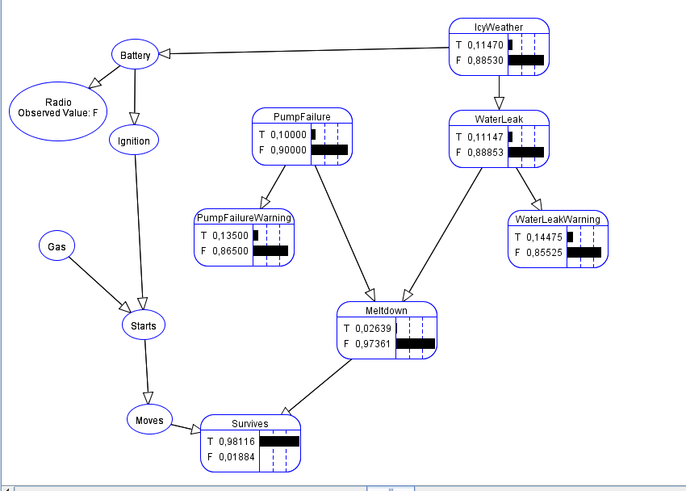

Probability to survive with a bike improve a lot

Exact inference

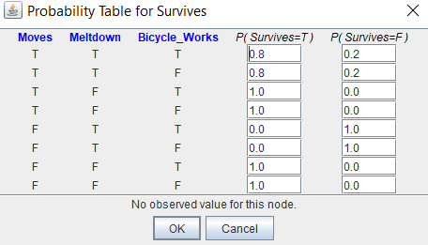

PART IV --------

Q2 ------

In my model, if pomp failure is set to false (100% chance reliable), survives chance rise up to 99.46%

Mr H.S rise this probability to 93.5% so it’s better to change the pomp to a new one

By representing a human reaction, we suppose that the human do not change, can’t improve or get worst 