TDDC17 LAB 4 : Planning

# Task 1

Check shakey.pddl and problem.pddl

# Task 2

For the problem 3 :

Below you will see the visualisation of the problem 3 using the Fastforwarding algorithm and the goalcount, both stepped forward to 40 step.

The graph of the fastforwading algorithm resembles to the deph-first search and the Goal count search resemble to the breath first search algorithm.

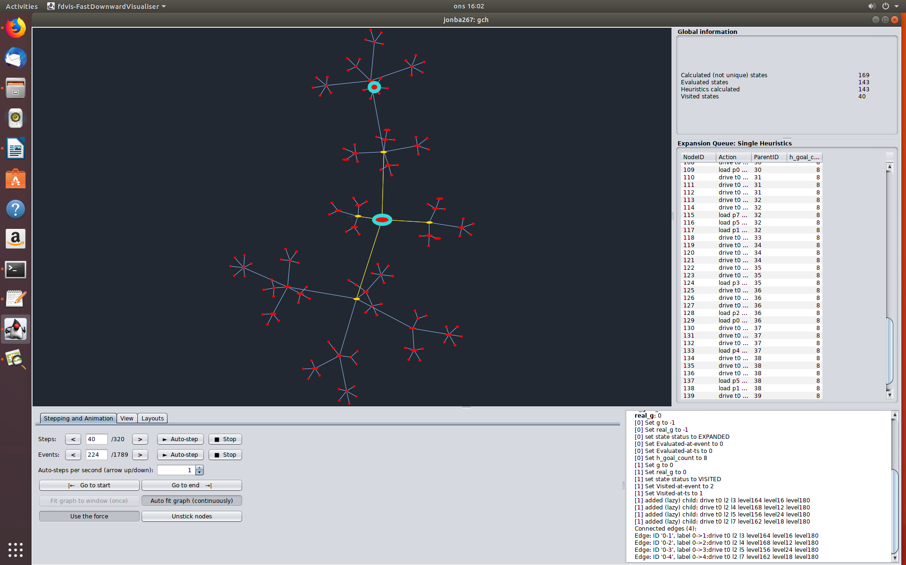Problem 3 : Gaol count heuristic

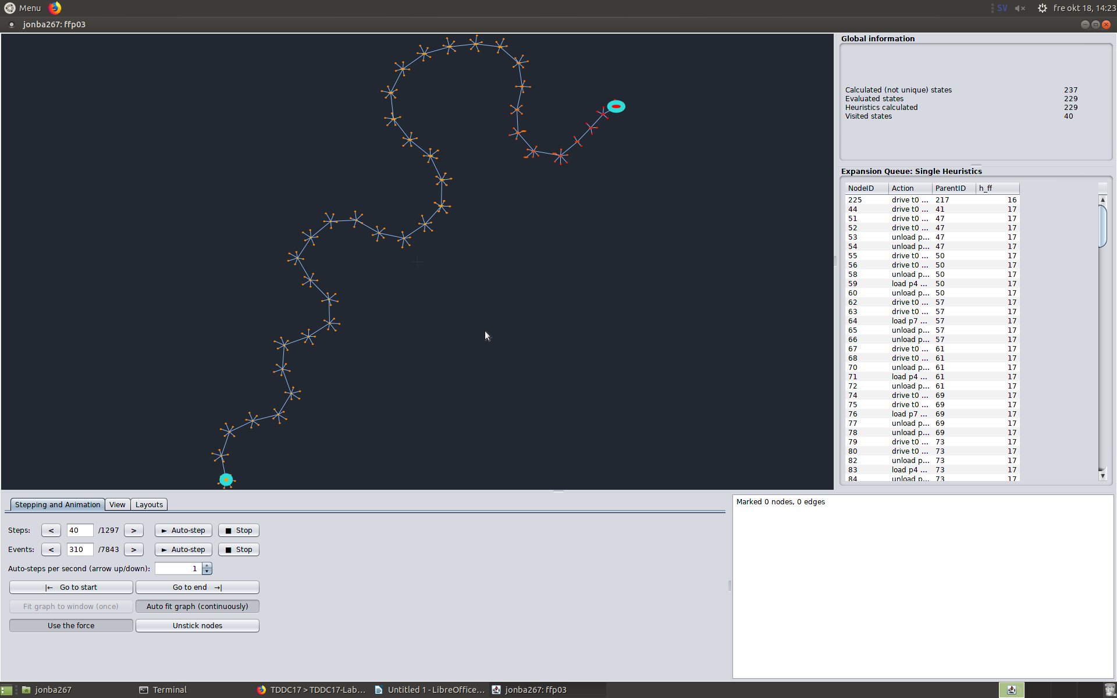

Problem : Fastforwarding heuristic

3) Both configuration leads to the same solutions by proceeding in diffrent way. Both configuration do the same action.

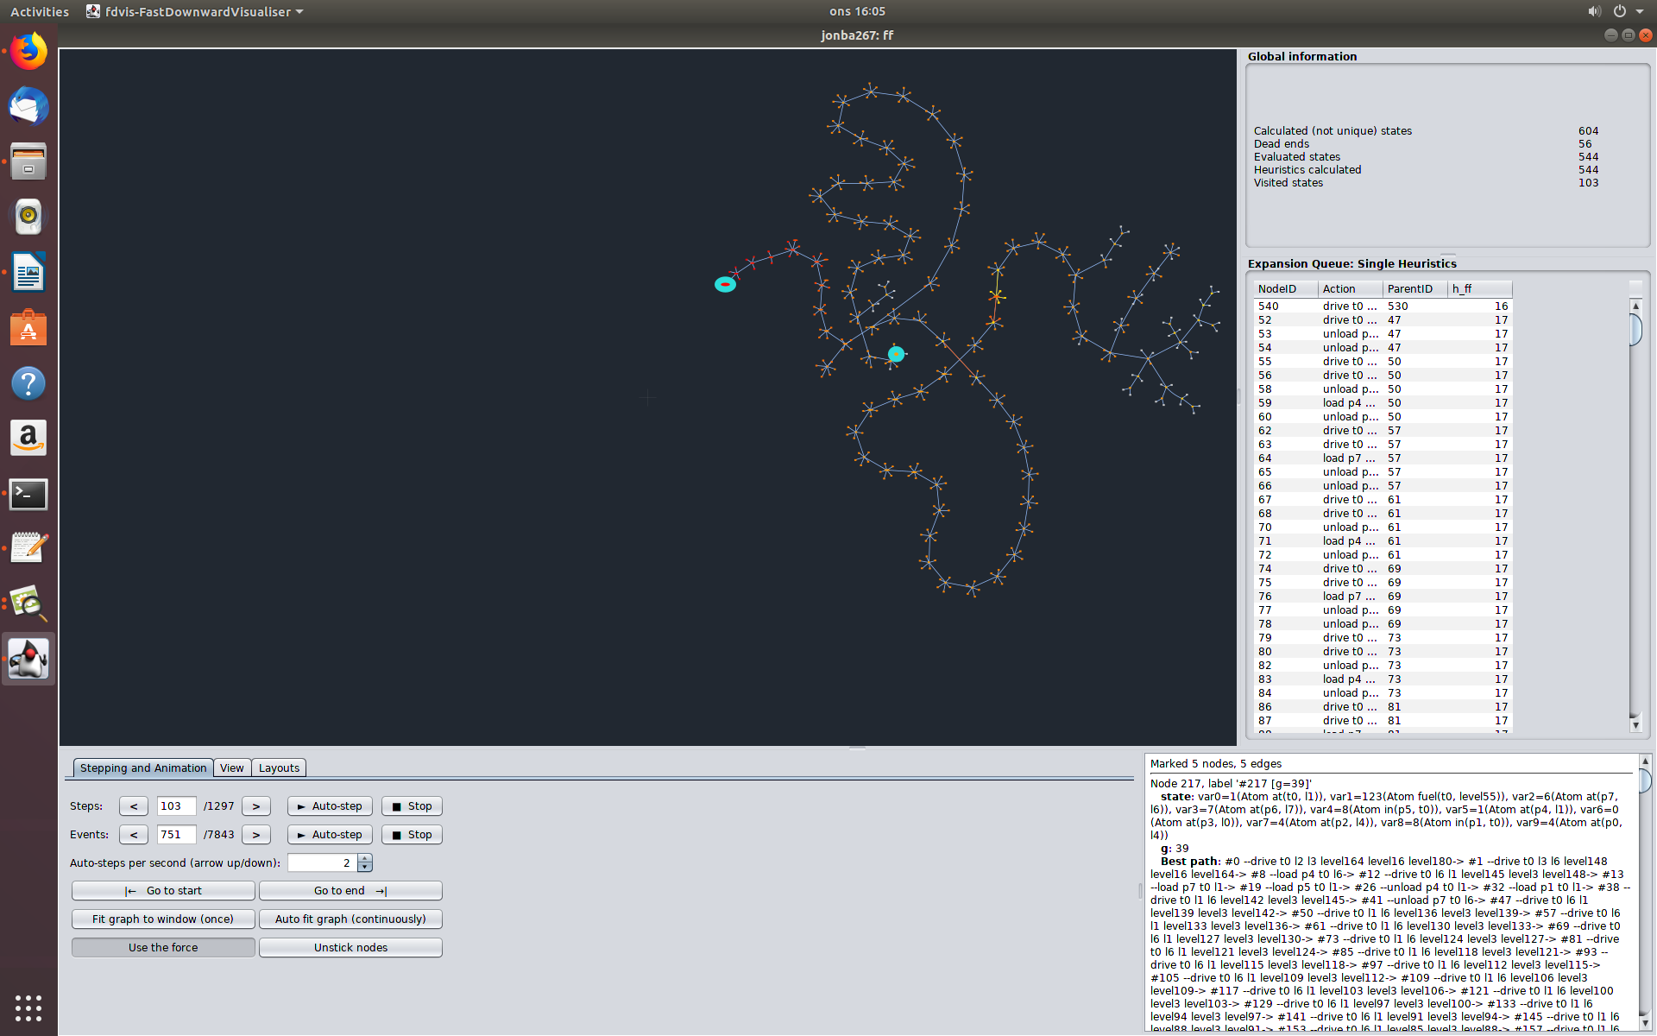4) During the algorithm working, we observe that after developping a branch until the end it abandonned it to another branch to develop. It does like this until the path is found. It does not uses any of the other expanded nodes of the original chain.

Problem 3: Expansion of one branch and then expansion of another branch

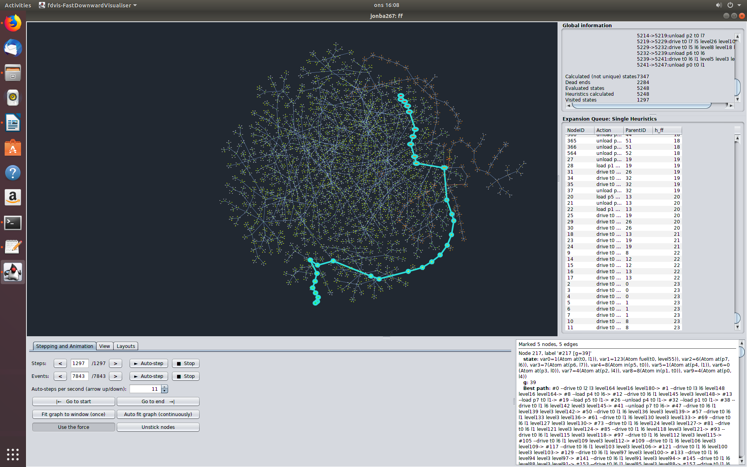Problem 3: Expansion of one branch and then expansion of another branch

For the problem 2 :

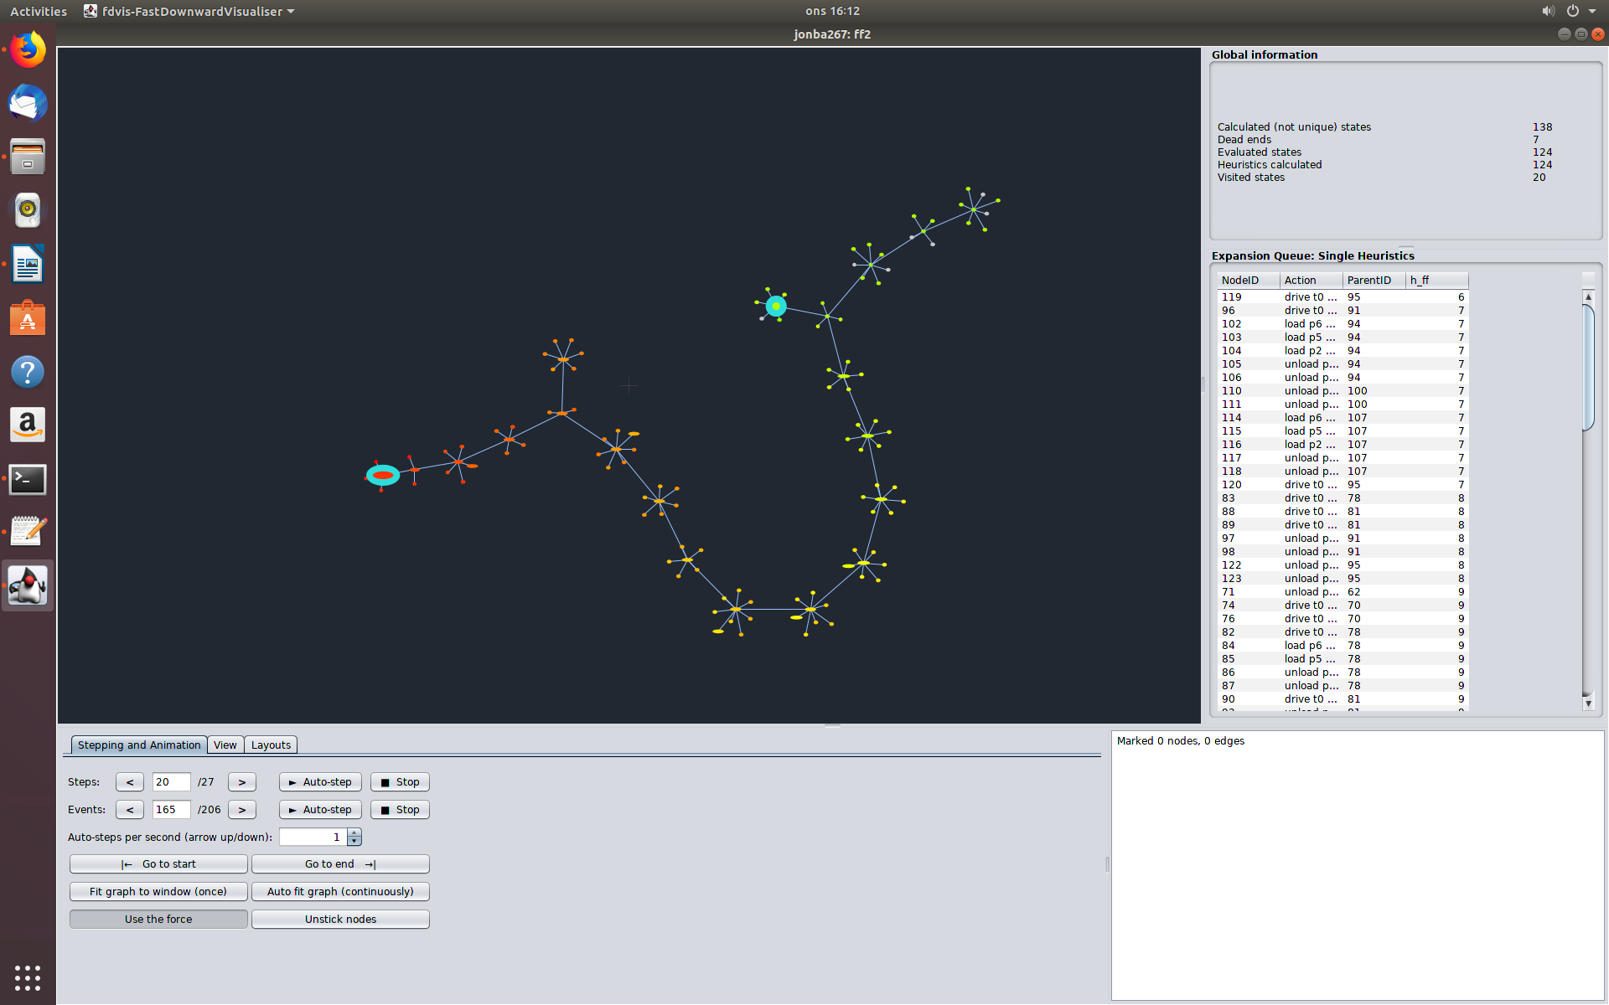2) The heuristic of the fastforwarding algorithm decrease on the step 3. In the Gaol count search, the heuristic decreases at step 20 and then decreases constantly.

Problem 2: FF heuristic comparation

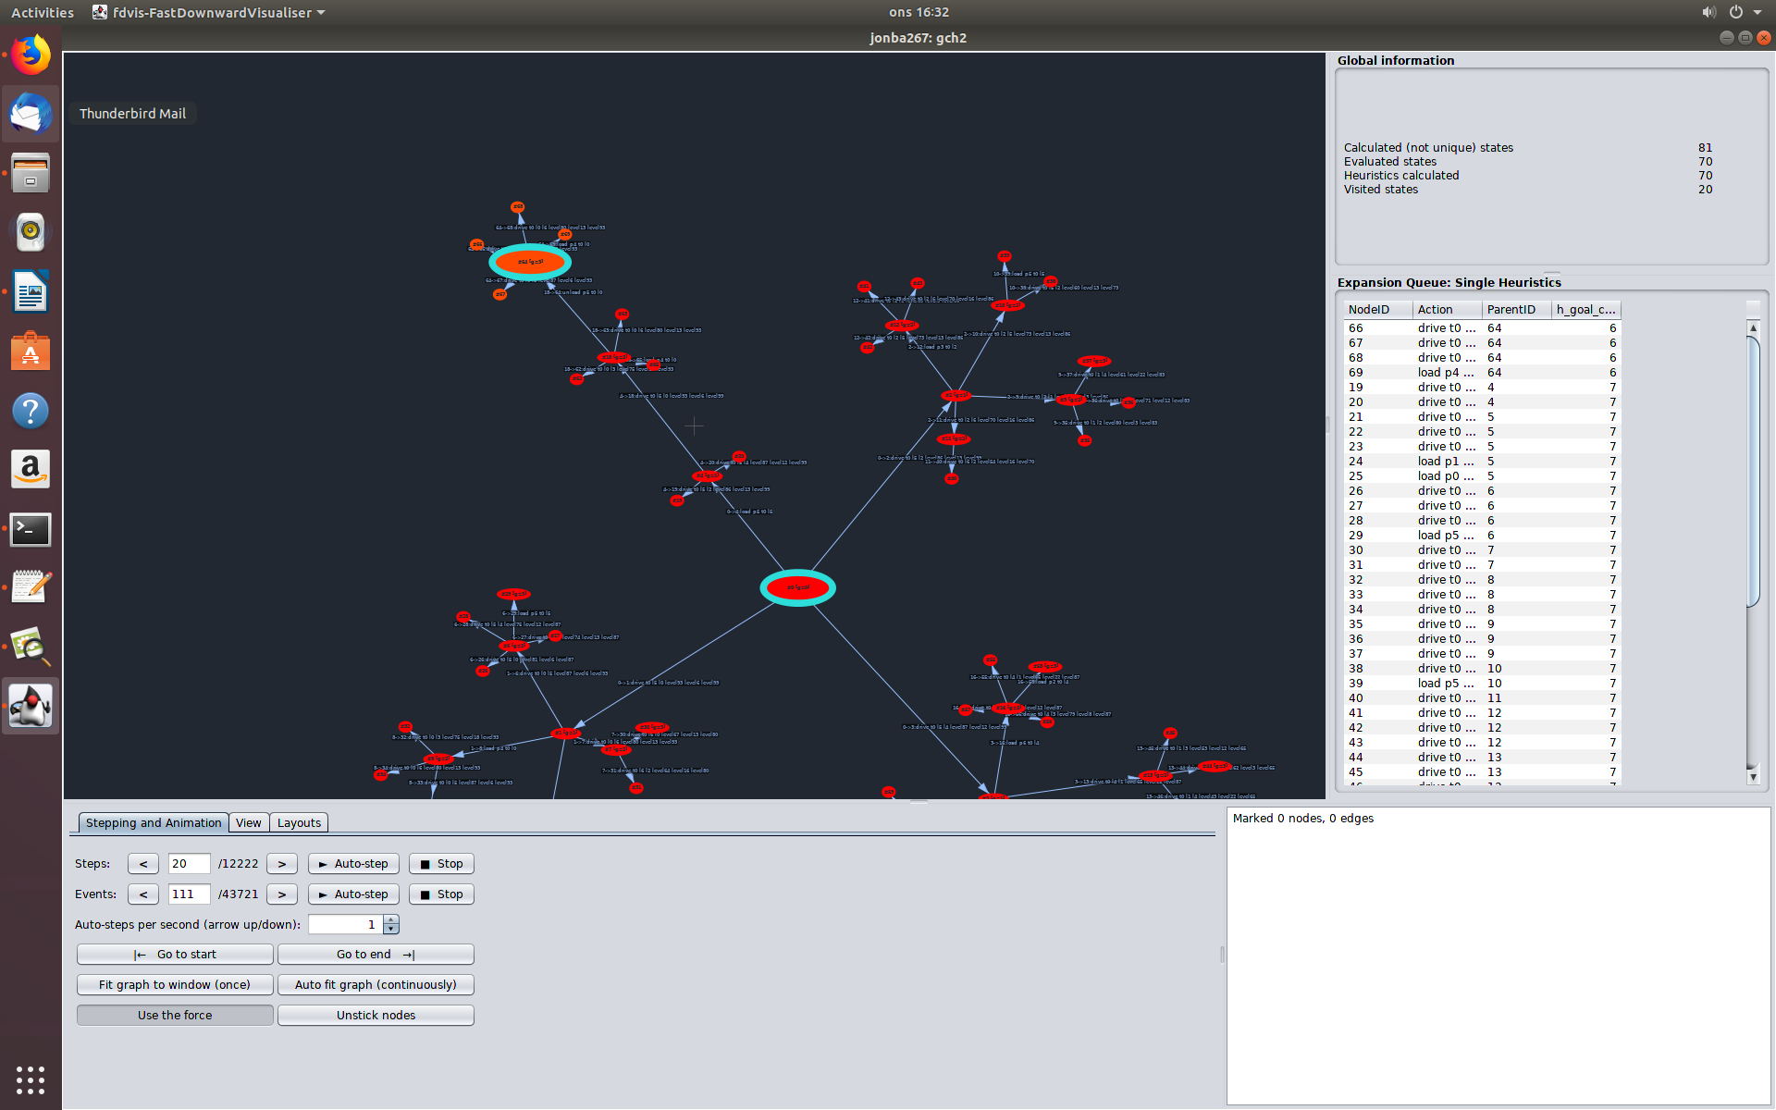Problem 2: Goal count heuristic comparation

3) For the FF, at the step 27, we found the solution and for the step 27 for the goal count heuristic search, the goal count is 6.

4) No it does not increase but the count will always decrease from the starting node to the final node

For ou shakey problem :

We use both the FF and th Goal count heuristics search. We observe that the it is similar to what we found previously. The FF seems to be similar to DFS and the GC heuristic searche seems similar to a BFS.