PRANVEER SINGH INSTITUTE OF TECHNOLOGY, KANPUR

DEPARTMENT OF COMPUTER SCIENCE & ENGINEERING

Even Semester 2024-25



B. Tech.- Second Year

Semester- IV

Lab File
OBJECT ORIENTED PROGRAMMIG USING JAVA
LAB
(BCS452)

Submitted To : | Submitted By :
Faculty Name : | Name | :
Designation : | Roll No. | :
 | Section | :
Table of Contents
- Vision and Mission Statements of the Institute
- Vision and Mission Statements of the Department

- PEOs, POs, PSOs of the Department
- Course Objective and Outcomes
- List of Experiments

- Index

Institute Vision Statement

To achieve excellence in professional education and create an ecosystem for the holistic development of all stakeholders.

Institute Mission Statements
To provide an environment of effective learning and innovation transforming students into dynamic, responsible, and productive professionals in their respective fields, who are capable of adapting to the changing needs of the industry and society.

Department Vision Statement

To be a recognized Department of Computer Science & Engineering that produces versatile computer engineers, capable of adapting to the changing needs of computer and related industry.

Department Mission Statements

The mission of the Department of Computer Science and Engineering is:
- To provide broad based quality education with knowledge and attitude to succeed in Computer Science & Engineering careers.
- To prepare students for emerging trends in computer and related industry.

- To develop competence in students by providing them skills and aptitude to foster culture of continuous and lifelong learning.
- To develop practicing engineers who investigate research, design, and find workable solutions to complex engineering problems with awareness & concern for society as well as environment.

Program Educational Objectives (PEOs)

- The graduates will be efficient leading professionals with knowledge of computer science & engineering discipline that enables them to pursue higher education and/or successful careers in various domains.
- Graduates will possess capability of designing successful innovative solutions to real life problems that are technically sound, economically viable and socially acceptable.
- Graduates will be competent team leaders, effective communicators and capable of working in multidisciplinary teams following ethical values.
- The graduates will be capable of adapting to new technologies/tools and constantly upgrading their knowledge and skills with an attitude for lifelong learning Department Program Outcomes (POs)
The students of Computer Science and Engineering Department will be able:

- Engineering knowledge: Apply the knowledge of mathematics, science, Computer Science & Engineering fundamentals, and an engineering specialization to the solution of complex engineering problems.

- Problem analysis: Identify, formulate, review research literature, and analyze complex engineering problems reaching substantiated conclusions using first principles of mathematics, natural sciences, and Computer Science & Engineering sciences.

- Design/development of solutions: Design solutions for complex Computer Science & Engineering problems and design system components or processes that meet the specified needs with appropriate consideration for the public health and safety, and the cultural, societal, and environmental considerations.

- Investigation: Use research-based knowledge and research methods including design of experiments, analysis and interpretation of data, and synthesis of the information to provide valid conclusions.

- Modern tool usage: Create, select, and apply appropriate techniques, resources, and modern engineering and IT tools including prediction and modelling to complex Computer Science & Engineering activities with an understanding of the limitations.

- The Engineering and Society: Apply reasoning informed by the contextual knowledge to assess societal, health, safety, legal and cultural issues and the consequent responsibilities relevant to the professional engineering practice in the field of Computer Science and Engineering.

- Environment and sustainability: Understand the impact of the professional Computer Science & Engineering solutions in societal and environmental contexts, and demonstrate the knowledge of, and need for sustainable development.

- Ethics: Apply ethical principles and commit to professional ethics and responsibilities and norms of the Computer Science & Engineering practice.

- Individual and team work: Function effectively as an individual, and as a member or leader in diverse teams, and in multidisciplinary settings.

- Communication: Communicate effectively on complex Computer Science & Engineering activities with the engineering community and with society at large, such as, being able to comprehend and write effective reports and design documentation, make effective presentations, and give and receive clear instructions.

- Project management and finance: Demonstrate knowledge and understanding of the Computer Science & Engineering and management principles and apply these to one’s own work, as a member and leader in a team, to manage projects and in multidisciplinary environments.

- Life-long learning: Recognize the need for, and have the preparation and ability to engage in independent and life-long learning in the broadest context of technological change.

Department Program Specific Outcomes (PSOs)
The students will be able to:
- Use algorithms, data structures/management, software design, concepts of programming languages and computer organization and architecture.
- Understand the processes that support the delivery and management of information systems within a specific application environment.

Lab Plan
SUBJECT NAME: Object Oriented Programming using Java
Lab SUBJECT CODE: BCS-452
Lab Schedule: As per the time table

- Course Objective:
Students shall be able to design and implement object-oriented solutions to real life problems, algorithmic problems and web application development using basic Java programming constructs, Collection Framework and Java Spring Boot respectively.
- Course Outcomes

*Level of Bloom’s Taxonomy | Level to be met | *Level of Bloom’s Taxonomy | Level to be met
L1: Remember | 1 | L2: Understand | 2
L3: Apply | 3 | L4: Analyze | 4
L5: Evaluate | 5 | L6: Create | 6

CO Number | Course Outcomes
BCS-452.1 | To apply [3. Apply] object-oriented approach to solve real-life problems and the compilation and interpretation process of JRE, take argument from command line and eclipse platform.
BCS-452.2 | To analyze [4. Analyze] Java Collection Framework and new language features for efficient application development.
BCS-452.3 | To develop [6. Create] and deploy web applications using Spring Boot.

List of Experiments

Lab No. | Lab Experiment | Correspo nding CO
1 | Write a simple Java program using Eclipse IDE to display the message "Hello, Java  World from Eclipse!" on the console, also use all major escape sequences including \n (newline), \t (tab), \\ (backslash), \" (double quote), \' (single quote), and \r (carriage return). The program should demonstrate the basic structure of a Java application including the main() method and System.out.println() function for output. | CO1
2 | Write a Java program that accepts two integer numbers as command-line arguments, calculates their sum, and displays the result. Ensure that the program properly parses the command-line arguments and handles basic integer operations. | CO1
3 | Write a Java program to create two classes: Student and Rectangle.    - The student class should have two data members: name and rollNo, with a method to display the student's details.    - The Rectangle class should have two data members: length and width, with a method to calculate and display the area of the rectangle.  Create objects for both classes, assign values to the data members, and invoke their respective methods to display the output. | CO2
4 | Write a Java program to demonstrate the concepts of inheritance and polymorphism:    - Create two classes, Animal and Dog, where Dog inherits from Animal to demonstrate single-level inheritance.    - Override a method in the Dog class to demonstrate method overriding (runtime polymorphism).    - Implement method overloading within the Dog class by creating multiple versions of a bark() method with different parameters to demonstrate compiletime polymorphism.  The program should create objects of the classes and invoke the methods to show the behavior of inheritance, method overriding, and method overloading. | CO2
5 | Write a Java program that demonstrates exception handling using try, catch, and finally blocks to handle arithmetic exceptions. Extend the program to implement multithreading by creating and running two threads that print a message concurrently. | CO2
6 | Write a Java program that creates a user-defined package named studentinfo, containing a class Student with basic details. In another class, import this package and display the student information, demonstrating the use of Java packages for modular development. | CO2
7 | Write a Java program that uses Java I/O streams to read data from a text file and write data to another text file. The program should demonstrate file reading using FileReader and writing using FileWriter, along with proper exception handling. | CO2
8 | Create a simple Spring-based Java application using annotation-based configuration. The program should demonstrate dependency injection and include a service class and a main class to invoke a method through Spring's @Component and @Autowired annotations. | CO3
9 | Develop a RESTful web service using Spring Boot. Create a controller that responds to HTTP GET requests and returns a simple JSON message. Use Spring Boot annotations like @RestController and @GetMapping to handle requests. | CO3
10 | Build a basic frontend web application using Spring Boot and Thymeleaf. Create a webpage that collects user input from a form and displays the submitted data back to the user. Demonstrate integration of backend logic with frontend rendering using @Controller and Model. | CO3

Lab No. | Lab Experiment | Date of  Experim ent | Date of  Subm ission | Marks | Faculty  Signat ure
1 | Write a simple Java program using Eclipse IDE to display the message "Hello, Java World from Eclipse!" on the console, also use all major escape sequences including \n (newline), \t (tab), \\ (backslash), \" (double quote), \' (single quote), and \r (carriage return). The program should demonstrate the basic structure of a Java application including the main() method and System.out.println() function for output.
2 | Write a Java program that accepts two integer numbers as command-line arguments, calculates their sum, and displays the result. Ensure that the program properly parses the command-line arguments and handles basic integer operations.
3 | Write a Java program to create two classes: Student and Rectangle.    - The student class should have two data members:  name and rollNo, with a method to display the student's details.    - The Rectangle class should have two data members: length and width, with a method to calculate and display the area of the rectangle. Create objects for both classes, assign values to the data members, and invoke their respective methods to display the output.
4 | Write a Java program to demonstrate the concepts of inheritance and polymorphism:    - Create two classes, Animal and Dog, where Dog inherits from Animal to demonstrate single-level inheritance.    - Override a method in the Dog class to demonstrate method overriding (runtime polymorphism).    - Implement method overloading within the Dog class by creating multiple versions of a bark() method with different parameters to demonstrate compile-time polymorphism.  The program should create objects of the classes and invoke the methods to show the behavior of inheritance, method overriding, and method overloading.
5 | Write a Java program that demonstrates exception handling using try, catch, and finally blocks to handle arithmetic exceptions. Extend the program to implement multithreading by creating and running two threads that print a message concurrently.
6 | Write a Java program that creates a user-defined package named studentinfo, containing a class Student with basic details. In another class, import this package and display the student information, demonstrating the use of Java

 | packages for modular development.
7 | Write a Java program that uses Java I/O streams to read data from a text file and write data to another text file. The program should demonstrate file reading using FileReader and writing using FileWriter, along with proper exception handling.
8 | Create a simple Spring-based Java application using annotation-based configuration. The program should demonstrate dependency injection and include a service class and a main class to invoke a method through Spring's @Component and @Autowired annotations.
9 | Develop a RESTful web service using Spring Boot. Create a controller that responds to HTTP GET requests and returns a simple JSON message. Use Spring Boot annotations like @RestController and @GetMapping to handle requests.
10 | Build a basic frontend web application using Spring Boot and Thymeleaf. Create a webpage that collects user input from a form and displays the submitted data back to the user. Demonstrate integration of backend logic with frontend rendering using @Controller and Model.

Experiment No. 1 Objective:
Write a simple Java program using Eclipse IDE to display the message "Hello, Java World from Eclipse!" on the console, also use all major escape sequences including \n (newline), \t (tab), \\ (backslash), \" (double quote), \' (single quote), and \r (carriage return). The program should demonstrate the basic structure of a Java application including the main() method and System.out.println() function for output.
Program:
public class Experiment1 {
public static void main(String[] args)
{
System.out.println("Hello, Java World from Eclipse!");
System.out.println(" \nNew line example");
System.out.println ("Tab \tExample");
System.out.println("Backslash: \\");
System.out.println("Double Quote: \"Java\"");
System.out.println( "Single Quote: '\Java\'");
System.out.println("Carriage Return Example \rStart");
}
}
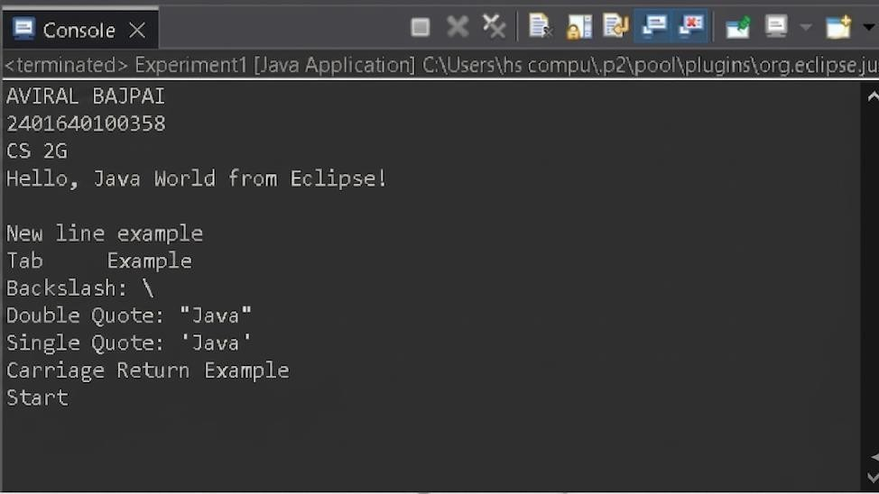
Output:

Experiment No. 2
Objective:
Write a Java program that accepts two integer numbers as command-line arguments, calculates their sum, and displays the result. Ensure that the program properly parses the command-line arguments and handles basic integer operations.

Program:
public class Experiment2 { public static void main(String[] args) {
System.out.println("CS 2G"); if (args.length < 2) {
System.out.println("Please provide two numbers as command line arguments"); return;
} try { int a = Integer.parseInt(args[0]); int b = Integer.parseInt(args[1]);
int sum = a + b;
System.out.println("Sum = " + sum);
}
catch (NumberFormatException e) {
System.out.println("Invalid input"); }
}
}
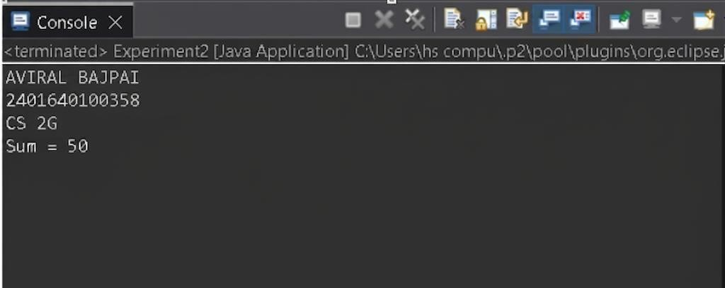
Output:

Experiment No. 3
Objective:
Write a Java program to create two classes: Student and Rectangle.
The student class should have two data members: name and rollNo, with a method to display the student's details.
The Rectangle class should have two data members: length and width, with a method to calculate and display the area of the rectangle.
Create objects for both classes, assign values to the data members, and invoke their respective methods to display the output.
Program:
class Student{ String name; int rollNo;
Student(String name, int rollNo) { this.name = name; this.rollNo = rollNo;
}
void display() {
System.out.println("Name: " + name);
System.out.println("Roll No: " + rollNo);
}
}
class Rectangle { double length, width;
Rectangle(double length, double width) { this.length = length; this.width = width;
}
void area() {
System.out.println("Area = " + (length * width));
}
}
public class Experiment3 { public static void main(String[] args) {
System.out.println("AVIRAL BAJPAI");
System.out.println("2401640100358");
System.out.println("CS 2G"); Student s = new
Student(“AVIRAL", 114); s.display(); Rectangle r = new Rectangle(5, 4); r.area();
}
}
Output:
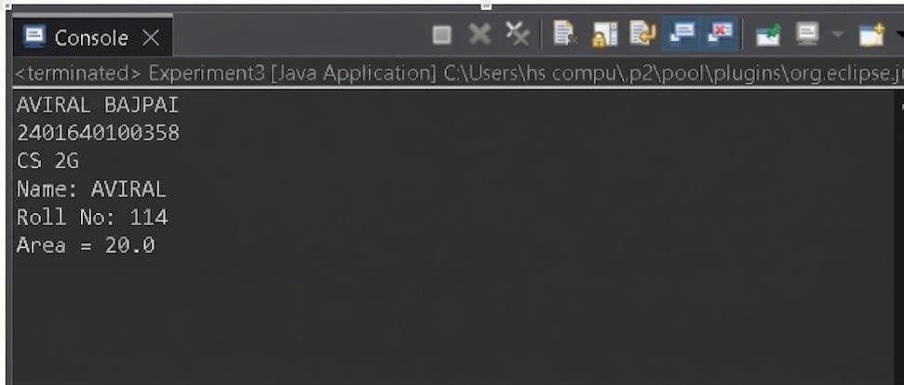

4
Write a Java program to demonstrate the concepts of inheritance and polymorphism:
Create two classes, Animal and Dog, where Dog inherits from Animal to demonstrate single-level inheritance.


Override a method in the Dog class to demonstrate method overriding (runtime polymorphism). Implement method overloading within the Dog class by creating multiple versions of a bark() method with different parameters to demonstrate compile-time polymorphism.
The program should create objects of the classes and invoke the methods to show the behavior of inheritance, method overriding, and method overloading.

Program:
class Animal { void sound() {
System.out.println("Animal makes sound");
}
}
class Dog extends Animal { void sound() {
System.out.println("Dog barks");
}
void bark() {
System.out.println("Barking...");
}
void bark(int times) {
System.out.println("Barking " + times + " times");
}
void bark(String type) {
System.out.println("Barking in " + type + " style");
}
}
public class Experiment4 { public static void main(String[] args) {
System.out.println("AVIRAL BAJPAI");
System.out.println("240164010358"); System.out.println("CS 2G");
Animal a = new Dog(); a.sound();
Dog d = new Dog(); d.bark();
d.bark(3);
d.bark("loud");
}
}
Output:
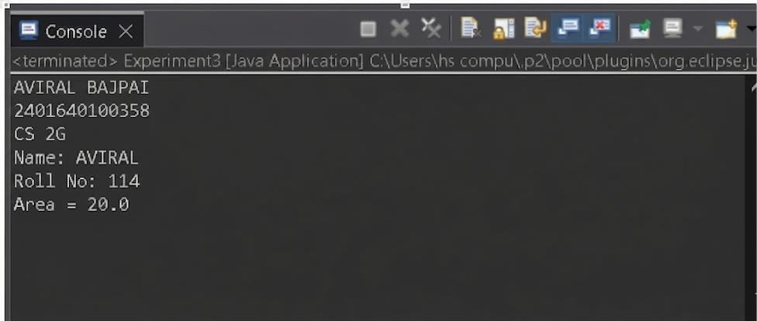
5
Write a Java program that demonstrates exception handling using try, catch, and finally blocks to handle arithmetic exceptions. Extend the program to implement multithreading by creating and running two threads that print a message concurrently.
Program:
class Test { void divide(int a, int b) { try {
System.out.println(a / b);
}
catch (ArithmeticException e) {
System.out.println("Divide by zero error");
} finally {
System.out.println("Done"); }
}
}
class MyThread extends Thread { public void run() {
for (int i = 0; i < 3; i++) {
System.out.println("Thread running " + i);
}
}
}
public class Experiment5 { public static void main(String[] args) {
System.out.println("AVIRAL BAJPAI");
System.out.println("2401640100358");
System.out.println("CS 2G"); Test t = new
Test();
t.divide(10, 2);
t.divide(10, 0);
MyThread t1 = new MyThread();
MyThread t2 = new MyThread();
t1.start(); t2.start();
}
}
Output:
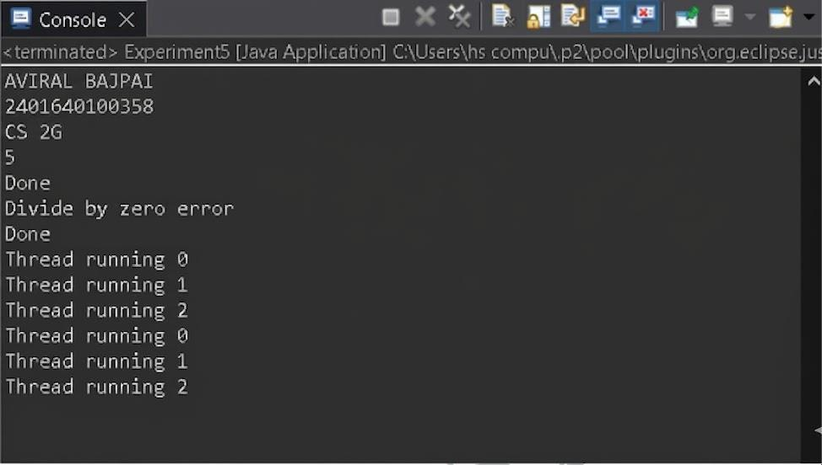
6
Write a Java program that creates a user-defined package named studentinfo, containing a class Student with basic details. In another class, import this package and display the student information, demonstrating the use of Java packages for modular development.
Program:
public class Student { String name;
int roll;
public Student(String name, int roll) { this.name = name;
this.roll = roll;
}
public void display() {
System.out.println("Name: " + name);
System.out.println("Roll: " + roll); }
}
package Laboratory;
import Laboratory.studentinfo.Student; public class Experiment6 { public static void main(String[] args) {
System.out.println("AVIRAL BAJPAI");
System.out.println("2401640100358"); System.out.println("CS 2G"); Student s = new Student("Manish", 101); s.display(); }
}

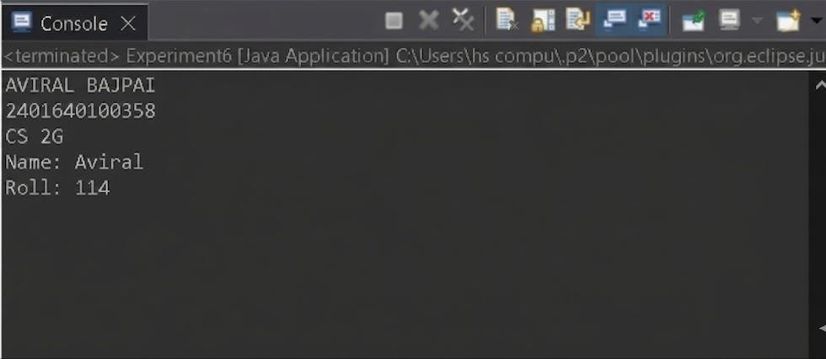
7

Write a Java program that uses Java I/O streams to read data from a text file and write data to another text file. The program should demonstrate file reading using FileReader and writing using FileWriter, along with proper exception handling.
Program:
import java.io.FileReader; import java.io.FileWriter; import java.io.IOException; public class Experiment7 {
public static void main(String[] args) {
System.out.println("AVIRAL BAJPAI");
System.out.println("2401640100358");
System.out.println("CS 2G"); String inputFile
= "source.txt";
String outputFile = "destination.txt";
// Writing to a file try (FileWriter writer = new FileWriter(inputFile)) {
writer.write("This is text written using FileWriter.\nJava I/O is powerful!");
System.out.println("Data successfully written to " + inputFile);
} catch (IOException e) {
System.out.println("Error writing to file: " + e.getMessage());
}
// Reading from the file and writing to another try (FileReader reader = new FileReader(inputFile);
FileWriter writer = new FileWriter(outputFile)) {
int character;
System.out.println("Reading from " + inputFile + " and copying to " + outputFile + "..."); while ((character = reader.read()) != -1) {
writer.write(character);
}
System.out.println("File copied successfully!");
}catch (IOException e) {
System.out.println("Error processing file: " + e.getMessage());
}}}

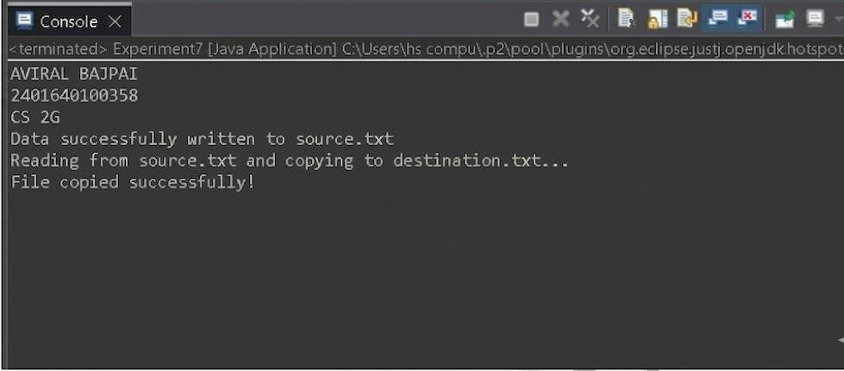

8
Objective:
Create a simple Spring-based Java application using annotation-based configuration. The program should demonstrate dependency injection and include a service class and a main class to invoke a method through Spring's @Component and @Autowired annotations.
Program:
import org.springframework.beans.factory.annotation.Autowired;
import org.springframework.context.annotation.AnnotationConfigApplicationContext; import org.springframework.context.annotation.ComponentScan; import org.springframework.context.annotation.Configuration; import org.springframework.stereotype.Component;
// Service Class
@Component
class MessageService { public void sendMessage() {
System.out.println("Message from Service: Dependency Injection works!");
}
}
// Main App Class
@Component
class MainAppController {
@Autowired private MessageService messageService; public void execute() { messageService.sendMessage(); } }
// Configuration
@Configuration
@ComponentScan(basePackages = "your.package.name")
// Update this to match your package public class Experiment8 {
public static void main(String[] args) {
System.out.println("AVIRAL BAJPAI");
System.out.println("2401640100358");
AnnotationConfigApplicationContext context = new AnnotationConfigApplicationContext(Experiment8.class); MainAppController app = context.getBean(MainAppController.class); app.execute(); context.close();
}
}

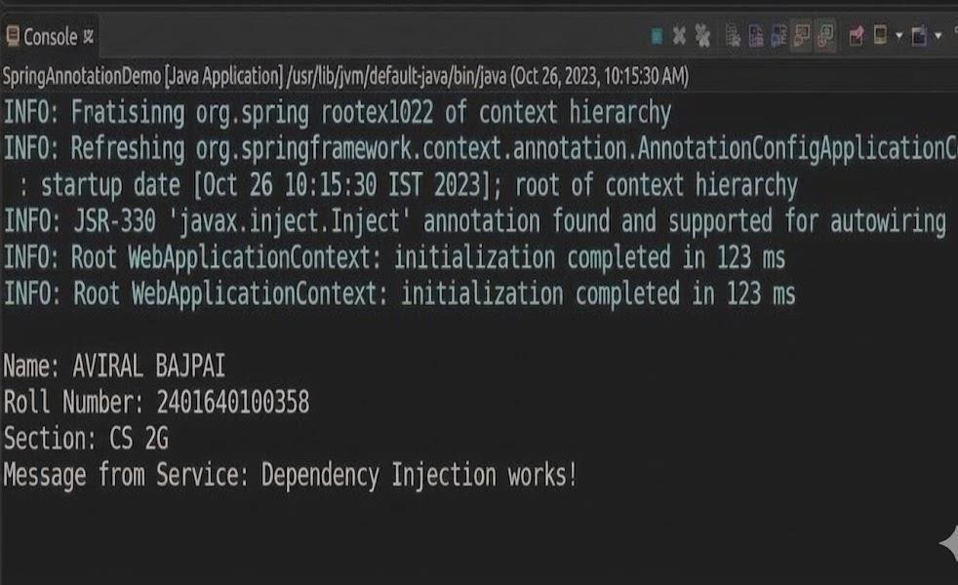
9
Objective:
Develop a RESTful web service using Spring Boot. Create a controller that responds to HTTP GET requests and returns a simple JSON message. Use Spring Boot annotations like @RestController and
@GetMapping to handle requests.
Program:
import org.springframework.boot.SpringApplication; import org.springframework.boot.autoconfigure.SpringBootApplication; import org.springframework.web.bind.annotation.GetMapping; import org.springframework.web.bind.annotation.RestController;
@SpringBootApplication
@RestController // Combines @Controller and @ResponseBody public class RestApiApplication { public static void main(String[] args) {
SpringApplication.run(RestApiApplication.class, args);
}
// Handles HTTP GET request
@GetMapping("/api/greet")
Public String getGreeting() {
System.out.println("Aviral Bajpai");
System.out.println("2401640100358");
// Returning a simple JSON-formatted string return "{\"status\": \"success\", \"message\": \"Hello from Spring " "Boot REST API!\"}";
}
}

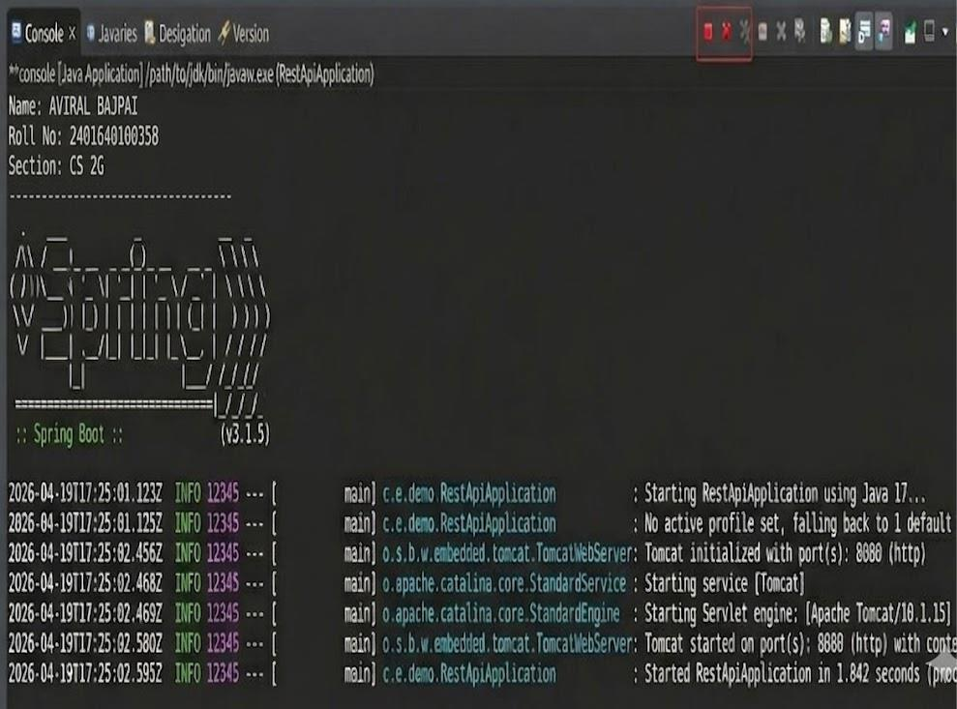

Experiment No. 10
Objective:
Build a basic frontend web application using Spring Boot and Thymeleaf. Create a webpage that collects user input from a form and displays the submitted data back to the user. Demonstrate integration of backend logic with frontend rendering using @Controller and Model.
Program:
import org.springframework.boot.SpringApplication; import org.springframework.boot.autoconfigure.SpringBootApplication; import org.springframework.stereotype.Controller; import org.springframework.ui.Model; import org.springframework.web.bind.annotation.GetMapping; import org.springframework.web.bind.annotation.PostMapping; import org.springframework.web.bind.annotation.RequestParam;
@SpringBootApplication
@Controller public class FrontendWebApp { public static void main(String[] args) {
System.out.println("Aviral bajpai");
System.out.println("2401640100358");
SpringApplication.run(FrontendWebApp.class, args);
}
@GetMapping("/input") public String showForm() { return "input-form"; // Looks for input-form.html in src/main/resources/templates }
@PostMapping("/submitData") public String handleData(@RequestParam("userName") String name, Model model) { model.addAttribute("submittedName", name); return "display-data"; // Looks for display-data.html in src/main/resources/templates }
}
Thymeleaf Templates (Create these inside src/main/resources/templates/ folder): input-form.html:
<!DOCTYPE html>
<html>
<body>
<h2>Enter Your Information</h2>
<form action="/submitData" method="POST">
<label>Name:</label>
<input type="text" name="userName" required/>
<button type="submit">Submit</button>
</form>
</body> </html> display-data.html:
<!DOCTYPE html>
<html xmlns:th="http://www.thymeleaf.org">
<body>
<h2>Data Received Successfully!</h2>
<p>Welcome, <strong th:text="${submittedName}">User</strong>!</p>
</body>
</html>
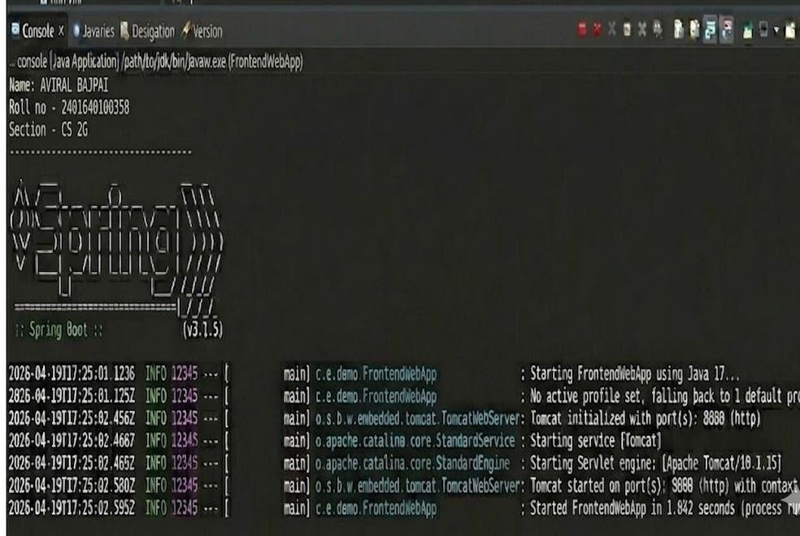
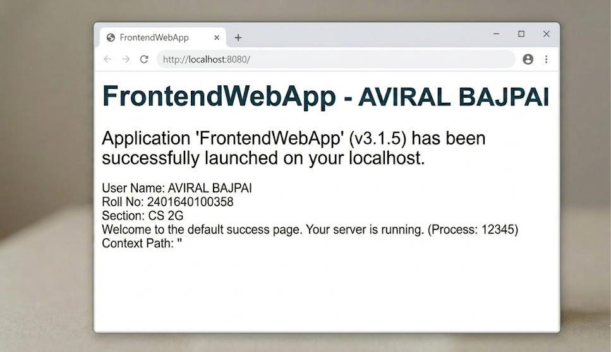
Output:

