SYNOPSIS
ON
“RESUMEIQ: AI RESUME ANALYZER & INTERVIEW ASSISTANT”
A Web-Based AI-Powered Platform for Resume Analysis, ATS Optimization, and Interview Preparation
Submitted in
Partial Fulfillment of requirements for the Award of Degree
of
Bachelor of Technology
In
Computer Science and Engineering
by
(Project Id: 26_CS_3L_10)

Baqa Abbas (Leader) (2401640100410)

Ayush Singh (2401640100392)

Ayush Bhardwaj (2401640100378)

Ayush Shukla (2401640100388)

Ayush Yadav (2401640100401)
Under the supervision of
Mr. Vinay Singh
(Assistant Professor)

Pranveer Singh Institute of Technology
Kanpur - Agra - Delhi National Highway - 19
Bhauti - Kanpur - 209305.
(Affiliated to Dr. A.P.J. Abdul Kalam Technical University)

1. Introduction

1.1 Background of Resume Screening and Recruitment Technology
Recruitment today is heavily mediated by technology. Before a resume reaches a human recruiter, it is commonly parsed and ranked by an Applicant Tracking System (ATS) that scans for formatting consistency, keywords, and structured section headings. Most students and fresh graduates, however, prepare their resumes with little awareness of how these systems work, and career preparation itself — resume formatting, skill assessment, and interview readiness — remains spread across disconnected tools.

1.2 Need for an Integrated AI-Based Career Preparation System
Because resume evaluation, ATS optimization, skill-gap identification, and interview preparation are typically handled by separate platforms, career preparation becomes fragmented and time-consuming. An integrated platform that brings these into a single, intelligent system removes this fragmentation, evaluating a candidate's resume as a whole and generating coherent, role-specific recommendations.

1.3 Problem Statement
Students and fresh graduates frequently struggle to present themselves effectively to automated recruitment systems, largely because they lack visibility into how ATS software scores a resume, lack a clear way to identify skill gaps relative to a target role, and prepare for interviews separately from resume evaluation. The underlying problem is therefore not a lack of relevant guidance in principle, but the absence of a single platform that connects these forms of guidance into one coherent, role-specific experience.

1.4 Proposed Solution
ResumeIQ addresses this by combining resume analysis, ATS optimization, skill-gap identification, and interview preparation into one integrated platform. A Spring Boot backend parses uploaded resumes and passes the content to the Gemini API for AI-driven analysis and interview-question generation, while a React.js frontend presents the results; MySQL stores application data and JWT secures user sessions.

2. Project Objective
The objectives of ResumeIQ define what the project intends to achieve by the end of development, with each objective tied directly to a specific component of the technology stack or to a specific aspect of the problem statement described above. The specific objectives are as follows:
- To design and develop a web-based platform that analyses resumes and provides ATS compatibility feedback to students and job seekers.
- To build a responsive and intuitive frontend using React.js that allows users to upload resumes and view analysis reports clearly.
- To integrate the Gemini API for AI-driven, context-aware resume analysis that goes beyond simple keyword matching.
- To implement resume parsing functionality capable of extracting structured content from PDF and DOCX resume files.
- To develop a skill-gap identification module that compares a candidate's resume against the requirements of a specified target job role.
- To generate personalized, role-specific interview questions based on the candidate's resume and target job role.
- To build a robust backend system using Spring Boot capable of handling user requests and coordinating data flow between the frontend, database, and Gemini API.
- To implement MySQL as the relational database solution for storing user accounts, resumes, analysis reports, and interview data.
- To implement JWT-based authentication to ensure secure, personalized access to the platform.
By the end of the project, ResumeIQ is expected to allow any student or job seeker to upload a resume, specify a target role, and receive a unified, actionable report covering ATS compatibility, skill gaps, and interview preparation — thereby directly translating the objectives above into a working, end-to-end system.

3. Feasibility Study
A feasibility study analyses whether the proposed project idea will succeed within the available resources, time, and technical constraints. For ResumeIQ, feasibility has been assessed along technical, operational, economic, and schedule dimensions.

3.1 Technical Feasibility
ResumeIQ relies on well-established and widely adopted technologies — React.js on the frontend; Spring Boot (Java) on the backend; MySQL as the relational database; and the Gemini API for AI-driven resume and interview analysis. Each of these technologies has mature tooling, active community support, and extensive documentation, which reduces technical risk considerably. Spring Boot's structured, modular architecture and MySQL's relational integrity make the stack well suited to handling structured user, resume, and report data, and none of the required integrations demand specialized hardware or proprietary infrastructure. The project is therefore judged to be technically feasible within the skill level expected of a final-year engineering team.

3.2 Operational Feasibility
Because ResumeIQ is a browser-based application, it requires no installation on the part of the end user and can be operated on any device with a modern web browser and an internet connection. The interaction model — uploading a resume, specifying a target role, and reviewing a generated report — is intentionally simple, which keeps the learning curve low for the intended users: students, fresh graduates, and job seekers with no specialized technical background. This simplicity directly supports the operational goal of making the platform usable without additional training or support.

3.3 Economic Feasibility
The technologies chosen for this project are open-source or available under free-tier access for development and academic purposes, including React.js, Spring Boot, and MySQL Community Edition. The Gemini API offers a free developer tier suitable for a project of this scope. Consequently, the project can be developed and demonstrated without incurring significant licensing or infrastructure costs, making it economically feasible for a final-year academic project.

3.4 Schedule Feasibility
The project has been planned within a defined academic timeline, structured into five sequential phases — Requirement Analysis, Design, Development, Testing, and Deployment — running from 13-July-2026 to 20-Nov-2026. The phased structure below (represented as a Gantt chart) allows each stage to be completed and validated before the next begins, reducing the likelihood of significant rework later in the timeline and confirming that the project is achievable within the available academic schedule.

Start Date: 13-July-2026 End Date: 20-Nov-2026
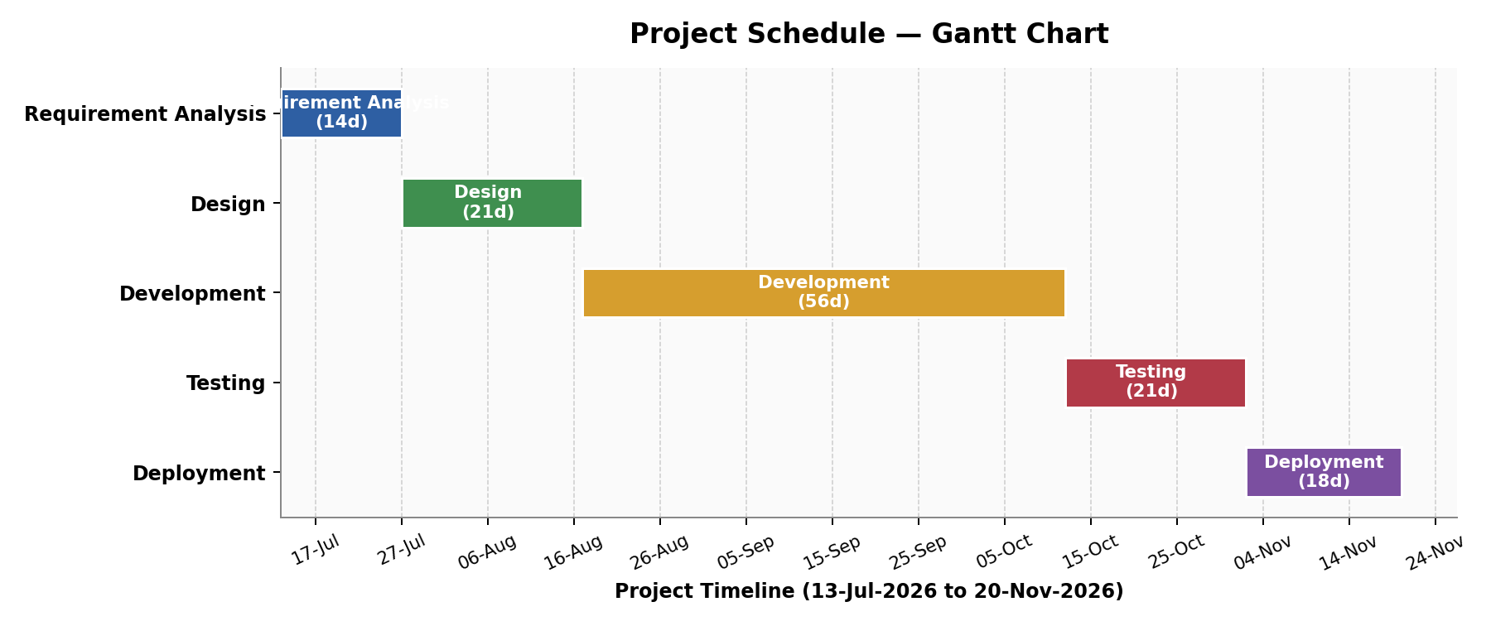
Phase | Duration | Start | End
Requirement Analysis | 2 weeks | 13-Jul-2026 | 27-Jul-2026
Design | 3 weeks | 27-Jul-2026 | 17-Aug-2026
Development | 8 weeks | 17-Aug-2026 | 12-Oct-2026
Testing | 3 weeks | 12-Oct-2026 | 02-Nov-2026
Deployment | ~3 weeks | 02-Nov-2026 | 20-Nov-2026

4. Methodology / Planning of Work
This section describes the steps to be followed to achieve the objectives of the project during development, supported by a system architecture diagram, the phased development methodology, the end-to-end system workflow, and the functional description of the platform.

4.1 System Architecture
ResumeIQ follows a typical three-tier web application architecture consisting of a presentation layer (frontend), an application logic layer (backend), and a data storage layer (database), supplemented by integration with the Gemini API for AI-driven analysis. This architecture ensures a clear separation of concerns, allowing each component of the system to function independently while communicating effectively with the others.
At the presentation layer, users interact with the system through a React.js-based web interface, uploading resumes and specifying target job roles, then viewing the resulting analysis reports and interview questions. The application logic layer, built using Spring Boot, handles incoming requests, performs resume parsing using dedicated PDF/DOCX parsing libraries, and communicates with the Gemini API to generate context-aware analysis and recommendations. The data storage layer, implemented using MySQL, stores user accounts, uploaded resumes, generated analysis reports, and interview question sets in a structured relational format. JWT-based authentication secures user sessions and protects access to personal data throughout the platform.
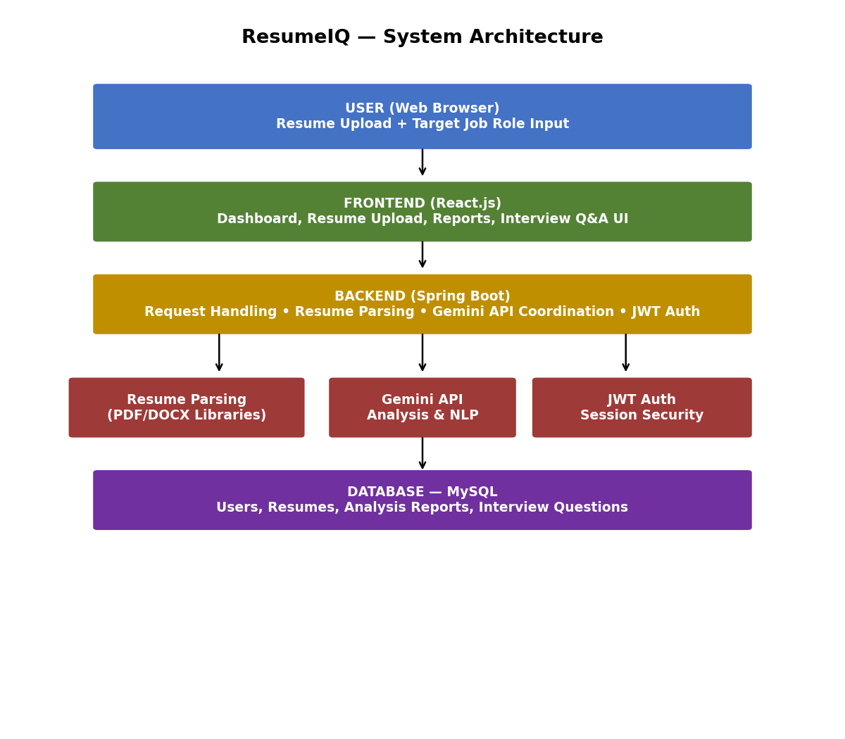

4.2 Development Methodology
The development of ResumeIQ follows a structured and phased methodology, ensuring systematic progress from initial planning through to final deployment.
Requirement Analysis: A detailed study of the project requirements, including the identification of the technology stack, the intended user base, and the core functionalities the system must provide.
Design: Planning of the overall system architecture, including the structure of the React.js frontend, the organization of backend logic using Spring Boot, the schema design for MySQL, and the planned integration points for the Gemini API and JWT-based authentication.
Development: The actual coding and implementation of the system — building the frontend interface, developing the backend logic, setting up the MySQL database, implementing resume parsing, and integrating the Gemini API and JWT authentication. This phase typically represents the most time-intensive part of the methodology.
Testing: Verifying that all components function correctly, individually and when integrated — including the accuracy of resume parsing, the relevance of Gemini API-driven recommendations, and the correct functioning of authentication and report generation.
Deployment: Making the completed application accessible for use, ensuring that the frontend, backend, database, and Gemini API integration all function correctly in the deployed environment.

4.3 System Workflow
- User Access — the user accesses the ResumeIQ web application through a browser and logs in or registers using JWT-based authentication.
- Resume Upload — the user uploads a resume in PDF or DOCX format and specifies a target job role.
- Request Submission — the frontend sends the uploaded resume and target role information to the Spring Boot backend.
- Resume Parsing — the backend extracts structured text and section content from the uploaded resume using PDF/DOCX parsing libraries.
- AI Analysis — the backend sends the parsed resume content and target role to the Gemini API for ATS compatibility scoring, skill-gap identification, and improvement recommendations.
- Interview Question Generation — the Gemini API also generates customized interview questions aligned with the candidate's profile and target role.
- Data Processing and Formatting — the backend processes and formats the AI-generated results into a structured report.
- Database Interaction — the resume, analysis report, and generated interview questions are stored in MySQL for future reference.
- Response Delivery — the processed report is sent back to the frontend and displayed to the user in a clear, organized manner.

4.4 Functional Description
- Resume Upload — allows users to upload resumes in PDF or DOCX format through the web interface.
- ATS Compatibility Analysis — evaluates resume formatting and content against ATS-friendly practices using the Gemini API.
- Skill-Gap Identification — compares resume content against a specified target job role to highlight missing or underdeveloped skills.
- Personalized Recommendations — generates context-aware suggestions for improving resume content and structure.
- Interview Preparation — generates customized interview questions based on the candidate's resume and target role.
- Data Storage — utilizes MySQL to store user accounts, resumes, analysis reports, and interview data.
- User Authentication — provides secure login and session management using JWT.

5. Tools/Technology Used

5.1 Minimum Hardware Requirements
Component | Specification
CPU | Intel Core i3 (8th Generation) or higher
RAM | Minimum 4 GB (8 GB recommended)
GPU | Integrated Intel UHD/HD Graphics — no dedicated GPU required
Storage | Minimum 5 GB available disk space
Others | Stable internet connection for accessing the Gemini API

5.2 Minimum Software Requirements
Category | Requirement
Operating System | Windows 10/11, Ubuntu Linux, macOS
Backend Framework | Spring Boot (Java)
Frontend Technology | React.js
Database | MySQL
AI/NLP Integration | Gemini API
Authentication | JWT (JSON Web Tokens)
Resume Parsing | PDF/DOCX Parsing Libraries
Web Browser | Google Chrome, Microsoft Edge
IDE / Tools | Visual Studio Code, IntelliJ IDEA, Node.js, Maven, Postman, Git, GitHub

5.3 Technology Description
React.js: Used to build the frontend of ResumeIQ, providing a component-based structure for the resume upload interface, analysis dashboard, and interview question display, along with responsive, dynamic updates as data is returned from the backend.
Spring Boot: A Java-based backend framework used to handle routing, business logic, resume parsing, and communication with the Gemini API. Its structured, modular design keeps the backend organized and maintainable as complexity grows.
MySQL: A relational database used to store user accounts, uploaded resumes, generated analysis reports, and interview question sets in a structured, query-efficient format.
Gemini API: Integrated to provide AI-driven Natural Language Processing capabilities, forming the core analytical engine for ATS scoring, skill-gap identification, personalized recommendations, and interview question generation.
JWT (JSON Web Tokens): Used to implement secure, stateless authentication, ensuring that user sessions and personal data remain protected throughout the platform.
PDF/DOCX Parsing Libraries: Used to extract structured text and section content from uploaded resumes, converting unstructured document files into a form that can be analysed by the Gemini API.
Git & GitHub: Used for version control and collaborative development, allowing the team to track changes and manage contributions throughout the project lifecycle.

6. References [IEEE Format]
The following study material, technical documentation, and reference sources were consulted for the design and development of the ResumeIQ project:
[1] VMware Tanzu / Spring Team, "Spring Boot Reference Documentation," [Online]. Available: https://docs.spring.io/spring-boot/. [Accessed: 2026].
[2] Meta Open Source, "React Documentation," [Online]. Available: https://react.dev/. [Accessed: 2026].
[3] Oracle Corporation, "MySQL Reference Manual," [Online]. Available: https://dev.mysql.com/doc/. [Accessed: 2026].
[4] Google, "Gemini API Documentation," [Online]. Available: https://ai.google.dev/gemini-api/docs. [Accessed: 2026].
[5] Internet Engineering Task Force, "JSON Web Token (JWT), RFC 7519," [Online]. Available: https://datatracker.ietf.org/doc/html/rfc7519. [Accessed: 2026].
[6] Postman Inc., "Postman API Platform Documentation," [Online]. Available: https://learning.postman.com/. [Accessed: 2026].

