Push: Source will send data to Target. Apache Kafka, MQTT. Pull: file download or database querying. Poll: Target periodically check the Source for change, if it changes, then read again. Web crawling.
Bounded Data: discrete datasets or batches; Unbounded Data: continuous stream
Throughput, Latency and Scalability: One-off tasks不需要考虑latency;在unbounded data stream要考虑 latency;当data volume grow必须考虑 throughput 和 scalability
ETL: 加载前转换,适用于中小数据,数据仓库, Data analysts excluded from ETL processes,结构化数据
ELT: 加载后转换,适用于大数据,数据湖,,非结构化数据
Orchestration: Manages the flow of data, automating extraction, transformation, and loading (ETL).
Data Quality: Believable(subjective), Value-added, Relevant, Accurate(objective), Interpretable
Data Cleaning: Missing(removed or imputed), Default, Incorrect(remove or adjust), Inconsistent(reconcile)
csv.reader reads rows into arrays
csv.DictReader reads rows into dictionaries
Bar Charts for Categorical/Nominal Data
Histograms for Numerical Data
Scatter Plots for comparing two continuing variables
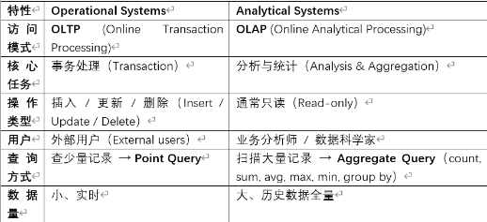
自动生成Schema：约束弱，没有FK和Integrity Constraints; 自定义Schema：约束强，速度慢
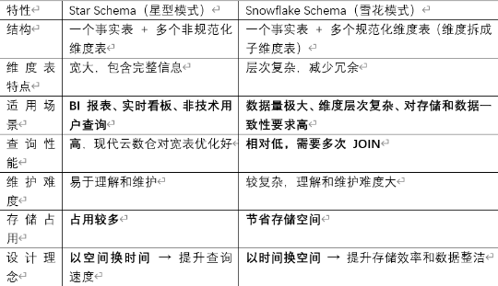
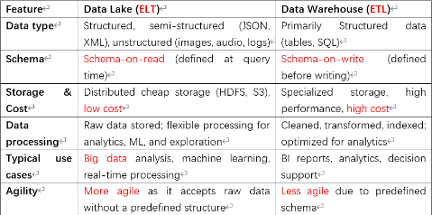
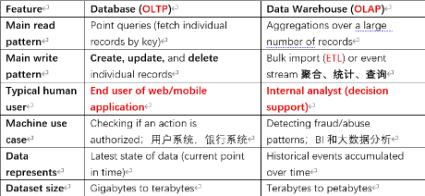
OLAP: Roll-up:向上汇总数据; Drill-down:小粒度;Slice: select a single dimension from a cube; Dice:create a smaller sub-cube from an OLAP cube.Pivot:改变观察角度,行列互换
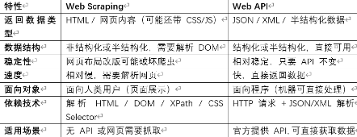
Data Warehouse: contains a read-only copy of data from various OLTP; Can be both source or sink; 有Data Silo; Fact Table通常包含度量和外键维度, 通常是数字，可以进行聚合; Dimension Table.
Web Scraping: Reconnaissance(Check terms-of-service and robots.txt; if in doubt, contact owner); Webpage Retrieval; Data Extraction; Data Cleaning transformation; Data Storage, Analysis
URL: protocol://site/path_to_resource
Scrapy: 专业的 Python 爬虫框架
Selenium: 可编程的浏览器
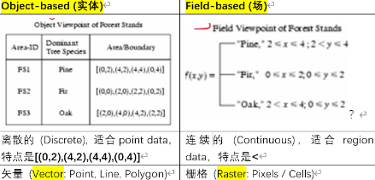
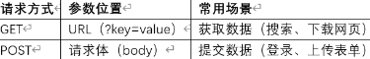
HTTP:Head部分用户看不到,Body部分是网页内容.DOM is an element tree, Sibling tags have an order from left to right!方法有下面2个
RESTful APIs: Stateless,使用上面2个HTTP方法; XML Web Services:基于SOAP,也是一种Web API
Semi-structured data: Nesting, Heterogeneous collections; HTML, XML and JSON belong to it.
HTML:主要用于网页设计和展示,pre-defined tags,宽松语法,浏览器容错率高,即使写错也能渲染
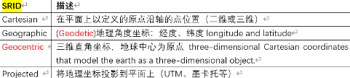
XML:主要用于数据交换和存储,user-defined tags,严格语法,必须成对闭合<title></title>,区分大小写,Empty elements <AUD/>, Well-Formed XML文档符合 XML 的基本语法规则,Valid XML文档不仅格式正确（well-formed），还要符合一个预定义的约束规则
DTD:定义XML文档的语法规则,?0或1,*0或多,+至少1次.属性genre在<>里面,子元素在<>外.
<book> 元素由 title, author, price 组成。`title` 必须出现 1 次 ；`author+` 表示 至少一个作者； `price?` 表示 价格可选（0 或 1 次）
<!ELEMENT book (title,author+,price?)>
<book> 元素必须有一个属性 genre；属性类型为 CDATA（字符串类型）
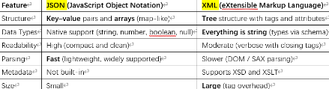
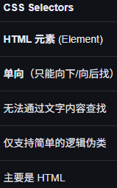
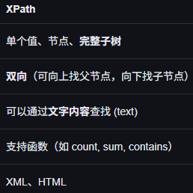
<!ATTLIST book genre CDATA #REQUIRED>
在XML DOM里面，root不对应文档里面的元素.
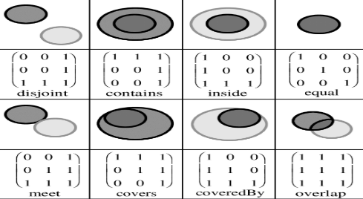
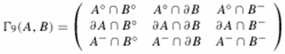
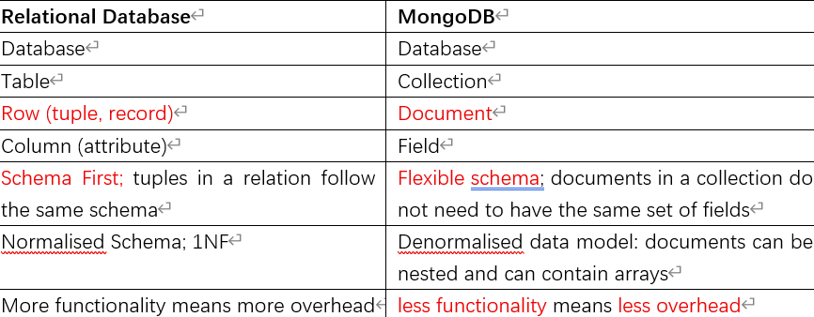
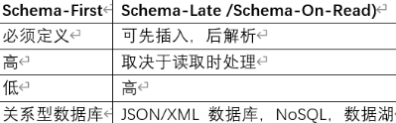
保存爬虫数据方法:File systems (CSV, XML or JSON files), HTML的核心目的是展示网页内容，不是为了存储结构化数据而设计. Database JSONB does not keep duplicate, JSON在Database里面不能有相同的key.
MongoDB shell不要求双引号around keys and string values; MongoDB compass要求双引号,错误{ name: 'Alice', age: 25 }
MongoDB更容易Scalability: Automatic Data Partitioning(把一个大集合的数据分布到多台机器上,horizontal range partitioning per ‘table’); Single-Leader Replication(每个 shard 内部有多个副本replica set但只有一个 primary主节点接收写入,保证数据可靠性和高可用), Load Balancing(将请求均匀分配到多个节点,负载均衡)
Graph Database: Neo4j,节点表示实体,边表示实体之间的关系,属性节点或边的元数据或属性.优势为高效关系处理,灵活性,性能.支持ACID,高可用,使用Cypher(a declarative graph query).
Python虚拟环境:隔离依赖,保证每个项目可以独立运行,不受全局或其他项目的影响,python -m venv myenv
Spatial Database Management System (SDBMS):Handle a large amount of spatial data stored in secondary storage.
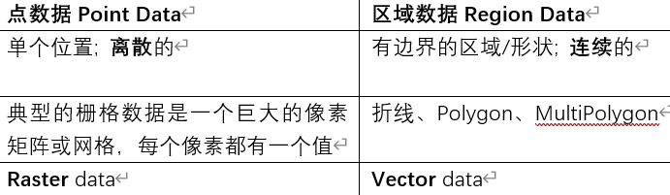
Geographic Information System (GIS):SDBMS Client, Information in GIS is typically organized in “layers”. a map has a layer of “roads”
对于Geodetic和Geocentric来说，北极点是不能一对一映射的，因为geodetic北极点有多个，比如(90°, 0°)(90°, 30°)(90°, 120°)
Mercator Projection:靠近北极的会被放大，introduces distortion (area distortion increases with latitude), preserves angles
世界通用WGS84 == 4326澳洲GDA94
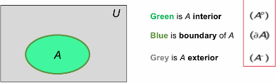
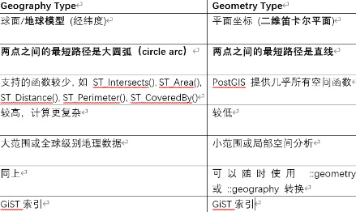
PostGIS: PostgreSQL的空间数据库扩展,支持地理空间对象.R-Tree 索引基于GiST.支持下面2种类型.
GeoSeries:属于Geopanda, GeoSeries 是一个“一维的空间对象集合”，里面的每个元素都是一个几何对象（Point / Line / Polygon），并且共享同一个坐标参考系（CRS）。
Point / Line / Polygon → 单个空间对象
GeoSeries → 一列空间对象
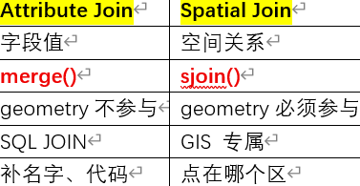
GeoDataFrame → 表（多列 + 一列 geometry）任一时刻只有一个Geometry列能被激活
gs = gpd.GeoSeries([Point(-120,45), Point(-121.2,46), Point(-122.9,47.5)])
KML:OGC 标准的一种 XML 空间文件格式
Semi-Temporal Database:只记录有效时间（valid-time）的一部分，从某个时间开始到现在 [since, now)
Instant | Point：something happening at an instant of time; DATE
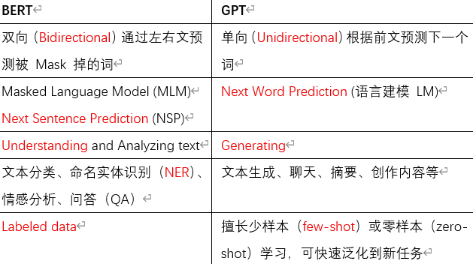
,TIME,TIMESTAMP(DATA+TIME)
Interval：a length of time; a duration比如3天
Period：an anchored duration of time (a recurring interval of time),比如2024年.half-closed interval [start, end),开始和结束的bound必须相同类型.在PostgreSQL里面叫做DATERANGE，也符合half-closed。此外对于这种类型的列，我们要用GiST作为index.
SQL supports time instants, intervals not support periods.
User-defined time: an uninterpreted time value. 用户自定义时间,数据库不解释其意义,不区分过去/现在/未来.
Valid/Fact time: application time. when a fact was true in the modelled reality.有效时间,事实在现实中成立的时间.可以向前修改,也可以向后修改.
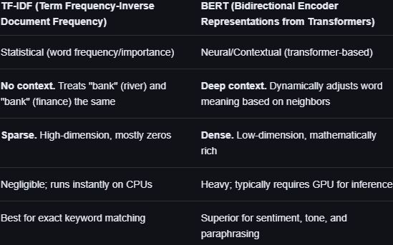
Transaction time: system time, Database time. when a fact was stored in the database,事务时间,事实被记录入数据库的时间.只能向后修改.
Current: 只关心现在的状态,不关心历史变化. How many products do we currently have in stock?
Sequenced: at a specific instant or period of time,查询数据的历史变化序列,要关注顺序,Give the sequence of how many product were in stock.
Nonsequenced: ignoring time查询过去曾经出现过的数据,关注数据的存在性,但不关注顺序. How many products A did we have at any time in stock?
transaction-time column是period type，即有开始和结束
valid-time column 是period type，即有开始和结束
transaction-time table：A table with a transaction-time column
valid-time table：A table with a valid-time column
bitemporal table：A table with both a transaction-time and a valid-time column
nontemporal table：A table with neither a transaction-time nor a valid-time column
时间数据库如何表示“当前仍然有效?
Minimum possible timestamp: 把end_time填成最小可能值, quite counter-intuitive
NULL value: 把end_time填成空表示数据仍然有效,Use of NULL as ‘unknown’ is no longer possible
Maximum possible timestamp: 给end_time设置最大值
Point representation: Set start_time = end_time; 丢失了区间的含义
Timeseries Data
Point-based representation: Multiple rows with atomic data types,用B-Tree作为INDEX
Sequence-based representation: Single row with array of time point data. Requires array datatype.用GIN作为INDEX. Unnesting把数组拆成多行; array_agg() 把多行合并成数组
Dedicated time-series database: TimescaleDB, InfluxDB
Text: usually does not have a pre-defined data model and is unstructured.
Image: can be described as vector graphics or raster data.RGB的channel就是3个.Number of bits per pixel (bpp) defines how many colors can be represented. 8 bpp=$2^{8}$=256 colors.
Gray-scale: Single channel, bpp defines how many shades of gray can be represented.
Binary image: Each pixel is just black (0) or white (1). Single channel.can be 1 bpp but also works with higher bpp. Referred as ‘mask’ in the image processing domain.
Supervised learning: Prediction, Classification, Regression.
Unsupervised learning: Clustering, Probability distribution estimation, Dimension reduction.
Unstructured Data Analysis Process
Data Acquisition→ Preprocessing→ Feature Extraction → Task
Feature Extraction：Unstructured data to vectors.
Word Embeddings: Using models like Word2Vec (word embeddings), GloVe, or BERT (contextual word embeddings) to represent text data in a dense vector format. Document Similarity可以通过 Vector Distance判断，比如Cosine-Similarity 1表示文档非常相似,0表示文档无关,-1表示文档内容相反.
TF: 词语在单篇文档中的出现频率；词出现次数/文档总词数
用CountVectorizer进行计算，可配置参数如下
ngram_range=(2,4)表示取2-gram, 3-gram, 4-gram
binary=True表示不再统计单词出现的次数，只记录该词是否出现过。
stop_words=['the','a'] 表示在构建词频矩阵时，手动排除列表中的高频但无实际含义的词（如 "the", "a", "is"）
min_df=0.1表示忽略在少于 10% 的文档中出现的极罕见词
max_df=0.5表示忽略在超过 50% 的文档中出现的极常见词
IDF：衡量词语在整个语料库中的稀有程度；log(总文档数/包含该词的文档数)
TF-IDF：TF与IDF的乘积，值越大代表词语对文档的区分能力越强;.
BERT: pre-trained transformer-based neural network, uses a bi-directional approach considering both the left and right context of words in a sentence, returns vectors.
ROI = 图像中你特别关注的区
Image descriptors (white box algorithms) typically based on image gradient主要依赖于gradient.使用手工设计的算法提取图像特征
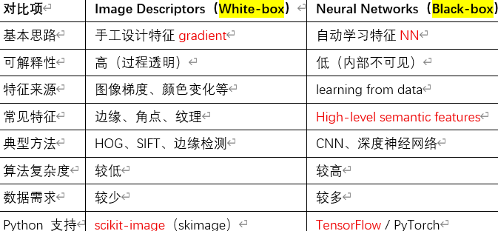
Neural networks (black box algorithms): 通过神经网络NN自动学习图像特征.
Metadata:
- GUI tools such as Photoshop, Lightroom, Preview
- Typically includes：GPS location，author, copyright
- in the form of key-value pairs
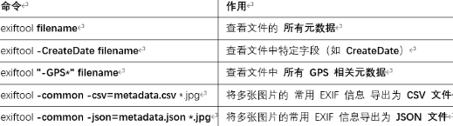
- 元数据可以被修改
Stream Processing: 处理正在流动的数据data in motion而不是先存储后处理,比如Fraud detection, Cybersecurity
传统数据分析: Not agile enough, Queries are specified over stored data, data at rest: favors infrequent updates
Data Streams: unbounded.
Transactional data streams: log interactions between entities；记录实体之间发生的“事件 / 交互”的数据流.比如credit card purchases by consumers from merchants
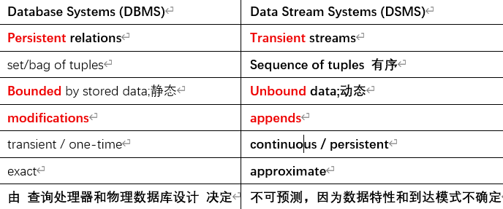
Measurement data streams: monitor evolution of entity states；持续监测某个实体“状态随时间变化”的数据流. IP network
第一种DSMS: Publish/Subscribe Messaging System
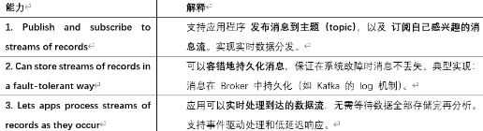
ability to consume constant stream of events. with QoS guarantees. 布者不直接把消息发给具体接收者，而是按“主题（topic）”发布到Broker；订阅者只从broker接收自己订阅的主题的消息。常见的有：Apache Kafka(Topics in Kafka are multi-subscribe)，MQTT. A broker mediates communication between producers and consumers, providing decoupling, scalability, and reliable message delivery in distributed systems
MQTT: 第一个是subscriber，第二个是publisher
subscribe.callback(print_msg, "MyTopic", hostname=broker)
print_msg：回调函数 = 系统帮你调用的函数，不是你手动调用
MyTopic：订阅 MyTopic 这个主题，当有新消息到来时，用 print_msg 这个函数来处理消息。Topics are case-sensitive
hostname=broker：是从broker订阅，而不是Publisher
publish.single("MyTopic", "TheMessage", hostname=broker)
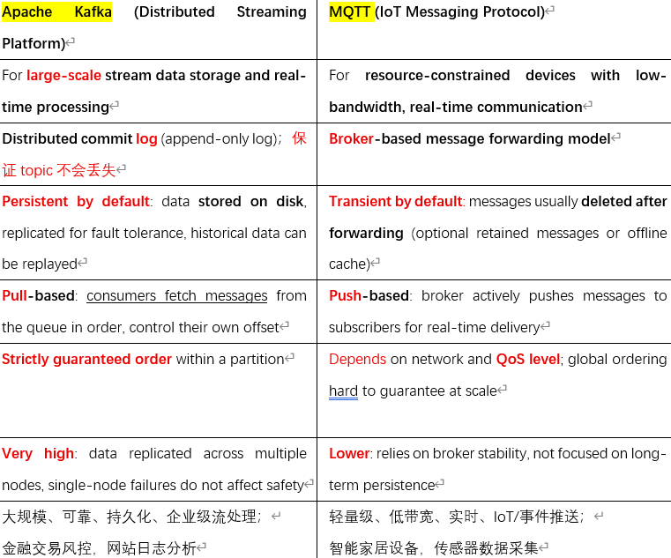
By default, MQTT broker does not store any message.只有在线的订阅者才能收到消息,但是可以设置为保留
Quality of Service
-At most once (QoS 0；Default): every message is processed at most once, but no guarantee；尽力而为，发了就不管了，最快
-At least once (QoS 1): no message will get ignored；一定送到，但可能送两次
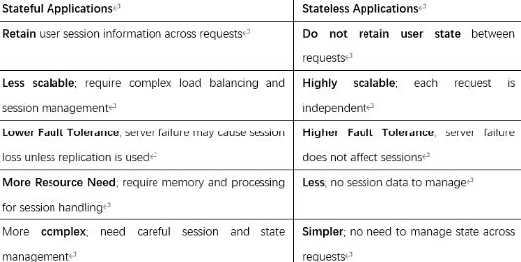
-Exactly once (QoS 2): system guarantees that every message is processed exactly once；一定送到，而且只送一次，最慢
第二种DSMS: Data Stream Processors
ability to execute query processing on stream data with clear semantics.
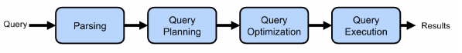
Data Stream Query Processing
State refers to data that is retained and updated across multiple events during stream processing.
Stateless operators look at each event individually
Stateful operators output results based on multiple events
Aggregation – need first to define a window on the data stream to process.
Agglomerative Window：incrementally aggregates incoming data and updates the result continuously without storing all events in the window.
Sliding Window: fixed size, moves forward at a fixed interval, overlap.
Tumbling Window: fixed-size, non-overlapping, 是特殊的Sliding Window.
Tuple-Count-Based Windows: 包含Sliding Window和Tumbling Window. 基于tuple的数量进行window的划分. 有个问题就是Tie，即当假设有 3 条数据时间戳都是 10:00:01，但窗口大小刚好在它们中间切断。系统这次可能把 A 放入窗口，下次可能把 B 放入窗口.解决办法为在时间戳之外，增加一个唯一且稳定的字段tie-breaker.
Punctuation-Based Windows: 基于punctuation划分窗口，窗口长度不固定.
Event time：事实真正发生的时间。有个Watermarks的机制可以确保这个，它是一个时间戳 𝑇，代表系统声明：“所有 Event Time≤T的数据都已经到齐了。因此可以通过窗口的last timestamp ≤ watermark来判断是否输出结果。
Ingestion time：数据进入系统边界的时刻。
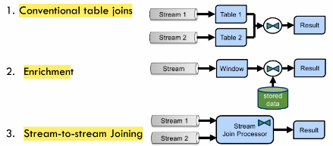
Processing time：数据被算法/算子执行的时刻。
Conventional Table Joins将两个已经存在的、完整的静态表（Table A 和 Table B）通过共有键（Join Key）合并。
Enrichment将实时的“事实流”与相对静态的数据通过一个window进行匹配。这个window确保了即使维度表在不断变化（Stored Data updates），流数据也能找到它“应有”的历史镜像。因为查询数据库会导致延迟，有2种办法解决In-memory Storage：通过把常用的存储在内存提升效率。External data Storage：通过index等提升查询效率
Stream-to-stream Joining将两个实时产生的数据流，在某个时间窗口内进行匹配。
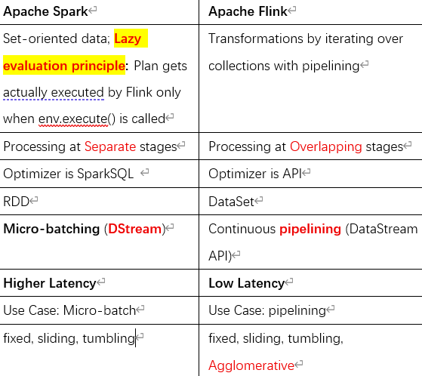
数据流处理工具Recall：Kafka or MQTT are not data stream processors.
Scale-Up: To scale with increasing load, buy more powerful, larger hardware
Scale-Out: need to scale-out to a cluster of multiple servers (nodes). shared-nothing architecture
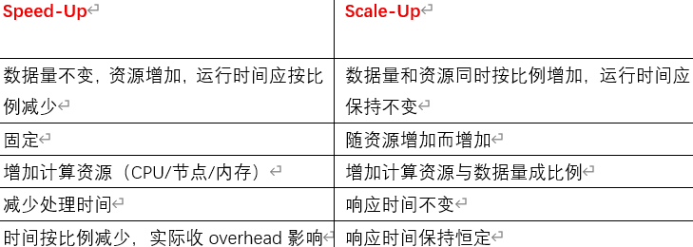
Scale-Agnostic Data Management 与规模无关的数据管理
数据分片（Sharding）：提升性能
数据复制（Replication）：保证可用性
应用透明：应用无需关心底层复杂性
Single Machine: 比如RAID因为显示为一个逻辑磁盘.
Row-oriented databases organize data by record (row).Optimized for reading and writing on rows efficiently适合OLTP
Column-oriented databases organize data by field (column). Optimized for reading and computing on columns efficiently.适合OLAP.优点:不必读取不需要的属性, Better compression possibility,都是减少IO. 缺点:不适合频繁更改, 读取多行时的开销大, 不适合small table.
Cluster of Machines
Data Partitioning / Data Sharding: Storing subsets of the original data set at different places. Sharding：if each partition is stored on a different site. 分布shard方法如下: Round-robin：in rounds. Hash partitioning：hash function Range partitioning：range predicate; 比如[0:1]放一起，[2:5]放一起. Inter-Query Parallelism：different Query independently on separate places Intra-Query Parallelism：same Query accesses several places in parallel
Data Replication: Storing copies (‘replicas’) of the same data at more than one place；适合READ-ONLY. 主要是为了Safety和availability. Lazy+Pri最常见；Eager+Mult是IDEA
Synchronous (Eager) Replication: update all replicas inside original transaction
Asynchronous (Lazy) Replication: Update one copy, 再扩散到别的
Primary Copy: 永远先更新一个replica
Multi Leader: 可以同时更新多个不同的replica；Eager导致死锁；Lazy导致Conflict；适合在每个transaction负责disjoint fragment的情况
CAP Theorem: Consistency：All copies have the same data. Availability：A data system should always be up. Partition Tolerance: Ensures the system functions despite communication breakdowns. CP：适合financial application. AP：适合social media platform. CA：只存在于“没有网络分区”的系统中
Scale-Agnostic Data Processing 与规模无关的数据处理
大规模并行处理：跨数百或上千 CPU。
性能：并行查询/计算处理。
可用性：系统理想情况下永远在线，可透明处理故障。
弹性（Elasticity）：运行中可动态调整规模。
Data Processing: Spark, Hive, HBASE, Hadoop, MapReduce, ApacheFlink
Storage:HDFS,MongoDB,snowflake,AmazonS3
HDFS：Allow clients to access files on remote servers “transparently”. One NameNode, Multiple DataNodes. Each block is replicated across multiple nodes default 3.
MapReduce是实现这些目标的经典处理模型, Map: filtering and sorting sorting students by first name into queues. Reduce: summary operation counting the number of students in each queue. Hadoop= HDFS+YARN+MapReduce
Loosely-Coupled System: Separation of computer and storage nodes. The more nodes, the higher the probability of some failure, Latency can increase.
Data Architecture: Architecture first, technology second. Operational Architecture: What needs to be done?
Technical Architecture: How data is ingested, stored, transformed, and served.
Batch-driven: 延时处理,大数据架构的一种.
Data Lake: Dump all of your data, structured and unstructured, into a central location.容易导致data swamp，缺乏治理、元数据和质量控制，数据湖变得混乱、难以理解、几乎无法使用的状态。
Feature Store Architecture: data pipeline server for training and serving machine learning models. Transformation, Storage, Serving, Monitoring, Feature Registry. Offline Serving: Access historical data; Online Serving: Provide fresh feature. Batch Transform静态数据Streaming Transform动态数据
On-Demand Transform只在预测的时候用. 替代方案: Custom ETL Pipelines：High flexibility；Increased complexity, lacks consistency. Data Warehouses & Lakes: Easy Integrated; Not suit real time ML. In-House Feature Management Systems: Tailored;扩展性差.
Lambda Architecture: Address latency by creating batch/cold layer存入serving layer确保了准确性and speed/hot layer直接被analytics使用确保低latency. 用户也可以通过serving layer结合两者。
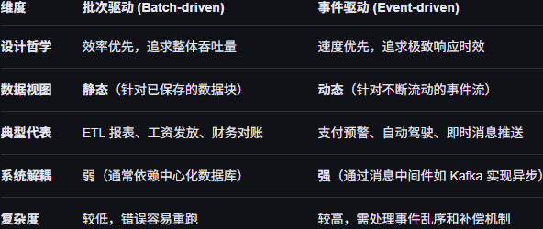
Event-driven: 即时处理,大数据架构的一种.Data Stream Processing Architectures. 例子Kappa Architecture, Only one path.
Continuous Integration (CI): Automatically testing and integrating new code into a shared repository
Continuous Deployment (CD): Automatically deploying tested code to production environments.
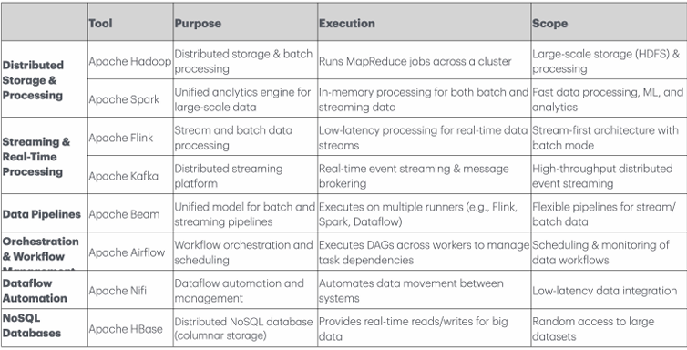
DataOps is a set of collaborative data management practices designed to speed up data delivery, maintain quality, and foster collaboration.
-Key goal: Break Silo by Unifying Data, Collaborative Framework
-Key Functions:
Pipeline Orchestration: 负责统一调度和管理数据与 ML 流水线
Data Quality Monitoring: 持续监控数据和特征的完整性、准确性与一致性，及时发现缺失值、异常分布
Governance and Security: 确保数据使用符合组织规范与安全要求
Self-Service Data Access: 通过标准化接口、目录和文档，使数据科学家和业务人员能够自助发现、理解并使用数据与特征，减少对数据工程团队的依赖
-Lifecycle: Plan, Dev, Integrate, Test, Deploy, Monitor
-Data Curation: Automate data cleansing, transformation, and standardization to ensure high-quality data.
-Master Data Management：确保数据一致性。
-The Five Pillars：Freshness, Distribution(acceptable ranges),Volume(Monitor Missing), Schema(Track structural changes), Lineage(data move/transform across system)
3种Scaling ML的方法如下
Feature Store: TFIDF是一种feature extraction方法.
Data to ML/Data to Computation: 适合小数据，不好扩展.Scale-up
ML to Data/Computation to Data: 适合大数据，好扩展。典型代表是MADlib(In-database analytic), 它还可以通ARIMA支持time series(只有point) 使用Greenplum则是a shared-nothing database using postgres per each node或PostgreSQL. Scale-out
PII: Information that, when used alone or with other relevant data, can identify an individual.
Sensitive information: is personal information that includes information or an opinion about an individual. 比如信仰，性取向。在PII里的优先级最高。
Data Minimalism: best way. Avoid collecting unless necessary. 不需要的历史数据要删除.
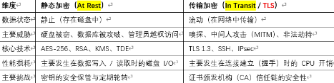
Least Privilege: grant human/machine only the necessary access.视图可以达成
3 – 2 – 1 rule: At least 3 copies On 2 different media At least 1 off-premise
RPO: how much data you can afford to lose; RTO: how fast you need to recover.
-An RPO of 1 hour means data backups must be made at least every hour
-An RTO of 2 hours means the system must be fully restored within that time.
On-Premise Backup: Local storage devices like NAS.
Cloud backups: may take longer to restore than local backups.
Best Practice: Combining local replication with remote cloud backups ensures both high availability and disaster recovery readiness.
Crash Recovery：Using log；Disaster Recovery：using log and backup.
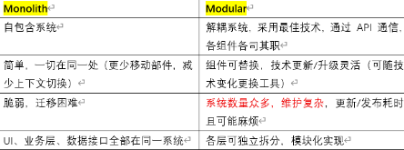
Choosing Technologies across the Data Engineering Lifecycle by using MOBILIST: Monolith/Modular, Optimizing cost, Build vs buy, Interoperability互操作性API, Location本地/云, Immutability, Speed to market, Team size

