- 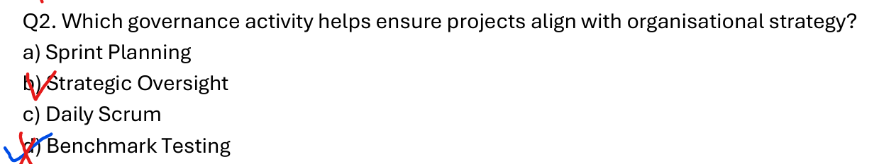a) Sprint Planning: A tactical Agile team meeting used to plan work for a short, upcoming sprint.
- c) Daily Scrum: A daily, operational Agile meeting for the team to synchronize activities and discuss blockers.
- d) Benchmark Testing: A technical quality assurance activity used to compare performance against a standard.

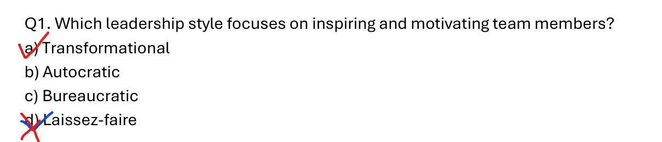

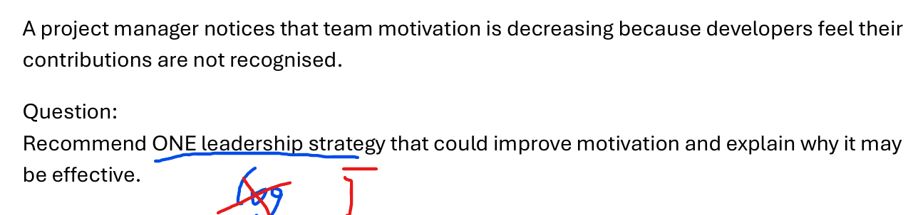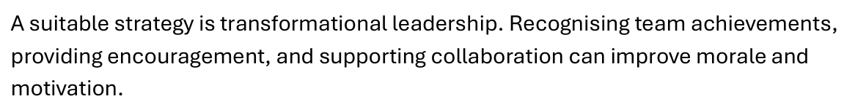

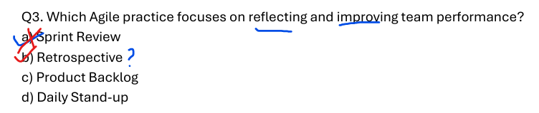
- Retrospective (Sprint Retrospective) is a dedicated Agile practice held at the end of a sprint where the team reflects on how things went and identifies specific ways to improve their processes, collaboration, and performance moving forward.
- • a) Sprint Review: Focuses on demonstrating the working product increment to stakeholders and gathering feedback on the product itself, not team performance.

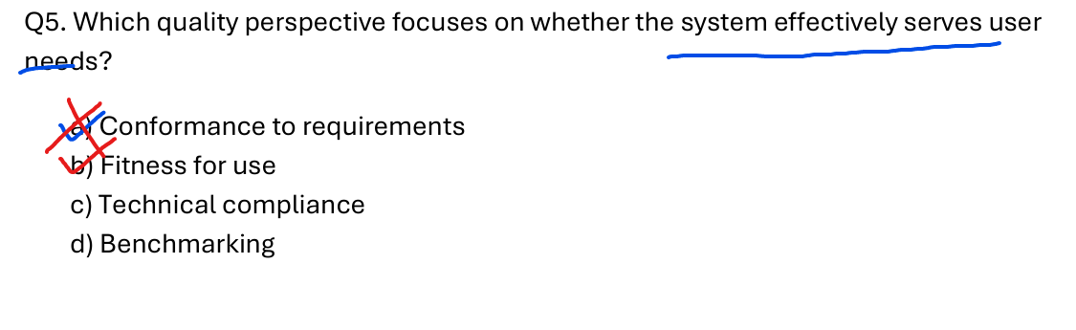
- Fitness for use: This perspective focuses on whether the product or system satisfies the customer's real needs and is suitable for its intended purpose.
- Conformance to requirements: This focuses strictly on adhering to predefined specifications and technical standards, regardless of whether those standards actually satisfy the user.
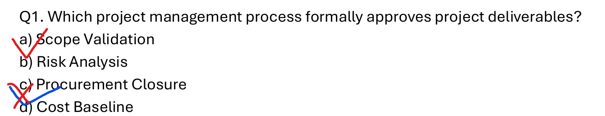
- Scope Validation is the project management process where the client or sponsor formally accepts and approves the completed project deliverables.
- Risk Analysis identifies and assesses potential project risks.
- Procurement Closure completes and settles each project contract.
- Cost Baseline is the approved budget used to measure project cost performance.

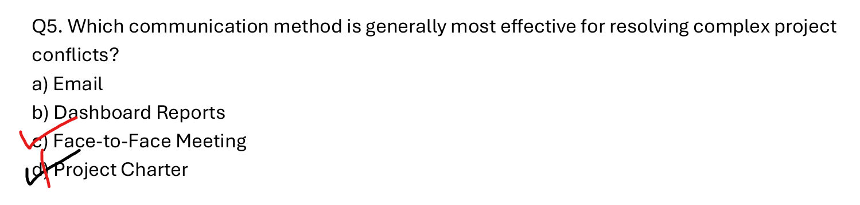
- Face-to-Face Meeting allows for real-time discussion, clarification, and the reading of non-verbal cues (like body language and tone), which is crucial for resolving complex conflicts.
- Email lacks personal context and can easily lead to further misunderstandings in high-stakes situations.
- Dashboard Reports are status tracking tools, not communication channels for resolving disputes.
- Project Charter is a foundational document that formally authorizes a project, not an active conflict resolution tool.

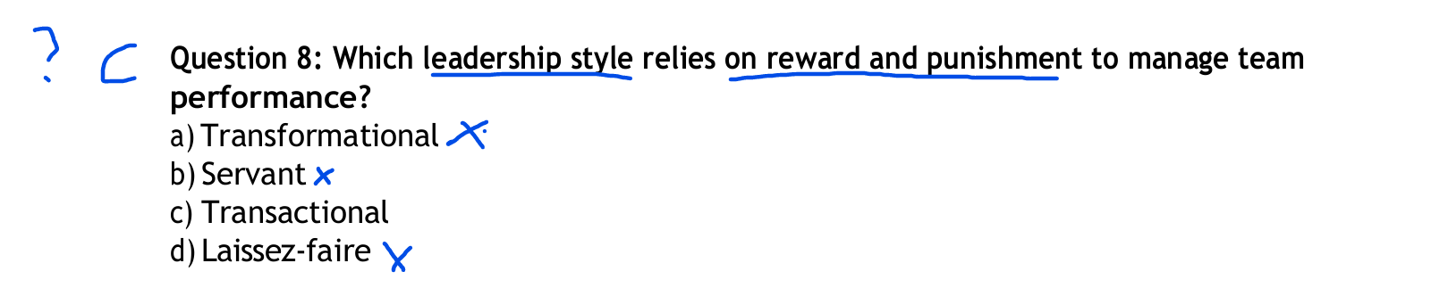

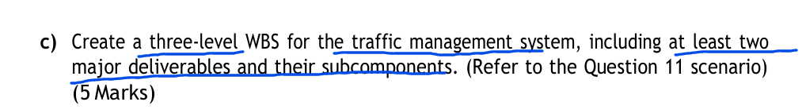
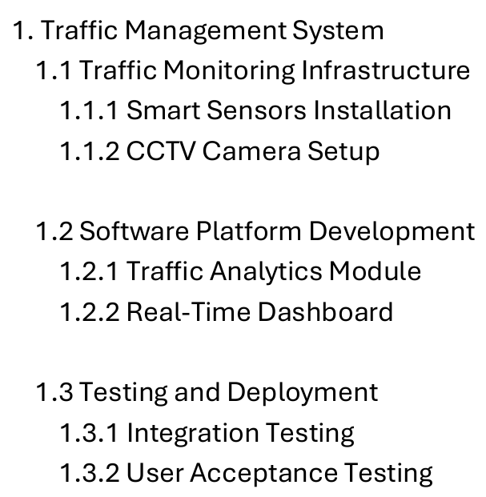
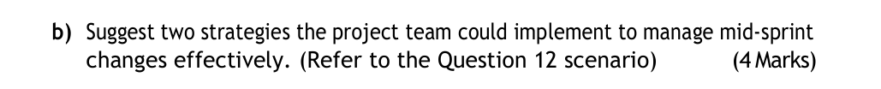
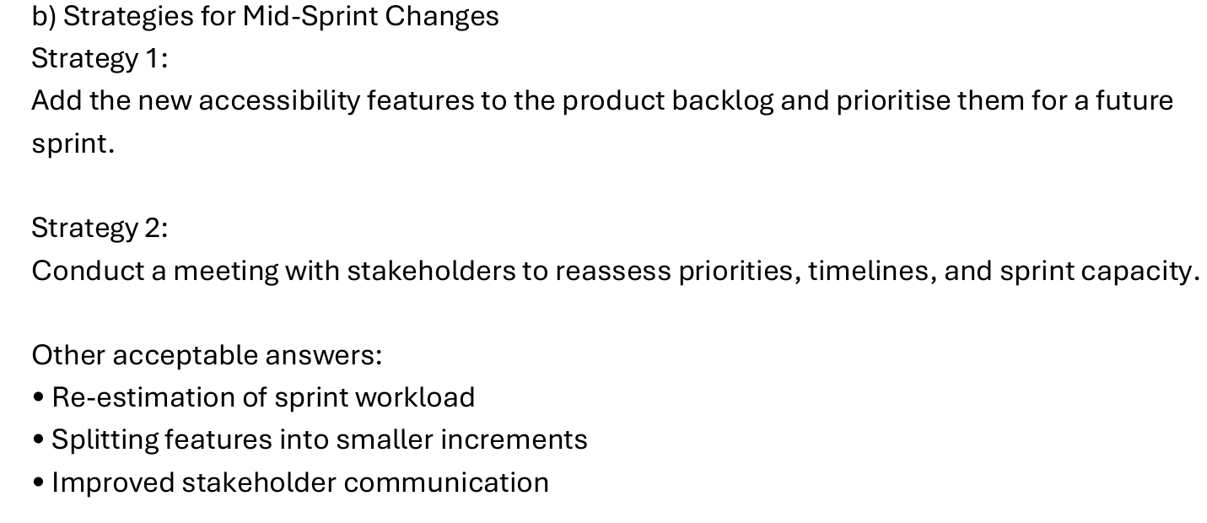

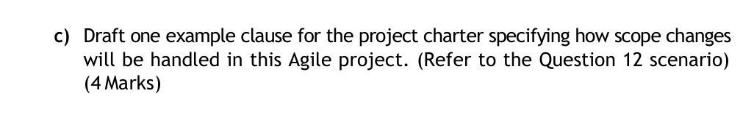
Clause是条款
