Final Project of web development course  
SIMPLE STOCK WEBSITE.

A database driven website for basic stock control

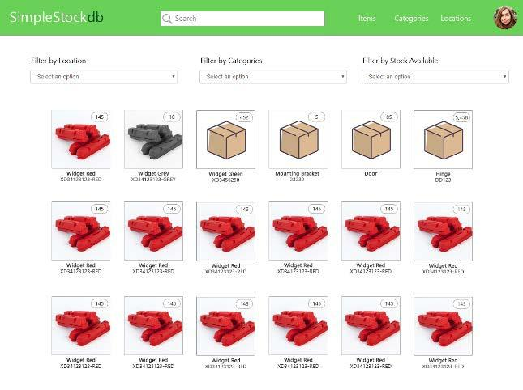

The site will contain a list of items (products) which can be linked to locations and categories and suppliers

Users will be able to add and remove items, the website will keep track of the current stock levels.

ITEMS

Each item can have the following data added to it. Mandatory data is shown with a *

* Item Name*
* Item code
* Item Description
* Item Notes
* Low Stock Threshold Amount
* Category
* Location
* Supplier
* Uploaded Photo (JPG, PNG, BMP, etc)
* Uploaded File (PDF, DOC, TXT, etc.)
* Current Quantity in Stock*

CATEGORIES

Each category is given a name and a description. Users can add, edit and delete categories.

If a category is deleted any items that are associated with that category remain but the category relationship is removed, they then have no category.

LOCATIONS

Each location is given a name and a description. Users can add, edit and delete locations.

If a location is deleted any items that are associated with that location remain but the location relationship is removed, they then have no location assigned.

SUPPLIERS

Each supplier is given a name and a description, phone fax, address. Users can add, edit and delete suppliers.

If a supplier is deleted any items that are associated with that supplier remain but the supplier relationship is removed, they then have no supplier assigned.

USERS

There is only one type of user who can access all features

Users are identified by their email address and a password.

Users can add a profile photo to their account.

User can

1. Add/edit/delete/view other users
2. Login, logout
3. Reset Password
4. Edit his own profile

USER INTERFACE

The site navigation is carried out by the item, category, location and supplier buttons located on the top bar.



The user icon on the right is used to offer the option of changing the profile (picture, name, email, password etc), manage other users and logout

The search bar should dynamically offer suggestions of items as the user types in list form. This should search item names and codes.

ITEM GRID VIEW

Clicking on **Items** from the menu bar shows the item grid view, as default this is listed in alphabetical order using the item name.

Items without photos use the placeholder icon. Items should be paginated on multiple pages

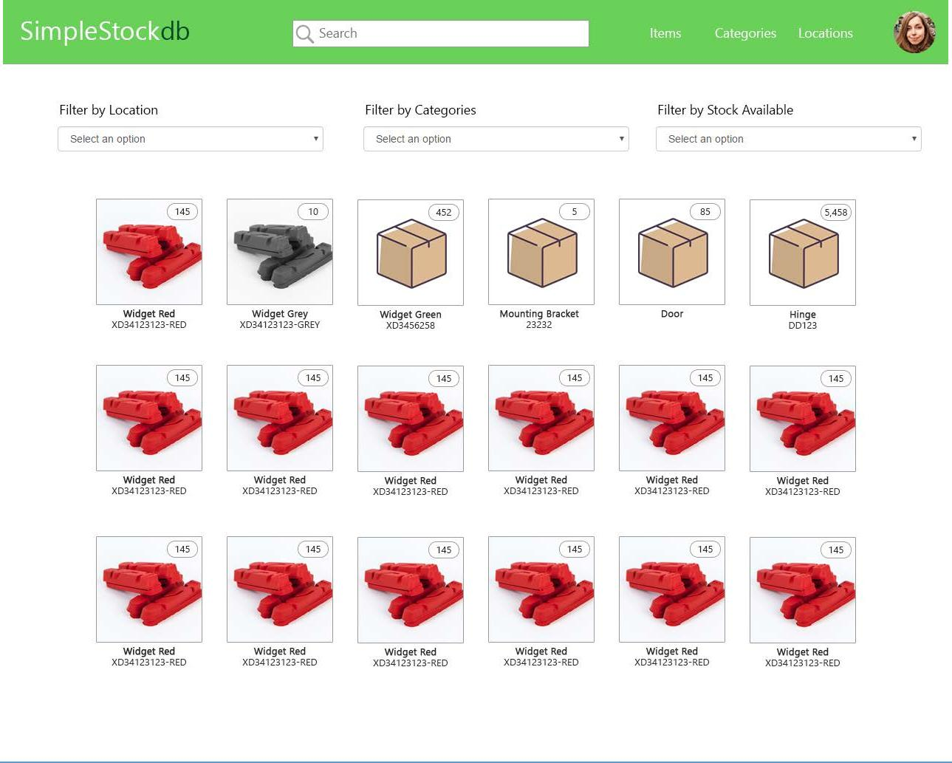

FILTER OPTIONS

The user can choose to filter the items shown by location, by category, by suppler, or by stock level.

Is filtered by location and/or category only items associated with those locations and/or categories area shown.

The filer by Stock level should provide the user with the following choices…

* Show all items
* Show only low stock items

Low stock items are those items who the current quantity in stock value is equal to or less than their low stock threshold amount.

ITEM VIEW

Clicking on an item from the search box or the item grid view displays that item page.

This shows a full size version of the item image along with the name, code and the current stock level. The item description and notes are shown here too.

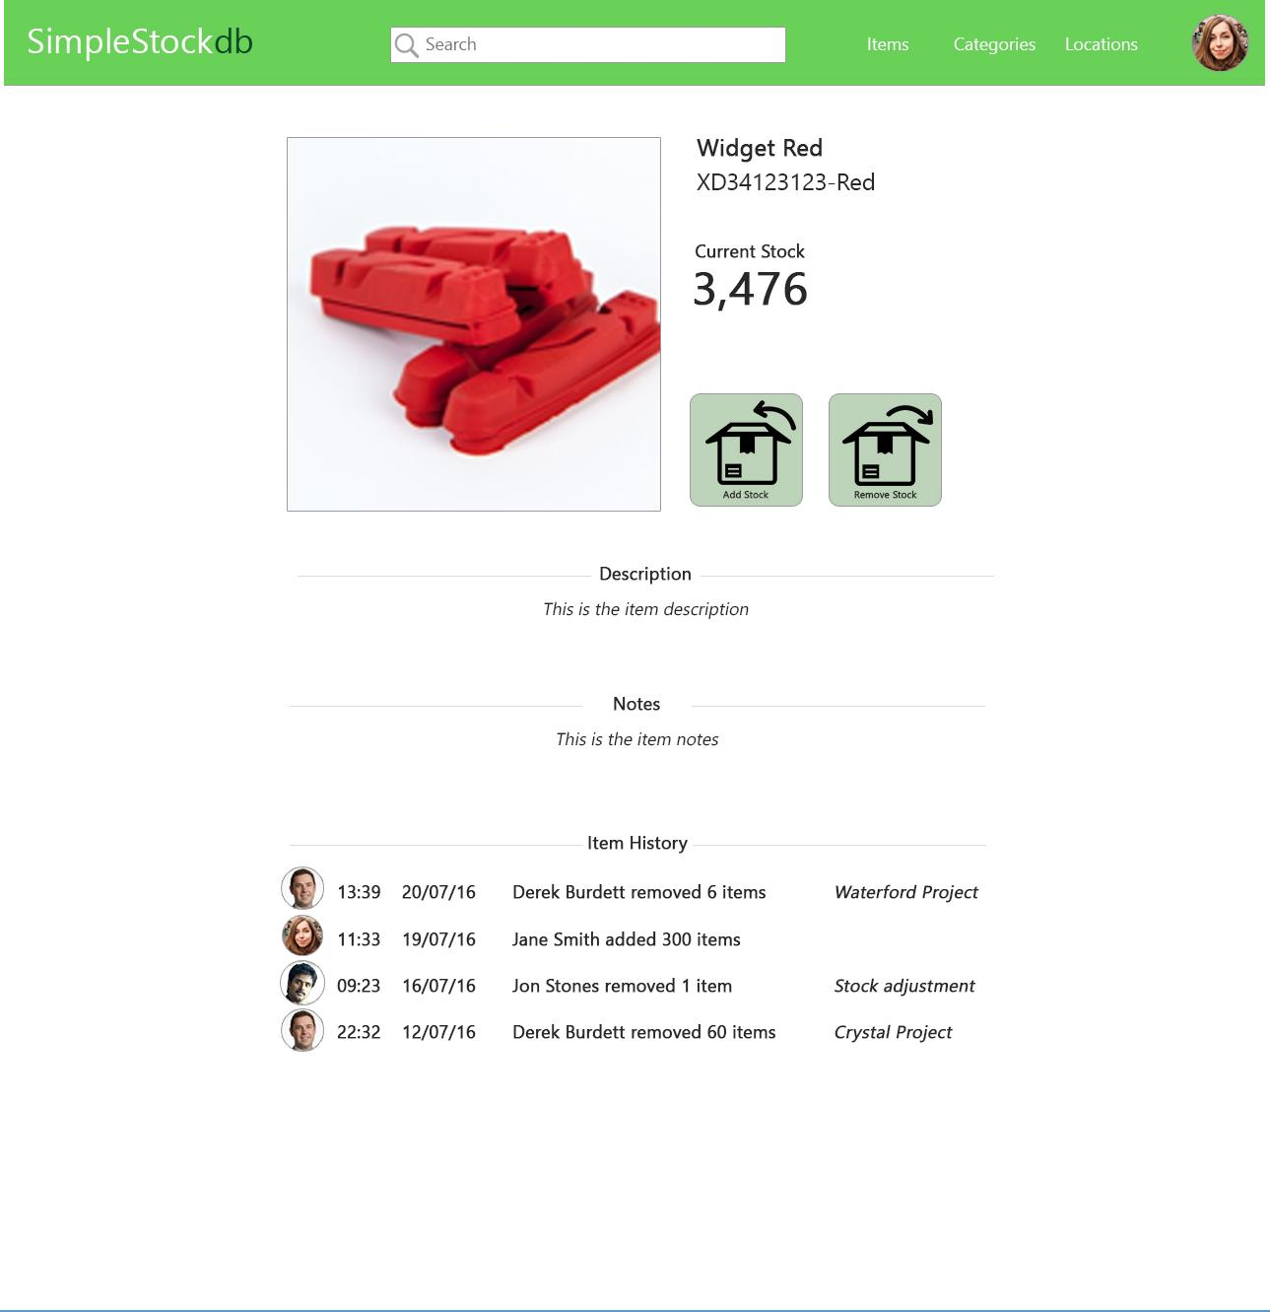

ADD / REMOVE STOCK BUTTONS

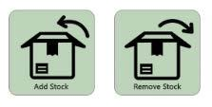

These buttons allow a user to add or remove items from stock, adding or subtracting from the stock total for that item.

When either button is pressed a pop-up prompts the user for the quantity they wish to add/remove along with an option reference for the transaction.

Each transaction is recorded in the database and shown in the Item History section of the Item View.

Item History

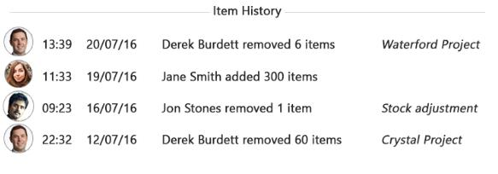

This section displays all previous activity for that item, this includes…

* User who carried out the transaction
* Time/Date of transaction
* How many items were added/removed
* Reference (if added)

LOCATION VIEW

When clicking on the location button on the menu bar a list of locations is displayed in alphabetical order.

Locations can be deleted by clicking on the trash can icon.

Location names can be edited by clicking on the spanner icon.

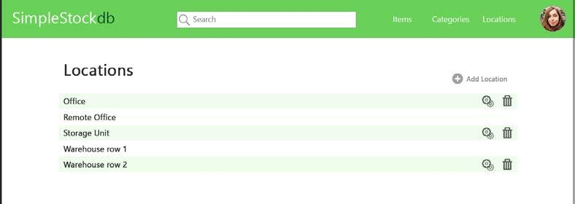

CATEGORY VIEW

When clicking on the category button on the menu bar a list of categories are displayed in alphabetical order.

Categories can be deleted by clicking on the trash can icon.

Category names can be edited by clicking on the spanner icon.

