**Binance.US Resumes USD Services in 2025 After Prolonged Suspension**

Fri 20 Dec 2024 ▪ 3 min read ▪ by Eddy S.

[Getting informed](https://www.cointribune.com/en/tag/getting-informed-en/)▪[Regulation Crypto](https://www.cointribune.com/en/tag/regulation-crypto-en/)

Binance.US, the American branch of the famous crypto exchange platform Binance, has announced its intention to restore USD services at the beginning of 2025. This news was confirmed by interim CEO Norman Reed, who stated that Binance.US is “closer than ever” to achieving this goal.

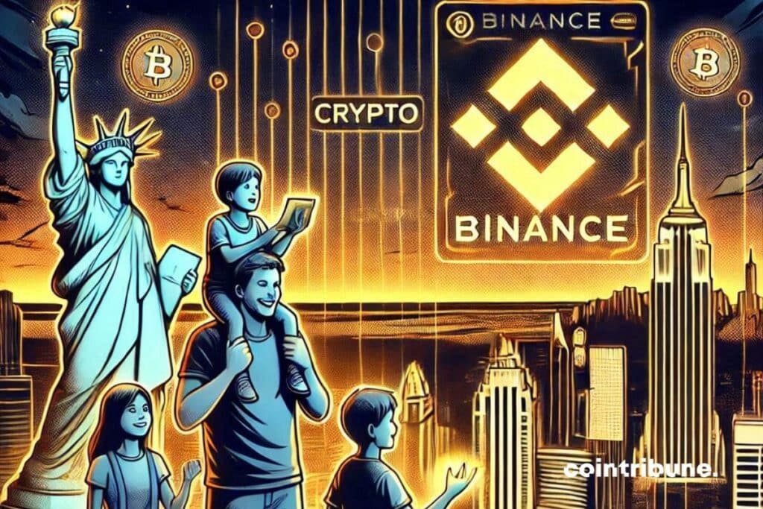

Binance.US plans to restore its services in 2025

Since its inception in 2019, Binance.US has provided regulated crypto trading services to residents of the United States. However, in June 2023, the Securities and Exchange Commission (SEC) filed a lawsuit against Binance, accusing the company of failing to register Binance.US as an exchange. This action led to the suspension of USD deposits on the platform.

Recently, Norman Reed expressed an optimistic vision for the future of Binance.US, stating that 2025 will be a decisive year for the crypto platform. He emphasized that the company is working on new partnerships and improvements to the exchange’s infrastructure, including expanded custody offerings and new wallet solutions.

Reed also mentioned that Binance.US remains determined to strengthen its reputation as the top crypto platform for low fees and high rewards. Especially since in November 2024, Binance recorded [a record influx of $8.73 billion in assets](https://www.cointribune.com/en/binance-hits-8-73-billion-in-asset-inflows/), bringing the total value of its holdings to $154.9 billion. This performance highlights the strength of the platform and user trust, despite an increasingly regulated global environment.

[€20 bonus for registering on Bitvavo](https://bitvavo.com/fr/affiliate/coinmedia?a=_cta)[*This link uses an affiliate program.*](https://www.cointribune.com/en/sponsored-content/)

Impact on the crypto market

[The restoration of USD services](https://blog.binance.us/2024-letter/) could have a significant impact on the crypto market in the United States. By restoring these services, Binance.US could attract new users and strengthen investor confidence, potentially boosting the growth of the platform and the cryptocurrency market in general.

In summary, the return of USD services on Binance.US marks an important milestone for the platform and could play a key role in its future expansion and its ability to offer high-quality crypto trading services to American users.

Maximize your Cointribune experience with our "Read to Earn" program! For every article you read, earn points and access exclusive rewards. Sign up now and start earning benefits.