Brooks Roberts

6/23/24

5.2 Assignment

1. LENGTH() Function: Returns the number of characters in a given string.
   1. You might use it to validate that a password meets the required length.

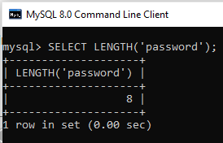

1. LOWER() Function: Converts all letters in a string to lowercase.
   1. Useful for when you need consistent casing in your data.

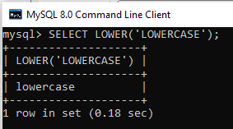

1. SUBSTRING() Function: Extracts a portion of a string.
   1. You can use it to retrieve specific parts of a longer string like domain names from email addresses.

