Brooks Roberts

2/9/25

Assignment 5.2

**Workout & Meal Plan - Value Stream Map (VSM)**

**1. Meal Prep & Planning**

1. Plan weekly meals (15 min)
2. Make grocery list (10 min)
3. Grocery shopping (60 min)
4. Meal prep (90 min)

Total Time: 175 min

**2. Workout Routine**

1. Change into workout clothes (5 min)
2. Warm-up (10 min)
3. Main workout (60 min)
4. Cool down (10 min)

Total Time: 85 min

**3. Post-Workout Recovery**

1. Make post-workout meal (15 min)
2. Eat and hydrate (20 min)
3. Shower & change (15 min)

Total Time: 50 min

Estimated Total Cycle Time: 310 min

|  |  |
| --- | --- |
| Meal Prep & Planning | 175 min |
| Workout Routine | 85 min |
| Post-Workout Recovery | 50 min |

**Optimizing the Process**

1. Reduce grocery trips - Buy in bulk, order online
2. Batch cook meals - Prepare larger portions to save time
3. Optimize warm-up & cool-down - Combine movements to save 5-10 min
4. Pre-mix post-workout shakes - Cut 5 min off meal prep

By applying these optimizations, the total time can be reduced by 30 -40 min. This will improve efficiency while maintaining health and fitness goals.

**Visual VSM Diagram:**

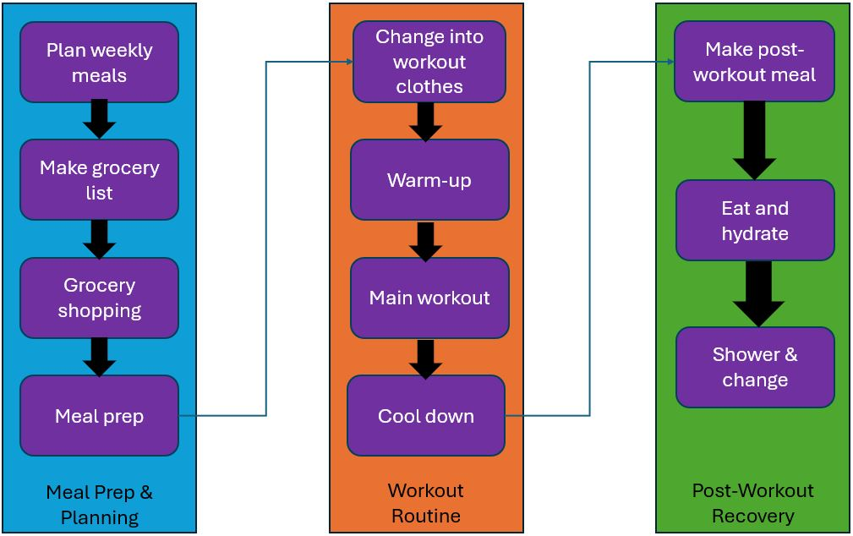

References:

Knight, L. (2020, October 29). 3 easy steps for using VSM in everyday life. ConnectALL. <https://www.connectall.com/3-easy-steps-for-using-vsm-in-everyday-life/>