Design patterns Course: Exercise 1

**Facebook basic experience:**

The user can view his profile pictures and slide through his profile pictures album.

**Facebook Feature 1:**

Shows the inactive liked pages so the user can know which pages to unlike.

The user can choose the number of days that will determine if a page is inactive.

(The Feature can be found at “MainForm.cs”)

# Feature 1: Sequence Diagram

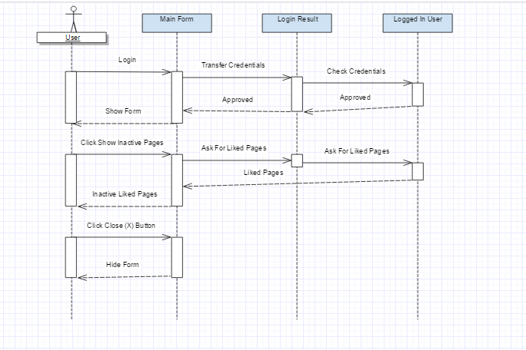

**Facebook Feature 2:**

The Feature gives the user basic image editing tools to edit photos either from facebook’s profile picture or from his local computer, and publish the edited photo to Facebook with a custom Post Title.

The User may also create custom image filters and save them for future usage.

Notes:

1.The default Privacy settings for the new uploaded post is “Only-Me”.

2.The Feature can be found at “ImageEditingForm.cs”.

# Feature 2: Sequence Diagram



# Use Case Diagram

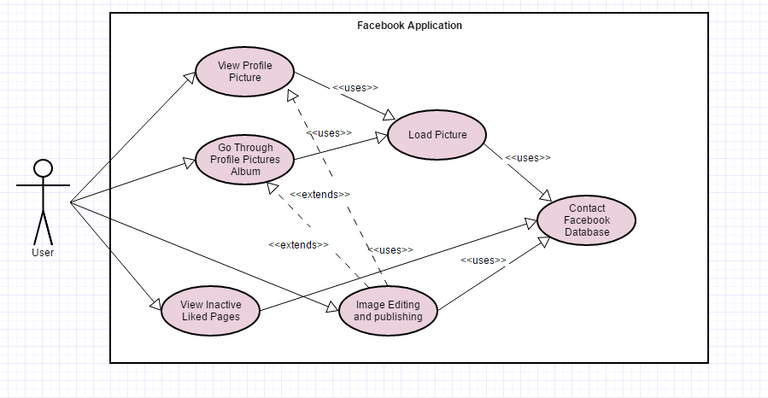

# Class Diagram (zoom in to read)

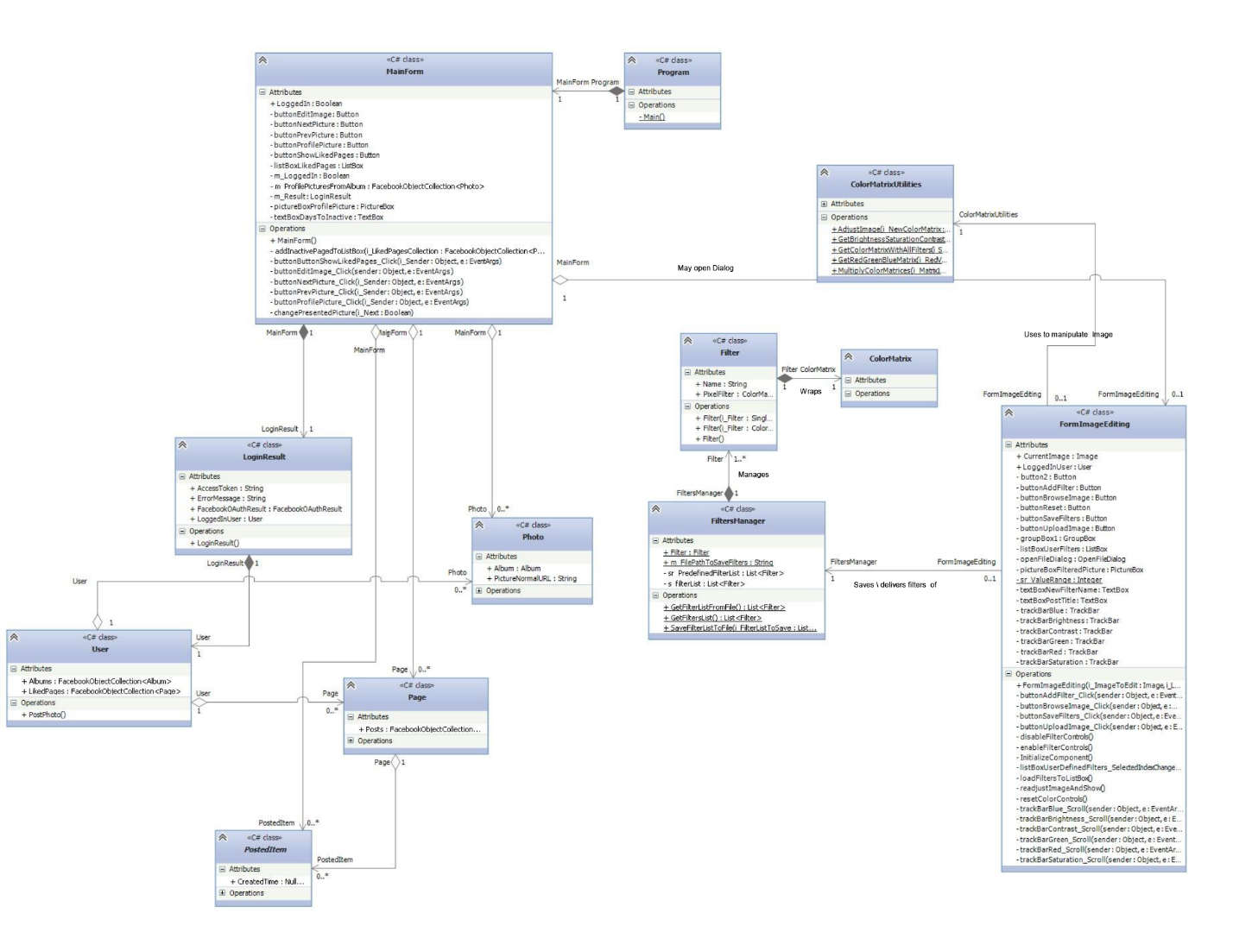

0..*

Reference to app user's Facebook profile and its content

0..*

..*

The user's liked pages

The user's Facebook profile

Reference to app user's Facebook user details

The user's photos on Facebook

The page's posts

Uses to determine which pages are inactive

Presents to user

May present in inactive pages list

Uses to operate