Threshold-Based Shot Boundary Detection:
Analysis and Findings
Shot Boundary Detection Project
2025-12-10
Abstract
This document presents results from threshold-based shot boundary detection experiments. Four feature extraction techniques (CNN, HSV Histogram, CLIP, Optical Flow) were tested with different preprocessing strategies (raw, smoothed, normalized-smoothed) and two detection methods (simple, constrained) across 10 videos, comparing performance with and without frame sampling (rate=8).

Introduction
Threshold-based detection identifies shot boundaries by detecting peaks in frame-to-frame dissimilarity scores. This report presents experimental results from testing multiple feature types and preprocessing configurations.

Methodology

Feature Extraction Methods
- CNN: Deep convolutional features
- HSV Histogram: Color distribution
- CLIP: Vision-language embeddings
- Optical Flow: Motion features

Preprocessing
- Raw: No preprocessing
- Smoothed: Gaussian smoothing
- Normalized-Smoothed: Z-score normalization + smoothing

Detection Methods
- Simple: All peaks above threshold
- Constrained: Minimum distance between detections

Configurations
- No Sampling: Every frame processed
- Sampling (Rate=8): Every 8th frame

Results

Overall Performance Comparison
Table 1 shows the mean performance across all 10 videos for the sampling configuration, while Table 2 shows results without sampling.
Performance with Frame Sampling (Rate=8) - Best configurations per feature
Feature | Config | Precision | Recall | F1-Score
CNN | Norm-Smooth (Constrained) | 0.242 | 0.683 | 0.348
HSV Histogram | Norm-Smooth (Constrained) | 0.388 | 0.711 | 0.488
CLIP | Norm-Smooth (Constrained) | 0.190 | 0.557 | 0.269
Optical Flow | Norm-Smooth (Constrained) | 0.149 | 0.723 | 0.241
Performance without Frame Sampling - Best configurations per feature
Feature | Config | Precision | Recall | F1-Score
CNN | Raw (Constrained) | 0.439 | 0.435 | 0.427
HSV Histogram | Norm-Smooth (Constrained) | 0.656 | 0.518 | 0.567
CLIP | Raw (Simple) | 0.661 | 0.785 | 0.671
Optical Flow | Raw (Constrained) | 0.126 | 0.190 | 0.145

Key Findings
- With Sampling: Normalized-smoothed preprocessing essential. Raw/smoothed yield near-zero performance.
- Without Sampling: Raw features perform well, especially CLIP (F1=0.671) and CNN (F1=0.427).
- Simple detection: High recall ($>$0.95) but very low precision ($<$0.05), causing massive over-detection.
- Constrained detection: 2-10x precision improvement, maintaining reasonable recall (0.5-0.7).

Best Performers
With Sampling: HSV Histogram (F1=0.488)
Without Sampling: CLIP (F1=0.671)
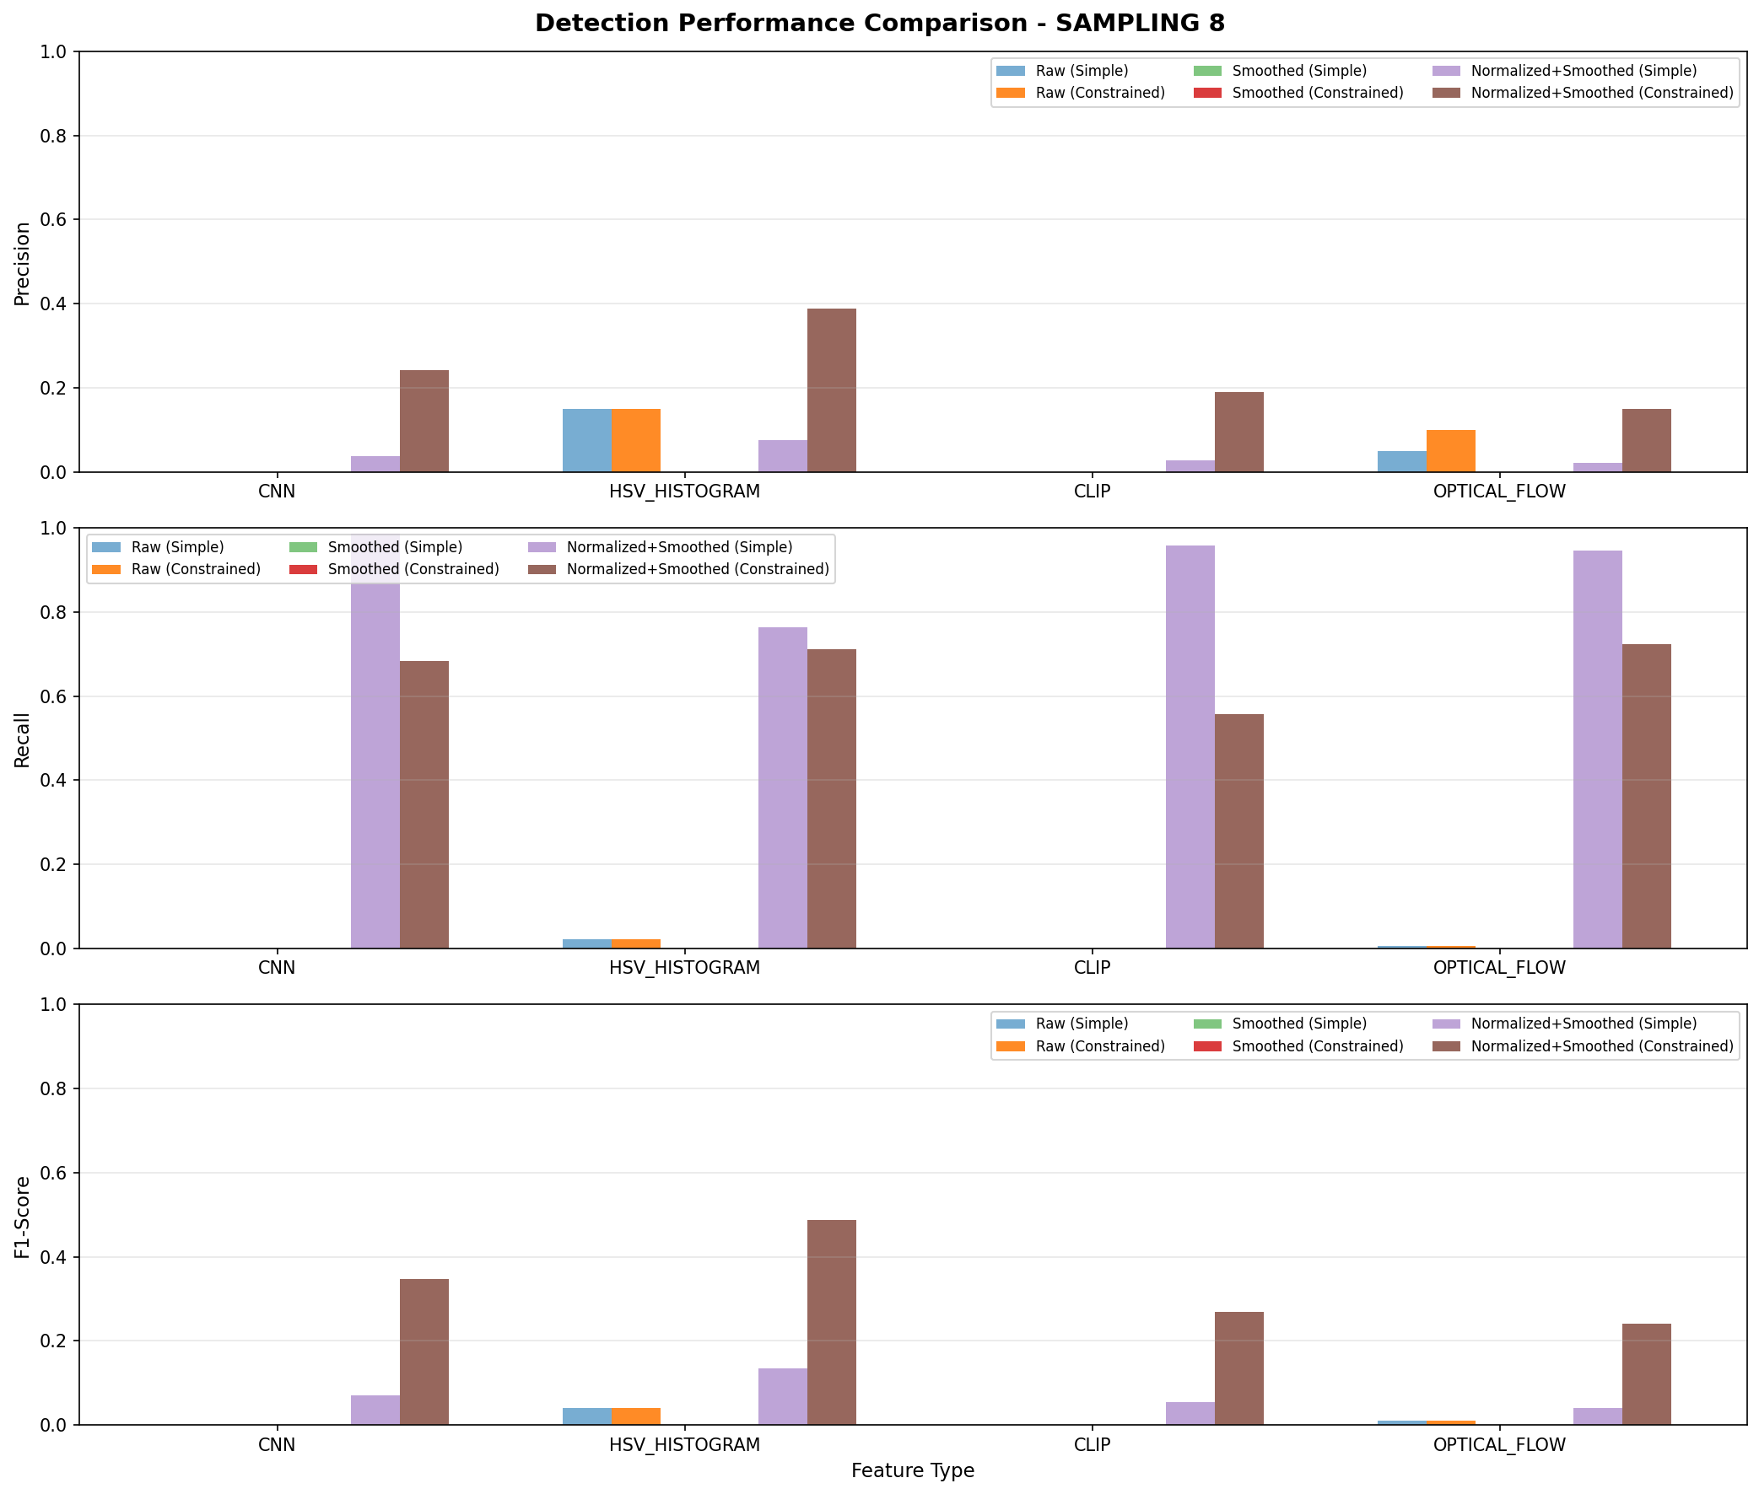
Performance comparison across features and configurations with frame sampling (rate=8)
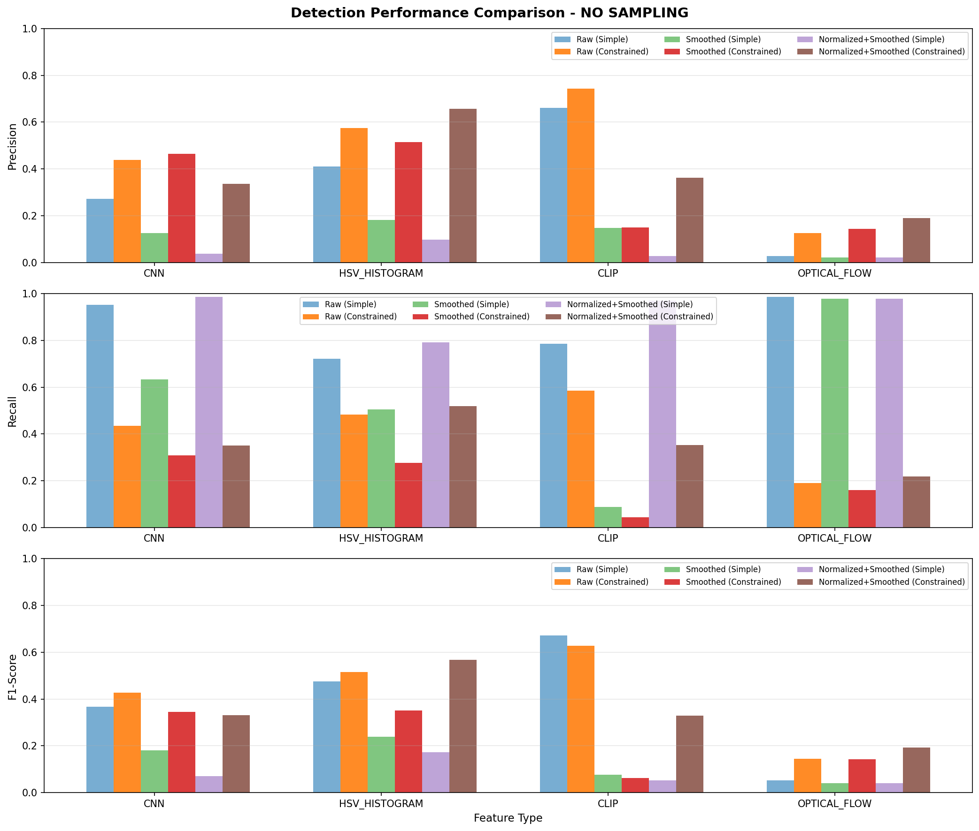
Performance comparison across features and configurations without frame sampling

Example Video Analysis
Table 3 and Table 4 show detailed results for the first video (AN5UYQXsQXLqO0UUYDklpw__) with 12 ground truth boundaries.
First Video Results - With Sampling (12 ground truth boundaries)
Feature | Method | Precision | Recall | F1 | TP | FP
CNN | Simple | 0.060 | 0.917 | 0.113 | 11 | 171
CNN | Constrained | 0.333 | 0.500 | 0.400 | 6 | 12
HSV | Simple | 0.076 | 0.833 | 0.139 | 10 | 122
HSV | Constrained | 0.417 | 0.833 | 0.556 | 10 | 14
CLIP | Simple | 0.052 | 1.000 | 0.098 | 12 | 221
CLIP | Constrained | 0.333 | 0.500 | 0.400 | 6 | 12
Optical Flow | Simple | 0.036 | 0.833 | 0.069 | 10 | 268
Optical Flow | Constrained | 0.276 | 0.667 | 0.390 | 8 | 21
First Video Results - Without Sampling (12 ground truth boundaries)
Feature | Method | Precision | Recall | F1 | TP | FP
CNN (Raw) | Simple | 0.131 | 0.917 | 0.229 | 11 | 73
CNN (Raw) | Constrained | 0.250 | 0.167 | 0.200 | 2 | 6
HSV (Raw) | Simple | 0.101 | 0.833 | 0.180 | 10 | 89
HSV (Raw) | Constrained | 0.333 | 0.250 | 0.286 | 3 | 6
CLIP (Raw) | Simple | 0.571 | 0.667 | 0.615 | 8 | 7
CLIP (Raw) | Constrained | 0.857 | 0.500 | 0.632 | 6 | 2
Optical Flow (Raw) | Simple | 0.073 | 1.000 | 0.136 | 12 | 152
Optical Flow (Raw) | Constrained | 0.083 | 0.083 | 0.083 | 1 | 11

Discussion
Frame sampling fundamentally changes optimal preprocessing: normalization becomes essential with sampling, while raw features excel without sampling. Constrained detection is critical to reduce false positives. HSV Histogram provides consistent performance across configurations, while CLIP achieves best results with full-frame processing.

Limitations
- May not capture complex transitions (dissolves, fades)
- Performance varies by video type
- Optical flow has low precision
- High false positive rates with simple detection

Conclusion
HSV Histogram with normalized-smoothed preprocessing and constrained detection provides consistent results (F1=0.488-0.567). CLIP achieves superior performance (F1=0.671) with full temporal resolution. Constrained detection reduces false positives by orders of magnitude while maintaining good recall.

