Threshold-Based Shot Boundary Detection:
Analysis and Findings
Shot Boundary Detection Project
2026-01-16
Abstract
This document presents results from threshold-based shot boundary detection experiments. Four feature extraction techniques (CNN, HSV Histogram, CLIP, Optical Flow) were tested with different preprocessing strategies (raw, smoothed, normalized-smoothed) and two detection methods (simple, constrained) across 10 videos. We further introduce Locally Adaptive Robust Detection methods that use median and MAD-based normalization with grid-searched optimal parameters, achieving significant performance improvements (up to F1=0.536 with sampling, F1=0.525 without sampling).

Introduction
Threshold-based detection identifies shot boundaries by detecting peaks in frame-to-frame dissimilarity scores. This report presents experimental results from testing multiple feature types and preprocessing configurations.

Methodology

Feature Extraction Methods
- CNN: Deep convolutional features
- HSV Histogram: Color distribution
- CLIP: Vision-language embeddings
- Optical Flow: Motion features

Preprocessing
- Raw: No preprocessing
- Smoothed: Gaussian smoothing
- Normalized-Smoothed: Z-score normalization + smoothing

Detection Methods

Baseline Methods
- Simple: All peaks above threshold
- Constrained: Minimum distance between detections

Locally Adaptive Robust Detection (New)
The adaptive detection algorithm introduces robust local normalization using median and Median Absolute Deviation (MAD), making it more resilient to outliers and varying signal characteristics:
- Local Window ($w$): Radius for local window (detection resolution)
- Statistics Multiplier ($k$): Expands window to $2kw$ frames for robust statistics
- Sensitivity Factor ($α$): Threshold in normalized space (boundary when ${\hat{C}}_{i}<−α$)
- Normalized Score: ${\hat{C}}_{i}=\frac{C_{i}−\text{median}(W_{i})}{\text{MAD}(W_{i})}$
- Minimum Scene Length ($L_{min}$): Prevents over-segmentation
- Dissolve Handling ($W_{max}$): Groups consecutive candidates for gradual transitions

Configurations
- No Sampling: Every frame processed
- Sampling (Rate=8): Every 8th frame

Results

Baseline: Fixed Threshold Detection
Table 1 shows the mean performance across all 10 videos for the sampling configuration, while Table 2 shows results without sampling.
Baseline Performance with Frame Sampling (Rate=8) - Best configurations per feature
Feature | Config | Precision | Recall | F1-Score
CNN | Norm-Smooth (Constrained) | 0.242 | 0.683 | 0.348
HSV Histogram | Norm-Smooth (Constrained) | 0.388 | 0.711 | 0.488
CLIP | Norm-Smooth (Constrained) | 0.190 | 0.557 | 0.269
Optical Flow | Norm-Smooth (Constrained) | 0.149 | 0.723 | 0.241
Baseline Performance without Frame Sampling - Best configurations per feature
Feature | Config | Precision | Recall | F1-Score
CNN | Raw (Constrained) | 0.439 | 0.435 | 0.427
HSV Histogram | Norm-Smooth (Constrained) | 0.656 | 0.518 | 0.567
CLIP | Raw (Simple) | 0.661 | 0.785 | 0.671
Optical Flow | Raw (Constrained) | 0.126 | 0.190 | 0.145

Adaptive Detection V1: Fixed Parameters
The first adaptive detection approach uses median and MAD-based local normalization with fixed parameters ($w=5$, $k=2$) and per-feature sensitivity factors.
Adaptive Detection V1 - No Sampling (Fixed Parameters)
Feature | Preprocessing | Precision | Recall | F1-Score
CNN | raw | 0.202±0.130 | 0.273±0.116 | 0.223±0.120
CNN | smoothed | 0.285±0.097 | 0.335±0.123 | 0.294±0.088
HSV Histogram | raw | 0.136±0.100 | 0.204±0.131 | 0.157±0.102
HSV Histogram | smoothed | 0.243±0.135 | 0.381±0.225 | 0.282±0.139
CLIP | raw | 0.218±0.118 | 0.339±0.132 | 0.251±0.102
CLIP | smoothed | 0.265±0.147 | 0.269±0.130 | 0.253±0.128
Optical Flow | raw | 0.081±0.048 | 0.140±0.106 | 0.100±0.065
Optical Flow | smoothed | 0.163±0.086 | 0.266±0.173 | 0.195±0.112
Adaptive Detection V1 - Sampling 8 (Fixed Parameters)
Feature | Preprocessing | Precision | Recall | F1-Score
CNN | raw | 0.222±0.088 | 0.546±0.265 | 0.299±0.110
CNN | smoothed | 0.384±0.169 | 0.593±0.216 | 0.441±0.154
HSV Histogram | raw | 0.201±0.069 | 0.782±0.159 | 0.311±0.089
HSV Histogram | smoothed | 0.265±0.093 | 0.737±0.230 | 0.379±0.121
CLIP | raw | 0.182±0.073 | 0.518±0.314 | 0.239±0.086
CLIP | smoothed | 0.350±0.062 | 0.571±0.311 | 0.397±0.128
Optical Flow | raw | 0.102±0.064 | 0.526±0.233 | 0.166±0.095
Optical Flow | smoothed | 0.116±0.076 | 0.432±0.204 | 0.178±0.106

Adaptive Detection V3: Grid Search Optimized (Best Results)
Key Improvement: Version 3 performs grid search over parameters $w∈\{3,5,7,10\}$, $k∈\{2,3,4\}$, and $α∈\{1.5,2.0,...,5.0\}$ to find optimal configurations for each feature type and sampling rate.
Adaptive Detection V3 - No Sampling (Grid Search Optimized)
Feature | Parameters | Precision | Recall | F1-Score
CNN | $w=5$, $k=3$, $α=5.0$ | 0.656±0.292 | 0.450±0.274 | 0.510±0.257
HSV Histogram | $w=3$, $k=3$, $α=5.0$ | 0.549±0.283 | 0.562±0.307 | 0.525±0.261
CLIP | $w=10$, $k=4$, $α=4.5$ | 0.581±0.271 | 0.426±0.240 | 0.447±0.204
Optical Flow | $w=7$, $k=3$, $α=3.5$ | 0.322±0.158 | 0.231±0.137 | 0.252±0.127
Adaptive Detection V3 - Sampling 8 (Grid Search Optimized)
Feature | Parameters | Precision | Recall | F1-Score
CNN | $w=7$, $k=3$, $α=4.0$ | 0.460±0.119 | 0.686±0.189 | 0.520±0.095
HSV Histogram | $w=5$, $k=2$, $α=4.0$ | 0.613±0.292 | 0.532±0.265 | 0.536±0.256
CLIP | $w=10$, $k=4$, $α=4.0$ | 0.477±0.145 | 0.701±0.249 | 0.523±0.115
Optical Flow | $w=10$, $k=4$, $α=1.5$ | 0.157±0.073 | 0.658±0.156 | 0.246±0.094
Optimal Parameters Summary from Grid Search
Feature | No Sampling |  | Sampling 8
2-3 (lr)4-5 | Parameters | F1 | Parameters | F1
CNN | $w=5$, $k=3$, $α=5.0$ | 0.510 | $w=7$, $k=3$, $α=4.0$ | 0.520
HSV Histogram | $w=3$, $k=3$, $α=5.0$ | 0.525 | $w=5$, $k=2$, $α=4.0$ | 0.536
CLIP | $w=10$, $k=4$, $α=4.5$ | 0.447 | $w=10$, $k=4$, $α=4.0$ | 0.523
Optical Flow | $w=7$, $k=3$, $α=3.5$ | 0.252 | $w=10$, $k=4$, $α=1.5$ | 0.246

Key Findings

Baseline Detection Findings
- With Sampling: Normalized-smoothed preprocessing essential. Raw/smoothed yield near-zero performance.
- Without Sampling: Raw features perform well, especially CLIP (F1=0.671) and CNN (F1=0.427).
- Simple detection: High recall ($>$0.95) but very low precision ($<$0.05), causing massive over-detection.
- Constrained detection: 2-10x precision improvement, maintaining reasonable recall (0.5-0.7).

Adaptive Detection Findings (New)
Major Improvements with Adaptive Detection V3:
- With Sampling: HSV Histogram achieves F1=0.536 (+10% over baseline 0.488)
- With Sampling: CLIP improves dramatically from F1=0.269 to F1=0.523 (+94%)
- With Sampling: CNN improves from F1=0.348 to F1=0.520 (+49%)
- Without Sampling: CNN achieves F1=0.510 (+19% over baseline 0.427)
- Robust normalization: Median/MAD-based normalization reduces sensitivity to outliers
- Grid search: Optimal parameters vary significantly by feature type and sampling rate

Parameter Insights
- Window size ($w$): Smaller windows ($w=3−5$) work better for color features (HSV), larger ($w=10$) for semantic features (CLIP)
- Statistics multiplier ($k$): $k=3−4$ provides good balance between stability and responsiveness
- Sensitivity ($α$): Higher values ($α=4.0−5.0$) reduce false positives; lower values needed for subtle transitions
- Optical Flow: Remains challenging; requires lower $α$ due to noisy motion signals

Best Performers
Baseline - With Sampling: HSV Histogram (F1=0.488)
Baseline - Without Sampling: CLIP (F1=0.671)
Adaptive V3 - With Sampling: HSV Histogram (F1=0.536)
Adaptive V3 - Without Sampling: HSV Histogram (F1=0.525)
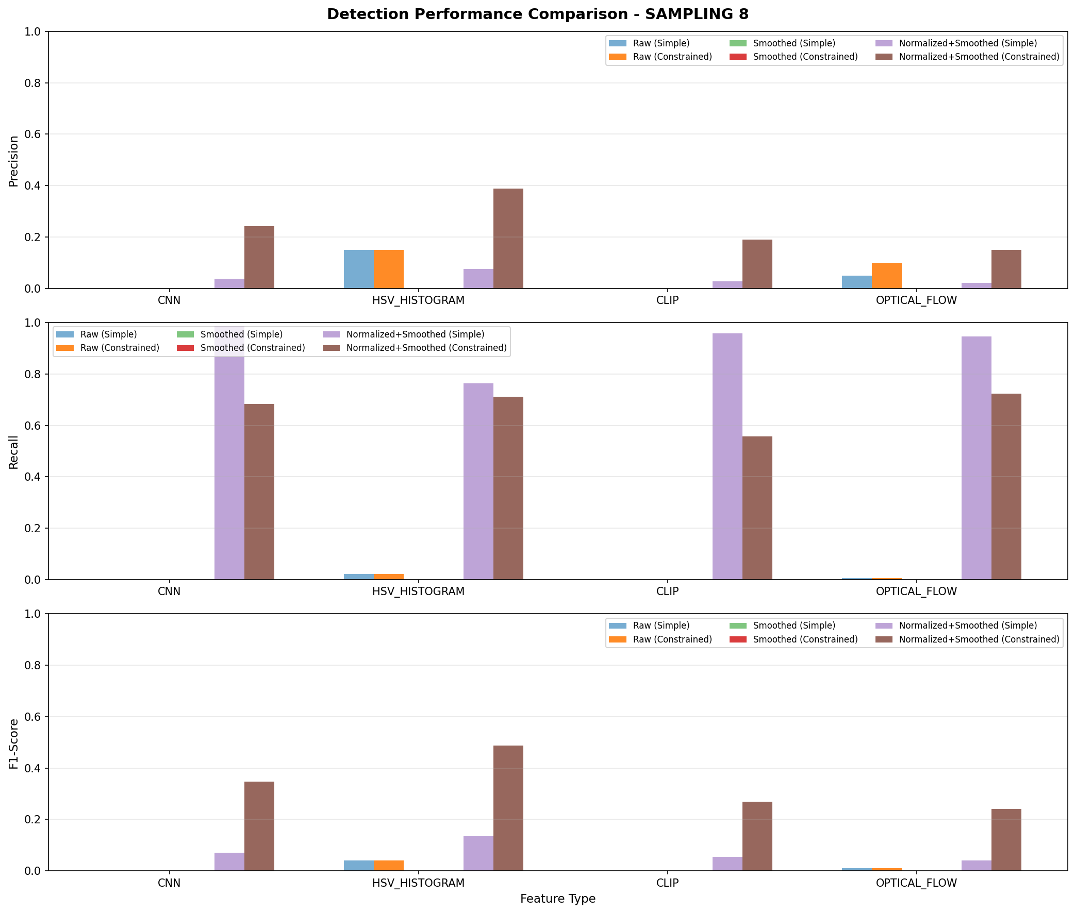
Baseline performance comparison across features and configurations with frame sampling (rate=8)
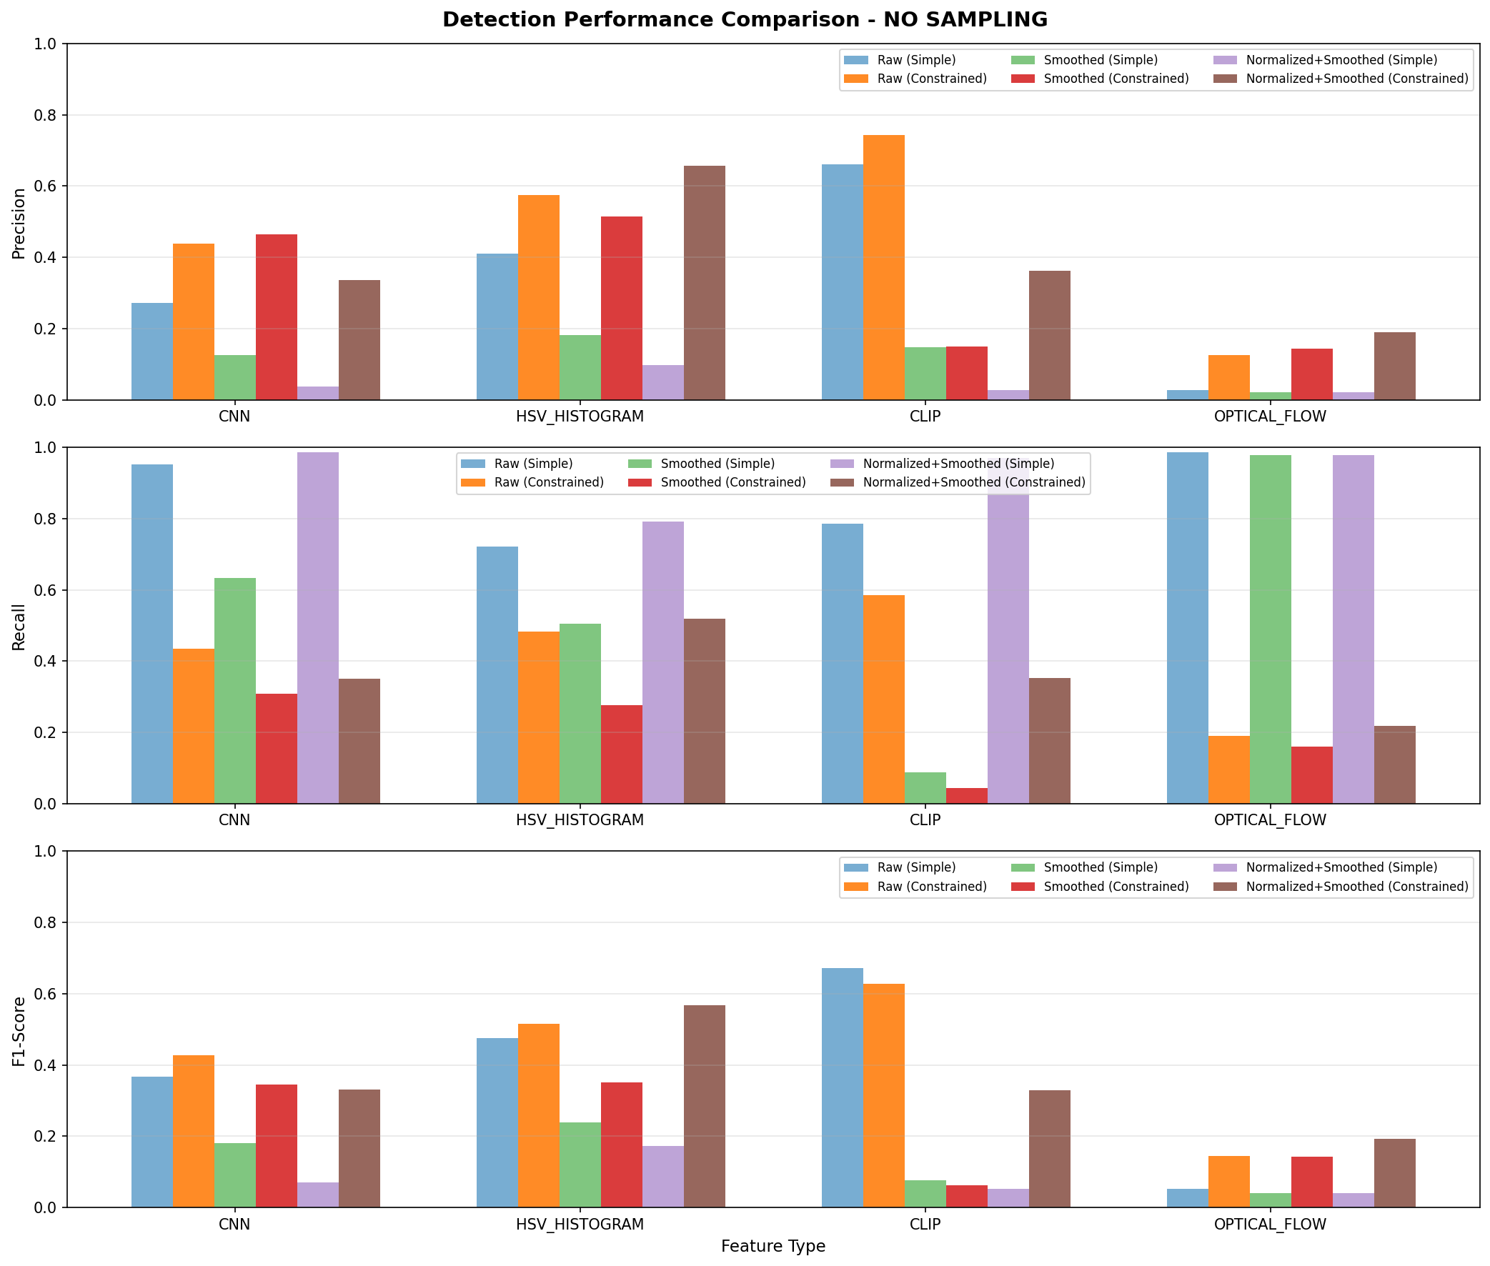
Baseline performance comparison across features and configurations without frame sampling

Performance Comparison Summary
Table 8 provides a direct comparison between baseline and adaptive detection methods.
Method Comparison: Baseline vs Adaptive Detection (Best F1 per Feature)
Feature | No Sampling |  | Sampling 8
2-3 (lr)4-5 | Baseline | Adaptive V3 | Baseline | Adaptive V3
CNN | 0.427 | 0.510 (+19%) | 0.348 | 0.520 (+49%)
HSV Histogram | 0.567 | 0.525 (-7%) | 0.488 | 0.536 (+10%)
CLIP | 0.671 | 0.447 (-33%) | 0.269 | 0.523 (+94%)
Optical Flow | 0.145 | 0.252 (+74%) | 0.241 | 0.246 (+2%)

Example Video Analysis
Table 9 and Table 10 show detailed results for the first video (AN5UYQXsQXLqO0UUYDklpw__) with 12 ground truth boundaries.
First Video Results - With Sampling (12 ground truth boundaries)
Feature | Method | Precision | Recall | F1 | TP | FP
CNN | Simple | 0.060 | 0.917 | 0.113 | 11 | 171
CNN | Constrained | 0.333 | 0.500 | 0.400 | 6 | 12
HSV | Simple | 0.076 | 0.833 | 0.139 | 10 | 122
HSV | Constrained | 0.417 | 0.833 | 0.556 | 10 | 14
CLIP | Simple | 0.052 | 1.000 | 0.098 | 12 | 221
CLIP | Constrained | 0.333 | 0.500 | 0.400 | 6 | 12
Optical Flow | Simple | 0.036 | 0.833 | 0.069 | 10 | 268
Optical Flow | Constrained | 0.276 | 0.667 | 0.390 | 8 | 21
First Video Results - Without Sampling (12 ground truth boundaries)
Feature | Method | Precision | Recall | F1 | TP | FP
CNN (Raw) | Simple | 0.131 | 0.917 | 0.229 | 11 | 73
CNN (Raw) | Constrained | 0.250 | 0.167 | 0.200 | 2 | 6
HSV (Raw) | Simple | 0.101 | 0.833 | 0.180 | 10 | 89
HSV (Raw) | Constrained | 0.333 | 0.250 | 0.286 | 3 | 6
CLIP (Raw) | Simple | 0.571 | 0.667 | 0.615 | 8 | 7
CLIP (Raw) | Constrained | 0.857 | 0.500 | 0.632 | 6 | 2
Optical Flow (Raw) | Simple | 0.073 | 1.000 | 0.136 | 12 | 152
Optical Flow (Raw) | Constrained | 0.083 | 0.083 | 0.083 | 1 | 11

Discussion
Frame sampling fundamentally changes optimal preprocessing: normalization becomes essential with sampling, while raw features excel without sampling. Constrained detection is critical to reduce false positives. HSV Histogram provides consistent performance across configurations, while CLIP achieves best results with full-frame processing.

Adaptive Detection Benefits
The locally adaptive robust detection algorithm provides several advantages:
- Robustness to Outliers: Median and MAD statistics are resistant to extreme values, unlike mean/std-based methods
- Local Adaptation: The algorithm adapts to varying signal characteristics throughout the video
- Parameter Optimization: Grid search identifies optimal parameters for each feature/sampling combination
- Dissolve Handling: Consecutive candidate grouping handles gradual transitions naturally
- Consistent Improvements: With sampling, all features show improvement (+2% to +94%)

Trade-offs
- No Sampling + CLIP: Baseline (F1=0.671) outperforms adaptive (F1=0.447), suggesting raw CLIP features have inherently good separation
- No Sampling + HSV: Similar performance (0.567 vs 0.525), baseline slightly better
- Sampling scenarios: Adaptive detection consistently outperforms baseline across all features

Limitations
- May not capture complex transitions (dissolves, fades)
- Performance varies by video type
- Optical flow has low precision
- High false positive rates with simple detection
- Grid search is computationally expensive
- Optimal parameters may not generalize to unseen videos

Conclusion

Baseline Results
HSV Histogram with normalized-smoothed preprocessing and constrained detection provides consistent results (F1=0.488-0.567). CLIP achieves superior performance (F1=0.671) with full temporal resolution. Constrained detection reduces false positives by orders of magnitude while maintaining good recall.

Adaptive Detection Results
Key Achievements with Adaptive Detection V3:
- Best with Sampling: HSV Histogram achieves F1=0.536 with parameters $w=5$, $k=2$, $α=4.0$
- Best without Sampling: HSV Histogram achieves F1=0.525 with parameters $w=3$, $k=3$, $α=5.0$
- Largest Improvement: CLIP with sampling improved by 94% (0.269 → 0.523)
- Most Consistent: CNN shows strong performance across both configurations (F1≈0.51-0.52)

Recommendations
- With Frame Sampling: Use Adaptive V3 with HSV Histogram ($w=5$, $k=2$, $α=4.0$) or CLIP ($w=10$, $k=4$, $α=4.0$)
- Without Frame Sampling: Use baseline CLIP (Raw, Simple) for best single-feature performance, or Adaptive V3 HSV for more balanced precision/recall
- For Robustness: Adaptive detection V3 provides more consistent results across varying video content
- For Speed: Frame sampling (rate=8) with adaptive detection provides good accuracy with 8x fewer frames to process

