На самостоятельню обработку - Замыкания

<https://github.com/azat-io/you-dont-know-js-ru/blob/master/scope%20%26%20closures/ch5.md>

Рекомендация к прочтению - <https://github.com/azat-io/you-dont-know-js-ru/blob/master/scope%20%26%20closures/README.md#%D0%92%D1%8B-%D0%BD%D0%B5-%D0%B7%D0%BD%D0%B0%D0%B5%D1%82%D0%B5-js-%D0%9E%D0%B1%D0%BB%D0%B0%D1%81%D1%82%D1%8C-%D0%B2%D0%B8%D0%B4%D0%B8%D0%BC%D0%BE%D1%81%D1%82%D0%B8-%D0%B8-%D0%B7%D0%B0%D0%BC%D1%8B%D0%BA%D0%B0%D0%BD%D0%B8%D1%8F>  
  
  
**1. Задание**

Using var, declare a global variable named myGlobal outside of any function. Initialize it with a value of 10.

Inside function fun1, assign 5 to oopsGlobal ***without*** using the var keyword.

условия выполнения:

myGlobal should be defined

myGlobal should have a value of 10

myGlobal should be declared using the var keyword

oopsGlobal should be a global variable and have a value of 5

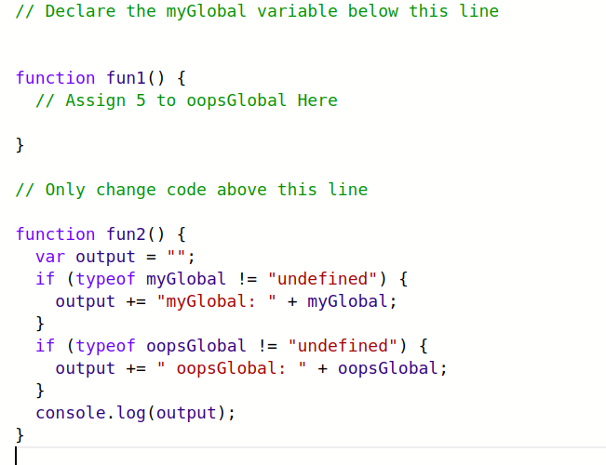

**2. Задание**

The editor has two console.logs to help you see what is happening. Check the console as you code to see how it changes. Declare a local variable myVar inside myLocalScope and run the tests.

Note: The console will still have 'ReferenceError: myVar is not defined', but this will not cause the tests to fail.

условия выполнения:

The code should not contain a global myVarvariable.

You should add a local myVar variable.

